**VIRUS**

1. Virus means "venom". Viruses are basically form of *genetic information* insures its continued survival.
2. Viruses are very small (submicroscopic) infectious particles (virions) composed of a protein coat and a nucleic acid either RNA or DNA.
3. Plant viruses are obligate [intracellular parasites](https://en.wikipedia.org/wiki/Intracellular_parasite) that do not have the molecular machinery to [replicate](https://en.wikipedia.org/wiki/Self-replication) without a [host](https://en.wikipedia.org/wiki/Host_(biology)).
4. The first virus to be discovered (see below) was [*Tobacco mosaic virus*](https://en.wikipedia.org/wiki/Tobacco_mosaic_virus) (TMV).
5. Plant viruses are grouped into 73 [genera](https://en.wikipedia.org/wiki/Genus_(biology)) and 49 [families](https://en.wikipedia.org/wiki/Family_(biology)).

**VIRION**

A complete infectious virus particle is called virion.

**PRION**

It is the viral protein which is infectious in nature

**VIROID**

It is a smaller low molecular weight ribo-nucleic acid that can infect plant cells, replicate themselves and cause diseases OR Naked RNA having no protein. The first viroid to be identified was the [*potato spindle tuber viroid*](http://en.wikipedia.org/wiki/Potato_spindle_tuber_viroid) (PSTVd).

## VIRUS MORPHOLOGY

## With the discovery of the electron microscope it became possible to study the morphology of viruses. It was quickly realized that the [size and shape](http://www.gene.com/ae/AB/GG/examples_of_viruses.html) of an individual virus is a constant and distinguishing characteristic.http://www.biologie.uni-hamburg.de/b-online/fo35/tmvem.jpg Viruses may consist of circles, ovals, long thick or thin rods, flexible or stiff rods and ones with distinctive heads and tail components.

The smallest viruses are around 20 nm in diameter and the largest around 250 nm. Icosahedral virus particles.

**Particle morphology: Amongst plant viruses, the most frequently encountered shapes are:**

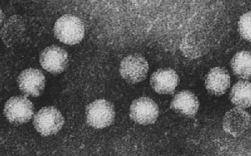**ISOMETRIC:** apparently spherical and about 18nm in diameter upwards.

**Example:** *Tobacco necrosis virus*, genus *Necrovirus* with particles 26 nm in diameter.

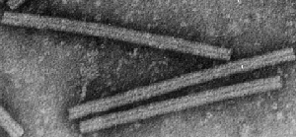

**ROD-SHAPED:** about 20-25 nm in diameter and from about 100 to 300 nm long. These appear rigid and often have a clear central canal. Some viruses have two or more different lengths of particle and these contain different genome components.

**Example:** *Tobacco mosaic virus*, genus *Tobamovirus* with particles 300 nm long.

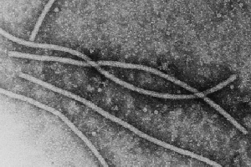**FILAMENTOUS:** usually about 12 nm in diameter and more flexuous than the rod-shaped particles. They can be up to 1000 nm long, or even longer. Some viruses have two or more different lengths of particle and these contain different genome components.

**Example:** *Potato virus Y*, genus *Potyvirus* with particles 740 nm long.

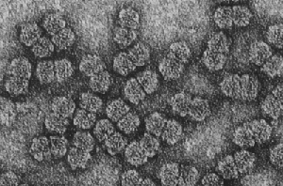**GEMINATE**: twinned isometric particles about

30 x 18 nm. These particles are diagnostic for viruses in the family *Geminiviridae* which are widespread in many crops especially in tropical regions.

**Example:** *Maize streak virus*, genus *Mastrevirus*.

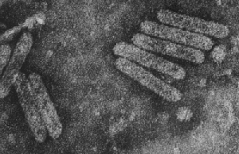

**BACILLIFORM:** Short round-ended rods.

These come in various forms up to about 30 nm wide and 300 nm long.

**Example:** *Cocoa swollen shoot virus*, genus *Badnavirus* with particles 28 x 130 nm.

**Nutrition:**

Viruses have no nutrition and no metabolic system. They use energy of host and only replicate within the host.