POPULATION PHARMACOKINETICS
Submitted To: Dr. Shazia Akram
Submitted By: Saira Nasir SPHF19M003
Anum Faryal SPHF19M004
Ph.D Pharmaceutics (2nd Semester)
COLLEGE OF PHARMACY
UNIVERSITY OF SARGODHA

CONTENTS

Sr.No Topics Page No.
- Population Pharmacokinetics 2
  - Introduction 2
  - Aims and objectives of Pop PK 2
  - Population Pharmacokinetic features 3
  - Comparison between traditional and population PK 3
  - Population PK model objectives 4
- Models and methods 5
  - Mixed effects modelling 5
  - Non-population method 5
  - Population method 6
- Data required for Population pharmacokinetics 8
  - Types of data 8
    - Kinetic data 8
    - Demographic data 9
  - Data Collection 9
  - Data Analysis 9
- Clinical Implications 10
- References 11

- POPULATION PHARMACOKINETICS:
1.1 Introduction:
The pharmacokinetics of a drug refers to how it is handled by the body. This includes absorption,
distribution, metabolism and elimination.
“Population pharmacokinetics (pop PK) is the study of variability in drug concentrations within a patient population receiving clinically relevant doses of a drug of interest”.
Pharmacokinetic studies have usually been carried out in small numbers of people, often healthy volunteers. In population pharmacokinetics opportunistic samples are collected from actual patients taking a drug. These patients are often taking different doses and have blood samples at different times.
1.2 Aims and objectives of Population PK:
Population pharmacokinetic studies aim to identify and quantify sources of variability in drug concentration in the patient population. Associations between patient characteristics and differences in pharmacokinetics can then be used to customize pharmacotherapy, such as the safe use of metformin in patients with renal impairment.
Population pharmacokinetics includes:
- Assessment of global variability of the plasma drug concentration profile in a patient population.
- Allocation of this variability to pharmacokinetic parameters (e.g. variability of clearance, bioavailability, etc.).
- Explanation of variability by identifying factors of demographic, pathophysiological, environmental, or concomitant drug-related origin that may influence the pharmacokinetic parameters.
- Quantitative estimation of the magnitude of the unexplained variability in the patient population.

1.3 Features of Population Pharmacokinetic:
Population PK analysis has the following features:
- Evaluates entire population
- Can be used for predictions and simulations
- Computationally intensive
- Intensive and sparse sampling
- Analysis time is longer
- PK/PD modeling (relationship between drug levels and drug effects)
- Can determine
  - Clearance
  - Volume of distribution
  - Effect of covariates (e.g. age, weight, sex, kidney function)
1.4 Comparison Between Traditional and Population PK:
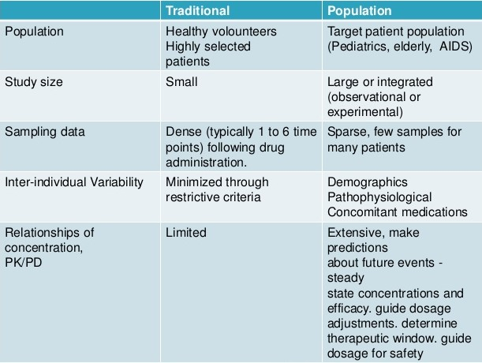
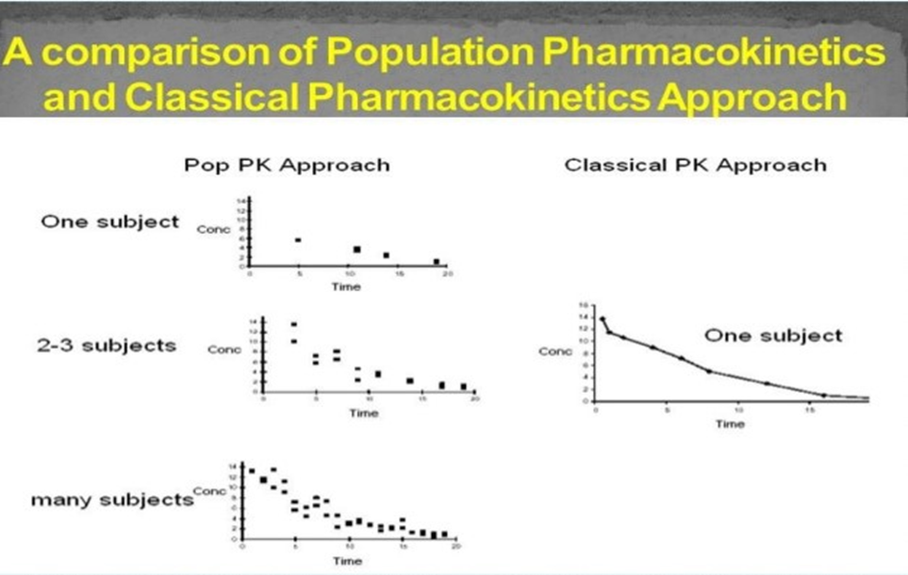
1.5 Population PK model Objectives:
- Provide Estimates of Population PK Parameters
- Provide Estimates of Variability
- Intersubject Variability
- Interoccasion Variability (Day to Day Variability)
- Residual Variability (Intrasubject Variability, Measurement Error, Model Misspecification)
- Identify Factors that are Important Determinants of Intersubject Variability
- Demographic: Age, Body Weight or Surface Area, gender, race
- Genetic: CYP2D6, CYP2C19
- Environmental: Smoking, Diet
- Physiological/Pathophysiological: Renal (Creatinine Clearance) or Hepatic impairment, Disease State
- Concomitant Drugs Other Factors: Meals, Circadian Variation, Formulations

- MODELS AND METHODS:
Pharmacokinetic modelling is a mathematical method for predicting how a drug will be handled by the body. The term population pharmacokinetics almost always refers to ‘mixed-effects’ modelling.
  - Mixed-Effects Modelling:
This is a mixture of fixed and random effects.
Fixed effects (structural model) are parameters such as clearance and factors that significantly influence clearance (for example weight, age).
Random effects (variance model) parameters include the inter subject variability, and the variability which remains unexplained after fitting the model to the data.
Estimation of these fixed and random effects allows:
1. The design of dosage regimens which will, in general, suit patient groups who are at particular
risk, e.g. the elderly or those with impaired renal or hepatic function.
2. The design of individual dosage regimens and their optimization by means of Bayesian feedback
techniques.
Ideally, all drugs for which a specific therapeutic range has been identified should be subjected to
this kind of analysis, and it may be of even greater importance to apply this approach to new drugs
where the relevant data may be collected throughout the various stages of drug development.
  - Non-Population Methods:
In traditional pharmacokinetics studies, small numbers of people are intensively sampled over a given post-dose period using a fixed design. This is the so-called ‘two-stage’ approach. It is still widely used, for example in comparative bioavailability trials and in clinical pharmacokinetics.
In the first stage the values of the pharmacokinetic parameters (for example clearance) in everyone are calculated. The second stage involves estimation of descriptive statistics, usually the mean or geometric mean and standard deviation for each parameter. For example, the mean renal clearance of metformin is 510 +/– 130 mL/minute.
There are deficiencies with traditional studies, including the inability to handle sparse data and to identify which covariates, such as age and weight, are important sources of pharmacokinetic variability. The imprecision in estimating the parameter values is also unidentified when fitting the model to the data. This uncertainty leads to the interindividual variability being overestimated.
Another traditional method is the ‘naïve pooled data’ approach in which data from all participants are pooled as if they had been collected from one ‘super-subject’. However, this approach ignores the sources of variability within and between individuals. It is not recommended even if there are numerous participants and the interindividual pharmacokinetic variability is relatively small.
Non-Population Pharmacokinetics
Advantages:
- Relatively small numbers of people are required (typically 8 to 16).
- Sampling design is often fixed and therefore similar in all participants, so there is less potential for sampling errors.
- Pharmacostatistical concepts are familiar and may require only simple calculations.
Disadvantages:
- Often performed in people who are not representative of the patient population.
- Infrequently performed in children.
- Multile blood sample are required (typically >10 samples per patient).

  - Population Methods:
A population pharmacokinetic method deals with modelling in a cohort which has many participants (usually more than 40). The population is studied rather than the individuals in it. Samples can be collected from patients taking different doses over different periods of time.
In population pharmacokinetics one may be interested, for example, in estimating a typical value of drug clearance or oral bioavailability. The typical parameter value is usually the mode (most frequently occurring value). This approaches the population mean value as the number of patients increases. However, the individuality of the information supplied by each patient to the population analysis is not lost but is used to estimate the most likely value of a parameter for each patient. The reliability of these individual estimates is predicated on the amount of data contributed by each patient and by how much their estimated parameter value varies from the typical population value. In a sense, each patient lends information to the population model, but borrows information back from the population model to obtain an estimate of their own pharmacokinetic parameters.
Population pharmacokinetic (PK) modeling involves estimating an unknown population distribution based on data from a collection of nonlinear models. A drug is given to a population of subjects. In each subject, the drug’s behavior is stochastically described by an unknown subject-specific parameter vector ∂. This vector ∂ varies significantly (often genetically) between subjects, which accounts for the variability of the drug response in the population. The mathematical problem is to determine the population parameter distribution F (∂) based on the clinical data.
Population pharmacokinetics
Advantages:
- Pharmacokinetic analysis is usually conducted in patients taking the drug.
- Can accommodate flexible study designs which occur during treatment.
- Only a few samples are needed from each patient.
- Opportunistic sampling has the potential to be cost effective.
- Screening and quantification of covariates for explaining variability.
- Can distinguish between interindividual and intraindividual variability.
- Modeling software is widely available (e.g. NONMEM).
Disadvantages:
- Relatively large number of patients are required (typically >40).
- Complex pharmacostatistical analysis.
- Requires collection, compilation and verification of large amounts of data.

- DATA REQUIRED FOR POPULATION PHARMACOKINETICS:
The concept of collecting data 'routinely' is fundamental to population pharmacokinetics, and in one sense there is no formal population pharmacokinetic study as such. Making sure that the appropriate data are collected is extremely important as this has considerable bearing on the success of population pharmacokinetic studies and determines:
(a) what can be learned from existing (retrospective) data; and
(b) what prospective data are required to answer specific questions.
3.1 Types of Data:
In general, two types of data, kinetic and demographic, are required for population pharmacokinetics.
3.1.1 Kinetic data:
As population pharmacokinetics is not confined to structured studies, a great degree of flexibility
in the collection and recording of kinetic data is required. There are two kinds of kinetic data:
1. Data specifying the dosage regimen which is associated with a concentration measurement, e.g.
the dose, route of administration, dosage interval, whether the interval represents steady-state and if not, details of the preceding relevant dosage history.
2. Concentration-time data, i.e. concentration measurement(s) and the time(s) since the previous
dose.
Since kinetic data may only be available at certain times during course of a study, or indeed
during 'routine' treatment, the information that can be obtained will vary considerably. Four categories of data should be considered.
- Steady-state trough concentrations
- Average steady-state concentrations
- Concentrations measured at any time after an oral dose
- Concentrations measured at an time after both intravenous and oral doses
    - Demographic data:
As data collection may span varying periods of time, the possible changes in pathophysiology must
be taken into account. There are therefore two kinds of demographic data:
1. That obtained at the beginning of a study which defines the pathophysiological status of
patients at that time, including age, sex, weight, height, smoking habits, alcohol consumption, nature and severity of disease, comedication and biochemical and hematological indices.
2. That obtained during any dosage interval of interest to account for changes which may have occurred during treatment.
3.2 Data Collection:
Data collection and storage can be greatly facilitated by the creation of a specially designed clinical pharmacokinetic (and pharmacodynamic) database. Input to such a database may be either at the level of the clinical investigator using, for example, a microcomputer, or at the level of the data analyst who assimilates data from all sources.
The exact structure of the database will vary according to the type of data. There are many suitable database programs available, such as dBASE (Ashton-Tate) or spreadsheet programs such as LOTUS 123 (Lotus Development Corp.).
  - Data Analysis:
Population pharmacokinetic data have been analyzed in a number of ways. for example, used stepwise multiple linear regression to relate theophylline clearance to demographic data.
In classic studies, several methods have been employed to obtain average values of population parameters. These include averaging concentration data at each time-point and fitting the averaged values to the appropriate pharmacokinetic model and fitting each set individually and then averaging the parameter values. It is sufficient to state that these methods have been thoroughly studied and are not, in general, satisfactory.
Currently, NONMEM (Nonlinear Mixed Effects Model) appears to provide the most acceptable method. A non-parametric maximum likelihood (NPML) approach has also been proposed as a method for analyzing population pharmacokinetic data.
- CLINICAL IMPLICATIONS:
Population pharmacokinetic modelling is a complex activity. It is also labor intensive and time consuming. Like all mathematical models, a population pharmacokinetic model only provides estimates of the true (but unknown) pharmacokinetic parameter values. Population analyses have numerous useful clinical applications, especially in patients who otherwise may be difficult to recruit for a traditional pharmacokinetic study, for example young children or patients in intensive care.
Another example is safely prescribing metformin for patients with impaired renal function. Using data from patients with various stages of renal dysfunction, a model was developed to identify and quantify the covariates, such as weight, which influence the pharmacokinetics of metformin. It then simulated dosage scenarios that could be used at various levels of renal dysfunction without the plasma concentration of metformin reaching a level which would result in adverse effects. This work is valuable because it provided guidelines for using metformin in patients with renal impairment in whom the drug was previously contraindicated.
Population pharmacokinetic methods are an emerging and important part of drug development including preclinical studies, clinical trials and post marketing surveillance. There are excellent reviews from the pharmaceutical industry and regulatory perspectives, and web-based guidelines from regulatory agencies. Studies have involved research and clinical applications in a wide variety of patients and conditions including diabetes, clotting disorders, malignancy, serious infection, apnea of prematurity, pregnancy, organ transplantation, self-poisoning and arthritis.

- REFERENCES

- Ansel's Pharmaceutical Dosage Forms and Drug Delivery Systems
- Remington the Science and Practice of Pharmacy
- Charles, B. (2014). Population pharmacokinetics: an overview. Aust Prescr, 37(6), 210-3.
- Wagner JG. History of pharmacokinetics. Pharmacol Ther 1981;12:537-62.
- Sheiner LB, Rosenberg B, Melmon KL. Modelling of individual pharmacokinetics for computer-aided drug dosage. Comput Biomed Res 1972;5:441-59.
- Ette EI, Williams PJ. Population pharmacokinetics I: background, concepts,and models. Ann Pharmacother 2004;38:1702-6.
- Whiting, B., Kelman, A. W., & Grevel, J. (1986). Population pharmacokinetics theory and clinical application. Clinical pharmacokinetics, 11(5), 387-401.

