we are going to learn how to solve absolute value inequalities using the standard approach usually taught in an algebra class. That is, learn the rules and apply it correctly. There are four cases involved when solving absolute value inequalities.

Four (4) Cases to Consider When Solving Absolute Value Inequalities
CASE 1:
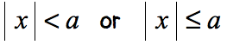<img src="https://www.chilimath.com/wp-content/uploads/2019/01/absvalineq-case1.png" alt="|x| < a or |x| ≤ a" class="wp-image-119465"/>
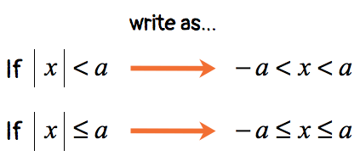<img src="https://www.chilimath.com/wp-content/uploads/2019/01/absvalineq-case1b.png" alt="If |x| < a, write as -a < x < a; If |x| ≤ a, write as -a ≤ x ≤ a" class="wp-image-119468" srcset="https://www.chilimath.com/wp-content/uploads/2019/01/absvalineq-case1b.png 423w, https://www.chilimath.com/wp-content/uploads/2019/01/absvalineq-case1b-300x130.png 300w" sizes="(max-width: 423px) 100vw, 423px" />
CASE 2:
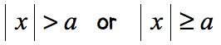<img src="https://www.chilimath.com/wp-content/uploads/2019/01/absvalineq-case2a.png" alt="|x| &gt; a or |x| ≥ a" class="wp-image-119479"/>
