SUBJECT
SOCIAL WORK
TOPIC
YOUTH WELFARE

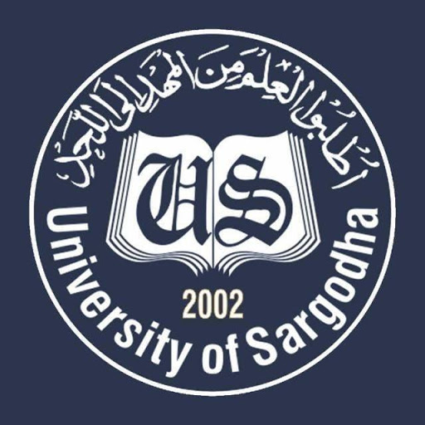

PROGRAM: BS SOCIOLOGY (Regular 2ND Semester)
SUBMITTED TO:
MA’AM SAMEEN SHAHZADI
SUBMITTED BY:
- YUSRA JAVED (Leader)
- ATIQA AKRAM
- AYESHA NASEER
- MUHAMMAD ALI
- SAHIR KHAN
- ALI RAZA HARAL

AROUSAL AND NEED OF YOUTH WELFARE:
The youth phase is commonly seen as a period in one's life which is particularly concerned with identity construction. Youth welfare denotes a condition in which a young person is uncertain about his status and role in the society. Identities are formed in an ongoing dialogue and struggle with the significant other. The social construction of identity be it individual or collective is mediated by others through interaction and therefore involves not just cognition but recognition. Identity achievement occurs when an individual makes a commitment to one after exploring different identities. Youth welfare organizations encourage young people to develop self-identity.

YOUTH WELFARE IN PAKISTAN:
Pakistan is one of the youngest countries in the world. According to the Pakistan National Human Development Report, 64% of the population is under the age of 30 and around 29% is between the ages of 15 and 30. This ‘youth bulge’ provides unique opportunities for the country’s social and economic uplift whereby the latent potential of young people can be harnessed by providing openings for growth and personal development. Unfortunately, lack of youth focused development in Pakistan has made young people vulnerable to violence and conflict, a situation exacerbated by the volatile security situation in the country.
Both the government and private sector are equally working for the social well-being and welfare of Pakistani youth. Their aim is for every young person they work with to be a positive force for change in their own life, and the lives of others. They recognize that to do this young people need to develop crucial life skills that are not always acquired at home or through formal education.

GOVERNMENT SECTOR PROJECTS AND SCHEMES:
The head of Bank of Khyber and the prime minister are making efforts for creation of jobs in erstwhile Federally Administered Tribal Areas (FATA). Attention is also being paid to provision of scholarships to students and for launch of projects that economically empowered young people.
Government is giving loans ranging between Rs 50,000 and Rs 100,000 to the youth in tribal districts so that they could start their own businesses.
Ehsas, the government’s flagship programme, would not only help fulfill the state’s responsibility to address issues like poverty, joblessness among youth and health, but it would also ensure effective utilization of government resources on welfare of the people.
Kamyab Jawan - Youth Empowerment Programme, a multi-pronged strategy that aims at creating a facilitating environment for youth in conflict affected areas of Sindh, Khyber Pakhtunkhwa and Balochistan to emerge as agents of positive change and development. Through the implementation of the programme, UNDP seeks to work with the Government of Pakistan as well as directly with excluded youth and other key stakeholders to ensure that ‘equal opportunities exist for all youth to participate in Pakistan’s social, political and economic development processes so that all youth feel an empowered part of society with a stage in its future.
Other than these many governmental youth welfare projects like UNESCO and UNICEF are present at national and provincial level.

NGOs DEDICATED TO YOUTH WELAFRE:

- YOUTH DEVELOPMENT FOUNDATTION (YDF):

Background:
Youth Development Foundation (YDF) is a Non-profit, Non-Government Organization, founded in 2007, by a group of young individuals from diverse faith backgrounds and Karamat Jameel as its Chairperson. It has since been recognized as a youth focused organization that effectively works with the youth towards achieving its vision of a vibrant, tolerant and pluralistic society that guarantees:-
- Freedom of speech
- Freedom of religious expression
- Provision of civil rights
- Elimination of discrimination based on race and opinions.
The organization aims to empower youth of Pakistan with the ability to understand the importance of their role in community and develop leadership, citizenship and ability for governance in youth.

Aims and objectives:
YDF serves as a network of diverse youth, which works for developing youth, and element that effect youth directly or indirectly, in different capacities, promoting pluralism and respect for religious diversity, and countering the growing trend of violent extremism among youth in Pakistan.
Thus, bridging gaps among youth through; interfaith dialogues, friendly relationship and human based coexistence. The philosophy of YDF focuses on Youth as its primary target as they will be important in the long run. YDF wants to promote religious freedom and cultural diversity not as a foreign concept, but tries to promote and dominate this idea through local symbols. Through grass root advocacy and social initiatives, YDF has helped in training the new generation of youth entrepreneurs.

Network:
Youth Development Foundation has its network of staff and offices spread to about 15 districts and 3 provinces of Pakistan. Currently, YDF has about 21 full time employees and 4 part time employees. Apart from this YDF has an outstanding network of volunteers in some of the remote areas like South Punjab and KPK which number to around 658. YDF has 4 offices in areas of Lahore (Head Office), Multan, Karachi and Faisalabad and a network of dedicated staff members throughout Pakistan.
Through its innovative projects like, Citizenship and Conflict Management Training, Awareness Sessions on Active Citizenship, Identity and Conflict Management, Adult Education and Peace-Building. YDF has been able to bring positive cultural changes in Pakistan in four provinces by directly affecting thousands of youth. YDF is working in Peshawar city which is one of the most volatile regions of Pakistan. After successful completion of our projects in Peshawar, Karachi (Lyari, Korangi and Sultanabad), YDF can now proudly say that it has worked in the hardest of environments and has a long experience, on engaging grass root youth activists through innovative initiatives on sustainable basis. Thus transforming the culture of intolerance and hopelessness into culture of tolerance and hope.

- PAKISTAN YOUTH ALLIANCE:

Background:
Pakistan Youth Alliance was founded in November, 2007. Syed Ali Abbas Zaidi and Maryam Kanwer are the founders of this youth welfare organization. Pakistan Youth Alliance is a network of progressive youth activists spread across 10 cities of Pakistan with 12 years of programming experience in rehabilitation, welfare initiatives, and peace building and capacity building of youth.
The organization has been undertaking broad-based initiatives like establishment of youth centers, conferences and seminars and taking youth mobilization initiatives in several cities of Pakistan including Lahore, Islamabad, Peshawar, Swat, Karachi, Mirpurkhas, Hyderabad, Faisalabad and Quetta alongside others. PYA was awarded Azme-Aalishan award 2012 for its multi-faceted initiatives for the youth.

Aims and Objectives:
Pakistan Youth Alliance is non-partisan network, a platform that enables, engages and empowers youth leaders. The organization is working relentlessly for the past 12 years. Its mission is to work as a youth activist organization to:-
- Motivate and empower youth
- Providing them opportunities and platforms
- Developing ability to understand the importance of their role in community and develop leadership and citizenship in youth.
- Counseling young people and stopping them from drug abuse.
- Indulge youth in social welfare activities through fund-raising for under-privileged and affected by disasters.
PYA envisions being the voice of youth of Pakistan. It wishes to create circumstances where in opinions of youth are included in decision making processes locally and nationally. They aspire to make youth leadership mainstream by empowering and enabling them to be responsible citizens of Pakistan.

Network:
The Organization holds its Head office in Islamabad and also operates in more than ten cities including Karachi, Lahore, Quetta, Awaran District, Peshawar, Waziristan, Bannu, Sialkot, Mirpurkhas, Hyderabad, Faisalabad and Multan. It has organized more than 230 workshops, completed 24 Youth welfare projects, more than 100 campaigns and 50 successful events at national as well as international level.

_______________________

