ATOMIC ABSORPTION SPECTROMETRY:

When atoms are placed in a flame or other energized (electrical) source, their electrons   
can be elevated to an excited state. Not all electrons are elevated to this excited state at   
the same time; million remain in their unexcited or ground state. These ground state   
atoms are capable of absorbing resonance energy, while the excited atoms are capable   
of emitting resonance energy. The word resonance describes the energy that is exactly equal to the difference between the ground state and the excited state of a given atom. This energy in the   
form of light has a particular wavelength called the resonance wavelength. Since the ground state electrons may be shifted into one or more permissible energy states, a given element exhibits more than one resonance line.



Atomic absorption spectroscopy (AA) is a spectrophotometery technique based on the   
absorption of radiant energy by atoms. To carry out the atomic absorption process, we   
need a:   
1. Source of monochromatic radiation and   
2. A means to vaporize the sample producing ground state atoms of the element being analyzed.

If a beam of light is passed via the flame, these ground state atoms will absorb this energy. In order for absorption to occur, the wavelength of radiation must be characteristic of atom (element) present. Approximately 70 elements can be determined by AA, in concentration ranging from perhaps 10 ppm (for some of the more difficult rare earths) to less than 1 ppb ( for mercury by the graphite furnace method). The absorption of this specific radiation follows Beer’s law and is directly proportional to the concentration of atoms in the flame. These spectral lines necessary for AA applications are approximately 0.002 nm wide. Therefore, a continuous source of radiation, such as a tungsten lamp, cannot provide sufficient energy. A source called a “hollow cathode lamp” is usually required for each element to be investigated. Since each element usually requires a different source. Atomic absorption is a poor qualitative tool but is extremely useful for quantitative determination.

**INSTRUMENTATION:**  
Following are the basic components:

1. Sources emitting radiation, characteristic of element of interest (hollow cathode lamp).  
2. Flame and burner or electrically heated furnace.

3. Monochromators

4. Photometers

5. Photo-multiplier detector

6. Recorder

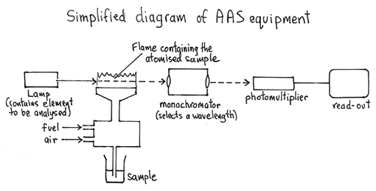



1. **Sources of radiation:**  
   **A. Hollow cathode lamp:**

The source of energy (radiant) is provided by a hollow cathode lamp in most conventional atomic absorption applications. These hollow cathode lamps usually contain two electrodes, a cathode and an anode.

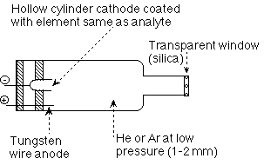

The hollow cathode lamp is an excellent, bright line source for most of the elements   
determinable by atomic absorption. The cathode of the lamp frequently is a hollowed   
out cylinder of the metal whose spectrum is to be produced. The anode and cathode   
are sealed in a glass cylinder normally filled with either neon or argon at low pressure.   
At the end of the glass cylinder is a window transparent to the emitted radiation. The   
emission process is illustrated in fig. given below,  
  
  
  
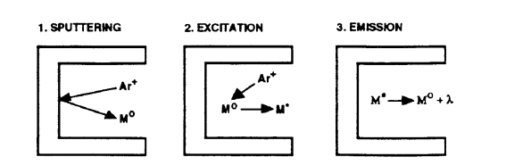

Fig. Where Ar+ is a positively charged argon ion, M0 is sputtered, ground state metal   
atom, M* is an excited state metal atom. λ is emitted radiation at a wavelength   
characteristic to metal.

When an electric potential is applied between the anode and cathode, some of the fill   
gas atoms are ionized. The positively charged fill gas ions accelerate through the   
electric field to collide with negatively charged cathode and dislodge individual metal   
atoms in a process called “sputtering”. Sputtered metal atoms are then excited to an   
emission state through a kinetic energy transfer by impact with fill gas ions. The window   
material is normally made of quartz for wavelength shorter than 250 nm and glass is   
used for wavelength longer than 250 nm. These lamps routinely have an operating life   
of approximately 1000 hours. (at 5 to 50 milliamps range) . Most hollow cathode lamps   
require between 5 and 30 minutes to warm-up. Multi-element lamps are also available in   
which a metallic powder from several highly purified elements is combined into a   
sintered cathode. These multi element lamps are normally limited to two or three   
elements because of their more complex spectral emission.

**B. Vapour Discharge lamp:**

Vapour discharge lamps are used in atomic absorption applications, and these lamps   
operate by having an electric current pass through a vapour containing the element of   
interest, such as mercury. This type of lamp is also used in conventional   
spectrophotometers as a source of ultraviolet radiation.

**C. The Electrode less Discharge lamp: (EDL)**

This radiation source does not contain a cathode or an anode. It is constructed of a   
small diameter quartz tube which contains the metal or metal salt of interest. These   
tubes are filled at a very low pressure with argon gas and wrapped with an electric coil.   
This tube is placed inside a small self contained RF field generator or driver. When   
power is applied to the generator or driver, an RF field is created. The coupled energy   
will vaporize and excite the atoms inside the tube, causing them to emit their   
characteristic spectrum. An accessory power supply is required to operate and EDL.   
EDL are typically much more intense and in some cases more sensitive than   
comparable hollow cathode lamps. They therefore, offer the analytical advantages of   
better precision and lower detection limits where an analysis is intensity limited. In   
addition to providing superior performance, the useful lifetime of an EDL is typically   
much greater than that of a hollow cathode lamp for the same element. EDL are   
available for more than 20 elements such as antimony, arsenic, bismuth, cadmium,   
cesium, lead, germanium, Mercury, phosphorus, potassium, tin, rubidium, selenium,   
tellurium, thallium and zinc.

1. **Flame and Burner:**

All conventional atomic absorption instruments require a burner and a flame. The burner   
head provides a means for suspending and exposing the free metal atoms to the hollow   
cathode light beam. There are two commonly used gas mixtures:

i. Air-acetylene, which burns at approximately 2300oC and   
ii. A nitrous oxide –acetylene combination that produces flame temperatures in the   
 3000oC range.

Usually a 10cm slot burner is used with air-acetylene mixtures and a smaller 5 cm slot   
burner with the hotter nitrous oxide-acetylene mixtures. A water filled loop in the drain tube prevents air from coming through the drain into the burner where it might cause an explosion. The burner orifice consists of a long, narrow slit, which produces a non turbulent quite flame. The advantages of this type of burner are a long path length for the light beam, stability and a low-noise reference path. Unlike the flame photometry, most atomic absorption burners are not of the total consumption type, sometimes referred to as turbulent-flow. Atomic absorption burners tend to be of the premix type, which aspirate the sample solution through a capillary tube into a mixing chamber where the sample is atomized and mixed with the fuel (acetylene). Some atomic absorption instruments use a nebulizer which simply reduces the sample solution by a pneumatic process to a spray of droplets of various sizes. The larger droplets of the sample settle to the bottom of the mixing chamber because of a series of baffles. A majority (approximately 90%) of the aspirated sample drains from the bottom of the mixing chamber and is discarded; only a small (but reproducible) portion of the sample solution passes through the burner head. Periodic cleaning of the nebulizer and burner assembly will help to minimize noise levels. Scraping the burner head to remove carbon deposits and placing the dismantled assembly in an ultrasonic cleaner should be a routine task.

1. **Photometer:**  
   The portion of an AA spectrometer optical system which conveys the light from the   
   source to the monochromator is referred to as the photometer. Three types of photometers are typically used in AA instruments. Single beam, double beam and compensated single beam or pseudo double beam.

**Single Beam Photometers:**

It is called “single beam” atomic absorption spectrometer because all measurements   
are based on the varying intensity of a single beam of light in a single optical path.  
  
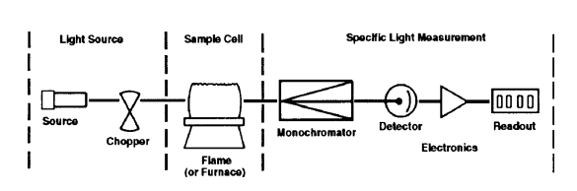  
The primary advantage of a single beam configuration is that it has fewer components   
and is less complicated than alternative designs. It is therefore easier to construct and   
less expensive than other types of photometers with a single light path and minimum   
number of optical components. Single beam systems typically provide very high   
throughput. The primary limitation of the single beam photometer is that it provides no means to compensate for instrumental variations during an analysis, such as changes in source   
intensity. The resulting signal variability can limit the performance capabilities of a single   
beam system.

**Double Beam Photometers:**

In double beam photometers additional optics are used to divide the light from the lamp into a sample beam (directed through the sample cell) and a reference beam (directed around the ample cell). In the double beam system, the double beam serves as a monitor of lamp intensity and the response characteristics of the common electronic circuitry. Therefore, the observed absorbance, determined from a ratio of sample beam and reference beam reading, is more free of effects due to drifting lamp intensities and other electronic anomalies which similarly affect both sample and reference beams.

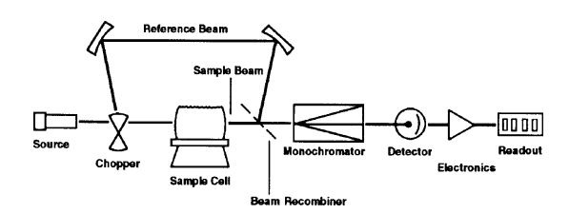

Fig: A double beam spectrometer

Modern AA spectrometers are frequently highly automated. They can automatically change lamps, reset instrument parameters and introduce samples for high throughput multi element analysis. Double beam technology, which automatically compensate for source and common electronic drift allows these instruments to change lamps and begin an analysis immediately with little or no lamp warm up for most elements. This not only reduces analysis time but also prolongs lamp life, since lamp warm up time is eliminated.

**Compensated Single beam or Pseudo double beam photometer:**

There are several alternative system designs which provide advantages similar to those of double beam optical systems and the light throughput characteristics of single beam systems. Such systems can be described as compensated single beam or pseudo double beam systems. One such design uses two mechanically adjusted mirrors to alternately direct the entire output of the source through either the sample path (during sample measurements) or through a reference path.

**Monochromator:**

Light from the source enters the monochromator at the entrance slit and is directed to the grating where dispersion takes place. The diverging wavelengths of light are directed towards the exit slit. By adjusting the angel of grating, a selected emission line from the source can be allowed to pass through the exit slit and fall on to the detector. All other lines are blocked from exciting.

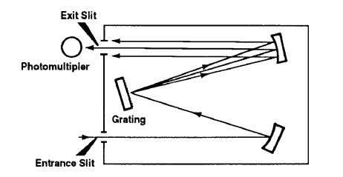

**Detector:**

A photo detector measures the light passing through the flame both before and after. The sample is introduced into the flame. Most atomic absorption detectors are basically the same as those used in ultraviolet and visible spectroscopy, photomultiplier tubes being the most common.

**Recorder or readout system:**

Direct recorder or computerized systems are used having amplifiers and reading devices.

**INTERFERENCES:**

Atomic absorption is known as very specific technique with few interferences.

The ultimate analytical method which is absolutely free of interferences from the nature of the sample will probably never exist. The next best thing to not having interference is to know what the interferences are and how to eliminate them or compensate for them. Interferences in atomic absorption can be divided into two general categories, spectral and non spectral interferences.

1. **Non spectral interferences:**

Non spectral interferences are those which affect the formation of analyte atom.

1. **Matrix interference:**

The first place in the flame atomization process subject to interference is the very first step, the nebulization. If the sample is more viscous or has considerably different surface tension characteristics than the standard, the sample uptake rate or nebulization efficiency may be different between sample and standard. If sample and standards are not introduced into the process at the same rate, it is obvious that the number of atoms in the light beam and therefore the absorbance will not correlate between the two. Thus matrix interference will exist. One way of compensating for this type of interference is to match as closely as possible the major matrix components of the standard to those of the sample. Any acid or other reagent added to the sample during preparation should also be added to the standards and blank in similar concentration.

There is a useful technique which may make it possible to work in the presence of matrix interference without eliminating the interferences itself, and still make an accurate determination of analyte concentration. The technique is called the method of standard additions. Accurate determinations are made without eliminating interferences by making the concentration calibration in the presence of the matrix interference. Aliquots of a standard are added to portion of sample, thereby allowing any interferent present in the sample to also affect the standard similarly.

1. **Chemical interference:**

A second place where interference can enter into the flame is the atomization process in this step, sufficient energy must be available to dissociate the molecular form of the analyte to create free atoms. If the sample contains a component which forms a thermally stable compound with the analyte that is not completely decomposed by the energy available in the flame a chemical interference will exist. The effect of phosphate on calcium is an example of a chemical interference. Calcium phosphate does not totally dissociate in an air-acetylene flame. Therefore as phosphate concentration is increased, the absorbance due to calcium atom decreases.

There are two means of dealing with this problem. One is to eliminate the interference by adding an excess of another element or compound which will also form a thermally stable compound with the interferent. In the case of calcium, lanthanum is added to tie up the phosphate and allow the calcium to be atomized independent of the amount of phosphate. There is a second approach to solving the chemical interference problem. Since the problem arises because of insufficient energy to decompose a thermally stable analyte compound, the problem can be eliminated by increasing the amount of energy that is by using a hotter flame. The Nitrous oxide-acetylene flame is considerably hotter than air-acetylene and can often be used to minimize chemical interferences for elements generally determined with air-acetylene.

1. **Ionization interferences:**

There is third major interference, which is often encountered in hot flames. If additional energy is applied, the ground state atom can be thermally raised to the excited state or an electron may be totally removed from the atom, creating an ion. As these electronic arrangements deplete the number of ground state atoms available for light absorption, atomic absorption at the resonance wavelength is reduced. When an excess of energy reduces the population of ground state atoms, ionization interference exist. Ionization interferences are most common with the hotter NO-acetylene flame. In air-acetylene flame, ionization interferences are normally encountered only with the more easily ionized element, notably the alkali metals and alkaline earth.

Ionization interferences can be eliminated by adding an excess of an element which is very easily ionized by creating a large number of free electrons in the flame and suppressing the ionization of an analyte. K, Rb, Cs salts are commonly used as ion suppressants.

1. **Spectral interferences:**

Spectral interferences are those in which the measured light absorption is erroneously high due to absorption by a species other than the analyte element. The most common type of spectral interference in atomic absorption is “background absorption”.

Background absorption:

It arises from the fact that not all the matrix material in the sample is necessarily 100% atomized. Since atoms have extremely narrow absorption lines, there are few problems involving interferences where one element absorbs at the wavelength of another. Even when an absorbing wavelength of another element falls within the spectral band width used, no absorption can occur unless the light source produces light at that wavelength. i.e. that element is also present in the light source. However, un-dissociated molecular forms of matrix materials may have broad band absorption spectra, and tiny solid particles in the flame may scatter light over a wide wavelength region. When this type of non specific absorption overlaps the atomic absorption wavelength of the analyte, background absorption occurs. To compensate for this problem, the background absorption must be measured and subtracted from the total measured absorption to determine the true atomic absorption components.

Continuum source background correction:

It is a technique for automatically measuring and compensating for and background component which might be present in an atomic absorption measurement. This method incorporates a continuum light source in a modified optical system. The broad band continuum (white light) source differ from the primary (atomic line) source in that it emits light over a broad spectrum of wavelength instead of at specific lines. Continuum source background correction is widely applied, and except in some very unusual circumstances, is fully adequate for all flam atomic absorption applications.

**GRAPHITE FURNACE ATOMIC ABSRPTION:**

Graphite furnace atomic absorption spectrometry (GFAAS) has grown in popularity due in part to its enhanced sensitivity and the ability to determine samples with a relatively complicated matrix. Trace elements in samples such as urine and environmental samples are routinely measured by GFAAS. This technique is more efficient than conventional AA because most of sample is atomized and stays in the optical beam. A typical graphite furnace consists of a small cylindrically shaped graphite tube equipped with an injection opening on the top. In this technique a tube of graphite is located in the sample compartment of the AA spectrometer, with the light path passing through it.

:Cross sectional view of heated graphite atomizer:

A measured amount ( usually 5-50 µL of sample is placed directly into the interior of the furnace. The furnace is normally heated electrically in three stages.

1. To a relatively low temperature to drive of the solvent.
2. To a higher temperature to ash the sample.
3. And finally approximately 2500 ̊C to atomize the sample absorb the radiation of particular wavelength passing through it.

As atoms are created and diffused out the tube, the absorption rises and falls in the peak shaped signal. The peak height or integrated peak area is used as the analytical signal for quantitaion.

Note: the graphite tube must be surrounded by a nitrogen or argon atmosphere to prevent air oxidation of the sample.

The graphite furnace technique has several advantages over conventional AA

1. It requires only a very small volume (5-50µL verses several mL)
2. Atomization of the sample is nearly 100% complete verses perhaps only 0.01 % by AA
3. Detection limits are improved for some elements by a factor of 1000 or greater

Matrix interferences and background absorption effects are common disadvantages to the graphite furnace technique. Automatic GFAAS systems employ advanced software programs that perform a range of tasks including spectrometer control, furnace temperature control, and data acquisition and reporting.

**INDIRECT ATOMIC ABSORPTION SPETROSCOPY:**

Cold vapour mercury technique:

Since atoms for most atomic absorption elements cannot exist in the free, ground state at room temperature, heat must be applied to the sample to break the bonds combing atoms into molecules. The only notable exception to this is mercury. Free mercury atoms can exist at room temperature and therefore, mercury can be measured by atomic absorption without a heating sample cell. In the cold vapor mercury technique mercury is chemically reduced to the free atomic state by reacting the sample with a strong reducing agent like stannous chloride or sodium borohydride in a closed reaction system. The volatile free mercury is then drives from the reaction flask by bubbling air or argon through the solution. Mercury atoms are carried in the gas stream through tubing connected to an absorption cell, which is placed in the light path of the AA spectrometer. The cell is heated slightly to avoid water condensation but otherwise the cell is completely unheated. As the mercury atoms pass into the sampling cell, measured absorbance rises indicating the increasing concentration of mercury atoms in the light path. Some systems allow the mercury vapour to pass through the absorption tube to waste in which case the absorption observed during the measurement will be taken as the analytical signal. In other system, the mercury vapour is rerouted back through the solution and the sample cell in the close tube. The absorbance will rise until an equilibrium concentration of mercury is attained in the system. The absorbance will then level off, and the equilibrium absorbance is used for quantitaion.

**Advantages of cold vapour technique:**

1. The sensitivity of the cold vapour technique is far greater than can be achieved by conventional flame AA. This improved sensitivity is achieved, first of all through a 100% sampling efficiency. All of the mercury in the sample solution placed in the reaction flask is chemically atomized and transported to the sample cell for measurement.
2. The detection limit for mercury by this cold vapour mercury technique is approximately 0.02µg/L.

**Limitation to the cold vapour technique:**

Of all of the options available, the cold vapour system is still the most sensitive and reliable technique for determining very low concentration of mercury by AA. The concept is limited to mercury however, since no other element offers the possibility of chemical reduction to a volatile free atomic state at room temperature.

**HYDRIDE GENERATION TECHNIQUE:**

**Principle:**

Hydride generation sampling systems for AA bear some resemblance to cold vapour mercury systems. Samples are reacted in an external system with a reducing agent, usually sodium borohydride. Gaseous reaction products are then carried to a sampling cell in the light path of A A spectrometer. Unlike the mercury technique, the gaseous reaction products are not free analyte atoms but the volatile hydrides. These molecular species are not capable of causing atomic absorption. To dissociate the hydride gas into free atoms, the sample cell must be heated. In some hydride systems, the absorption cell is mounted over the burner head of the AA spectrometer, and the cell is heated by an air-acetylene flame. In other systems, the cell is heated electrically. In either case, the hydride gas is dissociated in the heated cell into free atoms, and the atomic absorption rises and falls as the atoms are created and then escape from the absorption cell. The maximum absorption reading, or peak height or the integrated peak area is taken as analytical signal.

**Advantages of the hydride technique:**

The elements determinable by hydride generation are As, Pb, Sn, Bi, Sb, Te, Ge, Se. For these elements, detection limits well below the microgram per liter (µg/L) range are achievable. Like cold vapour mercury, the extremely low detection limits results from a much higher sampling efficiency. In addition, separation of the analyte element from the sample matrix by hydride generation is commonly used to eliminate matrix related interference. The equipment for hydride generation can vary from simple to sophisticated. Less expensive system use manual operation and a flame heated cell. The most advanced systems combine automation of the sample chemistries and hydride separation using flow injection techniques with decomposition of hydride in an electrically heated temperature controlled cell.

**Disadvantages of the hydride technique:**

The major limitation to the hydride generation technique is that it is restricted primarily to the elements given above. Results depend heavily on a variety of parameters, including the valence state of the analyte, reaction time, gas pressures, acid concentration, and cell temperature. Therefore, the success of hydride generation technique will vary with the care taken by the operator in attending to the required detail.