Globalisation is a process by which economies and cultures have been drawn deeper together and have become more inter-connected through global networks of trade, capital flows, and the rapid spread of technology and global media. The share of global GDP accounted for by exports of goods and services has risen from 12% in 1960 to almost 30% now.
What is globalisation?
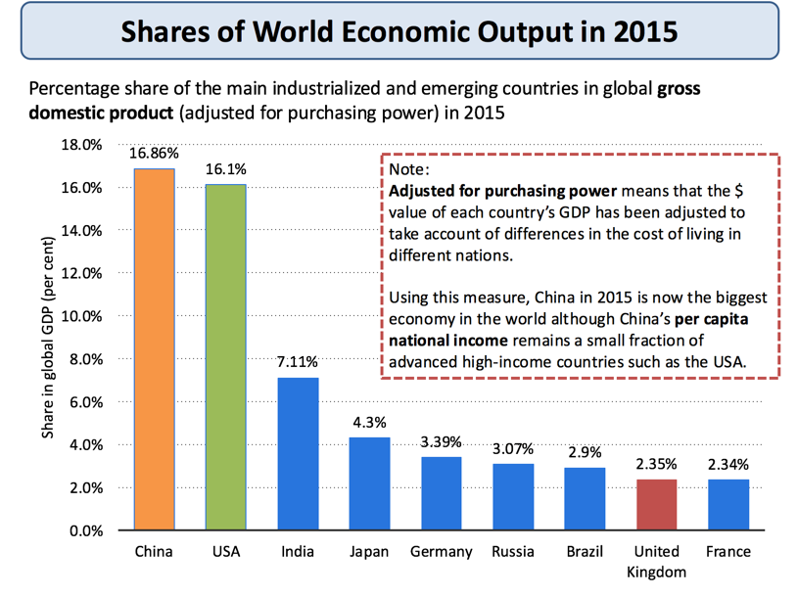
The OECD defines globalization as
"The geographic dispersion of industrial and service activities, for example research and development, sourcing of inputs, production and distribution, and the cross-border networking of companies, for example through joint ventures and the sharing of assets."
Characteristics of globalisation
- Greater trade in goods and services both between nations and within regions
- An increase in transfers of capital including the expansion of foreign direct investment (FDI) by trans-national companies (TNCs) and the rising influence of sovereign wealth funds
- The development of global brands that serve markets in higher and lower income countries
- Spatial division of labour– for example out-sourcing and off shoring of production and support services as production supply-chains has become more international. As an example, the iPhone is part of a complicated global supply chain. The product was conceived and designed in Silicon Valley; the software was enhanced by software engineers working in India. Most iPhones are assembled / manufactured in China and Taiwan by TNCs such as FoxConn
- High levels of labour migration within and between countries
- New nations joining the world trading system. China and India joined the WTO in 1991, Russia joined the WTO in 2012
- A fast changing shift in the balance of economic and financial power from developed to emerging economies and markets – i.e. a change in the centre of gravity in the world economy
- Increasing spending on investment, innovation and infrastructure across large parts of the world
- Globalisation is a process of making the world economy more inter-dependent
- Many of the industrializing countries are winning a rising share of world trade and their economies are growing faster than in richer developed nations especially after the global financial crisis (GFC)

