Painting buildings in an urban landscape is intimidating for many artists. Finding the right scene can be overwhelming. The different angles and perspective of the buildings, the busy streets, the many colors, how do we simplify it into a believable cityscape?
In the following post, award winning artist Scott W. Prior shares his Easy Steps to Painting an Urban Landscape or Cityscape. A native of California, Scott knows how to simplify the busy city streets into a compelling composition and work of art. I first met Scott at the Plein Air Convention where his bold approach toward painting makes him a crowd pleaser.
In his own words, Scott shares his simple in progress steps to painting a complex cityscape. Here is the making of “Soho Rooftops” 36×48, oil on panel.

Easy Steps to Painting an Urban Landscape or Cityscape by Scott W. Prior
First, I start out by drawing with a brush while figuring out the basic shapes, proportions and perspective.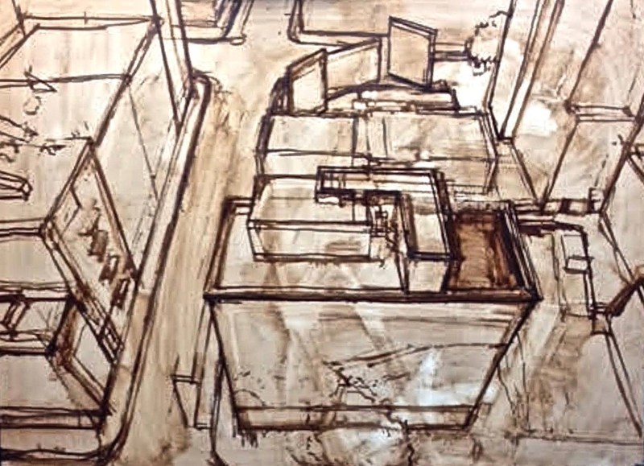
Next, I start refining my drawing and the proportions.
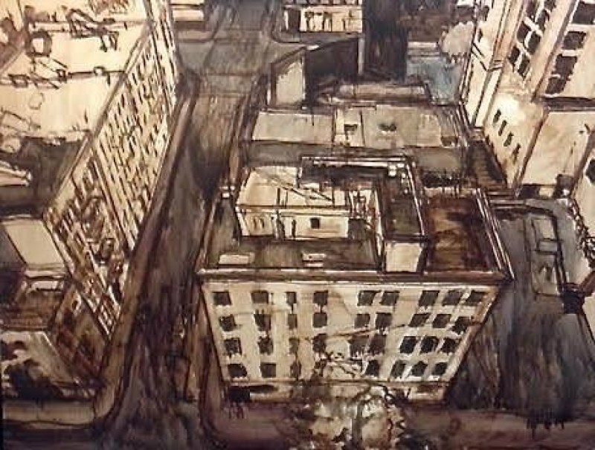
After that, I start the under painting while building up the values and adding some details of the buildings.
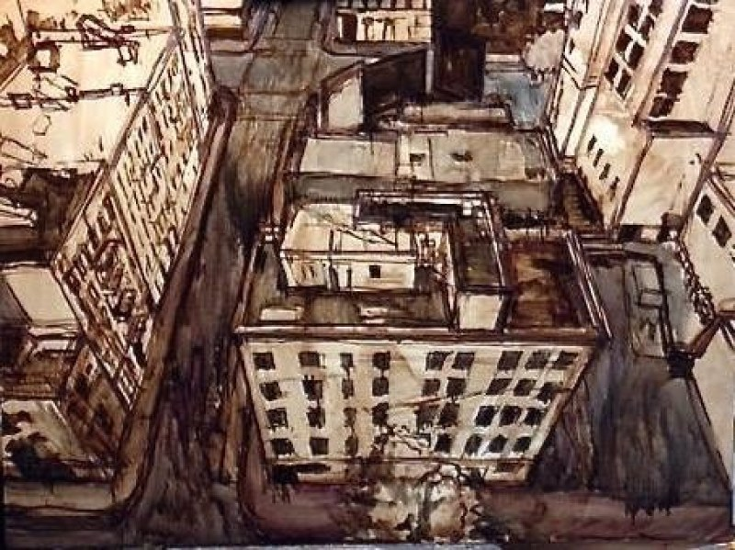
Still building the underpainting, I suggest more details and refine the drawing.
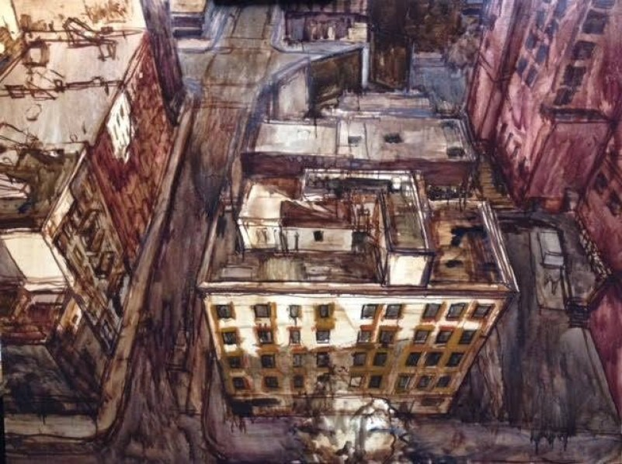
Once I’m happy with the underpainting drawing and the values, I’ll begin to add thin washes of dark colors to the underpainting. I allow it to dry before I paint on top of it with more darks.
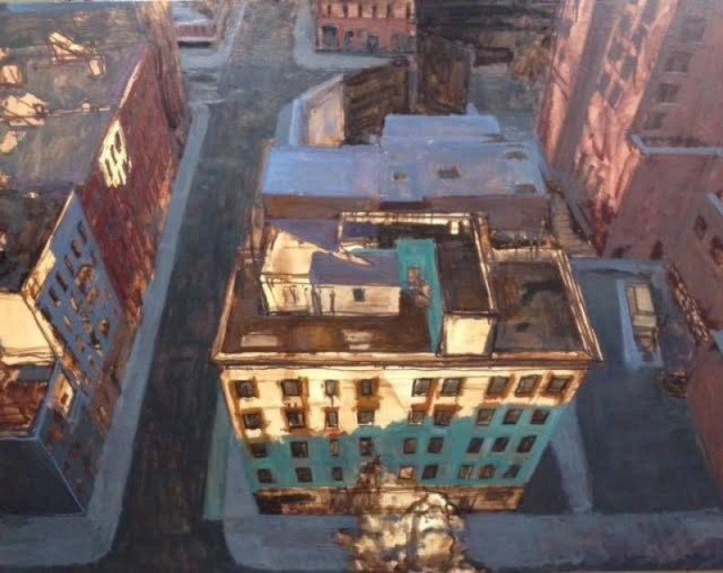
With the underpainting setup and dry, I then lay in and organize my dark colors, adjusting the values as I go.
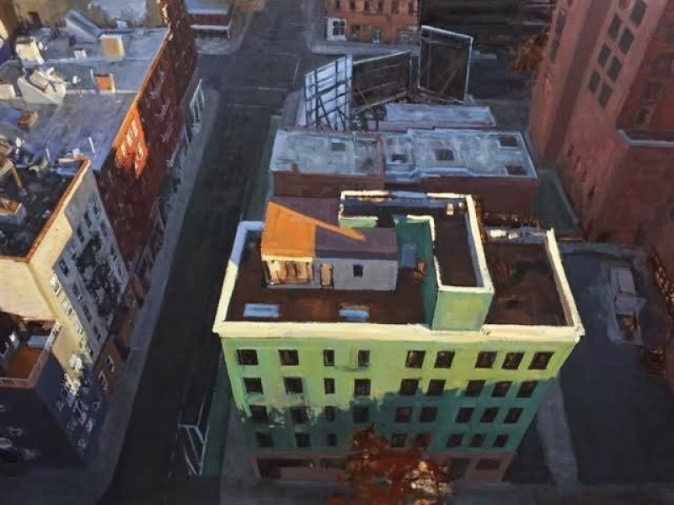
Once my darks are painted, I add the light colors and add more details as I go.
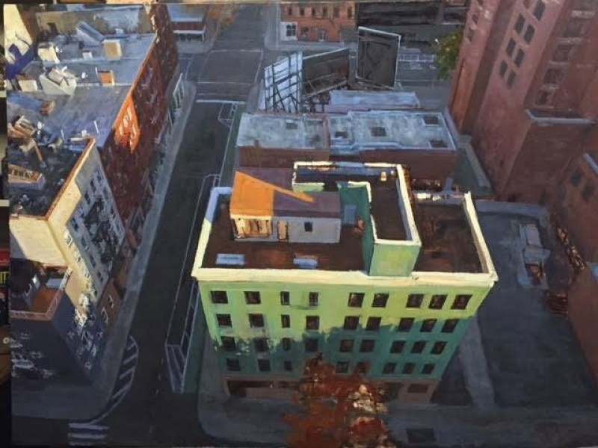
Next, it’s time to bring out more of the lights and to suggest more details.
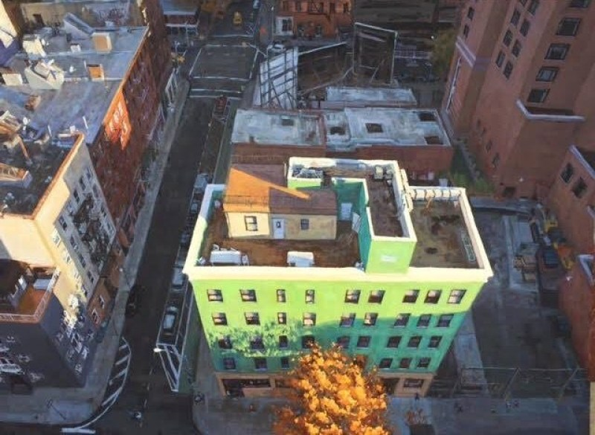
At last, I add more details on the streets and to the windows on the green building. Next, I add the vivid color to the tree. The final stretch consists of making the tree and building really pop with some fine tuning to indicate some of the small details….the end.
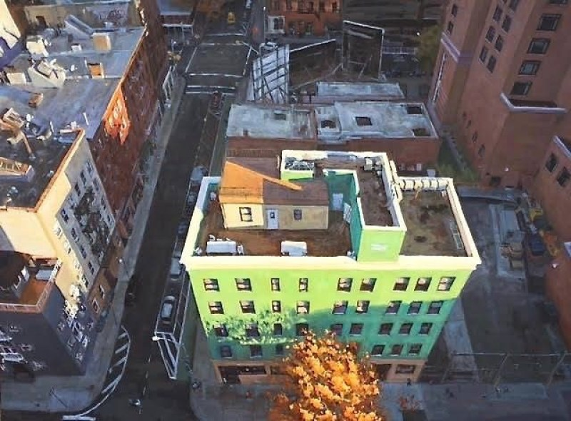
Guest author/artist: Scott W. Prior is an award winning oil painter and Southern California native. He received his BFA from The Academy of Art University in San Francisco, CA. During his time at the Academy of Art Scott established his skills in design, drawing and painting, giving him a solid foundation with which to develop his own unique, artistic style. Scott draws inspiration from the beauty in ordinary, everyday scenes. Scott is Signature Member of the California Art Club and a Signature Member of the Laguna Plein Air Painters Association.

