Experiment No-13
Familiarization with construction and operation of Distribution transformer.
Objective:
To understand the
- Main parts of Distribution Transformer
- Working principle
- Rating of transformer by its name plate.
Apparatus:
- Distribution Transformer
- Connecting wires
- Loads
Theory:
Definition of Transformer:
Electrical Power Transformer is a static device which transforms electrical energy from one circuit to another without any direct electrical connection and with the help of mutual induction between two windings. It transforms power from one circuit to another without changing its frequency but may be in different voltage level.
A transformer is an electrical device that transfers energy from one circuit to another purely by magnetic coupling. Relative motion of the parts of the transformer is not required for transfer of energy. Transformers are often used to convert between high and low voltages, to change impedance, and to provide electrical isolation between circuits.
Working Principle of Transformer:
The working principle of transformer is very simple. It depends upon Faraday's law of electromagnetic induction. Actually mutual induction between two or more winding is responsible for transformation action in an electrical transformer.
Faraday's Laws of Electromagnetic Induction:
According to these Faraday's law
"Rate of change of flux linkage with respect to time is directly proportional to the induced EMF In a Conductor or Coil".
Basic Theory of Transformer:
Say you have one winding which is supplied by an alternating electrical source. The alternating current through the winding produces a continually changing flux or alternating flux surrounds the winding. If any other winding is brought nearer to the previous one, obviously some portion of this flux will link with the second. As this flux is continually changing in its amplitude and direction, there must be a change in flux linkage in the second winding or coil. According to Faraday's law of electromagnetic induction, there must be an EMF induced in the second. If the circuit of the latter winding is closed, there must be an electric current flows through it. This is the simplest form of electrical power transformer and this is most basic of working principle of transformer.
Classification:
Step-Up:
The secondary has more turns than the primary.

Step-Down:
The secondary has fewer turns than the primary.
Isolating:
Intended to transform from one voltage to the same voltage. The two coils have approximately equal numbers of turns, although often there is a slight difference in the number of turns, in order to compensate for losses (otherwise the output voltage would be a little less than, rather than the same as, the input voltage).
Variable:
The primary and secondary have an adjustable number of turns which can be selected without reconnecting the transformer.
External Parts of Transformers & Functions:
Transformer parts are:-
1) Buchholz Relay:
It is a very sensitive gas and oil operated instrument which safely detect the formation of gas or sudden pressure inside the oil transformer. Oil-filled power transformers may be equipped with Buchholz relays - safety devices sensing gas buildup inside the transformer (a side effect of an electric arc inside the windings) and switching off the transformer.
2) Conservator Tank:
It is used to provide adequate space for the expansion of oil when transformer is loaded or when ambient temperature changes.
3) Silica Gel Breather:
It sucks the moisture from the air which is taken by transformer so that dry air is taken by transformer.
4) Double Diaphragm Explosion Vent:
It is used to discharge excess pressure in the atmosphere when excess pressure is developed inside the transformer during loading.
5) Oil Level Indicator:
It is used to show the oil level in the transformer.
6) Winding Temperature Indicator:
Used to show the temperature of transformer winding.
7) Radiators:
These are used for cooling of the transformer oil.
The supply voltage is connected to the primary winding, the load is connected to the secondary winding and in the transformer core only the magnetic flux path will be established. In power transformers (used for transmit the heavy voltages to the grid) on load tap changers used. But in distribution transformers off circuit tap changers are used.

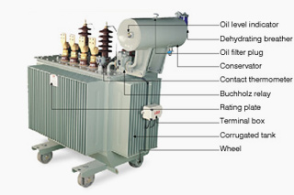

Internal Parts of Transformer:
Cores Construction:
- Steel Cores:
Transformers for use at power or audio frequencies have cores made of many thin laminations of silicon steel. By concentrating the magnetic flux, more of it is usefully linked by both primary and secondary windings. Since the steel core is conductive, it, too, has currents induced in it by the changing magnetic flux. Each layer is insulated from the adjacent layer to reduce the energy lost to eddy current heating of the core. A typical laminated core is made from E-shaped and I-shaped pieces, leading to the name "EI transformer". Certain types of transformer may have gaps inserted in the magnetic path to prevent magnetic saturation. These gaps may be used to limit the current on a short-circuit, such as for neon sign transformers.
A steel core's magnetic hysteresis means that it retains a static magnetic field when power is removed. When power is then reapplied, the residual field will cause a high inrush current until the effect of the remnant magnetism is reduced, usually after a few cycles of the applied alternating current. Over current protection devices such as fuses must be selected to allow this harmless inrush to pass.
Windings:
In most practical transformers, the primary and secondary conductors are coils of conducting wire because each turn of the coil contributes to the magnetic field, creating a higher magnetic flux density than would a single conductor.
Each strand is insulated from the others, and the strands are arranged so that either at certain points in the winding or throughout the winding, each portion occupies different relative positions in the complete conductor. This "transposition" equalizes the current flowing in each strand of the conductor, and reduces eddy current losses in the winding itself.
Insulation:
The conductor material must have insulation to ensure the current travels around the core, and not through a turn-to-turn short-circuit.
In power transformers, the voltage difference between parts of the primary and secondary windings can be quite large. Insulation is inserted between layers of windings to prevent arcing, and the transformer may also be immersed in transformer oil that provides further insulation. To ensure that the insulating capability of the transformer oil does not deteriorate, the transformer casing is completely sealed against moisture ingress. The oil serves as both cooling medium to remove heat from the core and coil and as part of the insulation system.
Coolant:
All transformers must have some circulation of coolant to remove the waste heat produced by losses. Small transformers up to a few kilowatts in size usually are adequately cooled by air circulation. Larger "dry" type transformers may have cooling fans. Some dry transformers are enclosed in pressurized tanks and are cooled by nitrogen or sulfur hexafluoride gas.
Terminals/Bushing:
Very small transformers will have wire leads connected directly to the ends of the coils, and brought out to the base of the unit for circuit connections. Larger transformers may have heavy bolted terminals, bus bars or high-voltage insulated bushings made of polymers or porcelain. A large bushing can be a complex structure since it must both provide electrical insulation, and contain oil within the transformer tank.

Enclosure:
Small transformers often have no enclosure. Transformers may have a shield enclosure, as described above. Larger units may be enclosed to prevent contact with live parts, and to contain the cooling medium (oil or pressurized gas).

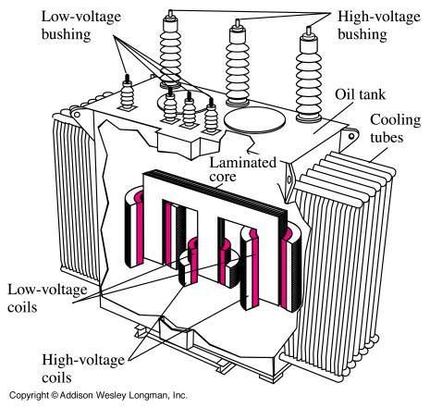

Uses of Transformers
- Electric power transmission over long distances.
- High-voltage direct-current HVDC power transmission systems
- Large, specially constructed power transformers are used for electric arc furnaces used in steelmaking.
- Rotating transformers are designed so that one winding turns while the other remains stationary. A common use was the video head system as used in VHS and Beta video tape players. These can pass power or radio signals from a stationary mounting to a rotating mechanism, or radar antenna.
- Sliding transformers can pass power or signals from a stationary mounting to a moving part such as a machine tool head. An example is the linear variable differential transformer,
- Small transformers are often used to isolate and link different parts of radio receivers and audio amplifiers, converting high current low voltage circuits to low current high voltage, or vice versa.
- Balanced-to-unbalanced conversion. A special type of transformer called a balun is used in radio and audio circuits to convert between balanced circuits and unbalanced transmission lines such as antenna down leads. A balanced line is one in which the two conductors (signal and return) have the same impedance to ground: twisted pair and "balanced twin" are examples. Unbalanced lines include coaxial cables and strip-line traces on printed circuit boards. A similar use is for connecting the "single ended" input stages of an amplifier to the high-powered "push-pull" output stage.

Observations:

Conclusion:

Comments:

