TABLE OF CONTENT
- DARK REACTION OF PHOTOSYNTHESIS
- PATH OF CARBON IN PHOTOSYNTHESIS
- CALVIN CYCLE
- COUPLING TO OTHER METABOLIC PATHWAYS
- DIAGRAM
- EQUATION
- STEPS
- PRODUCTS
- CAM CYCLE
- HISTORICAL BACKGROUND
- TWO PAT CYCLE
- BENEFITS
- BIOCHEMISTRY OF CAM
- PLANTS IN WHICH CAM OCCUR?
- C4 CARBON FIXATION
- DISCOVERY
- EFFICIENCY
- PLANTS IN WHICH IT OCCURS?
- COMPARISON OF CAM AND C4

Dark Reaction of Photosynthesis
There are two types of reactions in photosynthesis. Light and dark reaction .Light reaction can take place only in the presence of sunlight .Dark reactions can take place both in light and dark .Dark reaction are also given some other names on the basis of the name of person who discovered the reaction .Dark reaction also named as Blackman’s reaction because Blackman first discovered it in 1905.In dark reaction CO2 reacts with hydrogen of water and simple energy rich organic compounds are formed.
ATP ADP
CO2 +NADPH2 [CH2O] +H2O +NAD
Path of carbon in photosynthesis
Pathway of Carbon from CO2 to carbohydrates can be predicted with the help of radioactive isotopes of carbon C-14.C-14 was used by Melvin-Calvin and his associates in plants for 30 minutes at University of California. They found all C-14 in sugar form. In a very short photosynthetic period of about two seconds only, 90% of C-14 was found in the form of 3-carbon compound,3-phosphoglycerate (PGA).It is the most stable intermediate compound formed in photosynthetic dark reaction.
Calvin was awarded with Nobel Prize in 1961 for detection of pathway of carbon during the fixation of carbon.
According to recent research, three types of mechanisms about dark reaction has been investigated
1. Calvin Cycle
2. C4 photosynthetic carbon assimilation cycle (Hatch and Slack cycle)
3. CAM Cycle
CALVIN CYCLE
The Calvin cycle, also called Basham and Calvin cycle ,Reductive pentose phosphate cycle of photosynthesis is that type of chemical reaction of photosynthesis in which CO2 is converted into energy rich simple organic compound, Glucose. It was discovered in 1950. This reaction takes place in the stroma, area of chloroplast outside the thylakoid membrane and this area of chloroplast contains all the enzymes also. We can say this is fluid filled zone of chloroplast .Calvin cycle utilizes the products of light dependent reaction ATP and NADP and forms the products by many chemical processes. Light independent reaction of photosynthesis takes place in three phases and these three phases also called as Calvin cycle.
1. Carbon fixation
2. Reduction phase
3. Regeneration of original RuBP (1, 5-bisphosphate)
Calvin cycle called as Dark reactions does not occur only in the dark but it can also take place in light also. Because this process requires the product of light dependent reactions.
Coupling to other metabolic pathways
Calvin cycle is connected with other reactions like thylakoid electron transport chain because energy is provided from the NADPH formed in photosystem1 during the light independent reaction to reduce CO2.Calvin cycle is also attached with the photorespiration process ,because Calvin cycle reaction fallout from RuBisCO and the byproduct G3P .

DIAGRAM

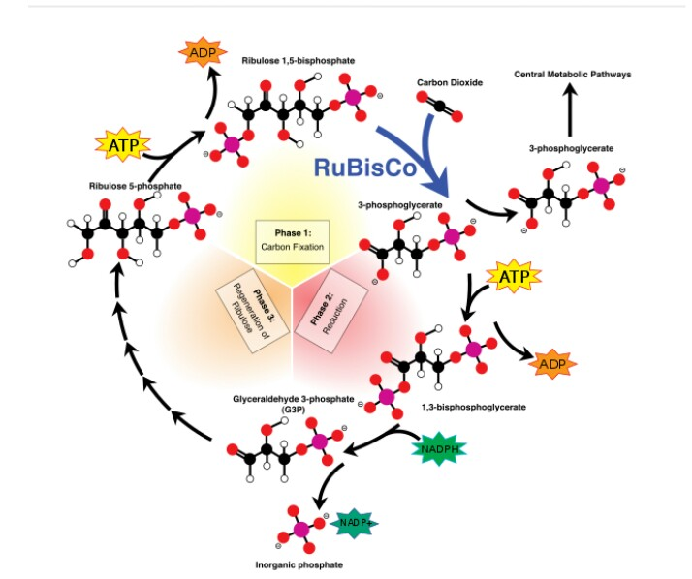
Photosynthesis occurs in two steps. The first stage, light-dependent reactions in which energy is captured from the sunlight and this energy is used to make energy storage compounds and many other transport molecules ATP and NADPH. Water and Carbon Dioxide are transformed into organic compound by utilizing the energy from short lived electronically excited carriers in Calvin cycle. These reactions are called carbon fixation reaction and the basic enzyme involved is RuBisCo. Enzymes of other metabolic pathways such as gluconeogensis and pentose phosphate pathway are functionally equalize to the enzymes in the Calvin cycle. However, these enzymes are not found in cytosol there in stroma. These enzymes stimulated in the presence of light and by-product of light re-action are utilized. Consequently, the name dark reaction is disingenuous.
EQUATION
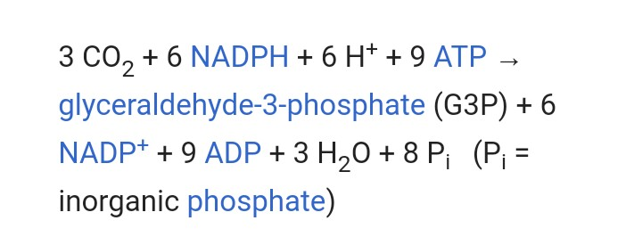

Calvin cycle result in three carbon compounds instead of six, i.e. Glyceraldehyde-3-phosphate.
Steps
The first step of is also called carbon fixation .In this step ,a molecule of CO2 is incorporated into the molecule of original 3-carbon intermediate formed called as glyceraldehyde 3 phosphate or G3P and products of light reactions ATP and NADPH are also involved in the reaction. Two molecules of ATP and NADPH are also involved in this step.
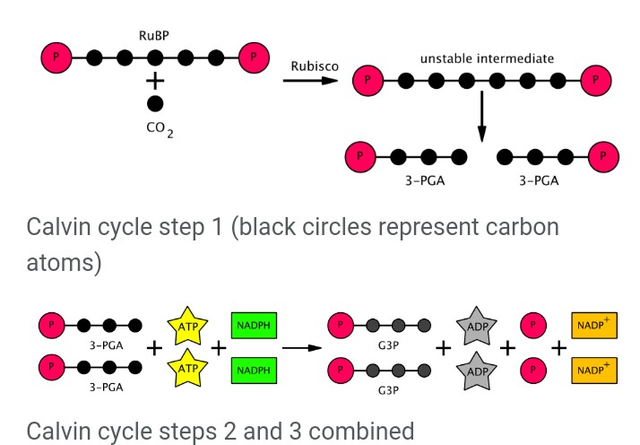

- The carboxylation of 5 carbon compounds takes place ribulose 1,5 bisphosphate ,RuBP, in the activity of an enzyme RuBisCO and CO2 is also involved in this process. This process occurs in two steps.Enediol-enzyme complex, artifact of first step, can incarcerate both CO2 and O2.The original carboxylase / oxygenase is enediol-enzyme complex. An unstable 6-carbon compound (2-carboxy 3-keto 1, 5-biphosphoribotol) is formed in the following stage, when CO2 is incorporated into enediol. This 6-carbon compound formed is highly unstable and it is broken down into two simple 3 carbon intermediates. The 3 carbon intermediates formed are named as 3-phosphoglycerate or PGA,3PGA
- In the following step ,phosphorylation of 3-PGA or PGA occurs in the presence of enzyme ,phosphoglycerate kinase, which will add molecule of phosphate into this 3- carbon intermediate and this molecule of phosphate will come from the ATP,ENERGY COMPOUND, this was produced in the light phase of photosynthetic reactions and then the products obtained in this phosphorylation are ADP and 1,3BPGA or 1,3 Bisphosphoglycerate .The important point to be noted is that two molecules of ATP,taken from light phase of photosynthesis, are consumed for the fixation of one Co2 because two phosphate are attached with G3P.
- In this step, reduction of 1,3BPGA will take place by the activity of an enzyme ,glceraldehyde 3-phosphate dehydrogenase and NADPH (By-product of light phase of photosynthesis) .NADPH will be oxidized And NADP+ is formed along with 3- carbon ,glyceraldehyde 3-phosphate(PGAL).The important point here to be noted is that two NADPH are again involved just like two ATP in the former step.
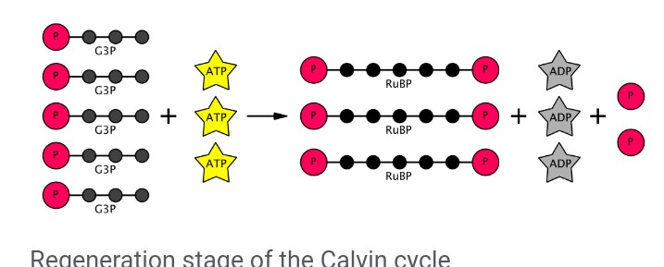

- The next step of Calvin cycle ,regeneration of original RUBP ,which will again form 5-carbon intermediate as it is in the first step of dark phase of photosynthesis .Here, molecules of ATP are again utilized.3 molecules of ATP are UTILIZED and will react with 5 G3P molecules and 3 RuBP MOLECULES are formed. Three CO2 molecules will result in six 3-carbon intermediates, G3P, because one molecule of CO2 will result in TWO molecules of G3P.OUT of these six molecules, five molecules are used to regenerated original 5-carbon compound, ribulose bisphosphate. The net gain of this reaction will be one molecule of G3P apiece 3 CO2 molecules.
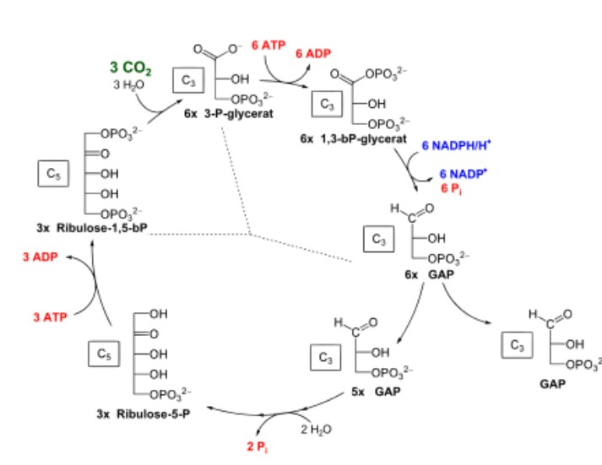

Regeneration can also be splitted up into further steps.
- Enzyme is involved to form isomerase of G3P.G3P is immediately converted into another 3-carbon compound, dihydroxyacetone phosphate ,DHAP .This conversion takes place in the presence of enzyme,Triose phosphate isomerae.
- Conversion of G3P and DHAP into fructose 6-phosphate will occur in the presence of enzymes, Aldolase and fructose-1,6-bisphophate.Phosphate ion will be vanished in this process of renovation.
- Two further G3P will be generated by the fixation of another Co2.
- The four carbon compound, erythrose 4-phosphate, will be generated by the activity of an enzyme, transketolase, on fructose-6 phosphate by the removal of two carbons. Here again G3P will react with two carbons removed by the activity of, transketolase, and these two carbons will be supplemented to G3P and xylulose-5-phosphate, Xu5P, a ketose.
- The aldolase enzyme will then alter 3-carbon compound, DHAP, AND E4P, erythrose-4-phosphate, into 7-carbon compound, sedoheptulose-1, 7-bisphosphate.
- Next dephosphorylation of 7-carbon compound will take place by the activity of an enzyme, sedoheptulose-1, 7-bisphosphatase ( one of the three unique enzymes of the Calvin cycle which are in plants) which will convert sedoheptulose-1,7-bisphosphate into seduheptulose-7-phosphate by removal of phosphorus.
- Further two G3P are formed by the fixation of another CO2.One more Xu5P is formed from G3P and 2 carbons, which are obtained by the removal of carbons from sedoheptulose-7-phosphate with the activity of an enzyme Transketolase, and product formed is ribose-5-phosphate. Net one G3P is formed along with 3 molecules of 5 carbon compound, ribulose-5-phosphate,which is isomer of xylose-5-phosphate
- Xylose-5-phosphate will be interconverted into riboluse phosphate by the activity of an enzyme; phosphopentose epimerase .Activity of PHOSPHOPENTOSE ISOMERASE will interconvert R5P into RuP OR Ru5P.
- Next phosphorylation of Ribulose phosphate will occur and this will be interconverted into ribulose biphosphate or 1,5 RuBP by the activity of exclusive enzyme of plants, phophoribulokinase,and thus the whole Calvin cycle is accomplished .For phosphorylation ATP is needed.

Total six G3P are generated, but only one of the G3P molecule is further used for plants consumption .This G3P will be converted into six carbon energy rich organic compounds, glucose or fructose. The other 5 molecules of 3-carbon compound are interconverted into 3 molecules of 5 carbon compound. These five carbon compounds are stored and then will be further utilized for other future activities.
The complete equation of Calvin cycle requires 9 ATP molecules ,6 NADPH molecules and 3 CO2 molecules.
Equation can be shown diagrammatically
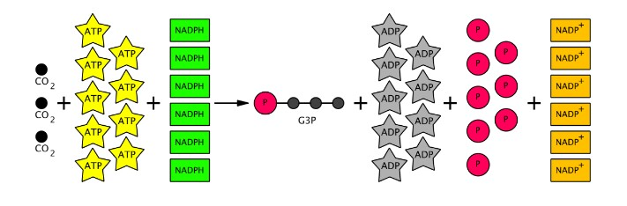

PRODUCTS
2 molecules of glyceraldehyde3 phosphate , G3P, 3 molecules of adenosine diphosphate ,ADP+ and two molecules of NADP+( these are not actual products ,they can be regenerated again and can be further utilized)in order to continue Calvin cycle, regeneration is essential stage. And G3P 5 MOLECULES are consumed in this process of regeneration out of 6.Only one G3P can be further utilized for plants activities. As G3P contains 3 carbons in it ,so, three molecules of carbon are required to make one molecule of G3P.One turn can form 3 carbon compound, so one glucose can be formed from two Calvin cycle.
Excessive Glyceraldehyde 3 phosphate will be consumed for making many other useful organic compounds (carbohydrates) i.e. starch, sucrose, cellulose and these compounds are formed on the basis of needs.
Alternative mechanism of photosynthesis
There are two other mechanisms of photosynthesis known as CAM cycle and C4 cycle.
CAM Cycle
It is Crassulacean acid metabolism, which is the passageway of carbon in those plants which are modified to survive in harsh environmental conditions .In those plants which survive in desert or arctic zone ,stomata remain bunged during whole day and open only at nights .AT night time ,plants take in CO2 and then by utilizing this CO2 ,will convert this CO2 to malic acid ,reason called acid metabolism is the formation of acid in the vacuoles,CO2 dispersion occurs in the mesophyll cells of leaves .This 4- carbon compound formed, malic acid ,during nights, will be utilized by plant’s chloroplast and then CO2 will be once more formed and then CO2 formed will go into Calvin cycle and thus products are formed. Mechanism of CAM cycle was very first time observed in plants of Crassulaceae family.

Historical Background
Initially ,in 1804, de Saussure, in his Recherchés Chimiques sur la Vegetation investigated observations regarding CAM metabolism .One of another scientist, Benjamin Heyne ,in 1812,investigated that leaves of Bryophyllum ,Indian plant ,turns insipid in dusk although these leaves were bitter in the dawn. Former remarks were further experienced and premeditated by many other scientists , Aubert,E. in 1892 in his Recherches physiologiques sur les plantes grasses and expounded upon by Richards, H.M.1915 in acidity and gas interchange in Cacti, Carnegie institute .but the name of this cycle was given by some other scientists who afterwards in family Crassulaceae investigated this phenomenon .Ranson and Thomas were the two botanists who gave this name but acid was due to acid,malic acid,metabolism named not any kind of crassulacean acid exists in the universe.
Two-part cycle
As CAM occurs in desert plants, so this cycle will automatically be very proficient to utilize water.
Night time
The plants in which CAM cycle occurs ,stomata in these plants will be opened at night time .As stomata remain open at night, so, CO2 will be taken into the mesophyll cells of the leaves and thus this CO2 will be fixed and an acid of 4 Carbon called as Malate is formed. This malic acid thus formed will be then accumulated into the vacuoles so that it can be used later. The CO2 formed during the process of CAM metabolism will be consumed in the Calvin cycle and along with it products of light phase of photosynthesis.
Day Time
As the metabolism is happening in desert plants, so the stomata is not opened during day time in order to save water. But the formation of CO2 occurs during night and along with it, malate is formed. This Co2 manufactured will be consumed in dark phase of photosynthesis and CO2 will be entered in with the help of an enzyme, found in the stroma of chloroplast.
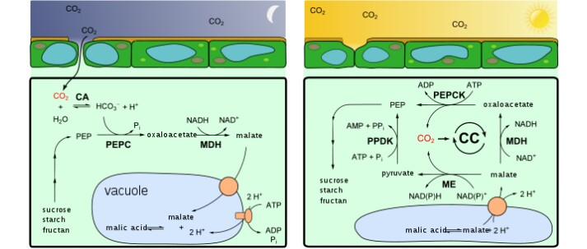
Benefits
The most important benefit of CAM cycle is that due to these stomata of the leaves are not exposed all the time. So, plants which are there in deserts or harsh conditions can hoard water and thus these plants can easily survive in these dreadful conditions. But those plants in which C3 occur, 97% water is vanished.
Biochemistry of CAM
Plants in which CAM metabolism occur, at low temperature, open their stomata and after opening of stomata,CO2 will be incorporated into the mesophyll cells and then this CO2 will react with PEP, phoshporylated triose and this reaction will give PEP carboxylase kinase but this will act only at low temperature and when acid is not present i.e. malic acid. PEP C-KINASE will phosphorylate and oxaloacetate is obtained and this can be converted into malate, the main product in CAM. This malate cannot be stored as such,instead, malic acid will be storage form and due to this reason malate is converted into malic acid with the help of enzymes
But plants having low water environment, during day, will always close their guard cells. So that water is not lost because they suffer already water deficiency. But Co2 from CAM metabolism is utilized in the dark phases of photosynthesis.
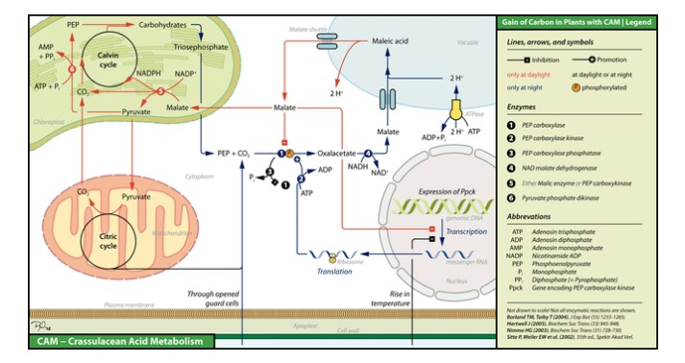
In plants of which type it occurs
CAM occurs mostly in desert plants which lesser availability of water and these plants have their stomata closed in day time. Correspondingly, plants which grow in saline environment or plants growing on other plants or rock i.e. epiphytes and lithophytes .In some kind of aquatic plants i.e. SAGITTARIA, which have some features alike to xerophytes plants also utilize this acid metabolism.
C4 Carbon fixation
This is named as Hatch-Slack pathway and this also a type of photosynthetic reation.This reaction will fix CO2 forming four carbon intermediate, so it is called as C4 fixation. In this type of photosynthetic reaction,CO2 is incorporated and a four carbon compound, malate ,will be formed but this malate will enter further into the bundle sheath cells of leaves and here it is again splitted into pyruvate and CO2.the CO2 formed will be then utilized in dark phase of photosynthesis.
Discovery
Initially when some plants do not show C3 fixation,instead,malate formation was investigated in 1950s and 1960s by Hugo Peter and Yuri Karpilov.But exact indication of this process was given by Hatch and Slack in 1966.
C4 pathways
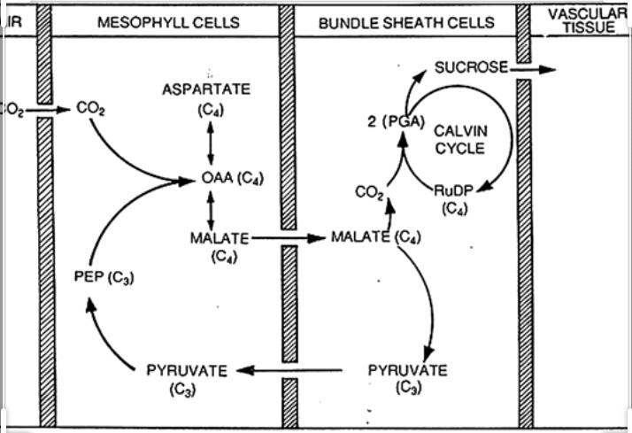
This process is also known as photorespiration because at the same time both oxygenase And carboxylasse work ,when original CO2 will be reacted with RuBisCO AND G3P is obtained. But proficient way has been adopted to overcome this photorespiration. This difficulty is overcome by the help of leaf internal features, because their leaves will have stomata not only in upper mesophyll cells but also in their lower bundle sheet cells.So,in this process CO2 will not be fixed by RuBisCO,instead,4-carbon malate which is found in mesophyll cells will be consumed here. This reaction of C4 pathway can simply occur in this way or it can also use various kinds of enzymes and by-products. Pathway is either simple or complex, result is always same, 4 carbon compound fixation takes place.
Efficiency
This process seems to be more proficient because carbon is fixed two times, in bundle sheath cells and in mesophyll cells also.
Which plants utilize this process?
Sugarcane, maize, millet and sorghum. Grass family, cabbage family and daisy family plants.All these will utilize carbon fixation.
Comparison of C4 and CAM
Both these are similar to each other in the way that both of these processes utilizes CO2 to enhance proficiency of RuBisCO .But C4 seems to be more proficient than CAM because CAM does not occur in daytime.

