Sugar Refinery Carbonation Process
Objective of Carbonation Process
a) The objective of these processes is to remove the impurities that cause turbidity in raw melt liquor.
b) Carbonation is generally applied to melt liquor in the refinery ahead of any decolourising process.
c) Carbonation has a good effect on sugar liquors. It is also purification process, enabling a colour reduction of about 40% to 50% together with a reduction in ash content of about 20-25%.
d) The addition of lime and Carbon Dioxide in the sugar liquor produces Calcium Carbonate precipitates that adsorb the impurities and coloring matter present in the sugar liquor. Less soluble salts such as sulphates, colour bodies, starch, and many other impurities are entrapped by the calcium carbonate.
e) These impurities are subsequently removed in the succeeding filtration process.

Reactions in Carbonation process
a) This carbonation process involves two distinct steps.
b) The first step involves the formation of a voluminous and gelatinous precipitate by reaction of calcium and CO2.
c) The second step involves the conditioning of the precipitate in order to improve its filterability.
Ca (OH)2 + CO2 = CaCO3 + H2O
d) The impurities are both absorbed by, and enmeshed in, the conglomerated particles of the calcium carbonate precipitated by the reaction of the carbon dioxide and calcium hydroxide.
e) This calcium carbonate entraps wax, gums, polysaccharides, colorants and ash and also destroys the invert sugars. This precipitate that contains most of the impurities from the sugar solution is removed in the process in the succeeding filtration processes.
Carbonation Process Description
a) The process consists of adding slurry of calcium hydroxide into the raw melt solution in liming tank to increase the pH to 10.5 – 11.
b) Liming tank is equipped with agitator to keep the liquor and lime solution mixture in suspension and for better mixing.
c) Generally, the carbonation process consists of two no’s of carbonators working in series as 1st carbonator and 2nd
d) The limed liquor from the liming tank flows transfer to first carbonator tank where scrubbed Carbon Dioxide gas drawn from Boiler flue gas after dilution is admitted to react with lime in the limed liquor to form calcium carbonate.
e) The CO2 addition will be controlled according to the carbonated liquor pH.
f) In 1st carbonated liquor tank pH maintained about 9.5 – 9.6 and amount of 75 -85 % of carbon dioxide gassing is carried out in the first carbonator tank.
g) The carbonated liquor passing from 1st carbonator to second carbonator. The pH of 2nd carbonated liquor tank comes is 8.2-8.4 and amount of 15 – 25 % of carbon dioxide gassing is carried out in the second carbonator tank.
h) Carbonated liquor from the second carbonator tanks flows by gravity into carbonated liquor buffer tank.
i) Each carbonator is equipped with Richard tubes for better mixing of CO2 with the liquor and facilitates the on line cleaning of nozzles and avoids jamming, which results better colour reduction in the carbonation system.
j) Boiler flue gas is used as source of CO2 requirement for this carbonation process and the concentration CO2 gas is about 12-14% in scrubbed flue gases.
k) The carbonated liquor heated to 850C in tubular heaters and filtered in Membrane pressure filters to separate the calcium carbonated precipitate from liquor.
l) Clarified melt from the carbonation system will be subjected to 2nd decolonization process.

Flow diagram of carbonation Process in Sugar Refinery for raw melt clarification.

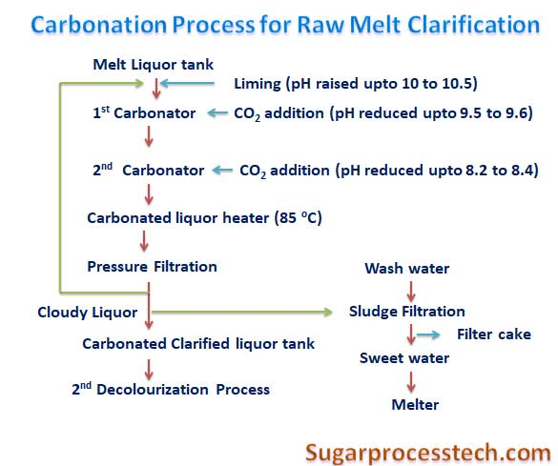

Complete Process
- The juice is heated to denature the protein in the juice, and then mixed with slurry of calcium hydroxide, called milk of lime. Then, in a vessel specially designed for the purpose, the mixture is treated with carbon dioxide gas bubbles. The quantity of gas used is that necessary to precipitate the majority of the calcium hydroxide added as calcium carbonate and to lower the alkalinity of the resultant mixture to the degree necessary for the resultant precipitate, called first carbonation sludge, to settle out rapidly.
- The first carbonation sludge contains the precipitated calcium carbonate (PCC), a loose amorphous precipitate with a tremendous amount of charged surface area. Many of the non-sugar materials are either absorbed onto or absorbed into this precipitate. When the mixture from the carbonation vessel is pumped to another vessel to allow the precipitate to settle out, the settled precipitate contains a great deal of the non-sugars, both soluble and insoluble, originally in the raw juice.
- The first carbonation sludge is pumped from the bottom of the settling vessel to the PCC filters, where the sludge is filtered and washed to remove residual sugar. The dried PCC is then destined for future reuse or sale as soil amendment. The filtrate and washings from the filters, called sweet water, are returned to the lime calcining operations area for the preparation of milk of lime. Excess sweet water is returned to first carbonation.
- The clear juice from the top of the settling vessel is again heated and then enters another carbonation vessel. There, sufficient carbon dioxide is bubbled through it to lower the alkalinity to the point where all of the residual calcium hydroxide is neutralized and precipitated as calcium carbonate. This is done to facilitate concentration of the juice without scaling the heating surfaces with calcium salts. The precipitate formed is removed by filtration and the precipitate is mixed with the first carbonation sludge prior to its filtration and wash.
Disadvantage of Carbonation Process
The major disadvantage of this system is the fact that high pH levels lead to a certain degree of destruction of invert sugars (monosaccharides). The breakdown products are generally organic acids, which require more lime in neutralization and increase the ash in the final molasses, thereby increasing the loss of sugar in molasses.

