Topic :Lysosomes, Peroxisomes and Glyoxisomes
Lysosomes are membrane-bound, dense granular structures containing hydrolytic enzymes responsible mainly for intracellular and extracellular digestion.

- The word “lysosome” is made up of two words “lysis” meaning breakdown and “soma” meaning body.
- It is an important cell organelle responsible for the inter and extracellular breakdown of substances.
- They are more commonly found in animal cells while only in some lower plant groups ( slime molds and saprophytic fungi).
- Lysosomes occur freely in the cytoplasm. In animals, found in almost all cells except in the RBCs.
- They are found in most abundant numbers in cells related to enzymatic reactions such as liver cells, pancreatic cells, kidney cells, spleen cells, leucocytes, macrophages, etc.

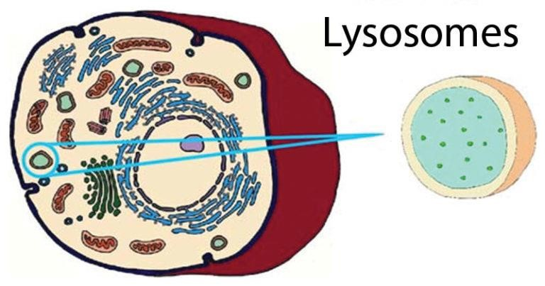
Structure of lysosomes

- Lysosomes are without any characteristic shape or structure i.e. they are pleomorphic ❖ They are mostly globular or granular in appearance.
- It is 0.2-0.5 μm in size and is surrounded by a single lipoprotein membrane unique in composition.

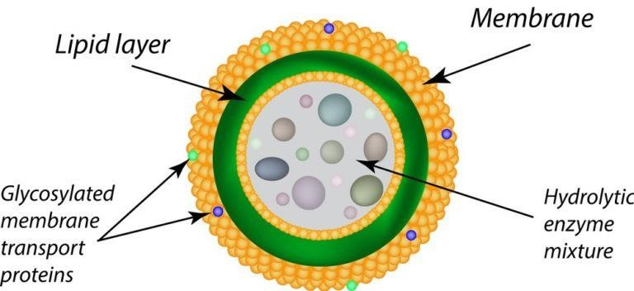

Diagram of Lysosomes
- The membrane contains highly glycosylated lysosomal associated membrane proteins (LAMP) and Lysosomal integral membrane proteins (LIMP).
- LAMPs and LIMPs form a coat on the inner surface of the membrane
- They protect the membrane from attack by the numerous hydrolytic enzymes retained inside.
- The lysosomal membrane has a hydrogen proton pump which is responsible for maintaining pH conditions of the enzyme The acidic medium maintained by the proton pump that pumps H+ inside the lumen, ensures the functionality of the lysosomal enzymes.Inside the membrane, the organelle contains enzymes in the crystalline form.

Lysosomal Enzymes

For degradation of extra and intracellular material, lysosomes filled with enzymes called hydrolases. It contains about 40 varieties of enzymes which are classified into the following main types, namely:
- Proteases, which digest proteins
- Lipases, which digests lipids
- Amylase, which digests carbohydrates
- Nucleases, which digest nucleic acids
- Phosphoric acid monoesters
Collectively the group of enzymes is called hydrolases which cause cleavage of substrates by the addition of water molecules. Most of the lysosomal enzymes function in the acidic medium.

Types of lysosomes

Primary Lysosomes
- Small sac-like structures enclosing enzymes synthesized by the rough endoplasmic reticulum.
- Simply called as storage granules storing enzymes.

Secondary Lysosomes
- Formed by the fusion of primary lysosome with phagosomes.
- Contain engulfed material plus enzymes. ❖ Materials are progressively digested.

- Primary lysosome are small saclike structures enclosing enzymes synthesized by the ribosomes. Since they store enzymes, they are also said to be storage granules.
- Secondary lysosome are formed by the fusion of primary lysosome with phagosomes. They contain engulfed materials and enzymes. The materials are progressively digested by the enzymes. So it is also otherwise called as digestive vacuole.

Functions of lysosomes

These serve two major functions:

1. Intracellular Digestion
- To digest food, the lysosome membrane fuses with the membrane of food vacuole and squirts the enzymes inside.
- The digested food then diffuses through the vacuole membrane and enters the cell to be used for energy and growth.

2. Autolytic Action
- Cell organelles that need to be get ridden are covered by vesicles or vacuoles by the process of autophagy to form autophagosome.
- The autophagosome is then destroyed by the action of lysosomal enzymes.

Processes in which lysosomes play crucial roles include:

a. Heterophagy
The taking into the cell of exogenous material by phagocytosis or pinocytosis and the digestion of the ingested material after fusion of the newly formed vacuole with a lysosome. b. Autophagy
Autophagy is essential in helping to maintain the balance between the increase and decrease in the number of a cell population. It is undoubtedly active at a basal level in most cells and contributes to the routine turnover of cytoplasmic components. Three predominant cellular functions can be assigned to autophagy. Autophagy is a response to nutrient starvation. Decreased levels of amino acids can induce the autophagic response in numerous cell types and situations e.g. the neonatal period, when the supply of nutrients via the milk has not yet replaced the nutrients via the placenta.

Autophagy is a housekeeping process whereby long-lived proteins and organelles are recycled e.g. Mitochondria. Autophagy has tissue-specific roles e.g. during erythrocyte development, following nucleus expulsion, autophagy is required to degrade the remaining organelles. Degradation of the autophagic vesicle results in the functional biconcave shape. The term ‘Autophagy’ covers three processes; microautophagy, macroautophagy and chaperone-mediated autophagy:

Microautophagy is the transfer of cytosolic components into the lysosome by direct invagination of the lysosomal membrane and subsequent budding of vesicles into the lysosomal lumen.

Macroautophagy involves formation of a double-membrane structure called the autophagosome which sequesters cytosolic material and delivers it to the lysosome for degradation. Although this degradation can be selective (i.e. specific removal of damaged mitochondria sparing normal functioning ones), degradation of soluble cytosolic proteins is non-selective.

Chaperone-mediated autophagy (CMA) is characterised by its selectivity regarding the specific substrates (cytosolic proteins) degraded.

c. Extracellular Digestion
Digestion of materials outside the cell is called extracellular digestion. In certain occasions lysosomes release enzymes outside the cell by exocytosis and bring out digestion. Extracellular digestion takes place during bone erosion process. Osteoclast cell of bone contain more number of lysosomes. These cells when release their lysosomal content on the surface of the bone, lysosomal enzymes bring about the extracellular digestion of bone and it result in bone desorption. d. Autolysis
Autolysis refers to the digestion of own cells by the lysosomes. Auto means self and lysis means digestion. It is self digestion. It is also otherwise known as programmed cell death or apoptotic lysis. In autolysis, the lysosome digests its own cell. Hence autolysis is also called as cellular autophagy. In this process, the lysosome ruptures inside its cell and the released enzymes digest and degrade the cell. As lysosome kills its own cell, it is called as suicidal bag.
- Autolysis occurs during amphibian metamorphosis, insect metamorphosis, mensuration etc., During amphibian metamorphosis, the cells in tail, gills etc., are digested by autolysis. Similarly during menstruation the cells in the uterine epithelium are lysed by autolysis.
- It refers to the killing of an entire set of cells by the breakdown of the lysosomal membrane. It occurs during amphibian and insect metamorphosis.

e. Fertilization
The acrosome of the sperm head is a giant lysosome that ruptures and releases enzymes on the surface of the egg. This provides the way for sperm entry into the egg by digesting the egg membrane.
f. As Janitors of the Cell
Lysosomes remove ‘junk’ that may accumulate in the cell helping to prevent diseases.

Lysosomal Storage Diseases /Disorders
The scientific community has identified more than 40 types of lysosomal storage diseases, and that number keeps growing. Although the different types of LSDs are rare individually, taken together they affect roughly 1 in 7,700 births, making them a relatively common health problem.
- Some of the most common lysosomal storage disorders include:
- Gaucher disease: Gaucher disease often causes spleen and liver enlargement, blood problems and bone issues.
- Fabry disease: This disorder often causes severe burning pains in hands and feet and, in some cases, a distinctive skin rash on the legs. Untreated, this disease can cause kidney failure, heart failure, strokes and death before age 50. Although men are more likely to have severe disease, women may also be seriously affected.
- Niemann-Pick disease: Similar to Gaucher disease, Niemann-Pick disease involves organ enlargement, lung dysfunction and central nervous system damage for certain subtypes.
- Hunter syndrome: This disease is part of a group of disorders that cause bone and joint deformity as well as interference with normal growth.
- Glycogen storage disease II (Pompe disease): Depending on the specific subtype, Pompe disease may cause heart enlargement and heart failure in infants. It may also cause respiratory problems and severe muscle weakness in adults.

Peroxisomes
Peroxisomes are membrane-bound organelles in most eukaryotic cells, primarily involved in lipid metabolism and the conversion of reactive oxygen species such as hydrogen peroxide into safer molecules like water and oxygen.

Structure and composition
Peroxisomes are organelles that can vary in shape, size and number depending on the energy needs of the cell. In yeast cells, a carbohydrate-rich growth medium shrinks peroxisomes. On the other hand, the presence of toxins or a lipid-rich diet can increase their number and size.
❖ These organelles are made of a phospholipid bilayer with many membrane-bound proteins – especially those that act as protein transporters and translocators. The enzymes involved in detoxification and lipid metabolism are synthesized on free ribosomes in the cytoplasm and selectively imported into peroxisomes, making them more similar to mitochondria and chloroplasts when compared to lysosomes that bud off from the endoplasmic reticulum (ER). However, there is also some evidence linking ER-mediated protein synthesis to the enzymes present in peroxisomes.

Functions
Peroxisomes derive their name from their use of molecular oxygen for metabolic processes. These organelles are largely associated with lipid metabolism and the processing of reactive oxygen species. Within lipid metabolism, peroxisomes mostly deal with β–oxidation of fatty acids, the mobilization of lipid stores in seeds, cholesterol biosynthesis and steroid hormone synthesis. β–oxidation
- The main reason for the high energy density of fats is the low proportion of oxygen atoms in every fatty acid molecule. For instance, palmitic acid, a fatty acid containing 16 carbon atoms and having a molecular mass of over 250 gms/mole, has only two oxygen atoms.
- While this makes lipids good storage molecules, they cannot be directly burnet as fuel or quickly catabolized in the cytoplasm through glycolysis.
- They need to be processed before they can be shunted into the mitochondria for complete oxidation through the citric acid cycle and oxidative phosphorylation.
Peroxisomes in Plants
- In plants, peroxisomes play important roles in seed germination and photosynthesis. During seed germination, fat stores are mobilized for anabolic reactions that lead to the formation of carbohydrates. This is called the glyoxalate cycle and begins with β–oxidation and the generation of acetyl coA as well.
Lipid Biosynthesis and Detoxification
- In animal cells, peroxisomes are the sites for some amount of lipid biogenesis, especially of special phospholipids called plasmalogens that form the myelin sheath in nerve fibers.
Peroxisomes are also necessary for the synthesis of bile salts.
- About 25% of the alcohol we consume is oxidized to acetaldehyde in these organelles. Their role in detoxifying and oxidizing a number of molecules, metabolic byproducts and drugs makes them a prominent part of kidney and liver cells.

Glyoxysomes
Plants contain an organelle, which in addition to glycolic acid oxidase and catalase also possess number of enzymes that are not found in animal cells , this organelle is known as Glyoxysomes and are most abundant in plant seedlings which rely upon stored fatty acids to provide them with energy and the material to begin the formation of new plant.
❖ One of the primary activities in these germinating seedlings is the conversion of stored fatty acids to carbohydrates . This is achieved through a cycle, the glyoxylate cycle, the enzymes of which are present in Glyoxysomes .

Size and composition
Glyoxysomes are distinct from peroxisomes because of different functions. They are found in fungi and other higher plants. Storage organs rich in oil globules contain greater number of glyoxysomes. Such membranous structures loaded with oil globules are also called spherosomes of 0.5 to 1.5 nm size and they are associated with mitochondria.
- When such oil laden seeds germinate, the number of glyoxysomes increases significantly and remains very active.
- Glyoxysomes contain a host of enzymes responsible for b-oxidation of a fatty acids, citrate synthase, isocitrate lyase, malate synthase, hydrogenase, urate oxidase, etc. Thus it has all the enzymes necessary for fatty acid oxidation as well as glyoxylate cycle and gluconeogenesis.

Functions
- The most important function of glyoxysomes is to convert stored lipids into carbohydrates; which are required for the growing seeding. The conversion of lipids in to glucose requires co-coordinated functions of glyoxysomes, mitochondria and proplastids.
- Primarily, glyoxysomes first convert lipids into glycerol and fatty acids; then the latter is subjected beta-oxidation. In germinating seeds, the acetyl CO-A produced during boxidation is not drawn into Kreb’s cycle, but it is utilized in glyoxylate cycle. The succinate, produced in glyoxylate reactions, is transported across the membranes into mitochondria where it is further converted into glucose phosphate through phosphoenol pyruvate pathway.
- The last part of the reaction takes place in proplastids. Besides oxidation and glyoxylate reactions, glyoxysomes also contain urate oxidase and allantoinase responsible for the conversion of urate into allantoin.

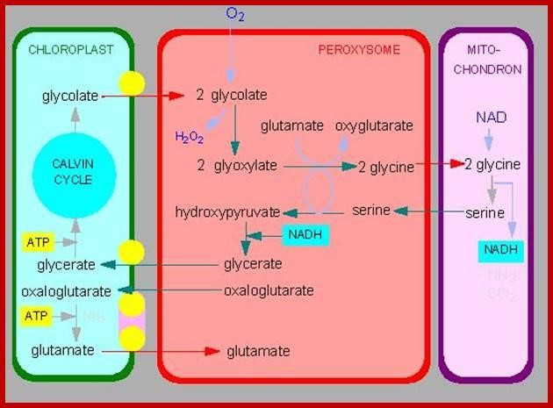

Multiple choice questions
- Which of the following organelle is called the “suicidal bags” of the cell?
  - Cytoplasm
  - Lysosomes
  - Mitochondria (d) Endoplasmic reticulum Sol:(b) Lysosomes.
- The lysosomal membrane is rich in ___________.
  - Sterols
  - Cardiolipin
  - Sialic acid (d) All of the above Sol:(c) Sialic acid.
- In which of the following cells Lysosomes are absent?
  - Animal cells
  - Erythrocytes
  - Hepatocytes (d) Muscles cells
Sol: (b) Erythrocytes.
- What is the pH of a lysosome?
  - Acidic
  - Basic
  - Neutral
  - Depends on the cell type Sol: (a) Acidic.
5.Inside the cell, H₂O₂ clearance is brought about by______.
a) Peroxisome with enzyme amino oxidase (b) Glyoxysome with the enzyme catalase
- Peroxisome with the enzyme catalase
- Glyoxysome with enzyme isocitrate lyase
Answer: (c)
6.Organelle – Glyoxysomes is involved in _____.
- Conversion of fatty acids to lipids
- Conversion of amino acids to proteins
- Conversion of amino acids to carbohydrates
- Conversion of fatty acids to carbohydrates
Answer: (d)
7. _______ forms the crystalline core inside the peroxisome.
- Salt crystals
- collection of phospholipids
- highly condensed oxidative enzymes
- Condensed ammonium chloride
Answer: (c)
8. The organelle helping in penetrating of sperm into egg during fertilization is
- peroxisome
- nucleus
- lysosome
- mitochondrion

Answer ( c)

9. _______ forms the crystalline core inside the peroxisome.
- Salt crystals
- collection of phospholipids
- highly condensed oxidative enzymes
- Condensed ammonium chloride
Answer: (c)
10. What is the group of proteins in the peroxisomal membrane called?
- Peroxins
- Transporters
- Translocation proteins
- Peroxisomal membrane proteins
Answer: (a)

…Thank you…

