BACKCROSS BREEDING

The backcross is a form of recurrent hybridization by which a desirable allele for a character is substituted for the alternative allele in an otherwise desirable cultivar. The plan of the backcross is to cross an adapted and productive cultivar, yet one that lacks a desirable allele (or alleles) controlling a superior character, to a breeding line or cultivar in which the desirable allele is present. Beginning in the F₁ and continuing for several generations, hybrid plants containing the dominant allele are selected and successively crossed back to the adapted parent cultivar. The adapted parent, to which the allele is being added, enters into each backcross and is called the recurrent parent. The parent with the superior character enters into the initial cross

but does not enter into the backcrosses, and is called the donor or nonrecurrent parent.

The purpose of the backcross is to recover the genotype of the recurrent parent, except for the substitution of the allele (or alleles) for superior expression of the character being contributed from the donor or nonrecurrent parent. The backcross is a form of inbreeding, and the features of the recurrent parent are automatically recovered after successive backcrosses. The only selection practiced is for the one superior trait contributed by the nonrecurrent parent. The number of backcrosses may vary from two to five, or more, depending upon how completely the breeder wishes to recover the genes from the recurrent parent. The backcross procedure is most easily carried out if the character being added is simply inherited, dominant, and easily recognized in the hybrid plants.

SIGNIFICANCE OF BACK CROSS MATHOD

One feature of the backcross procedure is that a backcross derived cultivar will be adapted in the same general environment as the recurrent parent, reducing the testing normally necessary to confirm adaptation of the backcross derived cultivar. An additional feature is that it is repeatable. A breeder can recover the same line if the same recurrent and donor parents are used. If two or more characters are to be added to the same recurrent cultivar, separate backcross procedures may be pursued for each character and the backcross-derived lines from each finally merged into a single line.

The backcross procedure is further utilized to transfer entire sets of chromosomes into a foreign cytoplasm to obtain cytoplasmic male sterility for the production of hybrid seed as in corn, millet, onion, sorghum, wheat, and other crops. The species or cultivar with the foreign cytoplasm is the female and recurrent parent as cytoplasm is transferred only through the egg. The donor of the chromosomes is crossed as the pollen parent until all donor chromosomes are recovered in the cytoplasm of the recurrent parent. Normally, the original cross and four or five backcrosses are required.

BACK CROSS FOR DOMINANT GENE TRANSFER

The backcross procedure is illustrated in Fig. 9.6 in which the dominant alleles for a gene controlling disease resistance (RR) are to be substituted for the recessive alleles in an adapted cultivar. In this cross cultivar A is the recurrent parent, and contains the genes for adaptation and yield that the breeder wishes to recover in the new cultivar. Cultivar B is the donor parent with a dominant allele for disease resistance that the breeder wishes to add to cultivar A. With each successive backcross, the progeny becomes more like the recurrent parent as additional genes for adaptation are recovered. With completion of the fourth backcross, theoretically, 93.75 % of the genes of the adapted parent will have been recovered in the backcross progeny. After each backcross, disease resistant progeny plants (Rr) are identified, by artificially inoculating all progeny plants and noting their disease reaction. As many backcrosses may be made as are necessary to obtain plants that are indistinguishable from the recurrent parent except for the substituted allele for disease resistance. The disease-resistant plants in the final backcross progeny will be heterozygous for resistance (Rr), and must be selfed for one generation to obtain true breeding resistant plants (RR).

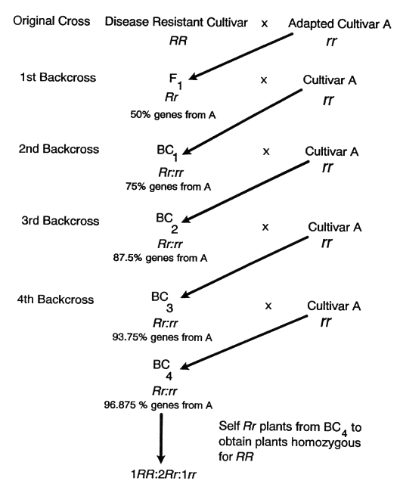

Fig. 9.6.Procedure for a backcross in which a dominant allele for disease resistance (R) is transferred from a disease resistant cultivar to an adapted cultivar A. The resistant donor cultivar is crossed to the adapted recurrent cultivar A, and the F₁ backcrossed to cultivar A. The BC₁ generation from this cross will be segregating for disease resistance (Rr:rr). The Rr plants may be identified from the rr plants by inoculating the seedling plants with the disease pathogen and observing whether plants exhibit the resistant or the susceptible disease reactions. Only Rr (resistant) plants are backcrossed to A in the second and succeeding backcross generations. After the final backcross, the heterozygous (Rr) plants are selfed one generation to obtain homozygous (RR) and heterozygous (Rr) resistant plants. Progeny tests of the resistant (RR and Rr) plants are grown to identify the homozygous (RR) from the heterozygous (Rr) plants, so that lines pure for resistance may be established.
BACK CROSS FOR RECESSIVE GENE TRANSFER

If the alleles for disease resistance being transferred should be recessive (rr), the progeny of the first backcross would segregate into genotypes (RR) and (Rr). Because the heterozygous plants that contain the resistance allele (r) cannot be identified, it is necessary to self the progeny one generation to find resistant (rr) plants before making the next backcross to the recurrent parent. Another procedure would be to backcross both the homozygous (RR) and heterozygous (Rr) plants to the recurrent parent and simultaneously self each backcross derived plant and test the selfed progenies for resistance. The backcross progenies from the plants that prove to be heterozygous are then kept, and the backcross progenies from the homozygous plants are discarded. If genes for undesirable characters are closely linked with the gene for resistance, they may be added along with the resistance gene. The new cultivar would then differ from the recurrent parent by the genes that were added. If characteristics being added by the backcross procedure are determined by multiple genes, it will be necessary for the backcross progenies to be grown through the F₂ or later generations to obtain plants that exhibit the desired characteristics before proceeding with the next backcross.
