Light Reaction
Steps of Light Reaction:
1-Light absorption.
2-Photolysis of water.
3-Electron transport and photophosphorylation.

Q (primary electron acceptor)
Q
2e_

PQ

2e_ 2e_

2e_ Cytochrome bf
Complex 2e_
Fd

2e_

PC 2e_

NADP⁺
2e_ NADP^{2e} +2H⁺
(reductase)
NADPH+
p680 p700 H⁺

2-Calvin Cycle/Dark Reaction
The series of reactions catalysed by respective enzymes by which the carbon is fixed and reduced in the synthesis of sugar during the dark reaction of P/S is called Calvin cycle.

3CO₂ + 6NADPH + 9ATP (CH₂O)₃ ₊ 6NADP + 9ADP + 9Pi + 3H₂O
Steps of Dark Reaction:
1-Carboxylation

RuBP + CO₂ 3PGA

2-Reduction

3PGA 1,3 bis PGA G₃P

3-Regeneration

G₃P Ru₅B RuBP

CO₂

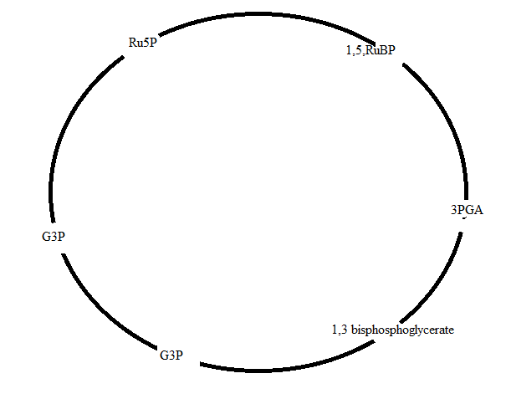

(Glyceraldehyde 3 Phosphate) G3P

Glucose and other organic matter containing a large number of chloroplast. The bundle sheath is surrounded by many layers of mesophyll cells. The cells of mesophyll also contain chloroplast but these are of smaller size than those present in the cells of bundle sheath because the bundle sheath surrounds the vascular tissue all around, therefore the substances that move b/w mesophyll cells and vascular tissue must pass through the bundle sheath. The chloroplast of mesophyll cell in C₄
Plants are without Rubisco (ribulose 1, 5_bisphosphate carboxylase oxygenise) this
Anatomical arrangement of cell is called KRANZ ANATOMY
C₄_ Pathway
- Carboxylation PEP in mesophyll cells.
- OAA is reduced into malate or aspirate.
- Malate or aspirate is translocated to bundle sheath cells.
- Malate is decarboxylated (CO2 in B.S.C).
- The process of Calvin cycle in B.S.C.
- P.A transported back to mesophyll
Mesophyll ` Bundle sheath cells .

PEP=phosphoenol private, OAA = oxaloacitic acid
Significance of C₄ cycle
The significance of C₄ cycle lies in high CO₂ affinity of PEP carboxylase which enables this enzyme to act at low concentration than Rubisco carboxylase. When C₄ plants are illuminated in an air tight container, they can lower the eternal CO₂ concentration to 0_5 PPm, while C₃ plants can lower it only to 50_70 PPm. Another characteristic of C₄ plants is that they are efficient in their use of water, being able to synthesize 2_4 time more dry matter per unit mass of water transpirated then C3 plants.C₄ metabolism may be regarded as an adaptation to warm climates. The conservation of ATP per molicules of CO₂ over and above the ATP required in the C₃ cycle alone. The C4 cycle is advantageous under condition where CO₂ is limiting rather than light and the C₄ species are native to tropical and subtropical habitats where high irradiance and high temperature would tend to bring about CO₂ limitation.
CAM Plants
A third group of plants fix CO₂ by CAM, crassulacean acid metabolism. Due to this these are known as CAM plants. The CAM plants are mainly succulent of hot and arid climates; the name is derived from the family crussulaceae, which contains many succulent members. Although CAM is by no means confined to this family, e.g. cacti (family cactaceae) are CAM plant.
Characteristics
Structural
- They have thick succulent leaves.
- They have very low surface to volume ratio.
- They have very low transpiration rate.
Cellular adaptation
- The cells of these plants have very large control vacuole.
- They have very thin layer of cytoplasm around the vacuole.
- They have lack of palisade mesophyll arrangement.
- Most of the leaves and stem cell of these plants have spongy mesophyll cells.
- In these plants B.S.C are present but similar to mesophyll cells.

Stomatal Behaviour
Stomata remain close during the day time while open during night time.
Biochemical adaptation
During night time CO₂ fixed by PEP carboxylase as in C₄ plants into malate but malate is stored in vacuoles. The p/s cells of CAM plants typically possess large vacuoles and the vacuoler PH fall steeply at night (dark acidification) during the day time malate disappears and is converted into CO₂ and starches, the CO₂ is refined via Calvin cycle. Biochemically CAM resembles C₄ P/s but where as in C₄ plants CO₂ fixation by PEP carboxylase and RUBP carboxylase occur, simultaneous but separated in space, in CAM plants the two enzymes act in the same cells, but sequentially separated in time. CAM is obviously an adaptation to hot and dry condition. It enables the plant to conserve water by keeping stomata close in the heat of the day when transpiration would be most rapid, and CAM plants are extremely economically on water. Their rate of net P/s per unit area of plant or ground, and their growth rate are however very low. The small surface to volume ratio of the succulent organs is un favourable for gas exchange.

