Value Added Marketing and Marketing Functions
Marketing is the study and management of exchange relationships. It is the business process of identifying, anticipating and satisfying customers' needs and wants. Because marketing is used to attract customers, it is one of the primary components of business management and commerce
Value Added Marketing
Also known as customer-centric or empathetic marketing, value-added marketing is based on the idea that exceeding customer expectations is the best way to success. To be more specific, it is the fastest and cheapest way to fuel loyalty of customers, turn them into brand ambassadors, gain positive reviews.
Value-added marketing is not a brain surgery. Neither is it an approach that requires cosmic budgeting or radical changes of standard business processes. Any business, without exception, can switch to a more value-added approach almost in a heartbeat.
Types of Value-Add Marketing
Value-add marketing can take many forms. Some of the most popular include:
- Expert advice and blog content
- Referral and VIP rewards
- Educational content such as how-to videos, webinars, and workshops
- Surprise samples and free products
- Priority service and shipping
No matter what type of value-add marketing you choose to start, the key is to make sure that your customers find it valuable. After all, you are looking to create engagements, not just brand awareness!
Why you need to start value-add marketing
There are a number of reasons you need to include value-add marketing as part of your ongoing marketing strategy.
- Traditional advertising isn't sustainable
With ever-increasing competition in the world of commerce, acquisition marketing costs continue to skyrocket. It’s more expensive than ever to purchase ad space and as the demand for this marketing real estate continues to climb, it will only increase in cost.
As fewer customers continue to trust traditional advertising, it becomes an even more unsustainable strategy. People don’t want to be sold to, which means they’re less likely to make purchases based on the expensive advertising messages you’re creating.
Value-add marketing is an affordable way to capture and hold a customer's attention over time.
Value-add marketing creates a marketing ecosystem that allows you to improve and expand your strategy without eating into your margins. Instead, it helps you invest in profitable customers who will continue to engage with you over time, raising your bottom line and setting your business up for sustainable growth.
- Builds emotional relationships
Loyalty isn’t a thing — it’s an emotion. Too often we discuss the idea of customer retention as building customer loyalty, when in fact it’s all about building sustainable, lasting customer relationships. These relationships are only possible when customers trust your brand and, as a result, the products and services you’re offering.
Additional value helps customers trust you and your brand, laying the foundation for long-term relationships.
Value-add marketing is the key to establishing these relationships because it instills a sense of trust in you and your brand. By delivering exceptional experiences by sharing your expertise, running a rewards program, or improving your customer service, you build a strong base for long-term emotional connections between your brand and customers.
- Retains more customers
When customers feel you have their best interests in mind, they will choose to do business with you instead of the many other competitors they could choose from. The emotional relationships you establish with a value-add strategy are what set you apart and will help keep customers engaged with your brand community.
This not only allows your business to continue growing but also saves you significant resources on ad spend. These factors are what allow you to transition from being a business built on transactional relationships to one rooted in emotional connections.
- Inspires brand advocacy
One of value-add marketing’s greatest strengths is its ability to build trust between your brand and your customers. Whether it’s because you position yourself as an expert in your industry or consistently deliver fresh, exciting content, value-add marketing has the power to influence how much your customers trust your brand and the content you’re producing.
Brand advocates can dramatically shift the success of outgoing marketing efforts by using their personal relationships to refer others to your brand.
This is extremely valuable because customers who trust your brand are more willing and likely to share it with others. People are communal creatures by nature, which means we like to share our positive experiences with others. Value-add marketing is the perfect way to inspire a sense of brand advocacy or ambassadorship in your best customers, unlocking the potential for your brand community to continue growing and thriving over time.
Marketing Tips for Creating the Best, Useful Ads
- Look at Your Business Through the Eyes of Your Customer.
Since the major idea of value-added marketing is to bring extra value to customers, the first step a brand should take is to define what in particular would be considered valuable for its target audience. This is where looking at things from a customer’s perspective comes into play.
Walking a mile in your customers’ shoes is crucial for understanding their pains, wants, and needs. This information is essential for creating a quality value-added proposition. Once a brand starts to understand its audience, it becomes a lot easier to come up with ideas that will eventually turn this brand into a customer-centric one.
To see your brand or a brand of your client from a customer’s perspective is tricky but possible. Be creative: talk to returned customers and ask what makes them return; talk to one-time customers to find out why they never came back; ask your friends and family to use your product or service and give honest feedback.
- Recognize the Importance of Content Marketing.
This is especially true now, when the fight for customers’ attention becomes increasingly tough. Being a manufacturer or a service provider is no longer enough. To win the fight for customer attention, money, and loyalty, a brand needs to become a trustworthy source of information and support. Naturally, useful and interesting marketing becomes paramount.
For Instance, producing sportswear? Help your customers learn the principles of healthy workouts, educate them on the topic of sports nutrition, support their efforts to become fit by creating motivational communities or shooting inspirational videos. The bottom line is that you create content that will build and support your authority in the field within which you are operating.
Become a source of information your customers will rely on, earn their trust, and you will earn their loyalty, too.
- Incorporate the Voice of Customers into Decision-Making.
As a business owner or a marketer, you are likely inclined to look at things from a (purely) money-making perspective. While there is nothing inherently wrong with this mindset, it can make you unable to see obvious areas for improvements.
While you are the driver of long-term strategic vision for your company, getting there demands understanding your customers. The truth is that nobody knows a product or service better than its customers. Not even brand owners or marketers themselves. That’s why it is so important to let customers speak up, listen to what they say, no matter good or bad, and base major strategic and marketing decision on their opinions and views.
How to translate this into action? It’s fairly simple. Try focus groups, online polls, competitions, test drives.
- A Final Word About Value-Added Marketing.
As the old marketing adage goes, people don’t buy products or services, they buy solutions to their problems. If you wonder how to be a better marketer, build your marketing strategy with this thought in mind.
Brands and marketers should recognize that going the “extra mile” as the new normal and will produce the best ads in the long run. Educating customers and helping them grow, supporting them with extra service or advice, and making decisions based on their feedback is the only way to win today’s marketing fight.
How to start value-add marketing
Value-add marketing can take a number of different forms. This allows you to tailor it perfectly to you and your brand community.
Here are the 5 best ways to get started with value-add marketing.
- Create rewarding experiences
Rewards have been a vehicle for exceeding expectations for over a hundred years. From simple punch cards to elite VIP rewards, they are undoubtedly the best way to build sustainable brand communities because the best reward programs always make customers the priority.
Reward programs ensure your brand community is always focused on your customers, not how many sales you've made.
That’s why they’re the perfect place to start value-add marketing. By offering your customers tangible value for engaging with your brand, you create an environment that encourages reciprocal relationships. When they receive rewards that are tailored to their interests for completing specific actions, they’ll want to return the favour by continuing to engage with your brand.
This cycle draws them into your brand community and gets them excited to share their experience with their friends. In this way, your rewards program becomes your most valuable marketing tool as it mobilizes your existing customers to share its additional value with their own networks.
- Teach customers something new
One of the best things you can do as a brand is to put yourself in your customer’s shoes. If someone’s new to your brand or products, are they going to understand how to engage with it or get the most out of it? How is your brand going to benefit them in the short term or over time?
Since nobody knows your products better than you, you have everything you need to make yourself an expert with value-add marketing. By focusing on what’s important to your customers and how you can help them get that with your brand, you start helping and stop selling.
Value-add marketing redirects your brand's focus from selling to helping, with your customer's priorities at the centre.
You can help customers overcome obstacles and get more out of your brand in a number of ways:
- Video tutorials — show customers how to get the most out of your products by walking them through how to use them and what they can do
- eBooks and blog posts — add new content to your website regularly to make your site the one-stop shop for information on your products, industry, and values
- Webinars and workshops — give your community the chance to learn more about your brand and how to get the most out of your products with exclusive learning sessions offered only to your brand community
These and other types of content help transform the way customers see your brand. Instead of being about what you can get from them, it becomes how you can benefit your customers. This change of focus has a huge impact on how customers respond to your brand and delivers an incredible amount of low cost, high impact value every time.

- Include customers in your brand story
Everyone wants to be included. Whether they care to admit it or not, the fear of missing out has the power to dramatically influence our decisions — especially if we’re already emotionally invested.
Show customers the inner workings of your brand to strengthen their emotional connection to your community. As members of your brand community, your customers are looking for opportunities to be included in your brand’s story. After all, that’s one of the reasons they chose to join your community in the first place! Recognizing that your customers care about the inner workings of your brand and developing content to include them there is a very powerful way to deepen each individual’s emotional connection to your brand.
The best part is that this doesn’t have to be complicated! Sometimes the simplest ideas can have the biggest impact. Why not take your customers behind-the-scenes on your official Instagram page, or film an interview with a couple members of your team? These are only two low effort, high value ways to expand your brand story outside the walls of your headquarters that will go a long way to enriching the experience customers have with your brand.
- Make customer service a priority
Value-add marketing doesn’t always have to be a tangible product. Your ability to meet your customers’ needs is the foundation of your emotional relationship with them, meaning your customer service is extremely important to how valuable your community members find your brand. Customers are much more likely to talk about a negative customer experience than a positive one.
That means you need to make sure your customers know they matter. Too often brands forget that the little things go a long way to making or breaking their customer experience and end up losing their valuable community members as a result.
You can avoid this by making customer service one of your top priorities. Pay attention to every type of customer interaction you have and make it easy for your customers to engage with the value your brand has to offer. Good customer service includes making it easy for customers to find and engage with all of the value your brand offers.
Better yet, actively seek your customers’ feedback and act on it! No one understands the effects of your customer service better than they do, which means their opinions are extremely valuable. Motivate them to share their experiences by including a regular call-to-action in your marketing emails or offering them a reward.
Regardless of how you ask for it, taking the time to do so demonstrates your commitment to making your customer experience valuable — a fact that won’t go unnoticed by your community.
- Offer an exciting unboxing experience
Very few brands seem to remember that their customer experience doesn’t end with making a purchase. Until customers have received your product and experienced it working as promised, you’re still impacting their overall experience with your brand. Long shipping times, poor packaging, and low-quality products all significantly impact how likely your customers are to shop with you again, and can influence them to share their poor experiences with friends.
Make your packaging a significant piece of your customer experience to increase satisfaction throughout your entire customer journey.
That’s what your unboxing experience is so important. Not only is it fun to open something that looks beautiful and on brand, but it also positively colours every stage in your customer’s journey with your products. Paying attention to things like package design and little touches like thank you notes do not go unnoticed by customers, and can actually become one of the highlights of shopping with you!
When you pay attention to these details, you create opportunities to add value to your customers that turn into even bigger value for you and your brand.
Marketing Functions
Marketing function is a role which helps a company to identify and source potentially successful products for the marketplace they operate on and then promote them by differentiating them from similar products. It is a vital part of any company.
Marketing is important, because it is the way in which a business, company, or seller reaches out to their customers. If you are selling a wonderful product, brand, or service – but no one knows about it, then you will not be able to profit financially from your efforts. Marketing is ultimately about understanding what people want, and then applying that data to the marketing activities of your company or business.
There are seven Functions of Marketing that make business wheels turn.

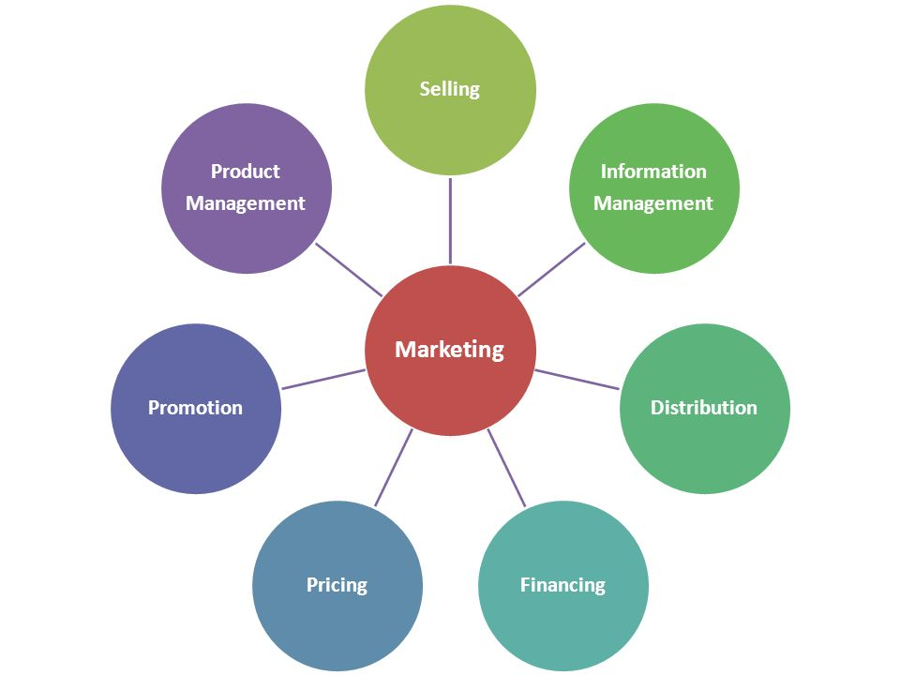

The Seven Functions of Marketing
When applying marketing, there are seven functions that pop up in at least one type of marketing tactic. They are as follows:
- Financing
- Information Management
- Pricing
- Product and Service Management
- Promotion
- Selling
- Distribution
1. Financing
The basis for the emergence of business is a good investment. The company must have sufficient financial resources to advertise their product. As soon as the product begins to gain popularity, the company should spend more to make its product easily accessible.
For example
If the company is based on online advertising, the marketing tools will be limited to creating a website to launch its product, etc.

2. Marketing Information Management
This function includes understanding your target audience, which involves understanding the interests of customers, and their needs.

For example
Carrying out customer surveys is one of the most effective ways to understand what your customers think of your company. The company can send a part of its promo-personnel to shopping centres and other stores to interview customers. This information is analysed and helps to develop more efficient business models.
3. Pricing
This is one of the most difficult aspects of marketing. Fixing the price of a product requires extensive market research, since this can lead to large losses of the firm.
Prices are constantly changing. The growth and fall in prices is directly related to the economy of the country and the growth in demand for the product.
For example
Let’s consider a business that sells seasonal vegetables. If the firm is the only one that sells this kind of goods in this territory, then it can afford to set the price above the market prices. In this case, the buyer will have nowhere to go and he will buy this vegetable.
4. Product and Service Management
Product management is the planning of the assortment at all stages of their production. The goal of product management is to create a balanced volume of products in terms of maximizing sales in the longest term.
5. Promotion
This is one of the most important functions of marketing. The goal of promotion is to increase demand and increase brand awareness. Promotion should be seen as an integral part of the marketing complex. Have you noticed that the opening of a new supermarket or store is always accompanied by substantial discounts and promotions? This technique called as an advertising tactic.
For example
A new store can offer one product for free, with the purchase of two identical products. "2+1=1". Or the supermarket can offer a discount on the goods during the first days after the opening. These are effective advertising strategies that attract customers.

6. Selling
The sale depends on how much your product is preferable to people.
For example
You can sell your products directly or indirectly. If you have a store where you sell your own products, you can personally make sure that you have staff that will help customers.
If this is an online sale, then you need to have explanatory brochures for each of the products.
7. Distribution
If talking shortly this is how you plan to distribute your products. You have to understand all the advantages and disadvantages of your company, in order to know how it is more profitable to distribute your products.
For example
A new company that produces handmade items, to create a reputation, will choose a well-known store, in order to earn the trust of customers. As soon as clothes were distributed to a popular boutique, the brand is gaining popularity. After the company has recommended itself, it is possible to switch to the Internet and expand in this direction. Thus, the company will no longer depend on another brand and will open new opportunities for itself.

