Scales of Measurement
Measurement scales are used to categorize and/or quantify variables. This lesson describes the four scales of measurement that are commonly used in statistical analysis: nominal, ordinal, interval, and ratio scales.

Properties of Measurement Scales
Each scale of measurement satisfies one or more of the following properties of measurement.
- Identity. Each value on the measurement scale has a unique meaning.
- Magnitude. Values on the measurement scale have an ordered relationship to one another. That is, some values are larger and some are smaller.
- Equal intervals. Scale units along the scale are equal to one another. This means, for example, that the difference between 1 and 2 would be equal to the difference between 19 and 20.
- A minimum value of zero. The scale has a true zero point, below which no values exist.

Nominal Scale of Measurement
The nominal scale of measurement only satisfies the identity property of measurement. Values assigned to variables represent a descriptive category, but have no inherent numerical value with respect to magnitude.
Nominal scales are used for labeling variables, without any quantitative value. “Nominal” scales could simply be called “labels.” Here are some examples, below. Notice that all of these scales are mutually exclusive (no overlap) and none of them have any numerical significance. A good way to remember all of this is that “nominal” sounds a lot like “name” and nominal scales are kind of like “names” or labels. 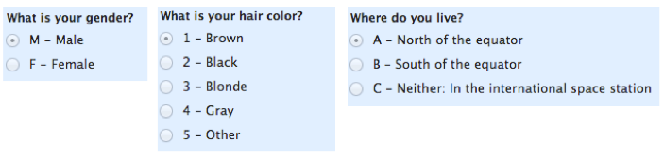

Ordinal Scale of Measurement
The ordinal scale has the property of both identity and magnitude. Each value on the ordinal scale has a unique meaning, and it has an ordered relationship to every other value on the scale.
With ordinal scales, the order of the values is what’s important and significant, but the differences between each one is not really known. Take a look at the example below. In each case, we know that a #4 is better than a #3 or #2, but we don’t know–and cannot quantify–how much better it is. For example, is the difference between “OK” and “Unhappy” the same as the difference between “Very Happy” and “Happy?” We can’t say.
Ordinal scales are typically measures of non-numeric concepts like satisfaction, happiness, discomfort, etc.

Note: The best way to determine central tendency on a set of ordinal data is to use the mode or median; a purist will tell you that the mean cannot be defined from an ordinal set.
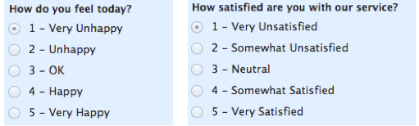

Interval Scale of Measurement
The interval scale of measurement has the properties of identity, magnitude, and equal intervals. A perfect example of an interval scale is the Fahrenheit scale to measure temperature. The scale is made up of equal temperature units, so that the difference between 40 and 50 degrees Fahrenheit is equal to the difference between 50 and 60 degrees Fahrenheit.
With an interval scale, you know not only whether different values are bigger or smaller, you also know how much bigger or smaller they are. For example, suppose it is 60 degrees Fahrenheit on Monday and 70 degrees on Tuesday. You know not only that it was hotter on Tuesday, you also know that it was 10 degrees hotter.

Ratio Scale of Measurement
The ratio scale of measurement satisfies all four of the properties of measurement: identity, magnitude, equal intervals, and a minimum value of zero. The weight of an object would be an example of a ratio scale. Each value on the weight scale has a unique meaning, weights can be rank ordered, units along the weight scale are equal to one another, and the scale has a minimum value of zero.
Weight scales have a minimum value of zero because objects at rest can be weightless, but they cannot have negative weight. Ratio scales provide a wealth of possibilities when it comes to statistical analysis. These variables can be meaningfully added, subtracted, multiplied, divided (ratios). Central tendency can be measured by mode, median, or mean; measures of dispersion, such as standard deviation and coefficient of variation can also be calculated from ratio scales.
Summary

In summary, nominal variables are used to “name,” or label a series of values. Ordinal scales provide good information about the order of choices, such as in a customer satisfy action survey. Interval scales give us the order of values + the ability to quantify the difference between each one. Finally, Ratio scales give us the ultimate–order, interval values, plus the ability to calculate ratios since a “true zero” can be defined.

