Market Analysis-II
Equilibrium, Disequilibrium and Changes in Demand and Supply
Market Equilibrium
- What is Market?
As stated above “Market is set of all actual & potential buyers & sellers of any particular product irrespective of place”
- What is Equilibrium?
Equilibrium is a state in which opposing forces or influences are balanced.
- What is Market Equilibrium?
The situation in which market forces of demand and supply are balanced i.e. market demand is equal to market supply is called market equilibrium. Graphically the point where demand curve and supply curves intersect each other is called market equilibrium.
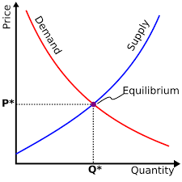
- Market Disequilibrium
The situation in which market forces of demand and supply are not balanced i.e. market demand and market supply are not equal. In case of disequilibrium the following situations may occur:
Shortage: When demand is greater than supply such situation is referred to as Shortage. Graphically shortage can be depicted as follows:
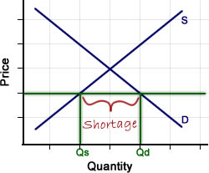
Shortage puts upward pressure on prices.
Surplus: When demand is less than supply such situation is referred to as Surplus. Graphically surplus can be depicted as follows:
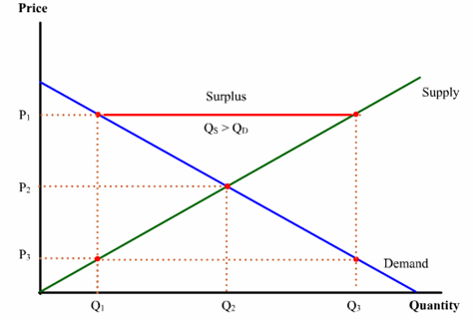
Surplus puts downward pressure on prices.
- Changes in Demand & Supply and their effect on Equilibrium
This topic may be performed in the following steps
- What is the change?
- Either it affects demand or supply or both
- How it affects demand or supply or both?
- How it affects market price and market quantity?

