1
MEASUREMENT OF
METEOROLOGICAL VARIABLES
by
PROF. A. BALASUBRAMANIAN
DEPARTMENT OF STUDIES IN EARTH
SCIENCE
UNIVERSITY OF...

2
Introduction:
Meteorological observations are made for a
variety of reasons. They are used for the real-
time preparatio...

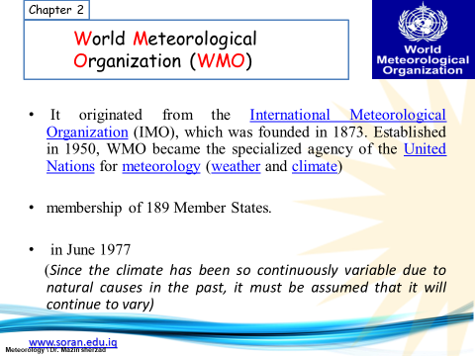

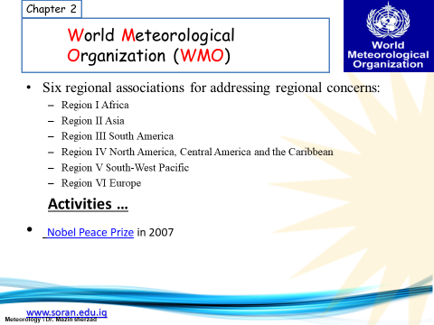

3
These data are required for analysis in
hydrology and agricultural meteorology, and for
research in meteorology and clim...

4
For small-scale or local applications, the
considered area should have the dimensions of
10 km or less.
Meteorological a...

5
The scale ranges of measurements are as
follows:
(a) Microscale (less than 100 m) for agricultural
meteorology, for exam...

6
(e) Planetary scale (larger than 3 000 km), for
example, long upper tropospheric waves
General Requirements of a Meteoro...

7
3. Wind direction and speed
4. Cloud amount
5. Cloud type
6. Cloud-base height
7. Visibility
8. Temperature
9. Relative ...

8
13. Sunshine and/or solar radiation
14. Soil temperature
15. Evaporation .
Instruments are available to measure all of
t...

9
Automatic weather stations
Most of the elements required for synoptic,
climatological or aeronautical purposes can be
me...

10
The ground should be covered with short grass
or a surface representative of the locality, and
surrounded by open fenci...

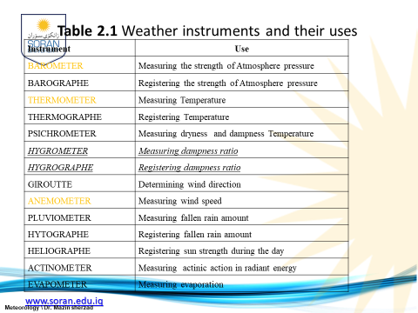

11
Measurement of temperature:
For meteorological purposes, temperatures are
measured for a number of media.
The most comm...

12
The thermodynamic temperature (T), with units
of Kelvin (K), (also defined as âKelvin
temperatureâ), is the basic tempe...

13
(b) The surface of the ground
(c) The soil at various depths
(d) The surface levels of the sea and lakes and
(e) The up...

14
Local temperature also has direct physiological
significance for the day-to-day activities of the
worldâs population.
M...

15
3) by the presence of buildings and other
objects,
4) by ground cover,
5) by the condition of, and changes in, the
desi...

16
Such information is known as metadata (data
about data).
The major equipments used are:
1. Thermometers
2. Liquid-in-gl...

17
Soil thermometers :
For measuring the soil temperatures at depths of
20 cm or less, mercury-in-glass thermometers
are u...

18
Measuring grass minimum temperatures :
The grass minimum temperature is the lowest
temperature reached overnight by a
t...

19
Many RTD elements consist of a length of fine
wire wrapped around a ceramic or glass core.
The RTD wire is a pure mater...

20
Thermometer exposure and siting
Radiation from the sun, clouds, the ground and
other surrounding objects passes through...

21
Measurement of atmospheric pressure
The atmospheric pressure on a given surface is
the force per unit area exerted by v...

22
The basic unit for atmospheric pressure
measurements is the Pascal (Pa) (or Newton
per square metre).
Some barometers a...

23
For meteorological purposes, atmospheric
pressure is generally measured with electronic
barometers, mercury barometers,...

24
Aneroid displacement transducers
The aneroid displacement transducer contains a
sensor with electrical properties (resi...

25
It is cheap, and still delivers a good result.
But it has drawbacksâsignificant power
requirements, low output signal, ...

26
Cylindrical resonator barometers
A cylindrical resonator barometer (or vibrating
cylinder air-pressure transducer) is d...

27
Aneroid barometers
Aneroid barometers have lower accuracy than
mercury barometers.
These are compact and portable equip...

28
Bourdon-tube barometers
Bourdon Tubes are known for its very high
range of differential pressure measurement in
the ran...

29
Automatic digital barometers
Automatic digital barometers make use of a
combination of sensor and microprocessor
techni...

30
The outcome of most of the sensors, however, is
temperature dependent.
So inside most of the devices the temperature of...

31
The most frequently used quantities in
humidity measurements are as follows:
Mixing ratio:
It is the ratio between the ...

32
Dew point temperature :
The temperature at which moist air saturated
with respect to water at a given pressure has a
sa...

33
Vapour pressure:
The partial pressure of water vapour in air.
Saturation vapour pressures :
Vapour pressures in air in ...

34
Humidity measurements
Humidity measurements at the Earthâs surface
are required for meteorological analysis and
forecas...

35
Hygrometers
Any instrument used for measuring the
atmospheric humidity is known as a
hygrometer.
A hygrometer is an ins...

36
Humidity measurement instruments usually rely
on measurements of some other quantity such
as temperature, pressure, mas...

37
The psychrometric method
The measurement of atmospheric humidity is
an important requirement in most of the areas of
me...

38
Sorption methods
Certain materials interact with water vapour and
undergo a change in a chemical or physical
property t...

39
Measurement of surface wind :
Wind velocity is a three-dimensional vector
quantity with small-scale random fluctuations...

40
c) for the estimation of wind energy, and as part
of the estimation of surface fluxes.
For nearly all applications, it ...

41
Averages over a shorter period are necessary for
certain aeronautical purposes.
Wind direction should be reported in de...

42
Cup and propeller sensors are commonly used
for this measurement. these are called as wind
vanes. For the purpose of ob...

43
2) Sonic anemometers Hot-disc anemometers
are recently developed solid-state instruments
3) Hot-wire anemometers
4) Rem...

44
Open terrain is defined as an area where the
distance between the anemometer and any
obstruction is at least 10 times t...

45
There should at least be a map of the station
surroundings within a radius of 2 km,
documenting obstacle and vegetation...

46
Measurement of precipitation :
Precipitation is defined as the liquid or solid
products of the condensation of water va...

47
The total amount of precipitation which reaches
the ground in a stated period is expressed in
terms of the vertical dep...

48
The common observation times are hourly,
three hourly and daily, for synoptic,
climatological and hydrological purposes...

49
Rain gauges are the most common instruments
used to measure precipitation.
Point measurements of precipitation serve as...

50
The commonly used precipitation gauge
consists of a collector placed above a funnel
leading into a container where the ...

51
Recording precipitation gauges/Weighing-
recording gauge
Tipping-bucket gauge/ Measurement of dew,
ice accumulation and...

52
Measurement of ice accumulation
Ice on pavements:
Sensors have been developed and are in
operation to detect and descri...

53
Measurement of snowfall and snow cover
Snowfall depth:
Depth measurements of snow cover or snow
accumulated on the grou...

54
Snow pillows:
Snow pillows of various dimensions and
materials are used to measure the weight of the
snow that accumula...

55
The greater the water equivalent of the snow,
the more the radiation is attenuated.
Measurement of radiation :
The vari...

56
To analyse the properties and distribution of the
atmosphere with regard to its constituents, such
as aerosols, water v...

57
Radiation quantities may be classified into two
groups according to their origin, namely solar
and terrestrial radiatio...

58
97 per cent of which is confined to the spectral
range 290 to 3 000 nm is called solar (or
sometimes shortwave) radiati...

59
For a temperature of 300 K, 99.99 per cent of
the power of the terrestrial radiation has a
wavelength longer than 3 000...

60
In meteorology, the sum of both types is called
total radiation. In the past, several radiation
references or scales ha...

61
Direct solar radiation is measured by means of
pyrheliometers, the receiving surfaces of which
are arranged to be norma...

62
Meteorological radiation instruments are:
Absolute Pyrheliometers,
Pyranometer,
Sunphotometer
Spectral direct solar irr...

63
Measurement of global and diffuse sky
radiation
Broadband sensors
Narrowband sensors
Spectroradiometers
Parameters:
1. ...

64
5. Radiance,
6. Radiant exposure & Intensity,
7. Quantity of light- Luminous flux &
Exitance,
8. Light exposure,
9. Ill...

65
Measurement of sunshine duration:
The term âsunshineâ is associated with the
brightness of the solar disc exceeding the...

66
The physical quantity of sunshine duration (SD)
is, evidently, time. The units used are seconds
or hours.
For climatolo...

67
One of the first applications of SD data was to
characterize the climate of sites, especially of
health resorts.
This a...

68
Measurement methods
Pyrheliometric method
Pyranometric method
Campbell-Stokes sunshine recorders
Specially designed mul...

69
Scanning method:
Discrimination of the irradiance received from
continuously scanned, small sky sectors.
Measurement of...

70
However, the estimation of visibility is affected
by many subjective and physical factors.
Visibility, meteorological v...

71
Luminous flux (symbol:
F (or Î¦); unit: lumen) is a quantity derived
from radiant flux.The meteorological visibility
or ...

72
Meteorological visibility in daylight and at
night.
Visual estimation of meteorological optical
range
A meteorological ...

73
Instrumental measurement of the
meteorological optical range
Visual extinction meters
Transmissometers
Visibility lidar...

74
Measurement of evaporation(Actual)
evaporation: Quantity of water evaporated from
an open water surface or from the gro...

75
Potential evaporation (or evaporativity):
Quantity of water vapour which could be
emitted by a surface of pure water, p...

76
It includes evaporation from the soil and
transpiration from the vegetation from a specific
region in a specific time i...

77
Factors affecting the rate of evaporation from
any body or surface can be broadly divided into
two groups, meteorologic...

78
The wetted surfaces are either porous ceramic
spheres, cylinders, plates, or exposed filter-
paper discs saturated with...

79
Exposure of evapotranspirometers
Measurement of soil moisture
Soil moisture is an important component in the
atmospheri...

80
Water budgeting for irrigation planning, as well
as the actual scheduling of irrigation action,
requires local soil moi...

81
The basic technique for measuring soil water
content is the gravimetric method.
Unfortunately, gravimetric sampling is
...

82
Soil water content:Indirect methods
The capacity of soil to retain water is a function
of soil texture and structure. W...

83
Radiological methods:
Two different radiological methods are
available for measuring soil water content.
One is the wid...

84
The prevailing methods are:
a) Neutron scattering method, b) Gamma-ray
attenuation.
Soil water dielectrics-
Tensiometer...

85
Tensiometers are simple instruments, usually
consisting of a porous ceramic cup and a sealed
plastic cylindrical tube c...

86
Resistance blocks:
Electrical resistance blocks, although
insensitive to water potentials in the wet range,
are excelle...

87
The most common block materials are nylon
fabric, fibreglass and gypsum. This method
determines water potential as a fu...

88
Measurement of upper-air pressure, temperature
and humidity
Measurement of upper wind
Present and past weather; state o...