ROLES AND PROBLEMS OF
AGRICULTURE
Instructor:
Sir.Nasir Singhar
Submitted by:
Rebam Aslam
Rahemeen sheikh
Nadir Ahmed
Maaz...

INTRODUCTION OF AGRICULTURE
• WHAT IS AGRICULTURE?
Agriculture is the practice of cultivating and
farming animals, food an...

Types of Agriculture
• Nomadic Herding
• Shifting Cultivation
• Intensive Subsistence Farming
• Commercial Plantations
• M...

What is crops?
CROPS:
Cultivated plants or agricultural produce, such
as grain, vegetables, or fruit, considered as a
grou...

TYPES OF CROPS
There are two crops season in PAKISTAN namely:
• RABI CROPS
• KHARIF CROPS
 

CASH CROPS OF PAKISTAN
• The crops which are grown in Pakistan in
abundance & earn foreign exchange for the
country are ca...

1. COTTON
• Pakistan is the fifth
largest producer of
cotton in the world.
• The third largest
exporter of raw cotton.
• C...

2.WHEAT
• It is the second largest
cash crop of pakistan.
• It is essential for food.
• It contributed 14.4% to
value adde...

3.RICE
• It is the third largest crop
after cotton and wheat.
• Highly valued cash crop
• Types of rice in Pakistan:
• Sup...

4.SUGARCANE
• Sugarcane serves as a
major raw material
• It share in value added
in agriculture is 3.5%
• Through which we...

5.FRIUTS AND VEGETABLES
• Most of the fruits and
vegetables pakistan export
to other
counties.INDIA,USA,CHINA
and SAUDI AR...

SOILS OF PKAISTAN
14.7
11.4
6.6
5.85.2
30.6
hilly sandy soil
loamy calvey soil
rockop out-crop soil-very
shallow
mainly lo...

0
10
20
30
40
50
60
70
information
techonology
business agriculture
Series 1
Series 1
 

MAJOR PROBLEMS OF
AGRICULTURAL SECTOR OF PAKISTAN
 

Problems of Agriculture After the
Independence
Of Pakistan
 

Problems of Farmer’s Living
 

Given land to farmer
 

TECHNO-ECONOMIC PROBLEMS
 

Limited Cultivable Area
http://gmopundit.blogspot.com/2013/12/bt-cotton-damage-control-and-optimal.html
 

Water Logging and Salinity
 

Golden Era of Pakistan
 

Low Per Hectare Yield
 

Inadequate Infrastructure
 

Uneconomic Land Holdings
 

Old Methods of Production
 

NATURAL PROBLEMS
 

Various Plant Diseases
 

Natural Calamities
 

Storage of Water
 

SOCIO-ECONOMIC PROBLEMS
 

Joint Family System
 

Illiteracy and Ill-health
 

Political Instability
 

FINANCIAL PROBLEMS
 

Lack of Credit
 

Poor Financial Position of Farmers
 

Govt must control fertilizers prices:
 

Comparison
Pakistan Developed Countries
 

MEASURES TO REMOVE
THESE PROBLEMS
• Following measures are suggested to improve
the agriculture:
1) Supply of Agriculture ...

2) Water Logging and Salinity Control
Water logging and salinity destroys about
one million acre of land every year in Pun...

4) Provision of HYV Seed
High yielding variety seed is not available
at suitable price in Pakistan. So, farmers have to de...

6) Agricultural Research
Agricultural research is compulsory
to remove the backwardness of agriculture
sector. Major agric...

8) Tax Concessions
Mechanization is necessary to remove
the problems of agriculture sector.
Government should give tax con...

10) Prices of Agricultural Productivities
Sometimes, our farmers receive low prices of their crops. There is
no proper eff...

• Being an agrarian country,agricultural sector of PAKISTAN’s economy is still
backward.use of modern techniques,provision...

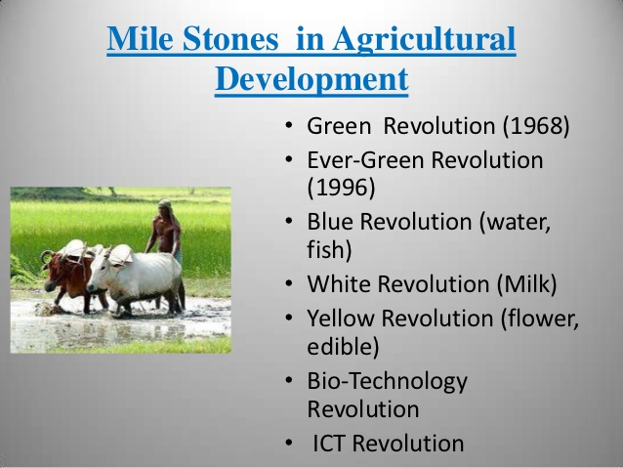

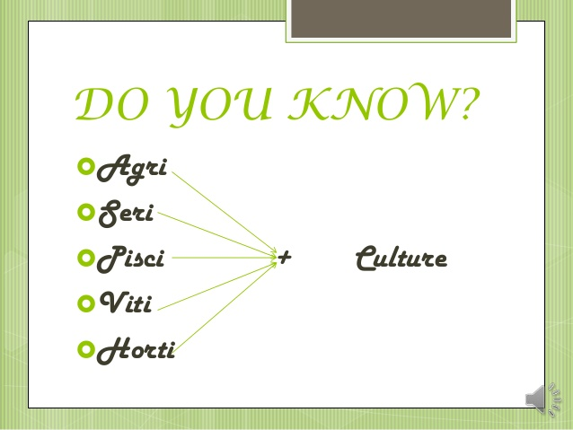

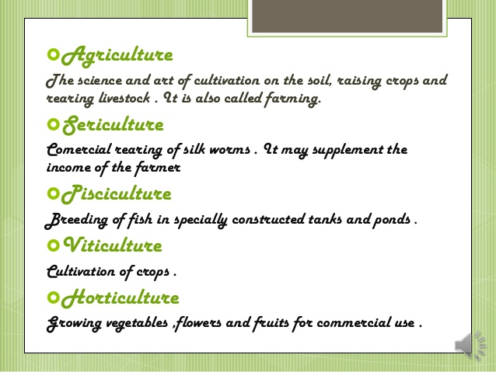

nomadic herding .
•Shifting cultivation : Shifting
cultivation is practised in thickly
forested areas of Amazon basin ,
tr...

is practised in the semi-arid and arid
regions of Sahara , Central Asia and some
parts of India like Rajasthan and Jammu
K...

farming , mixed farming &
plantation agriculture .
Commercial grain farming : In it
crops are grown
for commercial purpose...

Plantation Agriculture : Plantation
is a type of commercial farming
where single crop of tea , coffee ,
cashew , etc . Lar...