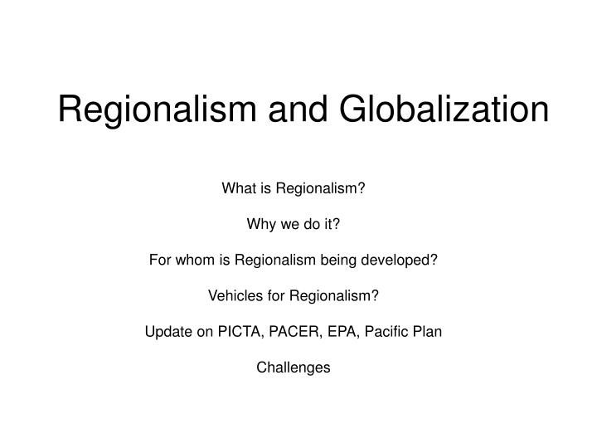

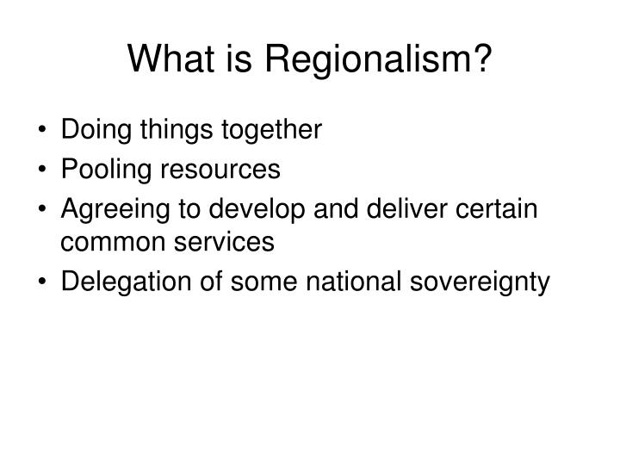

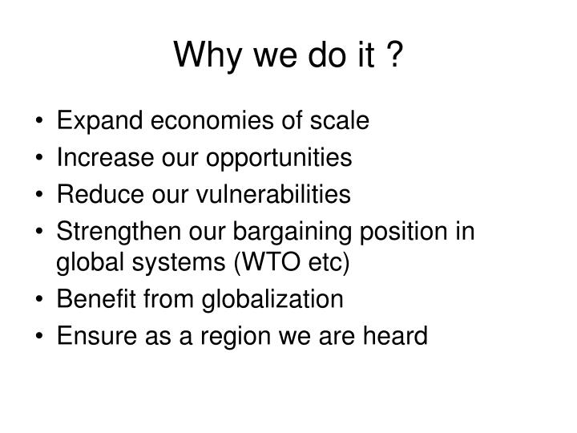

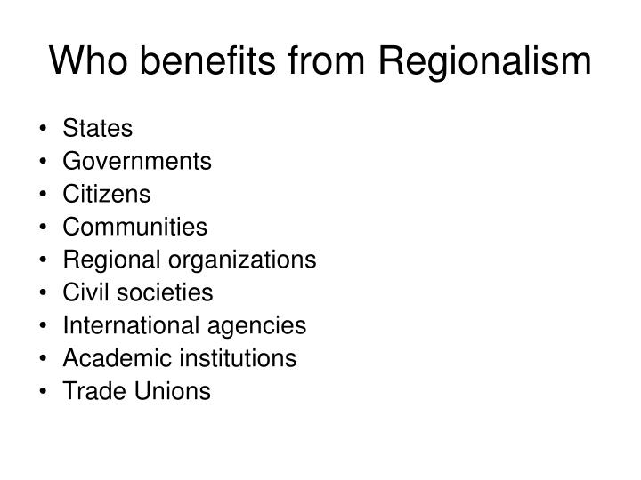

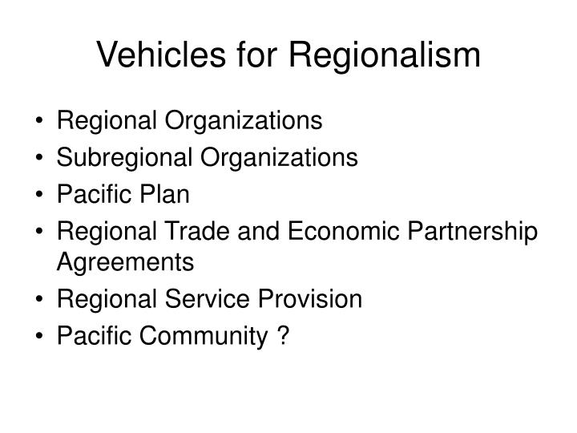



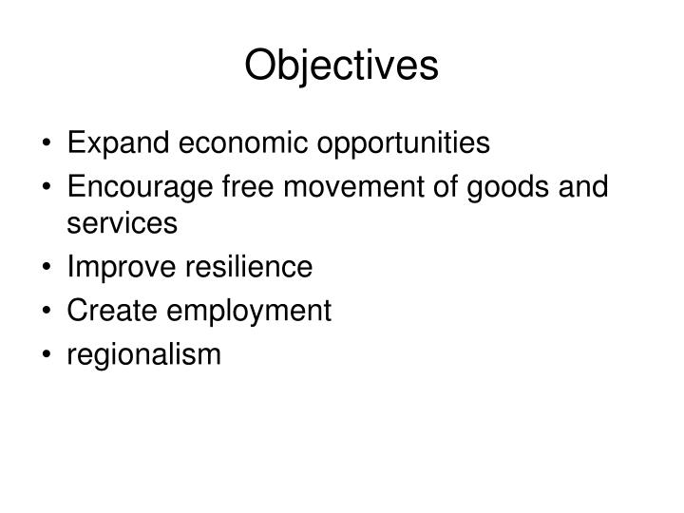







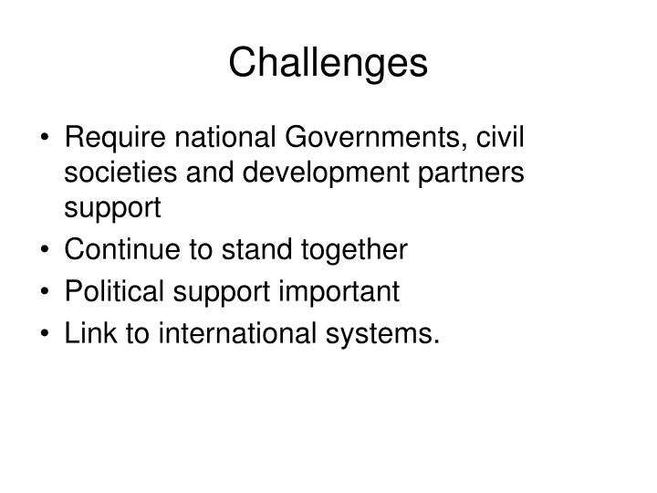

Region is one of the most fundamental concepts in
Geography. which has been defined differently by
different geographers. ...

Regionalism also known as sub-nationalism, is a
concept of political geography. It is a movement
which seeks to politicize...

 Regionalism may help in overcoming and solving

some of the socio-political and economic problems
of its supporter, but ...

 This type of sub- nationalism has posed some

serious problems to India, like that of Punjabiat
and Kashmiriat. What eve...

Regionalism in geography has for a long time been
recognized as a form of classification, but not until
the late 1950s was...

 In terminology of science, the objects being

classified are called the Individuals, and the totality
of individuals und...

 On the basis of the selected

classes

differentiating characteristic,
individuals are initially grouped
Set of classes ...

 Regionalization is akin to scientific procedures of

classification and division, the principles of
classification and d...

 There exist differences in kind between objects ;

objects which differ in kind shall not easily fit into
the same syste...

 Classification are not absolute : they require to be

changed as new information becomes available
about the object bein...

 Classification of any group of objects should be

based upon properties of those objects. In other
words, the differenti...

 When dividing, the division should be exhaustive,

and the classes formed should exclude each other. In
the case geograp...

Thus, a system of climatic regions can logically be
based upon variations in annual and seasonal incidence
of rainfall, or...

 For geographers, regionalism may be a good area

for research, especially to identify the basis of
regional strong biasn...