Project report (Group#04) BS BOTANY Regular 2nd Semester
Course Name:
Citizenship Education and Community Engagement
Project Titles:
- Free Home Tuition and Awareness of safety measures of COVID-19 to Childern
- Planation
- Helping Daily Wagers in CM Usman BusdarInsafImdad Package
Submission Date:
07 june 2020
Group Members
- Maheen Gul
- Mohammad Owais
- Rehaa Hussain
- Farah bibi
- Sokaina Shehzad
- NajamUl Hassan
Submitted to:
Respected MehlahJabeen
Session:
2019-2020
Department:
Department of Biological Sciences

University of Sargodha Sub Campus Bhakkar

Project #01
Title of the project
Helping daily wagers in CM busdar Insaaf imdad package
2) INTRODUCTION:
2.1) Background of the problem:
Coronavirus disease caused by severe acute respiratory syndrome coronavirus 2.First confirmed case of covid-19 traced back to november17, 2019 in Wuhan, China. On 31 december2019, the World Health Organizationwas informed of a cluster of cases of pneumonia of unknown cause detected in Wuhan, Hubei province, china. Then it broke out many other countries resulting in an ongoing pandemic. On 10 January 2020, the first novel coronavirus genome sequence was made publicly available. By 20 January there were reports of confirmed cases from three countries outside china; Thailand, Japan and South Korea. As of 25 March 2020,150 countries worldwide are effected. As of 15 April 2020 all countries started to adjust their response measures. Its first two cases in Pakistan were reported on 26 February which one was in Sindh when a student in Karachi tested positive and second patient was from federal territory of country.Both patients had recently returned from Iran. Zafar Mirza, the prime minister’s special assistant on health stated in a tweet.
“I can confirm first two cases of coronavirus in Pakistan”
By 18 march cases had been registered in all four provinces, the two autonomous territories, and the federal territory of Islamabad. Then, it broke out in whole country.The country put under a nation-wide lockdown until 9 may. On 21 May, the number of positive cases passed 48,000, and death toll reached 1,017, as the number of recoveries reached 14,155. Planning Minister Assad Umar said that Pakistan could test 25,000people a day. (http://www.live science.com)
2.2) Present situation:
As of 28 may, there have been about 61,200 confirmed cases with 20,200 recoveries and 1,260 deaths in the country. Sindh has recorded the most cases at over 24,200 while Khyber Pakhtunkhwa has reported the most deaths in the country, a total of 425. The country was put under a nation-wide lockdown until May which was initiated on 1 April and later extends twice. The lockdown imposed is causing unfold misery to daily wagers and needy people. Daily wagers of our area were not following the lock down due to fear of death with hunger. They were going outside during the lockdown to fulfill their basic needs and nourishment. To helpthese daily wagers and needy people the CMof Punjab Usman buzdar approved chief ministers Insaaf imdad package worth’s RS 4000 for three months will be given to 2.5 million deserving families. For this package an online application can be installed or a message can be sent to the number 8171. Now people of our areas do not know about this package and do not have android phone to avail them with this package. (http://nation.com .pk)
3)JUSTIFICATION OF PROJECT:
1)Importance of project activity
In order to reduce the number of effected people of Covid-19 in Pakistan a lockdown was imposed in a Pakistan. The lockdown affected daily wagers and other poor people badly. They faced a huge problem of financial resources. During these crises, Insaaf imdad package of Usman Buzdar proved a source of relief. He declared to give 12000 rupees to each and every deserving family of Punjab. Our project was based on this concept that we will help our daily wagers in this crisis by applying on this package for them. So that our community could stabilize itself we will also prove good citizens. (http://.com.pk)
PRACTICAL IMPLICATIONS:
Daily wagers got benefit from our project. We gave their data to government. And government supported them financially indirectly government alsogot benefit from this activity. Initially, daily wagers used to come out from their houses in order to satisfy the hunger their hunger. But due to our effort they got money and financial help. So they followed the rules of lockdown and they stayed in their houses. In this way pressure of increase in number of Covid-19 patients also reduced on government. We all group members also got benefit from this activity. We realized that how we can become good citizen. When we saw that all the helpless daily wagers were receiving their money we felt an untellable happiness. For the first time in our life we feel that we are really very important for our society. Daily wagers got money due to our efforts and they spent this money in buying flour, fruits, sugar, medicines mask and other necessities. To pen off, we helped the two major pillars of country i.e masses (daily wagers) and government. (solaina Shehzad BBTF19BM0021.(2020)
4) OBJECTIVES OF PROJECT ACTIVITY:
When we decided to do this activity our objective was to support daily wagers of our area financially. Actually, poor people were misunderstanding government of Pakistan in the crises of covid-19. They were thinking that their government has no concern for them. Government is doing nothing for them. We realized that if we want to come out of this situation we should show unity as a nation. When we come to know about the package of Usman busdar we thought that it is a chance to unite our poor people at society and create a link between daily wagers and government. And we can overcome this crisis as a nation. And we succeeded much in our objective. After getting money daily wagers followed the lockdown and supported the government. Thus the pressure of patients on medical staff and government in our areas was also reduced. Moreover, we also decided to provide awareness to all those people for which we apply on the package. Due to this awareness people maintained social distance, wear masks and sanitized their hands many times a day. (Maheen gul BBTF19BM001.2020)
PLAN OF ACTION
How did we do this activity?
There are six members in our group. We all possess different localities. So we all made a survey of our area on April 7. And after extending date for application we made a survey again at 13 April for the people who left. We gave awareness about this package and also aware about the Covid-19- we told them it would be very dangerous for them to go outside the home. We make sure that we are there only for their help. We did not want anything. We identified the deserving people and all daily wagers in our areas; we got their exact CNIC number and name and mobile number. We got Mobile number so that we can tell them when they received their amount. We used their correct data and applied for them before them so that they remain satisfied. But before starting our survey we all installed Insaaf imdad application in our android.
We all got more and more information about this package from Google. We got information that hat kind of data should be required in order to apply. We also come to know that we can also send a message to 8171 in order to apply. After collecting the accurate information we made survey. People for those we applied almost 90% of them received the message that they are able for this amount. We inform them about this message that they were selected for this package. We told them that Government purpose for this package is to help u and to keep u at home so u should follow the Government lockdown as they help u. They joy of those were indescribable after receiving this message. First person received his money at 8 May named Gulam Sadiq. We call him and told him about his received amount and guide how he can receive his amount. He was very excited and want to thanks us but we make sure to him it’s our duty and there is no need for thank. And then needy people received their money one after one. We remained with them for guidance. The process of receiving this amount is still continue and we will be with them for aware and guidance. (Farah bibi BBTF19BM003.2020)
Needed resources and source of generation (financial human resources)
We used our android in order to apply for daily wagers. We and also used application “”Insaaf imdad” for confirmation. For this application package we used our pocket money. We also got the help of our family in survey of our area so that we could apply only for deserving people. Our family gave us their precious time. (Najam ul Hassan BBTF19BM041.2020)
Purposed Duration:
First we took a week for the completion of our activity from 3 April to 9 April. When the government extended the date for this package till 19 we took a week more from 13 to 19 April so that we could give more support to needy people.
Each person role in project:
Maheen Gull:
First of all, I made a whole survey of my area in order to find deserving people and daily wagers. I got help of my mother and brother. (Maheen gul BBTF19BM001.2020)
Kosar parveen:
She is my mother. She helped me a lot in finding the families of daily wagers in my area. Due to her help I went to several houses of my area, analyzed whether a family deserves or not, got their exact data which included CNIC number and name phone number. I analyzed about thirty two families in different chaks of jandanwala which were deserving so I applied for them and make sure that I will inform u when they received this amount or a message that they are able for this package.
M. Ahsan:
He is my brother and he better knows the area besides my Mohallahs. He got help of my father. My father guided him to the houses of daily wagers and poor people. He visited their houses aware them about covid-19 and this package. He collected their data, made a list and provided it to me. I applied for those people with the help of my brother. I applied about 22 people with the help of my brother.
After some days I received the message about the capability of many families for this package. I called them and inform them about this package. Almost 13 people have received their amount. When I saw that many of families are following the lockdown and receiving this amount I realised that I had achieved the aim of my activity.(Maheen gul BBTF19BM001.2020)
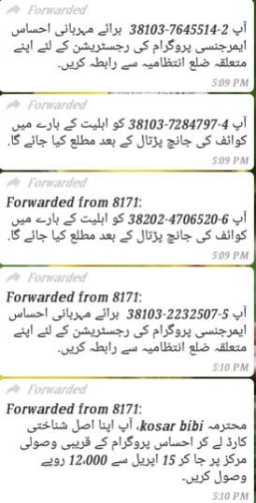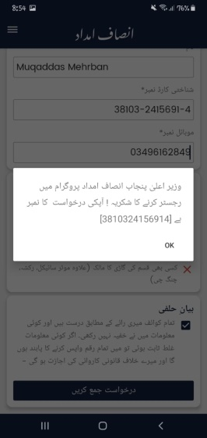
Farah Bibi:
I did this activity with the help of my two persons.
- My elder sister (Aneela parveen)
First of all, she guided how I should do this activity. He also helped me in analyzing the deserving families and daily wagers in my own Chak for this package. He also went with me when I made a survey in my area and also for the time of data collection.
- My father (Inayat ullah)
My father helped me so much in this project. He collected the data from different chaks for me. He collected the data from 205TDA, 209TDA and from Dostwala. He made a list of those people including their CNIC, mobile number and their names and locations.
First of all, I went to three Mohallahs of Chak no.208 at April 7 to 12 April. I give complete information about this package and show them proves so that their satisfaction could achieve. Then I collect their data i.e CNIC, mobile number and names. I applied for the 23 families in this package. I did all this work before them so they remain satisfied. My father provided me the list of 22 families. I also applied for them with the help of my sister. There were 45 families for which applied and 21 families were selected for this package, and 16 families have received their amount at different days. First family selected for this package has received his amount at 15 May. After that 16 families got their amount on different dates. When I realized that people are happy and satisfied with this help and following lockdown, I felt that I achieved the object of my activity. Farah bibi BBTF19BM003
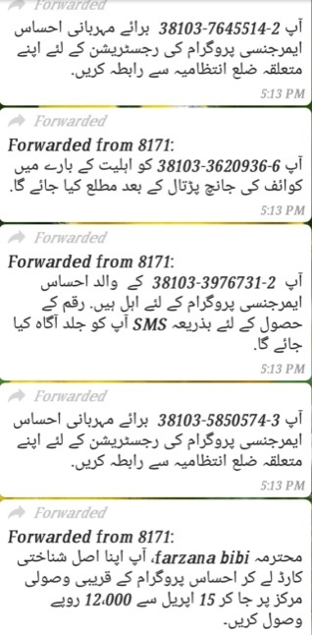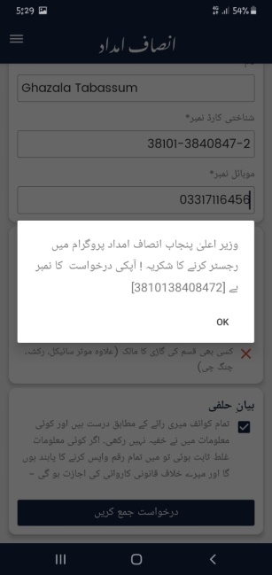
Sokaina Shehzad:
I did this project activity with help of my mother (kneez Fatima) and brother (zeeshan Shehzad). We made a survey of our area. My brother helped me in searching the houses of deserving families. We went to their houses, aware about this package. We collected their data i.e CNIC mobile number and their names. I applied for them in their house before them so that they will be satisfied. I applied about 26 families for this package in duration of two weeks. I also aware them about Covid-19 and convinced them to remain at their houses. I also guided them to wear masks, use sanitizers and maintain social distance. Out of 26 applications 19 families received the message that they are able for this package, and through it I realized that I achieved the aim of my activity to a greater extent. Then at 29 May first family received his amount. I informed them and guide them to get their money and stay home to save their lives. (Sokaina shehzadBBTF19BM021.2020)
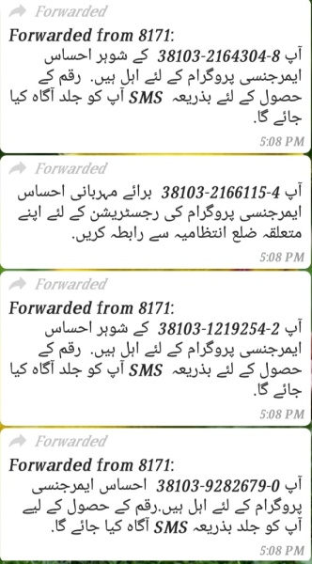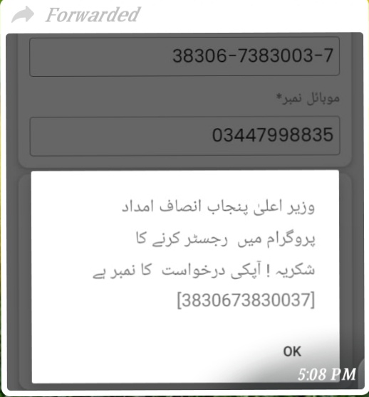
Reeha Hussain:
I go with my elder sister and brother in different home and take a data of them family but some people behave very rudely they do not know any scheme and consider us as we a deceive them it is not false because there are many people in our society that they make a fool with people. And then we give information to these people and sure them that we are ready for your help and we collect their data which includes name, CNIC number and phone number. And apply for them in this package. And tell them that when your massage is arrived then we told them and when there massage is arrived we helped them and told them the whole process to get this money. Many people get advantage from our project. Because many people in our society not educated and they would not be able to get this benefits. I take help of my elder sister and brother because they better knowing the people in our society and have ha technique how to talk with the people and how convenience at our talk. I applied for 24 families in this package. About 22 families got the message that they are able for this package. About 9 families have received their amount and it is a clue for the success of my project. (Reeha Hussain BBTF19BM054.2020)
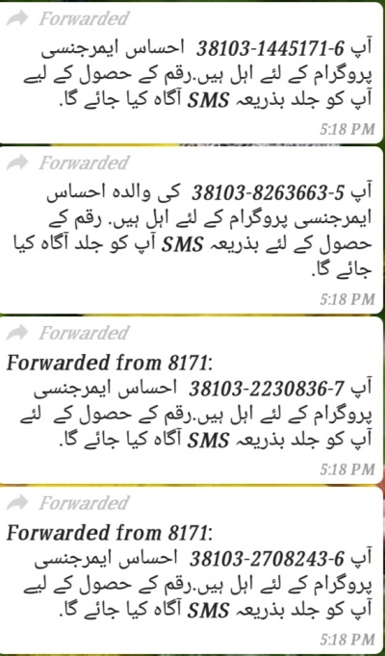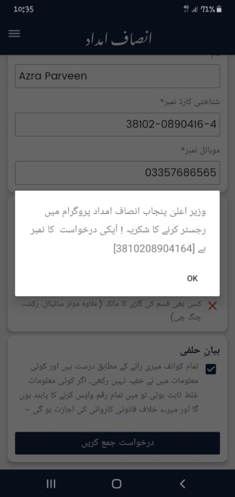
Malik Owais:
I did this activity with the help of my brother because he knows well the needy people and daily wagers in our area. First we reached at home of a needy person and asked him to give I'd card and mobile number so that we apply for ehsas Imdad package. He didn't ready to give his card because he was afraid from us. After this we gave him awareness about this package and then he gave his I'd card and mobile number and then we apply for ehsas Imdad package. In my village many people didn't know about this scheme. We went and told about this and helped them in this regard.And after that I applied for 33 families in this package. I applied for this package before them so that their fear vanished and they will be satisfied. Out of 33 families to whom I applied 23 families was selected for this package. I informed them that they are able for this package and told them to stay at home and they will receive this amount soon. First person in area got his amount on 22 of May. And then one after one 14 families have received this amount. When I saw the joy on the face of these families I was satisfied that I gained the aim of my activity. (M.Owais BBTF19BM046.2020)
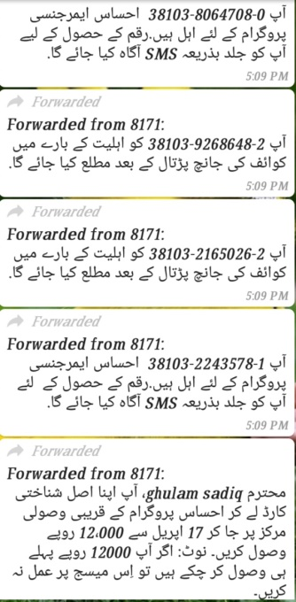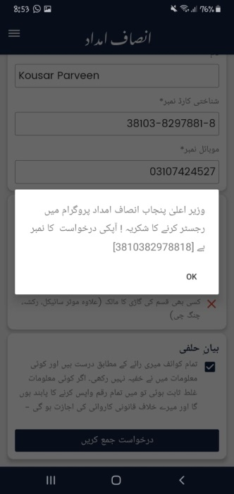
Najm ul Hassan
I did this activity (helping daily wagers in Cm Busdar insaaf imdad package) with the help of my friends (Ahsan Azaq and Zeshan Haider). We were three friends but only two laptops were available. My third friend Zeshan Haider did this on his anroid mobile.We started this activity 07-April (Tuesday) 3:00pm-6:30pm form my own chack 203 T.D.A and applied 14 people`s data. 08 April (Wednesday) we visited chack no 204 T.D.A and applied 24 people`s data. Then, 09 April (thrusday) we visited chack no 206 T.D.A and applied 19 people`s data. Due to my online classes, we could not do this at morning. Both friends helped me a lot in reaching the daily wagers home and other needy people. They also helped me in applying data for this programme. First of all, we askded them to stay at home and not going to the public places. Avoid social contact especially from those who are already sick. If they meet any person then maintain 6 ft distance. Then, we told them that it is a programme launched by CM Busdar to give 12000/= for needy people. We asked them to bring their id cards. During applying their data we used our mobile number, because if we use their mobile number, they were not able to read message because they were totally gentle and uneducated people. We applied almost 57 people. But only 41 of them received amount.
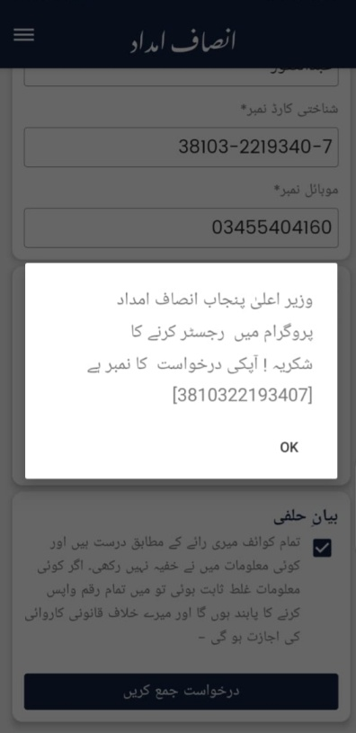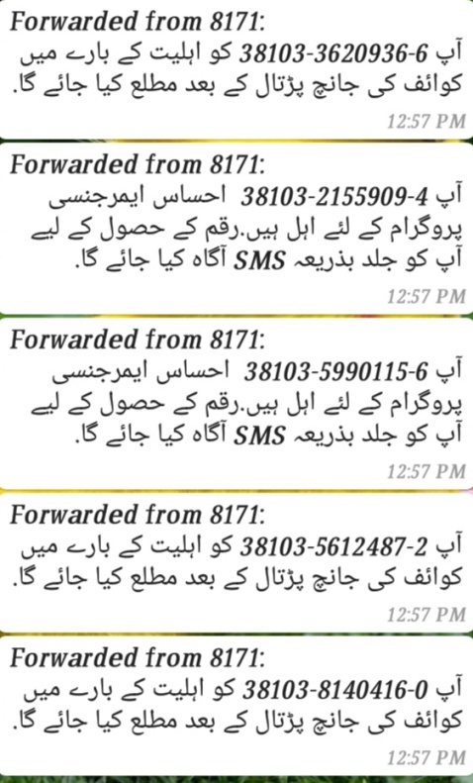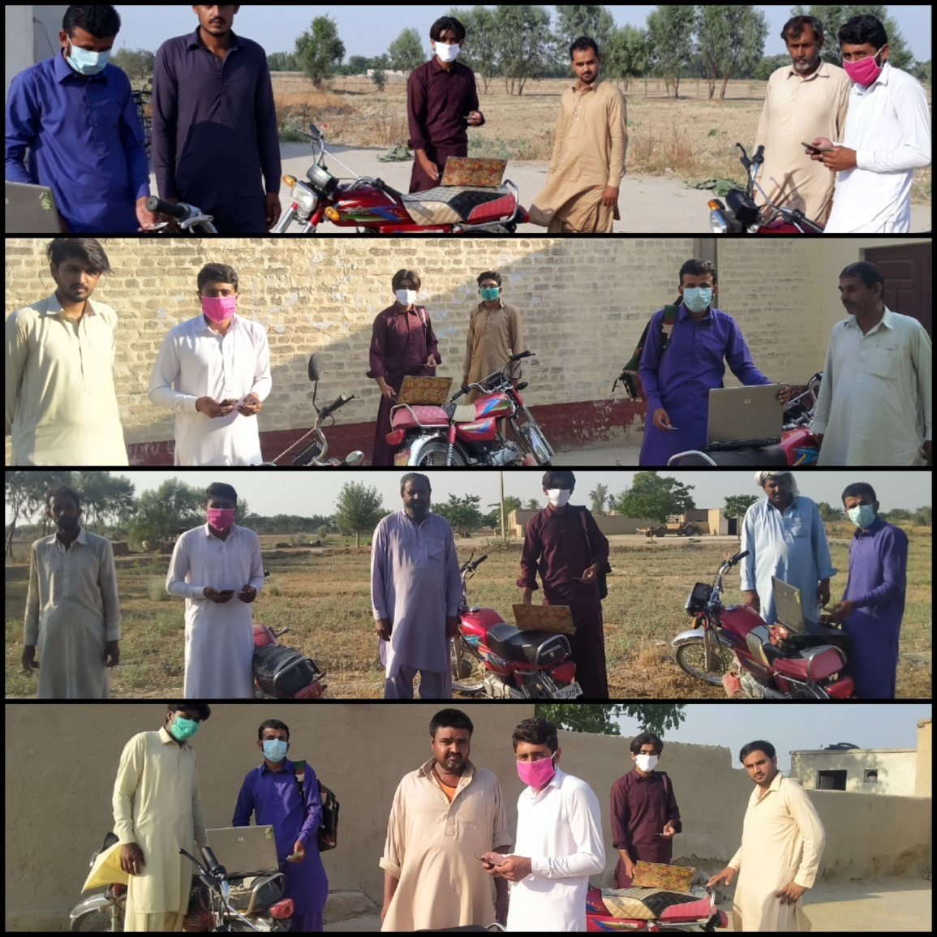
Second part of my this project was to give awareness against covoid-19.First of all I started giving awareness from neighbor who were coming my home again and again during lock down and also those people who were near in my home (check no 23 TDA). I wanted to tell them how much could be dangerous if they were continuing their normal routine like gathering or visiting. I asked them to stay at home. In this way they are not only safe their own life but they safe their whole family but also safe Pakistan. I wanted to tell them to avoid shaking hand with anybody. I thought how can it be controlled? I discuss it with my friends (Ahsan Rzaq and Muhammad Ghaffar). We decided to visit our chack 203 T.D.A and share them some precautions on (23 April – Tuesday). We started our plan from our neighbors. We ask them to stay at home and not going to the public places. Avoid social contact especially from those who are already sick. If they meet any person then maintain 6 ft distance. Observe the symptom in the person around your surrounding and avoid meeting them. They must wash their hand after meeting any person or after 10 mints and when they touch any surface wash their hand. It is better to use hand sanitizer. After using sanitizer avoid to touching your hand to the noise or mouth. Some people asked us about symptoms of this virus. We told them that a person with corona virus has dry cough, tiredness and fever with pain. These symptoms may be different in different people. Due to my online classes, we could not went to them first time, therefore we shared them precautions from ‘’2:30pm-6:20pm’’. 23-24 April (thrusday , Friday), I with my friends( Ahsan Rzaq and Muhammad Ghaffar) visited chack no 203 T.D.A and shared them above mentioned precautions. 25-26 April (Saturday, Sunday) we visited chack no 204 T.D.A and shared them precautions against contagious disease. 27-28 -29 April (Monday, Tuesday, Wednesday) we visited chack no 206 T.D.A and we shared them precautions against covoid-19. We used three bikes to give awareness against covoid-19. (Najam ul Hassan BBTF19BM041.2020)
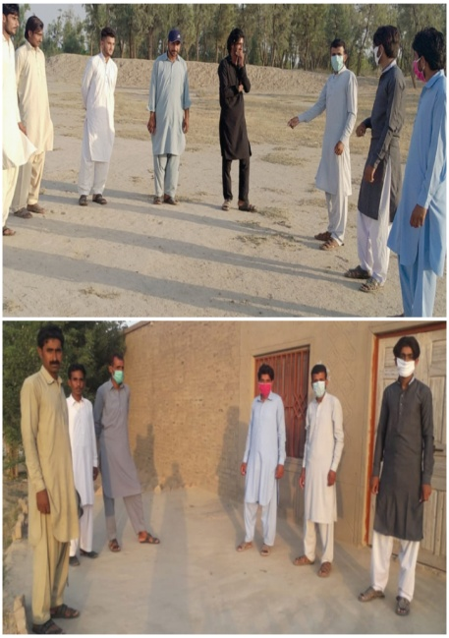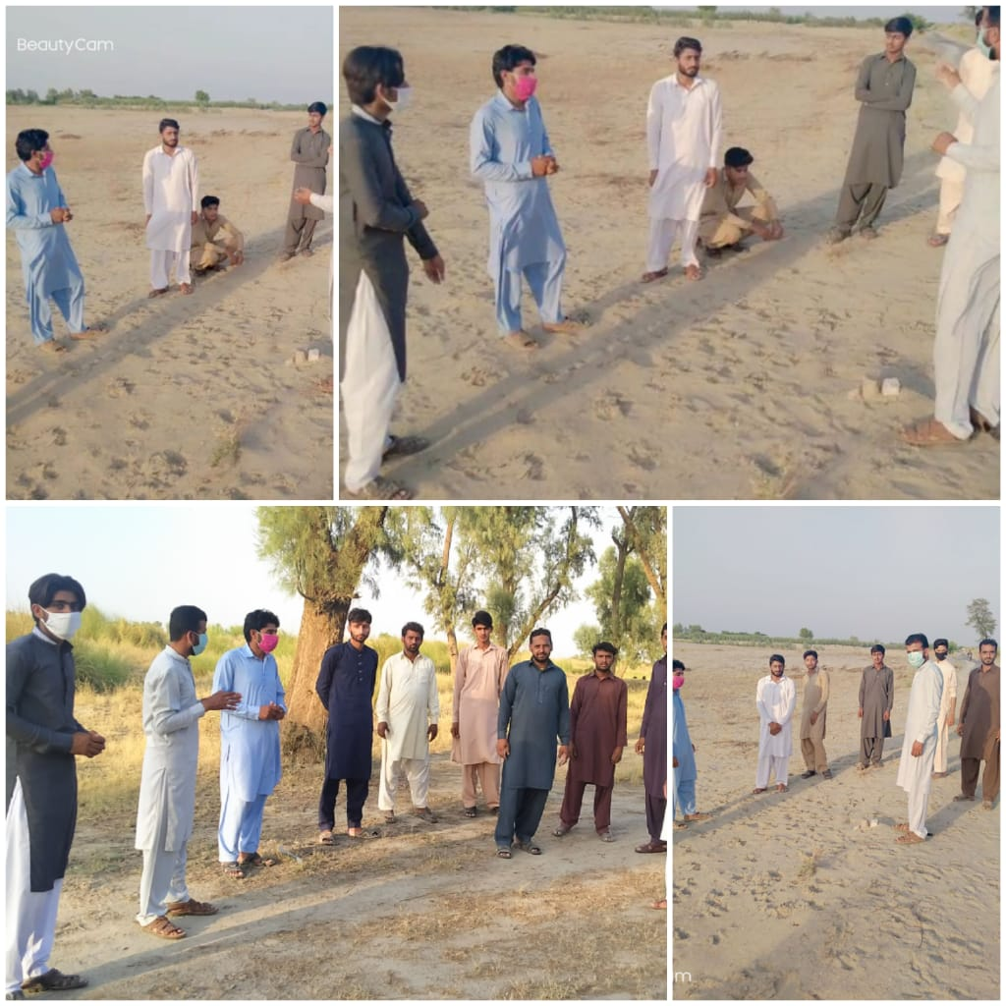

How we evaluate our project for possible outcomes
- First of all, we decided that what actual goal to do this activity is. Main purpose of activity was to help the daily wagers and poor.
- Second we analyzed that what is scope of our project in the crisis of covid-19. And we come to know that this project is of great scope. Because not onlythe needy people of society also whole country is facing a lot of financial problems in this crisis.
- We made a conceptual model of our project. We made a purpose plane that how and when we will visit our area and how we make a survey of our area. We made a sketch to analyze the deserving ones in our area. We visited their houses and took information about their profession, daily income, other supporting members in the family and theirexpenditures. After analyzing this information we applied for them.
- We confirmed the resources that we use in our activity. We ensured that our family members and friends also analyzed the data of the people for whom they are applying. We also confirmed the resources like mobile phone for each member.
- We analyzed the expectation which are expected from our host and deserving ones from us.
- We satisfied the people for whom we applied. We gave them our phone number so that if they want any guideline or confusion they can contact us.
- We kept the timeline in our mind and also decide a day or two for review.
(Maheen gul BBTF19BM003.2020)

Project #02
Title of the project
“Plantation”
2) Introduction:
2.1) Background of the problems:
Plants provide necessary things that are necessary for human beings. The provide food, shelter and also source of fuel. They are the basics for food. They produce oxygen that is essential for human beings. Animals are not able to produce this oxygen. Plants in the form of wood are used in fire and also source of clothing like cotton fiber. They are used in the form of furniture. They also make perfume which is used in equal by the males and females. According to these things that are necessary for life, we started plantation. Wood of trees is used in various factories. This way they can help in our economy. They are also used in making paper, which is used in large quantity In Pakistan and some other countries. They are placed in houses and also outside of offices, in this way they enhance the beauty of our houses and offices. They give coldness to our eyes. They also increase the vision of our eyes. They are also sourcing of food especially some fruity plants, like mango, apple, orange, lemon and banana etc. (http://en.m.wikipedia.org)
2.2) Present situation:
Many people are cutting the plants in a larger quantity. They cut the plants for construction, factories and also in make the land suitable foe cultivation. Ratio of plantation is too much less than cutting plants. They do not think about birds that live on trees and also they do not think about our environment which they are directly damaging by cutting the trees. Furthermore, to avoid soil erosion, to maintain the fertility of soil, we need plants. Today people used fertilizers to increase the production. They forget that plants can maintain the fertility of their soil, in this way they can increase their production. Today population of world is increasing rapidly, for their basics needs, like houses, food clothing, people are cutting trees rapidly.
“Cutting trees is not like cutting your nails but like cutting your breath”
People do not think that only plants are able to clean our environment, and they are essential for life. Now a day’s plants are remaining very less in number. So we should take part in plantation actively. We should maintain the soil fertility of soil and also minimize the soil erosion. By cutting plants, actually people are damaging our climate. Therefore, took decision to do plantation. (http://www.dictionary.com)

3) Justification of project:
(A). importance of project activity:
Plants are very much important for not only human beings but also for all living organisms. they do many function that are essential for our survival. Ayurveda has said,
“No plant of this world is useless”.
Plants provide food (fruits, grains), fiber, shelter, protection, medicine and fuel. The basic food for all organisms is produced by green plants. During the process of food production, oxygen is released. This oxygen, which we obtain from the air we breathe, is necessary for our survival. The only source of food and oxygen are plants; no animal alone can supply these. Shelter, in the form of wood for houses; and clothing, in the form of cotton fibers, are common uses of plant materials. But also plants provide fuel, furniture, paper products, certain medicines like aspirin, and so many other products like perfume and chewing gum etc. we must also add the importance of beauty and relaxation derived from plants. Since animals are surrounded by and dependent upon plants. Terrestrial plants provide residence to wild animals. Plants keep environment clean (by reducing air pollution).
Forests and lawns are considered as unique biotic communities. A community is a naturally occurring, interactive assemblage of plants and animals living in the same environment. The interaction between plants and animals often exists out of the need for food, protection, transportation, and reproduction. Reproduction of some plants is by insects. In this way insects gets pollinators from flowers and plants get help in reproduction process. Plants are not only beneficial for human beings but also they are beneficial for birds. Birds make their nests on the trees. If someone is cutting trees, it means he is killing birds.
They also provide many functions in our daily life. The most common is as reliable provisions of food through agriculture.Plants are used in medicine and provide a number of drugs. These practices are common from the earliest times to the present. All Industrial products like timber, a wide range of chemicals and paper are some examples. Plants also give pleasure through gardening to us.
Plants provide building materials and pharmaceuticals. Plant also decorates our homes, both inside and outside and also beautifies special occasions like weddings and funerals. Some people (living in close area) around the world have grown plants in containers and brought them into their living spaces. Plants and gardening are considered good for people physically, mentally and socially. ( Najam ul Hassan BBTF19BM041.2020)

(B). practical implications:
All the living organisms that are living in our community will get benefit from this plantation activity. As the oxygen is essential for all livings, so plants provide all livings oxygen that is necessary for our survival. Not only this, but they also provide food to animals. Not only human being, but also animals and birds can benefit from this activity. Birds make their nests on the trees. Green colored birds hide themselves in the leaves of plants (due to green color of leaves) when someone is hunting them. Many medicines and fuel (woods) are obtained from plants. They also play important role in protection to many birds and animals that live in forests. Plants also provide keeping the water level. As they also used to reduce noise pollution, so whole community gets benefit from plants. Human response to trees goes well beyond simply observing their beauty. We feel serene, peaceful, restful, and tranquil in a grove of trees. We are “at home” there. Plantation keeps us safe from climate change. The calming effect of nearby trees and urban greening can significantly reduce workplace stress levels and fatigue, calm traffic, and even decrease the recovery time needed after surgery. Insects get nectar from flower of fruity plants. In this way, all human being, birds, insects and animals gets benefit from plantation. (Reeha Hussain BBTF19BM054.2020)
4) Objectives of project:
Main objective of this project was to promote plantation. We took decision of plantation in order to make the environment pleasant. We also thought that by doing such activity, we would be saving from climate change. Another purpose of us was to increase the ratio of plantation as compared to cutting trees. We did this activity to provide the residence place to animals. As plants reduce air pollution, so we did this activity to reduce the air pollution. Another objective of was that, to provide place to birds on which they can make their nests. We did plantation to avoid the soil erosion. Population of the world is increasing day by day; level of oxygen consumption is increasing, to increase level of oxygen we did such activity.(M.owaisBBTF19BM046.2020)
- Plan of action:

1; How will you do this activity?
We are six members in this group. We are located in different areas. Therefore, we did plantation in different areas nearer to our homes. First, we made a round to find that which piece of land is suitable for plantation. And which plants can easily grow in that land. Individually we were not able to do this activity. Therefore, some of our group member got help from their parents and some of them got help from their friends.
“You may not plant millions of trees but if you can take care of single tree with love and care that will make you great”
First of all, we bought plants from nursery. Then took them to field in which we were to do plantation. We dug the soil. Then, placed them plant and closed that ditch. After doing this, we watered those plants with help of small canes. (Mahhen gul BBTF19BM001.2020)

2; Needed resources and source of generation (financial human resources)
We had to buy total 420 perennial plants. To buy these pants some amount was required, that was provided us by our parent. We also used our pocket money to buy plants. Some of our group member got help from their friends in doing plantation. Without the help of our parent and friends we were not able to do this project activity. We also used special equipment to dig the soil like shovel, hoe and trowel. We also used small canes to water the plants. (solaina Shehzad BBTF19BM021.2020)
3; each person role:
1).Maheen Gull
I decided to perform the activity of plantation in my area. For this purpose I needed a financial help. In order to get money I got some help from my sister, brothers and parents. They contributed some money so that I become able to buy plants from nursery. I made a list of plants which I used for plantation. I decided to buy some fruity plants and also some woody and shady plants. In this way I will contribute more and more to my community.
1.1) Muhammad Rafi
He is my brother. He knows the barren areas surrounding me very well. I got his help in plantation of shady and water resistant plants to the barren areas. If somehow water is not continually available then, they can survive to that areas. I planted all fruits bearing plants in the areas nearby the localities. I urged the neighbors surrounding those localities to water those plants at least two times a day. My brother contributed a lot in gaining consent of the neighbors.
Number of plants and their names
I planted almost 70 plants. I planted 20 plants of mulberry, 10 plants of sheesham and 10 plants of neem in barren areas at which were located at distance from the localities. I planted 10 plants of guava, 10 plants of lemon, and 5 plants of orange and 5 plants of oxcimum, in the localities. I am satisfied my activity and I hope that my plantation contributed great to the society. (Maheen gul BBTF19BM003.2020)
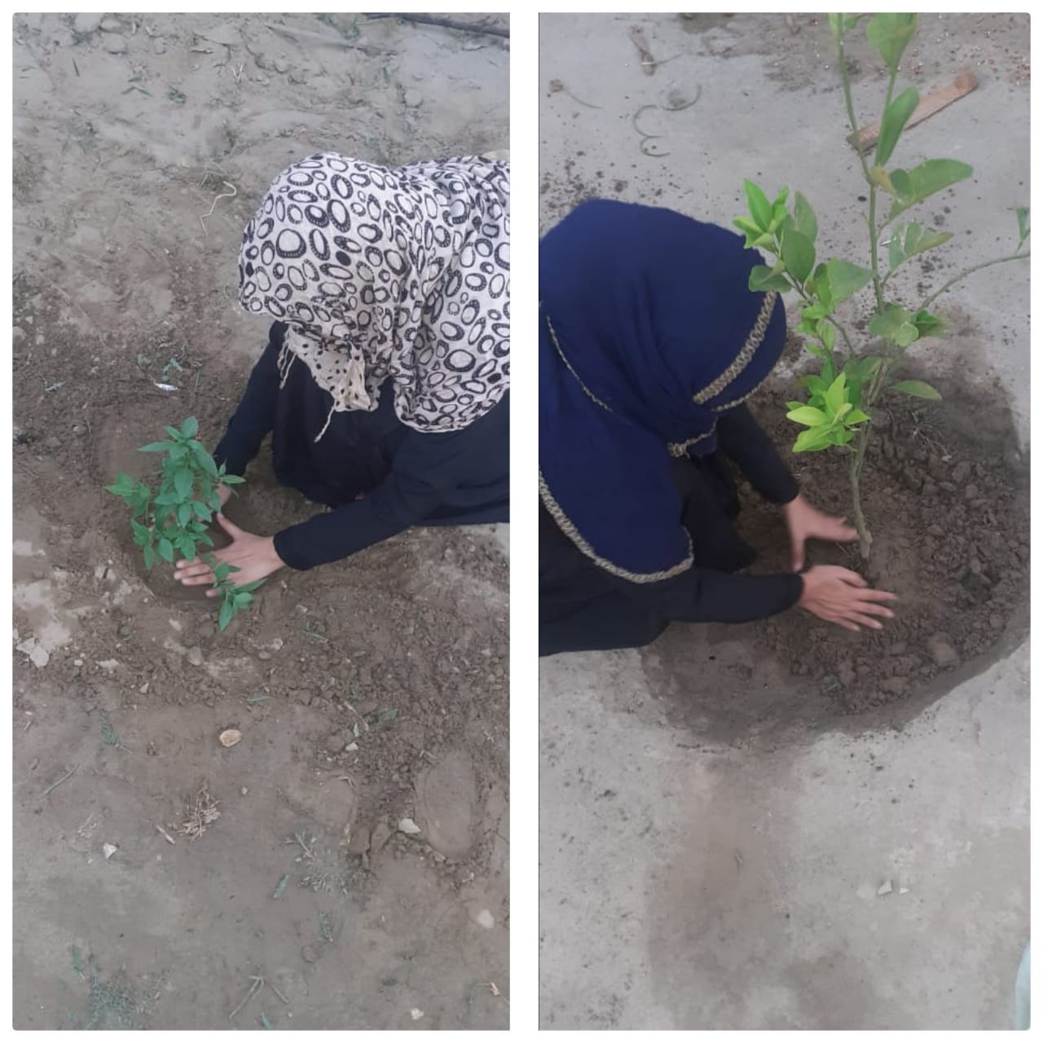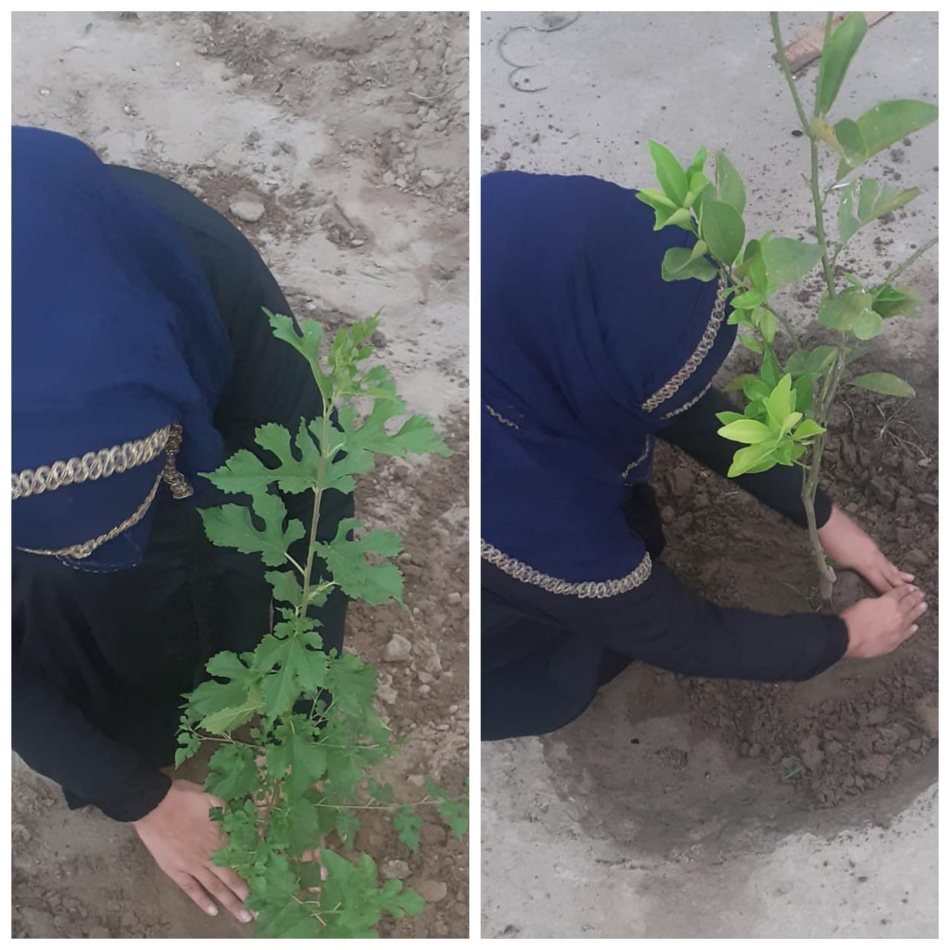
2). Farrah bibi
I did this activity with the help of my father and uncles first of all I declared with the help of my father that I will gain 20 fruit plants and 50 woody plants. I bought 30 plants from nursery and 20 plants by grafting of plants. I started this activity on 20thApril.
2.1) Inayat ullah( father)
My father helped me in selecting plants. He bought plants from nursery. He helped me in planting these plants. He also helped me in selection of best places where was the need of plantation. He also cared these plants and helped me in planting.
2.2) Javed Iqbal (uncle)
My uncle did grafting for me. He told me some good tips for plantation. He helped me in watering and caring plants.
>Farrah bibi
I did plantation in my area with the help of my father and uncle. I daily went to see these plants and watering them because the weather was hon. I did plantation along the road in our area and other places where the people can get more benefits between the lands of two farmers youngsters of my village impressed of my this activity and they asked me that they will help me in caring these plants. They were also happy with the plantation of road when they praised me and helped me in this activity. I realized that I achieved the aim of my activity to some extent. All plants are in good position due to the care of these people and my family. (Farah bibi BBTF19BM003.2020)
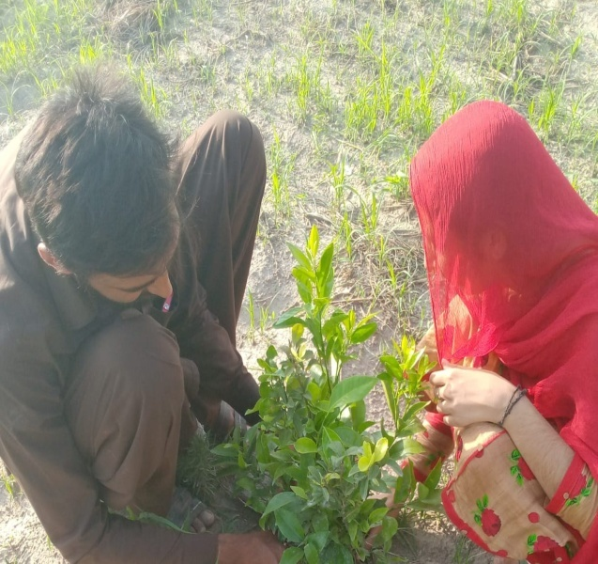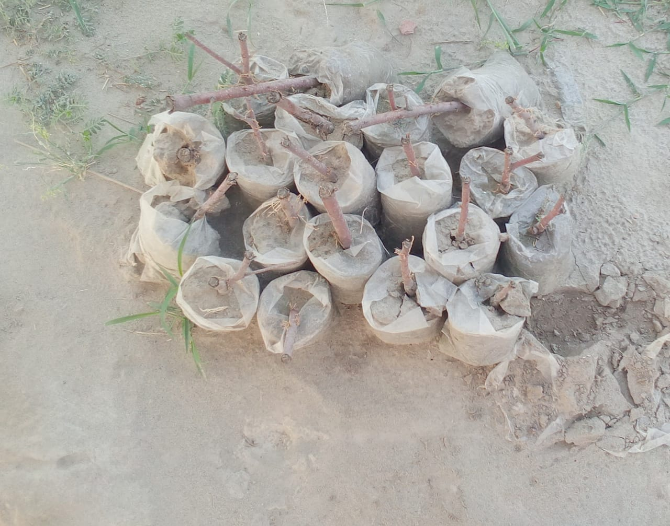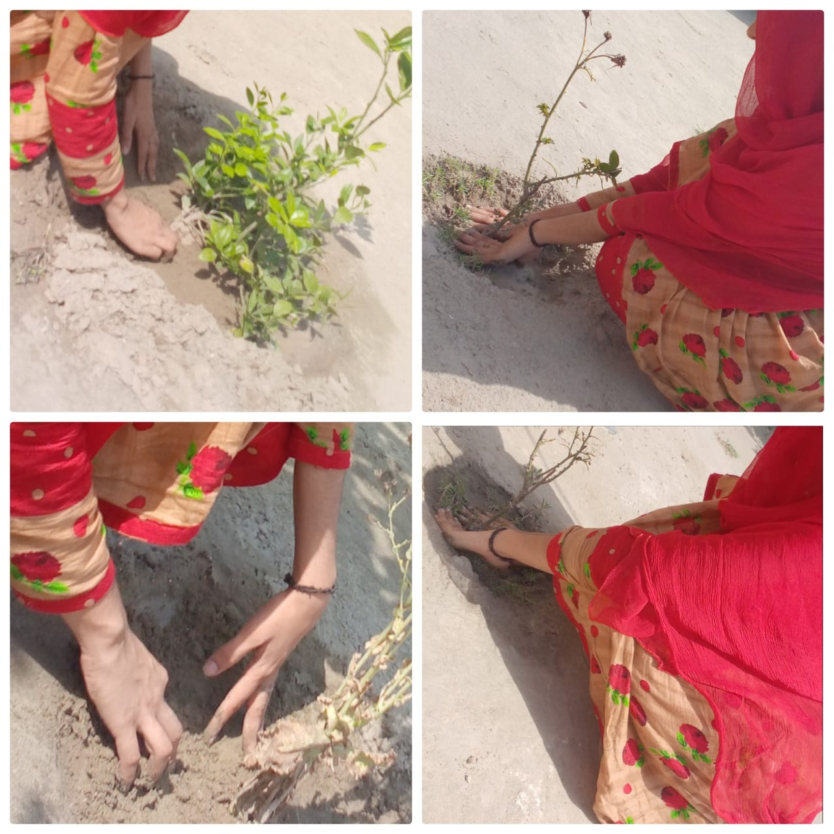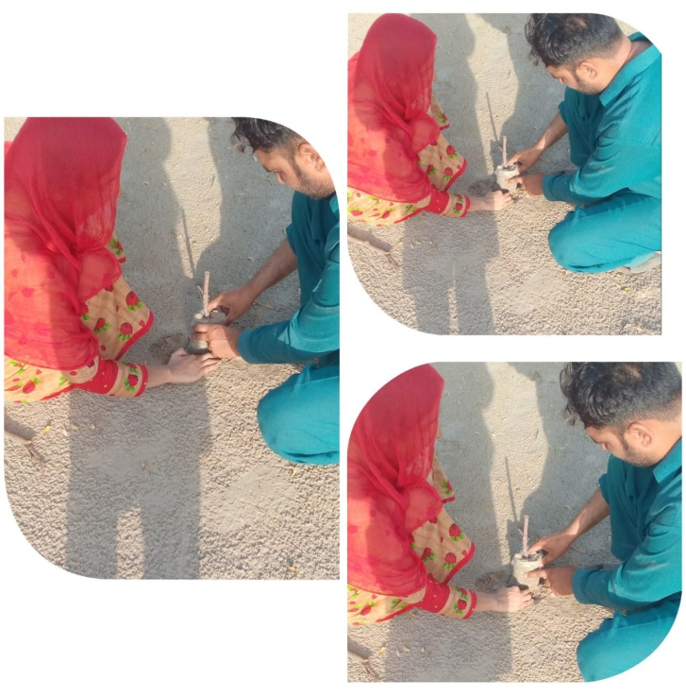
3). Sokaina Shahzad
I did this project activity with the help of my brother ( rana ali) I also took help of my cousin( Rana Hassan).we made a plan of planting 70 trees for this activity we needed a fund my brother and cousin made a survey of our area and they collected fund for this activity. People of my area cooperate with us. They gave us money for plantation with the money of this fund we bought 70 plants we grew these plants in our area. My brother and my cousin helped me a lot in growing trees. My brother better knows the barren land of the area. We made a proper time for watering these plants. We watered them daily. These plants were growing day by day. These plants are increasing the beauty of our environment. We did this project activity for the benefits of the community. When growth of these plants completed they will prove very beneficial for our community. (Sokaina Shehzad BBTF19BM021.2020)
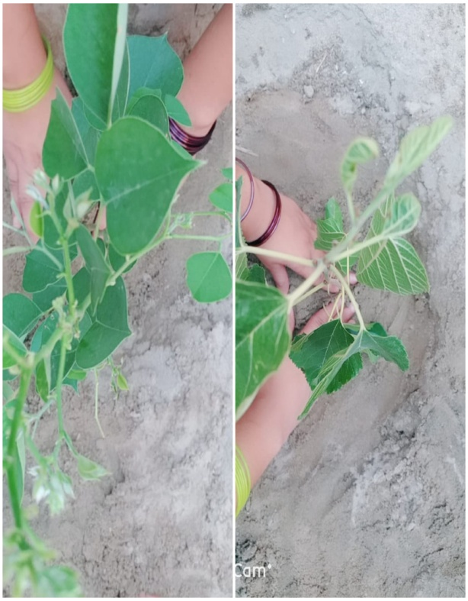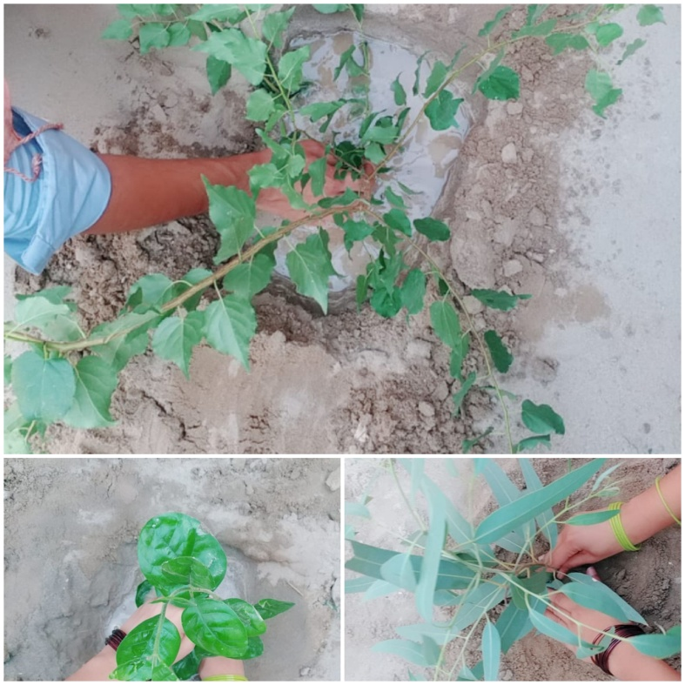
4). Muhammad Owais
I did this activity with the help of my brother. First of all we needed money for buying plants. This money we take from father. We decided to buy plants for plantation. We went at the nursery and bought 70 plants in which many of them were fruit plants and some of them were woody. So we select a proper place in our village for growing fruit plants near our house. we gave them daily water and care of them. And other woody plants we grow at different places. We daily went to these plants and gave water two times in a day due to the weather was very hot in this way the plants grows very rapidly. It is because we take care of these plants. Our main purpose of plantation was that we wanted to give benefit to the community. We satisfied that after the growth of these plants community will get benefits more and more. M.owais BBTF19BM046.2020)
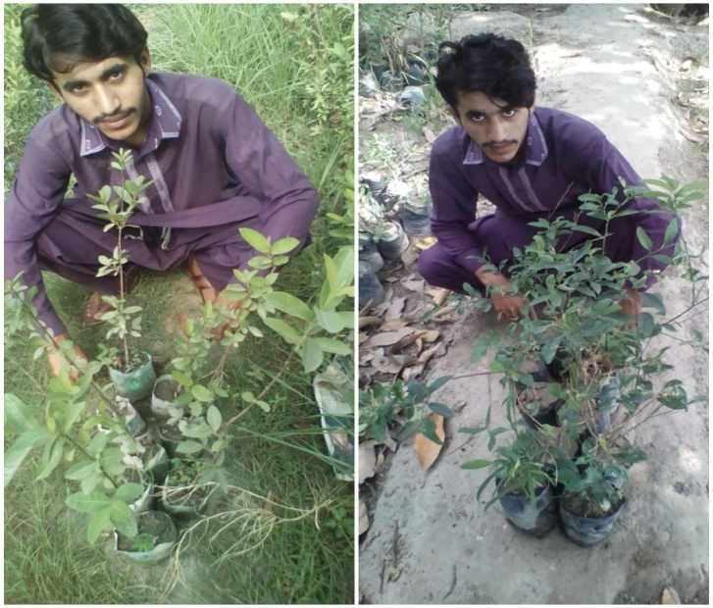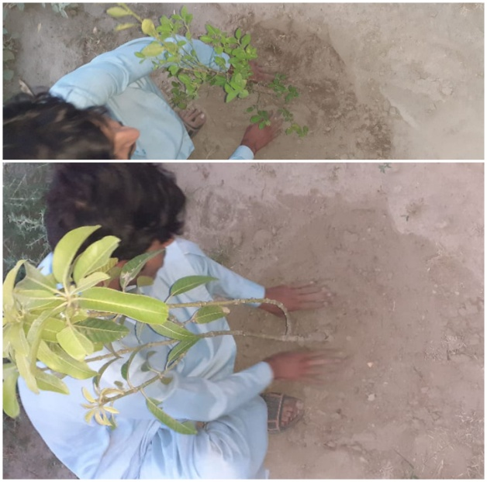
5; Reeha Hussain
I did this activity with the help of my brother and my cousin. They we went to nursery to buy some woody and fruity plants. We bought plants according to the gardener because they better knew that which plants grow in that season, and which plants are suitable for our land. We brought these plants into our home and grafted them with the help of brother and cousin. We gave the basic information to the people that have no idea about information of plants. We grafted some fruity plants that give both shadow and fruits to people. We also planted some woody plants that have greater resistance against the climate change and water storage. After plantation, my brother watered them with small cane. He daily went to them till now to water them and also for their look after. (Reeha Hussain BBTF19BM054.2020)
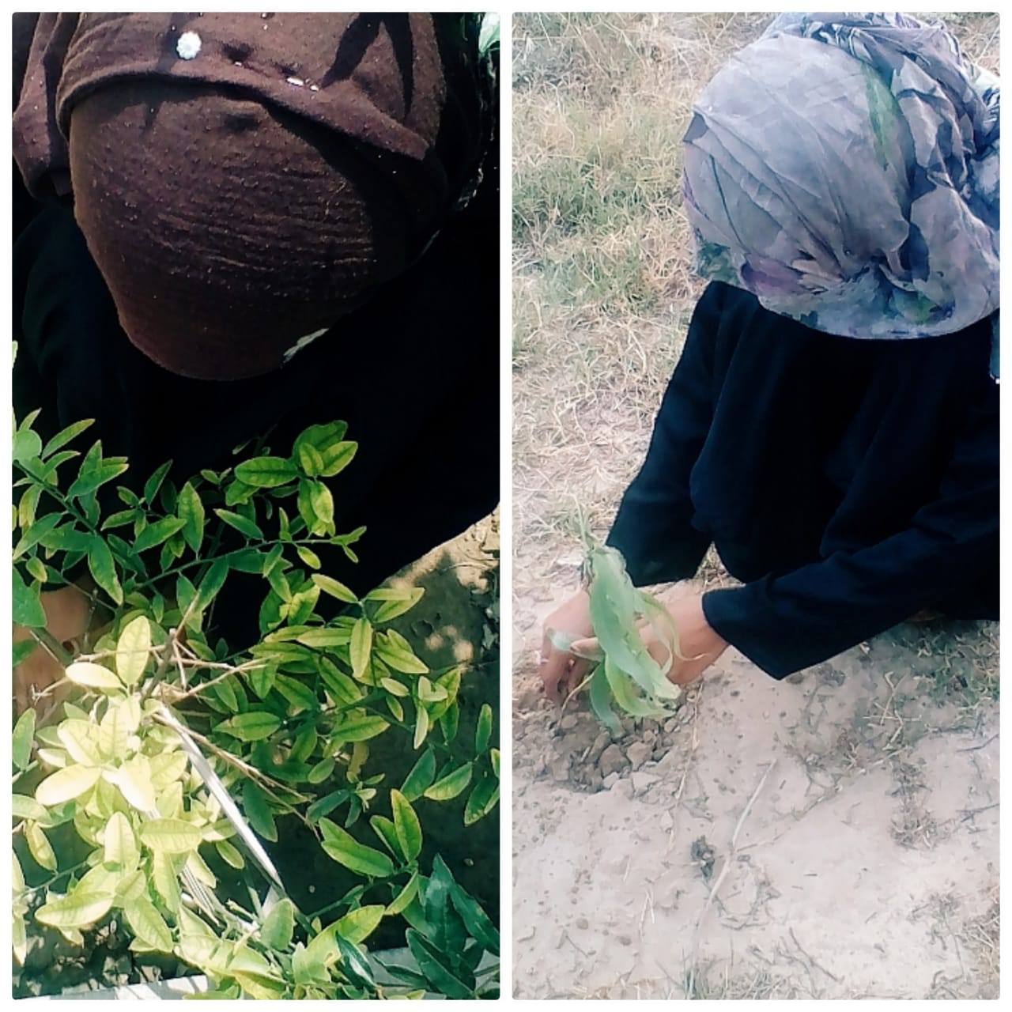
6; Najm ul Hassan
When I was assigned this project, I discussed it to with my father Imam Bakhash and also friend Chahoudhry Usama Riaz and my cousin Muhammad Faheem Baloch. On Friday 15 May 2020, we made survey the land, which was decided by my father for plantation. Because that land was not too much fertile therefore, my suggested to buy safeda plants (this was dessert area) .We fixed a date (16 May 2020, Sunday), when we will do plantation. At fixed day, we went to nursery, which was located at Sray Muhajir and, bought 70/= safeda (eucalyptus) plants. After paying 560/= rupees (08 rupees for single plant), we brought them to that place where we have to do plantation. After this, I started digging the soil with the help of shovel. But my cousin and friend was further curling with their hand that so that plants can easily grow in these ditches. At first we prepared 70 ditches in the field in three rows, which were purely suitable for plantation. We arranged three rows in the fields so that plants can easily grow without interaction with each other. Plants growing in rows also look pleasant.
First of all, I planted 1st plant in that field. Then, my friend Usama Riaz planted seconded plant. After him, next plant was planted by my cousin Muhammad Faheem. In first row, we planted 24 plants. Then we stared plantation in 2nd row. After this we did plantation in 3rd row. In second row, we planted 23 and also 23 plants in third row. When we planted 70 plants, then we watered these plants with the help of three cans. I watered all plants that were planted in 1st row. My friend Usama Riaz watered all those plants that were planted in 2nd row and my cousin watered the 3rd row of plants. After watering all plants we again made a round around those plants in order to note is every plants watered. Then next day 17 May (at 5:30 pm) we again went to those plants for their look after and also for watering them. I with my some other friends ( Choudhry Alian Haider, Ahsan ali, Mhammad Nveed and Akhtar Abbas) daily went to them(still now) at before evening for watering and also for their look after. (Najam ul Hassan BBTF19BM041.2020)
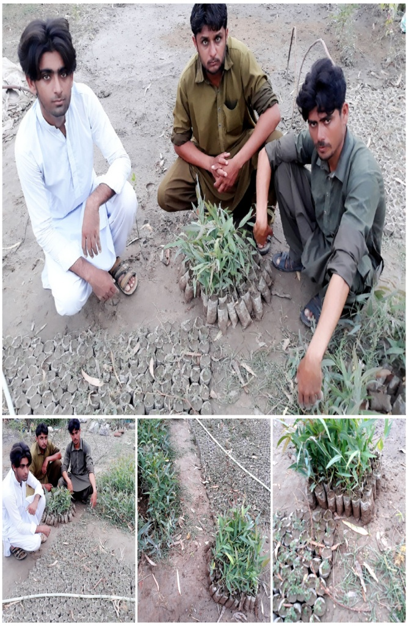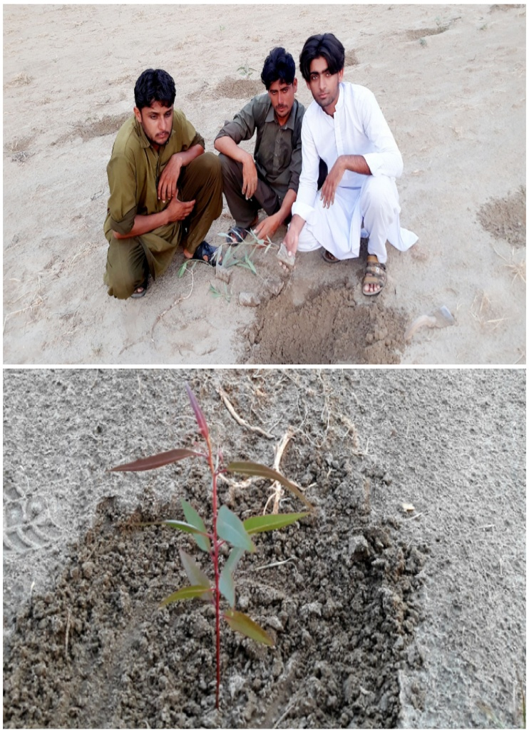

4; proposed duration
We completed our plantation almost in 15 days (06-21 May 2020).
6: How will you evaluate your project for possible outcomes?
After doing this activity, we all were being able to live in a clean environment. After doing this activity we save our environment from climate change, Climate change result as increasing global temperature, loss of life biodiversity of changing of seasons and poor agricultural productivity.
Environment changes greatly in the changes of plantation rate. Deforestation also effected such as volcano eruption, rainy seasons, forestry and nature of earth surface. Chloro Flouro Carbons CFC_{s}, which released things such as refrigerators and AC etc. These chemical decreases the ozone layers and whole are appears on the ozone layer. Plants provide oxygen which fulfills the density plantation decrease level of carbon dioxide and avoid from green house effect with the help of plantation, we were be able to reduce noise pollution. With the help of plants we clean of pleasant our environment. Plants also give wood which is used in many construction or decorations process.
Plants give other temper which is used in many industries. This plantation will give benefits to whole community. Farah bibi BBTF19BM003.2020)

Project #03
Title of the project
Free Home Tuition and Awareness of Safety Measures of COVID-19 to Children
2) Introduction:
2.1) Background of the problem:
First Covid-19 case was confirmed in Wuhan, China on November 17, 2019.
Now every continent of the world was affected by this virus. Millions of cases were diagnosed in our entire world. The disease of corona virus was caused by severe acute respiratory syndrome corona virus 2.
On 10 January 2020, CDC reported 59 cases in China. On 20 January 2020, cases of this virus were reported other than China. These countries are Thailand, Japan and South Korea. On 23 January 2020, the city of Wuhan was locked down. Then on 24 January 2020, first case of this virus was reported in France. On 30 January 2020, the WHO declared this outbreak as “Public health emergency of international concern.”
On 22 February 2020, a number of cases of corona virus reported in Italy. After this corona virus broke out in many countries. The first case of corona virus was reported on 26 February 2020, in Pakistan. This first case was reported in Sindh. A student in Karachi tested positive for this virus.
After this, this virus was spread out in whole country. All provinces of Pakistan were affected by this virus. Then government of Pakistan took an important step. Government imposed lock down in whole country. In this concern all educational institution were closed. It caused a big loss to the study of the student. (http://en.m.wekipedia.org
2.2) Present situation:
Now 89, 249 patients of corona virus are reported in Pakistan. The number of died patients are 1,838. The number of recover patients is 31,198 in Pakistan.
The most cases of corona virus are reported in province of Sindh. Punjab on second number. Due to lockdown people are facing many problems. Government closes all the educational institutions to decrease the spread of this virus. Schools are close due to this pandemic. Children are spending their time in playing different games in their areas. Our government tries to teach students on Television and classes are started on Television. The children of our areas do not pay heed to these classes. Children are not interested in those classes in which teacher are physically absent. The children of our areas are wasting their precious time in playing different outdoor games. The parents are very worried about the study of their children. Children did not stay at their homes. They are interests in playing games in grounds. In this way they are become the carrier of covid-19.
The virus is spreading day by day. Children are not paying heed to the precautionary measures and they are busy in playing games. It has caused a big loss in their studies. (http://bbbc.com)
3) Justification:
Importance of project activity:
When the cases of corona virus were reported in a big number, government imposed lockdown in country. This lockdown caused many problems. All educational institutions were closed. This lockdown affected the study of the students. Children had wasted their precious time in playing games. A big loss of their studies was occurred. We started to give free home tuition to the children. We were worried about the future of children. In this activity we gained the help of our family members, friends and cousins. All these helped us in providing free home tuition to children of our area.
We provided free home education to the children of our area. We also gave them awareness about covid-19. When we gave free home tuition to the children, we maintained social distancing. We advised them to use masks and sanitizer. We also convinced them to spend their most of their time in their homes. We advised them to follow the precautionary measures.
The parents of the children were very worried about the study of their children. We tried to overcome their worries. So we started free home tuition for them. The parents of the children were very happy that their children were gaining free home tuition and they were not wasting their time in playing games. We tried to overcome the loss of study of children in these crises. (http://www.pk.undp.org)

Practical Implications:
We did not gain any charges for teaching children of our area. We provided them free home education. The children of our area got a big benefit. We also gave them awareness of covid-19. We told them about the precautionary measures of covid-19. We convinced them to spend their time in homes, in this way the number of reported corona virus were also decreased.
By doing this activity we tried to become a good citizen. Our activity proved very beneficial for the children of our area and they got free home education. We felt so happy that we had fulfilled the responsibilities of a good citizen. (Maheen gul BBTF19BM001.2020)
4) Objectives of the project
Main purpose of our project gave free home tuition to the students which loss their precious times in playing due to COVID-19. Due to the COVID-19 all the educational institutions were closed and it was the big loss of the children's education. So that it was our responsibility that we gave education and awareness to the children of our areas. We started that project because the government gave lecture on television but in our village the students did not pay heed on these lecture and wasted their time. We wanted that if we did that project the children got benefits. And the other purpose that the children played all the day and their parents were worried about their studies and spread the pandemic disease. We did this activity so that the children didn't waste their time in playing and by giving awareness about COVID-19 they saved their lives and spend most of their time in homes. We also wanted to pacify families of children about their progress in studies and about their safety in this crisis. Another objective was to motivate senior citizens from children. (Farah bibi BBTF19BM003.2020)
5) Plan of action
a) How did we do this activity?
We were six members in this group and everyone belong to different areas. We did this activity with the help of children’s teachers, our friends, and our family members. In these lockdown situations first of all we contacted with the teachers and the children’s parents with the help of our friends and we said that we wanted to give free home tuition in our homes so that you send their children in our homes and they continue their studies. We insured them we maintain social distances and followed all the instructions which are given by the government. The parents worried about their children’s education and they agreed.When the children’s came first we asked them washed their hands for 20 seconds and used sanitizers. We also gave them awareness about covid- 19 told the danger of this pandemic disease. We also asked them to use masks and avoid shaking hands with any person and lives homes so that lives of your and your families saved. We studied them in different times. (Sokaina shezad BBTF19BM021.2020)
b) Need resources and the source of generations (financial human resources)
Those resources which were used soap and sanitizers for sanitized hands of the children’s. Human resources children’s parents and teachers, our friends, and family members.
c). Proposed duration of the project
Our project duration is longer. We decided that we teach the children untill the educational institutions not open again. So we teach them in a proper way.(Najam ul Hassan BBTF19BM041.2020)
d)Each person’s role in the project
1. Maheen gul
I decided to provide free home to the children of my area, because their classes were disconnected due to the lock down I faced a difficulty because the parents of the children were not aware of my contribution. For providing education to the more and more number of the children. I took help of my friend Mehvish.
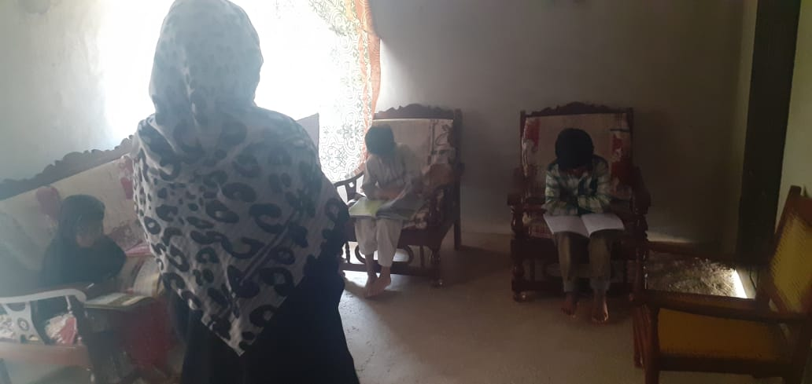
  - Mehvish (friend)
She is my friend. She is a teacher in beacon public high school jandan wala. She contacted with the mothers of the children and helped me in gaining their consent. She made them agreed to send their children at my home for free tuition.
I also contacted with them and assured that I would provide a proper sanitized environment to their children. Thus with the help of my friend I got successful in gaining willingness of the parents of the children.
1.2). Areeba (friend)
She is also my friend I got also help in teaching children at home. She lives in my neighborhood. I got her help in order to avoid overcrowding of children. She also providessanitized conditions to the children.
Timing and strategies for tuition
In order to avoid overcrowding I made a timetable for all children.We arranged all the students into two shifts. There were almost 35 students for tuition I arranged them into 4 groups. I taught two groups and the remaining two groups taught by my friends. I took class of first group at 4 pm to 5 pm and the class of second group from 5 pm to 6 pm. Timing of classes were also same for my friends when the students came to us we used to make it sure that they properly washed their hands with soap. During class we maintained the distance between the students. For about 15 minutes. We provided awareness’ about covi-19 and about its safety precautions.
To pen off I say that I am satisfied with my work towards my community because all students become good in studies and they are providing information to others about safety measurements of covid-19. (Maheen gul BBTF19BM001.2020)
2. Farrah bibi
I did this activity with the help of my elder sister ( aneela parveen) who is a govt teacher at contract with qualification Bs Botany and a male cousin M Zahid who is a teacher in academies with a qualification BS Chemistry (last semester). I took help of them because they have better experience. They not only help me in this project but also guide me how to teach because it was my first experience.
First of all we make a survey of our area I with the help of my sister and cousin met to the parents of the children and convinced them to send their children for study. Some of them were thinking that we are asking them to send their children. Because we want to make a academy and to earn money we make sure them we are here for their help in this situation of corona. We want to decrease the illiteracy rate and loss of children in studies. We satisfied them we do not want any fee. Due to our efforts 24 children were ready to come our homes for studies. We also met by children some of them ready before and some of them were ready after our convocation. i sure their parents we will mention their social distance and care their children.
I taught eleven students in two shifts I taught six students two 8th class, two 1st year, two 1 class students from 3 am to 4 pm and in second shift I taught 5 students and then take a extra class of 10 minutes about corona awareness. In this class I aware them about corona present situation and took activities like made charts and place in their homes or any best place. I taught five students from 4:30 to 5:30 two 6th class 2 three class and one5th class. I also took extra class of 10 minutes for them we arranged a peaceful place in our houses for children. We maintained social distances strictly guided them to wear masks and wash their hands as enter in our houses. We have completed at one third of their course. (Farah bibi BBTF19BM003.2020)
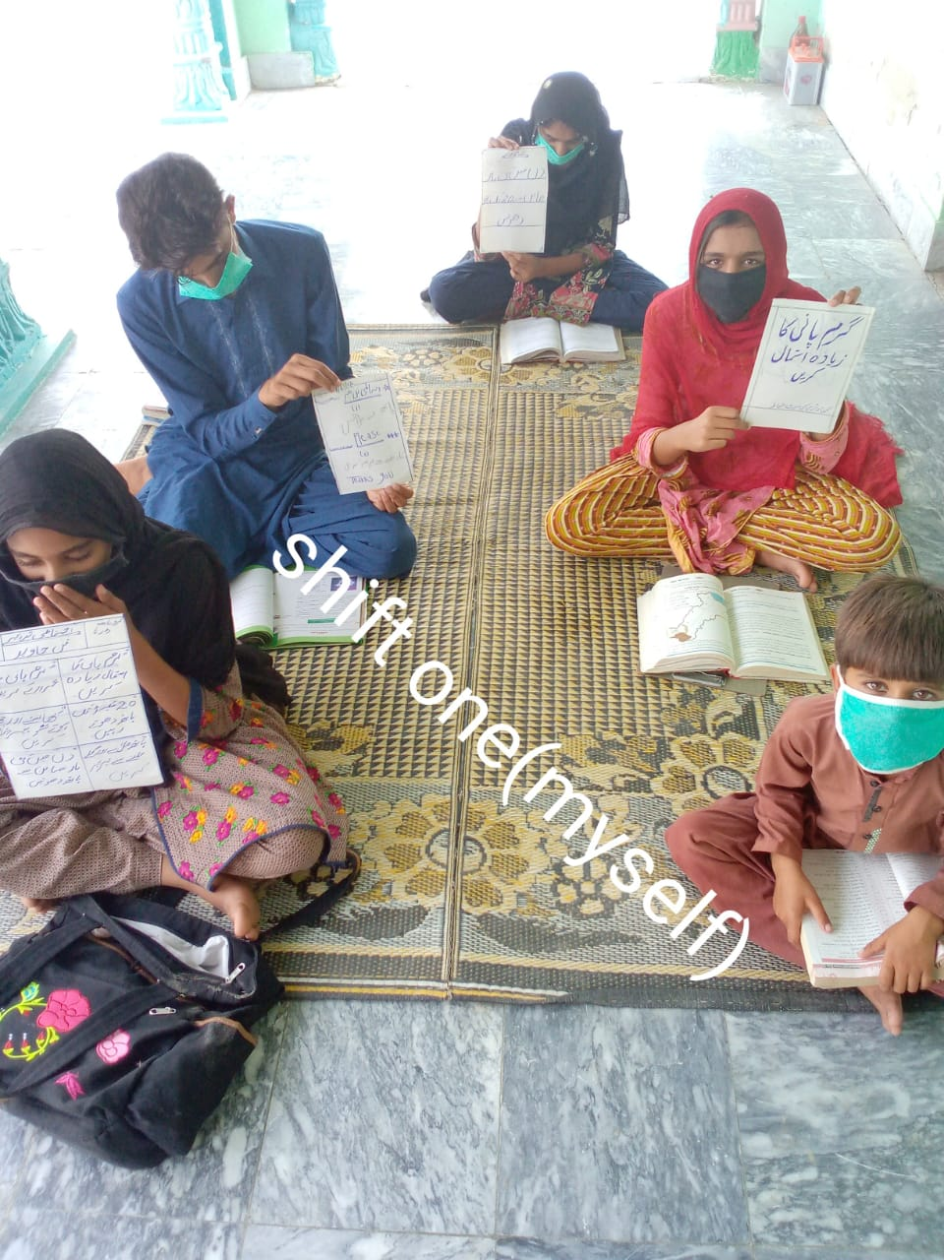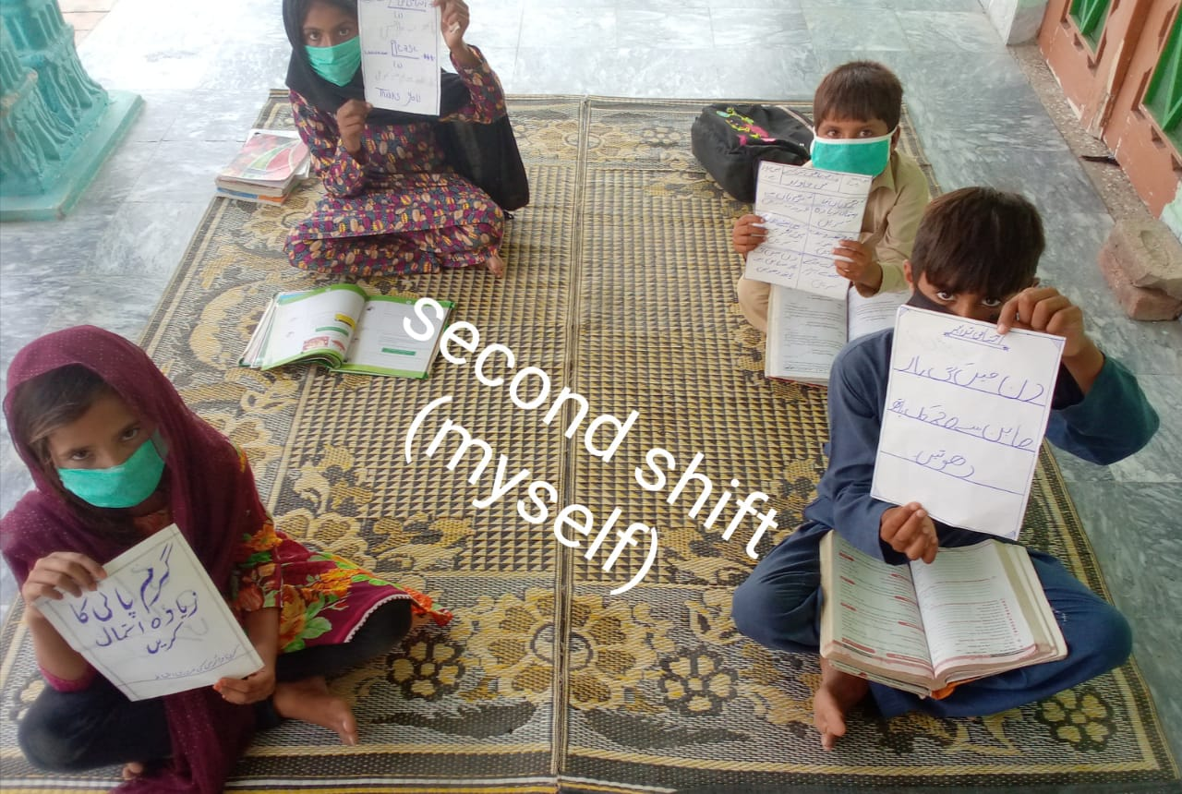

2.2 Aneela parveen (sister)
My sister taught ‘6’ students two 9th class one 8th class and three 10th class students. She also took an extra class of 15 minutes to aware the children about corona, also took different activities in this class such as made charts from students in regard of corona.
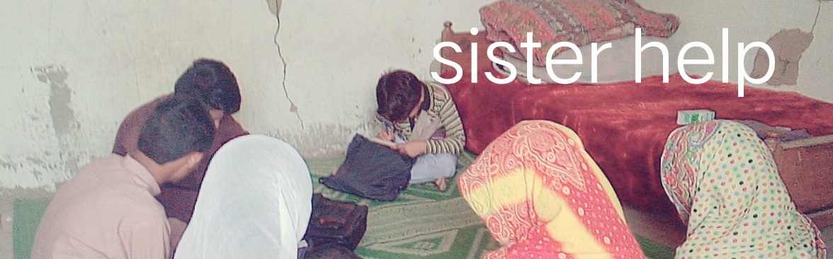
2.3 M Zahid (cousin)
He taught 7 students (boys). Three students of class 5th, one 7th two boys of fsc, and one boy from class 9th.

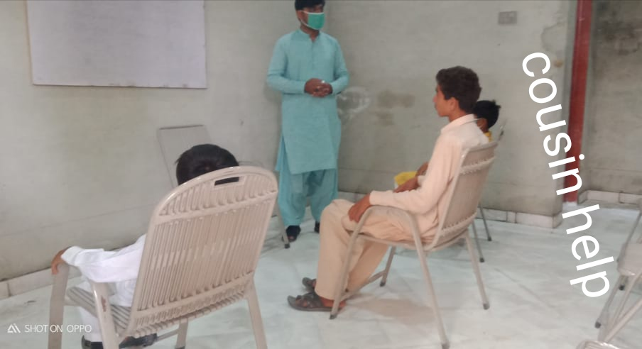

3). Sokaina shahzad
I did this project activity with the help of my brother (zeeshan shahzad) I also took help of my cousin Rana Hassan. My cousin has recently done Msc zoology. My brother is a teacher. He has a great experience of teaching we convinced the people of our area to cooperate with us. The people helped us and many children come started in our home. We didn’t gain any charges. We provided free home education to the children of our area. We also gave awarenessabout covid-19. We advised them to wear masks and use sanitizers. We convinced them to spent most of their times in their homes. We taught students of different classes like 5th, 6th, and 7th. We have decreased the worries of the parents because they depressed about the study of their children. We wanted to decrease the loss of the study of children so we provided them free home tuition. In this project I also learnt many things. I gained the experience of teaching children. We also maintain social distancing during teaching of the children. We gave them a peaceful environment for study. We taught almost 20 students. This project activity proved very beneficial for the study of the children of our area. We had completed a lot of their syllabus. By doing this project activity we proved the responsibility of a good citizen. (Sokaina Shehzad BBTF19BM021.2020)
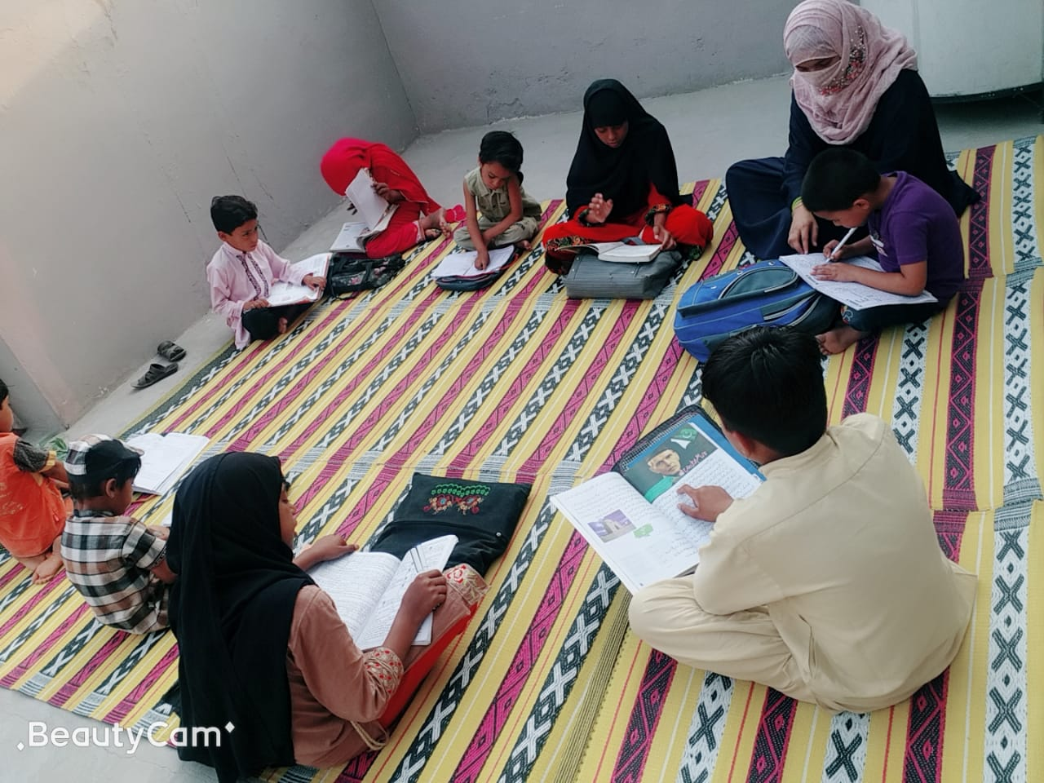
4). Reeha hussain
According to the current situation all schools are closed and student carrier destroys very badly. At the home students did not carry your study and parents are very worried about their future and study. Consider the current situation we decided to give the student free home tuition till school we're opened. I start this work with the help of my cousin (Muhammad shafique) who is a teacher in primary school. I fulfill our tasks with the willing of my parents. I go to the neighbor’s home and get there willing about teaching of the student. And then I started this process of free home tuition. I teach about 20 students. Parents of student cannot pay the high fee of tuition during this lock down situation. Thus they easily agree with my discussion and send their children's at my house for study. (Reeha Hussain BBTF19BM054.2020)

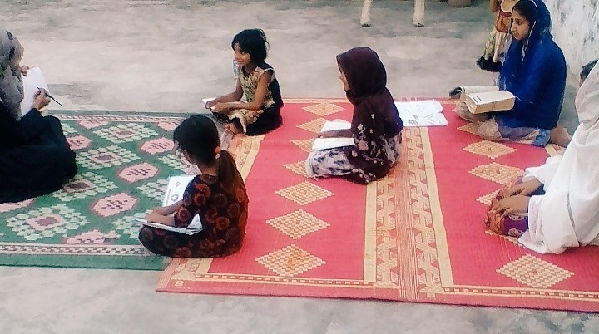
5). Najam ul Hassan
I started my task from 3 May (Sunday), when I went to neighbors’ house I asked to the parents of the children that I will teach your children totally free until their schools remains closed. I also asked them in this way their children remains busy in the study and never try to go outside in this way the chance of spreading covid-19 will be decreased. They agreed it. Next day I went to their homes at 4 pm and knocked the door. An aged man whose name choudhry Allah dad appear there. I told him that I came to teach their children. Then we entered the room he gathered all children of his family. There were seven students. Their names and grade are following M Zameer hussain 10th class, Rauf haider 12th class, Aown jawadi 7thclass, M Safeer 7th class, M Asif 5th class, Usman riaz 3rd class, and Hamza riaz 5th class. I started teaching each student from the first chapter of each book. I teach them 2 hours daily 4 pm to 6 pm. In first 30 minutes I asked those questions whatever I taught yesterday when there is essay or story I liked to prefer write it on their copies and checked me then next 60 minutes I teach them next topic and last 30 minutes I specified for questioning and I answered them. Not only had this but I also watched them video clip related to their topics on my laptop. In this way they understand lecture more deeply. When I am teaching them suddenly I asked them questions in order to gain their attention. I always asked them to understand the things instead of reading. At the end time I shared them precautions against covid-19. And next day I asked whether they acted upon my precautions or not.In this way I am not only teaching them but also saving their lives by sharing them precautions against covid-19 that are mentioned below I asked them to stay at homes, never go outside, never shake hands with one another, use masks or piece of cloth to cover mouth and nose, I also asked them washed their hands after touching anything for 20 seconds. In this way I am educating them and saving them. (Najam ul Hassan BBTF19BM041.2020)
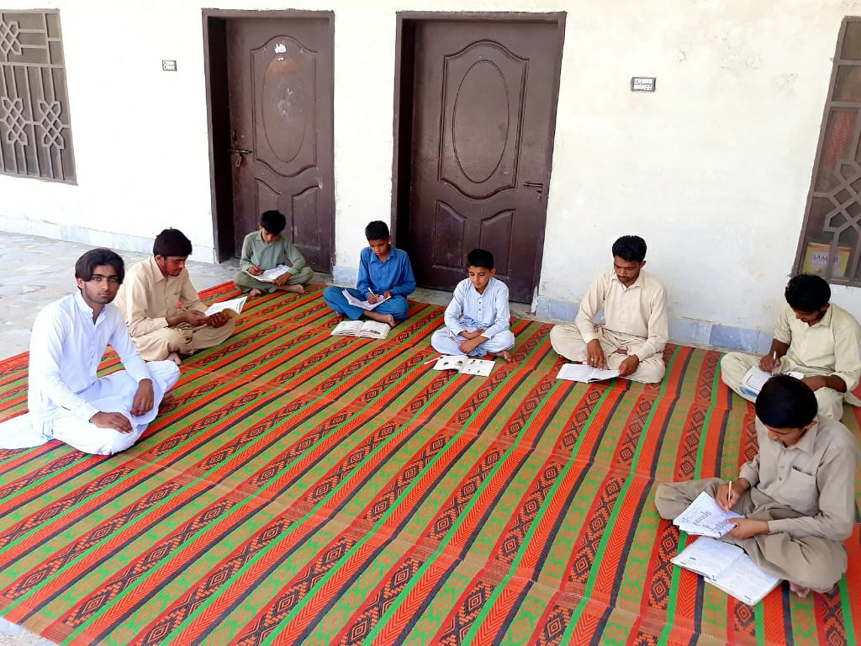

6). Muhammad Owais
I did this activity with the help of my friend (M Danial). He is a teacher in high school. So that he better knows and guide me in teaching because it was my first experience. He helped me also by gaining the willingness of the parents of children. We went to the children teachers and their parents and asked them we started free home tuition for children, so that their precious time due to lockdown did not waste and they gained benefits that we provided them education in our homes. We also told them that we followed all the instructions which are given by the govt and also aware the children about the danger of covid-19 pandemic disease. Their parents were worried about their education loss. So that they were agreed with us and they ensured that they send their children in my home.
After this I started teaching the children taught 7 students from 5 pm to 6 pm. They belong to different classes one from 10th class, three from 5th class and two from 4th class.
First when they came my home I asked them washed their hands with soap for 20 seconds. I maintained a social distance between them. After the ending of class I gave awareness about covid-19. In this way I not only teaching them but providing awareness about covid-19 also saved the lives of the children and their families. I saw that this activity is beneficial for the children. First they continue their studies and their loss of education decrease. Second they did not waste their time playing games and as they followed the instructions they avoid from the covid-19 disease. (M.owais BBTF19BM046.2020)

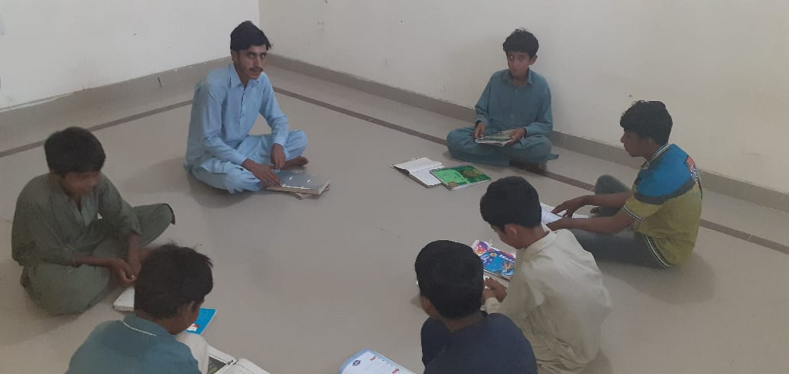

7).How we evaluate our project for possible outcomes

- We provided free home tuition to the children and they got benefits from this activity.
- We provided the children good quality of education which secures the future of the children.
- When we convinced the parents of the children and they send their children in our homes after this the loss of the children education decreased.
- We analyze that when we maintain social distance and gave awareness about the COVID-19 children followed then and remain at their homes. In this way they avoid from COVID-19 diseases.
- We asked them made charts and placed in their homes and other places so that all the people got awareness about this covid-19 pandemic disease.
- This project proved beneficial for needy and poor people because they did not pay their fee in other academies and got free education in our homes.
- This project proved beneficial for us because it was our first experience and in this way our knowledge increases by teaching children.
- We provided them timetable in which time they play and in which time they study so in this way their time not wasted and they work at proper time.
- We realized that when we gave them awareness about COVID-19. They followed them and become a role model to the senior citizens.
- We satisfied our work because it proved beneficial for the children and their families.
Sokaina Shehzad BBTF19BM021.2020)

REFERENCES:
http://en.m.wikipedia.org
http://bbc.com
http://www.pk.undp.org
Maheen gul BBTF19BM001 BS Botany 2nd department of biological sciences UOS sub campus Bhakkar 2020
Farah bibi BBTF19BM003, BS Botany 2nd department of biological sciences UOS sub campus Bhakkar 2020
Sokaina Shehzad BBTF19BM021, BS Botany 2nd department of biological sciences UOS sub campus Bhakkar 2020
Najam ul Hassan BBTF19BM041 BS Botany 2nd department of biological sciences UOS sub campus Bhakkar 2020
Malik owais BBTF19BM046, BS Botany 2nd department of biological sciences UOS sub campus Bhakkar 2020
Reeha Hussain BBTF19BM054, BS Botany 2nd department of biological sciences UOS sub campus Bhakkar 2020

