YIELD REGULATION

Once the structure of a normal or ideal forest has been decided upon, it is necessary to plan the management of the given working cycle so as to develop it towards this standard. The management procedure leading to this result is called yield regulation.

Y.R. consists of: (a) Estimating productive capacity of the area in its present condition i.e.

production possibility.

(b) Deciding how much of this should be retained to built up the grows stock or how much of the excess growth stock should be removed to minimize loss and balance the yield.

(c) Deciding in what localities, time, proportion and total volume of timer to cut (i.e. where, when and how much to cut).

(d) Deciding on the kind of timber species and size that should compose the volume cut. The very essence of Y.R. is in determining the cut. There is no single formula for the solution of cut-determination. This depends on state and trends of market, intensity of management and silvicultural systems adopted. Thus Y.R. necessarily involves a compromise between economic and silvicultural consideration in management. Generally the main objectives why timber production and telling of trees should be regulated can be broadly discussed under 4 headings namely:

1. Silvicultural

2. Labour

3. Industries Object of Yield Regulation

4. Economic Reasons.

1. SILVICULTURE

(a) Over Cutting (i.e. Cutting more than required or cutting more than can be replaced). This may cause determination of the soil, introduction of unwanted species. (example Musanga cescropioides) and dieing out of wanted species due to lack of regeneration.

(b) Under-Cutting: May lead to over matured trees which deteriorate in wood quality and the seeds and fruits of which loose viability rapidly. The dense shade of an over-matured tree will make it difficult for young plant on forest floor to survive due to lack of light.

2. LABOUR

The employer needs skilled labour to carry out his work and this can only be got by regular employment intermittent employment leads to forced employment of casual labour with consequent lack of skill and responsibility. Similarly an employee will not stay in a job or trade hthat offers only intermittent employment. It means then that both parties employer and employee suffer when the work is intermittent.

3. TIMBER INDUSTRY

Both the industries themselves and the workmen they employed cannot continue to operate it the out turn of wood raw material is only intermittent. They must have a continuous and steady supply of timber to function adequately and profitably.

4. ECONOMIC REASONS

We can liken forestry to a business operating within biological limits. These capital investments is made up of two things – the trees themselves and the money expended in operations in that forest. Although the owner of the forest may make a profit by waiting 60 years or more for the trees to mature before selling them, yet he has nothing to line on in the meantime. Whereas he can get better returns on this money by merely putting it in a saving bank.We must consider the capital tied up in the forest to be an investment upon it every sensible petran expects a return or profit. Not as a final profit but as a steady interest on the money invested. This can only be got by regular periodic (Preferably Annual) yield from the forest.

METHOD OF YIELD REGULATION

The objects of management are firstly to obtain sustained yield and secondly to aim at a normal forest. Several methods have been tried particularly in Europe to regulate yield and attain those objectives. Some methods have been move successful than others. The type of method to be adapted depends on the type of forest and the degree of accuracy required.

The methods used so far can be divided into 4 major groups:

1. Methods based on area only.

2. Methods based on area and volume control.

3. Methods based on volume or volume and increment of growing stock

4. Methods based on number and size of trees.

A. AREA ONLY

i. Annual Coupe Method.

B. AREA AND VOLUME CONTROL

(i) Control by rotation and age classes or periodic blocks methods.

C. VOLUME OF VOLUME AND INCREMENT OF G. S.

(i) Von Mantel’s method and Smythies modification.

(ii) The Austrians formula and Heyers modification.

(iii) Methods of successive enumeration or continuous inventory base on Biolleys method of control.

D. NUMBER AND SIZES OF TREES

(i) Brandis or Indian methods.

(ii) Melands or French methods of 1883

A. AREA ONLY (DIRECT METHOD)

ANNUAL COUPE METHOD:-This is the oldest method of regulating the cut (14th–16th) century agobased on an area and rotation methods. The methods consist of dividing the whole forest into equal areas, equal in number to the rotation. Each part is cut and regenerated sequentially every year. Size of annual coupe = area of forest Rotation It should be noted that only one rotation is used throughout. The annual coupe then consist of a series of “R” stands differing in age by one year (R = Rotation)

Assumptions:-1. Since there will be site difference or micro site variation; each area will produce at different yield. It follows therefore that the longer the Rotation the greater the differences will be. Hence this method is assumed to be best suited for short rotation crops.

2. The method also assumes an evenness in ages of crop.In general this method is best suited for plantations grown on short rotation e.g. fuel wood, poles, pulpwood plantation e.t.c.

ADVANTAGES:

The method is direct and simple and aims directly at establishing a normal series of age gradation in the first Rotation.It is this the quickest way of attaining a sustain yield from the forest.

DISADVANTAGES

This method is rigid and tend to ignore economic and silvicultural conditions for example it may entail some heavy sacrifices of immature stands. The method tries to decide ahead the allowable cut and its location for the whole rotation. Due to the fact that the tropical high forest is compared of many different species, it means that the yield from each annual coupe is likely to be vastly different in the first rotation. This difference is further aggravated by the facts that some species are economic while some are not. And it is only the economic ones that are exploited several attempts have been made to overcome these vast difference in annual yield. This include:

1. Reservation of some rotation of the forest. A part of the forest is set aside as a reserved area and is not considered as part o the yield. This reserve is intended to be used as a BUFFER against large fluctuations in yield and will be used to replace or supplement any areas of very low yield. In this case area of annual coupe is equal to the area of the whole forest misuse area of reserve divided by the rotation.i.e. Area of Annual Coupe = Area of whole far- Area of Res. Rotation

2. Free choice of coupe by contractors In this case, the contractor is allowed to choose the order in which he takes the annual coupes. Normally the contractor enumerates the forest and from his data he can nominate which coupe he wants to take next. He can then select his yield to sait the market demand.

For instance if the contractor wants obese, he will nominate or choose the coupe with a large proportion of obeche while on the other hand if he wants mahogany, he will opt for a coupe with a large proportion of mahogany. By so doing it is hoped that by the time he eventually gets to the coupe with a lower yield, it is likely the number of economic species taken to the market should have increased considerably so that they are which was thought to be of low yield earlier on will now be considered as high yielding area.

3. Fixing of minium felling girth.

The third method for adjusting the yield of a coupe is also practiced in high forest. By this method a mnim fell girth is set for each species below which the contractor is not allowed to fell. This method acts as a guide against over cutting and also ensures that there is something left behind for the next rotation (this method however prevents the quick achivert of uneven aged forest).

B. METHOD BASE ON AREA AND VOLUME CONTROLS

PERMANENT OR FIXED PERIODIC BLOCK METHOD. The method of annual coupe is more suitable for the crop that is clear felled at rotation age and for system of direct planfix or artificial regeneration. In this method however it can be applied suitably to a high forest system i.e. shelter wood system. The shelter wood system demands a gradual removal of the trees in the area to encourage natural regeneration. i.e. fellings are made on the same area over a period of time until the whole area is felled and completely regenerated. The periodic block is therefore that part of the forest allocated fir regeneration or other treatment during a specific period.When all the periodic blocks are allocated and maintain their territorial identity or a working plan they are termed fixed or permanent periodic blocks.To avoid the vigidity and reduce the sacrifices of the permanent periodic block method, the obvious remedy is to abandon fixed periodic blocks and realot then according to circumstances at each revision of the work plan namely at the end of each period. Such blocks that di bit retain their territorial identities at a W. P. is termed a Revocable periodic block. Generally we call the period over which the fellings are completed as the regeneration period (P). The whole forest has to be divided ino a number of equal areas known as periodic blocks equal in number to rotation over regeneration period. i.e.

Number of periodic block = Rotation/regeneration period, Regeneration Period= p, For example if r = 100 and p = 20

Then number of periodic block = 100 = 5

If the total area of the forest is equal to 2,000 hectares, then area of

periodic block = 2,000 = 400 hectares. 5 These periodic blocks are then marked on the ground and hene the system is known as the Permanent Periodic block method. Within each P.b., fellings are done over a wide area accord to silvicultural regts. Hence it is impossible to calculate yield by area but it has to be calculated by volume. If the trees were not growing, then the yearly volume yield would be their present volume (v) divided by the period

(P). But they do grow. Now the trees cut at the beginning of the period have no time to grow but those cut at the end of the period can grow for the whole period. So on average the trees put on half the increment (I) they would have put on if they have been left untouched. So the volume available for cutting annually in the regeneration block is the present volume (v) plus half the increment (I) that the untouched stands would have put on in the period. This can be expressed in symbols known as COTTA’s formula.

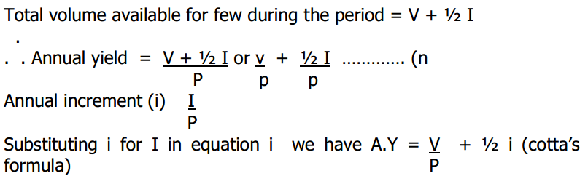 P Generally the convenience of this method is its flexibility since felling can be varied in intensity and position to suit progress of regeneration.

C. METHODS BASED ON VOLUME OR VOLUME AND INCREMENT OF GROWING STOCKA methods of Y.A. own at determine how much timber should be cut from a working cycle. The volume of cut can be determined indirectly through area control methods or directly through volume control method. The mgority of methods of Y.R. had been based on direct approach which is the only one available for irregular forest where age-class cannot be recognized by area.

There are a number of methods based on this direct approach which have been derived on the basis of relationship between growing stock and increment under certain assumed conditions and expressed in formulae. It is always necessary to check up whether the presumed conditions have been fulfilled otherwise these formulae would be misleading.

Advantages:

1. Applicable to all types of silvicultural system.

2. Useful as an overall guide to appropriate cut.

3. Useful in bringing an unmanaged forest under some degree regulation.

4. Being derived from a mathematical model of the grow stock, it allows

for the quick estimation of the allowable cut often from a limited amount of data.

Disadvantages:

1. Even though more accurate than area method, it could be more expensive in the sence that regular or constant enumeration will be required and this is time and money consuming and labour demanding.

2. Increment which is regard in most volume formulae tend to be a weak figure. If volume or increment data are incurrect, there is no assurance that the forest is constituted as desired. Therefore for safe application of V.C.M. a reasonably high degree of accuracy of volume and increment data are regard.

VON MANTEL’S FORMULA

Some volume methods are certainly more successful than the others. The simplest method is von Mantel’s formula. Von Mantel assumed the concept of a normal forest i.e. that the N.G.S is equal to the annual yield multiplied by Rn all upon 2.

i.e. N.G.S = (I x r)/2 where I = Annual Yield

r = Rotation

I = 2 NGS/r

A.Y = 2 NGS/r (Von Mantel’s Formula)

1. If the G.S. is completely measured include the small and big trees then the annual yield can be calculated quite simply.

2. However in practice, trees are not enumerated or mimed below a certain girth limit.

3. Another disadvantage is that the formula is wrongly applied to all forest irrespective of their normality. If there is no normal distribution of trees of all age classes then the annual yield will be very wrong. Therefore there is a modification to this called

SMYTHIES MTD OR MODIFICATION.

In many countries especially in the tropics, it is usual to measure the volume over a certain minimum girth. Let us call the volume ‘V’ and the age at which the trees reach the minimum girth as ‘X’ and rn as “r”

Smithies submission is that: A. Y. = 2V/(r-x)

The disadvantage of these methods (i.e. Von Mantel & Smithies) is that the forest is assumed to be normal. Anything contrary to this assumption (i.e. that the forest in normal will lead to great errors in calculation.

AUSTRIAN METHOD

The Austrian method is a means of calculate the yield by comparison of actual growing stock and normal growing stock. (AGs & NGs). The AGs is mmed and it is assumed that the stock on Rn age plot is equal to the annual yield and is equal to (I) sum of increment of all the age classes of the growing stock.

That is:

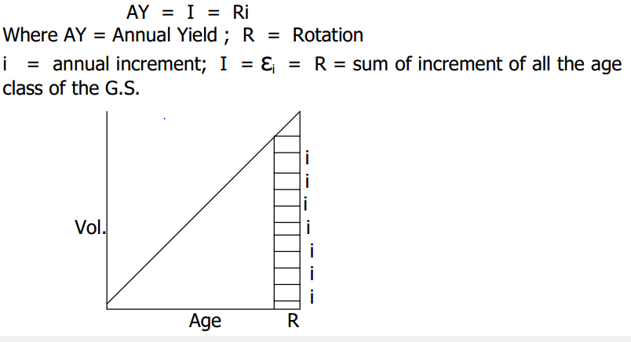

i earlier assumption on the NGs it was found that NGs = I x r/2 (Von Mantel formula)

However when the AGs was mmed it was found out that the total volume is either greater than or less than the volume of the normal growth stock. The Austrian tax collector mmed the Volume of the AGs and the volume of the Rn age stand.

This was assumed to be equal to I = AY.

He postulated that AY ought to be the volume of R N (I) age plus the AGs minus the NGS all upon Rn.

AY = I + (AGs - NGs)/R

And if the AGs is greater than NGs the little excess will be positive and if

the AGs is less than the NGs, the little deficit will be negative.

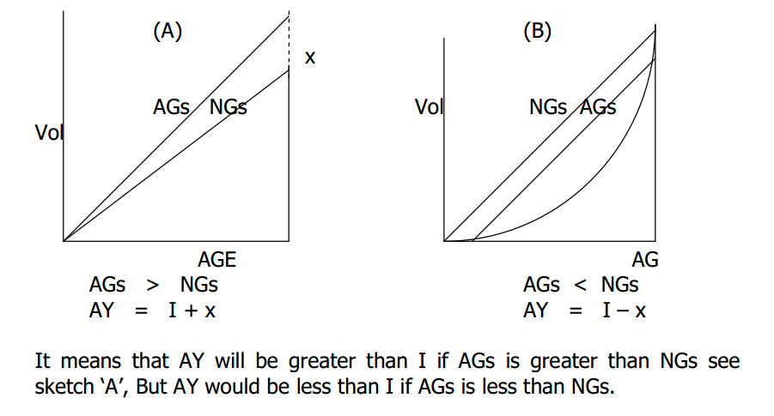HEYER’S MODIFICATION

The disadvantage of Austrian’s method is that too much emphasis have been placed on the stand of the Rn age. However he thought that it would be better to measure the actual increment of each stand after a certain period says 10 years i.e.

AY = PMAI + (AGs - NGs)/R

METHODS OF SUCCESSIVE ENUMERATION OR CONTINUOUS INVENTORY BASED ON BIOLLEYS METHOD OF CONTROL

This is infact the most detailed and probably accurate method but it depends on successive enumeration or short interval so that it is practicable where forestry is intensive. It is also suitable for forest under selection system and clear fell into. Depends on complete enumeration at regular intervals and works as follows:

P = Period between enumeration

V1 = Volume enumerated in the 1st enumeration

V2 = Volume enumerated in the 2nd enumeration

N = Volume felled between enumerator

Note:- These Vols (“N”) are got from things . The annual yield for the succeeding period is equal to PMA = (V2+ N – V1)/ P

AY = PMAI = (V2+ N – V1)/P

Since the AY in the preceding period is N the aim is to get the calculated P Yield exactly equal to this so that the volume remains constant.

Other Methods of Volume Control

1. Hundeshagen method

2. Hufuagels Method

3. Kuusela Nyyssonen method (finish formular)

4. Armorlization formula

5. Grosenhangl’s allowable cur formula

i) NUMBER AND SIZES OF TREES

Up till now we’ve been discussing methods it take into consideration the age of the trees. This is possible where we are considering approximately over-aged forest as is obt’ed in clear felling, or in temperate countries. In the tropical high forest trees of different ages are all mixed together. It therefore becomes meaningless to use age class distribution as a yard stick or measure of yield regulation. Hence we apply size class distribution to uneven-aged forests. Further more it is difficult to know ages of trees in tropical high forest since there are no clear-cut relationship between age and size classes. Also growth rings are not equivalent to annual rings and so it is difficult to assess the ages of these trees. Methods of yield regulation of un even-aged forest based on size classes includes:

1. French method of 1883 or Meland method

2. Brandis method or Indian Method

3. Meyers method

4. The Recruitment method

5. The chapmans Horizontal cut method.

FRENCH METHOD OF 1883 OR MELARD METHOD

In this method we divide the growth stock into three parts according to the sizes and these are equated to the rotation as follows:

Let size at Rn

(r) be equal to x i.e. Rotation Size girth in fees

R = 75 x = 6

1/3r = 25 1/3x = 2

2/3r = 50 2/3x = 4

The G.S is divided into three.

1. The large Trees (L.W) = 2/3x and above.

2. The Medium Trees (M.W.) 1/3x to 2/3x

3. The small trees (S.W) – below 1/3x

The vol. of the large tree is then measured and the annual yield is then calculated by Cotta’s formular. AY = V/P + ½ i

A.Y. Vol of L.W/1/3r + ½ annual increment of L.W. Above is of course the figure representing trees in the final yield. During this period thinnings have been done especially among the medium trees and it is assumed that in a well stocked forest 1/3 of the annual increment of the medium trees can be removed as thinnings. In some cases however it is less than 1/3 of annual increment i.e. about ¼ only.

The total AY therefore becomes Total AY = (Vol of LW/)/ 1/3r)+ 1/3 annual increment of L.W.

BRANDIS/INDIAN METHOD

This method was developed to regulate the cutting of teak in Burma. The regulation is by size classes based on number of trees that can be removed with respect to rate of replacement or recruitment. Method:-i. Classification of growth stock to three girth classes namely:

I = > 6ft

II = 4½ - 6ft

III = 3–4½ feet

Fixing of class I as the minimum felling girth.

ii. Calculation of TIME it will take all trees in girth class II to go into

girth class I.

Note:- This can be done by ring count or observation of trees of known ages.

iii. Brandis determine the recruitment period to be 24 years.

iv. Therefore allowable cut = 1/24 of the present number of class I trees.