INCREMENT

Forest is a capital in the economic sense, which should produce interest. Trees are the capital and growth (increment) is interest; both are indistinguishable. Increment is the increase in growth of a tree or crop with age. It may be in term of wood content, or any of the factors which increase with age-diameter, height, basal area, volume, quality price or value. It is determined for any given period, by measuring it at the beginning and at the end of the period.

Definition: The increase in girth, diameter, basal area, height, volume, quality, price of individual trees or crops during a given period. In Forest Management, the term increment refers usually to only volume increment, and that too of crops rather than of individual trees. It is intimately connected with the volume and age of the crops.

KINDS OF INCREMENT

Current Annual Increment (C.A.I.): The increase in growth that takes place in a particular year is called the C.A.I. for that year. Usually taken as the periodic annual increment over a short preceding period. It may be expressed as [ V (n+1) – Vn ) where V (n+1) is the volume of wood produced in (n+1) year and Vn the volume in n years.

Periodic Annual Increment (P.A.I.): The average increase in growth which takes place in any short period (5 or 10 years); sometimes referred to as periodic mean annual increment. Since annual measurements are very difficult in forest and impossible in practice, only P.A.I. is taken as C.A.I. and all the yield tables consider P.A.I. as C.A.I. If the period is short, P.A.I. and C.A.I. will be very close to each other.

Mean Annual Increment (M.A.I.): It is the average annual rate of growth up to any given date i.e., it is an average rate of growth representing the total growth or yield at a given age distributed or spread over the period. The total increment upto a given age divided by that age is M.A.I. The volume of a tree is built up of successive C.A.Is., which, of course, vary considerably from year to year. The C.A.I. is a chapter in the history of the tree. The mean of all C.A.Is. is known as Mean Annual Increment (M.A.I.) an average annual rate of growth upto any given age; it is derived by dividing total increment upto any specified age by that age.

M.A.I. = ( Vx – Vo )/x, when Vx is volume at the end of x years; Vo is the volume at the beginning. Final Mean Annual Increment (F.M.A.I.): It is the M.A.I. at rotation age.This is calculated by dividing the total of volumes (final yield at the end of rotation + intermediate yields from thinnings, etc.) by the rotation period. F.M.A.I. = (Vr + Vi)/r, when Vr is the volume at the end of rotation; Vi is the intermediate yield, and r is the rotation in years. C.A.I. Curves: The study of C.A.I. curves is interesting. The C.A.I. is small in the seedling stage, gradually rises, reaches its maximum and falls till it approaches zero when death occurs. In case of light demanders and moderate shade bearers, the maximum is reached when the height growth culminates. In case of shade bearers, maximum is attained several years after the culmination of height growth, and after attaining maximum, C.A.I. falls rapidly at first and then more slowly.

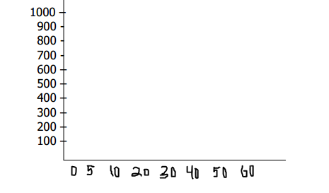

C.A.I. and M.A.I. Curves, Their Relationship and Significance There is a definite relationship between C.A.I. and M.A.I. The curves drawn for different species conform to the same pattern as show in Fig. The C.A.I. and M.A.I. curves allow to draw following conclusions: - At first M.A.I. Keeps below C.A.I.- C.A.I. attains its maximum before M.A.I. and will be falling while M.A.I. will be still rising.

- While C.A.I. is greater that M.A.I., the latter is rising.

- When C.A.I. is less than M.A.I., the latter is falling.

- When C.A.I. = M.A.I., the latter is stationary.

- When C.A.I. and M.A.I. curves meet, the latter has attained its maximum.

- The meeting points of C.A.I. and M.A.I. curves determine the rotation of maximum volume production.

INCREMENT PERCENT

The average annual growth in volume (or basal area) over a specified period expressed as a percentage of the volume (or basal area) either at the beginning or, more usually, half way through the period.It is an expression of the relation between increment and volume. It is the ratio of increment and volume expressed percentage.

Increment % (I.P.) = Increment/Average volume x 100

TYPES OF INCREMENT PERCENT (I.P.)

Current annual increment percent: It is the relation between the annual increase of increment during a given year and the volume at the beginning of the year expressed as percentage. Period increment percent: This is the percentage ratio between the increment during a given period to a basic volume i.e., mean volume for that period or the volume at the beginning of the period. Mean annual increment percent: It is the percent ratio which the M.A.I. for a given age bears to the total volume at that age.

UTILITY OF I.P.

(i) It is the indicator of maturity of individual trees or crops and used for fixing the rotation or the yield. The decrease in I.P. indicates the increase in age/maturity of the stand (Fig. 2).

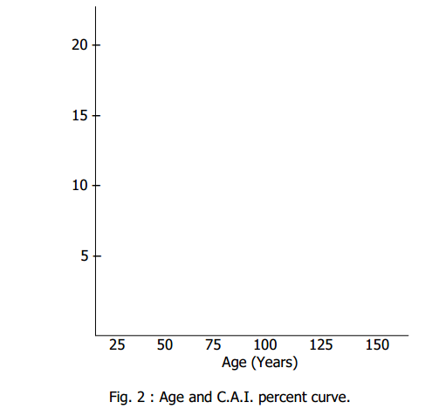

(ii) The trees/crops showing lowest I.P. should be selected for felling. This allows the removal of greatest possible volume of wood capital with reduction of smallest possible amount of increment. In effect it transforms the forest capital from low to increased I.P. as a whole.

Increment percent (I.P.) is the C.A.I.%, which is usually computed from

Yield Tables by Pressler’s Formula as under:

Increment percent (I.P.) = [[(V-v)/n]/( V + v )/2] x 100

= ( V – v)/( V + v ) x 200/n

Where V = Present volume of the crop,

V = Volume of the crop n years ago,

C.A.I. = ( V – v )/n, and

Average Volume = ( V + v)/2.

Pressler also discovered that the increment percent (I.P.) for the year r, in which the M.A.I. culminates, can be expressed by the formula:

I.P. = 100/r