* **ELISA INTRODUCTION**

In this method, an enzyme, which reacts with a colorless substrate to produce a colored product, is covalently linked to a specific antibody that recognizes a target antigen. If the antigen is present, the antibody-enzyme complex will bind to it, and the enzyme component of the antibody-enzyme complex will catalyze the reaction generating the colored product. Thus, the presence of the colored product indicates the presence of the antigen. Such an enzyme-linked immunosorbent assay, which is rapid and convenient, can detect less than **a nanogram (10-9 g)** of a protein. ELISA can be performed with either polyclonal or monoclonal antibodies, but the use of monoclonal antibodies yields more reliable results.

* **HISTORY OF THE ELISA**

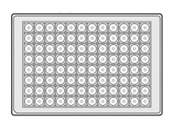The format of the ELISA was developed in the 1960s independently at the same time by two research groups; Peter Perlmann and Eva Engvall at Stockholm University, and the Dutch research group of Anton Schuurs and Bauke van Weemen. The assay was based on the underlying principles of conventional radioimmunoassay, with the key difference that the antibodies are labelled with an enzyme, rather than radioisotopes.

* **BRIEF DEFINITION OF ELISA TERMS**

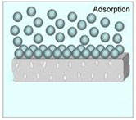***Solid******phase***:Usually a microtiter platewell.Specially prepared ELISA plates are commerciallyavailable. These have an 8 × 12 well format and can be used with a wide variety of specialized equipment designed for rapid manipulation of samples including multichannel pipets.

***Adsorption:*** The process of adding an antigen or antibody, diluted in buffer, so that it attaches passively to the solid phase on incubation. This is a simple way for immobilization of one of the reactants in the ELISA and one of the main reasons for its success

***Washing:***The simple flooding and emptying of the wells with a buffered solution to separate bound (reacted) from unbound (unreacted) reagents in the ELISA. Again, this is a key element to the successful exploitation of the ELISA.

***Antigens:***A protein or carbohydrate that when injected into animals elicits the production of antibodies. Such antibodies can react specifically with the antigen used and therefore can be used to detect that antigen.

***Antibodies****:* Produced in response to antigenic stimuli. These are mainly protein in nature. In turn, antibodies are antigenic.

***Antispecies******antibodies****:* Produced when proteins (including antibodies) from one species are injected into another species. Thus, guinea pig serum injected into a rabbit elicits the production of rabbit anti¨Cguinea pig antibodies.

***Enzyme:*** A substance that can react at low concentration as a catalyst to promote a specific reaction. Several specific enzymes are commonly used in ELISA with their specific substrates.

***Enzyme******conjugate****:* An enzyme that is attached irreversibly to a protein, usually an antibody. Thus, an example of antispecies enzyme conjugate is rabbit antiguinea linked to horseradish peroxidase.

***Substrate:*** A chemical compound with which an enzyme reacts specifically. This reaction is used, in some way, to produce a signal that is read as a color reaction (directly as a color change of the substrate or indirectly by its effect on another chemical).

***Chromophore:*** A chemical that alters color as a result of an enzyme interaction with substrate.

***Stopping****:* The process of stopping the action of an enzyme on a substrate. It has the effect of stopping any further change in color in the ELISA.

***Reading****:* Measurement of color produced in the ELISA. This is quantified using special spectrophotometers reading at specific wavelengths for the specific colors obtained with particular enzyme/chromophore systems. Tests can be assessed by eye.

* **ELISA PRINCIPLE**

A general ELISA is a five-step procedure:

1) coat the microtiter plate wells with antigen;

2) block all unbound sites to prevent false positive results;

3) add [**primary antibody**](http://www.sinobiological.com/Primary-Antibody-a-3674.html) (e.g. [**rabbit monoclonal antibody**](http://www.sinobiological.com/Rabbit-Monoclonal-Antibody-a-1569.html)**)** to the wells;

4) add [**secondary antibody**](http://www.western-blot.us/index.php?page=secondary-antibody) conjugated to an enzyme (e.g. anti-mouse IgG);

5) reaction of a substrate with the enzyme to produce a colored product, thus indicating a positive reaction.

* **COMPONENTS IN ELISA ASSAY(ELISA KIT )**

ELISA assays play important roles in clinical detection.

Three necessary ELISA reagents include:

1. immunosorbent,
2. conjugate
3. and substrate.

All the components of ELISA reagents for a complete ELISA assay, or an ELISA kit are as follows:

* **IMMUNOSORBENT (Solid Support Which Has Been Coated Antibodies Or Antigens)**

Solid supporter which has been coated with antigens and antibodies can be stored in low-temperature (2~8℃) and drying condition for six months.In ELISA test, solid carrier is adsorbent and container, so do not react. There are lots of materials, usually polystyrene, that can be used in ELISA. Polystyrene is strong in adsorbing protein. Antibody or protein antigen remains activity after adsorbed on it. In addition, it is widely used because of cheap price. Polystyrene is plastic material, so it can be made all kinds of shapes.

* There are three shapes of ELISA carrier:

1. microtiter plate,
2. small ball
3. and small tube.

Usually, microplate which is 96 wells plate is generally used. The character of ELISA plate is that it can be used to detect large amount of samples at the same time and the results are quickly calculated on a colorimeter. The good ELISA plate is strong adsorbing, and high-transparency in the bottom of well.

* **CONJUGATE (Antigen or antibodies conjugated enzyme)**

Conjugate is antibody (antigen) linked with enzyme, it is the key substance in ELISA. The good conjugate possess not only catalytic activity of enzyme but also immunological competence of antibody. Antibodies (antigens) are in proportion to enzymes in order to reduce uncombined enzymes or unlinked antibodies (antigens). In addition, the conjugate must be favorable stability. If conjugates are contaminated or improperly stored, they may lose enzymatic activity or may have an apparent increase in background. Most kits supply a ready-to-use conjugate.

A).ENZYME

Enzymes used in ELISA should meet requirements such as

1. high purity,
2. high conversion rate,
3. favorable specificity,
4. stable properties,
5. rich resources,
6. cheap price
7. and remaining active component and catalytic capacity after becoming conjugate.

Non-ferrous products is easy to be detected.

In ELISA,

1. horseradish peroxidase (HRP)
2. and alkaline phosohatas (AP) are usually used.

* B).Antigen and antibody

1. High purified IgG is usually used in conjugate in order to avoid the interference of other proteins when it is linked with enzyme.
2. It is the best to utilize antibodies that is purified through affinity chromatography.
3. These enzyme conjugates are all specific in immunocompetence and can react in low concentration.

* **SUBSTRATE (The substrate of enzyme)**

1. The chemical activity of the substrate will be compromised if it is exposed to light or comes into contact with metal.
2. Protect this solution by storing it in a dark container until ready for use.

* **SAMPLE DILLUENT And WASH SOLUTION**

1. Make sure the sample diluent and wash solution have come to room temperature (18–25°C) before use.
2. These are usually the largest bottles in a kit and require the most time to equilibrate.
3. If the wash solution still shows crystal formation after reaching room temperature, mix it by inverting it several times.
4. In plate form of ELISA, **0.05 % of tween 20 of PBS is widely used as diluent.**

* **STOP SOLUTION**

1. Be sure to use the stop solution included in the kit.
2. Follow any safety precautions in the package insert.
3. The stop solution should be at room temperature before use.
4. If the stop solution shows crystal formation after reaching room temperature, mix it by inverting several times.
5. The stop solution may crystalize at lower temperatures.
6. Before use, make sure that it is completely dissolved and appears clear.
7. **H2SO4 is widely used as stop solution for HRP reaction.**
8. Its concentration is based on the final volume of solution, **usually 2 mol/L** in ELISA plate.

* **GENERAL ELISA PROTOCOL**
* **General ELISA protocol** includes plate preparation, assay procedure and calculation of results.
* **A.Plate Preparation**

1.Dilute the capture antibody to the working concentration . Immediately coat a 96-well microplate with 100μL per well of the diluted capture antibody. Seal the plate and incubate overnight at 4℃.

2.Aspirate each well and wash with at least 300μl wash buffer, repeating the process two times for a total of three washes. Complete removal of liquid at each step is essential for good performance. After the last wash, remove any remaining wash buffer by inverting the plate and blotting it against clean paper towels.

3.Block plates by adding 300 μL of blocking buffer to each well. Incubate at room temperature for a minimum of 1 hour.

4.Repeat the aspiration/wash as in step 2. The plates are now ready for sample addition.

* **B.(ELISA Protocol) Assay Procedure**

1.Add 100 μL of sample or standards in sample dilution buffer per well. Seal the plate and incubate 2 hours at room temperature.

2.Repeat the aspiration/wash as in step 2 of plate preparation.

3.Add 100 μL of the detection antibody, diluted in antibody dilution buffer, to each well. Seal the plate and incubate 1 hour at room temperature.

4.Repeat the aspiration/wash as in step 2 of plate preparation.

5.Add 200 μL of substrate solution to each well. Incubate for 20 minutes at room temperature ( if substrate solution is not as requested, the incubation time should be optimized ). Avoid placing the plate in direct light.

6.Add 50 μL of stop solution to each well. Gently tap the plate to ensure thorough mixing.

7.Determine the optical density of each well immediately, using a microplate reader set to 450 nm.

* **C.ELISA Protocol) Calculation of Results**

1.Calculate the mean absorbance for each set of duplicate standards, controls and samples. Subtract the mean zero standard absorbance from each.

2.Construct a standard curve by plotting the mean absorbance for each standard on the y-axis against the concentration on the x-axis and draw a best fit curve through the points on the graph.

3.To determine the concentration of the unknowns, find the unknowns’ mean absorbance value on the y-axis and draw a horizontal line to the standard curve. At the point of intersection, draw a vertical line to the x-axis and read the concentration. If samples have been diluted, the concentration read from the standard curve must be multiplied by the dilution factor.

4.Alternatively, computer-based curve-fitting statistical software may also be employed to calculate the concentration of the sample

* **ELISA DEVICE**
* **A.TYPES OF PLATES**

1. Most plates used in ELISA are either polystyrene or derivatives of polystyrene obtained by chemical modification or irradiation of the surface.
2. The most common configuration is 96 wells organized into 8 rows and 12 columns.
3. Each well holds approximately 350 ul of volume with an internal area of approximately 2.5 cm2 .
4. More recently, 384 well and 1536 well plates have been developed with the same overall dimensions as the traditional 96 well plates.
5. They are used in high throughput screening

* **B. ELISA Pipettes**

1. Single-channel, fixed-volume and adjustable-volume (1–20 μL, 10–100 μL, 20–200 μL, etc.)
2. Multichannel, 8- and 12-channels
3. Semi-automated dispensing units
4. Fully automated systems that can process multiple plates

* C. **Washer Systems**

1. Manual systems that wash one row or column at a time
2. Semi-automated systems that handle one strip or plate at a time
3. Fully automated systems that can process multiple plates

* **D. ELISA Plate Readers**

1. Manual readers that read one row or well at a time
2. Semi-automated readers that read one plate at a time
3. Fully automated systems that can process multiple plates simultaneously

* **TYPES OF ELISA**

Four main methods form the basis to all ELISAs:

* 1. Direct ELISA
* 2. Indirect ELISA
* 3. Direct Sandwich ELISA
* 4.Indirect Sandwich ELISA

DIRECT ELISA

* Direct Antigen; antibody conjugated to enzyme

INDIRECT ELISA

* Indirect Antigen; antibody; antispecies conjugate

DIRECT SANDWICH

* Capture antibody; antigen; conjugated second antibody

INDIRECT SANDWICH

* Capture antibody; antigen; second antibody;antispecies conjugate against second antibody
* Direct ELISA

1. Antigen is attached to the solid phase by passive adsorption.
2. After washing, enzyme-labeled antibodies are added.
3. After an incubationperiod and washing, a substrate system is added and color is allowed to develop.

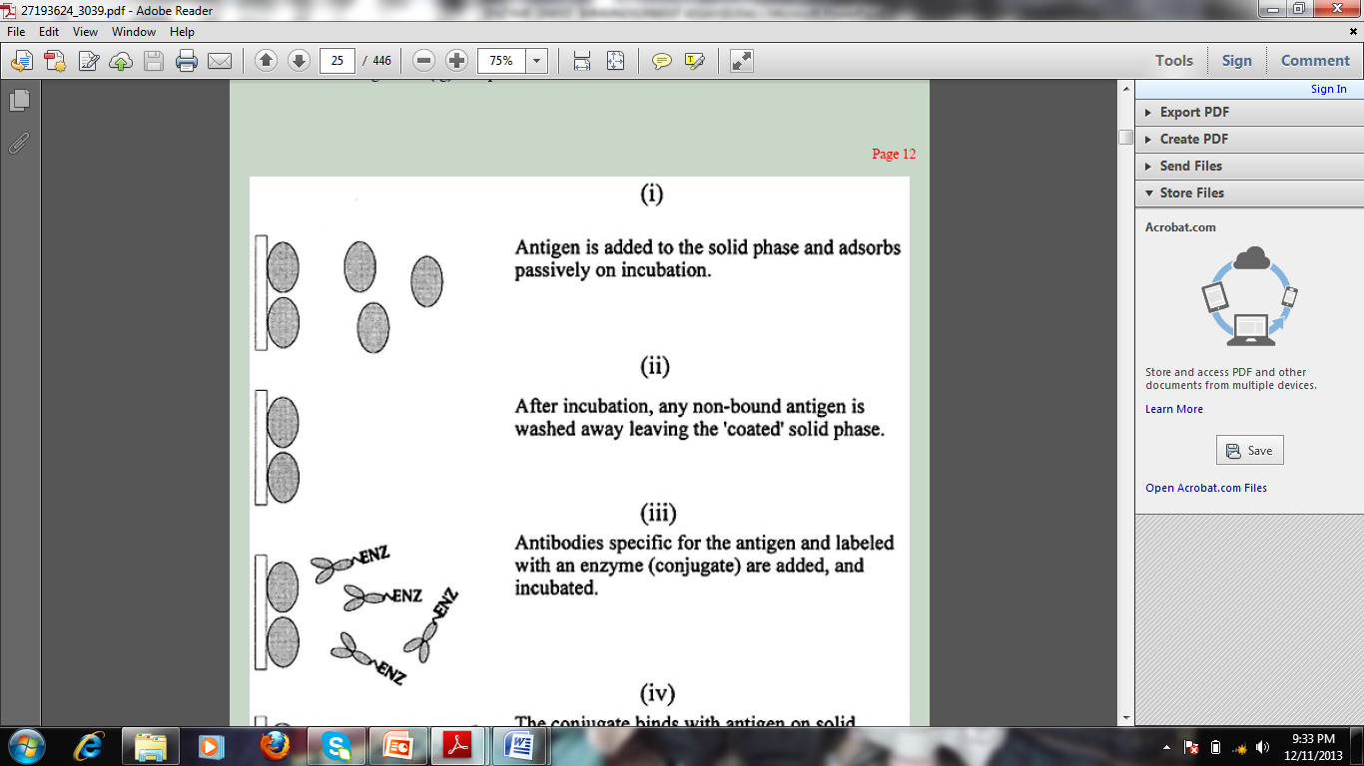

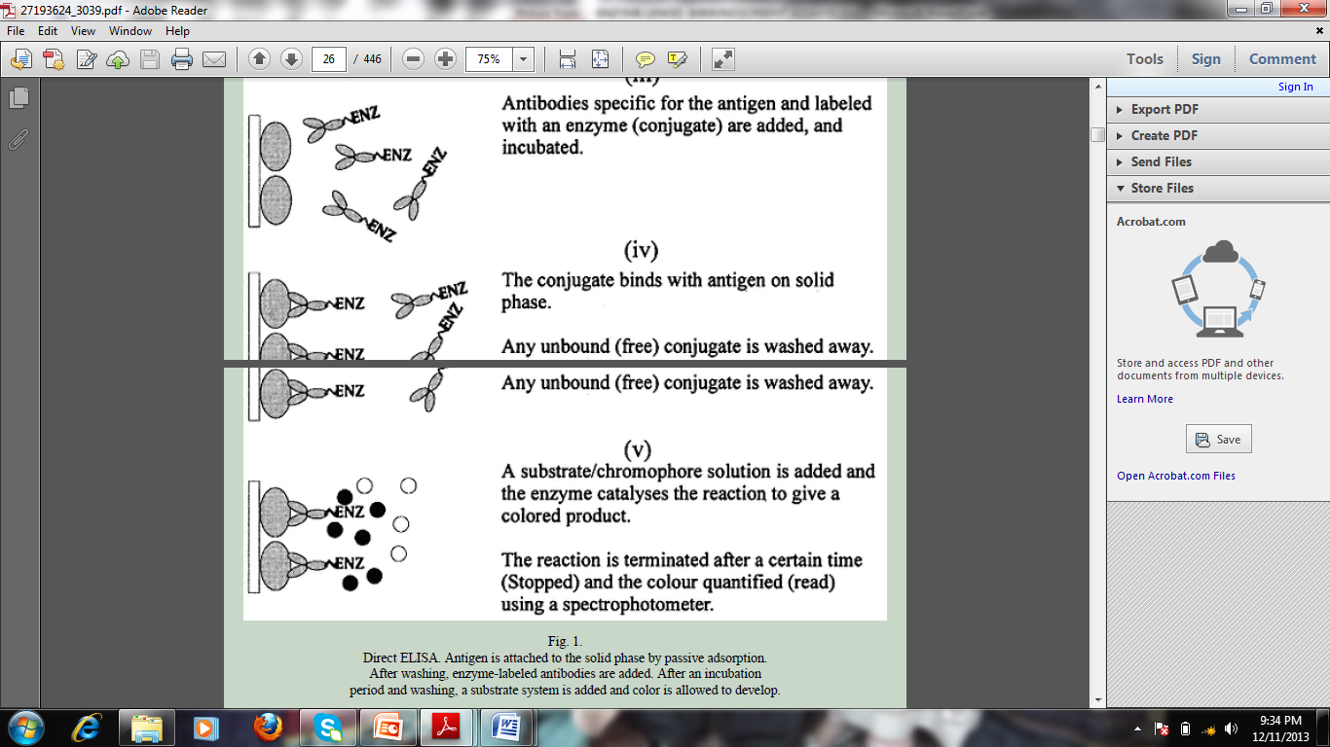

* (CROWTHER,J.(2000)*The Elisa Guidebook.2nd edition.Humana Press* )
* .**INDIRECT ELISA**
* **Indirect ELISA**

1. Antibodies from a particular species react with antigen attached to the solid phase
2. Any bound antibodies are detected by the addition of an antispecies antiserum labeled with enzyme.
3. This is widely used in diagnosis.

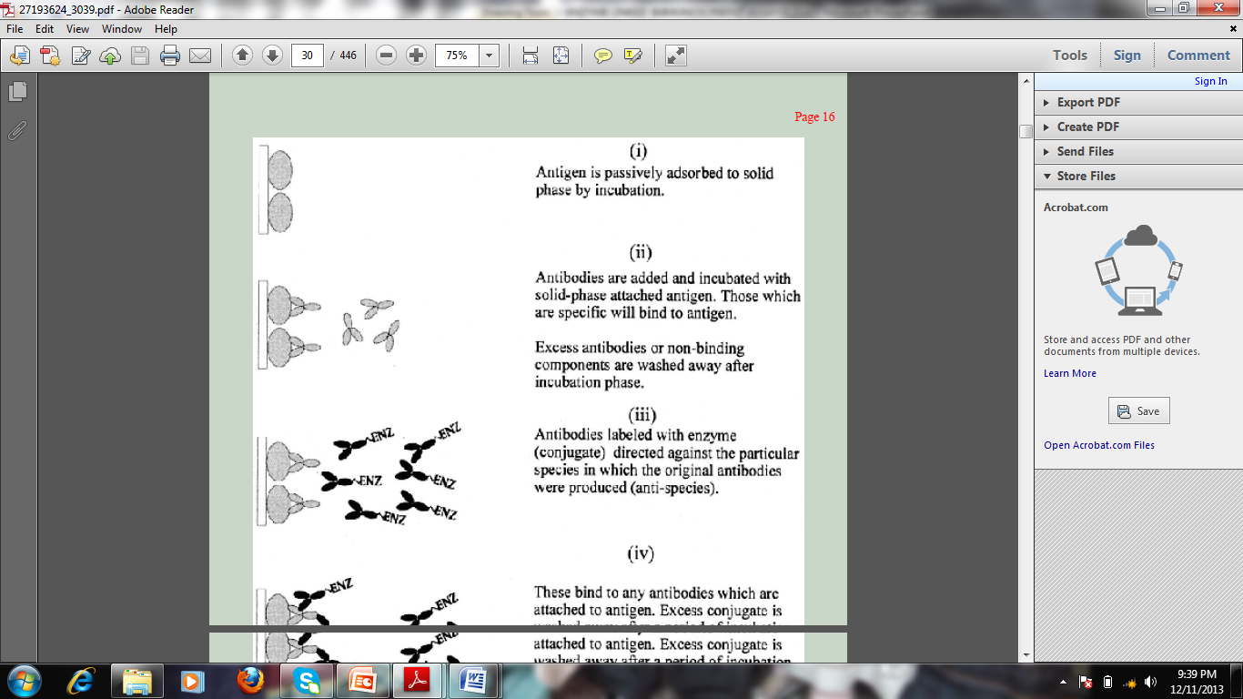

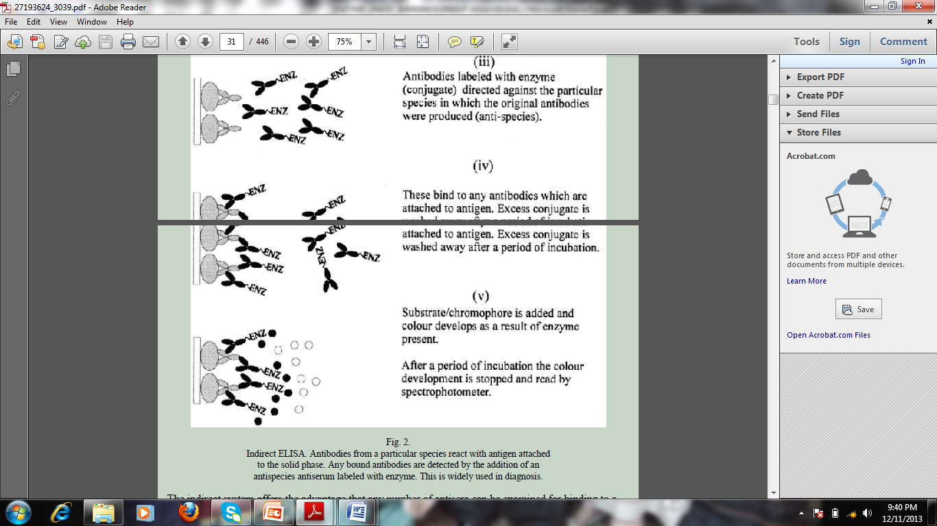

* (CROWTHER,J.(2000)*The Elisa Guidebook.2nd edition.Humana Press* )

**3.DIRECT SANDWICH**

1. The success of an ELISA assay is dependent upon the underlying level of immunoreactivity of the capture and detection antibodies to the target analyte.
2. Direct sandwitch elisa uses two separate antibodies: the first to recognise and bind the target analyte, the second to detect the bound target.
3. In Step 1, one of the antibodies is applied to the well of a microtitre plate: this is known as the capture antibody. The capture antibody binds to the plate via passive adsorption and this step is often performed at 4oC overnight.
4. A blocking solution (typically milk protein (casein), bovine serum albumin or fish gelatin) is applied. These proteins adhere to any vacant sites on the plastic surface of the well that are not occupied by capture antibodies thereby minimising the effect of non- specific binding by other reagents to the plate surface during subsequent incubation steps.
5. Excess blocking agent is removed and the plate is rinsed before addition of the test sample (wash steps are incorporated between all incubation steps to minimise the background signal due to non-specific binding).
6. 6.If the test sample contains the target analyte, this is bound by the capture antibody that is anchored to the plate (Step 2).
7. After the incubation step with the test sample, the plate is washed prior to the addition of the enzyme-linked detection antibody (Step 3).

* The detection antibody is conjugated with an enzyme which is commonly either

1. **horseradish peroxidise,**
2. **alkaline phosphatase or**
3. **β-*D-galactosidase****.*

* *These enzymes are proteins that catalyse the hydrolysis of a chromogenic substrate, such as*

1. ***3,3’,5,5’-tetramethylbenzidine***
2. ***or 2,6-dichlorophenolindophenol****,*

* *which undergoes a colorimetric change that is measurable using a spectrophotometric plate reader at specified wavelengths (Step 4).*
* *With the catalysis of the traditional chromogenic substrates the reaction is terminated by the addition of a stop solution prior to measuring the absorbance of each of the wells of the microtitre plate.*

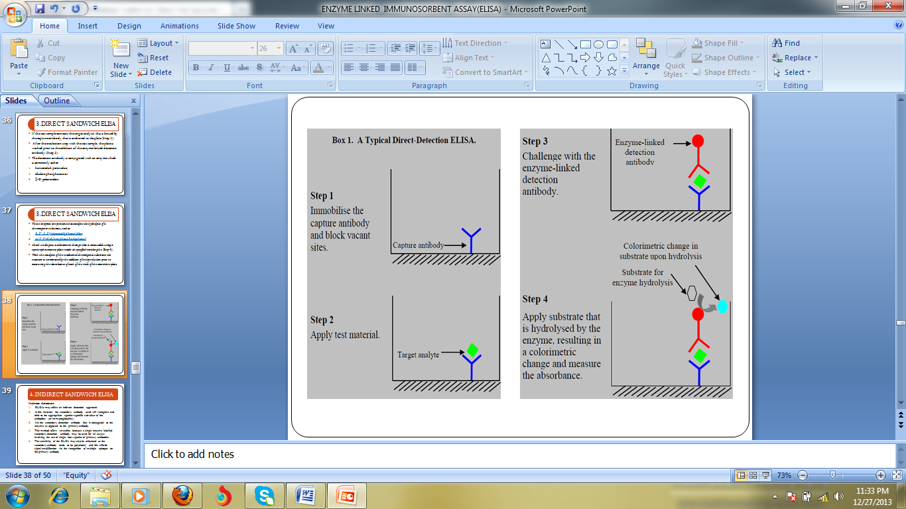

(ALBERTS ,B., JOHNSON ,A., WALKER,P., LEWIS ,J., RAFF,M. AND ROBERTS,K. (2008) *Molecular Biology of the Cell.5TH edition.Garland Publishing Inc,US)*

* **4.INDIRECT SANDWICH ELISA**

**Indirect detection**

1. ELISAs may utilise an indirect detection approach.
2. In this instance, the secondary antibody used will recognise and bind to the appropriate species-specific sub-class of the antibodies (or immunoglobulins).
3. It is the secondary detection antibody that is conjugated to the enzyme, as opposed to the primary antibody.
4. This method offers versatility because a single enzyme labelled secondary detection antibody may be used for all assays involving the use of single host species of primary antibodies.
5. The sensitivity of the ELISA may also be enhanced as the secondary antibody tends to be polyclonal, and this affords signal amplification via the recognition of multiple epitopes on the primary antibody.

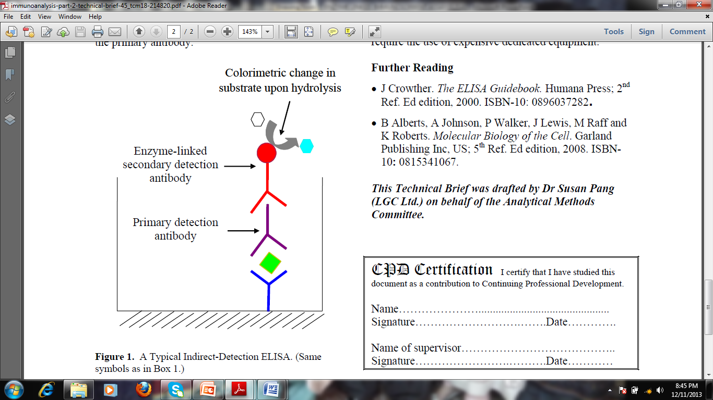

* **SIGNAL OUTPUT AND ASSAY PERFORMANCE**
* Recently, ELISAs have moved away from the use of chromogenic substrates that give the detectable colour change, to fluorogenic substrates (for example, acetyl-3,7-dihydroxyphenoxazine).
* Enhanced chemilumine-scence reagents are also used to emit light as the measure of the signal output.
* The fluorogenic and luminometric methods are more sensitive, and are reported to offer femtogram-level sensitivity with some recently developed commercially available proprietary substrates.
* Fluorogenic and luminometric substrates may also extend the linear detection range in comparison to the conventional chromogenic substrates.
* Target analyte quantification is facilitated through either internal or external standardisation, with the use of calibrants.
* ELISAs are often undertaken using duplicate or triplicate sample measurements where a coefficient of variation of around 10% is not uncommon for commercially available ELISA kits.
* Although kits are readily available for many common analytes, ELISAs may be constructed with relative ease if the antibodies to the analyte of interest can be commercially sourced.
* The success of ELISA is dependent upon the quality of the antibodies available.
* ELISA is popular because the technique is amenable to automation, and does not require the use of expensive dedicated equipment

(ALBERTS ,B., JOHNSON ,A., WALKER,P., LEWIS ,J., RAFF,M. AND ROBERTS,K. (2008) *Molecular Biology of the Cell.5TH edition.Garland Publishing Inc,US)*

* **ADVANTAGES OF ELISA**

1. **Simplicity**

(a) Reagents added in small volumes

(b) Separation of bound and free reactants is made by simple washing procedures.

(c) Passive adsorption of proteins to plastic is easy.

(d) Specialized equipment readily available.

* 2. **Reading**

(a) Colored end-product can be read by eye to assess whether tests have

worked (avoiding waiting for results where machine reading essential as

in RIA)

(b) Multichannel spectrophotometers quantify results that can be examined statistically.

* **3**. **Rapidity**

(a) Tests can be performed in a few hours

(b) Spectrophotometric reading of results is rapid (96 wells read in 5 s)

**4. Sensitivity**

Detection levels of 0.01 to 1 μg/mL are easily and consistently achievable. These levels are ideal for most diagnostic purposes

**5. Reagents**

Commercially available reagents offer great flexibility in ELISA design

and achievement of specific assays

**6. Adaptability**

Different configurations allow different methods to be examined to solve problems. This is useful in developing tests and research science

**Cost**

(a) Startup costs are low

(b) Reagent costs are low

**8. Acceptability**

Fully standardized ELISAs in many fields are now accepted as "goldstandard"

assays

**9. Safety**

Safe nonmutagenic reagents are available. Disposal of waste poses no

problem (unlike radioactivity)

**10. Availability**

ELISAs can be performed anywhere, even in laboratories where

facilities are less than state of the art

**11. Kits**

ELISA kits are widespread and successful

**12. Standardization**

Quantification of data allows easier standardization

* (CROWTHER,J.(2000)*The Elisa Guidebook.2nd edition.Humana Press* )

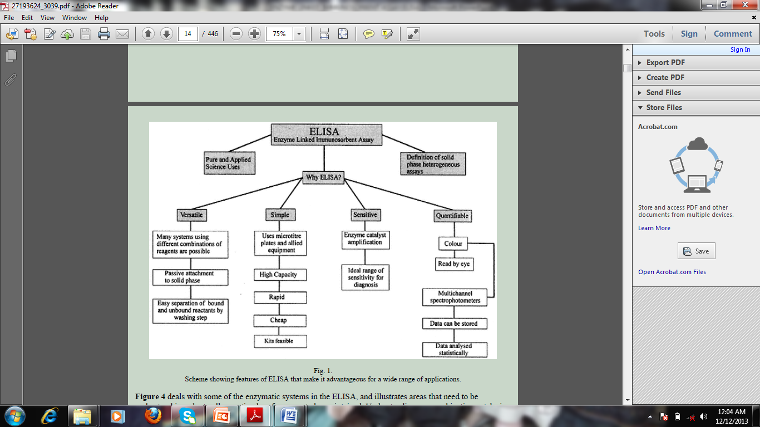

**REFERENCES**

* J Crowther. *The ELISA Guidebook.* Humana Press; 2nd Ref. Ed edition, 2000. ISBN-10: 0896037282**.**
* B Alberts, A Johnson, P Walker, J Lewis, M Raff and K Roberts. *Molecular Biology of the Cell*. Garland Publishing Inc, US; 5th Ref. Ed edition, 2008. ISBN-10**:** 0815341067.