**CARBOHYDRATES**

**DEFINITION**

Carbohydrates are defined as

“aldehydic or ketonic alcohols that contain carbon, hydrogen and oxygen in which hydrogen and oxygen are in the same ratio as in water (2:1)” e.g. glucose, fructose, maltose.

“OR”

“polyhydric alcohols with potentially active carbonyl group which may either be aldehyde or ketone”

“OR”

“aldehyde or ketone derivatives of higher polyhydric alcohols or compounds which yield these derivative on hydrolysis”.

“OR”

“polyhydroxy aldehydes or ketones, or substances that hydrolyze to yield polyhydroxy aldehydes or ketones”.

The term carbohydrate is most common in [biochemistry](http://en.wikipedia.org/wiki/Biochemistry), where it is a synonym of **saccharide**. The word *saccharide* comes from the [Greek](http://en.wikipedia.org/wiki/Greek_language) word (*sákkharon*), meaning "[sugar](http://en.wikipedia.org/wiki/Sugar)."

The **general formula** for a carbohydrate can be written as Cx(H2O)y. Most carbohydrates are **polymers**. Polymers are large, complex molecules composed of long chains of monomers. **Monomers** are small, basic molecular units.

While the scientific nomenclature of carbohydrates is complex, the names of the monosaccharides and disaccharides very often end in the suffix [-ose](http://en.wikipedia.org/wiki/-ose). For example, [blood sugar](http://en.wikipedia.org/wiki/Blood_sugar) is the monosaccharide [glucose](http://en.wikipedia.org/wiki/Glucose), table sugar is the disaccharide [sucrose](http://en.wikipedia.org/wiki/Sucrose), and milk sugar is the disaccharide [lactose](http://en.wikipedia.org/wiki/Lactose)

**BIOLOGICAL SIGNIFICANCE OF CARBOHYDRATES**

Carbohydrates perform numerous roles in living organisms.

* Glucose & galactose are the prime source of energy in the body, glycogen is the major storage form of energy in body.
* Polysaccharides serve for the storage of [energy](http://en.wikipedia.org/wiki/Energy) (e.g., [starch](http://en.wikipedia.org/wiki/Starch) and [glycogen](http://en.wikipedia.org/wiki/Glycogen))
* Polysaccharides serve as structural components (e.g., [cellulose](http://en.wikipedia.org/wiki/Cellulose) in plants and [chitin](http://en.wikipedia.org/wiki/Chitin) in arthropods).
* The 5-carbon monosaccharide [ribose](http://en.wikipedia.org/wiki/Ribose) is an important component of [coenzymes](http://en.wikipedia.org/wiki/Coenzyme) (e.g., [ATP](http://en.wikipedia.org/wiki/Adenosine_triphosphate), [FAD](http://en.wikipedia.org/wiki/FAD), and [NAD](http://en.wikipedia.org/wiki/Nicotinamide_adenine_dinucleotide)) and the backbone of the genetic molecule known as [RNA](http://en.wikipedia.org/wiki/RNA). The related [deoxyribose](http://en.wikipedia.org/wiki/Deoxyribose) is a component of [DNA](http://en.wikipedia.org/wiki/DNA). These are the most abundant compound found in nature.
* Saccharides and their derivatives include many other important [biomolecules](http://en.wikipedia.org/wiki/Biomolecules) that play key roles in the [immune system](http://en.wikipedia.org/wiki/Immune_system), [fertilization](http://en.wikipedia.org/wiki/Fertilization), preventing [pathogenesis](http://en.wikipedia.org/wiki/Pathogenesis), [blood clotting](http://en.wikipedia.org/wiki/Blood_clotting), and [development](http://en.wikipedia.org/wiki/Developmental_biology).
* Cellulose forms part of cell wall of plant cells and bacteria.
* They occur as simple form (sugar) or in bound form (mostly).
* The reducing carbon of a carbohydrate can attach to a great variety of organic & inorganic substances.

**PHARMACEUTICAL IMPORTANCE OF CARBOHYDRATES**

Carbohydrates are used in pharmacy:

* + For the preparation of simple syrup (sucrose).
  + As diluents& binders for the preparation of tablets (lactose, starch, gums) & for coating sugar-coated tablets (liquid glucose).
  + For preparation of infant’s food (starch & dextrin).
  + For preparation of sterile IV solutions (dextrose).
  + In anti–diarrhea drugs (pectin).
  + As laxatives (mucilage, lactulose), antacids (sucralfate) or diuretic drugs (mannitol & sorbitol).
  + As emulsifying agents (gums).
  + As a nutrient media for both bacteria and tissue cultures (agar).
  + In the preparation of surgical dressing (cellulose) & plasters (gums).
  + Some carbohydrate derivatives have various therapeutic use such as ascorbic acid, glucosamine, dextran etc.

**CLASSIFICATION OF CARBOHYDRATES**

Depending upon the monomer units present in the molecule, carbohydrates are classified as

1. Monosaccharides
2. Oligosaccharides
3. Polysaccharides

**MONOSACCHARIDES**

The monosaccharides are polyhydroxy aldehydes or polyhydroxy ketones which cannot be decomposed by hydrolysis to give simpler carbohydrates

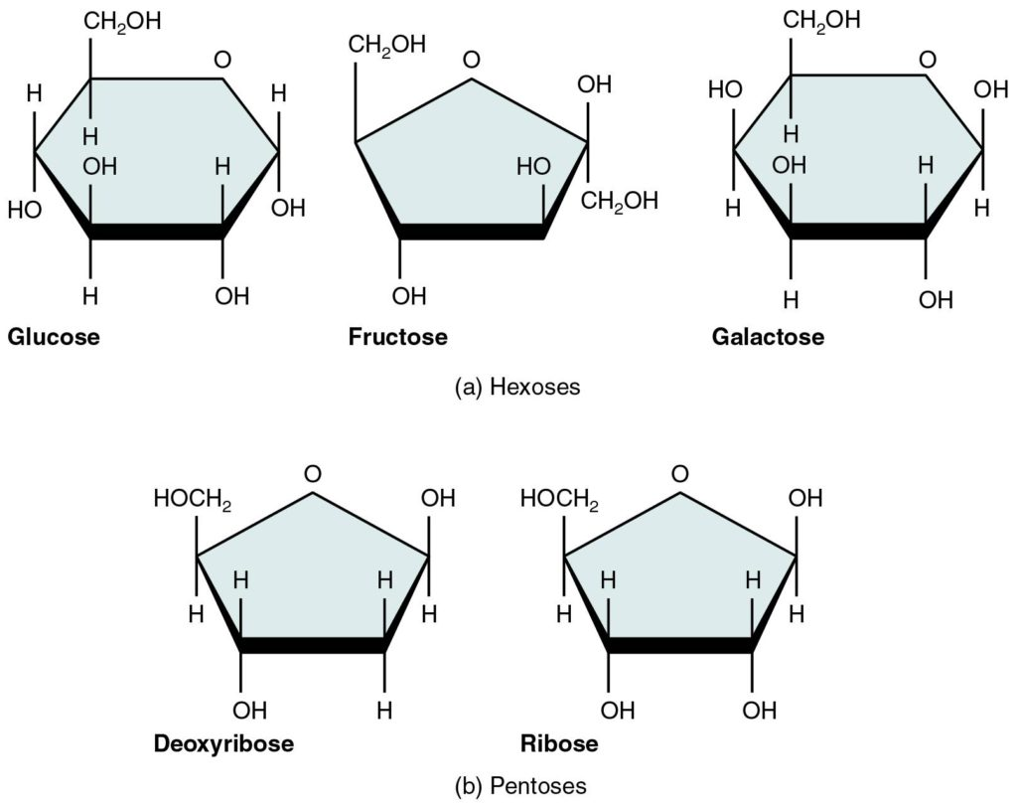

* Molecules having only one actual or potential sugar group are called Monosaccharides.
* Greek → Mono = one & Saccharide = Sugar
* **Monosaccharides** are simple sugars in which there are one oxygen atom and two hydrogen atoms for each carbon atom present in the molecule.
* They have **general formula** as (CH2O)n.
* Monosaccharides are **reducing sugars**.
* The test for reducing sugar is called **Benedict’s test**.
* They are **sugars**, which taste sweet, are soluble in water and are insoluble in non-polar solvents.
* They exist in **straight chains**or**in the ring**or**cyclic forms**.
* The names of all sugars end with **-ose**.
* They are used as a source of energy in respiration.
* They are important building blocks for large molecules.

**Some Common Monosaccharides**

**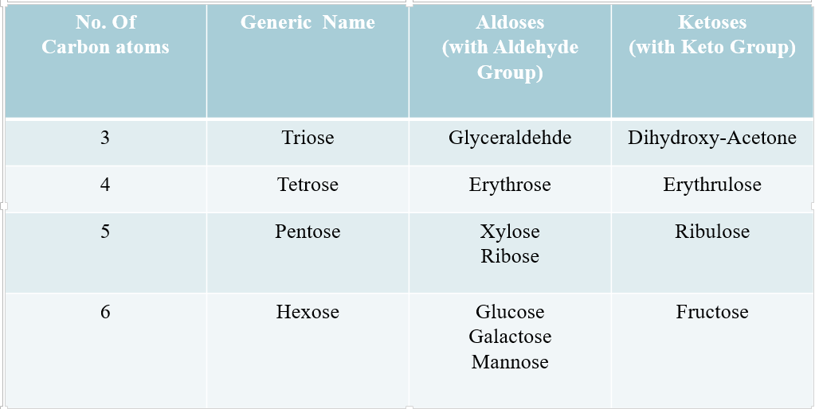**

**OLIGOSACCHARIDES**

The oligosaccharides (Greek, oligo, few) are carbohydrates which yield a definite number (2-9) of monosaccharide molecules on hydrolysis. They include,

**(a)**    **Disaccharides,** which yield two monosaccharide molecules on hydrolysis.

Examples are sucrose and maltose, both of which have molecular formula, C12H22O11.

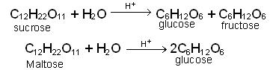

**(b)**    **Trisaccharides,** which yield three monosaccharide molecules on hydrolysis.

Example is raffinose, which has molecular formula, C18H32O16.

1162_carbohydrates.JPG

**(c)**    **Tetrasaccharides**, which gives upon [hydrolysis](https://en.wikipedia.org/wiki/Hydrolysis) four molecules of the same or different [monosaccharides](https://en.wikipedia.org/wiki/Monosaccharide). The general formula of a tetrasaccharide is typically C24H42O21.

Example, [stachyose](https://en.wikipedia.org/wiki/Stachyose) upon hydrolysis gives one molecule each of [glucose](https://en.wikipedia.org/wiki/Glucose) and [fructose](https://en.wikipedia.org/wiki/Fructose) and two molecules of [galactose](https://en.wikipedia.org/wiki/Galactose).

**DISACCHARIDES**

**Disaccharides** are made up of two monosaccharides joined together by a **condensation reaction**.

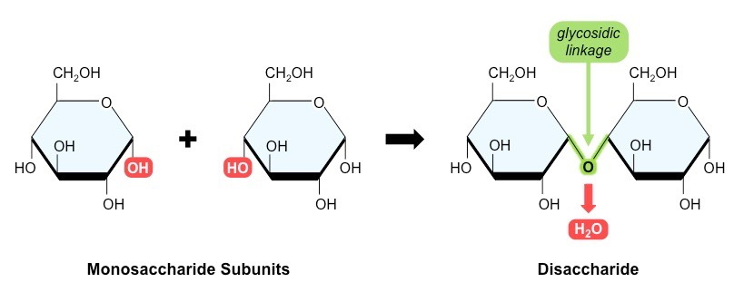

* **The condensation reaction** is the joining of two molecules with the formation of a new chemical bond and a water molecule is released when the bond is formed.
* A **glycosidic bond** is formed between two monosaccharides. If carbon 1 on one monosaccharide joins to carbon 4 on another monosaccharide, it is called a 1,4-glycosidic bond.

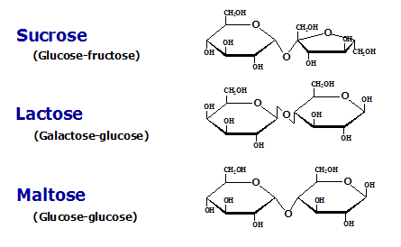

* **Examples:**

**Maltose** is formed from two α-glucose molecules joined together by a glycosidic bond.

**Sucrose** is formed from a condensation reaction between a glucose molecule and a fructose molecule.

**Lactose** (milk sugar) is formed from glucose and a galactose molecule.

* Sucrose is a **non-reducing sugar**.
* Disaccharides can be split apart into two monosaccharides by breaking the glycosidic bond by adding water molecules, which is known as **hydrolysis reaction**. The water provides a hydroxyl group (-OH) and hydrogen (-H), which helps the glycosidic bond to break.

**Reducing disaccharide** contains at least one free functional group & can reduce substances

e.g., Maltose & Lactose;

**Non-reducing disaccharide** does not contain any free functional group thus can not reduce any substance

e.g., Sucrose

**POLYSACCHARIDES**

* **Polysaccharides** are polymers formed by combining many monosaccharide molecules (more than two) by condensation reactions.
* Molecules with 3-10 sugar units are known as **oligosaccharides**while molecules containing 11 or more monosaccharides are **true polysaccharides**.
* Polysaccharides **do not taste sweet**.
* Because their molecules are so enormous, the majority of polysaccharides **do not dissolve in water**.
* Polysaccharides made solely from one kind of monosaccharides are called **homopolysaccharides** (Starch, glycogen, inulin, cellulose, dextran, dextrin) while those made of more than one monomer are called **heteropolysaccharides**(Hyaluronic acid).

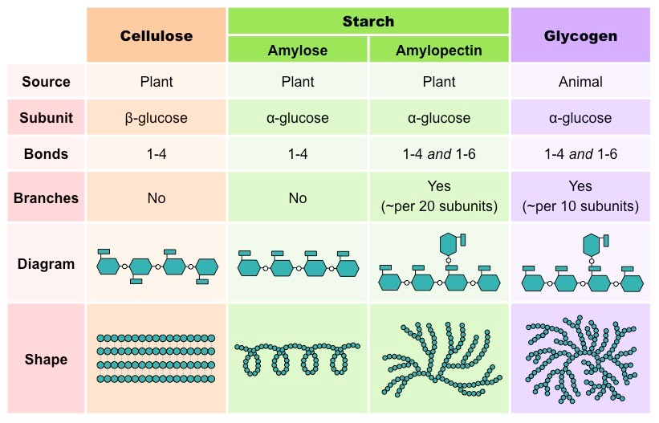

* [**Starch**](https://microbenotes.com/starch-hydrolysis-test-objectives-principle-procedure-and-results/) is made up of long chains of α-glucose (Amylose and Amylopectin).
* **Glycogen** is made of α-glucose linked together by glycosidic bonds.
* **Cellulose** is also made of many β-glucose molecules linked by glycosidic bonds between carbon 1 and carbon 4.
* **Starch** is the main energy storage materials in plants.
* **Glycogen** is the main energy storage materials in animals.
* **Cellulose** is the major component of cell walls in plants.
* The test for starch is called an **Iodine test**.

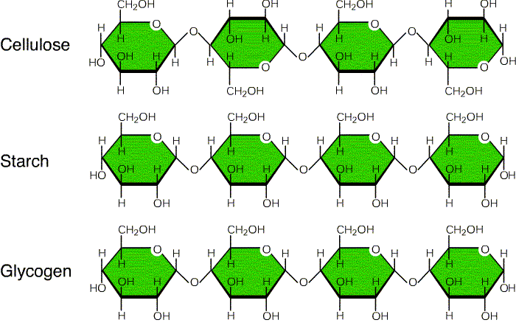

**DERIVED CARBOHYDRATES**

Consist of those products which are derived from CHO- by different chemical reactions.

* It include the following products.
  + **Oxidation products** e.g., Gluconic, Glucoronic & Glucaric acids.
  + **Reduction products** e.g., polyhydroxyalcohol, glycerol, sorbitol, & Ribitol
  + **Sugar amines** e.g., Glucosamine, galactosamine.
  + **Deoxy sugars** e.g., Deoxyribose (DNA).
  + **Glycolipids** e.g., Sulpholipid, Gangliolipid.
  + **Glycoproteins** e.g., Hormones, Antibiotics, Plasma proteins.