**PHANEROGAMIC PARASITE**

“The plants which produce flower and subsequently bear seeds in fruits and parasitized on other plants known as Phanerogamic parasite”

**General Properties of Parasitic Plants**

* Nutrients and water are transported via a Physiological bridge called the Haustorium.
* A parasite connects its vascular system (at least one of the tissue) to that of the host plant.
* The parasite may totally discard its own photosynthesis.
* Parasites may be mostly exposed at the surface of the host (Epiparasite).
* Mostly parasite hidden within the host organ (Endoparasite).
* The endoparasitic portion is composed of thread-like haustoria permeating the host tissue with a sinker, a single structure that becomes embedded in the host tissue.

**Types of Phanerogamic Parasites**

**There are two types of flowering plants**

1. Stem Parasite
2. Root Parasite

**Stem Parasite**

* **Holoparasite:** Entirely Dependent

For Example: Dodder on gardens, ornamentals and hedge plants.

* **Semi-Parasite:** Partially Dependent

For Example: *Loranthus* on fruits, wasteland, roadside and forest trees.

**Root Parasite**

* **Holoparasite**: Entirely Dependent

For Example: *Orobanche* on tobacco, mustard, Brinjal tomato, cabbage, cauliflower, turnip and many other solanaceous and cruciferous plants.

* **Semi-Parasite:** Partially Dependent

For Example: Striga on Sugarcane, Cereals, maize and Millets.

**Dodder (Love vine, Amarbel)**

* Scientific name*: Cuscuta* spp.
* It is a non chlorophyllous, leaf less parasitic seed plant
* It is yellow pink or orange in color and attached to the host.
* They do not bear leaves but bear minute functionless scale leaves
* Produces flower and fruits. Flower are white, pink or yellowish in color and found in clusters.
* Seed are form in capsules. A single plant may be produce 3000 seeds

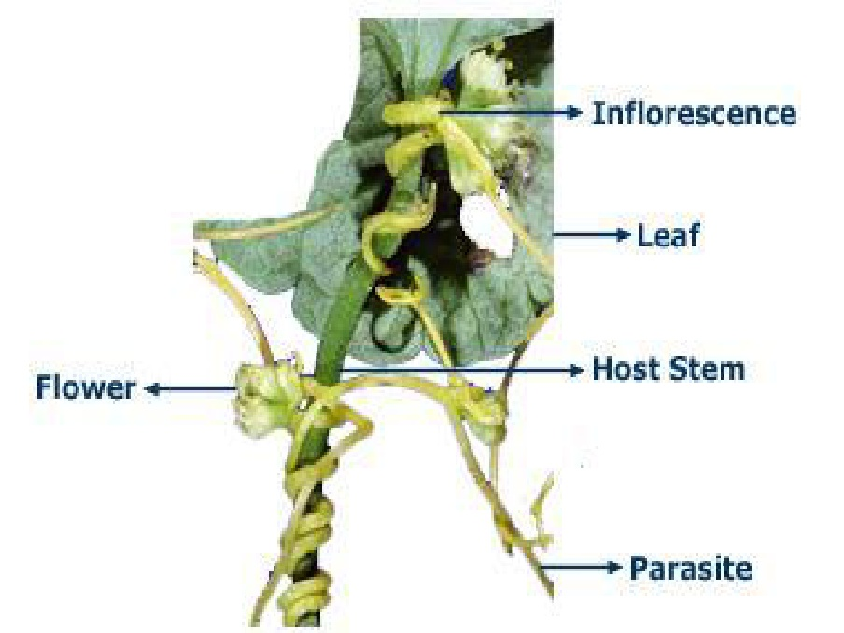

* 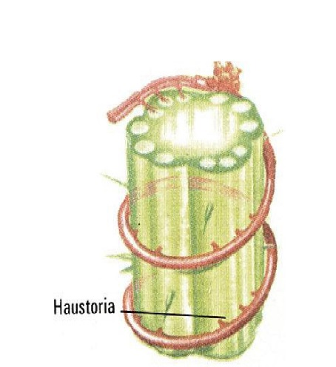When stem of parasitic plant comes in contact with host, the minute root like organs i.e. haustoria penetrates into the host and absorbs.

**Mechanism**

* The haustoria penetrate the stem or leaf and reach into the cortical region just outside the pericycle like an adventitious root.
* The haustoria secrete enzymes into the plant tissues that hydrolyze reserved food stuffs, such as, starch, and thus make them available to the dodder plant.
* These hydrolyzed substances and water are absorbed by the haustoria and are transported to the dodder stem where they are utilized for further growth and reproduction.

**Overwintering and Dissemination**

* As impurity of the crop seed.
* As seeds and stem pieces moved by irrigation water.
* As stem pieces present on the dry straw from infested fields.
* As seeds in the manure.
* As stem pieces transported by cattle and farm implements.
* As stem pieces carried by birds or strong winds.

**Symptoms on host plants**

* Host suffers from malnutrition
* Vitality of the host plant is reduced
* Plant may be dwarf
* Yellowing of the leaves with less flowers and fruiting
* In case of severe attack, the whole plant of the affected part may die.

**Mistletoes/Banda**

* Scientific name: *Lorunthus* sp.*/Dendrophthae* sp.
* Semi-parasitic plant of fruit and forest tree e.g. Mango
* Dense cluster of twigs
* Smooth green leaves
* [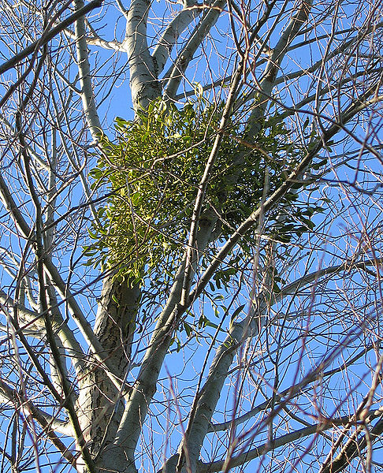](http://upload.wikimedia.org/wikipedia/commons/7/7d/MistletoeInSilverBirch.jpg)Tubular flower
* No root system
* Develop haustoria
* Synthesized carbohydrates
* It depends on host only for water and minerals but do not totally depend on host

**Overwintering and dissemination**

**Overwinters as seeds.**

* Spread by dispersal of its seed mostly through hybrids and to some extent by other animals.
* Birds are attracted by brilliant color of the fruit.
* Droppings of birds containing seeds also help in dissemination of the parasite

**Development of parasitic relationship with host**

* Seed lands on and becomes attached to the bark of a twig of host
* Germinates and produces a germ tube or radicle. This grows along the bark surface until it meets a bud or a leaf base, at which the radicle becomes broad and flattened on the side of the bark.
* Haustorium is produced and penetrate the bark directly and reaches the phloem and cambium.

**Symptoms on host plant**

* Stunted growth of the host
* Reduce the leaves size and may show unhealthy green color.
* Flowering and fruiting may be hampered.
* Tumor may form on the in1inch area.
* Quality and yield of fruit is considerably lowered.

**Parasitic plant: Broom-rape**

* 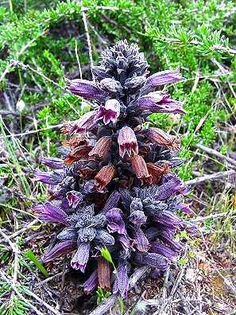Scientific name *Orobanche* spp.
* Total root parasites
* Has a stout, fleshy, stem, 10-15 inches long.
* The stem is pale yellow or brownish red in color and is covered by small thin and brown scaly leaves.
* Flowers are white and tubular. The seeds are very small and black in color and may remain viable in the soil for several years.
* They lack chlorophyll and hence any green coloration and their leaves are vestigial.
* Above-ground stems are produced only for the purpose of flowering and setting seed; in perennial species the plant may persist below ground, unseen for a number of years.
* Most species are highly host-specific, sometimes restricted to a single host species or genus. Others are capable of parasitizing a number of unrelated plants, but usually still show strong regional preferences.
* The seeds germinate when in contact with host roots, triggered by chemical recognition. The fine root of the broomrape grows into the host root, reaching and entering the vascular tissue. An underground tuber develops, from which, eventually, the flowering stems may develop.
* Broomrapes are thermophilic (warmth-loving) and often highly demanding in their habitat preferences.
* Frequently they require dry, open, often nutrient-poor grasslands but they are vulnerable to agricultural 'improvement', scrub development or other types of habitat loss.

**How does it persist and disseminate?**

The parasite overwinters as seed in the 1 ½ inches depth of soil. Dissemination of seeds are carried out by rain water, birds and even animals.

**STRIGA**

* 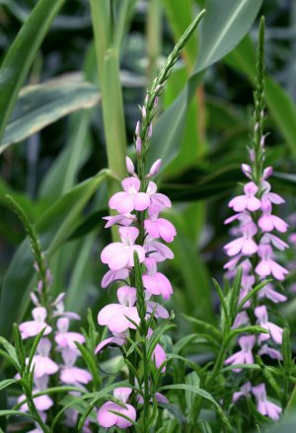Commonly known as witch weed, is a [genus](http://en.wikipedia.org/wiki/Genus) of 28 species of parasitic plants that occur naturally in parts of Africa and Asia.
* The genus is classified in the family [Orobanchaceae](http://en.wikipedia.org/wiki/Orobanchaceae) although older classifications place it in the [Scrophulariaceae](http://en.wikipedia.org/wiki/Scrophulariaceae).
* Although most species of Striga are not pathogens that affect human agriculture, some species have devastating effects upon crops, particularly those planted by subsistence farmers.
* Three species cause the most damage: *Striga* *asiatica, S. gesnerioides, and S. hermonthica.*
* Hosts: [corn](http://en.wikipedia.org/wiki/Corn) ([maize](http://en.wikipedia.org/wiki/Maize), Zea) [grasses](http://en.wikipedia.org/wiki/Grass), particularly [sorghum](http://en.wikipedia.org/wiki/Sorghum) and [pearl millet](http://en.wikipedia.org/wiki/Pearl_millet), [cowpea](http://en.wikipedia.org/wiki/Cowpea) ([Vigna unguiculata](http://en.wikipedia.org/wiki/Vigna_unguiculata" \o "Vigna unguiculata)).