|  |
| --- |
| Functional Specifications Document  <Project Title>  Project Code:  Internal Advisor:  External Advisor:  Project Manager:  Project Team:  Submission Date: _____________________**Project Manager’s Signature** |

# 

**Definition of Terms, Acronyms and Abbreviations**

*This section should provide the definitions of all terms, acronyms, and abbreviations required to interpret the terms used in the document properly.*

| Term | Description |
| --- | --- |
| ASP | Active Server Pages |
| RS | Requirements Specifications |
|  |  |
|  |  |
|  |  |
|  |  |
|  |  |
|  |  |

**Table of Contents**

1. Introduction 4

1.1 Purpose of Document 4

1.2 Project Overview 4

1.3 Scope 4

2. Functional Requirements 4

3. Non-functional Requirements 4

3.1 Performance Requirements 4

3.2 Safety Requirements 4

3.3 Security Requirements 4

3.4 User Documentation 4

4. Assumptions and Dependencies 4

5. System Architecture 5

6. Use Cases 5

6.1 Use Case Diagrams 5

6.2 Use Case Description 5

7. Graphical User Interfaces 6

8. References 8

# Introduction

This chapter details the functional specifications of flight management project, which includes introduction in Section 1 (purpose of document, project overview, scope), functional requirement in Section 2, non functional requirements in Section 3 (performance, safety and security requirements, etc.), ……………….

* 1. Purpose of Document

*Describe the purpose of this document and provide a description of the intended audience i.e., the personnel who will be reading this document.*

* Two to three sentences

The purpose of this document is to elaborate the functional specifications of airline reservation system mainly for the employees and the owners of the company.

* 1. Project Overview

State a brief description of the project under study. Describe how the software will be used and identify the relevant goals and benefits.

1. Goal statement (one or two sentences)
2. Methodology (any number of paragraphs)
3. Benefits (one sentence or paragraph)

For example

The project introduces the development of airline reservation system, which includes four modules: registration, searching, booking, payment. The first module registration deals with the simple signup/profile-building of customer, company personnel. Second module …………………. Third module ………………………………….. Fourth module…………………………………………………….. This system will ease flight management for passenger trying to buy airline tickets and travel agents who are managing flights.

* 1. Scope

*List down the scope of the project. Describe what the system will and will not do.*

As done in previous chapter

# Functional Requirements

This section should contain a textual description of the requirements related to the customer’s business. This should contain a list of all the business events related to the business process.

As done in previous chapter

# Non-functional Requirements

As done in previous chapter

* 1. Performance Requirements

The performance characteristics of the system that are required by the business should be outlined in this section. Performance characteristics include the speed, precision, capacity, safety, and reliability of the software. These characteristics define the performance of the project.

* 1. Safety Requirements

Specify the requirements that are concerned with possible loss, damage, or harm that could result from the use of the system. Define any safeguards or actions that must be taken, as well as potentially dangerous actions that must be prevented. Identify any safety certifications, policies, or regulations to which the system must conform.

* 1. Security Requirements

Specify any requirements regarding security, integrity, or privacy issues that affect the use of the system and protection of the data used or created by the system. Define all user authentication or authorization requirements, if any. Identify any security or privacy policies or certifications the system must satisfy.

* 1. User Documentation

List the user documentation components that will be delivered along with the software, such as user manuals, online help, and tutorials.

# Assumptions and Dependencies

*List any assumed factors that could affect the stated requirements. These factors are not system constraints, but areas where future changes might drive changes in the requirements. The project could be affected if these assumptions are incorrect, are not shared, or changed.*

*Also, identify any dependencies the project has on external factors. For example, if you expect to integrate into the system some components that are being developed by another project, you are dependent upon that project to supply the correctly operating components on schedule.*

The document notes the areas that the Software Engineering development teams should extend with the requirements from their documents. The development team should assume the following:

* Flight plans are filed as type IFR (instrument flight rules) only.
* The system will have access to the GPS in order to update aircraft position during flight.
* The development team will have access to the TGF (Target Generation Facility) simulator to generate realistic Aircraft trajectories and associated digital radar messages for aircraft in a simulated airspace environment.
* The GPS will report the estimated time to waypoint, true airspeed, distance, and location in real-time during flight.
* The system has been initialized with a database tables that contain predefined waypoints along with the location and a description of whether the waypoint is a beacon or an airport; valid airports along with the attributes of name, identifier and location in the form of latitude and longitude; and aircrafts of interest along with relevant attributes and characteristics.
* There will be reliable communication between the tablet and Google Glass.
* The user will not be able to add new waypoints.
* The characteristics of the aircraft are using general parameters and the algorithms are simplified based on this. It is important to note that there are many factors that impact fuel consumption, e.g., altitude.
* The development team will design for change, in particular considering the next version will extend the functionality such as being able to add waypoints and view a variety of maps.

# System Architecture

This section should provide the complete architecture of the system with description. Diagrammatic architecture is compulsory. Also include Data Flow Diagrams in this section.

* Introduce Context Level Diagram, DFDs (level wise), etc.

## System Overview

Provide a high-level diagram/description of the application architecture. Describe how the higher-level components collaborate with each other in order to achieve the required results.

Example diagram:

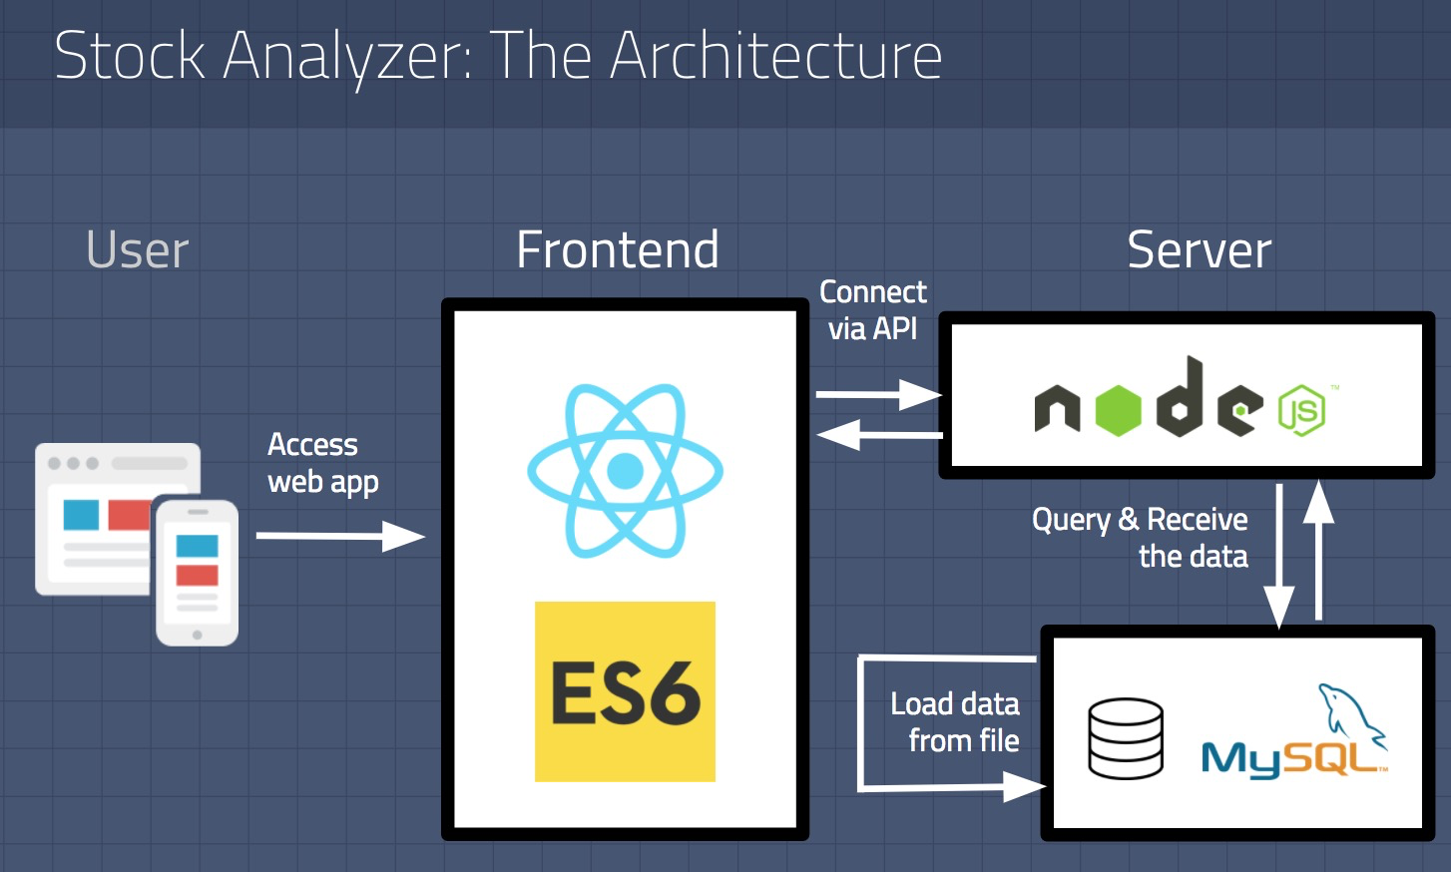

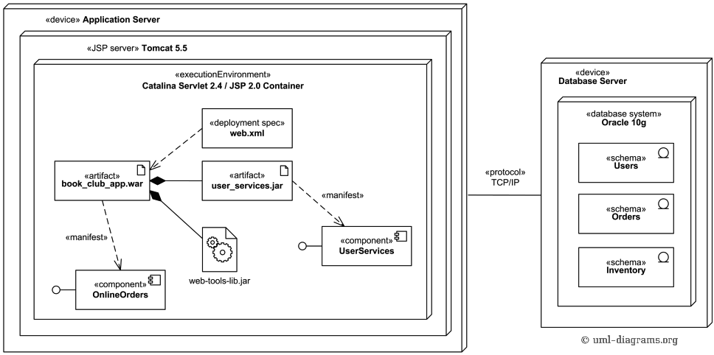

Context Level DFD



Level 1 DFD

Level 2 DFD



Program Structure/Design Architecture

# Use Cases

* 1. Use Case Diagrams

In this section provide use case diagrams using UML convention.

Online shopping UML use case diagram example - top level use cases.

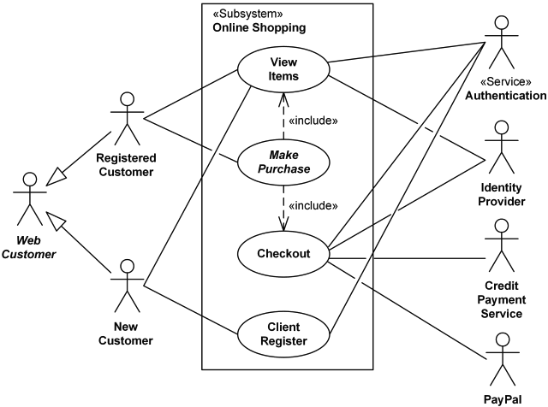

* 1. Use Case Description

*Each Use Case has a description, which describes the functionality that will be built in the proposed system. The template for Use Case description is given below:*

* *Take some old document from your supervisor’s office to get better understanding.*

|  |  |  |  |  |
| --- | --- | --- | --- | --- |
| **<1.2: Customer>** | | | | |
| **Actors:**  *<Customers >* | | | | |
| **Feature:**  *<Feature from which the use case is driven>* | | | | |
| **Use case Id:** | | *1.2* | | |
| **Pre-condition:** | | *<Registered Users for Booking a flight, etc. >* | | |
| **Scenarios** | | | | |
| **Step#** | **Action** | | | **Software Reaction** |
| **1.** | *Registration* | | | *Registration form, Checks, Successful* |
| **2.** | Searching | | |  |
| **3.** | Book a flight | | |  |
| **Alternate Scenarios:** *Write additional, optional, branching or iterative steps. Refer to specific action number to ensure understandability.* | | | | |
| **1a:**  **2a: Guest and Registered Users can search**  **3a: Registration is needed to book a flight.** | | | | |
| **Post Conditions** | | | | |
| **Step#** | **Description** | | | |
|  | *Sequentially list conditions expected at the completion of the use case.* | | | |
| **3** | **Payment is post condition of flight booking** | | | |
|  |  | | | |
| **Use Case Cross referenced** | | | *<Administrator>* | |
| **User Interface reference** | | | 1. *Registration Interface* 2. *Searching Interface* 3. *Etc.* | |
| **Concurrency and Response** *Give an estimate of the following*   * *50,0000* * *30mins* | | | | |

* 1. UML Diagrams
     1. Component Diagram

Online shopping UML **component diagram** example with three related subsystems - WebStore, Warehouses, and Accounting.

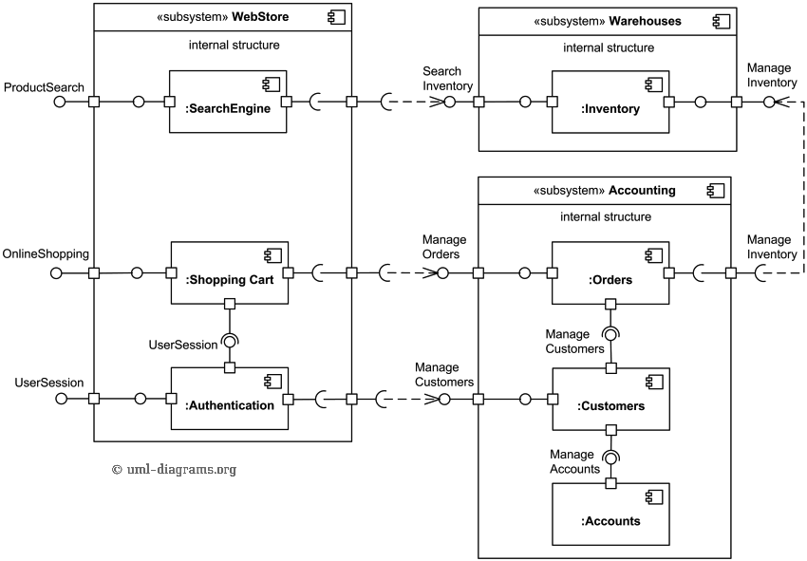

* + 1. Activity Diagram

An example of UML activity diagram for online shopping is as follows.

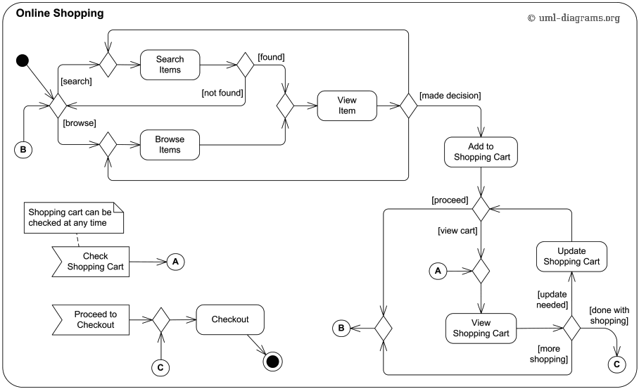

* + 1. State Machine Diagram (Optional)

Bank account user account protocol state machine diagram.

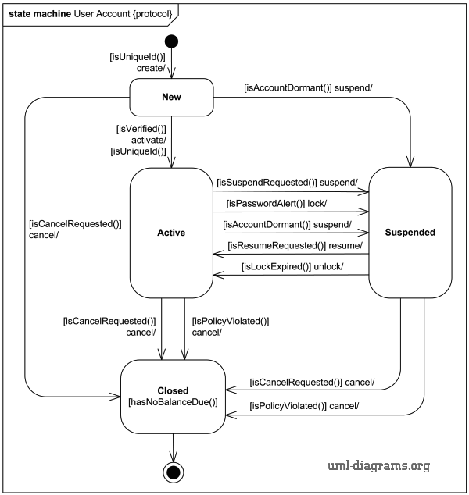

* + 1. Sequence Diagram

An example of UML sequence diagram for online bookshop.

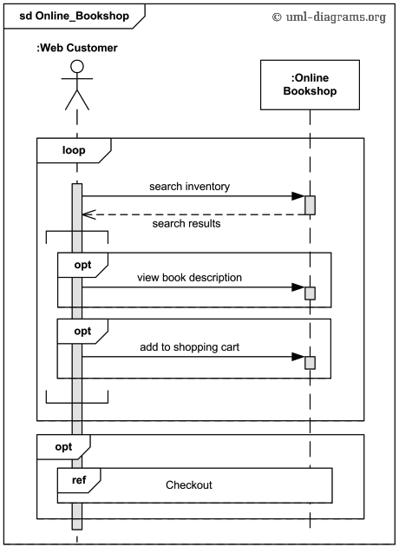

* + 1. Collaboration Diagram

A collaboration diagram (next) that describes part of the flow of events of the use case Receive Deposit Item in the Recycling-Machine System.

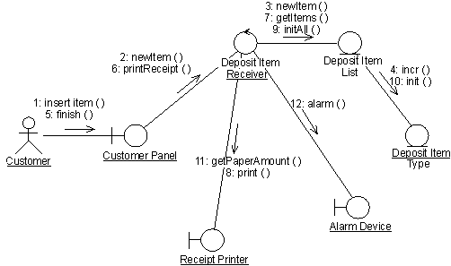

* + 1. Class Diagram

Online shopping domain UML class diagram example.

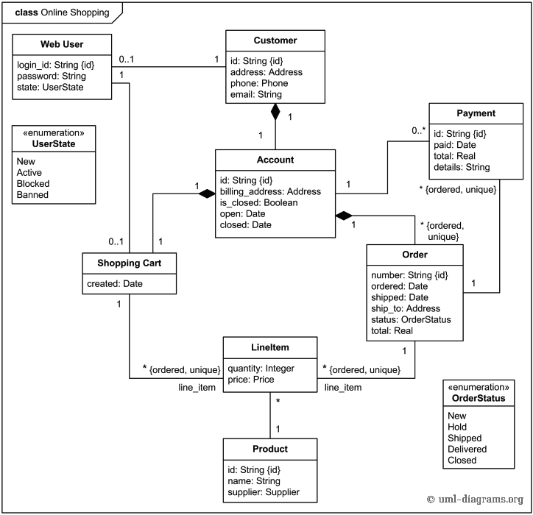

# Graphical User Interfaces

Give a detailed account of user interfaces included in this project.

|  |  |  |
| --- | --- | --- |
| **<User Interface Id: Title>** | | |
| **Interface Id.** | | *Write the reference number assigned to this UI.* |
| **Use case Reference** | | *Refer to the use case invoking this UI.* |
| **Snapshot** | | |
| *Include a labeled snapshot of the user interface.* | | |
| **Data dictionary reference** | | |
| **Label** | **Data dictionary identifier** | |
|  | *Refer to fields in data dictionary* | |
|  |  | |
|  |  | |
|  |  | |

# High Level Design

* 1. ER Diagram
  2. Data Dictionary

*The convention recommended for writing the data dictionary is as follows.*

* + 1. Data 1

*Description (Refer to Template on next page).*

* + 1. Data 2

*Description (Refer to Template next page).*

***.***

.

.

.

* + 1. Data n

*Description (Refer to Template next page).*

*.*

|  |  |
| --- | --- |
| **< Data 1>** | |
| Name | *Give primary name of the data or control item, the data store or an external entity.* |
| ***Alias*** | *Write other names used for the first entry.* |
| ***Where-used/how-used*** | *List all processes that use the data or control item and how it is used (e.g., input to process, output from the process, as a store, as n external entity)* |
| *Content description* | *Notation for representing content.* |
| ***Supplementary information*** | *Other information about data types, preset values, restrictions or limitations etc.* |

*Make Similar tables for all the data items.*

The notation to develop content description is given below:

|  |  |  |
| --- | --- | --- |
| **Data construct** | **Notation** | **Meaning** |
|  |  |  |
|  | = | *is composed of* |
| *Sequence* | + | *and* |
| *Selection* | [|] | *either-or* |
| *Repetition* | {}n | *n repetitions of* |
|  | ( ) | *optional data* |
|  | * … * | *delimits comments* |
|  |  |  |
|  |  |  |
|  |  |  |

# Requirements Traceability Matrix

|  |  |  |  |  |  |  |
| --- | --- | --- | --- | --- | --- | --- |
| **Sr. #** | **Feature** | **Use case ID** | **UI ID** | **Priority** | **Build Number** | **Use Case Cross reference**  **(Related Use Cases)** |
|  |  |  |  |  |  |  |
|  |  |  |  |  |  |  |
|  |  |  |  |  |  |  |
|  |  |  |  |  |  |  |

*The columns carry the following meaning:*

* *Feature: Lists system features based on which use cases are built.*
* *Use Case ID: Write the ID of the use case for easy lookup*
* *UI ID: Write the user interface ID for this use case.*
* *Priority: Give an appropriate rating to each use case according to its priority*
* *Build Number: Write the reference number to which this feature belongs.*
* *Use Case Cross Ref: Write the related use cases separated with commas.*

# Risk Analysis

**(Consult your Project Manager for this section)**

*Perform an analysis of the constraints and identify the potential problems that may arise in the project due to the constraints. For this section cover the following:*

* *Risk Identification*
* *Risk Drivers*
* *Percentage Impact of Risk Drivers*
* *Risk Mitigation Plan*

# Cost Estimation Sheet

**(Consult** **your Project Manager for this section)**

|  |  |  |
| --- | --- | --- |
|  | **Software development cost** |  |
|  | **Packaged software** |  |
|  | **Hardware** |  |
|  | **Network** |  |
|  | **Client** |  |
|  | **Misc.** |  |
|  |  |  |
|  |  | **Total cost =** |

# References

*This section should provide a complete list of all documents referenced at specific point in time. Each document should be identified by title, report number (if applicable), date, and publishing organization. Specify the sources from which the references can be obtained (This section is like the bibliography in a published book).*

| Ref. No. | Document Title | Date of Release/ Publication | Document Source |
| --- | --- | --- | --- |
| PGBH01-2003-Proposal | Project Proposal | Oct 20, 2003 | <Give the path of your Project repository/Folder> |
| 1 | [Mango Classification Using Texture & Shape Features](http://paper.ijcsns.org/07_book/201808/20180820.pdf). | August 2018 | International Journal of Computer Science and Network Security, Vol. 18(8), P 223-235 |
|  |  |  |  |
|  |  |  |  |
|  |  |  |  |
|  |  |  |  |
|  |  |  |  |
|  |  |  |  |

# Appendices

*Include supporting details that would be too distracting to include in the main body of the document.*