**X-bar theory: the shape of language in the mind.**

Words in different languages are very different, but sentence structures show a lot of similarities. It was Noam Chomsky who discovered that there are underlying cognitive structures (structures in the mind), shared by all humans, that define sentence and clause structure and allow us to interpret and create structured language. The term for this is Universal Grammar.

Syntax is a science, and the purpose of science is to discover the detailed inner of workings of natural or physical phenomena, so syntactic analysis can get very complicated. For example, here is a diagram showing some of the theorised inner structure of the Verb Phrase from my research project on the adverb ‘again’. This a very simple diagram compared to many in the Linguistic literature.

[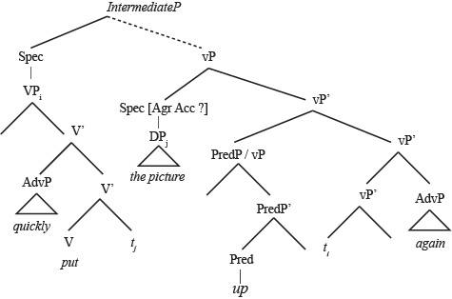](http://nzenglish.biz/wp-content/uploads/vpfromproject.jpg)

What follows is a highly simplified explanation of current theories of Syntax (in Linguistics, that’s capital-S ‘Syntax’). It’s intended to add some detail to the discussion on English sentence structure that can be found [here](http://nzenglish.biz/x-bar-theory/sentence-structure-clauses). However, you don’t need to read or understand this page to read that page, so you can skip straight there if you prefer.

***X-bar theory***

Currently, the dominant theory of Syntax is called ‘X-bar Theory’. It states that language is mentally structured in a huge tree, comprised of individual components (in Syntax we call these ‘constituents’, but I’ve avoided that term here), organised into structures known as XPs. XPs are phrases. The letter X is a generic variable that indicates that this phrase could be anything – a verb phrase, a noun phrase, a prepositional phrase or any other kind of phrase.

XP structure looks like this:

[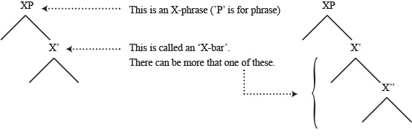](http://nzenglish.biz/wp-content/uploads/xp1.jpg)

XPs are binary, and they join onto one another in a hierarchical tree. In the example pictured below, the ZP is simply another XP (given a different variable name). Each of them could be any kind of phrase. The ZP is known as the complement of the Head of the XP. As mentioned above, these mental structures are binary: there are two branches at every position, though neither one is required to contain an element. 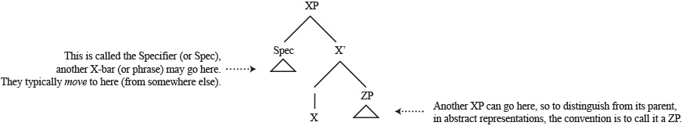

Every XP, whether it’s a verb phrase, a noun phrase, an adjective phrase, a prepositional phrase or whatever other kind of phrase, has the following structure.

* The XP is at the top, on one side there is a Specifier (or ‘Spec’, as we call it).
* The Spec can contain another phrase. This is a very common position for a Noun Phrase to appear. XPs often move into the Spec position from somewhere further down in the tree (to the right).
* Opposite the Spec is an X’ (or X-bar) branch. There can be more than one of these. If there is, the second one is called X” (X-bar-bar) On one side, the X-bar contains a Head. A Head may be a single word – in a Verb Phrase (VP), the Head is a verb, in a Noun Phrase (NP), a noun, and so on. A head can also contain something not verbally expressed, such as ‘tense’.
* Opposite the Head is a position where another X-bar or a new XP can appear.

Here is a very simple example of an XP, in this case a basic verb phrase. Actually the Verb Phrase in English doesn’t look like this – the subject is elsewhere. This is just a simplified example to show what a basic XP can look like.

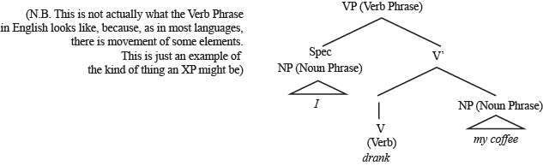

The most well-established theory of Syntax, known as GB or Government and Binding Theory), also states that an XP, or phrase, can have another XP as an ‘adjunct’, also known as a modifier. Adjectives and adverbs have been considered to be in this position. Newer theories suggest this may be an over-simplification of what is really happening, so this part of the theory should be taken with a little skepticism. Adjuncts can attach as follows:

[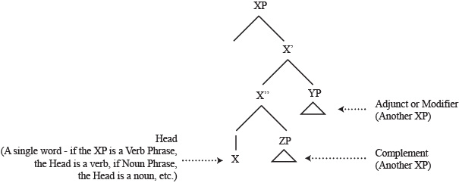](http://nzenglish.biz/wp-content/uploads/xp4.jpg)

***Movement***

The key discovery that Chomsky made was that Syntax is defined by movement. This is what makes gives one language a different sentence structure from another; and it is by movement that tense, case and other attributes are applied to a word. In Syntax the position an element has moved from is called its ‘trace’. the trace and the new position are marked with subscripts.

[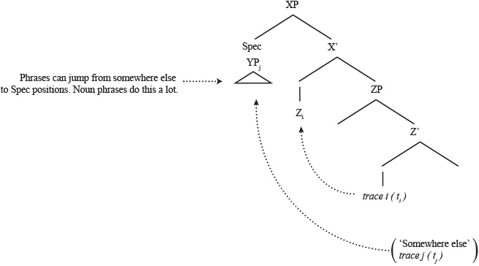](http://nzenglish.biz/wp-content/uploads/xpmovement.jpg)

Many elements move in human Syntax — this is what makes the sentence structure of language different from that of another. There are two main kinds of movement:

* Head-to-head movement  
  In head-to-head movement, a Head (a single word) moves to the Head position of the XP above it. Having moved, it can move again. It cannot move if the Head is occupied, though sometimes it can merge with the element in that Head. Head to head movement is common with elements that inflect*, such as verbs. (In fact, most Linguists believe such movement must happen for inflection to occur).

*(*Inflection is when a word-form changes depending on Tense (e.g. give /gave) or Case (e.g. they/them).*

* Moving to Spec  
  An XP can move to another Spec position to its left (higher up). XPs can also appear in Spec position without having moved from anywhere. In English, the Subject of the sentence is believed by some Linguists to appear in the Spec of the Inflection Phrase (IP), while other believe it moves there from within the Verb Phrase. Phrases can also leave behind bits of themselves when they move. Moving to Spec is especially common for Noun Phrases.

Here is a simplified version of a the top-level XPs found in a clause, showing where things appear. It contains most of the XPs that will be presented, in an even more simplified form, in the post on sentence structure.

[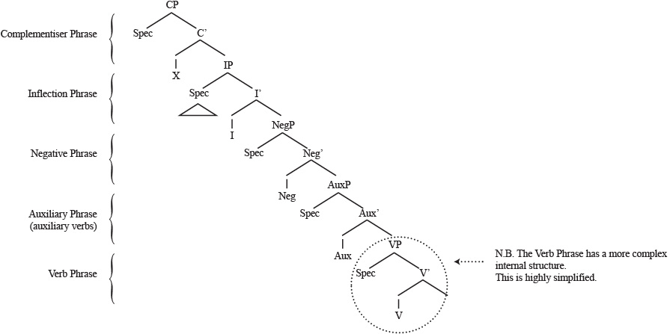](http://nzenglish.biz/wp-content/uploads/xpsentence.jpg)

There is a lot of detail missing in this diagram; some XPs are present or used in some languages but not others; some aspects are not fully understood or agreed on; and Complementiser Phrases (CPs, the highest structure in a clause) can be embedded within other CPS (which is what a relative clause is, for example); but the XPs above: CP, IP the Verb Phrase and so on, are universal to all languages — in fact to every human brain. They are the building blocks of Universal Grammar — the cognitive structures in every mind. These five XPs are also the building blocks of every English sentence or clause.

What makes one language different from another is how sentences and clauses make use of these elements. Movement is the key to this, and different elements will move to different positions in different  languages. That is the subject of my next post.