CONTEXT

1. WATER POTENTIAL
2. UNITS OF MEASUREMENT
3. ADVANTAGES OF USING WATER POTENTIAL
4. OSMOSIS
5. PRESSURE POTENTIAL
6. ROLE OF PRESSURE POTENTIAL IN PLANT CELL
7. AN OSMOTIC SYSTEM
8. A LIVING OSMOTIC SYSTEM
9. IMPORTANCE OF OSMOSIS
10. OSMOTIC POTENTIAL
11. POTENTIAL OSMOTIC POTENTIAL
12. RELATIONSHIP OF OSMOTIC QUANTITIES
13. MEASUREMENT OF OSMOTIC POTENTIAL
14. VAPOUR PRESSURE METHOD
15. ADVANTAGE
16. LIMITATION
17. SECONDARY METHOD
18. MATRIC POTENTIAL SENSOR
19. ACCURACY DEPENDS ON CUSTOM ACCURACY
20. LIMITED RANGE
21. CONCLUSION
22. REFERENCES

WATER POTENTIAL

In 1988, the institute of biology recommended the standardized terms for the movement of water through membranes. Term water potential is one of the most fundamental of them. Water potential is the measure of potential of water to do work. In able to do work a force must be applied on a body and that body must displaces. In case of water potential, water is displaced. The largest water potential any volume can have is 0, but the condition is if it has standard atmospheric pressure. Water potential for distilled water is 0. Hence, the greatest potential is for the distilled water to move or displaces any object.

Two main factors that determine the water potential of plant cells are as follows:

* Solute potential
* Pressure potential

Water potential can be defined as follows:

The difference between free energy of water in that system and the free energy of pure water at atmospheric pressure and defined temperature.

Greek letter psi is used to donate the water potential. Water molecules possess kinetic energy which causes the molecules of water to move randomly. The more the kinetic energy the greater the speed of movement of molecules and water potential is. If two system come in contact with one having high potential and other having low then transfer of molecules become start until both get equalized potential.



UNITS OF MEAUSREMENT

Unit used for measuring water potential is termed as psi, ψ. The relative tendency of water to move from one area to other is called as psi. It is also measured in bars. Bar is a unit of pressure. It can simply be defined as the difference of free energy of pure water and solution. The formula of water potential measurement is as follows:

Ψ = ΨS + ΨP

Here, ψs = solute potential or osmotic potential and ψp = pressure potential or turgor potential.

ADVANTAGE OF USING WATER POTENTIAL

Water potential can also be regarded as tendency of water to leave system. Using the term tendency of water to move not just means from cell to cell in a plant but, also from, for example, soil to root or from leaf to air. The steeper the gradient, the faster the flow is.

OSMOSIS

Osmosis is movement of water from a higher potential to a lower potential through semipermeable membrane.



PRESSURE POTETIAL

The hydrostatic pressure to which the liquid phase water is subjected is known as pressure potential. It can also be known as wall pressure or turgor pressure.

It can also be defined as the increase in water potential that is developed when a pressure greater than standard atmospheric pressure is applied on the pure water or solution. Pumping of water from one place to another is also equivalent to pressure potential.

As water potential is combination of both solute potential and pressure potential hence it can be written as,

Water potential= pressure potential + solute potential

Pressure potential is usually positive in a turgid plant cell but it may be negative in xylem in transpiring plant because of considerate tension.

ROLE OF PRESSURE POTENTIAL IN PLANT CELL

Following are the some important roles of pressure potential,

* Water enters from soil to the root and from root to all the aerial arts and then transpire. What make it so? It is the pressure potential which causes all such flow in plant.



* The normal turgidity is very important for the proper working of plant and its maintenance is ensured by pressure potential. If turgidity is not present then many cellular organelles will no work properly such as mitochondria, plastids which are very important for proper metabolic processes.
* It is main factor responsible for the cell enlargement during plant growth. If the cell potential is high only in such case the growth will occur because it causes the irreversible stretching of the primary cell wall of plant cell.
* It also causes turgor movement which are reversible changes in cell volume of plant cell. For example, during willing the drooping of leaves of some plant and then their recovery due to water absorption, the mechanism of opening and closing of stomata, balding and unfolding of leaflets, and at certain times the opening and closing of flowers.

AN OSMOTIC SYSTEM

In order to demonstrate osmosis, pure water should be placed in a beaker and in the expanded end of thistle funnel a concentrated sugar is present such as sucrose. A definitely semipermeable membrane is present between these two solutions to separate them. The membrane may be cellophane paper or parchment membrane. This membrane is non permeable to sucrose solution but permeable to water solution. The sucrose solution from the thistle funnel is immersed in the beaker containing pure water.

Chemical potential in the beaker is higher than the potential of sucrose. Chemical potential of pure water is zero so sucrose has less than zero.

As the water moves constantly from pure water beaker to the thistle funnel there is an increase in hydrostatic pressure of the thistle funnel tube to the point that both the chemical potential of pure water and sucrose solutions becomes equal to each other. At this point further net movement of water ceases. An equilibrium was reached with respect to movement of water molecules across membrane. This hydrostatic pressure is called osmotic pressure when equilibrium is reached.

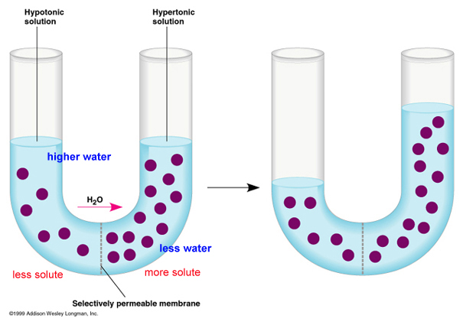

EXAMPLE OF OSMOTIC SYSTEM

A LIVING CELL

Living cell can also be taken as an example or an osmotic system. Cell wall is present outside the membrane in a cell. Primary cell wall is especially freely permeable to water and solute particles both. But, the cell membrane is very selectively permeable towards substances. It allows water molecules to pass but hinder the movement of solute particles.

It is because of this phenomenon the osmosis is possible in living cell, which causes turgidity. In some cells the cell wall is absent which causes them to burst when they become turgid. As hydrostatic skeleton provide support in same way for non woody plants turgidity provide support also.

It can also be represented in a pictorial way as under below.

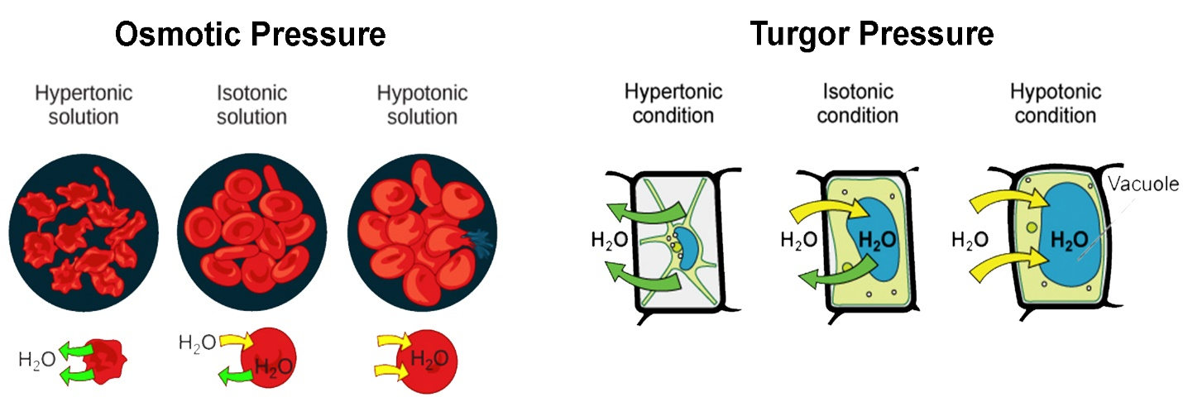

IMPORTANCE OF OSMOSIS

Following are some points related to the importance of osmosis.

* Osmosis is very important in the purification of water and in the biological systems as well.
* Water is medium of transport and everything in blood or in xylem is transferred by getting soluble in water and then osmosis causes the transport of water.
* Because of osmosis many vital processes in cytoplasm can occur because these processes need water.
* Reabsorption of water by the kidney tubules and absorption of water by the roots is due to osmosis.
* Osmosis facilitates the distribution of different nutrients in body.
* If the blood glucose concentration is high then it causes osmotic diuresis, which results in loss of glucose, water and electrolyte. It causes diabetes mellitus. Hence if osmosis is not proper then many problem may occur.
* Isotonic solutions are used for washing wounds.
* Osmosis regulates the cell volume.
* It regulates turgidity of plants.
* The oncotic pressure of blood plasma is also regulated by osmosis.

OSMOTIC POTENTIAL

To prevent the inward flow of pure solvent across the semi permeable membrane by applying minimum pressure. This minimum pressure is called as osmotic pressure.

POTENTIAL OSMOTIC PRESSURE

The maximum potential developed when the pure solvent is separated by solution through a semi permeable membrane.

RELATIONSHIP OF OSMOTIC QUANTITIES

Let us take a hypothetical situation. It helps to understand the relationship of water potential, osmotic pressure and pressure potential also known as turgor pressure.

SOLUTION B---- its water potential is equal to -30 bars and an osmotic pressure of -30 bars while a zero turgor pressure is enclosed to a membrane which causes only water to move through it. As there is no turgor pressure hence the osmotic pressure is equal to the water potential.

Now this system is submerged in SOLUTION A---- the osmotic potential now is -10 bars. As the turgor pressure is unconfined so the osmotic pressure is equal to water potential.

We can now observe that the water potential of solution A is less negative than solution B. Hence as a result an energy gradient is formed from solution A to B, and a net flow starts.

As solution B is enclosed in an elastic, so the turgor pressure will built up in it and then equilibrium will be reached with the entrance of small amount of water in the internal solution. The actual turgor pressure formed in the internal solution is about 20 bars. This 20 bars will counteract -20 bars of osmotic solution and at this point there will be wall pressure which will also be equal to 20 bars. The water potential of solution B can be made less negative by the amount of applied pressure, the water potential will become less negative by 20 bars, thus equaling it to the external solution. Hence,

WATER POTENTIAL= SOLUTE POTENTIAL + PRESSURE POTENTIAL

We are assuming here that there is no change in the osmotic potential because of the reason that the solutions are confined by the wall or inelastic membrane. The water loss or gain is not really sufficient to concentrate or dilute the solution respectively and hence no change in the osmotic potential. Turgor pressure has reverse relation, due to slight changes of solute concentration it is affected.

In fact water moves through semi permeable membrane into the cell however it faces some hindrances in the form of colloids or some other material called as matric potential.

Thus we can write relationship between all the osmotic quantities as follows,

WATER POTENTIAL= SOLUTE POTENTIAL+PRESSURE POTENTIAL+MATRIC POTENTIAL

It is very difficult to measure matric potential during osmotic system and hence we considered it as negligible while solving the equation and usually eliminate it.

Above equation suggests that when turgor pressure becomes equal to the osmotic pressure then the water potential becomes equal to 0. So, if in the any aqueous solution with the osmotic pressure of -10 bars submerged in the water and enclosed in the inelastic membrane will be in equilibrium to the turgor pressure of 10 bars and hence the water potential at that time also becomes equal to 0.

We have been using hypothetical condition in which the solution is enclosed in an inelastic membrane. The cell wall of the solution is somehow elastic due to which a certain increase in the volume when the flaccid cell becomes turgid. Increase in the cell volume causes dilution of cell sap. It also then causes the rise in osmotic potential. If we talk about the flaccid cell then its osmotic pressure is equal to water potential. So, when we place such cell in pure water solution then the water will move in the cell. It then increase a certain amount of elastic stretching and turgor pressure in the cell. With an increase in the cell volume causes increase in dilution and hence causes the dilution and as a result osmotic potential of the cell rises. The point where osmotic potential becomes equal to zero has fully turgidity. After this point no increase in turgidity occurs now.

MEASUREMENT OF WATER POTENTIAL

As a general rule, there are generally two ways to measure water potential: a pressure gauge and a vapor pressure method. The pressure gauge (tensiometer) works in the wet range-a special pressure gauge that delays the boiling point (UMS) from 0 to about -0.2 MPa. The vapor pressure method operates in the dry range-about -0.1 MPa to -300 MPa (0.1 MPa 99.93% relative humidity; -300 MPa 11%).

These intervals actually did not intercept or overlap, but modern and recent developments in tensiometer and temperature sensor technology have modified that. Now, experienced users with good methods and best equipment can fully measure the water potential of their laboratory.

However, it is necessary to review the secondary measurement method. The vapor pressure method cannot be used on the spot and the perfection or accuracy of the pressure gauge has to be paid with constant careful maintenance (although an automatic filling version of the pressure gauge is available).

Now we cover the merits and demerits or limitations of each method.

VAPOUR PRESSURE METHOD.

[WP4C Dew Point Hygrometer](https://www.metergroup.com/environment/products/wp4c/) is one of the very few available instruments in the market that use this technique currently. In it the dew point hygrometer is equilibrating a sample in a sealed chamber, like a traditional thermocouple psychrometers.

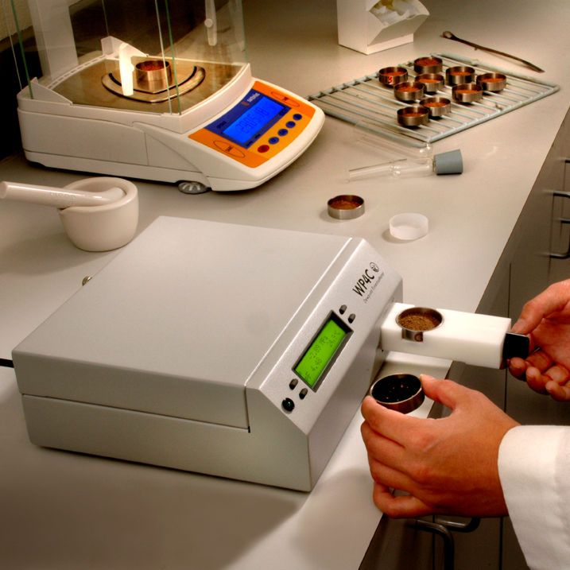

A tiny mirror in the chamber is cooled to form dew. At the dew point, WP4C measures the mirror and the sample temperature to the nearest 0.001. C to determine the relative humidity of the vapour above the sample.

ADVANTAGES

The latest design of this hygrometer method provides an accuracy of 1% to -5 to -300 MPa, and is very easy to use as well. Many types of samples can be analyzed in five to ten minutes, though wet or humid type of sample may take longer time.

LIMITATION

At high water potential content, the difference in temperature between the coils and subject flow in the sample chamber becomes smaller.

Restrictions on the temperature measurement resolution mean that tensiometers may not be replaced by vapour pressure.

The dew point hygrometer has a range of −0.1 to −300 MPa, although readings can be extended beyond −0.1 MPa using standard methods. Tensiometers are the best choice for readings in the range of 0 to-0.1 MPa.

SECONDARY METHODS

Water content is generally easier to measure than water potential, and given that the two values are related, you can use water content measurements to find the water potential.

A graph showing how the water capacity changes when advertising and extracting water from a particular soil matrix is called a moisture characteristic or moisture release curve.

Each matrix has unique moisture properties that keep water as unique and unique as fingerprints. In soils, even very minute or small differences in composition and texture have a very important impact on moisture properties.

Some researchers develop a moisture profile for a particular soil type and use it to determine the water potential of the water content. Matrix-capable sensors use a simpler approach, taking an advantage of the second law of thermodynamics also.

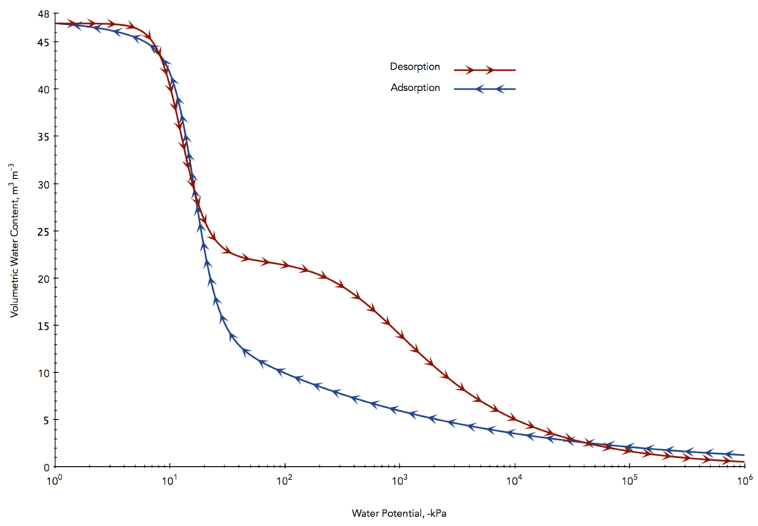

MATRIC POTENTIAL SENSOR

Matrix potential sensors use a porous material with a known moisture function. As all energy systems tend to balance, the porous material will reach a potential water balance with the surrounding soil.

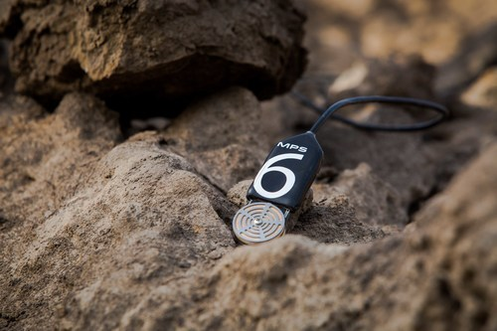

Using the moisture feature for the porous material, you can then calculate the water content of the porous material and determine the water potential of both the porous material and the surrounding soil. Potential matric sensors use a number of porous materials and several different methods to determine water content.

ACCURACY DEPENDS ON CUSTOM ACCURACY

At best, the accuracy is good, but the matric potential sensors are not very good. In the worst case, the method cannot tell if the ground is wet or dry. The accuracy of the sensor depends on the quality of the moisture property created by the porous material and the uniformity of the material used. To make a large error, the specific material used must be calibrated by the primary measurement method. The sensitivity of this method depends on how quickly the amount of water changes as the water capacity changes. Accuracy is determined by the quality of moisture measurement.

Accuracy may also depend on temperature sensitivity. This method is based on isothermal conditions that may be difficult to achieve. The temperature difference between the sensor and the soil can cause large errors.

LIMITED RANGE

All the senses that a matrix can have are limited by irrigation conductivity: as the soil dries, the balance of the porous material takes longer. The change also becomes negligible and really difficult to measure. At the wet end, the area of the sensor is limited by air pollution of the porous material used.

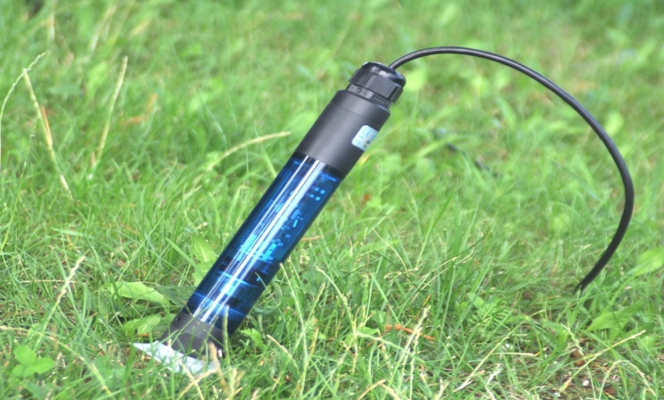

CONCLUSION

Water potential plays an important role in water flow theory, similar to temperature theory associated with heat flow, or voltage in the context of electric circulation theory. Water flows in response to liquid gradient. When the water potential is the same over the wall, the water does not flow, although the amount of water on either side of the wall may be different. Matric potential is one of the most important components of water capacity in terrestrial and plant systems. The matrix component of water potential is important as a driving force for flow in unburned soils and in cell walls of mesophilic leaf cortical and leaf root. The potential of the matrix is ​​always negative or equal to zero. The pressure and pine components of water potential account for changes in the hydrostatic or pneumatic pressure that water exerts. There are two components of the groundwater potential of the water content: matrix and osmotic. In plant cells, the third potential - turmeric pressure - depends on the amount of water. The relationship between matric potential and water content is called the soil moisture feature or moisture distribution curve. The relationship between water capacity and water content is not unique. It depends on the humidity and drying history of the porous material.

