**Preparation for cleavage;**

The increase in intracellular free calcium ions that activates DNA and protein synthesis also sets in motion the apparatus for cell division. The mechanisms by which cleavage is initiated probably differ among species, depending on the stage of meiosis at which fertilization occurs.

However, in all species studied, the rhythm of cell divisions is regulated by the synthesis and degradation of a protein called **cyclin**. Cyclin keeps cells in metaphase, and the breakdown of cyclin enables the cells to return to interphase. In addition to their other activities, calcium ions appear to initiate the degradation of cyclin. Once the cyclin is degraded, the cycles of cell division can begin anew.

Cleavage has a special relationship to the egg regions established by the cytoplasmic movements. In tunicate embryos, the first cleavage bisects the egg, with its established cytoplasmic pattern, into mirror-image duplicates. From that stage on, every division on one side of the cleavage furrow has a mirror-image division on the opposite side. Similarly, the gray crescent is bisected by the first cleavage furrow in amphibian eggs. Thus, the position of the first cleavage is not random, but tends to be specified by the point of sperm entry and the subsequent rotation of the egg cytoplasm. The coordination of cleavage plane and cytoplasmic rearrangements is probably mediated through the microtubules of the sperm aster.

Toward the end of the first cell cycle, then, the cytoplasm is rearranged, the pronuclei have met, DNA is replicating, and new proteins are being translated. The stage is set for the development of a multicellular organism.

**Cleavage**

After fertilization, the development of a multicellular organism proceeds by a process called **cleavage**, a series of mitotic divisions whereby the enormous volume of egg cytoplasm is divided into numerous smaller, nucleated cells. These cleavage-stage cells are called **blastomeres**. In most species (mammals being the chief exception), the rate of cell division and the placement of the blastomeres with respect to one another is completely under the control of the proteins and mRNAs stored in the oocyte by the mother. The zygotic genome, transmitted by mitosis to all the new cells, does not function in early-cleavage embryos. Few, if any, mRNAs are made until relatively late in cleavage, and the embryo can divide properly even when chemicals are used experimentally to inhibit transcription. During cleavage, however, cytoplasmic volume does not increase. Rather, the enormous volume of zygote cytoplasm is divided into increasingly smaller cells. First the egg is divided in half, then quarters, then eighths, and so forth. This division of egg cytoplasm without increasing its volume is accomplished by abolishing the growth period between cell divisions (that is, the G1 and G2 phases of the cell cycle). Meanwhile, the cleavage of nuclei occurs at a rapid rate never seen again (not even in tumor cells).

A frog egg, for example, can divide into 37,000 cells in just 43 hours.

Mitosis in cleavage-stage *Drosophila* embryos occurs every 10 minutes for over 2 hours and in just 12 hours forms some 50,000 cells.

This dramatic increase in cell number can be appreciated by comparing cleavage with other stages of development.

One consequence of this rapid cell division is that the ratio of cytoplasmic to nuclear volume gets increasingly smaller as cleavage progresses. In many types of embryos (such as those of *Xenopus* and *Drosophila,* but not those of *C. elegans* or mammals), this decrease in the cytoplasmic to nuclear volume ratio is crucial in timing the activation of certain genes. For example, in the frog *Xenopus laevis,* transcription of new messages is not activated until after 12 divisions. At that time, the rate of cleavage decreases, the blastomeres become motile, and nuclear genes begin to be transcribed. This stage is called the **mid-blastula transition**. It is thought that some factor in the egg is being titrated by the newly made chromatin, because the time of this transition can be changed by experimentally altering the ratio of chromatin to cytoplasm in the cell (Newport and Kirschner 1982a,b; Edgar et al. 1986). Thus, cleavage begins soon after fertilization and ends shortly after the stage when the embryo achieves a new balance between nucleus and cytoplasm.

**From fertilization to cleavage:**

The transition from fertilization to cleavage is caused by the activation of **mitosis promoting factor** (**MPF**). MPF was first discovered as the major factor responsible for the resumption of meiotic cell divisions in the ovulated frog egg. It continues to play a role after fertilization, regulating the biphasic cell cycle of early blastomeres. Blastomeres generally progress through a cell cycle consisting of just two steps: M (mitosis) and S (DNA synthesis).

Gerhart and co-workers (1984) showed that MPF undergoes cyclical changes in its level of activity in mitotic cells. The MPF activity of early blastomeres is highest during M and undetectable during S. Newport and Kirschner (1984) demonstrated that DNA replication (S) and mitosis (M) are driven solely by the gain and loss of MPF activity. Cleaving cells can be experimentally trapped in S phase by incubating them in an inhibitor of protein synthesis. When MPF is microinjected into these cells, they enter M. Their nuclear envelope breaks down and their chromatin condenses into chromosomes. After an hour, MPF is degraded and the chromosomes return to S phase.

**What causes this cyclic activity of MPF?**

Mitosis-promoting factor contains two subunits.

The large subunit is called **cyclin B**. It is this component that shows a periodic behavior, accumulating during S and then being degraded after the cells have reached M (Evans et al. 1983; Swenson et al. 1986). Cyclin B is often encoded by mRNAs stored in the oocyte cytoplasm, and if the translation of this message is specifically inhibited, the cell will not enter mitosis (Minshull et al. 1989). The presence of cyclin B depends upon its synthesis and its degradation. Cyclin B regulates the small subunit of MPF, the **cyclin-dependent kinase**.

This kinase activates mitosis by phosphorylating several target proteins, including histones, the nuclear envelope lamin proteins, and the regulatory subunit of cytoplasmic myosin. This brings about chromatin condensation, nuclear envelope depolymerization, and the organization of the mitotic spindle.



Without cyclin, the cyclin-dependent kinase will not function. The presence of cyclin is controlled by several proteins that ensure its periodic synthesis and degradation. In most species studied, the regulators of cyclin (and thus, of MPF) are stored in the egg cytoplasm. Therefore, the cell cycle is independent of the nuclear genome for numerous cell divisions. These early divisions tend to be rapid and synchronous. However, as the cytoplasmic components are used up, the nucleus begins to synthesize them. The embryo now enters the mid-blastula transition, in which several new phenomena are added to the biphasic cell divisions of the embryo. First, the growth stages (G1 and G2) are added to the cell cycle, permitting the cells to grow. Before this time, the egg cytoplasm was being divided into smaller and smaller cells, but the total volume of the organism remained unchanged. *Xenopus* embryos add those phases to the cell cycle shortly after the twelfth cleavage. *Drosophila* adds G2 during cycle 14 and G1 during cycle 17 (Newport and Kirschner 1982a; Edgar et al. 1986). Second, the synchronicity of cell division is lost, as different cells synthesize different regulators of MPF. Third, new mRNAs are transcribed. Many of these messages encode proteins that will become necessary for gastrulation. If transcription is blocked, cell division will occur at normal rates and at normal times in many species, but the embryo will not be able to initiate gastrulation.

**The cytoskeletal mechanisms of cleavage:**

**Cleavage**

**Karyokinesis Cytokinesis**

**Apparatus: Mitotic spindle Contractile ring**

**Microtubules Microfilaments**

**Tubulin Actin**

Cleavage is actually the result of two coordinated processes. The first of these cyclic processes is **karyokinesis** the mitotic division of the nucleus.

The mechanical agent of this division is the mitotic spindle, with its **microtubules** composed of **tubulin** (the same type of protein that makes up the sperm flagellum). The second process is **cytokinesis** the division of the cell. The mechanical agent of cytokinesis is a **contractile ring** of **microfilaments** made of **actin** (the same type of protein that extends the egg microvilli and the sperm acrosomal process).

The mitotic spindle and contractile ring are perpendicular to each other, and the spindle is internal to the contractile ring. The contractile ring creates a **cleavage furrow**, which eventually bisects the plane of mitosis, thereby creating two genetically equivalent blastomeres. The actin microfilaments are found in the cortex of the egg rather than in the central cytoplasm. Under the electron microscope, the ring of microfilaments can be seen forming a distinct cortical band 0.1 μm wide. This contractile ring exists only during cleavage and extends 8-10 μm into the center of the egg. It is responsible for exerting the force that splits the zygote into blastomeres; for if it is disrupted, cytokinesis stops.

Schroeder (1973) has proposed a model of cleavage wherein the contractile ring splits the egg like an "intercellular purse-string," tightening about the egg as cleavage continues. This tightening of the microfilamentous ring creates the cleavage furrow. Microtubules are also seen near the cleavage furrow (in addition to their role in creating the mitotic spindles), since they are needed to bring membrane material to the site of membrane addition.

Although karyokinesis and cytokinesis are usually coordinated, they are sometimes separated by natural or experimental conditions. In insect eggs, karyokinesis occurs several times before cytokinesis takes place. Another way to produce this state is to treat embryos with the drug cytochalasin B. This drug inhibits the formation and organization of microfilaments in the contractile ring, thereby stopping cleavage without stopping karyokinesis.



**Types of Egg**

There are vast groups of species living on the earth so their way of reproduction is also different. Every animal has variability in their egg content. Here I want to classify egg on the basis of  Yolk Content of animals.

**On the basis of the amount of Yolk** -- on the basis of the amount of yolk egg are of the following type:

* **Alecithal / Microlecithal / oligolecithal** - The amount of yolk present in an organism's egg is of a very small amount or absent.     
    Example -  Sea urchin,  Amphioxus, Tunicates, Eutherian egg
* **Mesolecithal** - In this type of egg, the yolk amount is medium or moderate.     
      Example -   Amphibian, Dipnoi fishes, lungfishes, Petromyzon
* **Polylecithal / macrolecithal / megalecithal** - The amount of yolk content is very large.    Example -    prototherian mammals,  insects, annelids, reptiles

[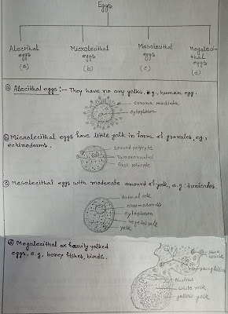](https://2.bp.blogspot.com/-k8imGnrpb7Y/W2fxDwCYeiI/AAAAAAAAJzM/e-CUUPdP2YInueqiP-H5u61THpzHHsmqACLcBGAs/s1600/Untitled-1-copy.jpg)

**On the basis of the distribution of yolk** -- On the basis of it egg is of the following type

* **Isolecithal / homolecithal Egg** -   The yolk is equally distributed in the whole egg.  
            Example -  Alecithal , micro, oligolecithal egg.
* **Teloleithal Egg**-  Here the yolk is found on the one pole of the egg . Usually, the egg has two opposite pole, one is the animal pole and the other one is the vegetal pole. Telolecithal types of the egg are those in which yolk is present on the vegetal pole while the other pole is free.

Example -  amphibian egg.

* **Centrolecithal Egg** - The yolk is present in the center of egg i.e., cytoplasm,  surrounded by superficial layer.         Example -  insect

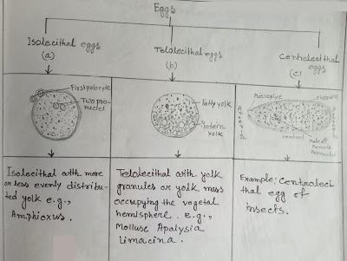

**On the Basis of Shell**- on the basis of a shell, the egg has following types -  
**Cleidoic Eggs** -  The egg is surrounded by a hard covering or shell. These types of eggs are generally seen in terrestrial animals.

Example - reptile, bird

[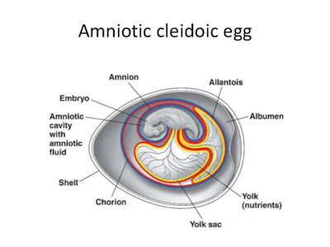](https://4.bp.blogspot.com/-vko6dByatic/W2fyUhfLGKI/AAAAAAAAJzY/mbz1iPdHg2wApkfz0lpMat_IdrolpArdQCLcBGAs/s1600/reptilia-classification-by-deepak-rawal-6-638.jpg)

* **Non - Cleidoic Eggs** - The egg which is not surrounded by any hard covering. Example - All viviparous animals.

[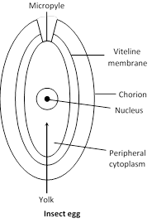](https://3.bp.blogspot.com/-nke5wwcLSwY/W2fyppS0oqI/AAAAAAAAJzg/GAFT8wL023YzshMaPnykM-2XTiU_O5_jwCLcBGAs/s1600/image005.png)

**Patterns of embryonic cleavage;**

In 1923, embryologist E. B. Wilson reflected on how little we knew about cleavage: "To our limited intelligence, it would seem a simple task to divide a nucleus into equal parts. The cell, manifestly, entertains a very different opinion." Indeed, different organisms undergo cleavage in distinctly different ways. The pattern of embryonic cleavage particular to a species is determined by two major parameters: the amount and distribution of yolk protein within the cytoplasm, and factors in the egg cytoplasm that influence the angle of the mitotic spindle and the timing of its formation.

The amount and distribution of yolk determines where cleavage can occur and the relative size of the blastomeres. When one pole of the egg is relatively yolk-free, the cellular divisions occur there at a faster rate than at the opposite pole. The yolk-rich pole is referred to as the **vegetal pole**; the yolk concentration in the **animal pole** is relatively low. The zygote nucleus is frequently displaced toward the animal pole. In general, yolk inhibits cleavage.

Following figure provides a classification of cleavage types and shows the influence of yolk on cleavage symmetry and pattern. At one extreme are the eggs of sea urchins, mammals, and snails. These eggs have sparse, equally spaced yolk and are thus **isolecithal** (Greek, "equal yolk"). In these species, cleavage is **holoblastic** (Greek *holos,* "complete"). meaning that the cleavage furrow extends through the entire egg. These embryos must have some other way of obtaining food. Most will generate a voracious larval form, while mammals get their nutrition from the placenta.

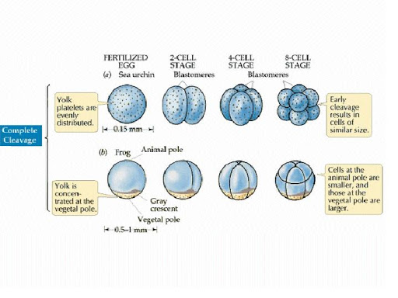

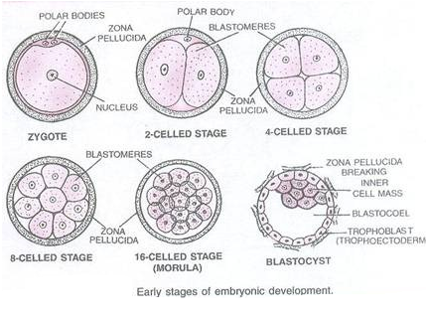

At the other extreme are the eggs of insects, fishes, reptiles, and birds. Most of their cell volumes are made up of yolk. The yolk must be sufficient to nourish these animals. Zygotes containing large accumulations of yolk undergo **meroblastic** cleavage, wherein only a portion of the cytoplasm is cleaved. The cleavage furrow does not penetrate into the yolky portion of the cytoplasm. The eggs of insects have their yolk in the center (i.e., they are **centrolecithal**), and the divisions of the cytoplasm occur only in the rim of cytoplasm around the periphery of the cell (i.e., **superficial** cleavage). The eggs of birds and fishes have only one small area of the egg that is free of yolk (**telolecithal** eggs), and therefore, the cell divisions occur only in this small disc of cytoplasm, giving rise to the **discoidal** pattern of cleavage. In amphibians, egg is equipped with moderate amount of yolk i.e **mesolecithal** and cleavage pattern is holoblastic (radial). These are general rules, however, and closely related species can evolve different patterns of cleavage in different environment.

However, the yolk is just one factor influencing a species' pattern of cleavage. There are also inherited patterns of cell division that are superimposed upon the constraints of the yolk. This can readily be seen in isolecithal eggs, in which very little yolk is present.

In the absence of a large concentration of yolk, four major cleavage types can be observed: radial holoblastic, spiral holoblastic, bilateral holoblastic, and rotational holoblastic cleavage. We will see examples of these cleavage patterns below when we take a more detailed look at the early development of four different invertebrate groups.

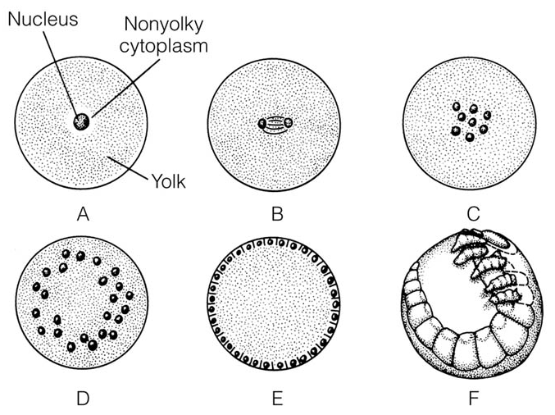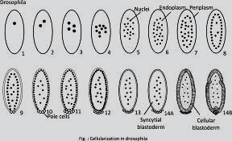

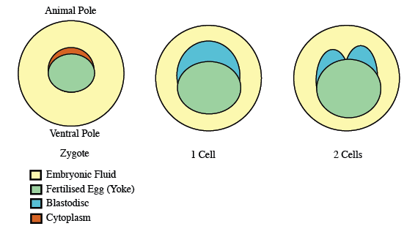

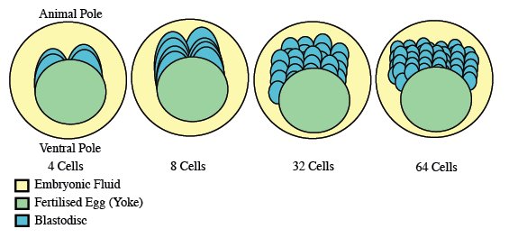

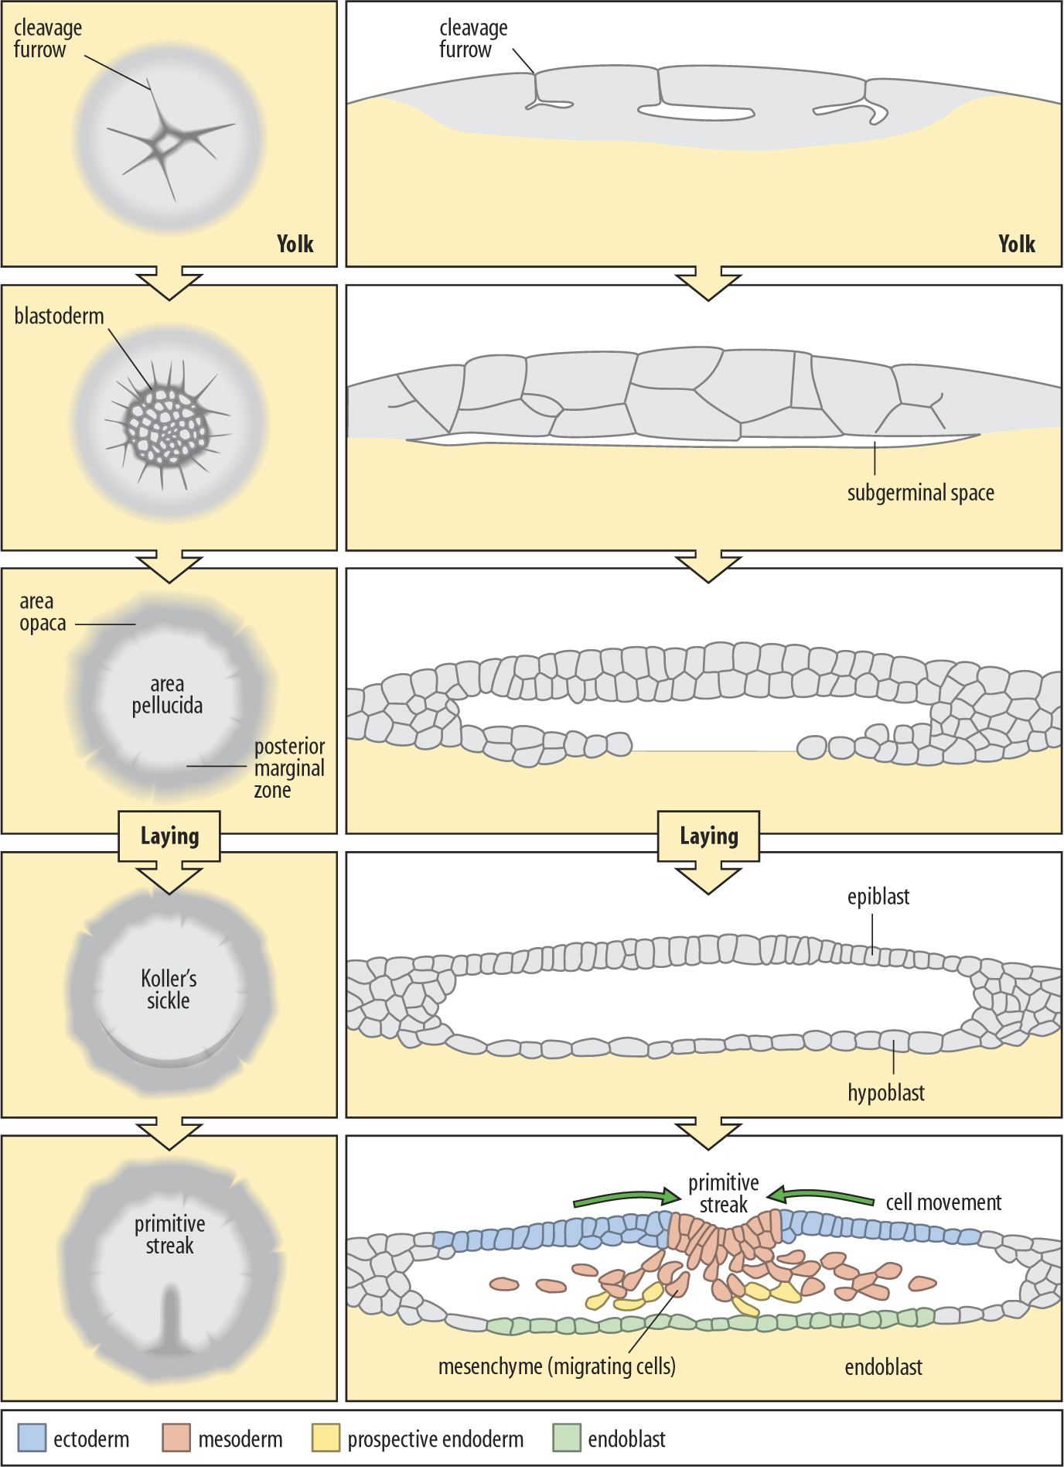

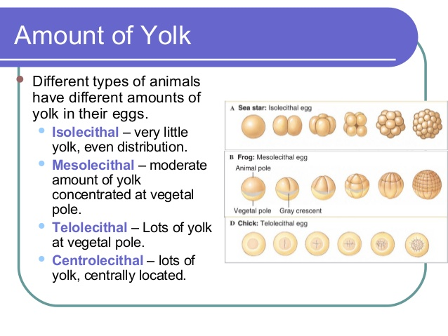



* Bilateral

The first cleavage results in bisection of the zygote into left and right halves. The following cleavage planes are centered on this axis and result in the two halves being mirror images of one another. In bilateral holoblastic cleavage, the divisions of the blastomeres are complete and separate; compared with bilateral meroblastic cleavage, in which the blastomeres stay partially connected.

* Radial

Radial cleavage is characteristic of the [deuterostomes](http://en.wikipedia.org/wiki/Deuterostomes), which include some [vertebrates](http://en.wikipedia.org/wiki/Vertebrate) and [echinoderms](http://en.wikipedia.org/wiki/Echinoderm), in which the spindle axes are parallel or at right angles to the polar axis of the [oocyte](http://en.wikipedia.org/wiki/Oocyte).

* Rotational

[Mammals](http://en.wikipedia.org/wiki/Mammal) display rotational cleavage, and an [isolecithal](http://en.wikipedia.org/wiki/Isolecithal) distribution of yolk (sparsely and evenly distributed). Because the cells have only a small amount of yolk, they require immediate implantation onto the uterine wall in order to receive nutrients.

Rotational cleavage involves a normal first division along the meridional axis, giving rise to two daughter cells. The way in which this cleavage differs is that one of the daughter cells divides meridionally, whilst the other divides equatorially.