**Height Measurement**

* Height is the linear distance of an object normal to the surface of the earth.
* Tree height is the vertical distance measured from the ground surface.
* Height of standing tree is measured to find out its volume. Height of selected trees in a forest are also required to read volume tables, form factor tables, yield tables etc.
* Lastly, heights of trees are required to find out productive capacity of site. Height is generally considered as an index of fertility and with the knowledge of age it gives a reliable measure of the site quality of a locality.

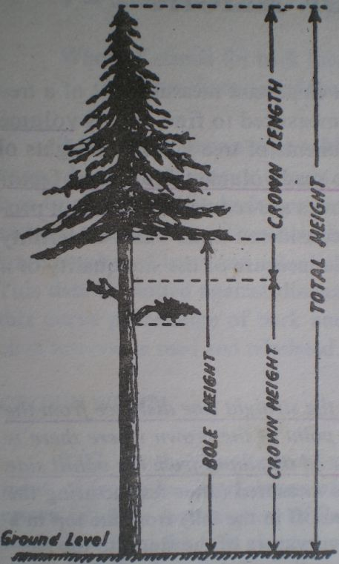**Total height** of a standing tree is the distance along the axis of the tree stem between the ground and the tip of the tree.

**Bole height** is the distance along the axis of tree between ground level and crown point. (crown point is the position of the first crown forming branch).

**Commercial bole height** is the height of bole that is usually fit for utilization as timber.

**Height of standard timber bole** is the height of the bole from the ground level up to the point where average diameter over bark is 20cm.

**Stump height** is the distance between the ground and basal position on the main stem where a tree is cut.

**Crown length**-The vertical measurement of the crown of the tree from the tip to the point half way between the lowest green branches forming green crown all round and the lowest green branch on the bole.

C**rown height -** The height of the crown as a measured vertically from the ground level to the point half way between the lowest green the lowest green branches forming green crown all round.

Figure 17: Tree height

**2.2.1 Principles of height measurement**

* Instruments used for measuring tree heights are collectively referred to as hypsometers.
* All height measuring instruments are based either on geometric principles of similar triangles or on trigonometric principles based on relations between the sides of right angled triangle.

**2.2.1.1 Trigonometric principles**

The principles follow the basic rules of trigonometry for deriving heights of trees from distance and angle measurements. Two laws are applicable for this purpose and they are: tangent law and sine law**.** Instruments based on Trigonometrical principles are Brandis hypsometer, Abney’s level, Haga Altimeter, Topographical Abney’s level, Relaskop, Tele Relaskop, Barr and Stroud dendrometer, Blume-Leiss hypsometer

**2.2.1.1.1 Tangent law**

* Applicable to right angle triangle
* For accurate results, trees must not lean more than 5° from the vertical, and the fixed horizontal distance must be determined by taped measurement.

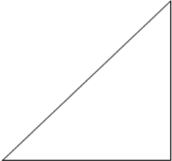



**2.2.1.1.2 Sine law**

* Applicable to non right angle triangle is useful in deriving tree height in difficult conditions.

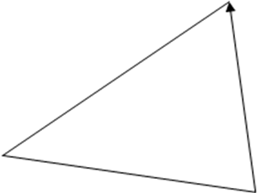

* Sines of angles are proportional to the opposite sides.

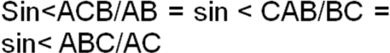

**2.2.1.2 Geometric principle of similar triangle**

* Corresponding angles are equal and the corresponding sides are proportional.
* By knowing the two sides of a triangle and only one side of the other, the corresponding second side of the latter can be found.
* Useful in rough estimation, not reliable for precise work. Eg. Christen’s hypsometer, Smythies Hypsometer etc.

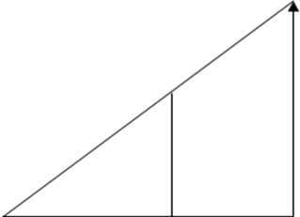

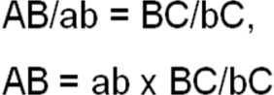

**Method of height measurement**

* Techniques for measuring tree height may be direct or indirect and essentially depend on the position or fate of the tree:
* Felled trees - when the tree is on the ground, measurement of the linear distance from base to tip or to the merchantable limit is done directly with linear tape or graduated pole.
* Standing trees - height can be measured by either direct or indirect methods (see below). Indirect methods are most common because the tip or merchantable limit is often inaccessible.

**Basic assumptions in measurement of standing trees:**

* The tree is vertical and
* The tip and the base of the tree are simultaneously visible.

**1. Direct methods**

* [Climbing](http://sres-associated.anu.edu.au/mensuration/BrackandWood1998/CLIMB.HTM) with tape and graduated pole. An accurate approach, but practicable only with some species under certain conditions. This technique is costly and dangerous and is normally restricted to experimental projects only.
* [Height sticks](http://sres-associated.anu.edu.au/mensuration/BrackandWood1998/HGTSTICK.HTM) or rods. A reliable method, with an instrument error less than l%. However this method can also be expensive for trees in excess of about 20 m.

**2. Indirect Methods (****Non Instrumental methods and Instrumental methods)**

**Non instrumental methods**

1. 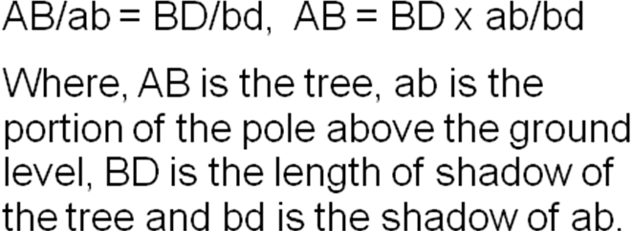**Shadow method**: a pole of convenient length is fixed upright in the ground and its height above the ground is measured. The shadows of the pole and the tree are also measured.

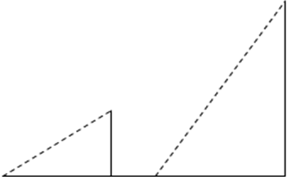

1. **Single pole method**

Pole of about 1.5 m length vertically at arm’s length in one hand in such a way that portion of the pole above the hand is equal in length to the distance of the pole from eye.

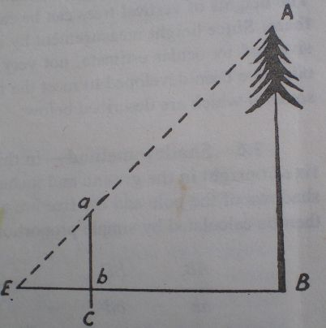

AB/ab = EB/Eb i.e. AB = EB x ab/Eb

Where,

AB = tree, ac=pole about 1.5 m long, Eb=ab

**Instrumental method**

* By using instruments like hypsometer, clinometer, altimeters, abneys level etc.
* All these instruments are based either on geometric principle of similar triangles or on trigonometric principles.

**2.2.2 Measurement of height (vertical & leaning) tree in plane and slope areas**

**Measurement of height of trees on plane area**

* 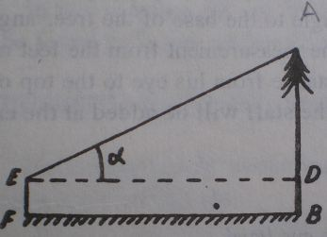The height of the tree is calculated with the help of the tangents of the angle to the top and the distance of the observer from the tree.

AB = AD + BD = ED tanα + BD = BF tan α + EF

Where, AB = tree, EF = eye height of the observer,

BF = horizontal distance

**Measurement of height of trees on sloped area**

* **Where the observer is standing at such a place that the top of the tree is above the eye level and the base below it.**

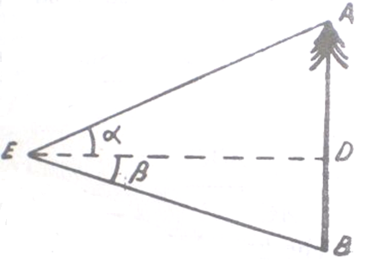

AB = AD + DB

= ED tan α + ED tan β = ED (tan α + tanβ)

= EB Cosβ (tan α + tanβ)

* 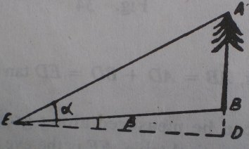**Where top and base of the tree are above the eye level.**

AB = AD-BD

= ED tan α – ED tan β

= ED (tanα-tan β)

= EB cos β (tanα-tan β)

* 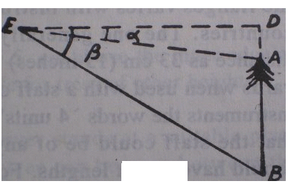**Where base and top of the tree are below the eye level**

AB = BD – AD

= ED tan β – ED tan α

= ED (tan β - tan α)

= EB cos β (tan β - tan α)

**Measurement of height of leaning tree**

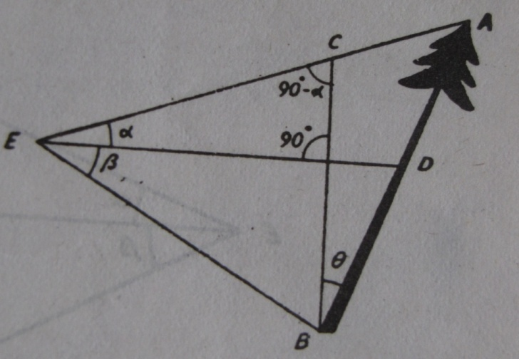**Case-1(a): In case of the observer standing at between the top and bottom of the tree (lean away from the observer)**



Now in triangle AEB**,**



**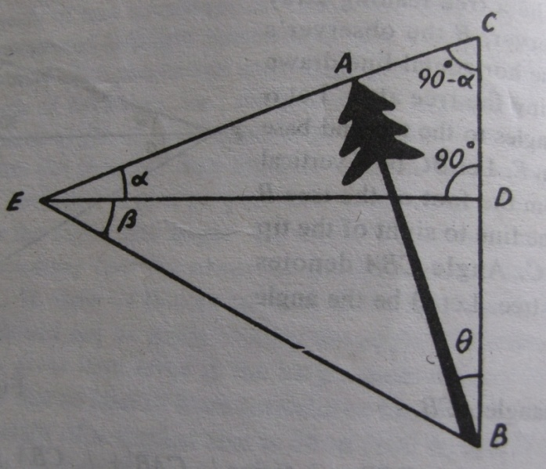****Case-1(b): In case of the observer standing at between the top and bottom of the tree (lean towards the observer)**

**In the triangle ACB,**



**Now in triangle AEB,**



**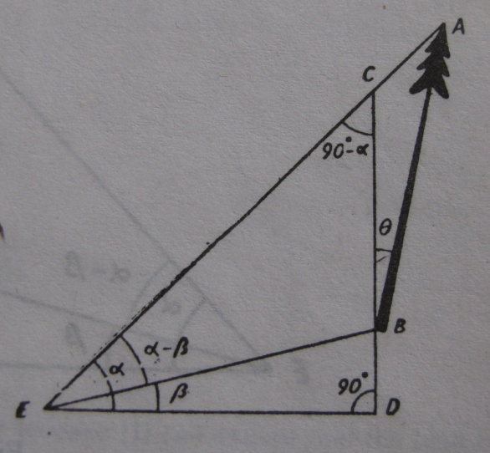****Case-2(a): When the observer is below the top and bottom of the tree (lean away from the observer)**

**In the triangle ACB,**



**Now in triangle AEB,**



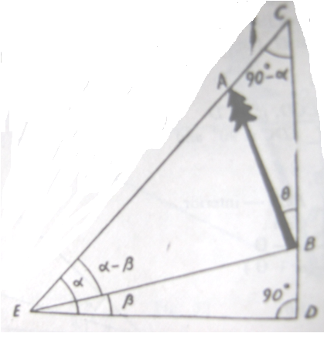**Case-2(b): when the observer is below the top and bottom of the tree (lean towards the observer)**

**In the triangle ACB,**



**Now in triangle AEB,**

**Case-3(a): when the observer is above the top and bottom of the tree (lean away from the 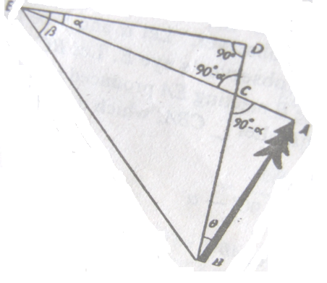observer)**



**In the triangle ACB,**



**Now in triangle AEB,**



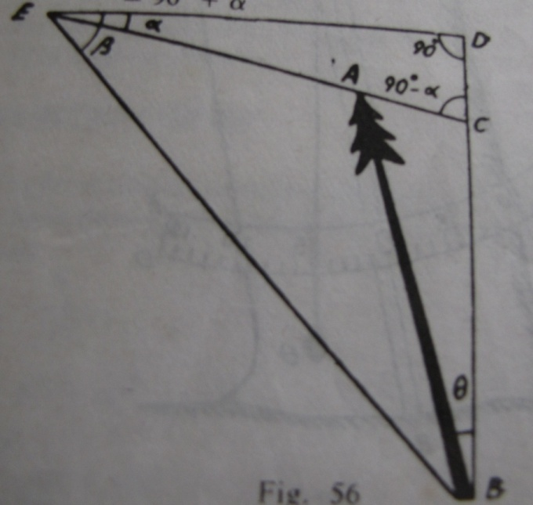**Case-3(b): when the observer is above the top and bottom of the tree (lean is towards the observer)**

**In the triangle ACB,**



**Now in triangle AEB,**



**2.2.3 Instrument used in height measurement**

* There are various instruments to measure height of the tree.
* Height measuring instruments are called hypsometer.
* Those instruments based on trigonometric principles are more accurate than the ones employing geometric principles.
* The Abney’s level, Haga Altimeter, Blume-Leiss Altimeter and Sunto Clinometer are similar in accuracy.

1. **Christen’s Hypsometer**

* It is based on the geometric relationships of similar triangles.
* Consists of a strip of metal, thin wood or card board about 2.5cm wide and 33 cm length.
* It has two flanges or protruding edges one at the top and other at the bottom.
* Each flange has a hole in it, the upper one to suspend the instrument by some thread passing through it at and the lower one to suspend a weight from it to prevent it from swinging.
* To use it, a pole (usually 5 or 10 ft long) is held upright against the base of the tree, or a mark is placed on the tree at a height of 5 or 10 ft above the ground.
* The hypsometer is then held vertically at a distance from the eye such that the two inside edges of the flanges are in line with the top and base of the tree.
* It may be necessary for the observer to move closer to or farther from the tree to accomplish this, but except for this, the distance from the tree is immaterial.
* The graduation on the scale that is in line with the top of the pole, or the mark, gives the height of the tree.
* 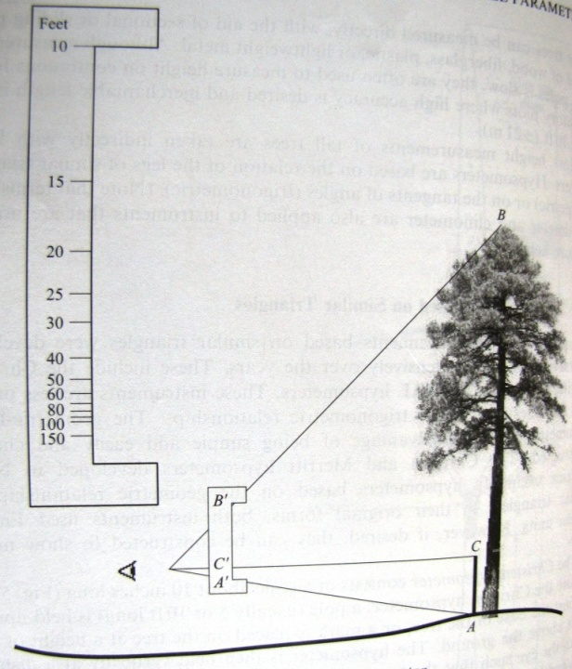The following proportion gives the formula for graduating the instrument.



For a given length of instrument A’B’ and a given pole length or mark height AC, the graduation A’C’ can be obtained by substituting different values of height AB in the equation.

* Although the christen hypsometer may be used to measure any type of height, it is practical only for total height measurements.
* A crowding of graduations at the bottom of the scale, makes the instrument unreliable for the determination of the height of tall trees.

**Advantages**

* It is light, easily made and easy to transport
* The height of the tree can be read directly.

Figure18: Christen hypsometer

* It is quicker to use and so it is useful in conditions where speed is required.

**Disadvantages**

* Extra care has to be taken to hold the top and bottom of the tree within the flanges while reading the heights.
* It should be held in the true vertical plane
* It is not suitable for more than 30m tree height.
* It requires the use of staff.
* Skill is necessary to use the instrument with consistent accuracy.

1. **Sunto clinometers**

* 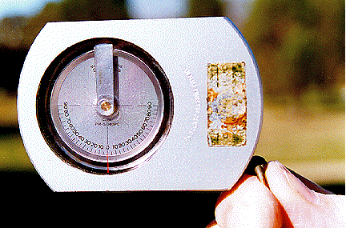Hypsometers based on tangent of angles such as Abney’s level, Haga altimeter, the Blume-Leiss altimeter and the Sunto clinometers are used in height measurement of trees.

Figure 19: Sunto clinometer

* The sunto clinometer is a handheld device house in a corrosion-resistant aluminum body.
* A jewel-bearing assembly supports the scale, and all moving parts are immersed in a damping liquid inside a hermetically sealed plastic capsule.
* The liquid dampens undue scale vibrations.
* The instrument is held to one eye and raised as lowered until the baseline is seen at the point of measurement.
* At the same time, the position of the hairline on the scale gives the reading.
* Due to optical illusion, the hairline seems to continue outside the frame and can be observed at the point of measurement.
* The instrument is available with several scale combinations: percent and degrees, percent and topographic, degrees and topographic, and feet and meter.
* Hypsometers based on the tangents of angle are more accurate than those on similar triangles.
* When used correctly, the Suunto Clinometer has an accuracy of about +/- 0.5 m for a 20 m tall tree (ie about 2.5%).

**Use**

1. Measure the horizontal distance from the base of a vertical tree (or the position directly beneath the tree tip of a leaning tree) to a location where the required point on the tree (e.g. tree tip) can be seen.

2. Sight at the required point on the tree:

* Using one eye: Close one eye and simultaneously look through the Suunto at the scale and 'beside' the Suunto at the tree. Judge where the horizontal line on the Suunto scale would cross the tree.
* Both eyes: With one eye looking at the Suunto scale and the other looking at the tree, allow the images to appear to be superimposed on each other and read where the horizontal line on the Suunto scale crosses the tree. Note: If you suffer from astigmatism (a common situation where the eyes are not exactly parallel), use the one eye approach.

3. Read from the percent scale and multiply this percentage by the horizontal distance measured in step 1.

4. Site to the base of the tree and repeat steps 2 - 3.

5. Combine the heights from steps 3 and 4 to determine total tree height:

* Add the 2 heights together if you looked up to the required point in step 2 and down to the base of the tree in step 4.
* Subtract the height to the base of the tree from the height to the required point if you are on sloping ground and had to look up to both the required point and the base of the tree.

6. Check all readings and calculations.

1. **Abney’s level**

* It is used to measure tree heights as well as land elevations.
* 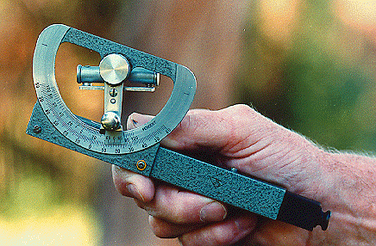The instrument consists of a graduated arc mounted on a sighting tube about 6 inches long.
* The arc may have a degree, percentage or topographic scale.
* When the level bubble, which is attached to the instrument, is rotated while a sight is taken, a small mirror inside the tube makes it possible to observe when the bubble is horizontal.

Figure 20: Abney's level

* The angle between the bubble tube and the sighting tube may be read on the arc.
* The abney’s level, however, is slower to use, and large vertical angles are difficult to measure because of the effect of refraction on observations of the bubble through the tube beneath.
* This makes the abney level difficult to use in tall timber that is so dense that the tops cannot be seen from a considerable distance.
* When used correctly, the Abney Level has an accuracy of about +/- 0.5 m for a 20 m tall tree (ie about 2.5%).

**Use**

1. Measure the horizontal distance from the base of a vertical tree (or the position directly beneath the tree tip of a leaning tree) to a location where the required point on the tree (e.g. tree tip) can be seen.
2. Sight at the required point and move the index arm over the scale until the bubble tube is level.
3. Read the percentage scale (or the degrees and minutes of the angle).
4. Calculate the height by multiplying the percentage read by the horizontal distance (or by multiplying the horizontal distance by *Tan* of the angle).

5. Site to the base of the tree and repeat steps 2 - 4.

6. Combine the heights from steps 4 and 5 to determine total tree height:

* + Add the 2 heights together if you looked up to the required point in step 2 and down to the base of the tree in step 5.
  + Subtract the height to the base of the tree from the height to the required point if you are on sloping ground and had to look up to both the required point and the base of the tree.

7. Check all readings and calculations.

**Advantages**

* It gives accurate angles of elevation and depression
* Reading can be taken after sighting the tree without distrubing the index.
* It is small and light and can be used even in hills without difficulty.

**Disadvantages**

* Shaking of the hand makes the sighting of the top or bottom of the tree a little difficult and time consuming.
* The spirit level has to be adjusted by moving the head of the screw while simultaneously looking to the top or bottom of the tree.

1. **Haga altimeter**

* 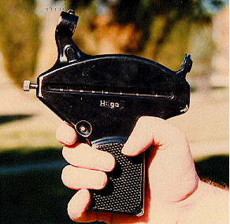It consists of a gravity-controlled, damped, pivoted pointer, and a series of scales on a rotatable, hexagonal bar in a metal, pistol-shaped case.

Figure 21: Haga altimeter

* The six regular American scales are 15, 20, 25, 30, percentage, and topographic scale.
* Sights are taken through a gun-type peep sight; squeezing a trigger locks the indicator needle, and the observed reading is taken on the scale.
* A range finder is available with this instrument.
* When used correctly, the Blume Leiss has an accuracy of about +/- 0.5 m for a 20 m tall tree (ie about 2.5%).

**Use**

1. Select a location, preferably 15, 20, 30 or 40 meters horizontal distance from the base of a vertical tree (or the position directly beneath the tree tip of a leaning tree) where the required point on the tree (e.g. tree tip) can be seen.
2. Select the appropriate distance scale on the rotating rod.
3. Release the pointer by pressing the button on the side of the instrument.
4. Sight at the required point on the tree, wait for a moment for the pointer to settle then pull trigger.
5. Read the height directly from the appropriate scale if you are 15, 20, 30, or 40 meters away from the tree. If you were unable to find a position at one of these distances:
   * If the horizontal distance is a simple fraction of one of the scale distances (e.g. 10 m is half of 20 m), read from the scale distance and multiply by the appropriate fraction.
   * Read from the percent scale and multiply this percentage by the horizontal distance measured in step 1.

6. Site to the base of the tree and repeat steps 3 - 5.

7. Combine the heights from steps 5 and 6 to determine total tree height:

* + Add the 2 heights together if you looked up to the required point in step 2 and down to the base of the tree in step 6.
  + Subtract the height to the base of the tree from the height to the required point if you are on sloping ground and had to look up to **both** the required point and the base of the tree.

8. Check all readings and calculations.

**e**. **Spiegel relaskop**

* 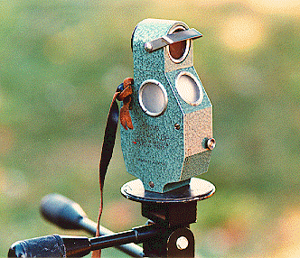The Spiegel Relaskop, also known as a Relaskop, is a sophisticated instrument that can be used to measure stand basal area and tree height and diameter at any point up a tree bole.

Figure 22: Spiegel relaskop

* In conjunction with other equipment, the Relaskop can be used in the estimation of distance (range) to an object and the number of trees / ha.
* The Relaskop has a peep-hole at the rear and a clear window at the front.
* Three additional windows in the lower half of the instrument allow light to enter and illuminate the scale.
* A brake button, bottom half at the front of the instrument, allows a weighted wheel within the Relaskop to rotate.
* When looking through the peephole, a circular field of view is seen.
* The scales are seen in the bottom half of this field of view and scale readings are taken where the scale touches the line halfway up the field of view.
* 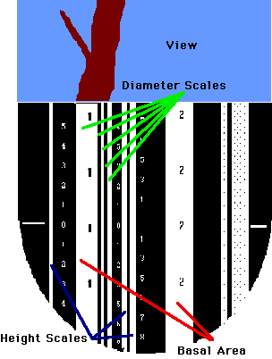The standard metric Relaskop has three scales for measuring (vertical) height. The appropriate scale will depend on the horizontal distance from the tree.

Figure 23: Scales in Spiegel relaskop

* left-most scale - 20 m from the tree.
* middle-left - 25 m from the tree.
* middle-right - 30 m from the tree.
* If you depress the brake button and look straight up or down, the appropriate distance values can be seen alongside their scales.
* Select a point from where base and tip (or any other points of interest) must be clearly visible from the selected point.

1. **Blume Leiss altimeter**

* 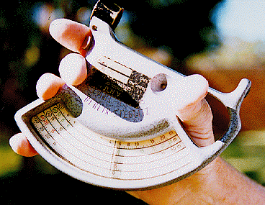It is similar in construction and operation to the Haga altimeter, although its appearance is somewhat different.

Figure 24: Blume leiss altimeter

* The regular scales are 15, 20, 30 and 40. A degree scale is also provided.
* All scales can be seen at a time. The instrument is available with a rangefinder.
* When used correctly, the Blume Leiss has an accuracy of about +/- 0.5 m for a 20 m tall tree (ie about 2.5%).

**Use**

1. Select a location, preferably 15, 20, 30 or 40 meters horizontal distance from the base of a vertical tree (or the position directly beneath the tree tip of a leaning tree) where the required point on the tree (e.g. tree tip) can be seen.
2. Release the pointer by pressing the button on the side of the instrument.
3. Sight at the required point on the tree, wait for a moment for the pointer to settle then pull trigger.
4. 4. Read the height directly from the appropriate scale if you are 15, 20, 30, or 40 meters away from the tree. If you were unable to find a position at one of these distances:
   * If the horizontal distance is a simple fraction of one of the scale distances (e.g. 10 m is half of 20 m), read from the scale distance and multiply by the appropriate fraction.
   * Read from the percent scale and multiply this percentage by the horizontal distance measured in step 1.

5. Site to the base of the tree and repeat steps 2 - 4.

6. Combine the heights from steps 4 and 5 to determine total tree height:

* + Add the 2 heights together if you looked up to the required point in step 2 and down to the base of the tree in step 5.
  + Subtract the height to the base of the tree from the height to the required point if you are on sloping ground and had to look up to **both** the required point and the base of the tree.

7. Check all readings and calculations



**g. Vertex IV and Transponder T3**

The vertex is primarily designed to measure the height of standing objects, and most often trees. The instrument can also be used to measure distance, horizontal distance, angle and inclination. The vertex instrument has with its ultrasonic measuring technique proved to be especially useful in dense terrains with thick undergrowth, where conventional methods such as measuring tapes, laser instruments and mechanical height measurers are difficult to use.

Figure 5: Vertex

To define a reference point is a secure and reliable way, the vertex works with the transponder. The vertex communicates with the transponder. This communication eliminates in an efficient way any mix-ups of signals from other instruments or places (echoes). A measuring operation will not in any significant way be disturbed by objects in between the vertex and the transponder. This reference is used as a sight mark for height measuring and can be placed at optional height, where visibility is the best in for example thick vegetation. The reference point height is set in a special menu in the vertex instrument and automatically added to the measured height.

Figure 26: Transponder 3

The vertex uses ultrasound to measure distances. Unlike for example measuring tapes and laser instruments, ultrasound can be used also when there is no free aim to the reference point. The ultrasound will not pass through an obstacle, but looks for the shortest way around it.

Heights are calculated trigonometrically using the variables contained when measuring angle and distance. The vertex automatically assumes that the measuring object is perpendicularly positioned to the ground.

With the vertex, an unlimited number of heights per object can be measured. The instrument display can show the 4 lastly measured heights per object at a time.

When using a relaskopic method to measure, an in built BAF (Basal Area Factor) can be used for the vertex instrument to control the minimum diameter for trees. The function is useful when some trees in an area are covered by other, making the decision whether to include the tree or to exclude if from the area difficult. By simply measuring the distance between the tree and the plot centre, the vertex can calculate the minimum diameter the tree should have in order to be included into the counting.

Data can be sent through IR or Bluetooth and results can be stored and processed in for example the Digitech Professional Caliper, other PC or handheld computer.

**Important facts**

The Vertex uses ultra sonic signals to determine distances. Humidity, air pressure, surrounding noise and, above all, the temperature can affect the range and extension of the ultra sonic signals. The Vertex has a built-in temperature sensor that automatically compensates for the divergence caused by variations in temperature. In some cases, distances of 50 meters and greater can be measured without problems, and in other cases, the maximum distance can be shorter than 30 meters.

To increase and optimize the measuring accuracy, calibration should be made regularly. When calibrating, it is of utmost importance that the instrument has been given enough time to stabilize at ambient temperature. If, for example, the instrument is carried in an inner pocket, it can take up to 10 minutes before it has adjusted to current outdoor temperature. The measurement inaccuracy pending on temperature is approximately 2 cm/C°.

*An example*: Your inner pocket holds +15 C°. Outdoor air temperature is -5 C°. The measurement result will show 10,40 m and not the correct 10,00 m.

The measuring fault can be made permanent if the instrument is calibrated before reaching the correct current temperature.

*-Check your instrument daily and recalibrate if necessary*

*-Do not touch the temperature sensor at the front of the instrument (the metal knob*

*between the sight and the loudspeaker)*

*-Never calibrate the instrument before it has reached ambient temperature*

When measuring heights, it is important to hold the instrument as straight as possible.

The trigonometric functions calculate the height based on two (2) angles and one (1) distance. The distance can be measured manually with a tape, or automatically by using the Ttransponder. If using a tape, the distance has to be input in the Vertex before starting (angle-) and height measuring.

**How to use the Vertex**

**HEIGHT**

Height measuring can be performed in different ways depending on type of surroundings and operation. Heights, distance and angle can be transmitted via InfraRed (IR) to, for example the Digitech Professional Caliper or other computer device for storage/processing with IR or Bluetooth (Vertex IV BT model only) by pressing right arrow key. For height measuring 3 last measured heights with angle and distance can be transferred.

**Height measuring with transponder**

Start the transponder and place it on/towards the object to measure. *Note that the transponder should be placed at the T.HEIGHT /(transponder height) that has been set in the settings menu.*

Walk a suitable distance from the object – for optimal results the distance equals the approximate height.

1. Press ON to start the Vertex and aim at the transponder. Keep pressing ON until the cross hair sight goes out momentarily. Now release ON. The Vertex has measured the distance, the angle and the horizontal distance to the transponder.

2. Aim at the height to measure with the sight cross blinking. Press ON until the cross hair disappears. The first height is locked and displayed. Repeat until all heights on the object are measured.

**Inclination (ANGLE)**

The Vertex is an excellent instrument to measure inclination and angles in the terrain.

1. Press ON to start the Vertex and step with the arrow keys to **ANGLE** and press ON.

2. The angle window is displayed. Aim at the point where you need to know the angle.

Push and press the ON until the cross disappears. Read the obtained value in display.

The angle is featured in Grads, degrees and percentage.

Note that the angle is measured from the Vertex with the cross hair sight. This implies that it is not possible to use the outside of the Vertex to measure the angle of, for example a flat table surface.

**Distance Measuring (DME)**

To measure the distance, press the DME key (left arrow key) when the vertex is turned off. The result, the distance between the vertex and the transponder, is presented in the vertex display.

**Distance measuring with the adapter for 360 degrees**

With the adapter, the ultrasound is spread and it is possible to measure from any direction. This is particularly useful when working in circular sample plots, where the distance from the plot centre to objects within a defined circle should be measured.

**Horizontal distance measuring (DME)**

The vertex can be used as horizontal distance measurer (DME). The display text will rotate 900 to simplify reading the results when measuring horizontal distances.

Figure27: Transponder with adapter

1. Press ON to start the vertex and go with the arrow keys to ANGLE and push ON.
2. Aim at the point where you need to know the angle. Push and press the ON until the Red Cross goes out.
3. To measure the distance, now push the left arrow key. The vertex presents the horizontal distance in the display.

**Basal Area Factor**

Working in dense forest with relaskopes or prism can sometimes offer difficulties and accurate diameter estimation hard to make.

When using relaskopic method to measure, an in built BAF function can be used for the Vertex instrument to control the minimum diameter for trees. The function is useful when some trees in an area covered by other, making the decision whether to include the tree or to exclude if from the area difficult.

By simply measuring the distance between the tree and the plot centre, the vertex can calculate the minimum diameter the tree should have in order to be included in the counting.

Basal area factors: 0.5, 1, 2, 3, 4, 5, 6, 7, 8, 9 (m2/ha)

**Transponder**

The transponder is an ultrasonic transmitter/receiver that communicates with the vertex instrument. The transponder can be used both for direct measuring (600), and in 3600 when used with “360 adapter”- for example when working in circular sample plots.

The transponder is equipped with an audible signal that tells if the transponder is activated or not.

Transponder T3 has no switch and the vertex and /or DME is used as a remote control to turn off and on. When turned on, the transponder stays activated for app. 20 minutes.

To measure in 3600 circle with the transponder, the T3 is attached to the adopter. The adapter spreads and receives the ultrasound in a full circle. The adapter can be mounted onto the custom plot center staff.

**Special considerations in measuring tree heights**

* It is difficult to measure accurately the height of large flat crowned trees. There is tendency to overestimate their heights.
* The optimum viewing distance for any hypsometer is the distance along the slope equal to the height to be measured. This rule of thumb should be used with discretion.
* Since all hypsometers assume that trees are vertical, tress leaning away from an observer will be underestimated and trees leaning towards an observer will be overestimated. This error will be minimized if measurements are taken such that the lean is to the left or right of the observer.
* The measurement of tree height with an accurate hypsometer is slow and expensive.

**2.2.4 Sources of errors in height measurement**

* Measuring the height of trees is time consuming and prone to errors.
* Experience has shown that when indirect methods are used to measure height, measurement from two independent positions is essential.
* The readings from the two positions should agree within the limits of instrumental error - this is an absolute check on instrument and operator error (sighted to correct tip, etc.).
* Thus, differences of up to 1 m in readings for a 40 m tree are acceptable - [precision of instruments under forest conditions is no better than this](http://sres-associated.anu.edu.au/mensuration/BrackandWood1998/HGTCOMP.HTM).

**The most common errors include:**

* The sources of the major errors in height measurement are:

1. Failure to measure correctly the horizontal distance from the observer to the tree

If the distance from the observer to the tree is not measured horizontally, the observer will stand too near the tree, and the height will be overestimated by the direct reading on the instrument scale.

1. Wind sway

Wind causes tree tops to sway and this can be very serious hindrance in tree height measurement and cause serious errors. Accurate readings cannot be made in high winds. The errors may be reduced by averaging readings taken at the extremes of the sway towards and away from the observer.

1. Leaning trees

If the tree is leaning away from the observer, height will be under estimated and if the lean is towards the observer, height will be overestimated.

1. Non linearity of the relationship of tree height and angle of sight.

The smaller the angle of the sight the easier it is to define the highest point in the crown; but the nearer the angle of sight to 450 the smaller is the error caused by an inaccurate reading of that angle. The best compromise between these two conflicting considerations is to select the observation point so that the angle of sight lies between 300 and 450, i.e the observer should stand between one and one-and-a-half times the tree height away from the tree. Angles greater than 450 must be avoided as the probability of mistaking a side branch for the top of the tree is unacceptably high.

1. Instrument error. All instruments should be checked periodically against some standard or known height and adjust as necessary.
2. Operator and recording error. - Personal error is always likely, e.g.

* incorrect setting of distance or booking of angles and distances, incorrect reading;
* forgetting to add on the section of tree below eye level or forgetting to sight to the tree base;
* Measuring to wrong tip - shaking the tree may help!

Difference of opinion amongst observers in nominating the tip of an umbrageous crown.