The Last Sermon (Khutbah) of Prophet Muhammad (Farewell Sermon)

webadmin

Prophet Muhammad (SAWS) delivered his last sermon (Khutbah) on the ninth of Dhul Hijjah (12th and last month of the Islamic year), 10 years after Hijrah (migration from Makkah to Madinah) in the Uranah Valley of mount Arafat. His words were quite clear and concise and were directed to the entire humanity.

After praising, and thanking Allah he said:

***“O People, lend me an attentive ear, for I know not whether after this year, I shall ever be amongst you again. Therefore listen to what I am saying to you very carefully and TAKE THESE WORDS TO THOSE WHO COULD NOT BE PRESENT HERE TODAY.”***

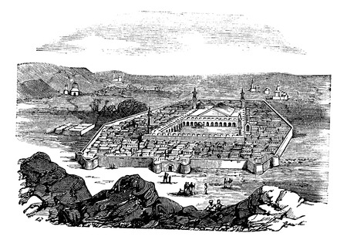

**Old Madinah Saudi Arabia Sketch**

[***Beware of Satan, for the safety of your religion***](http://www.iqrasense.com/satan-and-evil/satan-story-shaitaan-tactics-methods-to-ward-off-influences-whispers.html)***. He has lost all hope that he will ever be able to lead you astray in big things, so beware of following him in small things.O People, just as you regard this month, this day, this city as Sacred, so regard the life and property of every Muslim as a sacred trust. Return the goods entrusted to you to their rightful owners. Hurt no one so that no one may hurt you. Remember that you will indeed meet your LORD, and that HE will indeed reckon your deeds. ALLAH has forbidden you to take usury (interest), therefore all interest obligation shall henceforth be waived. Your capital, however, is yours to keep. You will neither inflict nor suffer any inequity. Allah has Judged that there shall be no interest and that all the interest due to Abbas ibn ‘Abd’al Muttalib (Prophet’s uncle) shall henceforth be waived…***

***O People, it is true that you have certain***[***rights with regard to your women***](http://www.iqrasense.com/muslim-character/muslim-women-and-cases-of-domestic-abuse.html)***, but they also have rights over you. Remember that you have taken them as your wives only under Allah’s trust and with His permission. If they abide by your right then to them belongs the right to be fed and clothed in kindness. Do treat your women well and be kind to them for they are your partners and committed helpers. And it is your right that they do not make friends with any one of whom you do not approve, as well as never to be unchaste.***

[**To get more valuable Islamic content on a regular basis, please subscribe to our newsletter here**](http://www.iqrasense.com/subscribe)

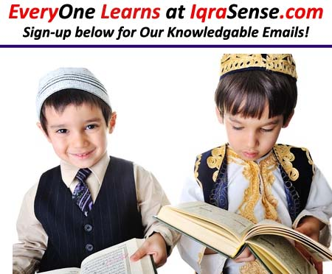

***O People, listen to me in earnest, worship ALLAH,***[***say your five daily prayers (Salah)***](http://www.iqrasense.com/quran-verses-by-topics/importance-of-quran-and-salat.html)***, fast during the month of Ramadan, and give your wealth in Zakat. Perform Hajj if you can afford to.***

**(**[**Click here to read stories from the Quran**](http://amzn.to/2ePkRVs)**)**

***Remember, one day you will appear before ALLAH and answer your deeds. So beware, do not stray from the path of righteousness after I am gone.All mankind is from Adam and Eve, an Arab has no superiority over a non-Arab nor a non-Arab has any superiority over an Arab; also a white has no superiority over black nor a black has any superiority over white except by***[***piety (taqwa)***](http://www.iqrasense.com/about-islam/taqwa-the-cornerstone-of-islamic-faith.html)***and good action. Learn that***[***every Muslim is a brother to every Muslim and that the Muslims constitute one brotherhood***](http://www.iqrasense.com/about-islam/muslims-vs-muslims-whos-right.html)***. Nothing shall be legitimate to a Muslim which belongs to a fellow Muslim unless it was given freely and willingly. Do not, therefore, do injustice to yourselves.***

***[](https://www.hilalplaza.com/products/ar-raheeq-al-makhtum-the-sealed-nectar)All those who listen to me shall pass on my words to others and those to others again; and may the last ones understand my words better than those who listen to me directly. Be my witness, O ALLAH, that I have conveyed your message to your people”.O People, NO PROPHET OR APOSTLE WILL COME AFTER ME AND NO NEW FAITH WILL BE BORN. Reason well, therefore, O People, and understand words which I convey to you. I leave behind me two things, the QURAN and my example, the SUNNAH and if you follow these you will never go astray.***

(Reference: See Al-Bukhari, Hadith 1623, 1626, 6361) Sahih of Imam Muslim also refers to this sermon in Hadith number 98. Imam al-Tirmidhi has mentioned this sermon in Hadith nos. 1628, 2046, 2085. Imam Ahmed bin Hanbal has given us the longest and perhaps the most complete version of this sermon in his Masnud, Hadith no. 19774.)

[**Click here to download the book “Letters of Prophet Muhammad”**](http://www.iqrasense.com/download-free-books/download-islamic-books-on-quran-hadith-fiqh-and-other-topics.html)

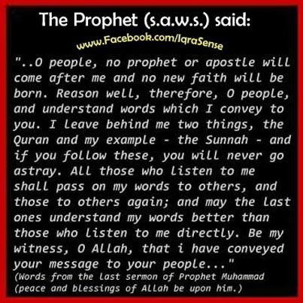

[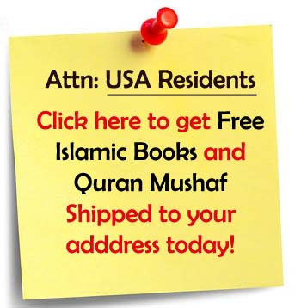](http://www.iqrasense.com/free-islamic-books)

[](http://amzn.to/2ePjeak)



One can heed words of wisdom and guidelines from the last sermon (khutbah) of the prophet (SAWS). His sermons emphasized on the following:

* Sacredness of a Muslim’s life and property
* The importance of propagating this message to all others (A Muslim’s responsibility thus does not end by following the religion)
* A reminder that everyone is fully accountable for their deeds and Allah (God) will take every person into account. If everyone heeded to this fact alone, the world would be a much better place today.
* “Hurt no one so that no one may hurt you.” These words of the prophet are self explanatory.
* The prohibition of dealing with interest (Numerous accounts in Quran and Hadith prohibit taking, giving or being a part of any transaction dealing with interest).

[](http://amzn.to/2aOlt8H)

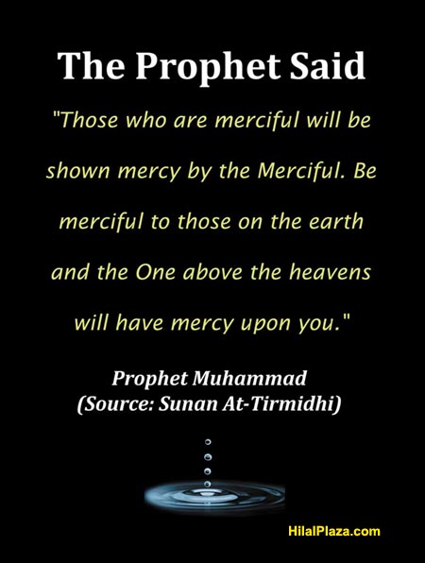

* “You will neither inflict nor suffer any inequity.” These words of the prophet are self explanatory.
* The awareness of satan and how satan can work to deviate us from the right path and doing evil things.
* [Rights of women over men and rights of men over women](http://www.iqrasense.com/muslim-character/two-tips-for-your-muslim-marriage.html).
* Treatment of women with kindness.
* Modesty and chastity in women.
* The importance of worshiping Allah (saying your five daily prayers (Salah), fasting during the month of Ramadan, giving charity (Zakat) and performing pilgrimage (Hajj).
* Equality amongst all (blacks, white, Arabs, non-Arabs, etc.)
* [The need to establish justice](http://www.iqrasense.com/quranic-tafsir/quranic-reflections-allahs-command-about-establishing-justice.html).
* Islam is the final divine religion (Last prophet and Last Book).

Let’s do our part in following the prophet’s message and propagating the message to everyone we know.

***[](https://www.hilalplaza.com/products/ar-raheeq-al-makhtum-the-sealed-nectar)***

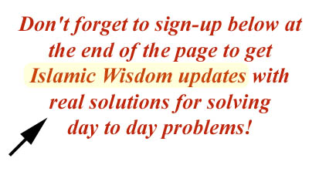

**More Words of Wisdom by Prophet Muhammad**

Some of the other Prophet’s Ahadith and Words of Wisdom are below.

**Prophet’s Hadith on Tears from Allah’s Fear**

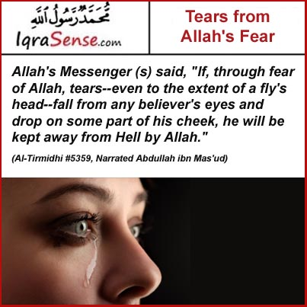

**Hadith on Praying on Fridays**

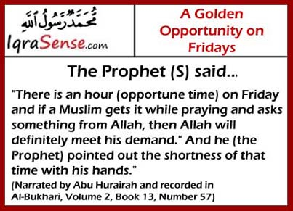

**Hadith on staying away from Innovations**

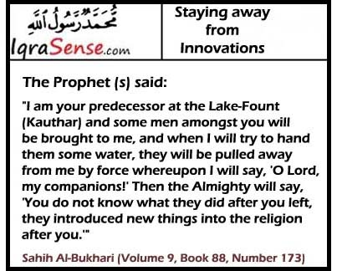

**Hadith on Allah’s Mercy**

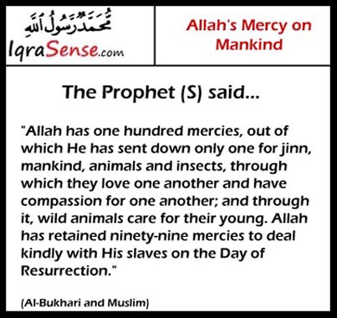

**Hadith on Allah’s Love for His Creation**

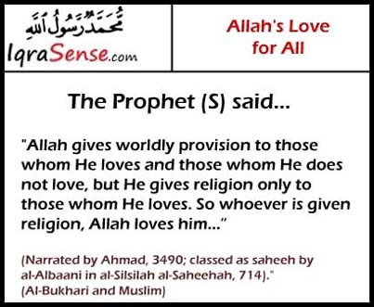

**Hadith on Allah’s Remembrance**

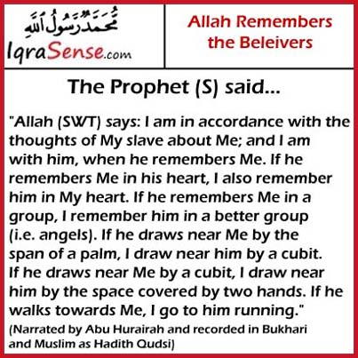

**Hadith on Rights of Allah and His Slaves**

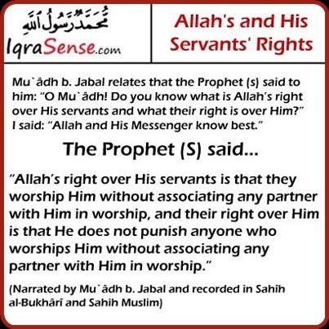

**Prophet Saying on Equality**

