**Western Blotting:** (sometimes called the protein immunoblot)

It is a widely accepted [analytical technique](http://en.wikipedia.org/wiki/Analytical_technique) used to detect specific [proteins](http://en.wikipedia.org/wiki/Proteins) in the given sample of tissue homogenate or extract. It uses [gel electrophoresis](http://en.wikipedia.org/wiki/Gel_electrophoresis) to separate native proteins by 3-D structure or denatured proteins by the length of the polypeptide. The proteins are then transferred to a membrane (typically [nitrocellulose](http://en.wikipedia.org/wiki/Nitrocellulose) or [PVDF](http://en.wikipedia.org/wiki/PVDF)), where they are stained with [antibodies](http://en.wikipedia.org/wiki/Antibody) specific to the target protein.1,2The method originated in the laboratory of Harry Towbin at the [Friedrich Miescher Institute](http://en.wikipedia.org/wiki/Friedrich_Miescher_Institute_for_Biomedical_Research).The name *western blot* was given to the technique by W. Neal Burnette.3

**Two Main Types of Westerns**

**1:Denaturing (Most Commonly Used)**

SDS-P AGE

**2:Non-Denaturing**

Native PAGE

[**Western Blot Principle**](http://www.western-blot.us/western-blot-test/western-blot-principle)

There are two types of blotting apparatus used to transfer proteins to solid supports; these facilitate either wet transfer (tank blotting) or semidry transfer. Both of them give good result. Electrophoresis is used to separate complex mixtures of proteins.

Denaturing discontinuous one dimensional gel electrophoresis separates proteins only based on molecular size as they move through a SDS- polyacrylamide gel(SDS PAGE) toward the  anode with the smaller protein migrating faster and bigger proteins running slower.

Western blotting is the transfer of proteins from the SDS- PAGE gel to a solid supporting membrane.A protein sample is subjected to polyacrylamide gel electrophoresis. After this the gel is placed over a sheet of nitrocellulose and the protein in the gel is electrophoretically transfered to the nitrocellulose.The nitrocellulose is then soaked in blocking buffer (3% skimmed milk solution) to "block" the non-specific binding of proteins. The nitrocellulose is then incubated with the specific antibody for the protein of interest. The nitrocellulose is then incubated with a second antibody, which is specific for the first antibody The second antibody will typically have a covalently attached enzyme which, when providedwith a chromogenic substrate, will cause a color reaction.Thus the molecular weight and amount of the desired protein can be characterized from a complex mixture (e.g. crude cell extract) of other proteins by western blotting.

**Western Blotting Specificity :**

Western blotting (1981) is an Immunoblotting technique which rely on the specificity of binding between a protein of interest and a probe (antibody raised against that particular protein) to allow detection of the protein of interest in a mixture of many other similar molecules.

The SDS PAGE technique is a prerequisite for Western blotting .

Steps in western blotting

1. A protein sample is subjected to electrophoresis on an SDS-polyacrylamide gel.
2. Electroblotting transfers the separated proteins from the gel to the surface of a nitrocellulose membrane
3. The blot is incubated with a generic protein (such as milk proteins or BSA) which binds to any remaining sticky places on the nitrocellulose.
4. An antibody that is specific for the protein of interest (the primary antibody - Ab1) is added to the nitrocellulose sheet and reacts with the antigen.  Only the band containing the protein of interest binds the antibody, forming a layer of antibody molecules .

After washing for removal of non-specifically bound Ab1, second antibody (Ab2)is added, which specifically recognizes  the Fc domain of the primary antibody and binds it. Ab2 is radioactively labeled, or is covalently linked to a reporter enzyme, which allows to visualize the protein-Ab1-Ab2 complex.

**Western Blot Theory :**

Antibodies bind to specific sequences of amino acids, known as the epitope. Because amino acid sequences are different from protein to protein, antibodies can recognize spe First, proteins are separated from each other based on their size. Second, antibodies are used to detect the protein of interest.

Finally, a substrate that reacts with an enzyme is used to view the antibody/protein complex

**SDS-PAGE (PolyAcrylamide Gel Electrophoresis):**

**SDS-PAGE**, **sodium dodecyl sulfate polyacrylamide gel electrophoresis**, is a technique widely used in biochemistry, forensics, genetics and molecular biology to separate proteins according to their electrophoretic mobility (a function of length of polypeptide chain or molecular weight). It is used to separate proteins according to their size, and no other physical feature.

**SDS-PAGE:**

**SDS (sodium dodecyl sulfate) is a detergent (soap) that can dissolve hydrophobic molecules but also has a negative charge (sulfATE) attached to it.**

**Before SDS:**

Protein (pink line) incubated with the denaturing detergent SDS showing negative and positive charges due to the charged R-groups in the protein.

The large H's represent hydrophobic domains where nonpolar R-groups have collected in an attempt to get away from the polar water that surrounds the protein.

**After SDS**:

SDS disrupt hydrophobic areas (H's) and coat proteins with many negative charges which overwhelms any positive charges the protein had due to positively charged R-groups.  
 The resulting protein has been denatured by SDS (reduced to its primary structure-aminoacid sequence) and as a result has been linearized.

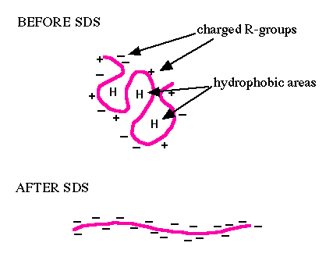

**SDS:**

Therefore, if a cell is incubated with SDS, the membranes will be dissolved, all the proteins will be solubalized by the detergent and all the proteins will be covered with many negative charges.

The detergent binds to hydrophobic regions in a constant ratio of about 1.4 g of SDS per gram of protein.

**PAGE:**

If the proteins are denatured and put into an electric field (only), they will all move towards the positive pole at the same rate, with no separation by size. However, if the proteins are put into an environment that will allow different sized proteins to move at different rates.

The environment is polyacrylamide. The entire process is called **polyacrylamide gel electrophoresis** (PAGE).Small molecules move through the polyacrylamide forest faster than big molecules.Big molecules stays near the well.

**SDS-PAGE:**

The end result of SDS- PAGE has two important features:

1. all proteins contain only primary structure
2. all proteins have a large negative charge which means they will all migrate towards the positive pole when placed in an electric field.

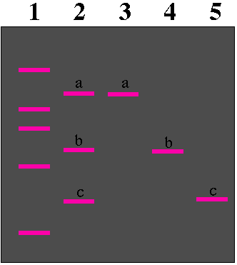

The actual bands are equal in size, but the proteins within each band are of different sizes.

***Native PAGE:***

* Native, unfolded, and not-denatured proteins can be separated using this method. This method allows for the separation of proteins that are inaccessible by other methods. One example would be the separation of modified and unmodified proteins of the same kind (e.g. phosphorylated versus unphosphorylated state of a protein).
* Native PAGE can also be used to confirm biologically relevant conformations, like di-, tri-, or tetrameric forms of proteins (contrary to SDS-PAGE, which would separate the individual and denatured peptide chains).
* This method can also detect different complexes of different proteins. The separation using native PAGE depends on a number of parameters such as the **charge**, **size** and **3D structure** of the protein.
* A suitable buffer is needed to maintain the 3D folding of the protein. The applicability of the buffer depends on the isoelectric point and the charges of the protein.

**SAMPLE:**

Cell lysates are the most common form of sample used for western blot. Protein extraction attempts to collect all the proteins in the cell cytosol.This should be done in a cold temperature with protease inhibitors to prevent denaturing of the proteins.Since tissue sample display a higher degree of structure, mechanical invention, such ahomogenization, or sonication is needed to extract the proteins. After extracting the protein, it is very important to have a good idea of the extract's concentration. This eventually allows the researcher to ensure that the samples are being compared on an equivalent basis. Protein concentration is often measured using a spectrophotometer. Using this concentration allows to measure the mass of the protein that is being loaded into each well by the relationship between concentration, mass, and volume.4

**Sample Preparation:**

The first step in sample preparation, is isolating the protein from a source. Usually, protein is purified from cells. However, other sources of protein, such as synthetically derived protein, can also be run through a Western blot.Next, the protein concentration is determined**.**

Loading buffer contains SDS (sodium dodecyl sulfate), and BME mercaptoethanol

* Sample is loaded into wel.Glycerol is added to make samples sink into wells and the Tris base provides appropriate pH.

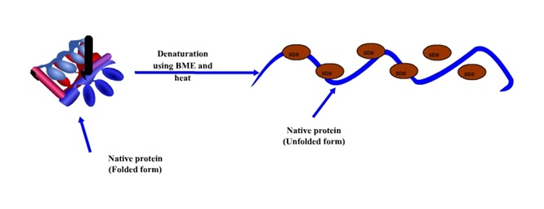

**SDS-PAGE Method:**

The first step in SDS-PAGE, is placing the sample, containing the protein-SDS compound, in a well on top of the gel. A ladder is usually loaded in one of the wells. Ladders are protein mixtures of known molecular weight, that allow the researcher to determine the molecular weights of the other proteins on the gel.



* Once the sample(s) and ladder are loaded, a current is run across the gel, with a negative pole on the well end of the gel, and a positive pole on the opposite end of the gel.Because the protein is bound to negatively charged SDS, it is pulled down through the gel to the positive pole.

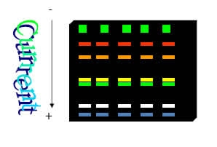

* Although running the gel is the last step in the SDS-PAGE method, it is important to make note of several pieces of information:
* Proteins are separated by their size as they run through the gel.
* The lower the concentration of acrylamide in a gel, the easier it becomes for proteins to move through the gel; so all proteins move further under the same conditions.
* Gradient gels are gels where the concentration of acrylamide increases.
* In order to make the proteins accessible to antibody detection they are moved from within the gel onto a membrane made of [*nitrocellulose*](http://en.wikipedia.org/wiki/Nitrocellulose) *or* [*polyvinylidene difluoride*](http://en.wikipedia.org/wiki/Polyvinylidene_difluoride) *(PVDF*). The primary method for transferring the proteins is called [electroblotting](http://en.wikipedia.org/wiki/Electroblotting) and uses an electric current to pull proteins from the gel into the PVDF or nitrocellulose membraneThe proteins move from within the gel onto the membrane while maintaining the organization they had within the gel.5

**Transferring Method:**

After the gel is run, it is placed against a membrane, and current is passed across the gel to the membrane, transferring the proteins onto the membrane.

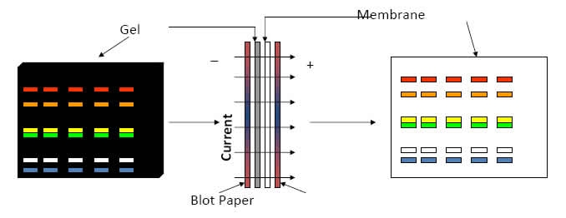

[Primary antibody](http://en.wikipedia.org/wiki/Primary_antibody)

The primary antibodies are generated when a host species or immune cell culture is exposed to protein of interest (or a part thereof).

Normally, this is part of the immune response, whereas here they are harvested and used as sensitive and specific detection tools that bind the protein directly.

[Secondary antibody](http://en.wikipedia.org/wiki/Secondary_antibody)

After rinsing the membrane to remove unbound primary antibody, the membrane is exposed to another antibody, directed at a species-specific portion of the primary antibody.Antibodies come from animal sources ( an anti-mouse) secondary will bind to almost any mouse-sourced primary antibody. This is known as a secondary antibody, and due to its targeting properties, tends to be referred to as "anti-mouse," "anti-goat,”6 There are now many reagent companies that specialize in providing antibodies (both [monoclonal](http://en.wikipedia.org/wiki/Monoclonal_antibodies) and [polyclonal](http://en.wikipedia.org/wiki/Polyclonal_antibodies) antibodies) against tens of thousands of different proteins.

Most commonly, a [horseradish peroxidase](http://en.wikipedia.org/wiki/Horseradish_peroxidase)-linked secondary antibody is used to cleave a chemiluminescent agent, and the reaction product produces [luminescence](http://en.wikipedia.org/wiki/Luminescence) in proportion to the amount of protein.

* A sensitive sheet of photographic film is placed against the membrane, and exposure to the light from the reaction creates an image of the antibodies b Next, the primary antibody is added to the solution in which the membrane is floating.
* Remember that the primary antibody recognizes a specific amino-acid sequence of a particular protein.

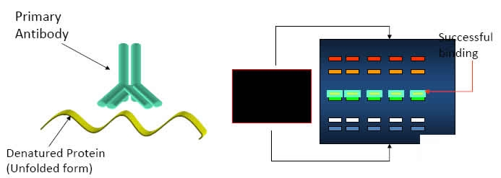

* After a wash is conducted to remove unbound primary antibody, secondary antibody is added.
* Secondary antibody recognizes the primary antibody, and usually is conjugated with an enzyme, such as HRP (Horse Radish Peroxidase).

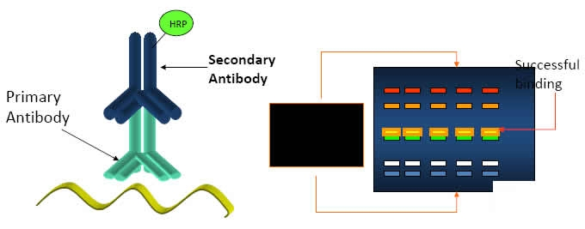

Lastly, another wash is performed to remove unbound secondary antibody.

* Non-specific binding of both the primary and secondary antibodies can occur, but thorough washing usually minimizes this problem.
* The amount of time the primary and secondary antibodies are applied, directly affects the specificity.

**Detection Method:**

The detection method used is dependent upon the enzyme to which the secondary antibody is conjugated. The most common enzyme used in Western Blotting is HRP, and the substrate used for detection is known as chemiluminescent substrate. Novus Biologicals' detection substrate is known as NovaLume.

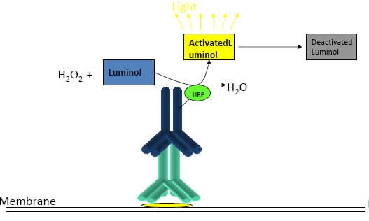

Once the substrate has been added, the light being emitted can be detected with film or a photo imager.

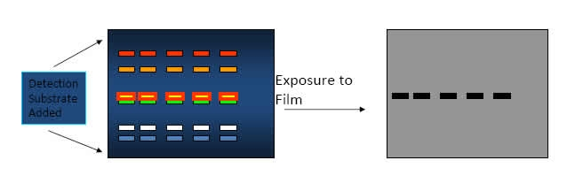

* Notice that the film does not contain information on where the lit bands are located in relation to the membrane. Therefore, it is very important to use a method that allows the film to be aligned with the membrane in the exact same manner as when the film was exposed. The membrane is usually stained after the detection step, so that the protein present can be visualized, and compared to the film.

**Fluorescent detection:**

* The fluorescently labeled probe is excited by light and the emission of the excitation is then detected by a photosensor such as CCD camera equipped with appropriate emission filters.This captures a digital image of the western blot and allows further data analysis such as molecular weight analysis and a quantitative western blot analysis. Fluorescence is considered to be one of the best methods for quantification, but is less sensitive than chemiluminescence.7,8

**WESTRN BLOT TROUBLESHOOTING:**

|  |  |
| --- | --- |
| **Common Problems** | **Recommended Troubleshooting** |
| Unusual or unexpected bands | * Use a fresh sample which had been kept on ice   or alter the antibody;   * Make sure the transfer sandwich is prepared   properly;   * Change the running buffer |
| No bands | * Make sure to use the right and appropriate   concentration of antibody; .   * Increase the conc. of antigen; * Buffers should be new and uncontaminated; * Lower the washing time. |
| Faint bands or weak signal | * Increase the conc. of antigen or antibody; * Increase exposure time; * Change nonfat dry milk into BSA or decrease   the amount of milk. |
| High background | * Lower the conc. of antibody; * Increase washing time; * Decrease exposure time. […](http://www.western-blot.us/guide-to-the-problem-of-wb/high-background) |
| Patchy or uneven spots | * Make sure of no air bubbles during transfer; * use a shaker for all incubation; * Change blocking buffer. |

**Western Blot Applications for Medical Diagnosis:**

[**Western Blot Applications for HIV**](http://www.western-blot.us/applications-of-western-blotting/applications-in-medical-diagnosis/HIV-Western-Blot)

* Western blot is applied in a confirmatory HIV-test to detect anti-HIV antibody in a human serum sample.Proteins from known HIV-infected cells are separated and blotted on a membrane. Then, in the primary antibody incubation step, the serum to be tested is applied; free antibody is washed away, and a secondary anti-human antibody conjugated with an enzyme signal is added.
* Then the stained bands will indicate whether the patient's serum contains anti-HIV antibody. This is the main principle of western blot medical diagnosis assay for HIV infection.

[**Western Blot Applications**](http://www.western-blot.us/applications-of-western-blotting) **:**

Western Blot for Lyme

Western Blot for HIV

Western Blot for Herps

Western Blot for Lyme

Western Blot for FIV

Western Blot for HBV

**References:**

1.Towbin H, Staehelin T, Gordon J. (1979). "Electrophoretic transfer of proteins from polyacrylamide gels to nitrocellulose sheets: procedure and some applications". *Proceedings of the National Academy of Sciences USA* **76** (9): 4350–54.

2.Renart J, Reiser J, Stark GR. (1979). "Transfer of proteins from gels to diazobenzyloxymethyl-paper and detection with antisera: a method for studying antibody specificity and antigen structure". *Proceedings of the National Academy of Sciences USA* **76** (7): 3116–20.

3.Burnette WN. (1981). "'Western blotting': electrophoretic transfer of proteins from sodium dodecyl sulfate—polyacrylamide gels to unmodified nitrocellulose and radiographic detection with antibody and radioiodinated protein A". *Analytical Biochemistry* **112** (2): 195–203

4.Tahrin mehmood,ping-chang yang.Western blot: Technique, theory, and trouble shooting.North American Journal Of Medical Sciences 2012;4: 429-434

5.Alwine J, Kemp D, Stark G, (1977). "Method for detection of specific RNAs in agarose gels by transfer to diazobenzyloxymethyl-paper and hybridization with DNA probes.". *Proceedings of the National Academy of Sciences USA* **74** (12): 5350–5354

6.Ambroz K. (2006-09-20). ["Improving quantification accuracy for western blots](http://www.licor.com./bio/QuantitativeWesterns/pdf/bt0609_LI-COR_final.pdf)

7. (Imaging system for westerns:chemiluminescence vs infrared detection(2009)

8.[(Methods in Molecular Biology, Protein Blotting and Detection, vol. 536“](http://www.springerlink.com/content/gt3658942x624vq6/fulltext.pdf))2010-20-26.