**Forest sampling and Inventory**

**5.1 Definition and scope of sampling**

* Sampling is the process in which enumeration is to be done only in a representative portion of the whole.
* In Sampling, the information is obtained only from a part of the population assuming that it is the representative of the whole. A part is studied and on that basis, the conclusion is drawn for the entire population.
* For example, a forest area may be of 1000 ha out of which only 100 ha have been selected for enumeration and estimate of the whole population of 1000 ha is made, it is called sampling.

**Sampling unit**: The population is divided into suitable units for the purpose of sampling.

Types of sampling units in forest surveys are:

* Compartments,
* topographical sections,
* strips of a fixed width,
* Plots of definite shape and size etc.

**Sampling frame:** The list of sampling units from which the sample units are to be selected is called sampling frame.

**Sampling Intensity (SI):** The ratio of sample to the whole population which is expressed on a percentage

SI = sample area/Total area x 100

**Size of the sample**

The number of sample units in the sample is known as sample size.

Factors affecting the size of sample

* Nature of population
* Number of classes
* Nature of Study
* Types of sampling
* Standard of accuracy/precision required, and
* Other considerations

**Scope of sampling**

* Less time
* Reduced cost
* Administrative convenience
* Better supervision
* Check result of census method
* Suitable for infinite/hypothetical population
* Suitable for destructing sampling

**Limitations of sampling**

Sampling is better over complete census only if

* The sampling units are drawn in a scientific manner.
* Appropriate sampling technique is used, and
* The sample size is adequate.

Sampling theory has its own limitations and problems, which are:

* Proper care should be taken in the planning and execution of the sample survey; otherwise the results obtained might be inaccurate and misleading
* Sampling theory requires the services of trained and qualified personnel and sophisticated equipment for its planning, execution and analysis. In the absence of these, the results of the sample survey are not reliable.
* If the information is required about each and every unit of the universe, there is no way but to resort to complete enumeration.

**5.2 Types of sampling**

Random and Non random Sampling

Probability/random sampling

* Simple random sampling
* Stratified random sampling
* Multistage sampling
* Multiphase sampling
* Sampling with varying probabilities

Non random sampling

* Selective sampling
* Systematic sampling

**5.2.1 Simple Random Sampling**

* It is a selection process in which every possible combination of sample units has an equal and independent chance of being selected in the sample.
* Sampling units are chosen completely at random.
* For theoretical considerations, SRS is the simplest form of sampling and is the basis for many sampling methods.
* It is most applicable for the initial survey in an investigation and for studies that involve sampling from a small area where the sample size is relatively small.

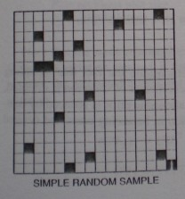**Selection of SRS**

* Lottery Method and
* Random number table method

**When to use**

* If the population is more or less homogenous with respect to the characteristics under study and
* If the population is not widely spread geographically.
* 16 samples are selected randomly from a population composed of 256 square plots

**Advantages**

Figure 2: Simple Random Sampling

* SRS is a scientific method and there is no possibility of personal bias.
* Estimation method are simple and easy.

**Disadvantages**

* If the sample chosen is widely spread, takes more time and cost.
* A population frame or list is needed.

**5.2.2 Stratified Random Sampling**

* It is a method of sampling in which the population is first divided into sub population of called strata of same or different size in such a way that characteristics within the strata are homogenous but between the strata are heterogeneous.
* Samples are taken from each stratum by randomly or other method regarding to optimum or proportional allocation methods.

**Criteria of stratification of forest area**

* Topographic features, Forest types, Density classes
* Volume classes, Age classes etc.

1. **Proportional allocation**

* When information regarding the relative variances within strata and cost of operations are not available, the allocation in the different strata may be made in proportion to the number of units in them or the total area of each stratum.
* Proportion to the area
* Formula, ni = (Ni/N) x n

Where, N = total number of sampling units in the population/forests (total population), Ni = the number of sampling units in the ith stratum (stratum size), ni = the no. of sample units, i = 1, 2, 3, …..k, k = the no. of strata and n = total sample size from all the strata.

* Larger size strata receive large size sample values.

**Example**

Sample size(n)=30

Total population size (N)=8000

Strata size N1=4000, N2=2400, N3=1600

Let Pi represent the proportion of population included in stratum i

Then,

For strata with N1=4000, we have P1=4000/8000

Hence,

n1=n*p1=30(4000/8000)=15

Similarly,

n2= n*p2=30(2400/8000)=9

n3=n*p3=30(1600/8000)=6

1. **Optimum Allocation**

* Sample plots are allocated to various strata according to standard statistical procedure resulting in smallest standard error possible with a fixed number of observations.
* Determining numbers of plots to be assigned to each stratum requires first a product of the area and standard deviation of each type
* Minimize the variance (i.e. maximize the precision) of the estimate
* Other thing being equal, a larger sample may be taken from a stratum with a larger variance so that the variances of the estimates of strata means get reduced.

ni = n x NiSi/∑NiSi

Where, Si = standard deviation of each stratum

**Example**

Sample size (n)=84

Total population size (N)=10000

Strata size N1=5000, N2=2000, N3=3000



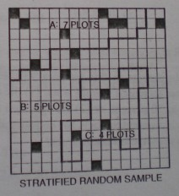

Figure 33: Stratified random sampling

**When to use** – when the sampling units are **heterogeneous** with respect to characteristics under study.

16 samples are selected randomly from a population composed of 256 square plots.

**Advantages**

* More representatives than SRS & systematic sampling
* Greater accuracy than SRS
* Administrative convenience

**Disadvantages**

* More time & cost
* Sampling units for each stratum is necessary or separate frame is needed for each stratum
* Need prior & additional information about population & its subpopulation.

**5.2. 3 Systematic sampling**

* Systematic sampling is a commonly employed technique if the complete and up to date list of the sampling units is available.
* In this sampling technique, first unit is chosen randomly and the rest being automatically selected according to some predetermined patterns.
* In this sampling, the sampling units are spaced at fixed intervals throughout the population.
* Measure of every ith tree along a certain compass bearing is an example of systematic sampling.
* A common sampling unit in forest surveys is a narrow strip at right angles to a base line and running completely across the forest, i.e. systematic sampling by strips.
* Another possibility is known is systematic line plot sampling where plots of fixed size and shape are taken at equal intervals along equally spaced parallel lines.

**When to use**- if the **complete or up to date lists** of the sampling units are available.

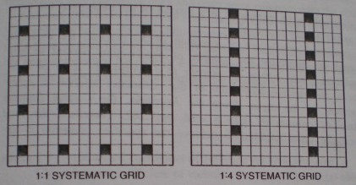

16 samples are selected systematically from a population composed of 256 square plots.

**Advantages**

* The distribution of the selected sampling units is controlled by designer and is regular.
* Field teams understand the layout and can usually identify and locate the units easily.
* Qualitative and quantitative information over the whole population can be collected at regular intervals during the survey
* The precision of the parameters estimated is usually high.

**Disadvantages**

* No valid estimates of the precision are feasible unless the pattern of variation is known.
* There is no rational method of choosing the sampling intensity and layout of sample to achieve a desired precision at minimum cost

**According to community forestry inventory guidelines,2061**

* **Sampling Method**

Stratified systematic sampling

* **Sampling Intensity**

*0.1%* (for regeneration and open land), *0.5 %* (general forest) in community forest

* **Timber Volume Calculation**

Timber volume = π x d2/4 x ht. x ff x TQ

Where, ff = form factor (0.5), TQ, first quality (by 2/3), second quality (1/2)

**Tree quality (TQ)**

* First quality- straight and clear bole, 3 or more logs with 6 feet length obtained.
* Second quality- straight bole, 2 logs with 6 feet length obtained.
* Third quality – crooked and abnormal bole and only fuel wood obtained.

**5.3 Inventory**

5.3.1 **Introduction and scope**

* Forest inventory is the procedure of obtaining information on the quantity and quality of the forest resources and many of the characteristics of the land area on which the forest is located.
* Most forest inventories have been, and will continue to be, focused on timber estimation. Thus, Forest inventory is the tabulated, reliable and satisfactory tree information.
* However, the need for information on forest health, water, soils recreation, wildlife and scenic values, and other non timber values has stimulated the development of integrated or multi resource inventories.
* It is also called enumeration or cruise

An inventory of a forest area can provide information for many different purposes; it may be part of-

* A natural resource survey with the aim of allocating land to different uses, i.e. land planning
* A natural project to assess the potential for forest and wood based industry development
* A wood based industry feasibility study
* A resource assessment for forest management planning
* The usual purpose of a timber inventory is to determine the volume ( or value) of standing trees in a given area. To attain this objective requires a reliable estimate of the forest area and measurement of all or an unbiased sample of trees within this area.
* The information may be obtained from measurement taken on the ground or on remotely sensed imagery (aerial photographs, satellite imagery etc.).

**Types of inventory**

**Total enumeration** (census): enumeration is carried out over the entire area of the forest unit under consideration. It is expensive and time consuming.

**Partial enumeration**: enumeration is to be done only in a representative portion of the whole forest.

* The choice of a particular inventory system is governed by relative cost, size and density of timber, area to be covered, precision desired, number of people available for fieldwork, and length of time allowed for the estimate.
* Regardless of the kind of inventory being under taken, a carefully developed plan is needed to execute the inventory efficiently.
* Many forest inventories are carried out using fixed area sample units. These fixed area sample units are called strips or plots, depending on their dimensions.
* Sample plots can be any shape (circular, square, rectangular or triangular), however, square/rectangular and circular plot shapes are most commonly employed.

A strip can be thought of as a rectangular plot whose length is many times its width.

* Population – is an aggregate of objects under study.
* Sample – a finite subset of the population selected from it for the purpose of the study/investigation.
* Sampling unit: The population is divided into suitable units for the purpose of sampling.

Types of sampling units in forest surveys are:

* Compartments, topographical sections, strips of a fixed width, plots of definite shape and size etc.
* Sampling frame: The list of sampling units from which the sample units are to be selected is called sampling frame.
* Sampling Intensity (SI): The ratio of sample to the whole population which is expressed on a percentage

SI = sample area/Total area x 100

**Inventory planning**

* Purpose of the inventory
* Background information
* Description of area
* Information required in final report
* Inventory design
* Procedures for interpretation of photo, satellite imagery, or other remote sensing material
* Procedures for fieldwork
* Compilation and calculation procedures
* Final report
* Maintenance

**5.3.2 Strip system of cruising**

* With this system, sample areas take the form of continuous strips of uniform width which are established through the forest at equally spaced intervals, such as 100m, 200m, or 300m etc.
* The sample strip itself is usually 20 m to 40 m wide.
* Strips are commonly run straight through the tract in the north-south or east west direction, preferably oriented to cross topography and drainage at right angles.
* By this technique, all soil types and timber conditions from ridge top to valley floor are theoretically interested to provide a representative sample.
* Strip cruises are usually organized to sample a predetermined percentage of the forest area.
* 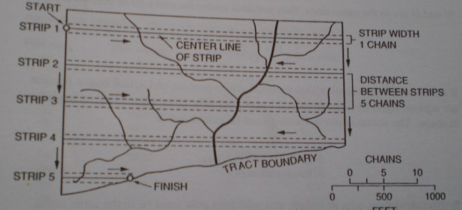Cruise intensity (I) = W/D x 100,

Where, W =strip width and D = distance between strips

**Advantages**

* Sampling is continuous and less time is wasted in traveling between strips.
* Strips have fewer bordering trees than plot cruise of the same intensity.
* With two persons working together, there is less risk to personnel in remote or hazardous regions.

**Disadvantages**

* Errors are easily incurred through inaccurate estimation of strip width.
* It is difficult to make spot checks of the cruise results, because the strip centerline is rarely marked on the ground.
* Brush and windfalls are more of a hindrance to the strip cruiser than to the plot cruiser.

**5.3.3 Line-Plot system of cruising**

* 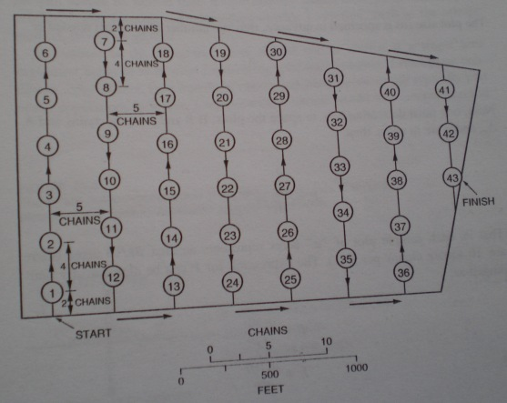Line plot cruising consists of a systematic tally of trees on a series of plots that are arranged in a rectangular or square grid pattern.
* Compass lines are established at uniform spacing, and plots of equal area are located at predetermined intervals along these lines.
* Shape of the plots may be circular, rectangular, square or triangles. But circular plot is widely used.
* Sampling intensity (I)

I = (no. of plots x area of plot)/ Total area x 100

* An intensity of plot sampling is governed by the variability of the stand, allowable inventory costs, and desired standards of precision.

**Advantages**

* The system is suitable for one person cruising.
* Tree tally is separated for each plot, thus permitting quick summaries of data by timber types, stand sizes or area condition classes.
* Cruisers do not have to tally trees while following a compass line.
* Cruiser gets some time, at each plot center to check stem dimensions, borderline trees, and defective trees.

**Disadvantages**

* It takes more time

**5.3.4 Inventory with Point Sampling**

* Point sampling is a method of selecting trees to be tallied on the basis of their sizes rather than by their frequency of occurrence.
* It has been found that counting from a random point, the no. of trees whose breast-height cross-section exceeds a certain critical angle when multiplied by a factor gives an unbiased estimate of basal area/ha.
* This technique is called : angle count cruising, Point Sampling, variable plot cruising, PPS (Probability proportional to size) sampling.
* Sample points are located within a forested tract, and a simple prism or angle gauge that subtends a fixed angle of view is used to sight in each tree diameter at breast height.
* Tree boles close enough to the observation point to completely fill the fixed sighting angle are tallied; stem to small or too far away are ignored. The resulting tree tally may be used to compute basal area, volumes, or numbers of trees per unit area.
* Point sampling can be either horizontal (For basal area estimation) or vertical (For ht. estimation)
* horizontal sampling has been widely used
* The probability of tallying a given tree depends on its cross-sectional area and the sighting angle used. The smaller the angle, the more stems will be included in the sample.
* PS does not require direct measurements of either plot areas or tree diameters. A predetermined basal area factor (BAF) is established in advance of sampling and resulting tree tallies can be easily converted to basal area per unit area.
* BA conversion factors are dependent or the sighting angle (or critical angle) arbitrarily selected.

**Horizontal point sampling**

* In horizontal point sampling, a series of sampling points are selected randomly or systematically distributed over the entire area to be inventoried.
* Trees around this point are viewed through any angle –gauge at breast height and all trees forming an angle bigger than the critical angle of instruments are counted.
* 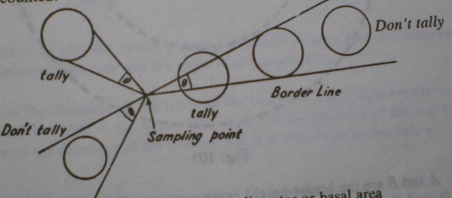Even though all trees are of same basal area, some are counted while others are not because of being far away from sampling points and they do not form an angle bigger than critical angle.
* Inclusion of trees in tally for a given angle depends upon (i) sizes of trees (ii) their distance from the sampling point.
* Basal area per ha = BAF x number of tally trees/ numbers of points
* Number of trees/ha = (no. of trees tallied) x (per-ha conversion factor)/ total numbers of points (per-ha conversion factor= BAF/BA per tree)
* Volume/h = basal area x stand form height

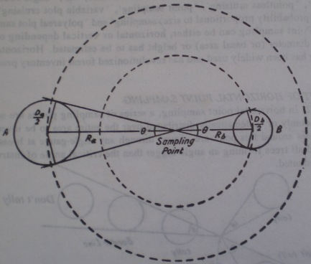

**Instruments used in horizontal point sampling**

* Angle gauge
* Wedge prism
* Spiegel Relaskop
* Tele Relaskop

**Choice of instruments**

* When steep slopes are regularly encountered, the Spiegel Relaskop is preferred
* For relatively flat topography, either the wedge prism or the stick gauge may be used.
* The prism is primarily desirable for persons who wear eyeglasses.
* The simple stick gauge is preferred in dense stand.

**Intensity of point sampling**

* There is no fixed plot size when using point sampling.
* Each tree has its own imaginary plot radius (depending on the BAF used), and the exact plot size can not be easily determined, even after the tally has been made.
* However, approximations can be made on the basis of the average stem diameter encountered at a given point.
* From the a statistical point view, however, the selection of trees according to size rather than frequency may more than offset this reduction of sample size and with an additional saving in time.
* Conversely, it must be remembered that smaller samples of any kind require larger expansion factors.
* Thus, when point sampling is adopted, the so-called borderline trees must always be closely checked.
* The only accurate method of determining how many sample points should be measured is to determine the standard deviation (or coefficient of variation) of BA or volume per ha from a preliminary field sample.

If the statistical approach is not feasible, the following rules of thumb will often provide acceptable results:

* If the BAF is selected according to tree size so that an average of 5 or 12 trees are counted as each point, use the same number of points.
* With a BAF 10 angle gauge and timber that averages 12 or 15 in. in diameter, use the same number of points.
* For reliable estimates, never use fewer than 30 points in natural timber stands or less than 20 points in even-aged plantations.

**Advantages**

* It is not necessary to establish a fixed plot boundary; thus greater cruising speed is possible.
* Large high value trees are sampled in greater proportions than smaller stems.
* BA and volume per ha may be derived without direct measurement of stems.
* When volume per ha conversions are developed in advance of fieldwork, efficient volume determinations can be made in a minimum of time. Thus the method is particularly suited to quick, reconnaissance type cruises.

**Disadvantages**

* Heavy underbrush reduces sighting visibility and cruising efficiency.
* Because of the relatively small sized of sampling units, carelessness and errors in the tally (when expanded to tract totals) are likely to more serious than in plot cruising.
* Slope compensation causes difficulties that may result in large errors unless special care is exercised.
* Unless taken into account, problems can arise in edge-effect bias when sampling very small tracts or long, narrow tracts.

**Vertical Point sampling**

* A method for deriving the mean stand height
* Within a full 360 degree sweep around the sample point all trees appearing taller than a critical angle are counted.
* Instrument used – Conimeter
* This instrument subtends a critical angle of 45 degree.
* 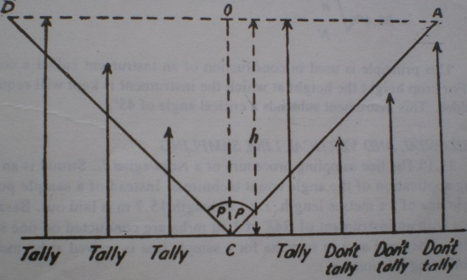By using Conimeter, if the number of trees per ha is N, then number of tree counted (n) in the area can be counted from the Conimeter.
* The average height of the trees (h) in meter (when the critical angle is 45 degree) is



For crop height, the height at which the instrument is kept will require to be added.

**5.3.5 Inventory of important NTFP found in Terai, Mid-hills and High Mountain, in each locality**

1. **Introduction**

Non –Timber Forest Products (NTFP) can be defined as all goods derived from forests of both plant and animal origin other than timber and firewood. Non-Wood forest products consist of goods of biological origin other than wood, derived from forests, other wooded land and trees outside forests (FAO 1999). Mallet (1999) defined NTFP as all products, with the exception of timber, that can be harvested from a forest ecosystem.

Resource assessment is an evaluation of some aspect of the resource based on information gathered from a variety of sources. It can include socio-economic issues, market issues, or the quantity and quality of the resource (FAO 2001)

Inventory is an itemized list of current assets (finished goods, components or raw material on hand) (Lund 1997). This may or may not include the quantity or other characteristics of the assests. Forest inventory is a sample-based survey of the forest resource (Burkhart & Gregoire 1994), the intention being to quantify the abundance of biological resources in the forest. The species lists are a subset of an inventory of biodiversity. Thus, a listing of all plants and animals in a forest is not a NTFP assessment but a biodiversity inventory. NTFPs are a sub-set of diversity that has utility to humans. Therefore the first step in the assessment of NTFPs has to be the identification of a plant or animal whole or part that is collected for some particular use.

It is agreed that the objective of NTFP assessments is to collect information about the distribution, frequency and seasonality of NTFP so that plans can be made for the sustainable management and utilization of the NTFPs for the improvement of human welfare. It is important to determine, prior to the assessment, for whom is the information being collected-who are the beneficiaries/clients. It is also important to determine that the policies and regulations governing the ownership, management and utilization of NTFPs are conducive to supporting farmers and the rural community and hence the local economy. There is no single technique for assessing NTFPs, because of the variety of products. The appropriate methods therefore depend on the objectives of the inventory. The following considerations are important.

The intended use of the inventory: The purpose may be to identify a management plan for an area, or it may be the conservation of an endangered species, or the development of specific products for marketing and processing.

Spatial scale: Inventories may be done at a local, district, national or regional scale, depending on their objectives. Local-level inventories are usually management or market oriented, while regional inventories are usually for planning or policy formulation.

Forest inventories are usual oriented towards specific products-most commonly timber, but increasingly also for some non-timber forest products such asbamboo, medicinal herbs and fruits. The incorporation of many different products in one inventory is complicated by differences in species phenology, scale and spatial distribution. Inventories of non-timber forest products can be purely to determine the quantity of the product available or to determine the quantity used. The latter involves market studies and the flow of products, which can be age or size dependent. In many cases the biophysical resource inventory would focus on individual products (e.g.,bark, fruits), while a socioeconomic flow inventory would concentrate on types of product usage (e.g.,food, medicines, gums). The need for an established methodology for NTFP inventory was recognised by a Working Group at an FAO meeting on NTFPs (FAO 1996) which attempted to define a standard for assessing NTFPs. However, the Group concluded that it is ‘virtually impossible and therefore perhaps futile to search for a generalised technique for NTFP resource assessment’ because of major differences in:

* intended use of the survey results,
* the groups of NTFPs to be included,
* spatial scale, and
* temporal scale.

To this list the resources available for the inventory in terms of technologies, skill levels and finances should be added. Despite these complexities inventory is done for the sustainable harvesting of NTFPs, monitoring the state of resources, considering promotion of resource based industries and informing conservation of endangered species. Though the inventory methods of NTFP are different, however they follow a basic strategy for managing on a sustained yield basis (Wong 2000).

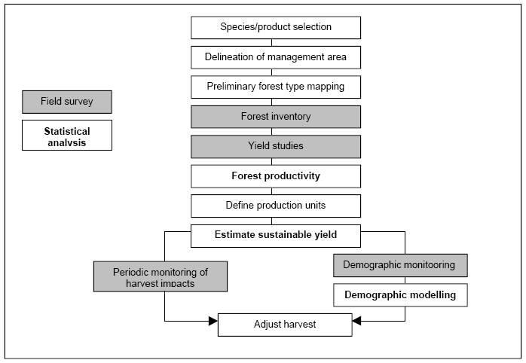**Figure: Flow chart of a basic strategy for managing NTFPs on a sustained-yield basis**

(After Peters 1994)

1. **Inventory methods for NTFPs**

For biologically sustainable exploitation of the products to be determined, there must be a minimum set of good information available on the resource species condition, abundance, distribution and reproductive biology. Resource assessment can be done either qualitatively or quantitatively. In qualitative assessment, based on the ocular judgment/estimation condition of the resource is assessed as abundant, moderate or poor.

Campbell (1989) describes quantitative ecological inventory as ‘enumeration of individuals and species of trees in a small patch of forest, the measurement of several important parameters of those individuals and the analysis of the abundance and distribution of those individuals as functions of their physical and biotic environments’. This is subtly different from the foresters definition of ‘a sample-based survey of the forest resource’ (Burkhart & Gregoire 1994) because of the emphasis on ecology in the former and on sample based observations in the latter. For the purposes of this study quantitative inventory is defined as a biometrically rigorous enumeration of the abundance and distribution of resource populations.

Since NTFPs can be plants or animals it is necessary to review methodologies for each. Although, at first glance these look very different they have the same underlying structure. This structure is envisaged as a hierarchy of design features. At the highest/largest level is the sampling design itself, whether the plots are to be located using random or systematic, stratified or uniform layouts etc. The next level down is the plot scale at which decisions about plot dimensions have to be made. Conventionally, the term plot is taken as meaning a measured area on the ground. However, observations at a point are area-less and therefore one-dimensional, also timed observations (e.g. for bird calls) are defined in terms of time rather than area. ‘Plot’ should therefore be understood to be any observational unit for enumerating the target species at the local scale (i.e. over metres and hours). Within each plot the enumeration that is undertaken is dependent on the target and product being investigated.

The status of NTFPs in an inventory largely determines how closely methodology is adapted to the peculiarities of the target species and products and the level of resources available. Single resource studies should be best placed to undertake methodological development of specific protocols for assessment of enumeration, this seldom happens. Inclusion of NTFPs into multipurpose resource inventories places very severe constraints on NTFP methodology though there are opportunities which often are not utilised. Methodological studies of optimal inventory design for a range of plant NTFPs are rare. In contrast, methodology for animal inventory is already well developed and requires application rather than further methodological work (Bibby & Moss 1998: Cited in Wong 2000). For the purposes of this study, three contextual settings for NTFP inventory are distinguished. These are single resource, single purpose multiple resource and multi-purpose resource inventories. The distinction between these is the focus of the inventory and the extent to which protocols can be tailored to specifics of the NTFPs in question. Single resource studies are focused exclusively on a particular product and provide the best opportunity for development of tailored protocols and should set the standards for NTFP studies. Single-purpose multi-resource inventories are generally designed to provide management information on NTFPs for a defined area and have as their focus the potential of the land in terms of the species and quantities of NTFPs present and they use land-centric methodology, and differ from multipurpose inventory in that they are undertaken by one institution within the context of a management structure. Multi-purpose resource inventories (MRI) are often multi-institutional and NTFPs are often a small component of the inventory and consequently the development of protocols is heavily constrained by the need to compromise with the needs of other elements of the inventory.

**2.1.1 Single resource inventory**

The objective of a single resource inventory is the quantification of the abundance and distribution of a single product. Such an inventory is unfettered by considerations of other products or purposes and one would expect methodology to be closely tailored to the characteristics of the species from which the product is derived. However, there are very few single product studies that have quantification of the insitu resource as an objective. This could be because a NTFP has to be either very valuable, or subject to legislation for it to justify a species-specific inventory. Therefore most species specific studies have been done for species that are traditionally important for export such as rattan. Although there are few true inventories for single species there are a number of studies that use inventory methodology to address resource related questions and it is these which are examined here.

Six reasons for undertaking a single resource inventory which are (Wong 2000):

1. To provide knowledge of the effects of exploitation of a species for which no other work has been done
2. To assess the potential of particular products for which increased commercialization is sought at either the national or local level
3. To assess the potential of a specific area for exploitation of a known commercial product
4. To investigate the spatial distribution of an exploited product
5. To provide supporting data for the determination of quotas, this is required for several products under national legislation or international treaty
6. For academic inquiry e.g. historical understanding of role of wild yams in historical human diet (Hladick & Dounias 1993, Cited in Wong 2000).

**2.1.2 Single purpose multi-resource inventory**

The single purpose inventories are intended to provide quantitative information for the purpose of management planning. As such they are area based and attempt to record the presence and abundance of a range of species that occur on a particular portion of land. In selection timber management the forest is divided into compartments (~ 100 ha – 1 km²). Immediately before logging the compartment is subjected to a stock survey which involves the location, identification, numbering and measurement of every timber tree in the compartment. Yield formulae are used to determine the sustainable yield of timber from the compartment based on the stock survey data. Trees are selected from the stock survey map to make up the allocated yield according to rules designed to protect the environment and the future potential of the forest. Stock survey protocols are generally 100% surveys with the area covered by consecutive enumeration strips. The integration of NTFPs into conventional forest management has resulted in attempts to incorporate NTFPs in timber stock surveys. For example, in Belize, Smith (1995) experimented with a 10% random sample of 1 ha stock survey blocks for a range of products including thatch, edible nuts, palm heart, chicle, incense resin, all spice and decorative epiphytes (Orchids and Bromeliads). Although it is difficult, in the absence of any data to make a judgment of this methodology, it would seem to be a sound and pragmatic means of discovering the distribution, abundance and NTFP management potential of the area to be logged. The only disadvantage is that non-tree NTFPs may be adversely affected by logging and consequently not be available after logging and the stock surveys would need to be complemented by species specific studies to determine optimal sustainable harvesting strategies for each species. This information could then be used to develop management plans for all resources available in each compartment. Detailed information on a range of resources including timber, other plant products and bushmeat has been acquired by the Adwenaase and Namtee communities using techniques derived from those used for timber stock survey (Gronow & Safo 1996, Cited in Wong 2000). A trial of a method designed to permit quantification of key plant resources to support National Park management planning was undertaken in the Bwindi Impenetrable National Park in Uganda (Cunningham 1996a). The design is based on a few small sample plots and uses basic forestry techniques to enumerate the number and size distributions of trees and bamboo. This methodology is intended to provide information to support management decisions but the small number of replicates leads to imprecision and incomplete coverage leads to bias and inaccuracy suggesting that the information is not adequate for detailed planning and is best used as a guide for strategic planning.

**2.1.3 Multi-purpose resource inventory**

Many resource assessments for NTFPs take place as a component of a multi-purpose resource inventory (MRI). MRIs have been defined as ‘data collection efforts designed to meet all or part of the information requirements for two or more products, functions (such as timber management and watershed protection) or sectors (such as forestry and agriculture)’ (Lund 1998b). NTFPs originate from forests which generally fall under the jurisdiction of a state forest authority which often have statutory responsibility for maintaining up-to-date forest resource data. Once the forest authority has accepted a responsibility for specific NTFPs they are generally included in routine resource inventory and monitoring. For example, the US Forest Service now includes special forest products as part of forest resource plans in accordance with the National Forest Management Act, the National Environmental Policy Act etc. (Molina *et al.*1993: Cited in Wong 2000). In addition, Lund (1998a) lists further national scale MRI with NTFPs for the Russian Federation. In northern and eastern Europe NTFPs in the form of berries and mushrooms have been recognised and included in recurrent inventory (statutory national inventories usually based around compartments undertaken every 10 years) for almost a hundred years. In Russia industrial scale interest in NTFPs led to the development of a journal (Plant Resources Journal established in 1967) and technical committee (Committee of Wild Berry Research established in 1975) dedicated to plant resources (Rutkauskas 1998: Cited Wong 2000). Rabindranath and Premnath (1997) suggested basically two methods of NTFP assessment based on source of information obtained.

**2.2.1 Tapping local knowledge**

Local people are knowledgeable and can provide information of the species identification, species location, different use and changes in the vegetation pattern. The medium for obtaining such information includes:

**Interview**

Rural people are the source of information regarding the use, distribution and harvesting of NTFPs, their personal knowledge can be explored through interview to give an overview of the resources. Alexiades (1996) defines four types of interview.

**Informal interview**: A completely informal interaction between two or more people. The researcher might take notes during or after the ‘interview’.

**Unstructured interview**: A discussion where one person is gathering information from another on a particular topic but no specific or guiding questions are used after the initial enquiry (e.g. ‘tell me about the plants in the forest’). The informant(s) is aware that it is an interview but the choice of topics to discuss and the direction of the conversation are mostly controlled by the informant.

**Semi-structured interview**: The interviewer has a list of open ended questions or topics to discuss (usually 6-10 key questions). The amount of information provided on a topic is largely controlled by the informant and the interviewer is free to follow leads. This type of interview is generally used once specific research topics have been identified.

**Structured interview**: The interviewer has a fixed length questionnaire. Questions are not open ended but have a limited range of possible responses. Understanding what would be a locally meaningful question is a pre-requisite to designing a questionnaire form. This is because inappropriate closed questions will invariably introduce interviewer bias. Formal surveys are generally used to obtain quantitative information regarding a problem. Nichols (1991) states that ‘In order to design a good structured interview survey, you need a full knowledge of the problem you are studying. This in itself limits their use. In a new area one needs methods that are more suitable for exploratory.

**Interest group discussion**

People who share particular set of interests make up an interest group, also called focus group. An interest group can be determined by differences in age, gender, ethnic group, wealth, belief etc. Interest group meetings are conducted to get the people with similar sets of interests to discuss the matter and decide the use and distribution of the resources.

**Other Participatory Rural Appraisals (PRA)**

PRA is qualitative method of resource assessment which is based on people’s view on status and trend of a species of interest. Different PRA tools give different information of a species. Timeline trend, resource mapping, seasonal calendar, matrix ranking are important to assess the species.

**2.2.2 Direct measurement**

The vegetation may be heterogeneous or homogenous. Depending upon the condition two methods are applied.

**Census survey or total enumeration**

Census survey means that enumeration of desired NTFPs over the entire area of the forest unit under consideration. Since it is expensive and time consuming; it is applied when the area of study is small (<5ha) and the NTFP is commercially valuable. Census surveys are often carried out to check on the statistical results of partial enumeration.

**Partial enumeration**

The area is partially enumerated and the enumerated samples represent the whole population under study. Partial enumeration can be plot method or plot less method.

**Plot method**

It is most common method employed for sampling various types of the vegetation (Rabindranath 1997). A plot may be rectangle, square, circle or any other shape. Plots may be again taken randomly or systematically and stratified or non-stratified. In Nepal generally rectangular and circular plots are used in community forestry inventory. Nested plot designed are commonly practiced for tree, shrub and herb. The size and number of plot depend on the objective of the study. Ideally 10 % to 15% of the total area should be sampled (Rabindranath 1997). If the area is too large this may not be possible, in this case a minimum of 1 ha should be studied. The sample plot should of course be located at randomly chosen spot. All vegetation falling inside the plot and its replication are studied. The figure below shows an rectangular nested plot design commonly adopted in inventory of community forest (25*20m2 for mature trees, 10*10m2 for pole, 5*5m2 for shrub and 1*1m2 for herbs).

10 m

10m mmmm

25m

20mm

5m

5m

1m

1m

**Plotless method**

|  |  |
| --- | --- |
|  |  |
|  |  |

The plotless method are best suited for large vegetation area having the heterogeneous plant population (forest area and uneven terrain), where laying plot becomes very difficult. There are several plotless methods however Point Centered Quadrant method is widely used. This is simple and requires less time and more suited for randomly distributed vegetation. In this process a number of points are selected randomly depending on the size of the area, from each point four lines are drawn perpendicularly in all four directions which results four quarters around the point. The nearest tree, shrub or herb is taken as the sample. The following figure illustrates the method.

1. **Productivity Assessment**

Productivity is the amount of height, girth, volume, biomass that is accumulated by a plant species in certain period of time; may be seasonal, annual or over its whole life span. Different inventory methods are used for different plant parts to determine the productive capacity. These inventory methods may involve the destruction of the whole plants or its parts or without destruction. Resource assessment and productivity of the plants can be done according to the convenience but few important things should be considered.

* One time resource inventory is not enough
* It should be done when the leaves are green for easy identification of plant
* When the products are ready for harvest for productivity estimation of NTFPs
* More than one period of data collection may be required within a year because different products are ready for harvest at different times of year.
* Productivity should be measured over several years, rather than just one year.

The inventory methods for fruits, root, leaf, bark taking one example of species is dealt here.

1. **Inventory process of Amala(*Emblica officinalis*) fruits**

Amala is a medium sized deciduous tree, but sometimes grows quietly and attains up to 19m height. In Nepal it is found in terai and subtropical valleys from east to west between 100-1600m. Fruits are commercially used. Brief inventory method of Amala is as described (Kunwar 2006).

* With the participation of local people and reconnaissance survey the distribution of Amala in the forest is determined
* Forest should be divided into blocks and sub-blocks on the basis of area, geo-structure, natural condition, management objectives, population of species
* Sampling intensity of 1.5% of site should be taken.
* Stratified systematic sampling method is adopted while surveying.
* Necessary inventory plots should be kept equally in every block where Amala is found
* 25*20 m rectangular inventory plot should be made at every 100 m distance at both right and left sides of the transect line
* Height and diameter of the trees are measured. Availability, density, etc are calculated.
* After calculating the density of Amala trees, girth classes (less than 10 cm, 11 to 30 cm, 31 to 65 cm, 66 to 100 cm and above 100 cm) of trees are computed.
* 5/5 trees per block from each girth class are selected (3/3 trees if there are less than 5).
* Select 5/5 (or 3/3) tree branches of uniform sizes from each of the upper, middle and lower canopy cover of tree.
* Pluck or collect the fruits from each branch and weigh the fruits. The mean weight of the fruits from each branch, each tree, each girth class, and each block is determined. This calculation gives the amount of Amala fruits per hectare and that of entire forest.

1. **Inventory of Kutki (*Neopicrorhiza scrophulariflora*) root**

Kutki is a perennial herb distributed in the North-Western Himalayan region from Kashmir to Kumaun and Garhwal regions in India, Pakistan, Nepal, Myanmar, Southeast Tibet, North Burma and China (Pollunin and Stainton, 1984: Cited in Giri 2006). It grows naturally in alpine and sub-alpine regions on rock scars as well as in organic soils. It prefers moist habitat formed by winter snow or depressions mostly on the exposed north facing slopes.

In Nepal, Kutki is distributed abundantly also in Sub-alpine and alpine Himalayan regions between 3000-4800m-elevation range with associated of *Rhododendron anthopogan,* Raktelo. It found in the eastern and central regions of Nepal, but most abundantly in the western region where it grows on the rock’s crevices on the north facing slopes, cliffs and the turf of glacial flats. Kutki prefers a moist habitat and sandy loam soil (Shrestha and Shrestha, 2004).

It is mainly found in the following districts of Nepal-Taplejung, Sankhuwasabha, Sindhuplancok. Nuwakot, Rasuwa, Ramechhap, Bahlung, Myagdi, Lamjung, Gorkha, Jumla, Mugu, Jajarkiot, Rukum, Bajhang, Bajura, Darchula, Humla, Mustang, Manang, (HMGN, 2055,2058: Cited in Giri 2006). Roots and rhizomes are used indigenously and scientifically. Inventory of Kuti can be done in the following way (Kunwar 2006).

* With the participation of local people and reconnaissance survey the distribution of Kutki in the forest is determined
* Forest should be divided into blocks and sub-blocks on the basis of area, geo-structure, natural condition, management objectives, population of species
* Sampling intensity of 0.5-1% of site should be taken.
* Stratified systematic sampling method is adopted while surveying.
* Draw a baseline to the survey block and draw parallel horizontal and vertical lines at a distance of 50m.
* Lay 2*2 m quadrates at a distance of 10m in each horizontal line.
* Study the availability, density and fresh weight of Kutki of all quadrant inventory quadrant plots.
* At the time of maturation leaves become yellow and plants wilt. Roots should be dug out from mature plants.
* The collection is fresh weighed, sun dried for one week and weighed again to its dry weight. From the difference between fresh weight and dry weight, the conversion factor can be found out. The conversion factor of kutki roots is 0.6140
* The productivity of kutki of definite location can be calculated by multiplying the conversion factor per hectare with area of forest surveyed.

1. **Inventory of Lokta (*Daphne bholua*) bark**

*Daphne bholua* (Kalo lokta) is an evergreen, erect standing shrub found at an altitude range of 1800m to 3600m. The inner bark of the plant is used for the local manufacture of extremely durable hand-made paper. Lokta paper making in Nepal dates back to at least the 12th century (Trier, 1972: Cited in NSCFP 2001) and continue as an important and rapidly growing cottage industry. The increasing demand of lokta makes its resource inventory an essential for its proper management. The inventory of lokta can be done in a participatory method (NSCFP 2001).

* Delineation and estimation of the potential area for lokta: From participatory mapping, focus group discussion and key informants survey the distribution of lokta in the forest, availability, harvesting suitability is assessed. The potential lokta areas are delineated, block division and estimation of the area of delineated block is conducted.

Field visit is done to verify the accuracy of participatory mapping, area estimation and preliminary assessment of condition of lokta. During the field visits, parallel transects are constructed covering the whole lokta area. Transects are walked, lokta distribution observed, verify and correct the boundary of potential area. By visual observation, estimate the area of the blocks, cross check it with the obtained values of areas estimated before. Final delineation of the different blocks of lokta and final estimation of their area is done.

* Defining the resource condition of lokta: This step involves common understanding of the different qualitative and quantitative resource condition of lokta. By peoples participation stocking condition of lokta can be defined and classified in four resource conditions namely good, fair, poor or nil. The users are asked to keep a visual picture of each of the condition in mind.
* Estimation of the availability of lokta plants and lokta bark in sample plots: This step involves the quantification of the amount of harvestable bark, according to different resource condition. Walk along parallel transects lines spaced 100m apart. Stopping at each 20 m interval, resource condition in plots of 5m*5m is defined as classified previously. In this way we achieve a sampling intensity of about 1%. After observing several plots of each resource condition, a sample of them is selected and measured to assess the amount of harvestable bark and regeneration of lokta. Either randomly or systematically, 10m*10m plots are taken, regeneration/plant condition measured and classified. Within these plots the plants above the agreed harvestable height are harvested according to the traditional practice; the external bark is separated from the collected product which is weighted (Kg). This helps to quantify the availability of harvestable lokta (number of stems, height of the stems and the weight of the harvestable amount of bark) in each starta or, and so representing each resource condition. This should be done at least 6 times to get reliable estimates.
* Data analysis: The total condition of the resource is estimated by multiplying the block area with the percentage spots with resource condition.

1. **Inventory of Machhino (*Gaultheria fragrantissima*) leaf**

Machhino is a robust shrub of up to 2m height with ovate to lanceolate evergreen leaves. It grows in open forests and shrubland between 1500 and 2700 m above sea level. It prefers moist and sunny places. The oil extracted from the leaves of Machhino is used as massage oil, as a flavoring agent by the confectionery industry and in the manufacture of soft drinks. The inventory method of machhino as outlined by NSCFP 2001 is as below.

* Delineation and estimation of the potential area for machhino: From participatory mapping, focus group discussion and key informants survey the distribution of machhino in the forest, availability, harvesting suitability is assessed. The potential machhino areas are delineated, block division and estimation of the area of delineated block is conducted.
* Field visit is done to verify the accuracy of participatory mapping, area estimation and preliminary assessment of condition of machhino. During the field visits, parallel transects are constructed covering the whole machhino area. Transects are walked, machhino distribution observed, verify and correct the boundary of potential area. By visual observation, estimate the area of the blocks, cross check it with the obtained values of areas estimated before. Final delineation of the different blocks of machhino and final estimation of their area is done.
* Inventory of the harvestable amount of machhino: This step involves the quantification of the harvestable raw materials in a number of sample plots. Walk along parallel transects lines spaced 100m apart. Stopping at each 50 m interval, resource condition in plots of 5.64 m radius is defined as good, medium or poor. In this way we achieve a sampling intensity of about 2%. The inventory of Machhino may be also integrated in a general forest inventory, using the same sample plots for the inventory of other products (fodder, fuelwood, litter, ground grass etc.). Once the quality of the shrub has been defined, its average crown diameter has to be estimated by measuring its maximum and minimum diameters and recording the data. In order to simplify this measurement, the borer of the crown can be visualized with a colored rope. The maximum and minimum diameters can then be easily measured with a measuring tape.
* Data analysis: The amount of harvestable machhino is estimated in Kg of fresh material. For this purpose a correlation factor has been defined, that relates the average diameter of the crown and the quality of the shrub to the fresh weight of the harvested product. The total amount of harvestable machhino in the plots is the sum of the fresh weight of all crown diameter classes (excluding those below the agreed minimum harvestable size).

1. **Gaps in the inventory methods of NTFPs**

NTFP inventory is complex, there are no particular systems. More over methods in one locality or time may not be appropriate in other locality. Major gaps in NTFP inventory can be outlined as below (Wong 2000).

**4.1 Problems with adopting traditional forest inventory techniques for NTFPs**

The problem of a lack of methods and protocols for NTFP inventory could be easily solved if it were possible to use traditional forestry methods as these are well described and understood.

Unfortunately, this is not a practical solution as there are certain characteristics of NTFPs that are not easily accommodated in traditional forest inventory. The main pitfalls are:

* Rarity - many NTFPs are rare which means that only a few plots of a conventional

systematic or random inventory will contain the species of interest.

* Imperfect detectability – people dealing with trees have rarely come across the problem of searching for an elusive or moving target because trees are generally easy to find. Unfortunately, many NTFPs are not that easy to find and these require that detectability is considered. This is an area where NTFP studies can borrow wildlife techniques.
* Seasonality - Many NTFPs are seasonal but in comparison, timber quantities are constant, consequently forest inventory methods do not cope well with seasonality.
* Motility - Animals run away, fruit falls off a tree and rolls down a hill but trees are static. This is an area where NTFP studies may be able to borrow wildlife techniques.
* Quantification of yield for non-destructive harvesting - most of the methods for determining timber yield from a forest are concerned with the harvesting of entire individuals. For NTFPs one is often only harvesting a small part of the individual. The review suggests that there is little theoretical background for determining harvesting levels of parts of a plant.
* Incorporation of local knowledge – most NTFP studies value local knowledge but there is at present no formal means of using this knowledge to optimise inventory designs. The fact that many studies have struggled with the problem of linking local and scientific knowledge suggests that this would be fruitful area for research.

**4.2 Lack of properly researched NTFP-specific sampling designs**

There are relatively few research studies that have looked at optimising sampling designs specifically for NTFPs. Most of these studies have been done on rattan and, unfortunately, several of these had their own failings. These were mostly to do with plot independence (the trial plot sizes and shapes were contiguous and from only one study site).

**4.3 Little guidance available on development of appropriate NTFP measurement (mensuration) techniques**

Even for the most commonly studied products there is little advice or standardization of methods.

**4.4 No application to NTFPs of sampling designs tailored to monitoring needs**

There has been no application to NTFP monitoring of any of the statistical thinking on monitoring. Monitoring from a statistical point of view is complicated as there is a problem with controlling the power of the design to discriminate change. Precise observations are required at each time interval to actually detect changes; if the data is imprecise the changes may reside within the errors of the estimates and mask any real change. There has been quite a lot of work done on how to address these problems but to date they have not been applied to NTFPs. Precise monitoring is often very expensive therefore many NTFP monitoring studies use indicators to track changes in the resource. However, there is little known about the linkages between indicators and the resource base. Where this has been studied it has often been shown that a change in off-take or harvest level (a commonly used indicator) is not directly linked to resource condition. What is required are some relatively easy means of determining and tracking change in the relationship between the chosen indicator and resource condition.

**4.5 Difficulties in determination of the sustainability of harvesting**

One of the more stark findings of the review is the general lack of good quality data and the almost complete absence of a theoretical background for determining sustainable yield of NTFPs. Consequently, despite the many hopes that NTFPs can be managed sustainably, we do not actually have the data or the means to demonstrate that this is possible It is suggested that this is a very severe and urgent problem.

**4.6 Application of novel sampling strategies to NTFPs**

There are a range of newer (at least to forestry) sampling techniques such as rank set sampling and adaptive cluster sampling, that appear to offer certain advantages for NTFPs. Clearly there is new methodology available, however, much of it may be at the cutting edge of statistics and has not yet been considered for NTFPs.

**4.7 Cross-disciplinary exchange of ideas and methods suitable for use with NTFPs**

There is an urgent need for cross-disciplinary exchange in the development of NTFP specific sampling designs and methods. There are many ideas and methods that apply in a wide range of different disciplines but there is little cross-over between them. In this respect the reviewer suggests we should think of NTFPs as wild-grown products from natural or seminatural environments. Although there are many products that lie in a grey area between the wild and domestic, it seems that the problems of managing cultivated or wild products are quite different and this needs to be reflected in methods selected for their quantification, management and monitoring. Areas where techniques and ideas can be shared between domestic and wild resources might also be identified.

**4.8 Effective communication of advice to field workers and communities**

To be effective, any advice that can be offered and the results of any research undertaken has to get to people on the ground. Research must be developed in the field in a manner responsive to expressed needs and then put into a form appropriate for use by field technicians and people in village communities.

1. **Possible solutions for difficulties in NTFP inventory**

In Nepal different organizations have developed different methods of NTFP inventory. Some have focused more on participatory approach while others emphasize on field measurement. These two methods should be combined to get the benefit of each other and exclude their demerits. Some of the possible strategies for NTFP inventory are;

* Inventory methods which are cost effective and locally adapted should be preferred.
* Indigenous and scientific knowledge should be linked to make inventory effective and more precise.
* Inventory methods for the hills and terai even for same species should be adopted accordingly
  + 1. **Use of Aerial Photographs in forestry inventory**

**Remote Sensing**

* Remote sensing is the science and art of obtaining information about an object, area or phenomenon through analysis of data acquired by a device that is not in contact with the object, area or phenomenon under investigation.
* Aerial remote sensing-it is that method of remote sensing in which cameras or other devices, fixed in an aircraft flying at fixed altitude are used to take photographs of any resource on earth. It is also called aerial photography.
* Space remote sensing- it is that method of remote sensing in which cameras, sensor or other devices attached to a satellite orbiting round the earth, take photographs of earth and resources inside it.

**Aerial photography**

* Aerial photography is the process of taking photograph of earth’s surface and its natural resources from an aircraft flying at fixed altitude from the earth
* Aerial photographs are the photographs of earth’s surface and its natural resources taken from an aircraft flying at fixed altitude from the earth.
* The relative position of the objects on photographs is superficially similar to the actual position on ground.
* Canada was the first country which applied aerial photography in forestry.
* In Asia(tropics), Burma is the first country to start aerial survey of vegetation.
* In Nepal, Aerial photography was used for the estimation of forest and shrub land cover and changes.
* Aerial photography are very useful tool for the forest manager.
* A basic knowledge of the location and extent of the forest is critical to the management of forest resources.
* Aerial photographs are useful in designing and conducting field inventories and used to estimate tree and stand characteristics

Scope

* To determine the volume (value) of standing trees in a given area.
* To get a reliable estimate of the forest area.
* The measurement of all or an unbiased sample of trees within the area
* 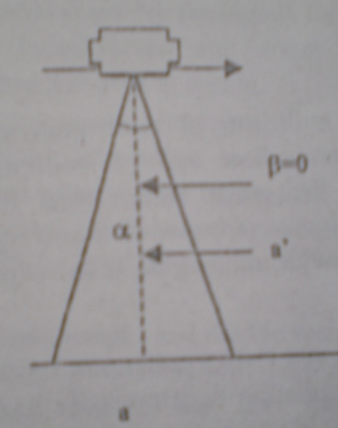 To get the knowledge of location of all tract corners and boundary lines

1. **Types of aerial photographs**

Aerial photography may be classified into various types depending on the different criteria.

**On the basis of position of optical axis of cameras**

* Vertical photograph
* Oblique photograph

**Vertical photograph**

* Optical axis of camera is kept perpendicular or nearly perpendicular to the horizontal plane
* The degree of tilt is less than 4 degree
* It is considered to be best because ground features like building, roads, streams, forest boundaries appear same as the map of similar scale covers small area but scale is quite uniform over the whole picture.

α= angle of view

β= deviation of optical axis from vertical line

a`= vertical line perpendicular to the horizon

**Oblique photographs**

**Low oblique photographs**

* Optical axis of camera is tilted by 30 degree or less from the vertical and horizon does not show in the picture

**High oblique photographs**

* Optical axis of camera is tilted by 60 degree and horizon is apparent.
* Unlike vertical photograph the scale of oblique is variable, and that is why there is distortion.
* The degree of distortion increases towards the horizon

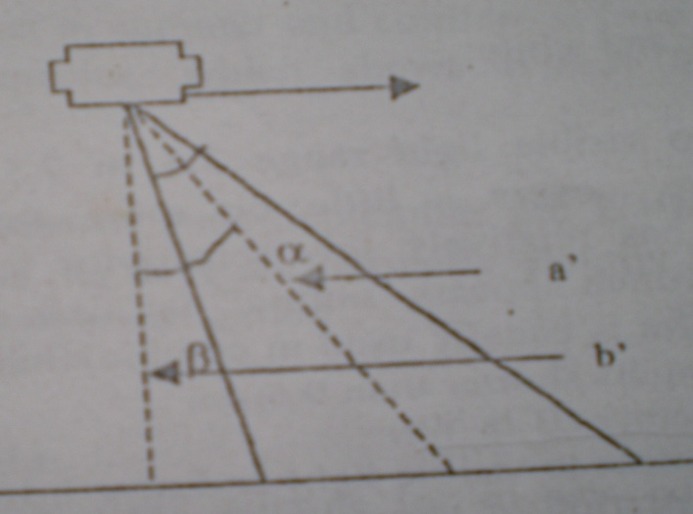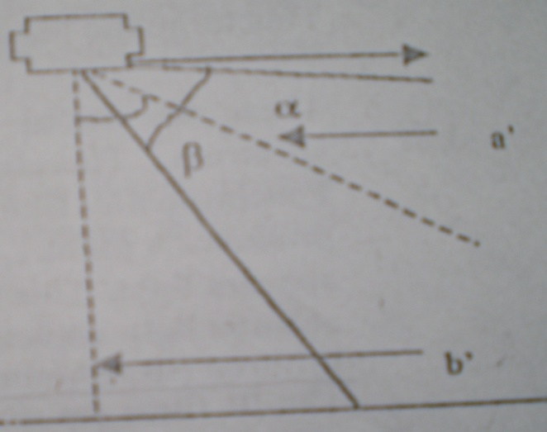

**On the basis of films or sensor used**

* Panchromatic black and white photograph
* Infra-red black and white photograph
* Normal color photograph
* Infra-red color photograph

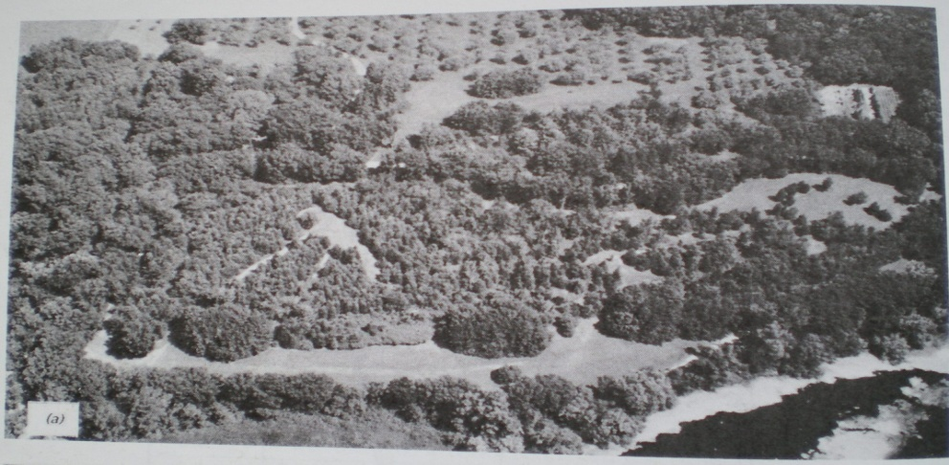**Panchromatic black and white photograph**

* This film is sensitive to the electromagnetic spectrum in the wavelength range of 0.3 to 0.75 μm
* When panchromatic film is used, the conventional black and white photograph is produced.
* This film has low sensitivity in the green region of visible spectrum and therefore is not suitable for identification of plant species. Panchromatic photograph recording reflected sunlight over the wavelength band 0.4 to 0.7 μm

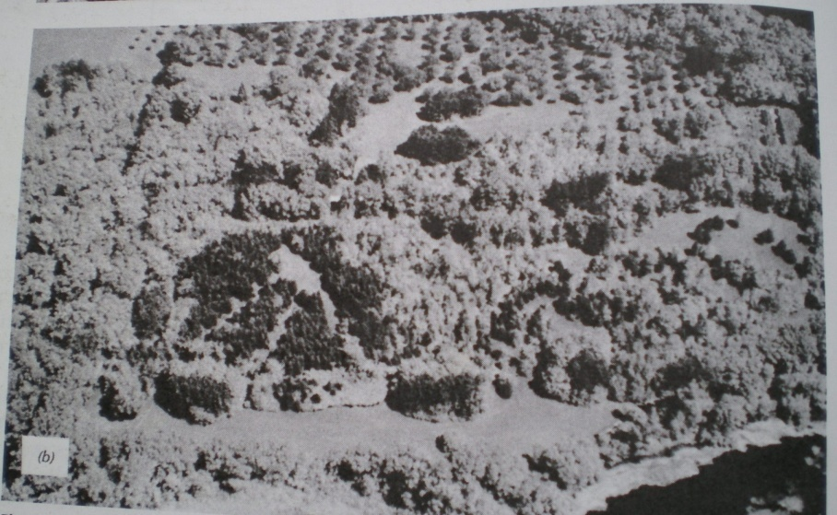**Infra-red black and white photograph**

* By the use of infra-red film and proper filter, the electromagnetic spectrum in the wavelength range of 0.3 to 0.9 μm is photographed as black and white photograph.
* The photograph is very useful in identification of broadleaved and coniferous trees.

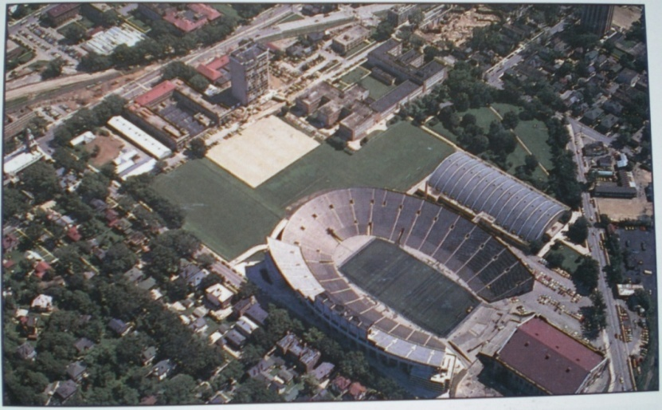**Normal Color photograph**

* A color film with proper filter produced colored photograph in true color. It registers visible color by human eye.
* It is three-layered film with emulsion sensitive to an additive primary color i.e. blue, green and red.
* The color photography is much more useful in separation and identification of different species and diseases.

**Infra-red color photograph**

* It is called false color photograph as it shows objects in different color as compared to the true color of the objects.
* 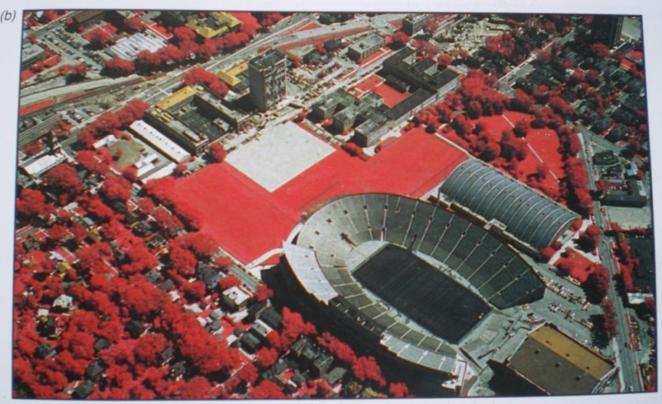 The film sensitive to infrared region is used in taking such photographs.
* The normal color of vegetation is green but in infrared color photograph, vegetation appears red.

**On the basis of device used**

* Single lens photograph-single lens camera used
* Multi-spectral photograph-more than one camera or camera with more than one lens used
* Multi-spectral imagery-optical mechanical scanner used

**On the basis of scale of photograph**

* Small scale photograph-1:40,000 to 1:70,000 or more
* Medium scale photograph-1:20,000 to 1: 40,000
* Large scale photograph-1:5000 to 1:20,000

**Season of photography**

* Depends upon the nature of the features to be identified, the film to be used and number of days suitable for photographic flights
* Less expensive in sunny area
* Best season-during October to Februray
* Another season-growing season
* Eg. Coniferous forests-October to November, Mixed deciduous forests-December to February, Tropical evergreen and moist deciduous forests-January to February
* Spring, Winter, Summer photographs

**Scale of Photographs**

* Scale= photo distance/ground distance or
* Scale= focal length of camera (f)/flying height above ground (h’)

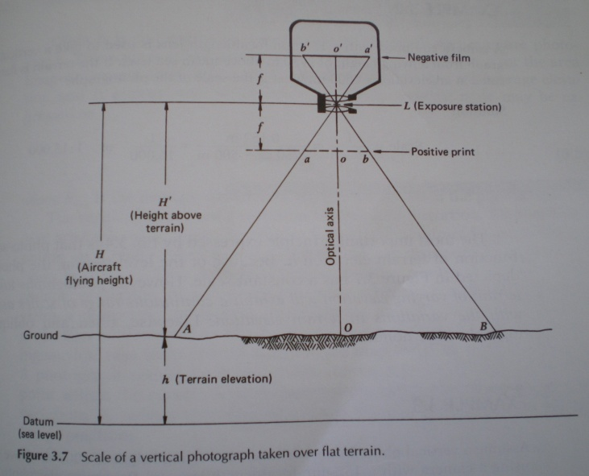

**b. Photo interpretation & technical terms**

* Photo interpretation is an act of examining photographic images and judging their significance.
* When we can identify what we see on the photographs and communicate this information to others, we are practicing aerial photographs interpretation.
* Aerial photo graphs contain raw photographic data. These data, when processed by a human intepreter’s brain, become useful information.
* Aerial photographs can be interpreted by using following basic elements/characteistics: Shape, Size, Pattern, tone, texture, shadows, site, association and resolution.

**Tone (or hue)**

* It refers to the relative brightness or color of objects on an image.
* Relative photo tones could be used to distinguish between deciduous(light tone) and coniferous trees(dark tone) on black and white photographs
* Without tonal difference, the shape, patterns, and texture of object could not be distinguished.

**Shape**

* It refers to the general form, configuration or outline of individual objects.
* Shape help a great deal in making interpretation in forestry.
* Eg. Some species have rounded crowns, some have cone-shaped crowns and some have star shaped crowns.
* Variation of these basic crown shapes also occur.

**Pattern**

* It related to the spatial arrangement of objects.
* The repetition of certain general forms or relationship is characteristic of many objects, both natural and constructed and gives objects a pattern that aids the image interpreter in recognizing them.
* For example, the ordered spatial arrangements of tree is an orchard is in distinct contrast to that of forest tree stands.

**Size**

* Size of objects on images must be considered in the context of image scale. A small storage shed, for example might be misinterpreted as barn if size were not considered.
* Relative sizes among objects on images of the same scale must also be considered.
* Similarly, size is also helpful in identifying the forest stands.

**Texture**

* It is the frequency of tonal change on a photo.
* Texture is produced by an aggregation of unit features that may be too small to be discerned individually on the image, sucha as tree leaves and leaf shadows.
* It is the product of their individual shape, size, pattern, shadow.
* It determines the overall visual “smoothness” or “coarseness” of image features.
* Difference in texture help distinguish tree species.

**Shadow**

* Shadows are important to interpreters in two opposite respects: 1). the shape of outline of a shadow affords and impression of the profile view of objects(which aids interpretation) and 2) Objects within shadows reflect little sight and are difficult to discern on a image (which hinders the interpretation)
* When trees are isolated, shadows provide a profile of image of trees that is useful in species identification.

**Sites**

* It refers to topographic or geographic location and is a particularly important in identification of vegetation types.
* For eg. Certain tree species would be expected to occur on well drained upland sites, whereas other tree species would be expected to occur on poorly drained lowland sites.
* Alnus nepalensis is expected to occur in degraded and exposed sites.

**Association**

* It refers to the occurrence of certain features in relation to others.
* Eg. Stak of wood nearby the forest would be easier to identify than the stack of wood kept in proximity with small shed in the agriculture land.

**Resolution**

* It depends on many factors, but it always places a practical limit on interpretation because some objects are too small or have too little contrast with their surroundings to be clearly seen on the image.
* There are certain equipments that can be used for the aerial photo interpretation. They help in viewing the photo, making measurement on the photo, performing interpretation tasks and transferring interpreted information to base maps or database.

**c. Forest classification**

* Forest classification can be done on aerial photographs using the basic elements for photo interpretation.
* The classification of forest types and plant species largely depends on quality, scale and season of photography and the ability of interpreter.
* The shape, texture, and tone or tree foliage as seen on vertical photographic along with other basic elements of photo interpretation are key to forest classification.
* The first step in forest classification is to determine which types should and should not be expected in given locality.
* It will also be helpful to get familiar with the most common plant and environmental association.
* This information can be derived by previous maps or direct observation.
* In some regions, photo-interpretation keys are available for recognition of forest cover types and such keys can be used.
* Classification can be conducted in minute details in large scale photographs where species can be identified and in small scale photographs, the knowledge of locality is essential for forest classification.
* In modern days, computer programs (image processing software like ERDAS, PCI, ENVI, GRASS etc) are available for making forest classification using the aerial photographs and other imageries.

**Relationship between photographic scale and expected levels of plant recognition**

|  |  |
| --- | --- |
| **Photographic Scale** | **General level of plant discrimination** |
| 1:30,000-1:100,000 | Recognition of broad vegetative types, largely by inferential processes |
| 1: 10,000-1:30,000 | Direct identification of major cover types of species occurring in pure stands |
| 1:2,500-1:10,000 | Identification of individual trees and large shrubs |
| 1:500-1:2,500 | Identification of individual range plant are grassland types |

**d. Area determination**

* A truly vertical aerial photo is just like a map and area can be measured with methods similar to that from a map.
* The scale of photographs is known and the area is calculated accordingly.
* But in aerial photo, the center part of the plant is generally true as map but as we move radially outward from the center, the scale changes and there is displacement.
* In determining the area, if all corners are at the same elevation, the area calculation from photographs can be made accurately. If not, substantial error can exist.
* Similarly, if the area are measured outward the center of the photograph, then some correction will only yield accurate result.
* Thus, we should use the photo where the area to be measured is as close to nadir as possible. Such errors can be reduced by using photos taken from higher flying height.
* Following methods and tools are used to measure area in aerial photographs- Dot grids, planimeter, weight apportionment and GIS method.

1. **Dot Grids**

* Determine number of dots per unit area
* 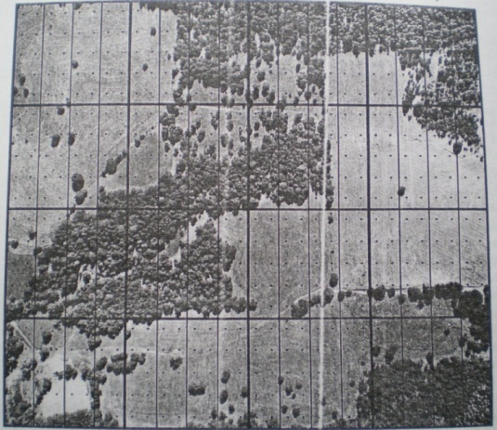 Count number of dots in stand or feature on map or photo
* Calculate the area of stand or feature
* Convert measurement to ground areas
* Widely used method of area calculation on aerial photo
* Relatively simple and inexpensive tool for estimating area on photographs

**2. Planimeter**

* 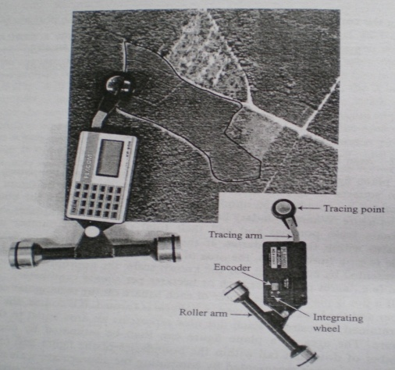 Run the pointer of an instrument around the boundaries of an area in clockwise direction; usually the perimeter is traced two or three times for an average and read the instrument details.
* Convert measurements to ground areas
* Laborious if many areas need to measure

**3. Weight apportionment**

* Traditional method
* Physically cut a method into individual areas
* Weigh each area and determine areas based on their weight
* Need a very sensitive instrument to weight small pieces of paper

**4. GIS method**

* Advance method
* By digitizing the particular area and using the different function, area can be calculated

**e. Volume estimation**

* For estimating individual tree volume, multiple entry tree volume tables based on dbh and height can be converted to aerial volume table when correlations can be established between crown diameter and stem diameters
* Photo determination of crown diameter is substituted for the usual ground measures of dbh, and total heights are measured on stereoscopic pairs of photographs.
* Large scale aerial photographs are essential for obtaining reliable crown diameter and health measurement of individual trees.
* 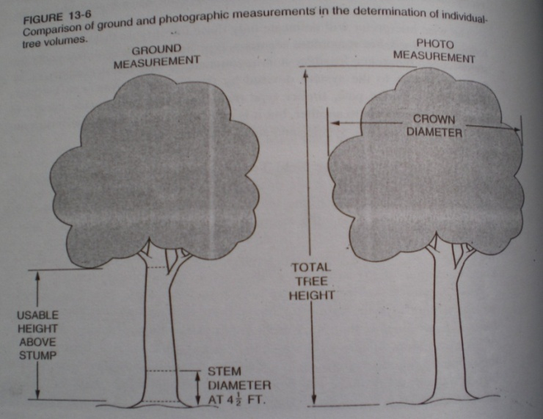Where only small scale aerial photographs are available, stand variables should be measured than individual tree variable
* Aerial stand volume tables are multiple entry tables that are used based on assessments of two or three photographic characteristics of the dominant –co dominant crown canopy; average stand height, average crown diameter and percent of crown close
* These tables are usually derived by multiple regression analysis; photographic measurements of independent variables are made by several skilled interpreters when developing the volume prediction equation.

**Other Forestry application of aerial photography**

* Vegetation growth distribution investigation
* Forest resource investigation
* Forest fire monitoring
* Forest disease and pest monitoring
* Shifting cultivation study
* Timber harvest planning
* Monitoring of logging and reforestation
* Forest recreation resource inventory and monitoring
* Wildlife habitat analysis
* Planning forest roads
* Monitoring power line right of way vegetation growth etc.