**Bacterial Culture Media and Staining methods**

**Reasons for culturing Bacteria**

* One of the most important reasons for culturing bacteria *in vitro* is its utility in diagnosing infectious diseases.
* Culturing bacteria is also the initial step in studying its morphology and its identification.
* Bacteria have to be cultured in order to obtain antigens from developing serological assays or vaccines
* Certain genetic studies and manipulations of the cells also need that bacteria be cultured in vitro.
* Culturing bacteria also provide a reliable way for estimating their number (Viable count)
* Culturing on solid media is another convenient way of separating bacteria in mixtures

**Culture media**

“A natural material prepared for the growth of micro organisms in a laboratory is called as culture medium.”

When microbes are introduced into a culture media to initiate the growth, they are called an “inoculums”.

The microbes that grow & multiply in or on a culture medium are referred as “culture”.

A variety of media are available for the growth of micro organisms in a laboratory. Most of them have pre-mixed components & require only addition of water & sterilization.  
  
**History:**

Louis Pasteur used simple broths made up of urine or meat extracts. Robert Koch realized the importance of solid media and used potato pieces to grow bacteria. It was on the suggestion of Fannie Eilshemius, wife of Walther Hesse (who was an assistant to Robert Koch) that agar was used to solidify culture media. Before the use of agar, attempts were made to use gelatin as solidifying agent. Gelatin had some inherent problems, It existed as liquid at normal incubating temperature (35-37C) and was digested by certain bacteria.

**Types of media:**

**(On the basis of physical state)**

There are 3 types of culture media:

* Solid media (agar)
* Liquid media (broth)
* Semi-solid media

**Solid media (agar):**

When it is desirable to grow bacteria on the solid media, a solidifying agent i.e. “agar” is added to medium.

**Concentration of agar 1.5%**

The test tubes are called ***slants***when they are allowed to solidify with the tube held at an angle so that a large surface area for growth is available.

When the agar solidifies in a vertical tube, it is called a ***deep.***

Agar media are usually contained in test tubes or *Petri dishes.* Petri dishes, named for their inventor, are shallow dishes with a lid that nests over the bottom to prevent contamination; when filled, they are called *Petri* (or culture) *plates*

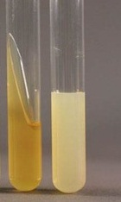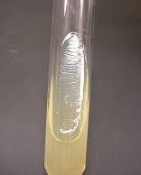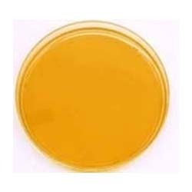

**Liquid Media (broth):**

Agar is not used in this media. These are available for use in test tubes, bottles or flasks. Liquid media are referred as Broths e.g. Nutrient Broth

**Uses:**

* It is used to kept bacteria in suspension form.
* It is also used for fast growth of bacteria.

**Limitation.** Properties of bacteria are not visible in liquid media and more than one type of bacteria cannot be detected.

**Semi Sold Media:**

It has soft custard like consistency. Agar Conc. is **0.5%** or less than.

U**ses:**

* It is used for the growth of microaerophillic bacteria.
* For the determination of bacterial motility.
* Certain transport media such as Stuart’s and Amies media are semisolid in Consistency.

**Types of Media:**

**(On the basis of Purpose of use)**

**General Media:**

This media sports the growth of majority of bacteria with simple nutritional requirement.

e.g. nutrient ager, nutrient broth.

**Enriched Media:**

Media for the growth of fastidious bacteria, addition of component such as blood, serum or extract provide additional nutrient e.g. blood agar.

**Selective Media:**

These media provide nutrients that enhance the growth and pre-dominance of a particular type of bacterium & do not enhance and even inhibit the other type or organism.

e.g. Brilliant Green ager it contain brilliant green dye that inhibit Gram positive bacteria, so is used to isolate Gram negative *Salmonella* (bacteria genera)

[MacConkey agar](https://en.wikipedia.org/wiki/MacConkey_agar) for [Gram-negative](https://en.wikipedia.org/wiki/Gram-negative) bacteria

.

**Differential Media:**

These media allow differentiation of various types of bacteria, growing on same plate.

e.g. Blood agar, use to differentiate hemolytic & non-hemolytic bacteria strain of *S. pyrogens*

**Reducing media:**

Media used for growth of anaerobic bacteria; it contains ingredients such as sodium thioglycolate, that chemically combine with dissolved oxygen & hence deplete the oxygen in the culture media.

Example Thioglycolate broth.

**Media for Enumeration:**

A wide variety of media are used to determine the bacterial contents of material such as milk & water.

### Transport media

Transport media should fulfill the following criteria:

* Temporary storage of specimens being transported to the laboratory for cultivation.
* Maintain the viability of all organisms in the specimen without altering their concentration.
* Contain only buffers and salt.

Example Cary and Blair Medium: semi-solid, white colored transport medium for faeces that may contain Salmonella, Shigella, Vibrio or Cam­pylobacter

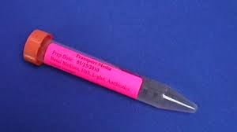

**Assay media**  
These media are used for the assay of vitamins, amino acids and antibiotics. E.g. antibiotic assay media are used for determining antibiotic potency by the microbiological assay technique.

**Types of media:**

**(on the basis of chemical composition)**

**Complex media:**

It is made up of nutrients such as extract from yeast (vitamins for bacteria), meat or plant, or may contain certain digests. So, exact chemical composition varies from batch to batch.



**Chemically defined media:**

It is the media of known chemical composition. All of the nutrients in the medium are known.



**Preparation of media:**

**Requirements:**

1. Nutrient media
2. Water
3. Media bottle or Flask
4. Autoclave
5. Cotton plug
6. pH meter/paper

**Procedure:**

1. Dehydrated medium is dissolved in appropriate volume of distilled water.
2. pH of the fluid volume is determined and adjusted, (if necessary).
3. Dissolved Medium is added in media bottle tube or flask.
4. The medium is sterilized generally by autoclaving, however, some media that are heat labile are sterilized by filtration.

**Culture Media Ingredients**

**Agar**

**Source.** It is water soluble polysaccharide isolated from marine algae like Gelidium and Gracilaria

Agar replaced gelatin (previously used as gelling agent) because of some suitable properties like

1. It remained solid at temperature required for bacterial growth.
2. I t is resistant to breakdown by bacterial enzymes.

**Peptones**

Amino acid and nitrogen source for bacteria

**Yeast Products**

Yeast extract, a water soluble derivative of yeast cells. Major source of B. Complex vitamin. It supplies not only vitamin but also proteins, carbohydrate and some micronutrients.

**STAINING**

Staining simply means coloring the microorganisms with a dye that emphasizes cellular shape and certain structures.

Before the microorganisms can be stained, a thin film of material containing the microorganisms is spread over the surface of the slide. This film, called a smear, is allowed to air dry.

They must be fixed (attached) to the microscope slide. Fixing simultaneously kills the microorganisms and fixes them to the slide. It also preserves various parts of microbes in their natural state with only minimal distortion. In most staining procedures the slide is then fixed by passing it through the flame of a Bunsen burner several times, or by covering the slide with methyl alcohol for I minute. Stain is applied and then washed off with water; then the slide is blotted with absorbent paper. Without fixing, the stain might wash the microbes off the slide. The stained microorganisms are now ready for microscopic examination.

**Microbiological stain:**

A large number of colored organic compounds (dyes) are available for staining. Stains are salts composed of a positive and a negative ion, one of which is colored and is known as the *chromophore.* The other non colored part is auxochrome*.* Dye also contain a benzene ring.

**Types of Stains**

1. **Basic Stain (Cationic stain)**

The color of so-called basic dyes is in the positive ion. Bacteria are slightly negatively charged at pH 7. Thus, the colored positive ion in a basic dye is attracted to the negatively charged bacterial cell. Basic dyes, which include crystal violet, methylene blue, malachite green, and safranin,

1. **Acidic stain (Anionic stain)**

In acidic stain the stain is in negative ion. Acidic dyes are not attracted to most types of bacteria because the dye's negative ions are repelled by *the* negatively charged bacterial surface, so the stain colors the background instead. Examples of acidic dyes are eosin and nigrosin.

1. **Neutral Stain**

In neutral stain both positive and negative ion contain stain. Example is the Eosinate of methylene blue, giemsa stain.

**Types of Staining:**

**Simple Staining*;*** it is the coloration of bacteria by applying a single solution of stain to a fixed smear is called simple staining.

**Principle of Simple Staining:**

The colored positive ion in basic dye is attracted to the negative charged bacterial cell and gives color to cell.

**Procedure**

1. Take a clean glass slide and air dry it.

2. Place a drop of water on slide and loop a full bacterial culture on the glass slide and

make a smear.

3. Allow it to air dry.

4. Fix it by passing it over the flame.

5. Add the basic dye and wash it with water after one to two minutes.

6. Blot the slide with blotting paper or filter paper and observe it under microscope

**NEGATIVE STAINING:**

**Negative staining** is an established method, often used in diagnostic [microscopy](https://en.wikipedia.org/wiki/Microscopy), In this technique, the background is stained, leaving the actual specimen uncoloured, and thus visible. This contrasts with 'positive staining', in which the actual specimen is stained.

**Procedure:**

1. Take a drop of acidic dye on glass slide. Place bacteria on the slide with the help of wire loop.
2. Prepare the smear without heating. Air dry the slide and
3. Observe under microscope.

**Advantages:**

It is valuable for the observation of cell shape, size and capsule because cells are visible against colored background. Because heat fixation is not done, so disturbances of cell shape and size are minimized.

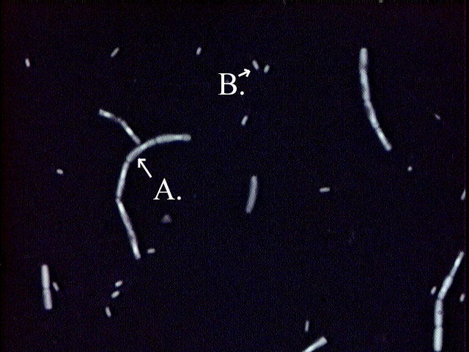

1. **Differential Staining**

Unlike simple staining differential staining reacts differently with different kind of bacteria and thus can be used to distinguish among them. Differential stain most frequently used for bacteria are Gram stain and Acid fast stain.

a) Gram staining

b) Acid fast Staining

**GRAMSTAINING**

This staining technique was introduced by CHRISTIAN GRAM in 1884. It is one of the most useful staining procedures because it classifies bacteria into two large groups: gram-positive and gram-negative.

The mechanism of staining is based on difference in structure of cell wall of Gram-positive and Gram-negative bacteria. PROCEDURE, Take a glass slide add water, add culture by wire loop and spread clockwise and anticlockwise to prepare smear. Heat fix the smear. After heat fixing smear is covered with basic crystal violet(primary stain) after a short time purple-dye is washed offand smear is covered with iodine(mordant), slide is washed with alcohol or alcohol acetone (decolourizing agents or decoulizer. Alcohol is rinsed off and slide is stain with safranin (secondary stain\counterstain).

Smear is washed again, blot dried and examine under microscope.

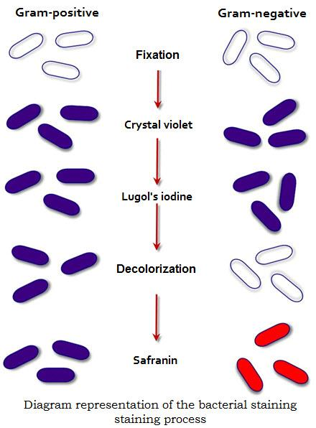

**Explanation**

Gram-negative bacteria have more lipid in their cell-wall than gram-positive bacteria on alcohol or decolorizer treatment lipid is extracted resulting in increase permeability and porosity of cell wall and hence crystal violet iodine complex can be extracted and cell takes colour of safrainin cell wall of gram positive bacteria because of its different composition become dehydrated on treatment with alcohol result is decrease permeability and hence crystal violet iodine complex can not extracted and cell remain purple.

**Acid Fast Staining:**

A differential stain which binds strongly only to bacteria that have waxy material (mycolic acid) in their cell wall.

**Use:**

It usually distinguishes acid fast bacteria such as mycobacterium species including 2 important pathogens:

* *Mycobacterium tuberculosis* that causes tuberculosis
* *Mycobacterium leprae* that causes leprosy

This stain is also used to identify the pathogenic stains of genus Nocardia.

In the acid-fast staining procedure, the red dye car& bolfuchsin is applied to a fixed smear, and the slide is gently heated for several minutes. (Heating enhances penetration and retention of the dye.) Then the slide is cooled and washed with water. The smear is next treated with acid-alcohol, a decolorizer, which removes the red stain from bacteria that are not acid -fast. The acid-fast microorganisms retain the red color because the carbolfuchsin is more soluble in the cell wall lipids than in the acid-alcohol whose cell walls lack the lipid components, In non acid fast bacteria the carbolfuchsin is rapidly removed during decolorization, leaving the cells colorless. The smear is then stained with a methylene blue counterstain. Non-acid-fast cells appear blue after application of the counterstain.

**SPECIAL STAINING:**

The special stains are used to color or stain specific parts of microorganisms such as endospores, flagella and to reveal the presence of capsule.

**Endospore staining:**

The most commonly used endospore staining is **Schaeffer Fulton** endospore stain. Primary stain is Malachite green solution (basic dye). Counter stain is Safranin.

Endospore staining demonstrates spore structure in bacteria as well as free spores.

1. Flood smear with malachite green and steam it by placing it over the beaker of Water placed on hot plate.
2. Cool the slide and wash out stain with distilled water, Water serves as decolorizing agent.
3. Counter stain the slide with Safranin for 30 seconds.
4. Now again wash off Safranin with distilled water.
5. Blot dry the slide and observe under microscope.

. 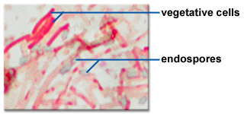

**Observation:**

Spores are visible in green color while cell retain color of Safranin stain.



**STAINING**

Staining simply means coloring the microorganisms with a dye that emphasizes cellular shape and certain structures.

Before the microorganisms can be stained, a thin film of material containing the microorganisms is spread over the surface of the slide. This film, called a smear, is allowed to air dry.

They must be fixed (attached) to the microscope slide. Fixing simultaneously kills the microorganisms and fixes them to the slide. It also preserves various parts of microbes in their natural state with only minimal distortion. In most staining procedures the slide is then fixed by passing it through the flame of a Bunsen burner several times, or by covering the slide with methyl alcohol for I minute. Stain is applied and then washed off with water; then the slide is blotted with absorbent paper. Without fixing, the stain might wash the microbes off the slide. The stained microorganisms are now ready for microscopic examination.

**Microbiological stain:**

A large number of colored organic compounds (dyes) are available for staining. Stains are salts composed of a positive and a negative ion, one of which is colored and is known as the *chromophore.* The other non colored part is auxochrome*.* Dye also contain a benzene ring.

**Types of Stains**

1. **Basic Stain (Cationic stain)**

The color of so-called basic dyes is in the positive ion. Bacteria are slightly negatively charged at pH 7. Thus, the colored positive ion in a basic dye is attracted to the negatively charged bacterial cell. Basic dyes, which include crystal violet, methylene blue, malachite green, and safranin,

1. **Acidic stain (Anionic stain)**

In acidic stain the stain is in negative ion . Acidic dyes are not attracted to most types of bacteria because the dye's negative ions are repelled by *the* negatively charged bacterial surface, so the stain colors the background instead. Examples of acidic dyes are eosin and nigrosin.

1. **Neutral Stain**

In neutral stain both positive and negative ion contain stain. Example is the Eosinate of methylene blue, giemsa stain.

**Types of Staining:**

**Simple Staining*;*** it is the coloration of bacteria by applying a single solution of stain to a fixed smear is called simple staining.

**Principle of Simple Staining:**

The colored positive ion in basic dye is attracted to the negative charged bacterial cell and gives color to cell.

**Procedure**

1. Take a clean glass slide and air dry it.

2. Place a drop of water on slide and loop a full bacterial culture on the glass slide and

make a smear.

3. Allow it to air dry.

4. Fix it by passing it over the flame.

5. Add the basic dye and wash it with water after one to two minutes.

6. Blot the slide with blotting paper or filter paper and observe it under microscope

**NEGATIVE STAINING:**

**Negative staining** is an established method, often used in diagnostic [microscopy](https://en.wikipedia.org/wiki/Microscopy), In this technique, the background is stained, leaving the actual specimen uncoloured, and thus visible. This contrasts with 'positive staining', in which the actual specimen is stained.

**Procedure:**

1. Take a drop of acidic dye on glass slide. Place bacteria on the slide with the help of wire loop.
2. Prepare the smear without heating. Air dry the slide and
3. Observe under microscope.

**Advantages:**

It is valuable for the observation of cell shape, size and capsule because cells are visible against colored background. Because heat fixation is not done, so disturbances of cell shape and size are minimized.



1. **Differential Staining**

Unlike simple staining differential staining reacts differently with different kind of bacteria and thus can be used to distinguish among them. Differential stain most frequently used for bacteria are Gram stain and Acid fast stain.

a) Gram staining

b) Acid fast Staining

**GRAMSTAINING**

This staining technique was introduced by CHRISTIAN GRAM in 1884. It is one of the most useful staining procedures because it classifies bacteria into two large groups: gram-positive and gram-negative.

The mechanism of staining is based on difference in structure of cell wall of Gram-positive and Gram-negative bacteria. PROCEDURE, Take a glass slide add water, add culture by wire loop and spread clockwise and anticlockwise to prepare smear. Heat fix the smear. After heat fixing smear is covered with basic crystal violet(primary stain) after a short time purple-dye is washed offand smear is covered with iodine(mordant), slide is washed with alcohol or alcohol acetone (decolourizing agents or decoulizer. Alcohol is rinsed off and slide is stain with safranin (secondary stain\counterstain).

Smear is washed again, blot dried and examine under microscope.



**Explanation**

Gram-negative bacteria have more lipid in their cell-wall than gram-positive bacteria on alcohol or decolorizer treatment lipid is extracted resulting in increase permeability and porosity of cell wall and hence crystal violet iodine complex can be extracted and cell takes colour of safrainin cell wall of gram positive bacteria because of its different composition become dehydrated on treatment with alcohol result is decrease permeability and hence crystal violet iodine complex can not extracted and cell remain purple.

**Acid Fast Staining:**

A differential stain which binds strongly only to bacteria that have waxy material (mycolic acid) in their cell wall.

**Use:**

It usually distinguishes acid fast bacteria such as mycobacterium species including 2 important pathogens:

* *Mycobacterium tuberculosis* that causes tuberculosis
* *Mycobacterium leprae* that causes leprosy

This stain is also used to identify the pathogenic stains of genus Nocardia.

In the acid-fast staining procedure, the red dye car& bolfuchsin is applied to a fixed smear, and the slide is gently heated for several minutes. (Heating enhances penetration and retention of the dye.) Then the slide is cooled and washed with water. The smear is next treated with acid-alcohol, a decolorizer, which removes the red stain from bacteria that are not acid -fast. The acid-fast microorganisms retain the red color because the carbolfuchsin is more soluble in the cell wall lipids than in the acid-alcohol whose cell walls lack the lipid components, In non acid fast bacteria the carbolfuchsin is rapidly removed during decolorization, leaving the cells colorless. The smear is then stained with a methylene blue counterstain. Non-acid-fast cells appear blue after application of the counterstain.

**SPECIAL STAINING:**

The special stains are used to color or stain specific parts of microorganisms such as endospores, flagella and to reveal the presence of capsule.

**Endospore staining:**

The most commonly used endospore staining is **Schaeffer Fulton** endospore stain. Primary stain is Malachite green solution (basic dye). Counter stain is Safranin.

Endospore staining demonstrates spore structure in bacteria as well as free spores.

1. Flood smear with malachite green and steam it by placing it over the beaker of Water placed on hot plate.
2. Cool the slide and wash out stain with distilled water, Water serves as decolorizing agent.
3. Counter stain the slide with Safranin for 30 seconds.
4. Now again wash off Safranin with distilled water.
5. Blot dry the slide and observe under microscope.

. 

**Observation:**

Spores are visible in green color while cell retain color of Safranin stain.

