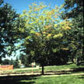**ABIOTIC DISEASES OF PLANTS**

**Girdling Roots**  
Girdling roots constrict the main stem of the tree causing wilting and browning of leaves, reduced vigor, and decline of the tree.

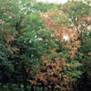**DROUGHT STRESS**  
Uniform wilting or browning of leaves throughout the tree. Leaf margins and branch extremities usually wilt first.

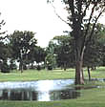**FLOODING**Prolonged periods of standing water create anaerobic conditions, causing decline and possible death of the tree. Leaves may yellow, brown, or drop prematurely.

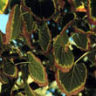**HEAT STRESS**  
Browning of the leaf margins. Leaves may also contain a yellow, chlorotic margin (halo) inside of the brown tissue.

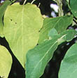

**NUTRIENT DEFICIENCY**  
Nutrient deficiency causing yellowing of the leaves.

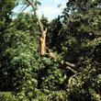**STORM DAMAGE**  
Physical damage to the leaves (shredding) and/or premature loss of healthy green leaves. Physical damage to the branches, bark, trunk, or roots of the plant may cause leaf browning.

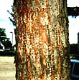

**SAP SUCKER DAMAGE**  
Multiple rows of holes caused by sap sucker feeding will girdle the tree. This causes drought-like symptoms to occur on the leaves.

**Examples of some abiotic diseases of plants**

* Chlorosis in sugarcane due to deficiency of nitrogen and iron and in citrus due to Fe, Zn and N.
* Tirak of cotton due to alkaline and light soils and N deficiency.
* Zn deficiency in rice known as khaira disease.
* Poor root system and burning appearance due to P deficiency.
* Dark green or bluish green color of leaves and late crop maturity due to K deficiency
* Black heart of potato due to poor O2 conditions in storage.
* Black tip of Mango due to brick-kiln.