**Generative Syntax**

Generative Syntax was developed by Noam Chomsky in 1957 and has been elaborated both by Chomsky himself and by other linguists in the following decades. As a result of these various elaborations and changes different frameworks of generative syntax exist.

In this section of the syntax module we will introduce you to Government & Binding Theory, a framework of generative syntax that has been introduced by Chomsky in 1981. We will mainly concentrate on the assumptions linked to X-Bar Theory, which is one of the sub-theories formulated in Government & Binding and concerned with the representation of sentences as hierarchical structures in the form of tree diagrams.

**X-Bar Theory and Constituent Structure**

**General claim of X-Bar theory:**

The words in sentences (and phrases) have not just a linear order but also a hierarchical structure.

**I. Hierarchical structures**

In generative syntax, hierarchical structures are organised in such a way that two syntactic objects are joined to form a larger syntactic object (unit, constituent).

Hierarchical structures are represented in tree diagrams and syntactic objects or units are then referred to as nodes (cf. A, B, C below).

Larger syntactic units (such as C above) can join with another syntactic object or another complex syntactic unit to form a new unit. Note that not more than two syntactic objects can be joined to form a new object, resulting in binary branching structures.

**II. Structural relations**

The hierarchies in tree diagrams can be expressed with reference to structural relations. The basic structural relations are defined below:

**(a) Motherhood:**

A node A is the mother of node B, if it directly contains it. B is then referred to as A's daughter.

Example: In the tree diagram above C is the mother of A and B, and G is the mother of E and F.

**(b) Sisters/Sisterhood:**

A node A is node B's sister if it has the same mother as B.

Example: In the tree diagram above A and B are sisters.

**(c) Dominance:**

A node A dominates node B if it is higher up in the tree than A and contains it.

Example: In the tree diagram above G dominates all other nodes since it contains them.

**Principles of X-Bar Theory**

All phrases (XPs) are constructed according to the same principles:

**I.** They are projections of a head of some syntactic category (V, N, A, P, Adv, D, INFL, COMP), and so have an endocentric structure, in which the head is of the same category as the phrase.

**II.** They have three levels of projection:

(a) a head (symbolized as X or X°):

A head is the lowest (or zero) level of projection, which lends its features to the whole XP. These features are lexical (N, V) and/or functional (e.g. person, number, gender).

Some heads take complements, i.e. obligatory XPs which are sister to the head.

**(b)** a recursive intermediate level (symbolized as X'):

If there is only one X', it may be sister to the specifier (SPEC) of XP. A specifier is a YP immediately dominated by XP.

If more than one X' is generated, in order to create (optional) adjunct positions, the top X' will be sister to the specifier, and the lower one(s) will be sister to an adjunct.

**(c)** a phrasal or maximal level (maximal projection; symbolized as Xmax, XP, or X")

**The X-Bar model**

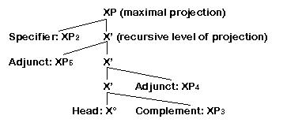

**The X-Bar Model: Lexical Categories**

**I. Lexical categories**

Lexical categories (i.e. verbs, nouns, adjectives, adverbs, and prepositions) have specific properties which distinguish them from functional categories:

**(a) Semantic criteria:** They carry semantic meaning.

**(b) Morphological criteria:** They are marked morphologically.

**(c) Distributional (syntactic) criteria:** They can be characterized by their distribution.

The features that are often taken to constitute the lexical (and phrasal) categories are [+/-noun] and [+/-verb]. Thus, the lexical categories can be decomposed into the following features:

noun: [+N,-V]

verb: [-N,+V]

adjective: [+N,+V]

preposition: [-N,-V]

For more detailed information on the properties of lexical categories, see the page on parts of speech from the Selected Subfields section (Syntactic Theory) of ELLO.

**II. Lexical categories and syntactic structure**

Lexical categories function as the head of phrases. Thus, a verb phrase (VP) is a constituent whose head is a verb (V). Analogously, a noun phrase (NP) is a constituent whose head is a noun (N); an adjective phrase (AP) is a constituent whose head is an adjective (A); a prepositional phrase (PP) is a constituent whose head is a preposition (P).

A head may require an obligatory XP as a sister. Sisters to X° are called complements. In contrast, optional YPs providing additional information are referred to as adjuncts; they are sisters to X'.

**The VP**

**I. The verb**

**II. Basic structure of VPs**

Example: VP [easily opened the door with her credit card]

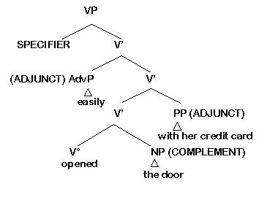

**III. Complements and adjuncts in the VP**

VPs are constituents whose heads are verbs. Verbs can be classified according to whether they require any VP-internal NP. Traditionally, three classes of verbs are distinguished: transitive, ditransitive and intransitive verbs.

If a VP has a transitive verb as its head, one NP (i.e. the direct object) is required: the verb takes an NP-complement; e.g. Sally [opened the door]. If a VP has a ditransitive verb as its head, two NPs or an NP and a PP (i.e. the direct and the indirect object) are required: the verb takes two complements; e.g. Sally [gave the money to John]. If a VP has an intransitive verb as its head, no complement is allowed; e.g. Sally [laughed].

The obligatory constituents that are required by a verb (i.e. subject and complements) are called its arguments. Thus, a sentence like Sally opened the door contains two arguments: the subject NP Sally is one argument and the object NP the door is the second argument of the verb open. The verb's specification for the number of arguments it requires is called its argument structure or (referring to the semantic relationships between verbs and their arguments) thematic structure. These semantic relationships are described in terms of thematic roles or theta roles. Thus, the verb open takes two arguments to which it assigns a theta role: it assigns the role AGENT to the subject argument of the sentence, and the role THEME to the object argument. In general, we can say that a verb theta-marks it arguments. The component of the grammar that regulates the assignment of thematic roles is called theta theory.

Adjuncts, such as PPs providing information about the manner, time, or place of the event expressed in the sentences, are not required by the verb but may be included optionally; e.g. with her credit card and on Monday in the sentence Sally [opened the door with her credit card on Monday]. Adjuncts may also appear in pre-verbal position, such as easily in the sentence Sally [easily opened the door with her credit card].

Whether an XP inside the VP is a complement or an adjunct can be determined with constituent tests. (Click here for the omission test for complements and adjuncts)

**IV. Specifiers in the VP**

According to the so-called VP (internal subject hypothesis) it is the subject that originates in the specifier position of VP where it receives a theta role. The subject is subsequently raised into the specifier position of IP (subject-to-subject raising), leaving a co-indexed trace. For further information read the page on INFL as a functional head.

**The NP**

**I. The noun**

**II. Basic structure of NPs**

Example: NP [young teacher of English from Braunschweig]

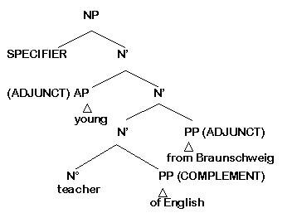

**III. Complements and adjuncts in the NP**

NPs are constituents whose heads are nouns. Complements are possible but are commonly not a feature of NPs. Compare for example: a student [of physics], the father [of the bride], a man [of few words], the children.

Because many nouns do not take complements, complements are often difficult to distinguish from adjuncts. However, there are two criteria to identify complements:

**(a)** The noun and its complement commonly have the form [N of NP], in which the N is a deverbal noun (i.e. a noun formed from a verb) and [of NP] corresponds to the NP complement of the original V. For example:

[VP study [NP linguistics]] —> [NP a student [PP of linguistics]]

[love [NP music]] —> [NP a lover [PP of music]]

[announce [NP the news]] —> [NP the announcement [PP of the news]]

**(b)** If there is more than one PP, complements must be closer to the N, and adjuncts can be further away. Compare for example: a student of linguistics with long hair vs. *a student with long hair of linguistics; an appointment with the dean on Monday vs. an appointment on Monday with the dean. In the first example of linguistics must be a complement, and with long hair an adjunct, while in the second example both PPs must be adjuncts.

**IV. Specifiers in the NP**

In earlier versions of X-Bar Theory, two standard types of specifiers in the NP have been assumed:

**(a) determiners**

**(b) NPs:** possessive pronouns (e.g. his) or genitive-marked full NPs (e.g. Sally's)

Note that this assumption has been modified by virtue of the so-called DP-analysis. Here, determiners are considered to be the functional head (D°) of a determiner phrase (DP), requiring a full NP as a complement. Possessive pronouns and genitive-marked full NPs (DPs) can occur in the specifier-position of DPs.

**V. Pronouns and X-Bar theory**

Pronouns do not to permit complements and can not be preceded by determiners:

* he of the bride

* the they

Since pronouns replace a full NP/DP consisting of a determiner and a noun (e.g. he replacing the man), it has been suggested that they are NPs/DPs with no internal structure.

**The AP**

**I. The adjective**

**II. Basic structure of APs**

Example: AP [extremely fond of chocolate with breakfast]

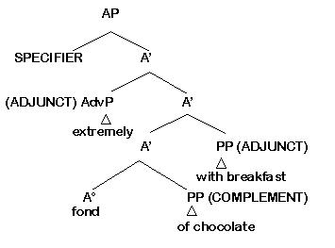

**III. Complements and adjuncts in the AP**

APs are constituents whose heads are adjectives. Complements of adjectives (as of nouns) are generally PPs of the form [of NP]; e.g. fond of chocolate, envious of John, fearful of strangers. Other PP complements are also possible: dependent on time, independent from another country, excited about the changes.

APs commonly appear as adjuncts in NPs. In this function adjectives take no complement:

*an envious of John man.

Example: [NP a [AP rather envious] man]

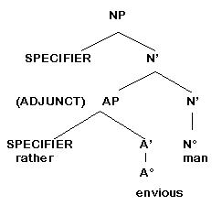

However, when adjectives are used with a predicative function (i.e. when they are complements of the copula be) they may take complements: He is AP [envious of John]

**IV. Specifiers in the AP**

Specifiers in the AP are not always easy to distinguish from adjuncts.

They include such degree expressions as rather, quite, and so. A typical characteristic of AP specifiers is that they cannot be modified (i.e. no expressions can be added to them to make their meanings more precise): * an AP [extremely rather envious] man.

In contrast, AP adjuncts can be modified: an AP [extremely moderately decorated] appartment.

**The PP**

**I. The preposition**

**II. Basic structure of PPs**

Example: PP [early in the morning on Wednesday]

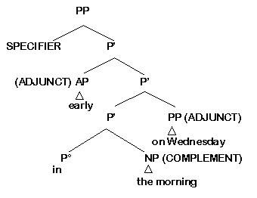

**III. Complements and adjuncts in the PP**

PPs are constituents whose heads are prepositions. Complements in the PP are most commonly NPs: on [NP Wednesday], but can also be PPs themselves: from [PP under the table].

Example: PP [from [PP under the table]]

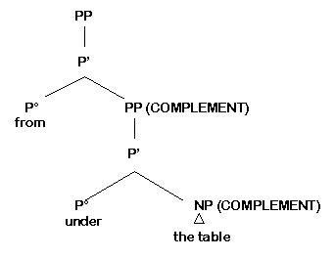

Clauses can occur as complements as well, e.g. They argued about [who should clean up the mess]. Note that for some prepositions it has been suggested that they are best treated as COMP elements, i.e. they have the function of a complementizer): I would prefer very much [CP for [IP you to leave]].

Adjuncts while rarer, are also possible: [P' decidely [P' beyond our comprehension]].

PPs commonly appear as adjuncts, e.g. as adverbials of place, time, means, and manner. Examples are in the garden (adverbial of place), on Monday (adverbial of time), with a knife (adverbial of means), in a strange way (adverbial of manner).

These PPs are all adverbials, i.e. they are structurally PPs but serve a semantic function similar to Adverb Phrases (AdvPs); cf. in a strange way (PP) and carefully (AdvP).

Note that certain NPs also serve an adverbial function: She goes [NP next year], They agreed to meet [NP Monday morning].

PPs can also occur as complements of verbs (e.g. [PP to John] in He gave the book to John or [PP in London] in He lives in London.), as complements of nouns (e.g. [PP of English] in teacher of English or [PP on Syntax] in exercises on Syntax, as complements of adjectives (e.g. [PP about the meeting] in excited about the meeting, or as complements of other prepositions (as illustrated in the example from under the table, see above).

**IV. Specifiers in the PP**

Specifiers in the PP include such degree expressions as just, quite, right, and so.

**X-Bar Theory and Constituent Tests**

**I. Constituent tests**

Constituent tests show which elements form a syntactic unit (constituent); these may be:

(a) category-neutral (i.e. they are used to determine whether a group of words is a constituent, and may be used to test for different syntactic categories and projections)

(b) category-specific (i.e. they are used to determine whether a group of words belongs to a particular lexical category and/or represents a particular projection)

**II. The tests**

**(a) category-neutral:**

**(i) distribution test: movement test**

**(ii) distribution test:** replacement or proform test (can be used in combination with a wh-movement test)

**(iii) coordination test**

**(b) category-specific:**

**(i) intrusion test:** position of adverbs (to test for VPs and their NP complements)

**(ii) omission test 1:** sentence fragment test (to test for XPs)

**(iii) omission test 2:** omission test for complements and adjuncts (to test for the optional or obligatory status of XPs)

**(iv) omission test 3:** VP-deletion (to test for VPs)

**Movement test**

**I. Basis of test**

Only constituents can be moved.

**II. Complication**

Movement of some constituents is ungrammatical for independent reasons, so the test is most reliably used with grammatical sentences involving movement, rather than ungrammatical ones.

Constituents that cannot be moved:

(i) X'

(ii) A°, N°, P°, determiners:

* a friend good (whether N or A is moved)

* friend a (whether N or determiner is moved)

* just the top over (where P is moved)

**III. Application to specific categories**

(a) VPs

Test sentence: John promised that he would finish his homework.

and [finish his homework] he will

* and [will finish his homework] he

(This example demonstrates that the modal is not part of VP; cf. the page on properties of INFL)

(b) NPs

Test sentence: He likes [John's sister] very much.

[John's sister] he likes very much.

(c) PPs

Test sentence: He went [down the river].

[Down the river] he went.

**Pro-form test**

**I. Basis of test**

(a) Only a constituent can be replaced by a proform.

(b) If we know the category of the proform, we know the category of the constituent.

II. Application to specific categories

Proform test: VPs

Proform: do so (replaces a V')

Test sentence: Sally will open the door with her credit card on Monday.

and John will do so too (open the door with her credit card on Monday is a V')

and John will do so on Tuesday (open the door with her credit card is a V')

and John will do so with his key on Tuesday (open the door is a V')

* and John will do so the window (open alone is not a V')

Some verbs (e.g. give, put) have two complements.

The do so-test shows that VPs headed by such verbs cannot have an X' structure in which one complement is sister to V° and another is sister to V' (since that would make it an adjunct):

John would give his key to the neighbors on Monday

* but Sally would do so to her cousin on Tuesday

One possibility is that such two-complement structures are ternary- (rather than binary-) branching. With such a structure, [give his key to the neighbors] would be the lowest V', and thus account for the ungrammatical do so replacement above.

Example: VP [give the key to the neighbors]

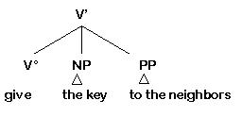

**Proform test: NPs**

(a) Proforms replacing NP:

(i) personal pronouns ( I put the book on the table)

(ii) interrogative pronouns (You put what on the table?)

Test sentence: Sally married a student of linguistics with long hair.

She married him. (substitution by personal pronouns)

Who married who(m)? (substitution by interrogative pronouns)

Whom did Sally marry? (substitution with wh-movement)

(Sally and a student of linguistics with long hair are NPs)

* Sally married this him. (substitution by personal pronoun)

(student of linguistics with long hair is not an NP)

(b) Proform replacing N': one

this one (not to be confused with the generic NP one (=German man))

**Complication:**

While one in this use is minimally an N', it can also be an NP proform, i.e. an N' with nothing in the SPEC position: [NP [N' one]]); cf.

I don’t like this [article on pronouns] or that [one]. (one replaces [N' article on pronouns])

I’m having [a drink]: Would you like [one] too? (one replaces [NP a drink]) (Quirk et al., p. 387)

Test sentence: Sally married a student of linguistics with long hair.

She married this one, not the other one. (substitution by one)

(student of linguistics with long hair is an N')

She married the one with long hair. (substitution by one)

(student of linguistics is an N', so with long hair must be an adjunct)

* She married the one of linguistics.

(student is not an N', so of linguistics must be a complement)

**Proform test: APs**

Proform: so (replaces A')

John used to be very [envious of Sally] but now he is much less so.

**Complication:**

So can also be an AP proform, in which case it requires inversion:

John used to be [very envious of Sally] and so was Anne.

* and Anne was so

**Proform test: PPs**

Proforms: (replace P')

(i) there and then

(ii) the wh-elements how, when, where, and why

While these may look like PP proforms, their ability to occur with PP specifiers demonstrates that minimally they have P' rather than PP status:

right [P' then/there]

[PP Just [P' where]] did you put the cat?

[PP [P' Where]] did you put the cat?

[PP Just [P' when/why]] did you do that?

[PP [P' When/Why]] did you do that?

**Coordination test**

**I. Basis of test**

(a) Only constituents can be coordinated; non-constituent sequences cannot be.

(b) Only constituents of the same syntactic category and projection can be coordinated.

**Exception:**

Certain constituents of the same projection but different syntactic categories can be coordinated if the two constituents serve the same semantic function:

[AP stupid] and [NP a Republican]

[AdvP easily] and [PP in no time]

**II. The structure of coordination**

Conjuncts are sisters dominated by a mother node of the same category (producing an odd X' structure which has more than one head).

Example:

John annoyed [his father and his mother].

Proform test:

John annoyed them. (his father and his mother is an NP)

John annoyed him and her. (the conjuncts are NPs)

Example: NP [his father and his mother]

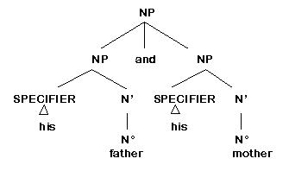

**III. Application to specific categories**

(a) VPs

John will [ [anger his father] and [disturb his mother] ]. (VP & VP)

John will slowly [ [anger his father] and [disturb his mother] ]. (V' & V')

* They will slowly [ [anger his father] and [all disturb his mother] ]. (V' & VP)

John will quickly [ [shred] and [burn] his report card] ]. (V & V)

(b) NPs

They found [NP [NP old records] and [NP furniture] ]. (only the records are old; NP & NP)

They found [NP [N' old [N' [N' records] and [N' furniture] ]. (the records and furniture are old; N' & N')

(c) PPs

She ran [down the hill] and [into the forest]. (PP & PP)

* She looked [up the number] and [out the window]. (out the window is a PP, but up the number is not: up is part of the phrasal verb look up)

The vase fell [right [off the table] and [onto the floor] ]. (P' & P')

She was able to meet him [ [before] or [after] lunch] ]. (P & P)

**Complication:**

PPs can be coordinated only when conjuncts serve the same semantic function:

* John ate with his fingers and on Monday. (with his fingers is an adverbial of means and on Monday is an adverbial of time)

**Intrusion test for VPs and their NP complements**

Certain adverbs, such as easily, occur only as adjuncts within the VP, and hence cannot be positioned between V and its complements (since they must be sister to V').

Test sentence: Sally can easily [open the door with her credit card].

* Sally can [open easily the door with her credit card].

Sally can [open the door easily with her credit card].

Sally can [open the door with her credit card easily].

These examples show that easily the door cannot be an NP; the door must be a complement and with her credit card must be an adjunct.

**Omission test for XPs: Sentence fragments**

**Basis of test**

Only phrases (hence constituents) like NP, AP, PP, VP can serve as answers to questions.

This is not surprising since question formation generally involves the use of a proform for the constituent which is then used to form the answer.

Test sentence: John will meet Sally at the train station.

Who will meet Sally at the train station? John. (NP)

Where will John meet Sally? At the train station. (PP)

Who will John meet at the train station? Sally. (NP)

What will John do? Meet Sally at the train station. (VP)

* Will meet Sally at the train station.

**Omission test for complements and adjuncts**

**I. Basis for test**

Complements are obligatory and adjuncts are optional, so the latter but not the former should be omissible.

Test sentence: Sally can easily [open the door with her credit card].

Sally can easily [open the door].

* Sally can easily [open with her credit card].

**II. Complication**

(a) VPs: complements can be omitted in certain contexts; e.g. recipe contexts:

Bake for fifteen minutes.

(b) NPs, APs, PPs: there are complement-taking and complementless versions of the same word:

father vs. father of the bride

envious vs. envious of John

fall down vs. fall down the stairs

Thus:

(a) If an XP associated with a head can be omitted, this does not prove that it is an adjunct.

(b) If an XP associated with a head cannot be omitted, this does prove that it is a complement.

**Omission test for VPs: VP-deletion (VP-ellipsis)**

**Basis of test**

If two sentences have identical VPs, the second VP can be omitted.

John should take the blame but Sally might.

* John should take the blame but Sally not.

(This example again demonstrates that the modal is not part of the VP.)

**Functional Categories: DP, IP, and CP**

Functional heads have specific properties which distinguish them from lexical categories.

(a) Functional heads carry grammatical properties rather than lexical/semantic properties:

INFL (or I°) bears finiteness and agreement features;

DET (or D°) bears features such as number, gender, definiteness, case (possessive);

COMP (or C°) bears clause-type features such as declarative or interrogative.

(b) Functional heads take one specific complement:

COMP takes an IP-complement;

INFL takes a VP-complement;

D° takes an NP-complement.

**D as a functional head**

D determines the referential or quantificational properties of its complement noun. In English we have various types of determiner reflecting these properties, e.g.:

definite vs. indefinite determiners: the/a letter

demonstratives: this/that letter

quantifiers: some letters/every letter

Motivation for assuming a D node:

(a) There is a kind of agreement relationship between determiners and nouns. Although evidence for this comes mostly from languages other than English (e.g. case agreement, gender agreement) we can see this in English with number agreement.

these letters

vs. *this letters

D is a functional head because it has abstract grammatical properties (rather than lexical properties), dominating features such as number, gender and case.

(b) Determiners are in complementary distribution with other determiners, i.e. there can be only one determiner in combination with a noun. This is a typical characteristic of heads.

the letter / a letter

vs. *the a letter

(c) D can combine with a complex nominal constituent, suggesting that it takes a complement.

this [NP extremely exciting book]

Under the assumption that D can bear case features possessive DPs can be licensed in the specifier position of DP (e.g. John's in John's friend).

**Some properties of D**

(a) Sometimes determiners do not have a phonological form:

e.g. bare plurals: I like (/) books.

e.g. mass nouns: (/) Oil was leaking from the furnace.

In these cases, we assume that D° exists in the form of a feature bundle but has no overt realisation.

(b) Determiners are considered as functional heads which take an NP-complement. Determiners can have specifiers in the form of possessives. In such a case they bear the functional feature [+Poss] and are lexically empty.

Peter’s book

Evidence for the fact that these possessives are inside the DP: they are usually in complementary distribution with the determiner, i.e. when there is a determiner, there must be no possessive DP and vice versa:

*Peter’s the book

*the Peter’s book

Evidence for the fact that they are in the specifier of DP (rather than in the head position) comes from rare cases where possessive DPs and determiners co-occur:

the king’s every wish

(Note: In English only every or a lexically empty D[+poss] allow a specifier, but in other languages this is a regular characteristic of D.)

(c) The analysis of pronouns and proper nouns:

Since pronouns replace a full DP consisting of a determiner and a noun complement (e.g. he replacing the man), it has been suggested that they are DPs with no internal structure. Proper nouns (such as names or place names) are analysed analogously.

http://www.ello.uos.de/uploads/Syntax/DPhe.jpg

http://www.ello.uos.de/uploads/Syntax/DPSally.jpg

**The Structure of DP**

Example 1: DP with determiner and complement-NP

the book

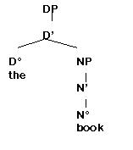

Example 2: DP without overt determiner

books

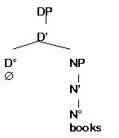

Example 3: DP with possessive DP in specifier-position

Peter's book

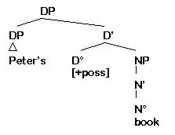

**INFL as a functional head**

So far, we have seen that the verb plays a major part in the organisation of the sentence, e.g. by determining the argument structure (and thus, the type of subject and the number and type of complements). However, in this section we will see that the VP is not the top-most node that represents the sentence. This becomes evident by looking at examples that contain more than one verbal element, e.g. a combination of an auxiliary and a lexical verb (cf. 1 below) or a combination of a modal and a lexical verb (cf. 2 below).

(1) Anne has bought a new car.

(2) Anne will/might buy a new car.

The examples illustrate that there must be a position for auxiliaries and modals outside the VP. We can further see that the subject occurs in a position to the left of modals and auxiliaries. This suggests that the subject, though base-generated in the specifier, moves to another position.

In this section we suggest that there is a functional category INFL (projecting to a phrase called IP) which takes the VP as its complement. Modals and auxiliaries may be residents of INFL (i.e. the head position) and the subject of the sentence moves to the specifier position of the IP.

**Motivation for assuming an INFL node:**

**I.** Finiteness is a feature of the clause that is often marked on a main verb or auxiliary by inflectional morphology.

(a) Clauses can be finite or non-finite.

(b) Verbs may take clausal complements, but they differ in whether they take complements in the form of:

(i) infinitival clauses only: * She wanted [that...]

(ii) finite clauses only: * She insisted him [to wash the dishes]

(iii) either finite or non-finite clauses: I promised him [to stop smoking] / [that I would stop smoking]

**II.** In English, finiteness is associated with tense, which in turn seems to be associated with the verb.

(a) Past tense verb forms can appear only in finite clauses:

* Mr. Miller seems [to lost his job]

Mr. Miller seems [to have lost his job]

BUT:

(b) Inflectional marking that normally appears on the main verb may appear outside the VP:

They [VP painted the wall]

Did they [VP paint the wall]?

The fact that the tense features can be separated from the VP shows that finiteness / tense is not a property of V° but of some other category.

(c) If we assume that the syntactic features of the whole phrase originate on the head, then we need to find a head to bear the feature responsible for the distinction between finite and non-finite (or tensed and tenseless) clauses.

**III.** We thus hypothesize INFL, which bears the functional features tense ([Tense]) and agreement ([Agr]) or closed class auxiliaries that realize these features (cf. IV. below).

Because it is associated with these elements rather than open class lexical heads, which bear the lexical features N and V, INFL is a non-lexical or functional head.

**IV. Certain closed-class items may be "residents" of INFL:**

(a) in finite clauses: modal auxiliaries, auxiliary have and be, periphrastic do (as well as inflectional morphemes (e.g. past tense -ed) although they are on the verb)

(b) in non-finite clauses: the infinitive marker to

**Some properties of INFL**

By X-Bar theory, INFL is the head of IP, which is the sentence.

Example 1: Finite IP

Anne will buy a new car.

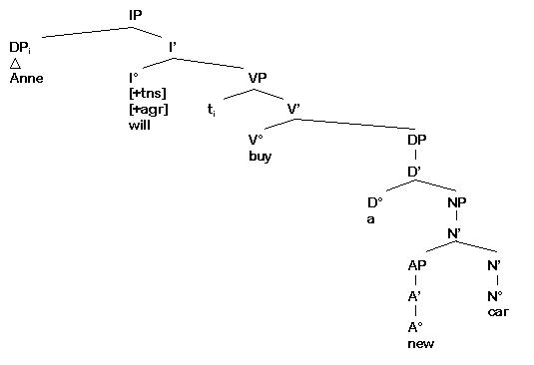

(a) INFL is always specified for [Tense] (and [Agr]), and may (but need not) be filled by a word.

(i) [+Tense] [+Agr] INFL may dominate modal auxiliaries, periphrastic do, or auxiliary have and be

(ii) [-Tense] [-Agr] INFL may dominate to.

(Other non-finite constructions are: infinitives without to, participial constructions and gerunds.)

(b) The specification of INFL as [+Agr] does not mean that agreement marking will be realized, and in fact in English it is only in present 3rd person singular verb forms:

she smiles/* she smile

(c) The specification of INFL as [+Tense] or [-Tense] (or perhaps [+Agr] or [-Agr]) determines whether a subject will have nominative or accusative case:

Subjects of non-finite clauses have accusative case:

John believed [her to be in love with him]

Subjects of finite clauses have nominative case:

John believed [that she was in love with him]

(d) Under certain conditions, subjects in non-finite clauses can also have no overt linguistic realisation. Such subjects are represented by the placeholder PRO. They are interpreted implicitly as co-referential with a DP of the main clause (i.e. the interpretation of PRO is "controlled" by a DP in the main clause, cf. Control Theory in the framework of Government & Binding Theory):

Anne wanted [PRO to buy a car] (PRO=interpreted as Anne)

Example 2: Non-finite IP

Anne wanted to buy a car.

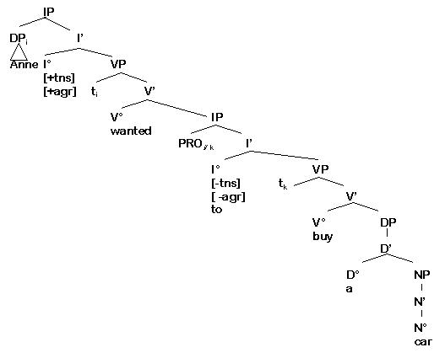

**Morphological properties**

**I.** Modal auxiliaries and periphrastic do have defective paradigms:

(a) modal auxiliaries have no:

(i) infinitive, e.g. * to can

(ii) imperative, e.g. * Can!

(iii) participle, e.g. * is canning/has could

(iv) agreement marking on the 3rd person singular form, e.g. * she cans

(b) periphrastic do has

(i) no infinitive, * He tried to do not sleep

(ii) no participle, * is doing not sleep

(iii) an imperative, Do (not) leave!

(iv) agreement marking on the 3rd person singular form, Does he sleep?

(BUT: main verb do does have infinitival and participial forms, He has done so. He tried to do so.)

**II.** Auxiliary have and be have complete morphological paradigms.

THUS:

Modal auxiliaries, auxiliary have and be, and periphrastic do form three different morphological paradigms.

**Thematic properties**

**I.** Modals, auxiliary have and be, and periphrastic do can appear with any subject, since they do not assign a theta role to the subject (which receives it instead from the main verb in the VP).

**II.** Auxiliary have and be and periphrastic do should be distinguished from main verb counterparts, which do have thematic structure.

(Note: periphrastic do should not be confused with do so, the proform for V': He didn't do so.)

**Syntactic properties**

We suggested that periphrastic do, modal auxiliaries and auxiliary have and be can be residents of INFL [+Tense].

However, the syntactic behaviour of auxiliary have and be differs from that of the other elements. There is syntactic evidence suggesting that have and be are not base-generated in INFL, but in V°. Have and be are assumed to be the head of a separate VP, and they move to INFL whenever this position is not filled by a modal auxiliary.

Despite the differences outlined above, we will continue to treat have and be as analogous to modal auxiliaries and periphrastic do (i.e. as base-generated under INFL), since we want to keep our tree diagrams as simple as possible. For more details on the differentiation between auxiliary have and be and modal auxiliaries / periphrastic do read the links below.

**Classification and position (advanced)**

**Classification:**

Modals and auxiliary do are not classified as V, but as INFL elements.

Auxiliary have and be are classified as V (based on the evidence given below).

Position: Lexical verbs versus have/be and modal auxiliaries

In contrast to main verbs, modal auxiliaries, auxiliary have and be, and periphrastic do can:

(a) be negated directly:

Sarah doesn’t/shouldn’t drive too fast.

Sarah hasn’t driven too fast.

Sarah isn’t driving too fast.

cf.: * Sarah drivesn't too fast.

(b) undergo inversion in questions:

Should/Does Sarah drive too fast?

Has Sarah driven too fast?

Is Sarah driving too fast?

cf.: *Drove Sarah too fast?

(c) form question tags:

Sarah drives too fast, doesn’t she?

Sarah should drive too fast, shoudn't she?

Sarah has driven too fast, hasn’t she?

Sarah is driving too fast, isn’t she?

cf. * Sarah drives too fast, drivesn’t she?

**I. Modal auxiliaries:**

(a) appear only in combination with, and always to the left of, another verbal element:

Tom should write the report.

Tom should have written the report.

(b) always appear to the left of negation, and negative and other preverbal adverbs:

Sarah would not/never/sometimes drive too fast.

(c) appear only in finite clauses (since they do not have infinitival forms):

I would like him to be able to drive a car.

* I would like him to can drive a car.

**II. Auxiliary have and be:**

(a) appear to the right of modal auxiliaries

(b) appear to the right of negation when occurring with modal auxiliaries:

John should not have stolen the money.

The fact that they occur in combination with modals shows that they must be base-generated in a category other than INFL.

(c) appear to the left of negation when no modal verb is present:

John has not stolen the money.

The fact that they can occur to the left and to the right of the negator shows that they can move to INFL (when this position is not occupied by a modal).

(d) appear in finite and non-finite clauses.

The fact that they can appear in non-finite clauses shows that they are not base-generated under INFL (since INFL [-Tense] can only dominate the infinitive marker to).

**III. Periphrastic do:**

(a) cannot appear with modal auxiliaries or auxiliary have and be:

* didn’t have stolen/* will didn’t steal

(b) cannot appear in infinitival clauses:

* I told him to didn’t steal the money.

The fact that do is in complementary distribution with the infinitive marker to suggests that it is base-generated under INFL.

(c) appears to the left of negation, like modal auxiliaries and unlike auxiliary have and be

He did not steal the money.

* He not did steal the money.

This shows that do is not base-generated under V° and moved to INFL, but that it is base-generated under INFL.

**Constituent structure (advanced)**

**I. Constituent tests show that:**

(a) Modal auxiliaries and periphrastic do are not part of the VP whose head is the main verb.

(b) Auxiliary have and be are not part of the VP whose head is the main verb, or of the projection containing the modal auxiliaries or periphrastic do:

**VP-deletion:**

**Modal auxiliaries:**

John should write the report but Sally will.

* John should write the report but Sally.

do:

John should write the report but Sally does.

* John should write the report but Sally.

have and be:

John should have written the report but Sally will have.

John should have written the report but Sally will.

**VP-fronting:**

**Modal auxiliaries:**

John should write the report and write the report he will.

* John should write the report and will write the report he.

do:

John should write the report and write the report he did.

* John should write the report and did write the report he.

have and be:

John should have written the report and written the report he will have.

John should have written the report and have written the report he will.

THUS:

(a) Modal auxiliaries and periphrastic do (which both appear only in finite clauses) are base-generated in a position, namely INFL, which is a different one from that of:

(i) main verbs

(ii) auxiliary have and be

(b) Auxiliary have and be are base-generated in a V position outside of the VP whose head is the main verb.

BUT:

The parallels in syntactic behaviour between modal auxiliaries/periphrastic do and auxiliary have and be can be captured syntactically (see below).

**II. Modal auxiliaries, auxiliary have and be, and periphrastic do are heads, and thus, according to X-Bar theory:**

(a) must project to the level of the phrase.

(b) may (and in fact must) have complements:

each requires a VP-complement, whose head is not inflected for tense/agreement:

* she can swam/swims

* she has/is swam/swims

* she does swam/swims

**Verb-to-INFL movement (advanced)**

**I.** We have seen that:

(a) Auxiliaries have and be behave in many respects like modal auxiliaries and periphrastic do. Each of these elements can:

(i) be negated directly

(ii) undergo inversion in questions

(iii) form question tags

(b) There is evidence that modal auxiliaries and periphrastic do are base-generated under INFL and auxiliary have and be are base-generated under V.

**II.** We can capture the similarities and differences between these two groups of elements by claiming that auxiliary have and be:

(a) must move from V to INFL under certain conditions, namely when:

(i) INFL is [+Tense] and

(ii) no modal auxiliary or periphrastic do has been base-generated under INFL

(NOTE: if there is more than one have or be available (in such VPs as have been working), the highest of these moves.)

(b) receive tense and agreement inflection as a result of this movement:

John could be/* could is reading a book.

John is/* be reading a book.

John is reading a book.

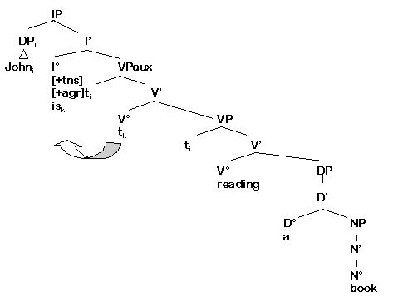

**III.** This movement also accounts for the appearance of auxiliary have and be to the left or the right of negation, depending upon whether INFL is filled by a modal auxiliary or not.

John should not have stolen money.

John should not be stealing money.

(auxiliary have and be cannot move into INFL)

John has not stolen any money.

John is not stealing any money.

(auxiliary have and be have moved into INFL)

**The structure of IP**

Example 1: IP as the head of sentences

Sally saw a black cat.

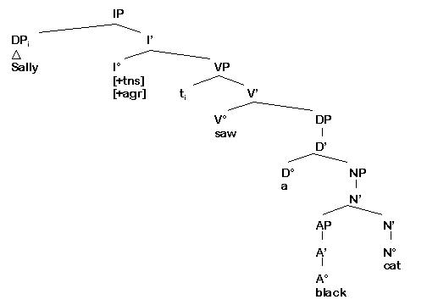

In this example INFL is specified as [+tense] and [+agr], i.e. we are dealing with a finite clause. The subject DP Sally has moved from the specifier-position of VP (cf. ti) to the specifier-position of IP.

Example 2: Embedded non-finite IP with overt subject

Peter wanted [IP Mary to drive the car].

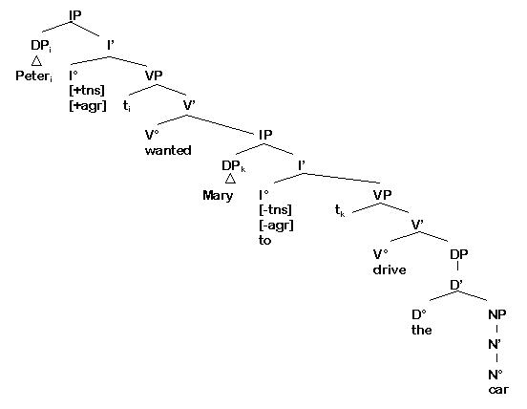

The second example is a complex sentence, consisting of a finite main clause (the IP Peter wanted + clausal complement) and a non-finite embedded clause (the IP Mary to drive a car). In the main clause INFL is specified as [+tense] and [+agr], and the subject DP Peter has moved from the specifier-position of VP (cf. ti) to the specifier-position of IP. In the embedded clause INFL is specified as [-tense] and [-agr], and it is lexically filled with the infinitive marker to. The subject DP Mary has moved from the specifier-position of VP (cf. tk) to the specifier-position of IP.

Example 3: Embedded non-finite IP with PRO-subject

The student planned [IP PRO to write a term paper].

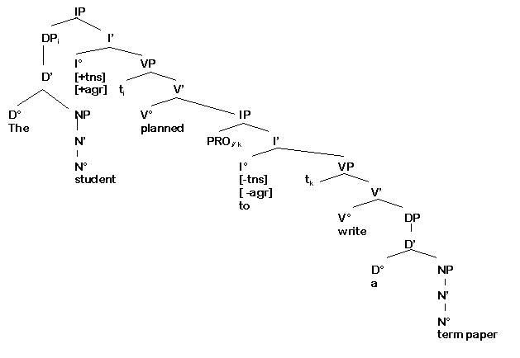

The third example is again a complex sentence, where a non-finite IP is the complement of the main clause verb planned. In the embedded clause INFL is specified as [-tense] and [-agr], and it is lexically filled with the infinitive marker to. The subject is not overtly realised, but interpreted as co-referential with the main clause subject the student (this is why both subjects bear the index i). It is represented as PRO, which - like all other subjects - has moved from the specifier-position of VP (cf tj) to the specifier-position of IP illustrated by tk).

**COMP as a functional head**

**Motivation for assuming a COMP node:**

**I.** Embedded clauses are commonly introduced by means of a certain element, known as the complementizer (e.g. that).

**II.** Verbs that take sentential complements:

(a) commonly select a particular kind of complement:

(i) verbs like ask take interrogative complements

(ii) verbs like think take declarative complements

(b) can place such specific requirements only on the heads of their complements, if we assume that the features of a phrase originate on its head.

**III.** We thus hypothesize the functional head COMP, which dominates the functional clause-type feature (or complementizers that realize this feature). This feature is referred to as [WH] and can have two values: [+WH] for interrogative (e.g. complementizer whether) and [-WH] for declarative (e.g. complementizer that).

**Some properties of COMP**

By X-Bar theory, COMP is the head of CP.

(a) COMP is always specified for [WH], and may (but need not) be filled by a word.

(b) The complement of COMP is IP.

(c) Particular COMP elements select particular types of IPs:

(i) that ([-WH]) selects [+Tense] IP:

think that [Anne has bought a car]

(ii) for ([-WH]) selects [-Tense] IP:

wait for [Anne to buy a car]

(iii) whether ([+WH]) selects [+Tense] or [-Tense] IP:

wonder whether [Anne has bought a car]

wonder whether [to buy a car]

(iv) if ([+WH]) selects [+Tense] IP

Example: that as COMP

Anne said that she would buy a car.

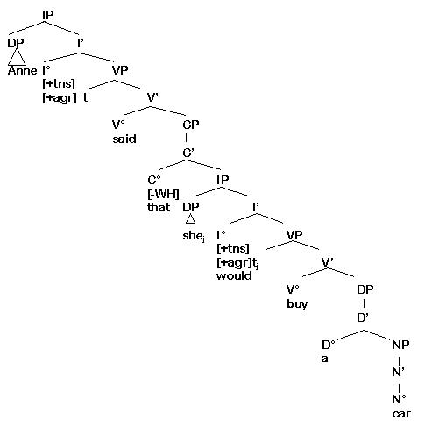

**Questions**

Word order in questions differs from word order in declarative clauses. As illustrated in the examples below, questions

(a) are introduced by an interrogative pronoun (wh-element);

(b) exhibit subject auxiliary inversion.

Declarative: Anne will buy a new car.

Question: What will Anne buy?

In generative approaches to syntax it is assumed that questions are derived from their declarative counterparts by moving constituents to positions inside the CP. There are two types of movement:

(a) INFL-to-COMP movement: the element that is located in INFL in declarative clauses moves to COMP (i.e. the modal, periphrastic do or have / be).

(b) WH-movement: the interrogative pronoun (e.g. what in the example above) moves out of its base-generated position (in our example the complement to V°) to the specifier position of CP.

Moved constituents leave a trace (t) in the position they leave. By convention the moved constituent and the trace are co-indexed (i.e. they have the same index).

Example: INFL-to-COMP and WH-movement

What will Anne buy?

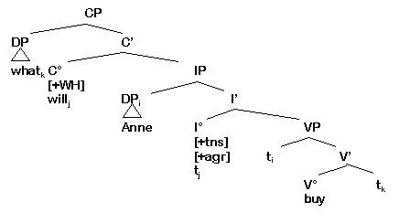

**INFL-to-COMP movement**

Question formation involves the phenomenon commonly known as subject-auxiliary inversion, a change in word order in which the auxiliary moves in front of the subject.

(a) Here we shall describe this phenomenon in terms of movement of the element under INFL into COMP position.

(b) According to this analysis, what looks like an exchanging of positions between the subject and auxiliary (or INFL element, in GB terms) is actually the movement of the INFL element past the subject position into COMP.

(c) INFL-to-COMP movement seems to be triggered by the presence of the [+WH] feature in COMP.

(i) If there is a [+WH] feature in COMP, then it must be 'supported' by a word.

(ii) If no complementizer is base-generated in COMP, then either the modal auxiliary or auxiliary have or be will move from INFL to COMP.

(iii) A clause containing neither of these elements will receive a periphrastic do, which will move from INFL to COMP.

Anne will buy a new car. Will Anne buy a new car?

Anne has bought a new car. Has Anne bought a new car?

Anne bought a new car. Did Anne buy a new car?

(iv) Movement of elements from INFL to COMP:

a. is possible only if COMP is not already filled by a word:

* Will that Anne has bought a new car? (the complementizer that is base-generated in COMP)

b. will leave a trace in INFL, preventing INFL from hosting any new elements:

* Will Anne does/can buy a new car?

Example: Movement of will from INFL to COMP

Will Anne buy a new car?

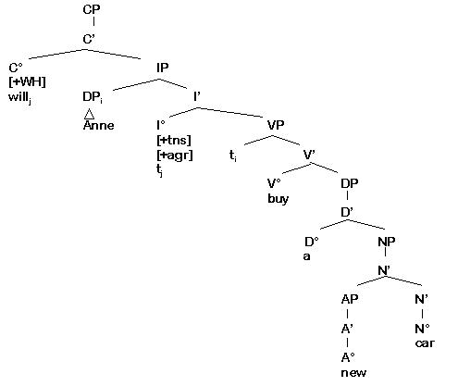

**WH-movement**

Questions differ from declarative clauses in that they are introduced by an interrogative pronoun (or WH-element).

(a) We assume that the interrogative pronoun replaces a phrasal constituent (e.g. the DP, PP or AdvP that is asked for) and is moved to the specifier of CP from its base-generated position.

Anne will buy a new car. What will Anne buy?

(what = DP; base-generated as a complement to V°)

Anne will buy a new car in London. Where will Anne buy a new car?

(where = PP; base-generated as adjunct in VP)

Anne will buy a new car tomorrow. When will Anne buy a new car?

(when = AdvP; base-generated as adjunct in VP)

(b) WH-movement is triggered by the presence of the [+WH] feature in COMP.

(i) If there is a [+WH] feature in COMP, its specifier is licensed as a "landing-site" for moved XPs.

(ii) Movement of interrogative pronouns to the specifier of CP :

a. is possible only if COMP is not already filled by a complementizer:

*What that Anne has bought?

*What whether Anne has bought?

b. will leave a trace in the position in which it is base-generated (e.g. what in the example below leaves a trace in the complement position of VP; where leaves a trace in the VP-adjunct position):

Whati has Anne bought ti?

Wherek will Anne buy a new car tk?

Example: WH-movement

Where will Anne buy a new car?

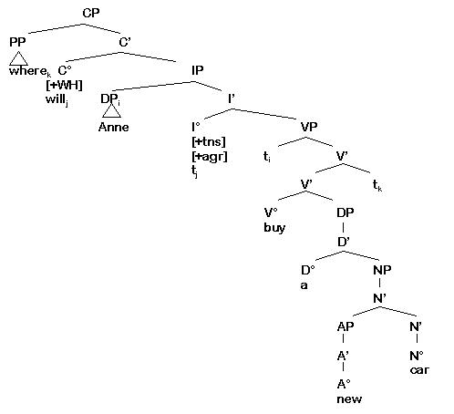

The structure of CP

Example 1: Embedded CP with the Complementizer that

The candidate hoped that he would win the election.

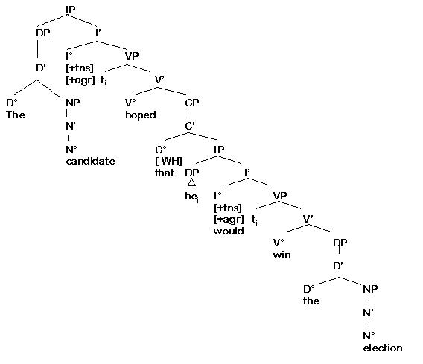

Example 2: Main clause question as CP

What did the candidate announce before the election?

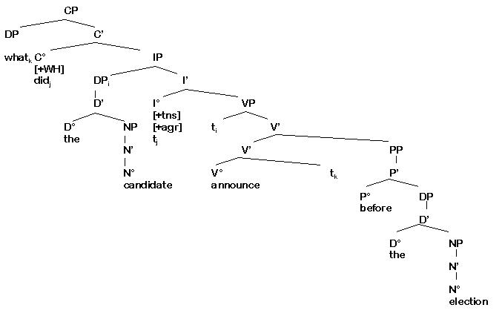

**Types of movement: A summary**

Note that there are certain restrictions on movement. For example, heads can only move to head-positions (e.g. INFL-to-COMP movement, Verb-to-INFL movement). This type of movement is called head movement (or head-to-head movement).

Phrasal constituents (i.e. complete XPs) can only move to phrasal positions. A typical position that can serve as a "landing site" for moved phrasal constituents is the specifier position. In the previous sections we have introduced two types of movement that affects phrasal constituents.

**(1) Movement of WH-elements**

In the example What will Anne buy? the wh-element what represents a phrase (DP) and moves from the complement position in VP to the specifier of CP. Movement of WH-elements to the specifier of CP is called WH-movement.

**(2) Subject movement**

In the example Anne will buy a new car the subject Anne is a DP that is base-generated in the specifier of VP and moves to the specifier of IP. Subject movement (and some other types of movement, such as movement in passives or raising, which will not be treated here) is referred to as argument movement, since it affects one of the verbal arguments.