**CLASSIFICATION OF PLANT PARASITIC NEMATODE**

**Animal Kingdom**

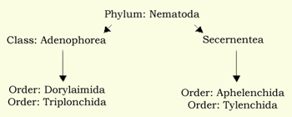PHYLUM: Nemata [Nematoda]

**Taxonomic status**

|  |  |  |  |
| --- | --- | --- | --- |
| **CLASSIFICATION OF NEMATODES** | | | |
| **Taxonomic category** | **Genera** | **Species** | **Common name/ hosts** |
| Order: Tylenchida  Family*: Heteroderidae* | 1. *Meloidogyne* | *M. incognita*  *M. hapla.*  *M. javanica.*  *M. arenaria.* | Root knot of vegetable, ornamental, fruit & field crops |
|  | 2.*Heterodera* | *H. glycine*  *H. avenae*  *Globoderarostochiensis*  *G. pallida* | Cyst  Cereals  Soybean  Potato |
| Order: Tylenchida  Family: *Anguinidae* | *Anguina*  *Ditylenchus* | *A. tritici*  *D. dipsaci* | Ear cockle of wheat  Stem & bulb nematode of garlic |
| Order: Tylenchida  Family: *Pratylenchidae* | *Pratylenchus*  *Radopholus* | *P. vulnus*  *R. similes* | Root lesion of walnut  Burrowing of chilies. |
| Order: Tylenchida  Family*: Tylenchulidae* | *Tylenchulus* | *T. semipenetrans* | Citrus decline |