**Nuclear Physics**

**The Structure of the Nucleus**

In 1896, the year that marks the birth of nuclear physics, the French physicist Henri Becquerel (1852 – 1908) discovered radioactivity in uranium compounds.

In 1911 Rutherford and his students Geiger and Marsden performed a number of important scattering experiments involving alpha particles.

Nuclei are several orders of magnitude smaller than the atom. Whereas atomic dimensions are of the order 10 -10m, those of nuclei are of the order 10-15m to 10-14 m.

* **Nuclear dimensions are usually expressed in terms of the unit known as the** ***femtometer*** or ***fermi:***

**1femtometer (fm) = 10-15m**

**SOME PROPERTIES OF NUCLEI**

Nucleons

Atomic nuclei are not elementary particles; they are themselves composedof more fundamental particles. The particles that comprise atomic nuclei are termed nucleons; the term indicates a proton or a neutron.

Protons carry the unit positive charge, **+e,** and have a rest-mass some 1836 times greater than that of the electron. Neutrons carry no net electrical charge; their rest-mass, 1839 times that of an electron, is marginally greater than that of the proton. Protons and neutrons are both fermions; each has a **spin** of a half.

The ordinary nucleus is the hydrogen nucleus, which is a single proton. In describing the atomic nucleus, we must use the following quantities:

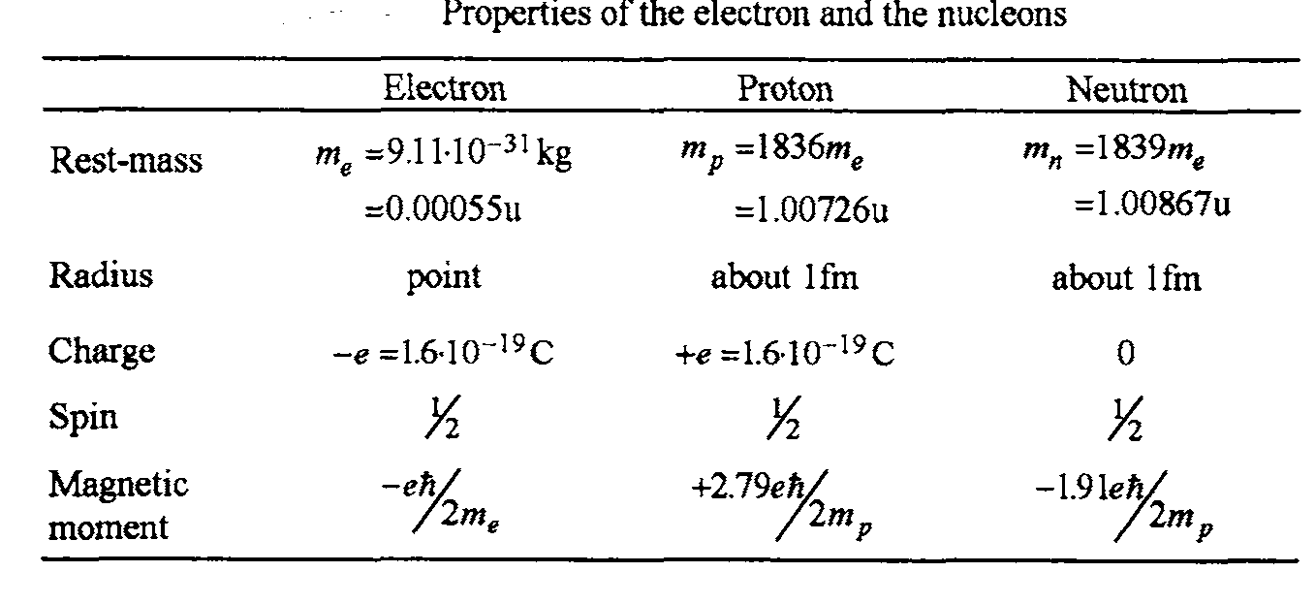

* **The atomic number,** *Z* (sometimes called the *charge number*), which equals the number of protons in the nucleus. The number of protons, ***Z,*** in an nucleus is called its ***atomic number.*** The atomic numbers of the naturally occurring nuclei range from **1** (hydrogen) to **92** (uranium). The nuclear charge is **equal** to ***+Ze;*** in a neutral atom the number of electrons around the nucleus also equals Z. For example, the atomic number of the element carbon is 6; andall **carbon** nuclei contain six protons and **possess a** nuclear charge ***+6e.***
* **The neutron number**, *N*, which equals the number of neutrons in the nucleus.
* **The mass number,** *A*, which equals the number of nucleons (neutrons plus protons) in the nucleus.

In representing nuclei, it is convenient to have a system of symbols to show how many protons and neutrons are present. The symbol used is where X represents the chemical symbol for the element. For example,has a mass number of 56 and an atomic number of 26; it therefore contains 26 protons and 30 neutrons. When no confusion is likely to arise, we omit the subscript *Z* because the chemical symbol can always be used to determine *Z*.

1. Charge

The proton carries a single positive charge, equal in magnitude to the electron charge **(where *e* = 1.602 177 3 x10-19 C**). The neutron is electrically neutral, as its name implies. Because the neutron has no charge, it is more difficult to detect.

1. Mass number

The total number, ***A,*** of nucleons in an atomic nucleus, i.e., the number of protons plus the number of neutrons, is called **its *mass number.*** The mass numbers of the naturally occurring nuclei range from 1 (hydrogen) to **238** (uranium).

Atomic mass (the mass of an atom containing a nucleus and *Z* electrons) can be measured with great precision with the mass spectrometer. The proton is approximately 1836 times as massive as the electron, and the masses of the proton and the neutron are almost equal. It is convenient to define, for atomic masses, the atomic mass unit, u, in such a way that the mass of the isotope is exactly 12 u. That is, the mass of an atom is measured relative to the mass of an atom of the neutral carbon-12 isotope (the nucleus plus six electrons). Thus the mass of is exactly 12 u, where 1 u = 1.660 540x 10-27 kg. The proton and neutron each have a mass of approximately 1 u, and the electron has a mass that is only a small fraction of an atomic mass unit:



Because the rest energy of a particle is given by *E* = *mc*2, it is often convenient to express the atomic mass unit in terms of its rest-energy equivalent. For one atomic mass unit, we have



**E=931.494 MeV**

The physicists often express mass in terms of the unit



Normally in nuclear physics the energy equivalent of mass is written by using the equation. So according to



Or = 

So it is clear that 1u = 931.5 MeV.

Table gives the masses of the proton, neutron, and electron in different units.

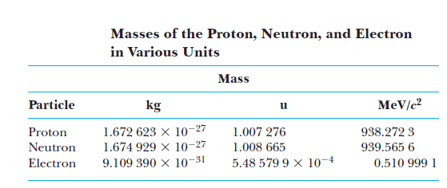

1. Neutron excess

The number of neutrons, N, in an atomic nucleus is given by the formula

***N = A - Z***

The difference, N - Z , between the number of neutrons and the number of protons in a nucleus is called the neutron ***excess.*** In stable nuclei, the general rule is that the larger the nucleus the greater the neutron excess

1. Isotopes

The nuclei of all atoms of a particular element contain the same number of protons but often contain different numbers of neutrons. Nuclei that are related in this way are called **isotopes**.

The natural abundances of isotopes can differ substantially. For example,,, and are four isotopes of carbon. The natural abundance of the isotope is about 98.9%, whereas that of the isotope is only about 1.1%.

The element uranium has a number of isotopes, the principle ones being **U-235** and **U-238.** Both **have 92** protons in their nuclei. But, whereas the **U-235** isotope **has 143** neutrons in **its** nucleus, that of the **U-238** isotope contains 146 neutrons.

The isotope of hydrogen with mass number A = ***2*** is called ***deuterium*** or ***heavy hydrogen.*** The nucleus of **this** isotope is called a ***deuteron*** and is designated **2D** or **2H**it is ***composed*** of one proton and one neutron. ***Heavy water,*** which constitutes about0.015% of naturally Occurring water, embodies **this** isotope of hydrogen.

**e)** Radius of Nucleus

It **has** been found, empirically, that, the number of nucleons in each unit volume of **an** atomic nucleus is **~ 0.15 nucleon/fm3**, irrespective of its **mass** number. The following conclusions can be inferred from **this** observation:

* nucleons can be regarded as having a fixed volume;
* the volume of a nucleus is directly proportional to its **mass** number;
* the nuclear radius, R, ***can*** be estimated from the formula



Here [1]is a constant and its value is 1.2 fm and A is the atomic mass number.



**f)** The Density of Nuclear Material

The **mass** of the material that constitutes the nucleus of the most abundant naturally occurring isotope of uranium is U-238. The radius of this nucleus *will* be and ***so,*** assuming it is spherical, its volume will is  **. The** usual definition of density is



**Thus,** the density of nuclear material is more than 2 x1017 times **greater** than that of water! **Such** immensedensities are **also** found in neutron **stars. A** neutron **star** *can* be regarded **as** a giant nucleus with **a** radius of approximately ***10,000*** meters and **mass** number 1057 that rotates at **high *speed.*** In 1967, neutron **stars were** identified **as** the **sources** of the **high intensity** radio waves **emitted** at a fixed frequency h m the stellar bodies ***called* pulsars.**

**g) BINDING ENERGY AND NUCLEAR FORCES**

The total mass of a nucleus is always less than the sum of the masses of its nucleons. Because mass is a measure of energy, the total energy of the bound system (the nucleus) is less than the combined energy of the separated nucleons. This difference in energy is called the binding energy of the nucleus and can be thought of as the energy that must be added to a nucleus to break it apart into its components. Therefore, in order to separate a nucleus into its constituent protons and neutrons, energy must be put into the system.

Conservation of energy and the Einstein mass–energy equivalence relationship show that the binding energy of any nucleus of mass **MA**is



Where *M*(H) is the atomic mass of hydrogen, *MA* represents the atomic mass of the element , ***m*n** is the mass of the neutron, and the masses are all expressed in atomic mass units. Note that the mass of the *Z* electrons included in the first term in Equation 13.4 cancels with the mass of the *Z* electrons included in the term *MA*, within a small difference associated with the atomic binding energy of the electrons. Since atomic binding energies are typically several electron volts and nuclear binding energies are several MeV, this difference is negligible.

A plot of binding energy per nucleon, **Eb/A**, as a function of mass number for various stable nuclei is shown in Figure below Except for the lighter nuclei, the average binding energy per nucleon is about 8 MeV. For the deuteron, the average binding energy per nucleon is ***Eb*/*A*=** 2.224/2 MeV _ 1.112 MeV.



Note that the curve in Figure peaks in the vicinity of *A* = 60. That is, nuclei with mass numbers greater or less than 60 are not as tightly bound as those near the middle of the periodic table. The higher values of binding energy near *A* _ 60 imply that energy is released when a heavy nucleus with *A*  200 splits or fissions into several lighter nuclei that lie near *A* = 60.

**Example 1** Determine the binding energy of the deuteron, which consist of proton and neutron, given that the atomic mass of the deuteron is **M2=2.014102u**.

**Solution** The atomic mass of hydrogen and mass of neutron are **M(H)=1.007825u and mn=1.008665u.**







**Example 2** The measured mass of neutral atom of O-16 is 15.99492u. What is the average binding energy per nucleon in the nucleus of this oxygen isotope?

**Solution**

As the mass of hydrogen atom is



The mass of O-16



The mass defect is



The nucleus contain 16 nucleon, so the average binding energy per nucleon is



**THE NUCLEAR FORCE**

The coulomb’s force is responsible for holding electrons together in an atom. But in nucleus, there are protons and neutrons. The protons are positively charged particles and they repel each other due to the coulomb’s repulsive force. So “*an attractive force is required which binds these nucleons together into the nucleus even in the presence of the repulsive force. This force is called Nuclear Force*”. The strongest of the so known forces and very short range, of the order of the diameter of the nucleus i.e. .

This nuclear force has very short range and drops very rapidly even if the separation between the nucleons increased with in the nucleus. Due to this reason a proton interacts only few of the neighboring protons not the whole of the positive charge present with in the nucleus. In contrast, a proton exerts a repulsive force on all of the other protons present within the nucleus.

The general features of the nuclear binding force have been revealed in a wide variety of experiments. We summarize them as follows.

• The attractive nuclear force is a different kind of force from the common forces of electromagnetism and gravitation, and since it dominates the repulsive Coulomb force between protons in the nucleus, it is stronger than the electromagnetic force.

• The nuclear force is a short-range force that rapidly falls to zero when the separation between nucleons exceeds several fermis. Evidence for the limited range of nuclear forces comes from scattering experiments and from the saturation of nuclear forces already mentioned.

A general trend shows that as long as the A and Z of any element remains very close to each other i.e., the nucleus will be highly stable. The other stable nuclei having much higher atomic number means that the neutrons must be in greater number than the protons. Because with nuclear force a proton can interact with a limited number of particles and the energy of strong force increases with A, but coulomb’s repulsive force increases very rapidly as compared to the nuclear force. So in heavy nuclei the extra neutrons guard against the increasing coulomb’s repulsive force.

**Nuclear Spin and Magnetism**

The Nuclear Spin is different from the electron spin. The nuclear spin represents the total angular momentum of the nucleus. It is represented by symbol, J. The nucleus is, although, composed of neutrons and protons but it acts as if it is a single entity which has intrinsic angular momentum.

The nuclear spin depends on the mass number, if the mass number is odd then the nucleus has half-integer spin like the electron while if the nucleus has even mass number then its spin will be integer spin.

The nuclear spin states can take any number, fraction or integer. The number is dependent on the three points,

1. If both the neutrons and the protons in the nucleus are even in number then the nucleus has NO spin states.
2. If the sum of the neutrons and protons in the nucleus is odd then the nucleus has half integer spin (1/2. 3/2, 5/2, …)
3. If both the neutrons and the protons in the nucleus are odd in number then the nucleus has an integer spin states (1, 2, 3, …)

In other words the nucleus with odd number of protons or neutron or both should have the nuclear spin while if both are even then there is no nuclear spin.

Both the proton and neutron, like the electron, have an intrinsic spin. The spin angular momentum is computed by. Her j is a quantum number called the nuclear spin quantum number and may be integral or half integral.

Since the spinning electron has an associated magnetic dipole moment (almost and very close) of 1 Bohr magnetone which is given by



Proton has a positive elementary charge and due to its spin, it should have a magnetic dipole moment. According to Dirac’s theory, it is given by



Again this result is approximation and is very close to one nuclear magnetone. The magnetic moments of the heavier nuclei can be measured in terms of magnetic moments of the individual protons and neutrons.

1. Actually this value lies between 1.2 fm to 1.4 fm