**Radiochemical Techniques**

**Isotopes**

All isotopes of an element have the same atomic number, and their chemical behavior is very similar. For example, tritium can substitute for hydrogen, and either 125 iodine or 131 iodine can substitute for 126 iodine in chemical reactions.

**Radioactive Isotopes**

Radioactive isotopes have unstable nuclei that spontaneously change to form more stable nuclei R. As a result, either new isotopes or new elements are produced isotopes have unstable nuclei that spontaneously change to form more stable nuclei

* Radioactive isotopes (radionuclides), undergo spontaneous disintegration, which ultimately leads to stable isotopes. Radioactive decay of isotopes occurs with the emission of electromagnetic radiation in the form of x-rays or gamma ray. Accompanying this emission is the formation of electrons, positrons and the helium nucleus or fusion in which a nucleus breaks up into smaller nuclei.

**Radiation measurement:**

The basic unit for quantifying radioactivity (i.e. describes the rate at which the nuclei decay).

**Curie (Ci):**

***Curie*** *(Ci),* named for the famed scientist Marie Curie

*Curie = 3.7 x 1010  atoms disintegrate per second (dps)*

*Millicurie (mCi) = 3.7 x 107 dps*

*Microcurie (uCi) = 3.7 x 104 dps*

**Becquerel (Bq):**

A unit of radioactivity. One becquerel is equal to 1 disintegration per second.

**Radioactive decay**:

**Half life** — symbol *t*1/2 — the time taken for the activity of a given amount of a radioactive substance to decay to half of its initial value.

***Total activity***— symbol *A* — number of decays an object undergoes per second.

***Radionuclidic purity-*** is that percentage of the total radioactivity that is present in the form of the stated radionuclide.

**SOURCE OF RADIOACTIVITY**

For a natural rock practically all the gamma radiation comes from three K40, u 238 series, and Th232 series. Uranium is generally found with thorium in nature in a ratio of about 10 parts of thorium to one part of uranium. The gamma rays from U 238 and Th232 themselves are of such a low energy value as to make direct measurements impractical.

*Natural Radioactivity - worked example*

Balance the following nuclear decay reactions and identify the emitted particle where appropriate.



1- **Alpha particle decay**:

* Alpha particles are made of **2 protons and 2 neutrons**.
* We can write them as alpha42 , or He42 , because they're the same as a helium nucleus.
* This means that when a nucleus emits an alpha particle, its atomic number decreases by 2 and its **atomic mass decreases by 4.**
* Alpha particles are relatively **slow** and **heavy**.
* They have a **low penetrating power** - you can stop them with just a sheet of **paper**.
* Because they have a large charge, alpha particles ionise other atoms strongly.
* Alpha-decay occurs in very heavy elements, for example, Uranium and Radium.

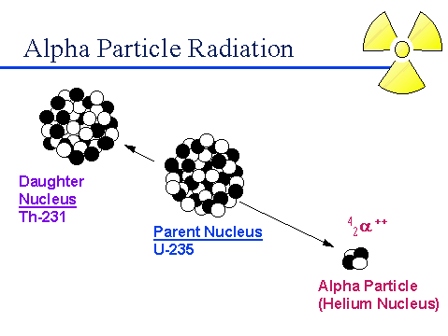

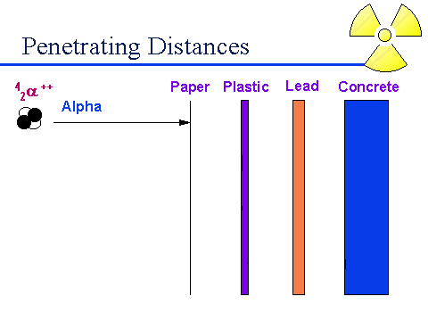

Since alpha particles cannot penetrate the dead layer of the skin, they do not present a hazard from exposure external to the body.

However, due to the *very large number of ionizations* they produce in a very short distance, alpha emitters can present a serious hazard when they are in close proximity to cells and tissues such as the lung. Special precautions are taken to ensure that *alpha emitters are not inhaled, ingested or injected.*

**2- Beta particle decay:**

* + Beta particles have a charge of **minus 1.** This means that beta particles are **the same as an electron**.
  + We can write them as betaminus or eminus , because they're the same as an electron.
  + This means that when a nucleus emits a -particle: the **atomic mass is unchanged** the **atomic number increases or decreases by 1**.
  + They are **fast**, and **light**.
  + Beta particles have a **medium penetrating power** - they are stopped by a sheet of **aluminium**.
  + Example of radiopharmaceutical emits betaminus , phosphorus-32
  + Beta particles ionise atoms that they pass, but not as strongly as alpha particles do.

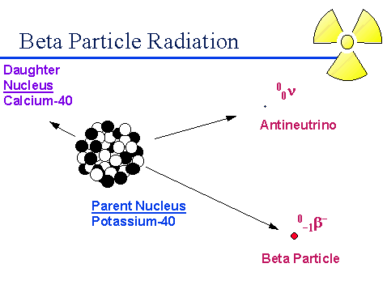

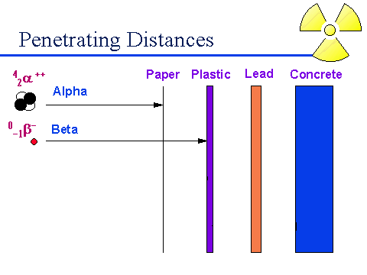

Beta particles are *much less massive and less charged* than alpha particles and *interact less intensely* with atoms in the materials they pass through, which gives them a longer range than alpha particles

**3- Gamma ray**:

* Gamma rays are **waves, not particles**.This means that they have **no mass** and **no charge**.
* In Gamma decay: atomic number unchanged, atomic mass unchanged**.**
* Gamma rays have a **high penetrating power** - it takes a thick sheet of metal such as **lead** to reduce them.
* Gamma rays do not directly ionise other atoms, although they may cause atoms to emit other particles which will then cause ionisation.
* We don't find pure gamma sources - gamma rays are emitted alongside alpha or beta particles.

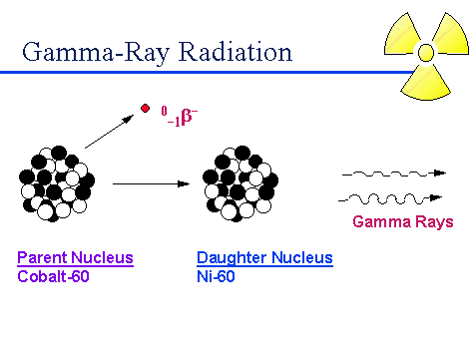

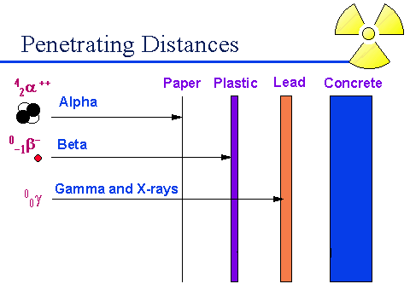

**3- Gamma ray:**

* Useful gamma sources inculde Technetium-99m, which is used as a "tracer" in medicine.
* This is a combined beta and gamma source, and is chosen because betas are less harmful to the patient than alphas (less ionisation) and because Technetium has a short half-life (just over 6 hours), so it decays away quickly and reduces the dose to the patient.

Alpha particles are easy to stop, gamma rays are hard to stop.

**Mode of radioactive decay**:



**X-Ray Emission...**

* X-Ray emission are formed from electronic transitions in which outer electrons fill the vacancies created by the nuclear process. One of the processes is electron capture. A second process which may lead to X-rays is internal conversion, a type of nuclear process that is an alternative to gamma-ray emission.

There are three types of radiochemical methods...

(1**) Activation analysis**. The activity is induced in one or more elements of the sample by irradiation with suitable radiation or particles. Most commonly thermal neutrons from a nuclear reactor source is used.

**Principle of Neutron Activation Analysis**

The principle of activation analysis is that a particle (neutron, proton, a-particle, etc.) or photon (y-rays,) induces a nuclear reaction in an atom of a target element. The product of the reaction is detected and quantified by prompt photon or particle emission or, more commonly, by its decay properties, if radioactive. For NAA, in which neutrons are used, several nuclear reactions are possible depending on the target nucleus and the neutron energy. 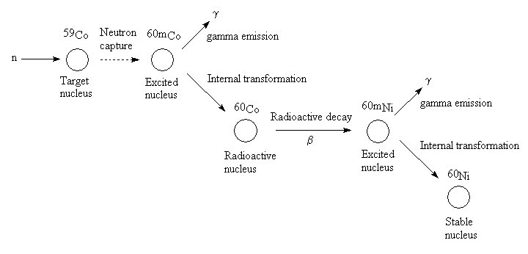

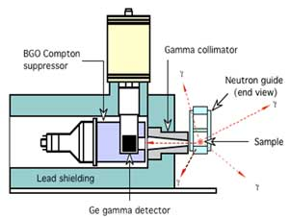

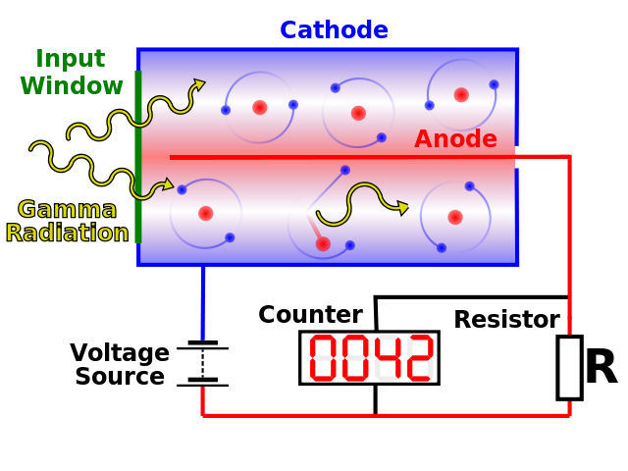

**(2) Tracer method**. Radioactivity is introduced into the sample by adding a measured amount of a radioactive species.

* Radioactive tracers are substances that contain a radioactive atom to allow easier detection and measurement. (Radioactivity is the property possessed by some elements of spontaneously emitting energy in the form of particles or waves by disintegration of their atomic nuclei.) For example, it is possible to make a molecule of water in which one of the two hydrogen atoms is a radioactive tritium (hydrogen-3) atom. This molecule behaves in almost the same way as a normal molecule of water. The main difference between the tracer molecule containing tritium and the normal molecule is that the tracer molecule continually gives off radiation that can be detected with a Geiger counter or some other type of radiation detection instrument.
* Some of the most interesting and valuable applications of radioactive tracers have been in the field of medicine. For example, when a person ingests (takes into the body) the element iodine, that element goes largely to the thyroid gland located at the base of the throat. There the iodine is used in the production of various hormones (chemical messengers) that control essential body functions such as the rate of metabolism (energy production and use).

**(3) Isotope dilution.** This method is the most important class of radiochemical quantitative method. In this method, a weighed quantity of radioactively tagged analyte having a known activity is added to a measured amount of sample. The mixture is then mixed to homogeneity and then a fraction of the compound of interest is isolated and purified. The analysis is based upon the activity of the isolated fraction.

Isotope dilution,  radiochemical method of analysis for measuring the mass and quantity of an element in a substance. The procedure involves adding to a substance a known quantity of a radioisotope of the element to be measured and mixing it with the stable isotope of the element. A sample is then taken from the mixture and analyzed. By measuring the amount of radioactive isotope and the amount of stable isotope present and determining the ratio of these amounts, both the quantity and mass of the element can be ascertained.

**Instrumentation...**

* Radiation from radioactive sources can be detected and measured in essentially the same way as X-radiation. Gas-filled transducers, scintillation counters and semiconductor detectors are all sensitive to alpha and beta particles and gamma rays because absorption of these particles induces ionization or photoelectrons, which can in turn produce thousands of ion pairs.
* The schematic below shows a well-type scintillation counter that is used for gamma-ray counting...



**Types of radioactivity**:  
How to produce a radioactive nuclide ?

**1- Natural radioactivity:**

Nuclear reactions occur spontaneously

**2- Artificial radioactivity:**

The property of radioactivity produced by particle bombardment or electromagnetic irradiation.

*A- Charged-particle reactions*

e.g. protons (1 1H)

e.g. deuterons (2 1H)

e.g. alpha particles (4He)

Types of radioactivity:

***B- Photon-induced reactions***

The source of electromagnetic energy may be gamma-emitting radionuclide or high-voltage x-ray generator.

***C- Neutron-induced reactions***

* It is the most widely used method
* It is the bombardment of a non radioactive target nucleus with a source of thermal neutrons.

**Production of radionuclides**:

*Charged particle bombardment*

Radionuclides may be produced by bombarding target materials with charged particles in ***particle accelarators such as cyclotrons.***

A cyclotron consists of Two flat hollow objects called dees. The dees are part of an electrical circuit. On the other side of the dees are large magnets that (drive) steer the injected charged particles (protons, deutrons, alpha and helium) in a circular path. The charged particle follows a circular path until the particle has sufficient energy that it passes out of the field and interact with the target nucleus.

Cyclotron



**Production of radionuclides**:

*2-* ***Neutron bombardment***

Radionuclides may be produced by bombarding target materials with neutrons in nuclear reactors

* The majority of radiopharmaceuticals are produced by this process



**Production of radionuclides: :**

*3- Radionuclide generator systems*

*Principle:*

A long-lived parent radionuclide is allowed to decay to its short-lived daughter radionuclide and the latter is chemically separated in a physiological solution.

*Example:*

* technetium-99m, obtained from a generator constructed of molybdenum-99 absorbed to an alumina column.
* 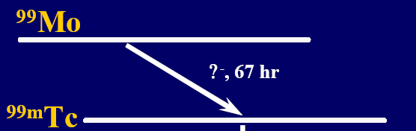

**Radioisotopes in Medicine**

**Nuclear Medicine**

* Nuclear medicine was developed in the 1950s by physicians with an endocrine emphasis, initially using iodine-131 to diagnose and then treat thyroid disease
* This is a branch of medicine that uses [radiation](http://www.world-nuclear.org/education/ral.htm) to provide information about the functioning of a person's specific organs or to treat disease. In most cases, the information is used by physicians to make a quick, accurate diagnosis of the patient's illness. The thyroid, bones, heart, liver and many other organs can be easily imaged, and disorders in their function revealed. In some cases radiation can be used to treat diseased organs, or tumours.
* The most common radioisotope used in diagnosis is technetium-99, with some 40 million procedures per year (16.7 million in USA in 2012, 550,000 in Australia), accounting for 80% of all nuclear medicine procedures worldwide.

**Diagnostic techniques in nuclear medicine**

* Diagnostic techniques in nuclear medicine use radioactive tracers which emit gamma rays from within the body. These tracers are generally short-lived isotopes linked to chemical compounds which permit specific physiological processes to be scrutinised. They can be given by injection, inhalation or orally. The first type are where single photons are detected by a gamma camera which can view organs from many different angles. The camera builds up an image from the points from which radiation is emitted; this image is enhanced by a computer and viewed by a physician on a monitor for indications of abnormal conditions.
* A more recent development is Positron Emission Tomography (PET) which is a more precise and sophisticated technique using isotopes produced in a cyclotron. A positron-emitting radionuclide is introduced, usually by injection, and accumulates in the target tissue. As it decays it emits a positron, which promptly combines with a nearby electron resulting in the simultaneous emission of two identifiable gamma rays in opposite directions. These are detected by a PET camera and give very precise indication of their origin. PET's most important clinical role is in oncology, with fluorine-18 as the tracer, since it has proven to be the most accurate non-invasive method of detecting and evaluating most cancers. It is also well used in cardiac and brain imaging.
* New procedures combine PET with computed X-ray tomography (CT) scans to give co-registration of the two images (PETCT), enabling 30% better diagnosis than with traditional gamma camera alone. It is a very powerful and significant tool which provides unique information on a wide variety of diseases from dementia to cardiovascular disease and cancer (oncology). A distinct advantage of nuclear imaging over x-ray techniques is that both bone and soft tissue can be imaged very successfully. This has led to its common use in developed countries where the probability of anyone having such a test is about one in two and rising.

**Radionuclide therapy (RNT)**

* Rapidly dividing cells are particularly sensitive to damage by radiation. For this reason, some cancerous growths can be controlled or eliminated by irradiating the area containing the growth.
* External irradiation (sometimes called teletherapy) can be carried out using a gamma beam from a radioactive cobalt-60 source, though in developed countries the much more versatile linear accelerators are now being utilised as a high-energy x-ray source (gamma and X-rays are much the same). An external radiation procedure is known as the gamma knife radiosurgery, and involves focusing gamma radiation from 201 sources of cobalt-60 sources on a precise area of the brain with a cancerous tumour. Worldwide, over 30,000 patients are treated annually, generally as outpatients.
* Internal radionuclide therapy is by administering or planting a small radiation source, usually a gamma or beta emitter, in the target area. Short-range radiotherapy is known as brachytherapy, and this is becoming the main means of treatment. Iodine-131 is commonly used to treat thyroid cancer, probably the most successful kind of cancer treatment. It is also used to treat non-malignant thyroid disorders. Iridium-192 implants are used especially in the head and breast. They are produced in wire form and are introduced through a catheter to the target area. After administering the correct dose, the implant wire is removed to shielded storage. This brachytherapy (short-range) procedure gives less overall radiation to the body, is more localised to the target tumour and is cost effective.
* Treating leukaemia may involve a bone marrow transplant, in which case the defective bone marrow will first be killed off with a massive (and otherwise lethal) dose of radiation before being replaced with healthy bone marrow from a donor.
* Many therapeutic procedures are palliative, usually to relieve pain. For instance, strontium-89 and (increasingly) samarium 153 are used for the relief of cancer-induced bone pain. Rhenium-186 is a newer product for this.

**Biochemical Analysis**

Radioisotopes can therefore be used to label molecules of biological samples *in vitro* (out of the body). Pathologists have devised hundreds of tests to determine the constituents of blood, serum, urine, hormones, antigens and many drugs by means of associated radioisotopes

**Sterilising**

Gamma irradiation is widely used for sterilising medical products and supplies such as syringes, gloves, clothing and instruments, many of which would be damaged by heat sterilisation. Cobalt-60 is the main isotope used, since it is an energetic gamma emitter

**Radiopharmaceuticals**

* + Every organ in our bodies acts differently from a chemical point of view. Doctors and chemists have identified a number of chemicals which are absorbed by specific organs. The thyroid, for example, takes up iodine, the brain consumes quantities of glucose, and so on. With this knowledge, radiopharmacists are able to attach various radioisotopes to biologically active substances. Once a radioactive form of one of these substances enters the body, it is incorporated into the normal biological processes and excreted in the usual ways.
  + Diagnostic radiopharmaceuticals can be used to examine blood flow to the brain, functioning of the liver, lungs, heart or kidneys, to assess bone growth, and to confirm other diagnostic procedures. Another important use is to predict the effects of surgery and assess changes since treatment.
  + The amount of the radiopharmaceutical given to a patient is just sufficient to obtain the required information before its decay.