**Physical and Chemical properties of virus**

**Physical properties:**

* Non-cellular
* Sub-microscopic having different number of particle type (mono, bi, tri or multiple)
* Live inside the host but some can remain infective outside the host e.g. TMV can remain infective for50 years outside the host.
* pH stability
* composition of protein

**Chemical properties:**

* Type of nucleic acid (RNA or DNA, ss or ds, +tive or –tive strand)
* A plant virus may consist of 5-40% nucleic acid and
* 60-95% protein

**Transmission of Plant Viruses**

There are a number of routes by which plant viruses may be transmitted:

* **Seeds:** These may transmit virus infection either due to external contamination of the seed with virus particles, or due to infection of the living tissues of the embryo.
* **Vegetative propagation/grafting:** It provides the ideal opportunity for viruses to spread to new plants.
* **Vectors:** Many different groups of living organisms can act as vectors and spread viruses from one plant to another:
  + **Bacteria** (e.g. Agrobacterium tumefaciens- the Ti plasmid of this organism has been used experimentally to transmit virus genomes between plants)
  + **Fungi**
  + **Nematodes**
  + **Arthropods:** Insects - aphids, leafhoppers, plant hoppers, beetles, thrips, etc.
  + **Arachnids** - mites
* **Mechanical:** Mechanical transmission of viruses is the most widely used method for experimental infection of plants and is usually achieved by rubbing virus-containing preparations into the leaves, which in most plant species are particularly susceptible to infection. However, this is also an important natural method of transmission. Virus particles may contaminate soil for long periods and may be transmitted to the leaves of new host plants as wind-blown dust or as rain-splashed mud.

**Transmission of viruses**

Transmissions of plant viruses take place through mechanical means, seeds, Insect- vectors, other plant pathogens and dodders.

**Life-cycle:**

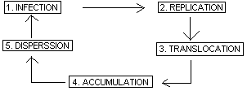

**Replication of Virus**

**Steps in Viral Replication**

The following steps take place during viral replication; -

1. Adsorption
2. Penetration
3. Uncoating(Viral genome replication)
4. Assembly
5. Maturation
6. Release

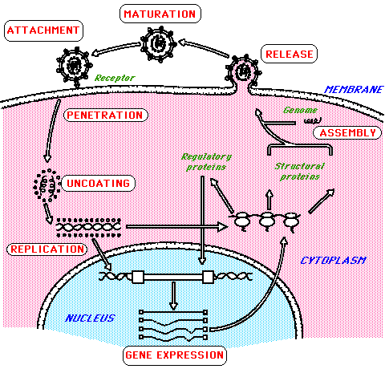

**Adsorption**

A [bacteriophage](https://www.thoughtco.com/facts-about-bacteriophages-373885) binds to the cell wall of a [bacterial cell](https://www.thoughtco.com/prokaryotes-meaning-373369).

**Penetration**

Penetration rapidly follows adsorption, and the virus can no longer be recovered from the intact cell. The most common mechanism is receptor mediated endocytosis, the process by which many hormones and toxins enter cells. The virion is endocytosed and contained within a cytoplasmic vacuole.

**Viral Genome Replication**

The [bacteriophage](https://www.thoughtco.com/facts-about-bacteriophages-373885) genome replicates using the [bacterium](https://www.thoughtco.com/prokaryotes-meaning-373369)'s cellular components.

**Assembly**  
[Bacteriophage](https://www.thoughtco.com/facts-about-bacteriophages-373885) components and enzymes are produced and begin to assemble.

**Maturation**   
[Bacteriophage](https://www.thoughtco.com/facts-about-bacteriophages-373885) components assemble and phages fully develop.

**Release**  
A [bacteriophage](https://www.thoughtco.com/facts-about-bacteriophages-373885) enzyme breaks down the bacterial cell wall causing the bacterium to split open.

**Replication:**

* ss RNA may be +ve or –ve. Positive ssRNA directly act as mRNA. In negative ssRNA does not directly act as mRNA
* RNA replication is carried out by RNA polymerase (which is released by RNA itself).
* DNA replication is carried-out through DNA polymerase using host enzymes
* transcription of DNA starts by the enzyme transcriptase

Transcription large RNA

DNA→ (transcriptase) →

small RNA

* Large RNA is converted into DNA by the reverse action of transcriptase enzyme
* Large RNA and small RNA are shifted to cytoplasm.
* 19s small RNA formed protein and 35s large RNA forms genome.
* Mini chromosome is called DNA
* Protein + DNA assembly forms the virion.