**Sargodha Medical College Sargodha**

DHND

**Food Science & Applications**

**Practical Note book 4th year DHND**

**Department of DHND SMC**

**Milk**

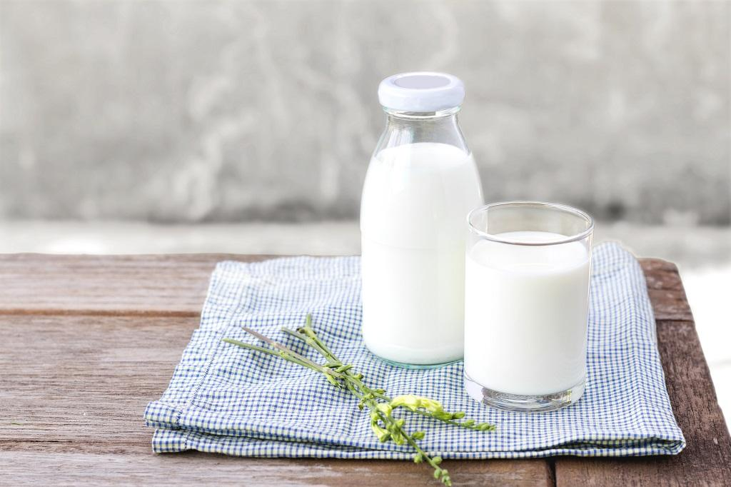

**Practical # 01**

**Composition of Milk**

Milk is the basis of all dairy products. The Pasteurized Milk Ordinance defines ***milk*** as: the lacteal secretion, practically free from colostrum, obtained by the complete milking of one or more cows.  
The basic composition of milk is as follows:

**Water: 87.3%** (85.5 - 88.7%)

**Milk fat: 3.9 %** (2.4 - 5.5%)

**Proteins: 3.25%** (2.3-4.4%)

Casein: 2.6% (1.7-3.5%)

Serum proteins

Minor proteins

**Carbohydrates (Lactose): 4.6%** (3.8-5.3%)

**Minerals: 0.65%** (0.53-0.80%)

Cationic: K, Ca, Mg, K, …

Anionic: chloride, phosphate, citrate, carbonate

**Organic acids: 0.18%** (0.13-0.22%) Citric, lactic, formic, acetic, oxalic

**Enzymes** - peroxidase, catalase, phosphatase, lipase

**Vitamins** - A, C, D, thiamine, riboflavin

**Gases** – CO2, N2, O2 (CO2 lost after drawing)

**Milkfat: 3.9%**

• ***Fats*** are made from individual fatty acid molecules attached to glycerol, a 3-carbon backbone. The most common type of fat is called a triglyceride, or triacylglycerol, which contains 3 fatty acids attached to the backbone and resembles a fork without the handle.

• Because there are many different fatty acids that can be attached to the backbone, there are many different types of triglycerides or fats. Fat compounds can also be diglycerides that have 2 fatty acids or monoglycerides that have 1 fatty acid on the glycerol backbone.

Mono- and diglycerides are used as emulsifiers, compounds that keep the fat and water from separating in foods such as ice cream.

• Milk fat has the most complex fatty acid composition of the edible fats. Over 400 individual fatty acids have been identified in milk fat. However, approximately 15 to 20 fatty acids make up 90% of the milk fat. The major fatty acids in milk fat are straight chain fatty acids that are saturated and have 4 to 18 carbons (4:0, 6:0, 8:0, 10:0, 12:0, 14:0, 16:0, 18:0), monounsaturated fatty acids (16:1, 18:1), and polyunsaturated fatty acids (18:2, 18:3). Some of the fatty acids are found in very small amounts but contribute to the unique and desirable flavor of milk fat and butter.

For example, the C14:0 and C16:0 ß-hydroxy fatty acids spontaneously form lactones upon heating which enhance the flavor of butter.

• Milk fat melts over a wide temperature range, from approximately -40°F (-40°C) to 104°F (40°C). This is best illustrated by the firmness of butter at refrigerator temperature versus room temperature. At refrigerator temperature butter is approximately 50% solid, but is only about 20% solid at room temperature, which is why it spreads more easily as the temperature increases. The melting properties of milk are a result of the melting points of the individual fatty acids that make up milk fat and their arrangement on the triglyceride molecule.

**Protein: 3.9%**

***Proteins*** are chains of amino acid molecules connected by peptide bonds.

• Milk contains 3.9% total protein. Milk ***proteins*** contain all 9 essential amino acids required by humans. Milk proteins are synthesized in the mammary gland, but 60% of the amino acids used to build the proteins are obtained from the cow's diet. Total milk protein content and amino acid composition varies with cow breed and individual animal genetics.

• There are 2 major categories of milk protein that are broadly defined by their chemical composition and physical properties. The casein family contains phosphorus and will coagulate or precipitate at pH 4.6. The serum (whey) proteins do not contain phosphorus, and these proteins remain in solution in milk at pH 4.6. The principle of coagulation, or curd formation, at reduced pH is the basis for cheese curd formation. In cow's milk, approximately 82% of milk protein is casein and the remaining 18% is serum, or whey protein.

• The caseins in milk form complexes called ***micelles*** that are dispersed in the water phase of milk. The casein micelles consist of subunits of the different caseins (α-s1, α-s2 and ß) held together by calcium phosphate bridges on the inside, surrounded by a layer of 6-casein which helps to stabilize the micelle in solution.

Casein micelles are spherical and are 0.04 to 0.3 µm in diameter, much smaller than fat globules which are approximately 1 µm in homogenized milk. The casein micelles are porous structures that allow the water phase to move freely in and out of the micelle. Casein micelles are stable but dynamic structures that do not settle out of solution. They can be heated to boiling or cooled, and they can be dried and reconstituted without adverse effects. ß-casein, along with some calcium phosphate, will migrate in and out of the micelle with changes in temperature, but this does not affect the nutritional properties of the protein and minerals.

The whey proteins exist as individual units dissolved in the water phase of milk.

*What is denaturing and why does it matter?*

• ***Denaturation*** is the alteration of a protein shape through some form of external stress (for example, by applying heat, acid or alkali), in such a way that it will no longer be able to carry out its cellular function. Denatured proteins can exhibit a wide range of characteristics, from loss of solubility to communal aggregation. Once this post-translational modification process has been completed, the protein begins to fold (spontaneously, and sometimes with enzymatic assistance), curling up on itself so that hydrophobic elements of the protein are buried deep inside the structure and hydrophilic elements end up on the outside. The final shape of a protein determines how it interacts with its environment.

• Denaturation of proteins results in change of function and ability to interact with other compounds, including proteins.

• Denaturation of protein enzymes results in inactivation of activity.

**Lactose:**• Milk contains approximately 4.9% carbohydrate that is predominately lactose with trace amounts of monosaccharides and oligosaccharides. ***Lactose*** is a disaccharide of glucose and galactose. The structure of lactose is:

• Lactose is dissolved in the serum (whey) phase of fluid milk. Lactose dissolved in solution is found in 2 forms, called the α-anomer and ß-anomer, that can convert back and forth between each other. The solubility of the 2 anomers is temperature dependent and therefore the equilibrium concentration of the 2 forms will be different at different temperatures. At room  
temperature (70°F, 20°C) the equilibrium ratio is approximately 37% α- and 63% ß-lactose. At  
temperatures above 200°F (93.5°C) the ß-anomer is less soluble so there is a higher ratio of α- to  
ß-lactose. The type of anomer present does not affect the nutritional properties of lactose.

**Vitamins/Minerals:**• Milk contains the water soluble vitamins thiamin (vitamin B1), riboflavin (vitamin B2), niacin (vitamin B3), pantothenic acid (vitamin B5), vitamin B6 (pyridoxine), vitamin B12 (cobalamin),  
vitamin C, and folate. Milk is a good source of thiamin, riboflavin and vitamin B12. Milk contains small amounts of niacin, pantothenic acid, vitamin B6, vitamin C, and folate and is not considered a major source of these vitamins in the diet.

• Milk contains the fat soluble vitamins A, D, E, and K. The content level of fat soluble vitamins in dairy products depends on the fat content of the product. Reduced fat (2% fat), low-fat (1% fat), and skim milk must be fortified with vitamin A to be nutritionally equivalent to whole milk.  
Fortification of all milk with vitamin D is voluntary. Milk contains small amounts of vitamins E  
and K and is not considered a major source of these vitamins in the diet.

**Practical # 02**

**Effects of Heat Treatments & Light Exposure on the Vitamin & Mineral Content in Milk**

The mild heat treatment used in the typical high temperature short time (HTST) pasteurization of fluid milk does not appreciably affect the vitamin content. However, the higher heat treatment used in ultrahigh temperature (UHT) pasteurization for extended shelf combined with the increased storage life of these products does cause losses of some water-soluble vitamins. Thiamin is reduced from 0.45 to 0.42 mg/L, vitamin B 12 is reduced from 3.0 to 2.7 µg/L, and vitamin C is reduced from 2.0 to 1.8 mg/L (Potter et al., 1984). Riboflavin is a heat stable vitamin and is not affected by severe heat treatments.

Calcium phosphate will migrate in and out of the casein micelle with changes in temperature. This process is reversible at moderate temperatures. This does not affect the nutritional properties of milk minerals.

At very high temperatures the calcium phosphate may precipitate out of solution which causes irreversible changes in the casein micelle structure. Exposure to light will decrease the riboflavin and vitamin A content in milk. Milk should be stored in containers that provide barriers to light (opaque plastic or paperboard) to maximize vitamin retention.

**Enzymes:  
*Enzymes*** are proteins that have biological functions. Milk enzymes come from several sources: the native milk, airborne bacterial contamination, bacteria that are added intentionally for fermentation, or in somatic cells present in milk

• There are a large number of enzymes in milk and the functions of many are not well-defined. It should be noted that the enzymes in milk do not make a major contribution to the digestion of  
milk in humans, which is accomplished by enzymes in the human stomach and small intestine.

• Lipases are enzymes that degrade fats. The major lipase in milk is lipoprotein lipase. It is  
associated with the casein micelle. Agitation during processing may bring the lipase into contact  
with the milk fat resulting in fat degradation and off-flavors. Pasteurization will inactivate the  
lipase in milk and increase shelf life.

• Proteases are enzymes that degrade proteins. The major protease in milk is plasmin. Some  
proteases are inactivated by heat and some are not. Protein degradation can be undesirable and  
result in bitter off-flavors, or it may provide a desirable texture to cheese during ripening.  
Proteases are important in cheese manufacture, and a considerable amount of information is  
available in the cheese literature.

• Alkaline phosphatase is a heat sensitive enzyme in milk that is used as indicator  
of pasteurization. If milk is properly pasteurized, alkaline phosphatase is inactivated.

• Lactoperoxidase is one of the most heat-stable enzymes found in milk. Lactoperoxidase, when  
combined with hydrogen peroxide and thiocyanate, has antibacterial properties. It is suggested  
that the presence of lactoperoxidase in raw milk inhibits the disease causing microorganisms  
(pathogens) present in milk. However, since there is no hydrogen peroxide or thiocyanate  
present in fresh milk, these compounds would have to be added to milk in order to achieve the  
antibacterial benefits. Lysozyme is another enzyme that has some antibacterial activities,  
although the amount of lysozyme present in milk is very small.

**Practical # 03**

**Determination of Calcium in Milk**

• In this experiment, The determination of calcium in milk is based on a  
**complexometric titration** of calcium with an aqueous solution of the  
disodium salt of EDTA at high pH value (12). “why?”  
• **Complexometric titration is** a type of titration based on complex  
formation between the analyte and titrant.  
• Such compounds are capable of forming chelate complexes with many  
cations in which the cation is bound in a ring structure.  
• The ring results from the formation of a salt-like bond between the cation  
and the carboxyl groups together with a coordinate bond through the lone  
pair of electrons of the nitrogen atom.

• The common form of the agent is disodium salt Na2H2EDTA.  
• It is colorless and can be weighed and dissolve in water to form a stable solution.  
• At high pH (> 10) the remaining protons leave EDTA forming EDTA4 - anion:

**Indicator Solochrome dark blue:**

• The Solochrome dark blue indicator is a suitable indicator in this case.

• The dye itself has a blue color.

• This blue dye also forms a complex with the calcium ions changing colour from blue to pink/red in the process, but the dye–metal ion complex is **less stable** than the  
EDTA–metal ion complex.

• As a result, when the calcium ion–dye complex is titrated with EDTA the Ca2+ions  
react to form a stronger complex with the EDTA changing the dye color to blue.

Ca-Indicator + EDTA 4 - 🡺 Ca-EDTA 2 - + Indicator

**Practical # 04**

**How to determine calcium in the presence of Mg?**

• This method for determining Ca2+concentration in the presence of Mg2+relies on  
the fact that the pH of the solution **is sufficiently high** ((The pH will be  
approximately 12.5 due to the addition of concentrated NaOH solution)) to ensure  
that all magnesium ions precipitate as magnesium hydroxide before the indicator is  
added.  
• In this condition, magnesium ions are precipitated as hydroxide and **do not interfere**with the determination of calcium.

**Method:**

• Combine 10mL of sample, 40mL distilled water, and 4mL of 8M sodium hydroxide solution into an Erlenmeyer flask and allow solution to stand for about 5 minutes with occasional swirling.  
• A small of magnesium hydroxide may precipitate during this time. Do not add the indicator until you have given this precipitate a chance to form.

• Then add 6 drops of the Solochrome dark blue solution.

• After that start to titrate with EDTA solution.

• Repeat titration for three trials.

**Erlenmeyer flask Set**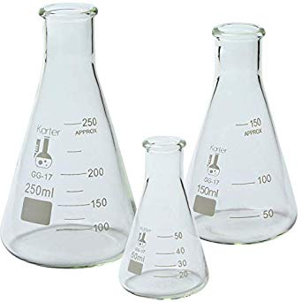

**Calculations:**

1. Calculate the moles of EDTA required to complex the Ca2+ ions in the sample:

🡺 Number of moles (for EDTA) = Molarity of EDTA x volume of EDTA in L  
**Note : Ratio Ca2+:EDTA = 1 : 1 (i.e moles of EDTA = moles of Ca2+)**

2. Calculate weight of Ca2+ :

🡺 Weight of Ca2+ = Number of moles x molecular weight (40.78)  
• **% of Ca2+ = (weight of Ca2+ / weight of sample) x 100**

**OR**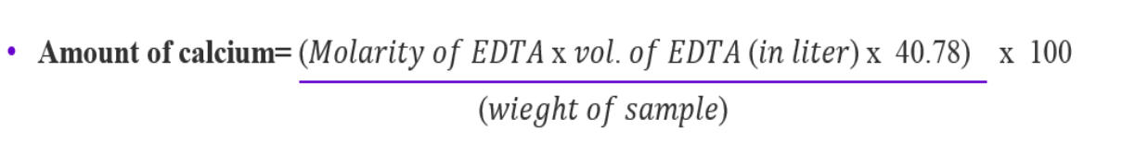

**Practical # 05**

**ANALYSIS OF MILK FOR THE LIPIDS, CARBOHYDRATES AND PROTEINS**

Milk is an emulsion or colloid of butterfat globules within an aqueous fluid. Each fat  
globule is surrounded by a membrane consisting of phospholipids and proteins which  
emulsifiers that keep the individual globules from joining together into noticeable grains  
of butterfat.

The largest structures in the fluid portion of the milk are casein protein micelles  
(aggregates of several thousand protein molecules) bonded with the help of nanometerscale particles of calcium phosphate. The casein proteins make up around 80% of the protein in milk, by weight.

The type of carbohydrate found in the milk structure is lactose (the conbination of  
glucose and galactose) which gives milk its sweet taste and contributes about 40% of  
whole calories of milk.

- Human milk contains, on average, 1.1% protein, 4.2% fat, 7.0% lactose, and  
supplies 72 kcal of energy per 100 grams.

- Cow milk contains, on average, 3.4% protein, 3.6% fat, 4.6% lactose, 0.7%  
minerals, and supplies 66 kcal of energy per 100 grams.

***Procedure:  
A) Determining the Percent Fat in Whole Milk:***

- Weigh a dry, clean, empty 100 mL beaker and record the mass.

- Using a 10 mL graduated cylinder, measure out 5 mL of milk and pour into the  
beaker and record the mass of the beaker and milk.

- Determine and record the mass of just milk. Then, add 20 mL of water into the beaker.  
- Pour all of the milk into a large test tube. In the fume hood add 25 mL methylene chloride to the milk and cork the tube. Methylene chloride is a nonpolar solvent which will not mix with the water but will take the fat out of the water since fat is also nonpolar.

- Shake the test tube for 30 seconds trying not to get the cork wet. Let the contents  
of the test tube separate into layers.

- Using a pasteur pipet remove the milk layer leaving behind the methylene chloride/fat layer. Put the milk back into the 100 mL beaker. Try to get as much of the milk as possible but do not take the nonpolar organic layer out of the tube.

- Weigh the beaker again with the milk and record your data.

***Questions:***✓ Determine the mass of the fat you removed from the milk and record. Find the  
percent of the fat in the milk and compare with the known values.  
***B) Determining if the Milk Fat Contains Unsaturated Fat:***

- **Do this part of the experiment in the hood!!**

- To the test tube with the methylene chloride and removed fat, add 3 drops of  
bromine solution.

- Record the color of the solution in the test tube after the bromine has been  
added.  
• **Keep the milk for the next part, pour the organic layer with the fat,  
methylene chloride and bromine solution into the liquid waste  
container.  
*Questions:***✓ Is the fat content saturated or unsaturated? Explain by giving your reasons.  
✓ Is there any other chemical test to determine the unsaturation of the structures?  
If any, explain the test briefly.  
***C) Determining the % Protein in Whole Milk:***

- **Do this part of the experiment in the hood!!**

- To the milk layer from part one, add 1 drop of concentrated acetic acid.

**DO NOT smell the fumes of the acid.**

- Swirl the beaker for 30 seconds and then let sit for a few minutes.,

- Record your observations.

- Using a buchner funnel and filter paper, filter out the liquid from the precipitate.  
**DO NOT discard the liquid. You will use it later.**

- Once the liquid has been separated from the precipitate, spread the filter paper with the solid onto a watch glass and put that on top of a water bath (250 mL beaker, 2/3 full of water on a hot plate). The purpose is to dry the solid so that you can weigh it.

- Weigh your solid and record the mass.

***Questions:***✓ Calculate the percent of protein in the milk and compare with the known values.  
✓ What happens when you add the concentrated acetic acid into the milk solution.  
Explain briefly by giving your reasons.

***D) Test for the Presence of Protein:***

- Test for protein in the liquid and in the solid. Label 2 test tubes #1 and #2. In test tube #1, put a few flakes of the solid that you collected in part C and about 1 mL of water. Place test tube #1 in the water bath. In test #2 put some of the the filtered liquid from part C.

- **Still, DO NOT discard the liquid.**

- Add about 1 mL of Biuret Reagent (0.01M CuSO4) to both test tubes, #1 and #2.  
- Add 3 drops of 6M NaOH to each test tube and mix.

- Record your observations.

***Questions:***✓ Why Biuret test is used to determine the absence or presence of proteins?  
Explain by giving your reasons and reactions if necessary.  
✓ Are your observations consistent with your expectations? Explain briefly.

***E) Determining the Percent Water and Percent Carbohydrate:***

- Label 4 test tubes as #1, #2, #3 and #4. Add 2 mL of Benedict’s (Fehling’s) Solution to test tubes #1 and #2. Place them in a water bath for about 4 minutes.

- Put about 10 drops of the liquid you filtered in a test tube #1 and #3 and a few flakes of the solid in the other test tubes #2 and #4. Leave tubes #1 and #2 in the water bath but remove from the heat. Record your observations.

- To test tubes #3 and #4, add 10 drops of iodine solution and record your observations.  
***Questions:***✓ What is the aim of performing Benedict’s Test?  
✓ What is the aim of performing Iodine Test?  
- Weigh a clean dry evaporating dish and record the mass.

- Add 5 mL of fresh milk to the evaporating dish and weigh again and record the mass.  
- Set the evaporating dish with milk on top of the water bath. Stir the milk continuously to prevent burning.

- Stop heating when the water is gone from the dish. You will no longer see steam  
coming from the top of the dish. The dried milk will stop changing at this point  
and keep its consistency (it may look like a paste). Also, take off the dried milk  
from the stirring rod on the edge of the evaporating dish.

- Remove the evaporating dish and dry its bottom before you weigh it.

- Weigh the dish with the dried milk and record.

***Questions:***✓ Calculate the percent water in the milk.

**Practical # 06**

**Casein Determination in Milk according to the Kjeldahl method**

**Introduction**The milk proteins are the oldest and most widely consumed food proteins. There is currently a large interest in these substances, both in nutritional field and in technological application. *Casein proteins* are a family of proteins involved in the production of cheese and fermented milk. They are very important nitrogen compounds not only for the dairy products production, but they are also additives in medicine, and they have a technical use in cosmetics, paints and adhesives. Casein content is determined by the difference between the *total nitrogen (Ntot)* content and the *non-casein nitrogen (NCN)*, obtained by the milk, following the procedure indicated in this document.

**Casein Determination in milk according to the Kjeldahl method**

Kjeldahl is nowadays the most used method for determining nitrogen and protein contents in foods and feeds, thanks to the high level of precision and reproducibility and to its simple application. The modern Kjeldahl method consists in a procedure of catalytically supported mineralization of organic material in a boiling mixture of sulphuric acid and sulphate salt at digestion temperatures higher than 400 °C. During the process the organically bonded nitrogen is converted into ammonium sulphate. Alkalizing the digested solution liberates ammonia which is quantitatively steam distilled and determined by titration.

**Sample**Liquid bovine high quality milk, whole and pasteurized Protein labeled value: 3.35 g/100 ml Casein content from literature: 2.66%

**Sample preparation**

The determination of the *non-casein nitrogen (NCN)* is necessary to calculate the casein content in the milk. The *NCN* is obtained separating and filtrating the milk.

**Chemicals and Materials for separating and filtrating**

Acetic acid solution 10% - 10 ml acetic acid diluted to 100 ml with deionized water

Sodium acetate solution 1M - 8,2 g sodium acetate diluted to 100 ml with deionized water

Filter paper nitrogen free, high speed filtration

**Procedure**The determination of NCN in milk includes the following steps:

- Stir the milk into a beaker using a VELP magnetic stirrer for 60 sec. at 700 rpm.

- Precipitation of the casein and filtration

- Digestion of the filtrate using DKL 20

- Distillation and titration of the sample using UDK 159

- Calculation (see the following formulas)

Place 20 ml of milk, previously thermostated at 20 °C, in a 50 ml volumetric flask with 20 ml of deionized water. Then, put the flask at 37 °C in an Open Circulating Bath (OCB, Code F40300240) for 30 minutes. After this period, add 2 ml of acetic acid solution (10%), swirl to mix and let stand for approximately 10 minutes. Add 2 ml of sodium acetate solution

1M, let the mixture cool down to 20 °C and fill up with deionized water to the calibration mark. Then, filter through a filter paper and collect the entire filtrate.

**Sample Digestion**

Put 20 ml of filtrate into a 250 ml test tube (Code A00000144), by using a pipette. In each the test tube add:

• 2 catalyst tablets CM (code CT0006650; 3.5 g K2SO4, 0.1 g CuSO4 5H20 Missouri)

• 4 antifoam tablets S (Code CT0006600)

• 15 ml concentrated sulphuric acid (96-98%)

• 5 ml of hydrogen peroxide (~ 30%)

Prepare some blanks with all chemicals and without sample.

Connect the Digestion Unit to a proper Aspiration Pump (JP code F30620198) and a Fume Neutralization System  
(SMS Scrubber code F307C0199) to neutralize the acid fumes created during digestion phase.  
Digest the samples, setting the following ramps in “Customizable Methods”: for 15 minutes at 150 °C plus 45 minutes at  
200 °C plus 15 minutes at 300 °C plus 60 minutes at 420 °C

**Distillation and Titration**Let the test tubes cool down to 50-60 °C.  
Condition the UDK 159 unit by performing the Automatic Check up in Menu-System and a Wash down.  
Distill the samples selecting the predefined method n° 1 :  
• H2O (dilution water): 50 ml  
• H2SO4 (0.1 N) as titrant solution  
• NaOH (32%): 70 ml  
• Protein factor: 6.38  
• H3BO3 (4% with indicators): 30 ml  
In UDK 159 settings, set as unit of measure mgN and %N for the final result and as sample quantity “ml”.  
Distillation &Titration analysis time: from 4 minutes for one test.

**Typical Results**The results of the *non-casein nitrogen (NCN)* are calculated as percentage of nitrogen, using as sample quantity the  
volume of filtrate (*V filtrate*) multiplied for 0,4. They are based on the following formula:  
***NCN% = mg N / [(G milk/V sol) x 1000 x V filtrate] x 100****G milk = milk weight (20 g)  
V sol = milk solution containing all the chemicals necessary for separating, filled up to volume (50 ml)  
V filtrate= filtrate used to perform 1 analysis (ml)*The obtained results have been exported and multiplied for the whole milk correction factor 0.994 (for semi skimmed  
milk, the correction factor is 0.998). Casein is calculated taking into account the measured total nitrogen content (N tot) of  
0.525% in whole milk. (For Ntot, see Application Note “*N/Protein Determination in Milk according to the Kjeldahl method”*)

***Casein%* = 6.38 x (%Ntot - %NCN)**

|  |  |  |
| --- | --- | --- |
| **Filtrate quantity (ml)** | ***NCN* %\*** | **Casein %** |
| 20.000 | 0.108 | 2.658 |
| 20.000 | 0.109 | 2.653 |
| 20.000 | 0.110 | 2.646 |
| **Average ± SD%** | **0.109 ± 0.001** | **2.652 ± 0.006** |
| **RSD% \*\*** | **0.923** | **0.243** |

|  |  |
| --- | --- |
| * already corrected with 0,994 factor | ** RSD% = (Standard Deviation x 100) / Average |
| The complete procedure was verified by using 5 ml of glycine standard solution (3%) containing 28 mg of nitrogen, as |  |
| reference substance. The obtained recovery falls into the expected range: between 98% and 102%. |  |
| **Conclusion** |  |
| The obtained results are reliable and reproducible in accordance with the expected values, with a low relative standard |  |
| deviation (RSD < 1%), that means high repeatability of the results. |  |

Benefits of Kjeldahl method by using DKL 20 and UDK 159 are:

• High level of precision and reproducibility

• High productivity

• Worldwide official method

• Reliable and easy method

• Time saving

• Affordable equipment cost

• Moderate running costs

**Practical # 07**

**Determination of chloride in milk using sequential injection automated conductimetry**

**Reagents and solutions**

All solutions were prepared from analytical grade reagents and distilled–deionized water, with a specific conductivity less then 0.1 mS cmÿ1, was used throughout in this work. A 1.0 mol lÿ1 Clÿ stock solution was prepared from solid sodium chloride, previously dried at 100 C for 120  
min. This stock solution was used to prepare reference solutions containing 0.0; 0.5*10-2; 1.0*10-2 and 5.0*10-2 mol l-1 Cl-1 in H2O medium. To study the effect caused by other ions in the conductimetric measure without standard addition approach, solutions containing the main concomitants, in concentrations normally found in milk, were prepared: 0.50*10-2 mol l.0*10-2 Cl-1 plus 1.8*10-2 of Na+; 0.50*10-2 mol l-1 Cl-1 plus 1.0*10-2 of PO4-2; 0.50*10-2 mol l-1 Cl-1 plus 4.0*10-2 of Mg2+; 0.50*10-2 mol l-1 Cl-1 plus 3.6*10-2 of K+ and 0.50*10-2 mol l-1 Cl-1 plus 2.7*10-2 mol l-1 of Ca2+ (based on, respectively: CH3COONa; NaH2PO4.H2O; MgSO4; K2SO4 and CaSO4.2H2O, Merck, diluted in H2O medium).

**Instrumentation**

The sequential injection system experimental set-up, schematically depicted in Fig. 1, was constructed using two peristaltic pumps with variable rotation (Ismatec, Switzerland), and a six-way electrically actuated solenoid valve (NResearch, USA). The manifold was built with 0.8 mm  
i.d. Perspex tubing. Tygon tubing (0.5 mm i.d.) was used for pumping the solutions. The dialysis unit consisted of a single unit of 1504928 mm. The path length of both donor and acceptor streams was 70 mm and the path was made with a semi-tubular groove with an i.d. of 0.3 mm  
(i.e. 0.3 mm wide and 0.3 mm deep). Between the entrance and exit sides of the grooves was inserted a Technicon premount dialysis membrane type C, which allowed the milk introduction without previous treatment. The detection was made by a conductimeter (Fisher Scientific, USA) with a home made flow cell with 50 mm diameter and 375 mm of conduction path (Fig. 1). Data acquisition and device control were achieved using a PCL 711-S interface  
board (American Advantech, USA) connected to an Ashford PC computer (USA). The time, injection volume and data acquisition and storage were developed in Quick  
Basic1 software package (Microsoft, USA).

**Sequential injection system**

Fig. 2 is a flow chart diagram of the program developed to control the conductimetric determination of C1-1 using the system outilined in Fig. 1. Pump 1 was connected to the selector valve, allowing that the sample of ‘‘in-natura’’ milk (142 ml) and standard solutions (750 ml) to be sequentially aspirated, mixed, and then transported to the holding coil (RC, 3.0 ml). After, sample and reference solutions were addressed, by the C1 carrier solution (water), to the dialysis unit where the chloride ions present in the donor solution were spread across the  
membrane and the solution carrier to the waste. The diffused chloride ions were collected by the C2 carrier stream (water) and carried toward the conductimetric cell, and  
then to the waste. The conductance values were collected every 1 s and stored for latter data treatment. The device operational sequence for the conductimetric determination by sequential injection is summarised in Table 1.

**Reference procedure**

For the chloride determination in milk, the volumetric method using silver (I) solution as titrant is recommended (AOAC, 1995) and was used for comparison purposes in this work. Certified reference materials (NIST milk powder 8435 and AIEA A-11 milk powder) were used  
for analytical accuracy.

**Standard addition procedure**

The standard addition approach was adopted (Rizov & Ilcheva, 1995) in order to avoid matrix interference. Firstly, different types of chloride saline matrices were studied to determine the interference due to the counter-ion passage through the dialysis membrane in the slope of the sample addition curve. Solutions of 0.5*10-2, 1.0*10-2 and 1.5*10-2 mol Cl-1 l-1 (based on KCl, NH4Cl and NaCl) were added to a sample of milk that had previously been set by an official titration procedure (AOAC, 1995). The chloride concentrations were then compared.

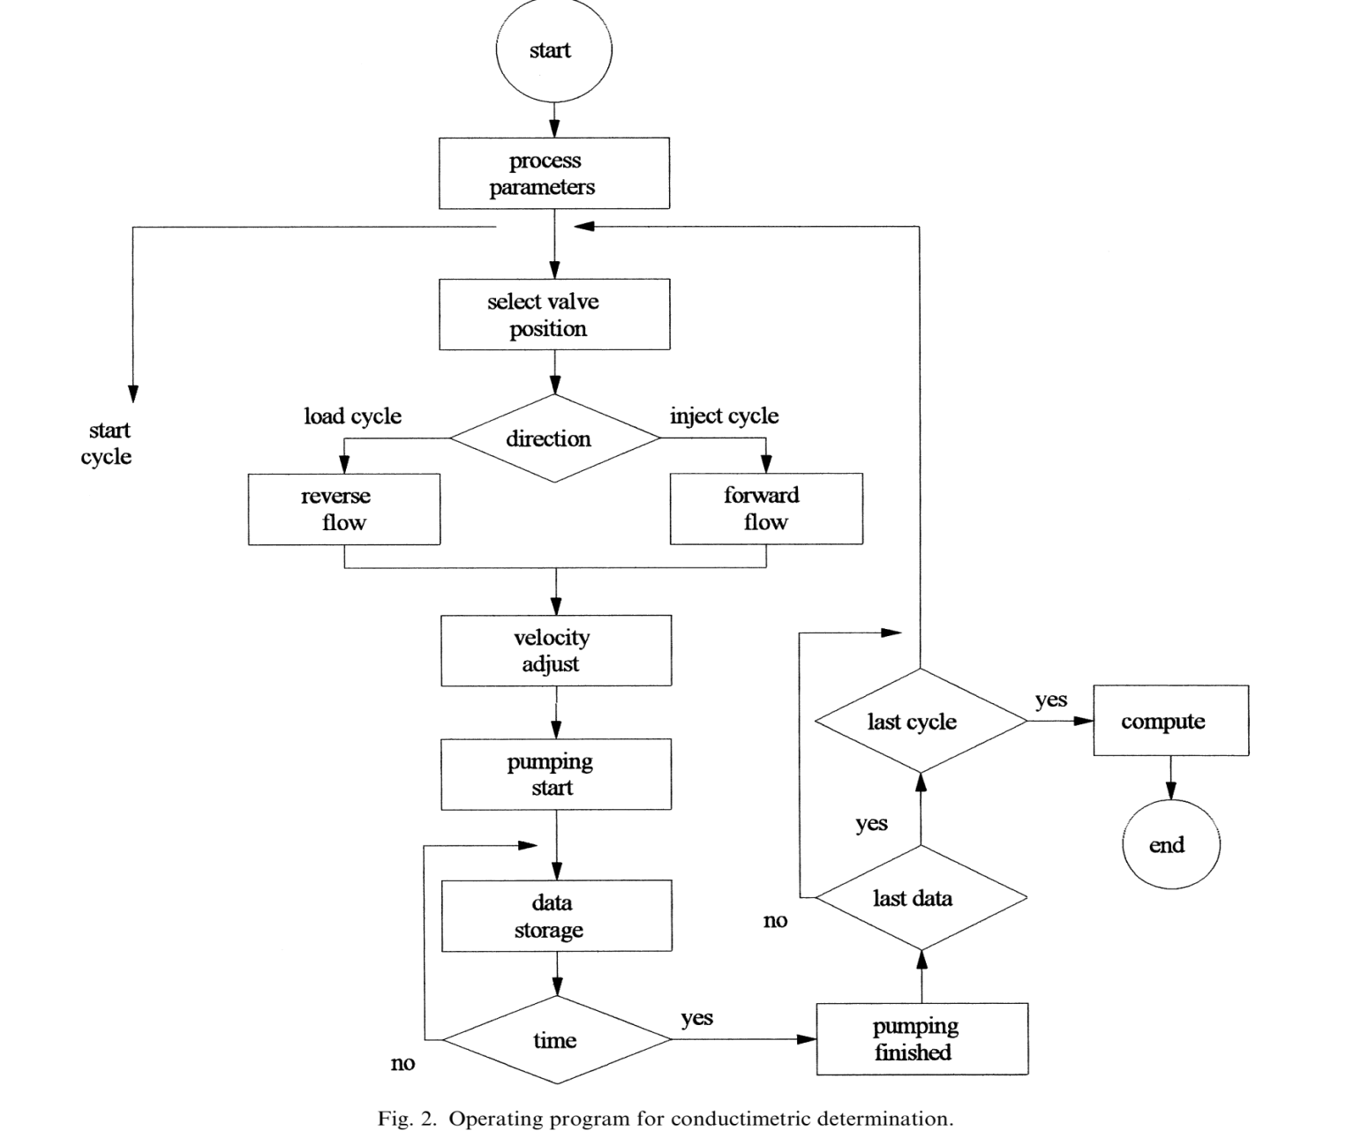

**Practical # 08**

**Determination of chloride in milk**

Method description

**Sample**

UHT milk  
**Sample preparation**No sample preparation is required.

**Configuration**

|  |  |
| --- | --- |
| 905 Titrando | 2.905.0010 |
| 801 Magnetic Stirrer | 2.801.0040 |
| 800 Dosino | 2.800.0010 |
| 20 mL Dosing unit | 6.3032.220 |
| Ag Titrode with AgS coating | 6.0430.100S |

**Solutions**

|  |  |
| --- | --- |
| Titrant | c(AgNO3) = 0.1 mol/L If possible, this solution should be bought from a supplier. |
| Nitric acid | c(HNO3) = 4 mol/L |
| 2-propanol | For rinsing |

**Analysis**Approx. 10 g milk is weighed into a titration beaker and  
diluted with 50 mL hot (55 °C), deion. H2O. After the  
addition of 2 mL c(HNO3) = 4 mol/L, the solution is  
titrated with c(AgNO3) = 0.1 mol/L until after the first  
equivalence point.  
The buret tip and electrode are rinsed with 2-propanol  
after each titration to remove organic residues.  
A blank determination is performed the same way as  
described above, omitting the sample.

**Parameters**

|  |  |
| --- | --- |
| Mode | DET U |
| Pause | 10 s |
| Signal drift | 50 mV/min |
| Max. waiting time | 26 s |
| Meas. point. density | 4 |
| Min. increment | 10 µL |
| EP criterion | 5 |
| EP recognition | Greatest |

**Results**Mean results for n = 5

|  |
| --- |
| NaCl content |
| Mean | 0.160% |
| s(rel) | 0.69% |

**WHEAT FLOUR**

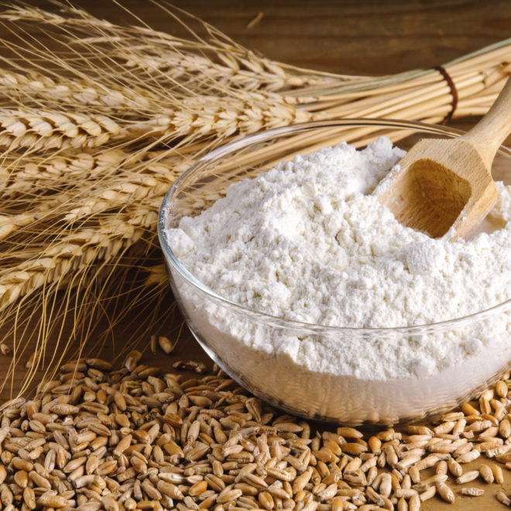

**Practical # 09**  
**TEST WEIGHT**  
High test weight indicates sound wheat. As test weights drop, the percentage of small, malformed, and broken kernels usually increases. Hence, this test is used in the grading of wheat in many countries.Test weight of wheat is determined by weighing clean (i.e., dockagefree) wheat occupying a given volume. In the United States, test weight is reported as pounds per bushel, with the volume of a bushel defined as 2,150.42 in.3 or 35.24 L, while most other countries use the unit kilograms per hectoliter (as reported in AACC Method 55-10, the  
method for test weight). Test weights may range from about 45 lb/bu(57.9 kg/hl) for a poor wheat to about 64 lb/bu (82.4 kg/hl) for a sound wheat.

**pH**

Testing the pH of a flour is required when it is important to know how much chlorine has been applied. The more chlorine applied, the lower the pH. Unchlorinated flour has a pH of 5.8–6.5, whereas a highly chlorinated flour can have a pH as low as 4.0.

**FLOUR YIELD**  
This test is of importance to the miller because it is a general indication of how much flour can be made from a given wheat. It is conducted on a laboratory mill (e.g., Buhler or Miag Multomat) under a standard operating procedure. The value obtained (i.e., the percentage of flour based on the initial weight of wheat) relates to the extraction rate on a commercial mill. It should be understood, however,that a small laboratory mill is not as flexible as a commercial mill.  
Often, a miller can make adjustments in a commercial mill to make better separations and obtain yields higher than those obtainable on a laboratory mill.

Color Tests

**PEKAR COLOR (SLICK) TEST**  
The Pekar Color Test (AACC Method 14-10) is a simple test, but it  
can be very useful to ensure that flour purity remains constant between flour shipments. For products in which bran specks are undesirable, this test can be especially valuable. Two or more 10- to 15-g samples of flour are placed side by side on a glass or metal plate. The  
flour is formed and smoothed (“slicked”) to create a distinct boundary between the samples. Color differences and the number of bran specks can be easily compared. To accentuate differences, the flour samples can be sprayed with cold water and dried.

**AGTRON COLOR TEST**  
A more sophisticated test for color, but one that is not widely used,involves the Agtron reflectance colorimeter (AACC Method 14-30).This instrument measures the reflectance of light from a flour-water slurry at a wavelength of 546 nm. The flour sample is calibrated against two disks of different reflectance to establish a range of brightness. Higher readings denote brighter color and generally purer flour.Straight-grade flour generally yields an Agtron color value of 80–85.Patent flours yield higher values, and high-ash flours yield lower values.

**Odor Test**

Flour is absorbent, and odors from various sources can be carried through to a final product. For example, flour stored near where a solvent has spilled will absorb the odor of the solvent. This odor and any associated flavors can carry through to the final product, even after it  
has been baked. Consequently, a very simple and valuable test often included in flour specifications is an odor test. A flour sample is simply evaluated for any unusual or undesired odors by someone in the quality lab. To facilitate the test, a standard flour can be maintained  
for comparison. Although this test is unsophisticated and subjective,it can be used to avoid major problems in final product quality.

**Basic Analyses**

**MOISTURE**  
The complexity involved in the analysis of moisture is often underestimated. Moisture is easily driven out of a sample by heat when there is excess water in the system, but as a sample becomes drier, the remaining water can be tenaciously bound and, consequently, more difficult to remove. For this reason, it is very important to follow any moisture method exactly, especially with respect to temperature and time for oven-based methods.The most commonly applied moisture-testing method for flour and wheat involves the use of an air oven (AACC Method 44-15A).  
Flour is analyzed directly, but wheat is ground in a laboratory mill before the analysis. If the sample is below 13% moisture, 2–3 g is weighed into a tared (preweighed) vessel. It is then heated for exactly 60 min at 130 ± 1°C, allowed to cool under desiccation, and weighed  
again. Percent moisture is calculated as the moisture loss divided by the original sample weight multiplied by 100. For samples over 13% moisture, an air-drying stage precedes this procedure (AACC Method 44-15A). Replicate determinations should agree within 0.2% moisture.Moisture content over 14% affects the storage quality of flour and wheat. At higher moisture contents, mold growth, increases in microbial content, and infestation by insects are favored. High moisture can also lead to production problems because flour agglomerates more readily as it becomes wetter. This often causes hoppers and other devices with bottlenecks to “bridge” when flour clumps, resulting in blocked passageways.Moisture should be included in every analysis of wheat or flour. Itshould also be the first test run, because it provides a basis for comparison for all other tests. Usually a 14% moisture basis is used for comparisons, but tests may also be compared on a dry basis or any other moisture basis. To assure accurate communication, it is important to always include the moisture basis when reporting wheat or flour analyses. Additionally, for other testing procedures where the dry matter in the sample governs the results (e.g., the farinograph test), it is important to know the moisture content of a sample to ensure that the appropriate amount of sample is analyzed. The following equation may be used to convert any analysis to any moisture basis:

*A=B* (100– C/100–*D* )  
in which *A* = the analysis percentage at the desired moisture basis,  
*B* = the analysis percentage as originally analyzed, *C* = the desired moisture basis, and *D* = the moisture percentage as originally analyzed.  
Example: A sample is analyzed and shown to contain 11.2% moisture and 12.5% protein. It is necessary to report the protein content  
on a 14% moisture basis.  
12.1%  
(14%*mb*)=12.5 (100–11.2 100–14 )

**ASH**The determination of ash (mineral) content requires that an accurately weighed sample be incinerated in a muffle furnace at or above 550°C until a constant weight is achieved (AACC Method 08-01). Ash content is calculated as the weight of the residue divided by the original weight of the sample, expressed as a percentage. As with most flour analysis results, it is usually reported on a 14% moisture basis.Ash content is an extremely important measurement when it is  
necessary to know the purity of a flour sample with respect to bran contamination, because the residue remaining after this procedure represents the mineral content of the sample. Bran has approximately 30 times the ash content of the endosperm, so elevated test results reflect contamination with this highly concentrated ash source. Often, the ash test is used in conjunction with a visual test(e.g., AACC Method 14-10) to determine purity. In some cases (e.g.,  
white wheat), ash content is a better indicator than a color test because the color of the bran is less apparent. The ash test can also be important if minimizing the effects of an  
enzyme is necessary to ensure product quality. In cereals, enzymes are concentrated in the aleurone layer of the endosperm. Because the aleurone is closely associated with the bran, samples high in bran are also high in aleurone content. Hence, there is a good correlation between enzyme activity and bran content in many cases. It is often possible to reduce the enzyme activity of a flour by eliminating some high-ash streams (i.e., using a patent flour instead of a straight-grade flour).

**Practical # 10**

**DETERMINATION OF WET GLUTEN IN WHEAT FLOUR - HAND WASHING**

**Introduction**The alternative techniques of washing out by hand and mechanical washing out, do not give  
equivalent results. Consequently the test report shall indicate the technique used. In the case of  
mechanical washing out, the type of machine used shall also be indicated.

**1: Scope**

**1:1** This standard specifies a method for the determination of wet gluten in wheat flour.

**1:2** This method is applicable to wheat flours (commercial and experimental flours) but not to the coarse whole meal of wheats.

**2: Definition**

Wet gluten in wheat flour: A plastic-elastic substance, consisting of gliadin and glutenin, obtained by the method specified in this international standard.

**3: Principle**

Preparation of dough from a sample of flour and a buffered solution of sodium chloride.  
Isolation of the wet gluten by washing this dough with a buffered solution of sodium  
chloride, followed by removal of excess washing solution and weighing of the residue.

**4: Reagents**

The reagents shall be of recognised analytical quality. The water used shall be distilled  
water or water of at least equivalent purity.

**4:1** Sodium Chloride, 20g/l solution, buffered to pH 6.2.

Dissolve 200g of sodium chloride in water; add 7.54g of potassium dihydrogen phosphate  
(KH2PO4) and 2.46g of disodium hydrogen phosphate dihydrate (Na2HPO4.2H2O).  
Dilute to 10 litres with water. Prepare a fresh solution daily.  
**4:2** Iodine, approximately 0.001 N solution.

**5: Apparatus**

Ordinary laboratory equipment and in particular:  
**5:1** Porcelain mortar, glazed inside, or enamelled metal vessel of diameter 10 to 15cm.

**5:2** Burette, 10ml, graduated in 0.1ml, complying with the requirements of ISO/R 385.

**5:3** Spatula, of horn, plastic or stainless steel, 18 to 20cm in length.

**5:4** Glass plate, about 40cm x 40cm, with slightly roughened surface.

**5:5** Gloves, of thin rubber and having a smooth surface.

**5:6** Wooden frame, about 30cm x 40cm, covered with No.56 grit gauze (mesh 315 µm) (for washing out by hand).

34:1/2  
**5:7** Container, with adjustable outflow, for the sodium chloride solution (4:1) used for washing out (6:3).

**5:8** Gluten press.

**5:9** Stop-clock.

**5:10** Balance, accurate to 0.01g.

**6: Procedure**

**6:1 Test Portion**

Weigh, to the nearest 0.01g, 10.00g of the test sample and transfer it quantitatively to the  
mortar or metal vessel (5:1).

**6:2 Preparation of dough**

**6:2:1** Add, drop by drop 5.5ml of the sodium chloride solution (4:1) from the burette (5:2) while continuously stirring the flour with the spatula (5:3).

**6:2:2** After adding the sodium chloride solution, compress the mixture with the spatula and form a dough ball, taking care to avoid loss of flour. Dough residues adhering to the wall of the  
vessel or to the spatula shall be collected with the dough ball.  
**6:2:3** To homogenise, roll out the ball to a length of 7 to 8 cm with the flat of the hand on the roughened glass plate (5:4), then fold it. During this operation the hands shall be covered with rubber gloves (5:5) in order to protect the dough from warmth and perspiration from the hands.

**6:2:4** Repeat this operation (6:2:3) five times.

**6:3 Washing out**

Washing out may be carried out by hand washing (6:3:1).  
**6:3:1** The operations described in 6:3:2 and 6:3:3 shall be carried out over the wooden frame covered with gauze (5:6) to avoid the possible loss of dough.  
**6:3:2** Take the dough ball (6:2) in the hand and allow the sodium chloride solution (4:1) to drip onto it from the container (5:7) at a rate such that 750ml flow in 8 min. During this time,  
successively roll out the dough ball, flatten it, stretch it to make two pieces, then mould  
them together into one piece; repeat these operations seven times.  
**6:3:3** The washing out time depends on the gluten content, but in general is about 8 min.  
**6:4 Verification of completeness of washing** The washing is considered to be complete when more sodium chloride solution (4:1)  
pressed out from the gluten ball obtained as in 6:3 contains only traces of starch. Use the  
iodine solution (4:2) for detection of starch.  
**6:5 Removal of excess washing solution**

**6:5:1** Eliminate most of the washing solution adhering to the gluten ball by holding it between  
the fingers of one hand and compressing it briefly three times.  
**6:5:2** Form the gluten ball into a laminate shape and place it in the gluten press (5:8). 34:1/3  
Close the gluten press and re-open it after 5 s; transfer the gluten leaf, without deforming  
it, to another dry spot in the press and press it again. Repeat this operation 15 times; dry  
the glass plates of the gluten press after each operation.  
**6:6 Determination of the mass of the wet gluten**

Weigh the pressed gluten to the nearest 0.01g.  
**6:7 Number of determinations**

Carry out two determinations on the same test sample.

**7: Expression of Results**

**7:1 Method of calculation and formula**

The wet gluten, expressed as a percentage by mass of the original flour weight, is equal to Wet gluten content = total gluten (g) x 100 = total gluten x 10 10 (g)

NOTE - Generally the result of the determination is not referred to the dry matter content.  
Take as the result the mean of the two determinations provided that the requirement for  
repeatability (see 7:2) is satisfied. If it is not, carry out a third determination on the same  
test sample and take as the result the mean of the three determinations if the difference  
between the lowest and highest values obtained does not exceed 1% wet gluten. If the  
difference exceeds 1%, carry out a fourth determination on the same test sample and take  
as the result the mean of all four values obtained.

**7:2 Repeatability**

The difference between the results of two determinations carried out simultaneously or in  
rapid succession by the same analyst using the same apparatus shall not exceed 0.5% wet  
gluten.

**8: Test Protocol**

The test protocol shall show the method used, i.e. manual washing out, and the result  
obtained. It shall also mention all operating details not specified in this standard, or  
regarded as optional, as well as any circumstances which may have influenced the result.  
The report shall include all details necessary for the complete identification of the sample.

**Practical # 11**

**STARCH**

**Determination of total, resistant, damaged and gelatinized starch and maltodextrins**

**Introduction**Starch is a natural vegetable polysaccharide. It serves as a storage form of glucose, and thus  
energy, in plants. Therefore starch is an important constituent in seeds and grains (corn, wheat, rice),  
tubers (potato) and root vegetables (e.g. tapioca or cassava). But it is also present in immature fruits  
as bananas. The main starch crops are cereals, potatoes, and tapioca.

In plant material, starch is present as small white granules insoluble in cold water. Both shape and  
size of the starch granules are characteristic to its botanical source. Depending upon the botanical  
origin, starch granule sizes range from less than 1 μm up to 50-60 μm.

**Chemical structure and physiological forms of starch**

From a chemical viewpoint, starch is a homopolymer of glucose. It consists of long linear unbranched chains of 1🡪4-α-D-glucose units (amylose) and/or long α-1🡪6 branched chains of 1🡪4-α linked D-glucose units (amylopectin). The repeating unit in starch is the disaccharide maltose.

**Starch**Starch can be present in raw materials, semi finished products, food, feed, and pet food in different physiological forms, being as native starch granules, as resistant starch, as damaged starch or gelatinized starch. The physiological state of the starch in a food and/or feed product  
strongly affects the digestibility of the starch by human and animal and therefore its energy value.

**Damaged starch**

Damaged starch granules hydrate rapidly and are susceptible to amylolytic hydrolysis and, therefore contribute significant to water absorption of a dough. The level of damaged starch in flours determines amongst others the baking capability of the flour and is therefore an important quality parameter for flours.

**Gelatinized starch**

Due to process conditions as heat, pressure and moisture (e.g. extrusion, drum, drying), starch  
granules can gelatinize. Gelatinized starch is accessible for digestive enzymatic hydrolyses, native granular starches are more or less inaccessible for those enzyme activities. For this reason, pet food contains significant levels gelatinized starch.

**Resistant starch**

By definition resistant starch is the total amount of starch, and the products of starch degradation that resists digestion in the small intestine of healthy people. (EURESTA, 1991). It enters the large intestine where it is partially or wholly fermented. Resistant starch is nowadays considered as dietary fibre.

**Maltodextrin**Maltodextrin is produced by partial hydrolysis of starch. Maltodextrins are classified by DE (dextrose equivalent) and have a DE between 3 to 20. The higher the DE value, the shorter the glucose chains, the higher the sweetness, the higher the solubility and the lower heat resistance. Above DE 20, the European Union's CN code calls it glucose syrup, at DE 10 or lower the customs CN code nomenclature classifies  
maltodextrins as dextrins.

**Analytical methods**

Different analytical methods are available for the different physiological forms of the starch. The enzymatic starch determination according ISO 15914 is applied for the determination of the total (native  
+ damaged/gelatinized + resistant) starch content. The method is very specific and selective for starch. Other nonstarch polysaccharides/ oligosaccharides/monosaccharai des do not interfere. In the enzymatic maltodextrin determination the total content of maltodextrins, starch and maltooligosaccharides are quantified, excluding the free glucose. For the quantitative determination of resistant starch  
in food a specific enzymatic analytical method is available (AOAC 2002.02). Specific digestive enzymes and physiological conditions are applied in this protocol, approximately mimicking the digestive tract.  
Damaged starch is enzymatically determined by the AACC 76-31 protocol and the determination of the gelatinized starch content is based on the same protocol.

**Overview Methods**

|  |  |  |  |
| --- | --- | --- | --- |
| **Total starch** | **Resistant starch** | **Damaged/gelatinized starch** | **Maltodextrins** |
| **Analytical protocol** | ISO 15914 | AOAC 2002.02 | AACC 76-31 | Own method |
| **Principle** | enzymatic | enzymatic | enzymatic | Enzymatic |
| **Statistics** | LOQ = 0.4 % Range 0.4 – 100 % RSDr < 2 % RSDR < 5 % Recovery > 98 ±2 % | LOQ = 0.5 % Range 1 – 75 % RSDr < 2 % RSDR < 4 % | LOQ = 0.3% Flour - range 0.3 – 20 % - RSDr = 0.9 % - RSDR < 4 % Petfood - Range 10 – 35 % - RSDr = 2.2 % - RSDR = 3.9 % | LOQ = 0.4 % Range 0.4 – 100 % RSDr < 2 % RSDR < 5 % Recovery > 98 ±2 % |

**Egg**

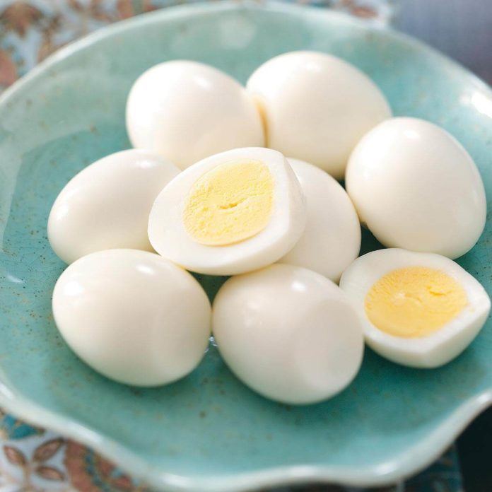

**Practical # 12**

**COMPOSITION OF EGG**

**The Egg :**

The egg is formed in the mature hen by a reproductive system composed of an ovary and oviduct. Most females have two functional ovaries,but chickens and most other birds have only one ovary and one oviduct. In this oviduct, all parts of the egg, except the yolk, are formed. The developing embryo, protected from drying out, can survive outside of water and in a variety of habitats. The yolk provides it with food, and the albumin supplies water and nutrients. Wastes are released to the allantois an extension of the embryonic gut. Oxygen diffuses easily through the thin outer shell of the egg; its passage to the embryo is regulated by the chorion.The yolk is formed in the follicular sac by the deposition of continuous layers of yolk material. Ninety-nine percent of the yolk material is formed within the 7-9 days before the laying of the egg. When the yolk matures,the follicular sac ruptures or splits along a line with few, of any,blood vessels called stigma.If any blood vessels cross the stigma, a small drop of blood may be deposited on the yolk as it is released from the follicle called blood spots in eggs.The shell is added in the uterus or shell gland portion of the oviduct. The shell is composed mainly of calcium carbonate.It takes about 20 hours for the egg shell to form. If the hen lays brown eggs, the brown pigments are added to the shell in the last hours of shell formation.When an egg is laid, it fills the shell. As it cools, the inner portion of the egg contracts and forms an air cell between the two shell membranes. A high quality egg has a tiny air cell, indicating the egg was collected soon after being layed and was stored properly.The air cell is usually located in the large end of the egg where the shell is most porous and air can enter easily.After fertilization,the embryo develop and the egg consist of the following :

1.albumin .

2.chorios.

3.yolk sac.

4.allantois.

**Chemical Composition Of Eggs** :

Egg consists of three main parts, the shell, the egg white and the egg yolk. The shell consists of calcite crystals embedded in a matrix of proteins and polysaccharide complex. Inside the shell the viscous colourless liquid called the egg white accounts for about 58 percent of the total egg weight. Percentage composition of egg white and yolk Egg White Egg white is composed of thin and thick portions. 20-25% of the total white of fresh eggs (1-5 days old) is thin white. The chief constituents of egg white besides water are proteins. Different types of proteins are present in egg white. Ovalbumin this constitutes 55% of the proteins of egg white. This is a phospho glycoprotein and is composed of three components A1, A2, and A3, which differ only in phosphorus content. Conalbumin this constitutes 13% protein of the egg albumin. It consists of two forms neither of which contains phosphorus nor sulphur. Ovamucoid is a glycoprotein. This constitutes about 10% of the egg white proteins. Ovomucin protein is responsible for the jelly like character of egg white and the thickness of the thick albumen. It contains 2% of the egg white. Its content in the thick layers of albumin is about 4 times more than in thin layers. It is insoluble in water but soluble in dilute salt solution. Lysozyme content of egg is 3.5%. This is an enzyme capable of lysing or dissolving the cell wall of bacteria. It is composed of 3 components A, B and C. It binds biotin and makes the vitamin unavailable. Avidin is 0.05% of the egg white protein. It is denatured by heat and cooked eggs and do not affect the availability of biotin. Ovoglobulin It is a protein consisting of two components G1 and G2 and both are excellent foaming agents. Ovoinhibitor % of egg protein is made up of ovoinhibitor. It is another protein capable of inhibiting trypsin and chymotrypsin.

**Egg yolk:**

Solid content of yolk is about 50%.

**Chemical composition of egg contents**

1. The weight and composition of a table egg is dependent on heredity, age, season, diet, and other factors. A typical White Leghorn egg usually weighs from 53 to 63 gm with an average of 55 gm.

2. In addition to water (74%), the main chemical compositions of hen egg are 11.8% lipids, 12.8% proteins, and small amounts of carbohydrates and minerals.

3. Most of the proteins are present in the egg white and the egg yolk, amounting to 50% and 44%, respectively; the eggshell contains the rest of the proteins. The yolk accounts for slightly over one third of the edible portion, but it yields three-fourths of the calories and provides all or most of the fat in whole eggs.

4. The yolk comprises 48% water, 16% protein, 32.6% fat, and some minerals and vitamins. The white consists of 88% water, 10% protein, and some minerals. The amount of lipid in the egg white is negligible (0.01%) compared with the amount present in the yolk.

5. The shell makes up 11% of the weight of an egg, and approximately 98% of the shell consists of calcium. Carbohydrates are a minor component of hen eggs. Their average content is about 0.5 g per egg, 40% of which is present in the yolk.

6. Carbohydrates are present as free and conjugated forms which are attached to proteins and lipids. Glucose accounts for about 98% of the total free carbohydrate in the egg white. 7. The content of carbohydrate in egg yolk is about 0.7-1.0 % and it consists of oligosaccharides bound to protein, composed of mannose and glucosamine; the remaining 0.3% is free carbohydrate in the form of glucose.

8. About 94% of the minerals are in the egg shell fraction; the rest are distributed in egg white and egg yolk. Most of the minerals are in conjugated form, and only a small portion is present as inorganic compounds or ions.

9. Calcium represents over 98% of total mineral in the shell; other inorganic components include phosphorus, magnesium, and trace contents of iron and sulphur. Egg yolk contains 2% minerals, phosphorus being the most abundant.

10. More than 61% of the total phosphorus of egg yolk is contained in phospholipids. The major inorganic components of egg white are sulphur, potassium, sodium, and chlorine.

**Practical # 13**

**ESTIMATION OF LIPIDS IN EGG**

**Introduction:**

Lipids are a structurally diverse group of amphipathic molecules. While the majority ofthemolecule is hydrophobic, each molecule contains a polar region. The hydrophobic nature of the molecule strongly determines the structures these molecules assume in nature. Being structurally diverse, lipids have a variety of biochemical functions, including structure, energy, energy storage, and signaling (steroids and eicosanoids). The bulk of the mass of lipid molecules in a mammalian system are those found structurally in cellular membranes and those involved in storage as triacylglycerides and cholesterol esters. Phospholipids are a major component of cellular membranes and can be divided into classes based on their headgroup and further into species based on the acyl group composition. Organic solvents are employed to separate lipids from proteins, carbohydrates and water soluble metabolites. Lipids are often subsequently separated into groups through the use of chromatography. Thin layer chromatography has traditionally been the chromatography of choice. The lipid composition of cells and membranes can differ significantly with respect to lipid group, phospholipids class and acyl group identity. In this lab, lipids will be isolated from egg yolk and mitochondria. The lipid composition of the two sources will be compared by 2-D TLC. The acyl group composition of the phospholipids will be compared through analysis by gas liquid chromatography (GLC).

**Methods:**

Throughout these procedures take care to avoid contamination with water.

Do not use Parafilm with organic solvents, including ethanol. If samples must be stored, store in hexane or chloroform under a layer of N2.

**Folch extract for isolation of lipids:**

**Egg yolk:**

Add 0.5 mL of egg yolk to 1.0 mL distilled water in a small beaker. Add 2 mL MeOH and mix well. Add 4 mL CHCl3 and mix well. Transfer mixture to a test tube. Centrifuge in a clinical centrifuge for 5 minutes at 1,000 rpm to promote rapid separation and clarification of phases. Aspirate off upper phase and remove lower phase to a clean test tube. Bring sample to dryness in a Nitrovap which heats samples under a gentle stream of N2. Reconstitute by adding 0.6 mL CHCl3 Mitochondria: Add 0.5 mL of mitochondria to 1.0 mL distilled water in a small beaker. Add 2 mL MeOH and mix well. Add 4 mL CHCl3 and mix well. Transfer mixture to a test tube. Centrifuge in a clinical centrifuge for 5 minutes at 1,000 rpm to promote rapid separation and clarification of phases. Aspirate off upper phase and remove lower phase to a clean test tube. Bring sample to dryness in an N-evap which heats samples under a gentle stream of N2. Reconstitute by adding 0.6 mL CHCl3 2)

**Thin Layer Chromatography:**

Select two Magnesium Acetate silica thin layer chromatography (TLC) plates. Etch a line, about 1 inch from the top and another about 1 inch from the right hand side on each plate. Prepare two TLC chambers with 100 mL of the following solvents systems. System 1: 65:35:5:1 (v/v) (chloroform: methanol: ammonia: water (C: M: N: W)). System 2: 30:40:10:7:5 (v/v) (C: A: M: HAc: W). Spot the lipid extract from egg yolk on one plate and some of the lipid extract from mitochondria on the other plate. The spot should be on the lower left hand corner of the plate. Spot it about ¾ inch from the left hand side and about ¾ inch from the bottom.

**Practical # 14**

**Determination of Egg Yolk Content in Egg Liqueurs**

**MATERIAL AND METHODS**

According to the literature, the following chemical markers of the egg yolk content were chosen: phosphorus, cholesterol, composition and total content of fatty acids, lysozyme and fat contents.  
The set of egg yolks were analysed for the evaluation of the raw material composition and quality. Seven model samples with the known egg yolk content were prepared and analysed to evaluate the relation between the egg content and the chemical composition. Finally, 10 samples of liqueurs of different trademarks obtained from the local market were analysed and the egg yolk contents were estimated.

***Material****.*

A sample of egg yolk was fully separated from the eggs (grade A) obtained from the local markets; the same sample of egg yolk was diluted with egg white to the final concentration  
of 90%. Twelve samples of liquid, pasteurised egg yolks were provided by egg liqueurs producers, seven of them were marked as the technological yolks, three of them were sweetened (with the addition of 45% of sucrose). Four samples of whole milk (lipid content 3.5%) were obtained from the local market. Ten samples of egg liqueurs and egg creams were obtained from the local markets. A set of model samples of liqueurs with the egg yolk contents of 70, 112, 125, 126, 140, 140, and 155 g/kg was prepared under laboratory conditions. One litre of liqueur emulsion that was produced by mixing whole milk (410 ml), ethanol (200 ml) and  
water with the acquired amount of egg yolks was stored in the refrigerator before analyses.

***Analytical methods***.

For the moisture determination, a 10 g sample was dried at 105°C for 4 h. The phosphorus content was determined according to the AOAC international method (PULLIAINEN 1996). The sample was dry-ashed and the acid-soluble inorganic residue was used for the colour reaction based on the formation of a blue complex (MoO2 × 4 MoO3) × H3PO4 in the presence of ascorbic acid. The intensity of the blue colour was measured spectrophotometrically at 823 nm.  
Cholesterol was analysed directly after saponification by GC/FID (KOVACS 1990). To saponify cholesteryl esters, the sample was heated at 60°C for 60 min with 50% KOH and ethanol mixture (1:9) and 5-α-cholestane as internal standard. Cholesterol was extracted with hexane, evaporated to dryness, diluted with ethanol and injected into the gas chromatograph. GC conditions: column DB-5 (30 m × 0.32 mm × 0.25 µm), carrier gas: nitrogen, constant flow rate of 0.45 ml/min, temperature program: 260°C, 6°C/min, 290°C (8 min), injector: 300°C, split 1:1, detector: 300°C.

To determine the total content and the composition of fatty acids, the sample was hydrolysed and  
esterified by boiling with 2% solution of H2SO4 in methanol for two hours under reflux. Fatty acids esters were extracted with heptane and analysed by GC/FID. GC conditions: column DB-wax (30 m × 0.32 mm × 0.25 µm), carrier gas: nitrogen, constant flow rate of 1.7 ml/min, temperature program: 60°C (1 min), 10°C/min, 250°C (10 min), injector: 230°C, split 1:1, detector: 280°C. Fat was extracted with chloroform/methanol mixture according to BOSELLI *et al.* (2001).

For the analysis of the lysozyme content (KVASNICKA *et al.* 2003), 2.5 g of sample with 30 ml 1M acetic acid was extracted at 40°C for 1 h. CITP-CZE (on-line coupled capillary isotachophoresis with capillary zone electrophoresis) conditions: UV detector LCD 2084 at 280 nm (ECOM, s.r.o.) and electrophoretic analysator EA 101 (Villa Labeco, SK).

Operating conditions: capillaries 110 mm × 0.8 mm and 140 mm × 0.3 mm, electrolytic system: TE (5mM HAc + 5mM ε-aminocaproic acid), LE (20mM HAc + 10mM NH 4OH), BGE (40mM EACA + 20mM HAc + 0.1% HEC).

To determine the lactose content in milk and liqueurs, the sample was homogenised, diluted with the mixture of H 2O/acetonitrile (25/75) and analysed by HPLC [column Maxsil 5 NH2 250 mm × 3.2 mm, mobile phase H2O/acetonitrile (25/75), flow rate of 0.5 ml/min, refractive detector].

**Practical # 15**

**Determination of Calcium Carbonate in Eggshells**

**Background**

The major component of eggshells is calcium carbonate, CaCO3(s). This analysis is done volumetrically by using a characteristic reaction of carbonate compounds, namely their reaction  
with acids. Calcium carbonate (limestone) is very insoluble in pure water but readily reacts in  
acid according to the reaction below.

2HCl(aq) + CaCO3(s) → CaCl2(aq) + CO2(g) + H2O(l) + HCl(aq) (1) (in excess) (limiting reagent) (unreacted) This reaction cannot be used directly to titrate the CaCO3 because it is very slow when the reaction is close to the endpoint. Instead the determination is achieved by adding an excess of hydrochloric acid to react with all of the CaCO3 and then titrating the remaining unreacted HCl with NaOH solution to determine the amount of acid which did not react with the calcium carbonate. The difference between the moles of the acid (HCl) initially added and the moles of HCl left unreacted after the reaction, is equal to the moles of HCl that did react with CaCO3. The reaction used to determine the amount of unreacted acid by titration is given below.

This type of analysis is generally referred to as a back-titration. HCl(aq) + NaOH(aq) → NaCl(aq) + H2O(l) (2) (unreacted)

**Calculations**:  
The purpose and goal of today's experiment is to determine the mass percent of CaCO3 in  
an eggshell. The following logic stream may be helpful to understand how you will reach that  
goal. The calculation steps are reproduced at the end of the written procedure in a more formal  
step-by-step manner. As with all calculations, make sure to show all units and pay close  
attention to significant figures.

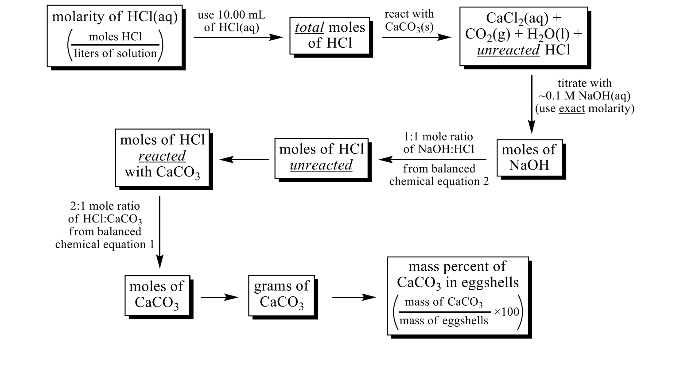

**Pre-Lab Homework**

1. How many milliliters of 0.383 M HCl are needed to react with 16.2 g of CaCO3?

2HCl(aq) + CaCO3(s) → CaCl2(aq) + CO2(g) + H2O(l)

2. If a 45.0 g sample of CaCO3 (s) is added to 1.25 L HCl (aq) that has a density of 1.13 g/mL  
and contains 25.7% HCl, by mass, what will be the molarity of HCl in the solution after the reaction is completed? (Assume that the solution volume remains constant.)

3. A piece of marble (assume it to be pure CaCO3) reacts with 2.00 L of 2.52 M HCl. After  
dissolution of the marble, a 10.00 mL sample of the remaining HCl(aq) is withdrawn, added to some water, and titrated with 24.87 mL of 0.9987 M NaOH.

(a) Write net equation for the two reactions involved.

(b) What must have been the mass of the piece of marble?

**Determination of Calcium Carbonate in Eggshells – Procedure**

**Purpose**: To measure the mass percent of calcium carbonate in a chicken’s eggshell.

**Special Equipment**: Things to use and return on the same day.

• You will be using a buret, buret brush, and a 10.00 mL volumetric pipet.  
• Be sure to rinse all the glassware with deionized water and return it when you are done.  
**Procedure**:

**Part 1. *Preparation of the Eggshell***

This part of the experiment can be performed together by two teams of lab partners (four  
students total). For each group of four students (two pairs of lab partners), obtain one egg and  
any necessary glassware. Break the egg into a large beaker. Add water to the egg and stir before  
pouring down the drain to dispose of it. Wash the shell with deionized water and peel off *all of  
the membranes* from the inside of the shell. There are two membranes, one that is easy to see  
and one that you can find by rubbing your finger on the inside of the shell.  
Dry the shell with a paper towel and put into a beaker labeled with your names. Place the  
beaker with the shell in the oven, and dry the shell for about 20 minutes. It is important that the  
shell be dry in order to get the best results. Be patient and keep the oven closed as much as  
possible! Remove the shell from the oven and grind it to a very fine powder using a mortar and  
pestle.  
**Part 2. *Dissolution of the Eggshell in Excess HCl(aq)***

The remainder of this experiment (Parts 2 and 3) should be done in teams of two, as  
usual. Accurately weigh between 0.450 g and 0.550 g of dried shell into each of three 125 mL or  
250 mL Erlenmeyer flasks, labeled as "trial 1", "trial 2" and "trial 3". Be certain you record the  
mass of shell for each flask in your notebook. Add several drops of ethanol to each flask. This  
acts as a wetting agent and helps the hydrochloric acid dissolve the CaCO3.  
Pour ~35 mL of the 0.1 M HCl(aq) stock solution into a clean, dry, labeled beaker from  
your drawer. You will pipet the HCl(aq) from this beaker and NOT from the stock bottle. A  
total of 30 mL will be used for the titrations and you need a little extra to rinse your pipet, so 35  
mL should suffice. Do not waste the HCl solution and DO NOT pour any excess back into the  
stock bottle. Excess HCl(aq) should be discarded in the proper waste container.  
Slowly and carefully pipet 10.00 mL of 1.0 M HCl solution into each of your labeled  
Erlenmeyer flasks. Swirl the flasks to wet all of the solids. Heat the solutions in the flasks until  
they begin to boil and the solid egg shell dissolves. It is important that all of the eggshell solids  
dissolve because this contains the material you want to analyze. Eggshell is dense and will settle  
on the bottom of the flask. A white proteinaceous substance may form, but it will be suspended  
in the solution. Maintain a consistent fluid level in the flask by periodically washing down the  
walls of the flask with deionized water from your squirt bottle. DO NOT allow the liquid to  
completely evaporate or your eggshell will burn to a brown crust! The process of dissolving the  
eggshell is complete when no more "sinkers" (the eggshell) are visible in the flask; you'll be left  
*CaCO3 in an Eggshell – Procedure* P-2 with only "floaters" (the white proteinaceous material). Allow the flasks to cool. Rinse the walls of the flasks one last time with water from your wash bottle.

**Part 3. *Titration of the Unreacted HCl(aq) With Your ~0.1 M NaOH(aq)***

Add 3-4 drops of phenolphthalein indicator to each flask. Using a funnel, partly fill a  
clean buret with your standardized ~0.1 M NaOH solution (saved from the last experiment) to  
rinse it. Drain the buret into a waste beaker. Fill the buret with your ~0.1 M NaOH solution.  
Run some solution out to remove all air bubbles from the tip. Replenish the solution in the buret  
if necessary. Read and record the initial volume to ± 0.01 mL. Titrate one sample to the first  
persistent barely-pink color. When you are close to the endpoint the color will fade slowly. Add  
more ~0.1 M NaOH(aq) dropwise until the color remains for at least 30 seconds. Read and  
record the final volume to ± 0.01 mL. Repeat the titration for the other two samples.

**Waste Disposal and Cleanup**:

• Dispose of all titrated solutions into the waste container. Wash the egg residue out of the Erlenmeyer flasks using hot soapy water and a test tube brush.

• Dispose of any excess ~0.1 M NaOH from the buret, and from your 1 liter polyethylene  
bottle, into the waste container. Rinse the 1 liter polyethylene bottle *three times* with deionized water and flush the rinses down the sink drain. Return the 1 liter polyethylene bottle to the stockroom cart.

• Rinse the buret *three times* with deionized water, and return the buret.  
• Rinse the 10.00 mL pipet *three times* with deionized water and return the pipet.

**Calculations**: Use the following steps to calculate the percent mass of CaCO3 in an eggshell. Use the correct number of significant figures and include *all* units.

**A.** Calculate the moles of HCl added to the eggshells.

**B.** Calculate the volume (L) of NaOH dispensed.

**C.** Calculate the moles of NaOH dispensed = moles HCl *unreacted* with eggshells.

**D.** Calculate the moles of HCl *reacted* with eggshells. totalmoles HCl = moles HCl reacted + moles HCl unreacted

**E.** From the balanced chemical equation, convert moles HCl to moles CaCO3.

**F.** Convert moles of CaCO3 to mass (g) of CaCO3.

**G.** Calculate the mass percent of CaCO3 in an eggshell.

100 mass of eggshell, g mass of CaCO , g mass % = 3 ×

**Conclusion**:  
Report the average percent CaCO3 by mass in the eggshell and the standard deviation.  
Comment on the accuracy of your average mass percent of CaCO3 in an eggshell by comparing it to reported values. (Be sure to cite your references.) Comment on your precision as shown by  
your standard deviation. What are possible sources of error that may have affected, or could  
affect your accuracy and precision? In your opinion, do you trust your calculations and results,  
and was the lab successful?

### **Bread**

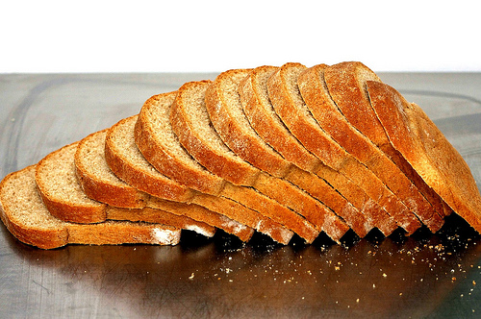

**Practical # 16**

### 

### **2.1 Physical analysis:**

### Breads produced from the composite flours were subjected to sensory Evaluation. Coded samples of the breads were served to 25 members/trained panelists positioned in partitioned booths. The taste, aroma, texture and overall Acceptability of the breads were evaluated under amber light while appearance was under bright illumination. These attributes were rated on a 10-point **Hedonic score scale** as: 1–2 poor, 3–4 fair, 5–7 very good and 8–10 excellent. Samples receiving an overall quality score of _7 were considered acceptable (Iwe 2002). The percentage proportion of moisture, fat, protein and carbohydrate of the accepted composite breads was carried out using recommended Standard methods (AOAC 2002).

### **There are different physical analysis for bread such as:**

### **2.1.1 Volume measurement:**

### Bread volume is a very important feature shown not only in the quality of the basic raw material which is flour, but also connected with the technological process of bread production dependent on personnel and the condition of the machinery.

|  |  |
| --- | --- |
| http://zbpp.com.pl/uploads/files/produkty/objetosciomierz-m.jpg http://zbpp.com.pl/uploads/files/produkty/objetosciomierz3-m.jpg http://zbpp.com.pl/uploads/files/produkty/objetosciomierz2-m.jpg  Figure 1. laboratory volumeter |  |

### **Procedure:** **The laboratory volumeter**is used for testing volume of bread. The instrument's operation is based on the measurement of millet grains equal to the volume of the tested bread. The instrument is used in bakery industry laboratories for quality control of bread and technological processes. The quality of the used flour has an influence on the volume of the bread .The larger volume of bread the better its quality. The general-purpose volumeter is built with two containers (an oblong and oval one) connected to each other with the glass tube equipped with two separate scales for laboratory volumeter from 0 to 3200 ml. The instrument is filled up with millet grain in quantity adjusted to the level of „0”. The measurement itself consists in putting a sample of bread into the top container and turning the instrument 180 °, and then reading the level of grains on the scale corresponding to the volume of the particular sample of bread. The quantity of the pushed out grain is equal to the tested bread volume expressed in millimeters **Technical parameters:**

### Dimensions - 1600 x 700 x 700 mm

### Weight - 21 or 24 kg

### Filling  - millet grain

### Scale - 0 – 1200  (test baking) ml or 0 -3200 ml (industrial baking)

### **Construction:**

### Container for oblong and oval bread (volumeter 0-3200 ml)

### Pouring pipe of gate valve for millet level regulation

### Container connector

### Instrument base

### Axis of rotation

### Wheels with brake

Bread volume calculated for 100 g of bread

Vav  
  
                           V100    =    -------   ×     100 ml  
                                                g

where:  
            Vav - average volume in ml  
            g     - mass in grams of 1 piece  
  
            The volumetric efficiency is calculated from the following formula:

               a ×   b  
                                             x    =   -------  
 c

where:  
            x - volume per 100 g of flour (volumetric efficiency)  
            a - bread volume in ml  
            b - dough efficiency (weight of dough obtained from 100 g of flour)  
            c - dough weight formed for baking in grams.

**Practical # 17**

**2.1.2 COLOUR MEASUREMENT:**

The BC-10 colorimeter can also report in the commonly used CIE Lab color space and scale units, measuring lightness and darkness in units from the darkest, 0, to the lightest, 100**.**

**Procedure:**

This instrument is designed for contact measurements, guaranteeing reliable and precise results. The BC-10 is not affected by lighting conditions and eliminates the inconsistencies in “human eye” subjectivity. It is so fast and simple to use, even first-time users can operate the BC-10. TO use: first, switch on; second, perform white tile calibration; third, place on product and press button; lastly, measurement results are displayed immediately on the screen. The LCD display shows the baking contrast units, which is the measure of the lightness or darkness of a product. This measurement system was developed specifically for the food industry. BCU is a derivative of the “L” value in standard tristimuluscolorimetry. The range is from 0 for the darkest and 5.25 for the lightest. Each change of .1 BCU equals approximately one discernable shade to the human eye. The screen also displays an averaging function. This means that the BC-10 takes as many measurements as required and calculates the average. The device can store up to 16 readings at a time. The BC-10 also includes some convenient functions such as protective window inserts which allow direct contact without the need of a cell, Petri dish, or test tube. Another function is its optional RS-232 output cable which allows it to be connected to a computer, printer, or storage device to save information or print it.



Figure .2. **BC-10 colorimeter** color measurement

**Practical # 18**

**2.1.3 Texture measurement:**

In case of bread creep-recovery test was carried out with a Stable Micro Systems TA-XT2 texture analyzer, fitted with a 35 mm diameter cylindrical flat probe. For the measurement a build-in sequence named “Relaxation test” was loaded. The sequence of events performed by the program is, as follows:

- The force was increased up to 5N

- This force is held for 60s

- The probe was retracted to the start point, approximately zero force

- This zero force is held for 60s and the deformation of the product was recorded.

The pre- and post-test speed of the probe was 2 mm/s, the test speed was 0,2 mm/s during measurements, the acquisition rate was 100 points pro second.

### **Procedure:**

### Cutting tests and compression tests were performed with Stable Micro System TA-XT2 Texture Analyzer. The cutting speed was 0.1 mm/s and the speed of the probe was 1.0 mm/s before and after the measurement at the cutting test. The cutting force was measured and the specific cutting force was calculated from the ratio of the maximum cutting force to the cutting diameter at the cutting method. At the compression tests the penetration speed was 0.2 mm/s with different probes depending on the material of the tested sample. However, the speed of the probe was 1.0 mm/s before and after the measurement (compression and decompression), respectively. The maximum compression force and the deformation were determined according to the character of the tested material.

### The results of the tests performed with the texture analyzer were recorded and evaluated by the Texture Expert 1.22 software. The variables and parameters were calculated by macros written in the same software and the processing and evaluation of the data were done by MS Excel 2003 software



**Figure**

**3.The TA-XT2 Texture Analyzer instrument**

### **Practical; 19**

### **2.1.4 Freshness measurement:**

### **APPLICATION**

### Adaptation of AACC 74-10A compression test for evaluating freshness of sliced loaf

### **OBJECTIVE**

### Measurement of bread firmness as an indication of freshness vs staling.

### **TEST PRINCIPLE**

### Single slice of 25mm or two slices of 12.5mm in thickness are placed under a 38.1mm diameter cylindrical probe. Bread is compressed 3mm and peak load is used as an indication of freshness. In addition, sample may be compressed to a certain load. The distance travelled to achieve that load is compressibility, which is an indication of softness.

### **Background**

### The original AACC method for bread compressibility specifies an apparatus known as the Baker Compressimeter, which quantifies the compressibility of a bread sample. The test is based on the theory that peak load increases and compressibility decreases as the bread ages. This adapted method of bread compression not only provides valuable information relating to product staling, but also can provide an invaluable indication of textural differences arising from ingredient and formulation manipulation.

### **METHOD**

### Test sample is placed on table with side toward center of loaf facing up. Center sample under probe. During test compression load sensed by probe is continuously recorded via software.

### 

### **Figure 4.Freshness measurement graph.**

### **Parameters: Results Day1**

### Crumb strength: Peak resistance to deformation crumb strength 482g

### Crumb extensibility: Distance between trigger point crumb extensibility 21.2mm

### & peak resistance

### Crumb work: Area between trigger point crumb work 4273.7gs

### & peak resistance

### 

### **Practical # 20**

### **2.2 Chemical analysis**

### **2.2.1 Moisture Content:**

### The moisture content of flour samples was determined according to method No.

### 44-15 A as described in AACC, 2000. 5 g flour was taken in a tarred crucible and dried in hot air oven (Memmert Model 200) at 100±5ºC till a constant weight. The moisture contents were calculated by the formula given below.

### Wt. of original sample – Wt. of dried sample

### Moisture (%) ═ ------------------------------------------------------- x 100

### Wt. of original sample

### **Practical # 21**

### **2.2.2 Crude protein content:**

### Crude protein was determined by the Kjeldahl method according to method No. 46-10 as described in AACC, 2000. The samples were first digested in digestion flask with H2SO4 in the presence of a digestion mixture for 3-4 h till the contents of digestion flask get transparent color. Samples were then diluted with distilled water up to 250 ml in a volumetric flask. The ammonia from the samples trapped in H2SO4 was liberated through distillation after adding 40% NaOH solution and collected in a flask containing 4% boric acid solution using methyl red as an indicator to determine nitrogen content in a sample by titrating against standard 0.1N H2SO4 solution. The crude protein percentage was calculated by using following formula

### 0.0014 × Vol. of 0.1N H2SO4× 250 ml

### N (%) = ------------------------------------------------------------ x 100

### Vol. of diluted sample × Wt. of original sample

### Protein (%) was then calculated by multiplying N (%) with factor 5.7.

### 

### 

### **Figure 5.Fat determination by kheldal method**

### **Practical# 22**

### **2.2.3 Crude fat content:**

### The method employed was that of solvent extraction using a Soxhlet extraction as described in method No. 30-10 (AACC 2000). 2 g of flour were taken in a thimble and placed in extraction tube of Soxhlet apparatus. About 250 ml of Hexane were added in 500 ml bottom flask of the apparatus and connected to the Soxhlet apparatus. The fat was extracted by running Hexane over the sample at the rate of 3-4 drops per sec for about 5 h. The content of the flask was transferred to a pre-weighed Petri dish and dried on a hot plate for 10 min at a temperature of 40-50ºC. The petri dish was cooled in desiccators and weighed.

### Fat percent age was calculated according to the following formula.

### Weight of fat in sample

### Crude fat (%) = -----------------------------

### Weight of sample

### **Figure 6. Soxhlet apparatus for crude fat determination**

### **Practical #23**

### **2.2.4 Crude fiber content:**

### Crude fiber content was determined by following the method No. 32-10 as described in AACC, 2000. 2 g fat and moisture free sample was taken and placed in 1000 ml beaker. 200 ml solution of 1.25 % H2SO4 was added in the beaker. The sample was then digested by boiling for 30 min. Then it was filtered by using suction apparatus. The residue was washed with hot water until become acid free. The residue was then again transferred to 1000 ml beaker and boiled with 200 ml solution of 1.25 % NaOH for 30 min. It was again filtered and the residue was transferred to pre-weighed crucible and dried in an oven at 100 ºC for 24 h till constant weight was obtained. Then the dried residue was charred on a burner and ignited into muffle furnace at 550-600ºC for 5-6 hours, cooled in desiccators and weighed. The loss in weight during incineration represents the weight of crude fiber in sample.

### The crude fiber % age was calculated by using the following formula.

### Weight of residue – Weight of ash

### Crude fiber (%) = ----------------------------------------------- x 100

### Weight of sample

### **Practical #24**

### **2.2.5 Ash content:**

### Ash content was determined by incineration of the sample at 600ºC according to method No. 08-01 as described in AACC, 2000. 5 g oven dried sample was taken in a pre-weighed crucible and charred on a burner. Then it was ignited in a muffle furnace at 550ºC till constant weight of grayish ash was obtained. The ash of sample was calculated by using following formula.

### 

### Weight of ash

### Ash (%) = ---------------------- x 100

### Weight of sample

### **2.2.6 ACID INSOLUBLE ASH:**

### **1**. Ash obtained above is boiled with 25 ml HCl (1:2.5) for 5 minutes in water bath, covering the dish with watch glass.

### **2**. It is then filtered through ash less filter paper No. 40.

### **3**. The residue is washed with water until free of acid.

### **4.** It is then ignited at 6000C for 20 min.

### **5.** It is then cooled and weighed.

### **Importance**

### The ash content in wheat and flour has significance for milling. Millers need to know the overall mineral content of the wheat to achieve desired or specified ash levels in flour. Since ash is primarily concentrated in the bran, ash content in flour is an indication of the yield that can be expected during milling. Ash content also indicates milling performance by indirectly revealing the amount of bran contamination in flour. Ash in flour can affect color, imparting a darker color to finished products. Some specialty products requiring particularly white flour call for low ash content while other products, such as whole wheat flour, have a high ash content. Acid insoluble ash indicates silica contamination.

WATER

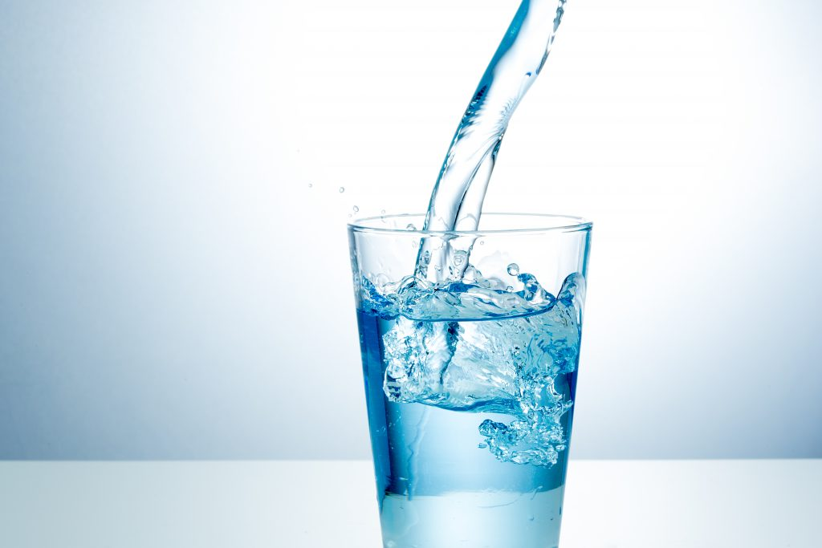

**Practical # 25**

**ALKALINITY**

**Apparatus:**

1. Burette: 50ml Borosilicate
2. Cylinder: 25ml / 50 ml
3. Erlenmeyer flask: 250 ml
4. Pipette: 5ml / 10 ml

**Procedure:**

1. Take 50 ml sample or an aliquot diluted to 50 ml in an Erlenmeyer flask.
2. Add a few drops of methyl orange indicator.
3. Titrate with standard 0.1 N H2SO4 titrant until the orange color changes to pinkish red.

Note the volume of titrant used.

**Calculation**

Alkalinity: mg/L = Vol. of H2SO4 used X 0.1 X 50000

ml sample taken

**Practical # 26**

HARDNESS

**Apparatus:**

**1.** Burette: 50ml

**2.** Erlenmeyer Flask: 250ml

**3.** Cylinder: 25ml / 50ml

**Procedure**:

1. Take 50ml sample or portion diluted to 50 ml in Erlenmeyer flask.
2. Add 1 to 2 ml Buffer solution.
3. Add 1 to 2 drop of dye indicator solution.
4. Titrate with EDTA solution with continuous stirring until the color change to blue.

Titration should be completed with in 5 minutes after addition of buffer solution. Note the volume of EDTA used.

**Calculation:**

Hardness as mg CaCO3/L = Volume of EDTA used *1000

ml sample taken

**Practical # 27**

**Phosphate Determination**

### Introduction

Phosphorus occurs in natural waters and in waste waters as phosphates. Phosphate arises from a variety of sources such as cleaning or laundering agents, fertilizers, biological processes, agricultural drainage, industrial wastes etc. Phosphates are also used extensively in the treatment of boiler waters.

**Determination of Phosphate** (Colorimetric method)

**Principle**

In a dilute orthophosphate solution, ammonium molybdate reacts under acid condition to form a molybdo – phosphoric acid. When vanadium is added in this solution, yellow vanado – molybdo – phosphoric acid is formed. The intensity of yellow color is proportional to the phosphate concentration.

**Apparatus**

1. Spectrophotometer (to use at 475 nm)
2. Acid washed glass wares.
3. Cylinder 50 ml
4. Pipette 10 ml
5. Volumetric flask 50 ml
6. Dispenser 10 ml

**Reagents**

1. HCl concentrated
2. Phenolphthaline indicator
3. Ammonium molybdate
4. Ammonium metavanadate
5. Standard phosphate solution

**Procedure**

1. Take 35 ml of sample or a portion diluted to 35 ml in a 50 ml volumetric flask. (Neutralize the sample pH with HCl if pH is greater than 10).

2. Take 35 ml distilled water in another 50 ml volumetric flask to use as blank.

1. Add 10 ml Vanado - molybdate reagent (Ammonium molybdate + Ammpnium Metavanadate) and fill up to the mark with distilled water.
2. Turn on the spectrophotometer and give sufficient time for worm up (15 to 20 minutes) Adjust the wavelength to 475 nm.
3. After 10 minutes, fill the cell with blank and adjust the instrument to 100% transmittance
4. Read the sample transmittence and check the phosphate concentration from graph.

**Or** Prepare the phosphate standard solution of 0, 1.0, 2.5, 5.0, 10.0, 15.0, and 20.0 mg/L concentrations and plot the calibration curve.

**Calculation**

Read the phosphate mg/L directly from the calibration curve if 35-ml sample is used.

**Or**

For diluted sample,

Phosphate (mg/L) = Calibration curve reading X 35

###### ml of sample

**Practical # 28**

**Sulfite Determination**

### Introduction

Sulfite ions may occurs in boiler and boiler feed waters treated with sulfite for dissolved oxygen control, in natural waters or waste waters as a result of industrial pollution. Water containing excess SO3-2 ion promotes corrosion in boilers and this type of water is also toxic for aquatic life.

**Determination of Sulfite** (titration method)

**Principle**

An acidified sample containing sulfite is titrated with standard Potassium Idodide – Iodate titrant. Free Iodine, librated by the Iodide – Iodate reagent, react with sulfite. The titration end point is blue color resulting from the first excess of Iodine reacting with a starch indicator.

**Reagents**

Sulfuric acid

Standard Potassium Iodide – Iodate (0.0125 M), KI-KIO3

Sulfamic Acid (NH2 SO3 H)

EDTA reagent

Starch Indicator

**Procedure**

a. Sample collection

Collect a fresh sample, taking care to minimize the contact with air. Fix cooled samples (less than 50 oC) immediately by adding 1 ml EDTA solution /100 ml sample. Cool hot samples to 50 oC or below. Don’t filter the sample.

**b. Titration**

1. Add 1 ml Sulfuric acid and 0.1 gm Sulfamic acid crystals to 50 ml erlenmeyer flask.

2. Measure 50 to 100 ml EDTA stabilized sample into flask, keeping pipette tip below the liquid surface.

3. Add 1 ml starch indicator solution.

4. Titrate immediately with standard Potassium Iodide – Iodate titrant, while swirling the flask until a faint permanent blue color develops

5. Analyze a reagent blank using distilled instead of sample.

**Calculation**

Sulfite (mg/L) = (A-B) X M X 40000

###### ml of sample

Where, A= ml titrant for sample

B= ml titrant for blank

M= molarity of Potassium Iodide – Iodate titrant

**Practical # 29**

## Microbiology (Tropical)

### Media and Vials Preparation:

### OGY. = **Take 18.5 gm in 500 ml. distilled water and cook till its first boiling and complete solubility. Distribute into media bottles. Sterilize by autoclaving at 115****oC for 10 minutes.**

### PCA. = **Take** **17.5 gm in 1 liter of distilled water. Dissolve it completely up till first boiling starts. Distribute into media bottles. Sterilize by autoclaving at 121 oC for 15 minutes.**

**A.A. =** 15 gms.Agar Agar in 1 liter distilled water.

**TRYPTONE =** 1 gms. Tryptone + 8.5 gms. NaCl in 1.0 liter distilled water, dissolve by mixing. Distribute in dilution vials autoclave at 121 oC for 15 minutes.

### Yeast and Mold

### Method:

### **Prepared 1:9 dilution of sample.**

1. Take 0.1 ml. sample from diluted ( 1:9 ) sample
2. Spread 0.1 ml. Sample in pettri dish
3. Then spread media “Oxytetracyline Glucose Yeast Agar’’ or OGY. (45 gms. Aprox. )

### Note: **In 500 ml. OGY. Mix 10 ml. Oxytetracyline – Glucose Yeast Extract Agar Supplement.**

Keep at room temperature for 120 hours. (5 days)

#### Total Plate Count

**Method:**

1. Take 1.0 ml. sample from dilution ( 1:9 )
2. 1.0 ml. sample mix in 9 ml. Tryptone media vials.
3. After mixing spread 1.0 ml. sample from media vials.
4. After some time, prepare a new layer of 15 ml. with “Plate Count Agar” or PCA.
5. Then spread 5 – 6 ml. “Agar Agar” at the layer of PCA.
6. Keep at 30oC in incubator for 72 hours.(3 days)

**Practical # 30**

##### **pH determination**

#### Activities / Procedure

1. Take 100 ml. of 11.5 brix juice sample in a beaker.
2. Immerse electrode into it. Care must be taken that electrode may not touch the beaker wall or bottom or stirring bar.
3. Press “pH” mode and then Auto mode & note the reading.

**Note:** For tropical product use sample directly