**Reproduction of Bacteria**

**Reproduction is of two types**

1. By asexual means
2. By sex-like process

**Asexual Reproduction**

Asexual reproduction does not involve the union of two compatible genetic materials

1. **Fission:** Bacterial cells divide into two, four or more cells. In one day about one million bacterial cells are produced by fission depending upon food availability and environment conditions.
2. **Binary fission:** Single cell produces two cells which are identical to their parents
3. **Endospores:** These are hard structures formed during the life-cycle of bacteria.
4. **Cyst:** It is similar to endospore and have lesser resistance than endospore and even survive during winter and summer
5. **Fragmentation-like process:** Group of bacterium known as actinomycetes are placed in fungi because of their way of reproduction like fungus.
6. **Conidia:** It is the reproductive unit in bacterium or fungus. Normally this term is used for fungus.

**Sex-like processes**

1. **Transformation:** The genetic alteration of a bacterium by the introduction or absorption of extraneous free DNA, especially by means of a plasmid. It consist of 3 steps:

a) External binding of the DNA fragments in to the cell membrane.

b) Penetration of the DNA fragments through the cell envelop.

c) Gene expression in the state of independent or integrated into the chromosomes of other cell.

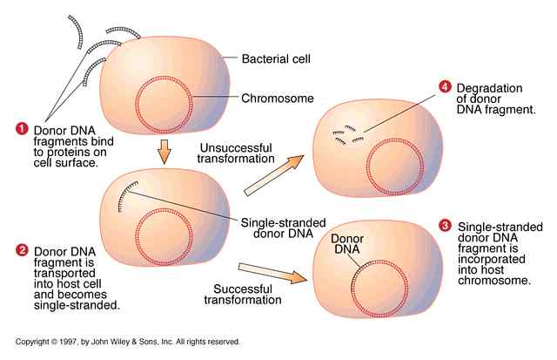

1. **Transduction:** Transfer of DNA from one bacterium to another through a virus called bacteriophage. When this phage is released from the host; they carry a very small portion of the host chromosome. This phage infects other cell; crossing over takes place between a fragment of chromosome of the donor cell and the homologous chromosome of the recipient cell.
2. **Conjugation: The ability of bacterial cells to transfer DNA between cells those are in physical contact.** It is the transfer of DNA from one bacterium to another through physical cellular contact with specific structure called sex pili.

The sex plasmid genes are responsible for the synthesis of special pili called [sex pili](http://www.slic2.wsu.edu:82/hurlbert/micro101/pages/Chap3.html#Pili). Sex pili are thin long, hollow protein tubes that have "sticky" receptors on their ends that bind firmly to molecules on recipient cell walls. The recipient cell receives DNA from donor bacterium through contact.

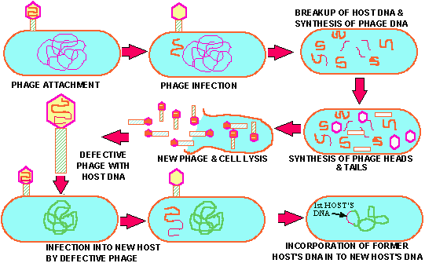

**4- Genetic Recombination**: When DNA enters the recipient cell by any of three mechanisms. It can synapse the homologous region of recipient genome and undergo recombination to give new genome or new DNA different from original one.

**Nitrogen Fixation**

“Nitrogen fixation is a process by which [nitrogen](https://en.wikipedia.org/wiki/Nitrogen) in the [Earth's atmosphere](https://en.wikipedia.org/wiki/Earth%27s_atmosphere) is converted into [ammonia](https://en.wikipedia.org/wiki/Ammonia) (NH3) or other molecules available to living organisms.Atmospheric nitrogen or molecular dinitrogen (N2) is relatively inert.It does not easily react with other chemicals to form new compounds.”

* Nitrogen fixation is essential for all forms of life because inorganic nitrogen compounds are required for the [biosynthesis](https://en.wikipedia.org/wiki/Biosynthesis) of the basic building blocks of plants, animals and other life forms, e.g., [nucleotides](https://en.wikipedia.org/wiki/Nucleotides) for [DNA and RNA](https://en.wikipedia.org/wiki/DNA_and_RNA).
* Coenzyme [nicotinamide adenine dinucleotide](https://en.wikipedia.org/wiki/Nicotinamide_adenine_dinucleotide) for its role in metabolism (transferring electrons between molecules), and [amino acids](https://en.wikipedia.org/wiki/Amino_acid) for [proteins](https://en.wikipedia.org/wiki/Protein).
* Therefore, as part of the [nitrogen cycle](https://en.wikipedia.org/wiki/Nitrogen_cycle), it is essential for [agriculture](https://en.wikipedia.org/wiki/Agriculture) and the manufacture of [fertilizer](https://en.wikipedia.org/wiki/Fertilizer).
* Nitrogen fixation is carried out naturally in the [soil](https://en.wikipedia.org/wiki/Soil) by nitrogen fixing [bacteria](https://en.wikipedia.org/wiki/Bacteria) such as [*Azotobacter*](https://en.wikipedia.org/wiki/Azotobacter).
* Some nitrogen-fixing Bacteria have [symbiotic](https://en.wikipedia.org/wiki/Symbiotic) relationships with some [plant](https://en.wikipedia.org/wiki/Plant) groups, especially [legumes](https://en.wikipedia.org/wiki/Legume).

**Non-Biological Natural Nitrogen Fixation**

* Nitrogen can be fixed by [lightning](https://en.wikipedia.org/wiki/Lightning) converting nitrogen and oxygen into [NOx](https://en.wikipedia.org/wiki/NOx) (nitrogen oxides), if there is oxygen in the air.
* NOx may react with water to make [nitric acid](https://en.wikipedia.org/wiki/Nitric_acid), which seeps into the soil, where it makes [nitrate](https://en.wikipedia.org/wiki/Nitrate), which is of use to growing plants.

**Biological Nitrogen Fixation**

* Biological nitrogen fixation was discovered by the German agronomist [Hermann Hellriegel](https://en.wikipedia.org/wiki/Hermann_Hellriegel)and Dutch microbiologist [Martinus Beijerinck](https://en.wikipedia.org/wiki/Martinus_Beijerinck)
* Biological nitrogen fixation (BNF) occurs when atmospheric nitrogen is converted to ammonia by an enzyme called a [nitrogenase](https://en.wikipedia.org/wiki/Nitrogenase).
* The overall reaction for BNF is:

N2 + 8 H+ + 8 e− → 2 NH3 + H2

* The process is coupled to the [hydrolysis](https://en.wikipedia.org/wiki/Hydrolysis) of 16 equivalents of [ATP](https://en.wikipedia.org/wiki/Adenosine_triphosphate) and is accompanied by the co-formation of one molecule of H2.
* The conversion of N2 into ammonia occurs at a [cluster](https://en.wikipedia.org/wiki/Metal_cluster) called [FeMoco](https://en.wikipedia.org/wiki/FeMoco), an abbreviation for the iron-molybdenum cofactor.
* The mechanism proceeds via a series of [protonation](https://en.wikipedia.org/wiki/Protonation) and reduction steps wherein the FeMoco [active site](https://en.wikipedia.org/wiki/Active_site)[hydrogenates](https://en.wikipedia.org/wiki/Hydrogenate) the N2 substrate

**Legume Family**

* In a symbiotic relationship with the soil bacteria known as 'rhizobia', legumes form nodules on their roots (or stems to 'fix' nitrogen into a form usable by plants).
* The process of biological nitrogen fixation was discovered by the Dutch microbiologist Martinus Beijerinck.
* Rhizobia (e.g., Rhizobium, Mesorhizobium, Sinorhizobium) fix atmospheric nitrogen or dinitrogen, N2 into inorganic nitrogen compounds, such as ammonium NH4+ which is then incorporated into amino acids, which can be utilized by the plant.
* Because legumes form nodules with rhizobia, they have high levels of nitrogen available to them. Their abundance of nitrogen is beneficial not only to the legumes themselves, but also to the plants around them.

**Non-leguminous**

Although by far the majority of plant species able to form nitrogen-fixing root nodules are in the legume family [Fabaceae](https://en.wikipedia.org/wiki/Fabaceae), there are exceptions:

* *Parasponia*, a tropical genus in the [Cannabaceae](https://en.wikipedia.org/wiki/Cannabaceae) also able to interact with rhizobia and form nitrogen-fixing nodules.
* [Actinorhizal plants](https://en.wikipedia.org/wiki/Actinorhizal_plant) such as [alder](https://en.wikipedia.org/wiki/Alder) and [bayberry](https://en.wikipedia.org/wiki/Bayberry) can also form nitrogen-fixing nodules
* Plants cannot fix nitrogen on their own, but need it in one form or another to make amino acids and proteins.

Click on an image to view larger version & data in a new window