Introduction:
A social group consists of two or more people who regularly interact on the basis of mutual expectations and who share a common identity. It is easy to see from this definition that we all belong to many types of social groups: our families, our different friendship groups, the sociology class and other courses we attend, our workplaces, the clubs and organizations to which we belong, and so forth. Except in rare cases, it is difficult to imagine any of us living totally alone. Even people who live by themselves still interact with family , coworkers, and friends and to this extent still have several group membership.

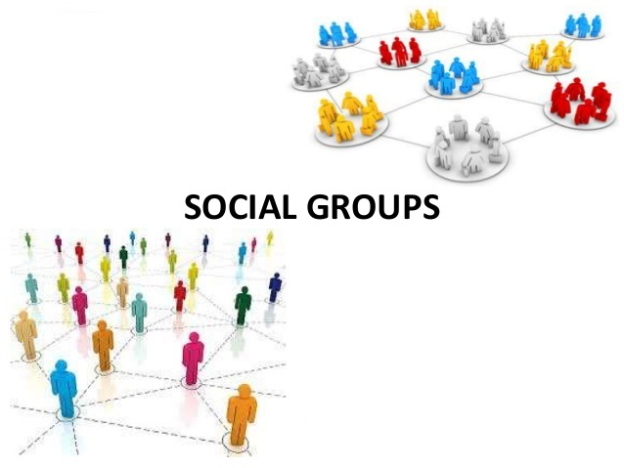
Meaning of Social groups:
Social group is the foundation of society and culture. Man is also a product of group life. Most of the Anthropologists believe that man started his life on this earth by living together. Man has always been dependent upon his fellow beings in defense, food and shelter. The satisfaction of various needs could be done only by cooperation among various people in society. This reciprocal help brought them into social contact with one another and here the social group was founded. It was the real foundation of human society. Imam Ghazali is also of the view that for the satisfaction of various needs the people formed social groups. Shah Wali Ullah Mohaddis Dehlvi said that for continuity of human race and satisfaction of other needs of food, house and clothes the human society was founded.

Definition
According to author “William Ogburn”, when two or more individuals come together and influence one another, they may be called a social group.
“Mayer nimkoff”, Social group is a group of two or more persons who can in state of interaction with another.
“Harry M johnson”, A social group is a system of social interactions.

“Marshal jones”, A social group is two or more people between whom there is an established pattern of social interact.

Example of social groups, A family living in a home, a group of employer work on same organization, a group of classmates, a group of meeting soon, a group of religious, a group of poor people. fraternities and sororities congregations.

Element of social groups:
- Two or more than two persons
- Common medium of communication
- Reciprocal relationship among them
- Influence on the events, behaviors, brain of the persons

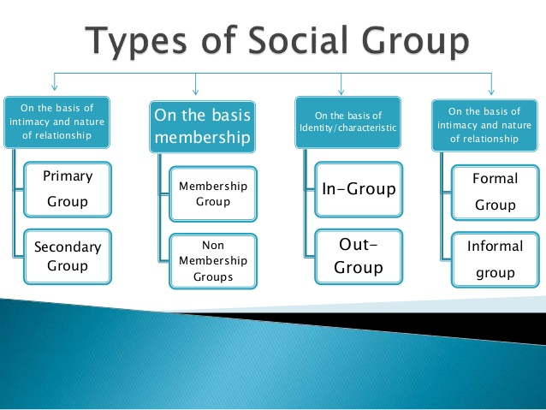
Types of social group:

Primary group
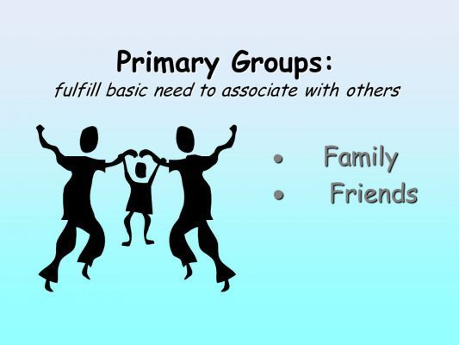
The primary group is the nucleus of all social organizations. It is a small group in which a small number of persons come into direct contact with one another. They meet “face to face” for mutual help, companionship and discussion of common questions. They live in the presence and thought of one another. Charles H. Cooley, the first sociologist to draw the attention to primary groups
Definition:
According to Horton and Hunt, a small group in which people come to know one and other intimately as individual personalities: distinct from the impersonal, forma, utilitarian secondary group.
Characteristic of Primary group:
The concept of primary is given by CH Cooley the primary group have following characteristics,
- There is face to face attraction among its member.
- There is frequent interaction among its member.
- The relation among the people personal intimate and intense.
- They are sense of we feeling in the members.
- The member possesses similar background attributes such as language interest culture religion etc.
- There is physical proximity among the members.
- These groups are similar in size.

Example:
Family, neighborhood, local brotherhood, close friends and peers primary group have great importance for instance, the family provide food, shelter and care to a kid. An individual learns his culture and develops a healthy personality within his primary groups to become a production citizen of a society.

Importance of Primary group:
Primary groups are important in several senses. They are equally important for individual as well as society. It is also equally important for child, youth and adults. Because they prepare individuals to lead a successful social life. Primary group is the first group with which a child comes in contact at the prime stage of his life. It is the birth place of human nature. Primary group plays a very important role in the socialization process and exercises social control over them. With the help of primary group we learn and use culture. They perform a number of functions for individual as well as society which show their importance.
(1) Primary group shapes personality of individuals. It plays a very important role in molding, shaping and developing the personality of an individual. Because individual first come in contact with primary group. Individual is socialized in a primary group. It forms the social nature, ideas and ideals of individuals. His self develops in primary groups. A child learns social norms, standards, beliefs, morals, values, sacrifice, co-operation, sympathy and culture in a primary group.
(2) Primary group fulfills different psychological needs of an individual such as love, affection, fellow feeling, co-operation, companionship and exchange of thought. In primary group he lives among his near and dear ones. It plays an important role in the reduction of emotional stresses and mental tensions. Participation with primary groups provides a sense of belongingness to individuals. He considers himself as an important member of group.
Secondary group
Secondary groups are large groups whose relationships are impersonal and goal oriented. People in a secondary group interact on a less personal level than in a primary group, and their relationships are generally temporary rather than long lasting.

Definition:
“Nimkoff and Ogburn”, A group which provide experience taking intimacy can be called secondary group.
“Diana Kendal”, A larger, more specialized group in which members engage in more impersonal, goal-oriented relationships for a limited period of time.

Characteristics:
- These group is large in size.
- There is Less physical proximity among the people
- Impersonal and secondary relations.
- Membership people always join and go away from group.
- Indirect communication.
- Social control (law and other regulation are enforcing on the members by authorities.

Examples
Let's take a look at some common examples of secondary groups.
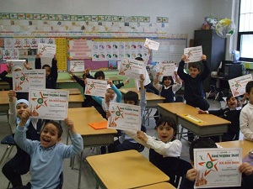
Classroom- A classroom consists of students and a teacher where the teacher is in charge of creating a structure and environment that help the students learn. This involves implementing a set of rules and expectations and helping the students meet their educational goals. A classroom is located in a school, which is a common meeting place for the students and the teacher.
Figure 1Secondary group - Students share the achievement of an educational goal
.
Place of Employment In a work environment, employees and supervisors come together in a mutual location (such as an office building) for the purpose of completing a task. The supervisors lead their employees by having an arrangement that highlights expectations and requirements. The goal of the structured environment is to fulfill a predetermined assignment. A shopkeeper customer relation A doctor patient relation an advocate client relation a teacher student relation a candidate voter relation.

Function of group:
Following are the main functions of secondary groups:
- To help in fulfilling various kinds of increasing human needs.
- To help in bringing social awareness and social change.
- To help in removing conservatism and superstition through education and rational thinking.
- To increase social mobility.
- To help in satisfying various special interests such as sports, dance, music, touring etc.
Importance of secondary group:
The impersonality and formality of the secondary group allows members to focus on skills and specialized interests rather than on personalities. Most jobs, whether they involve driving a bus or performing brain surgery, have clearly defined goals and role expectations, so the personal characteristics of the people fulfilling the role and the public’s need for emotional involvement with them are not of great importance.

ON THE BASIS OF IDENTIFICATION
W.G Summer has divided social groups into two type: In-group and Out-group

In-Group
A group, to which we directly belong, is called our in-group. It can be our own family, tribe, sex, occupation, games or interest group. For example, if I am player of a cricket team, my cricket-team in in-group for me. A religious group in in-group for its followers. A geographical community is in-group for its residents. The term ‘in-group’ is used when an individual wants to identify himself with a group or show an association with his group, such as by saying: We are Americans, we are English, we are Christian, We are Muslims, We are student, We are doctors, We are musicians.
The member of in-group has a sense of \we-feeling’ and belongingness towards their in-group.
DEFINITIATION
According to “Horton and Hunt” A group or category toward which one has a feeling of identity and belonging.
According to “Diana Kendal” A group to which a person belongs and with which the person feels a sense of identity.
Characteristics of in group:
- There is a strong unitary and brotherhood.
- There are we feelings
- They always trust on each other’s
- There is ability to stable
Out-group
A group, to which we do not belong, is called an out-group. It can be any group of others (not ours) including a family, tribe, ethnicity, sex, occupations or interest groups. For example, If I am a student of Psychology, the students of psychology are in-group for me, but the students of any other discipline (other than psychology) are an out-group for me. The term 'out-group' is used to distinguish one's identity from that of others or to compare one's identity to that of other, such as by saying: We are Americans (in-group) and they are Indians (out-group). We are Muslims (in-group) and they are Christians (out-group). We are doctors (in-group) and they are engineers (out-group).
There is a sense of 'they-feeling' while referring to an out-group.
Definition:
According to “Hortan and Hunt.” A group of categories toward which one has no feeling of identity and belonging”
According to Diana Kendal” A group to which a person belongs and with which the person feels a sense of identity”
Characteristics of outer group:
- Rules and regulations.
- Ethnocentrism.
- Stability
- Common interest
- Sincerity

ON THE BASIS OF RULES AND REGULATIONS
There are two types of social groups on the basis of rules and regulations: Formal and Informal Group.
Formal Group
It is a group that has well-defined rules and regulation for joining the group, staying in the group and leaving the group. Those, who fulfill these rules and regulations. can join and engage in the activities of the group. The membership can be canceled if the member violates the rules. The examples include organizations. banks. hospitals, educational institutions, official associations and firms and so on.
Informal Group
It is a group which has prescribed rules and regulation for joining the group. staying in the group and leaving the group. Any person can join the group. participate in it and leave it whenever he wants. For example. a group of students sitting in playground and gossiping with one another. Any other classmate can come and join it. Other examples include: People gathered to see a Joker in a public place, informal clubs and associations.
Characteristics of formal or informal group:
- Rules and regulation
- Nature of relations
- Durability
- Group structure
- Impact of personality
Furthermore
Difference between formal and informal group
 | Formal Groups | Informal Groups
1. | Formal groups posses the attributes of organization. | Informal groups don’t possess organization.
2. | These groups established for the fulfillment of some specific interests. | Informal groups established spontaneously.
3. | Social interaction among the members is formal, systematic and patterned. | Social interaction is informal and casual in nature.
4. | Formal groups have formal rules and regulations. | Informal groups have no definite norms and rules.
5. | Formal groups have formal structure. | Informal groups have no formal structure. Members of informal groups are usually scattered.

References Groups
The term reference group was introduced by Muzaffar sharif in his book “An outline of Social Psychology”. It is that group in which and individual was socialize, He identifies himself by his group, this group may include the member of the family and those who influence him. How left bright effects on the social life on individual or the member of references group.
Ethnic Group
It is group which has its culture, trades different from the general culture of society, these are smaller group, they are always in minority. This group has its on custom believes different from another group. In Pakistan society the people of tribe areas than nomadic tribe, the Hindu, the Christian, the American, they are ethnic group.
Cast
Cast is permanent group in which the status of individual is fixed through heredity alone. The member of cast usually creates Biradri in indo Pakistan society. Cast is ascribed status received at worth, different cast between different social position on our society. The people of same cast “Biradri” for inters marriage. The cast system prevalent in Pakistani society.
Pressure Group
It is that group which lays pressure on government to change its politics it is group of high-class people specially the rich and diplomatic. This group enjoy high status in society. The member of this group always participates in running government and administration.
Vested interested Group
It is the group which has its own ends, mostly the economics benefits are the major aim, this group for the sake of its aims doesn’t interfere in government like the pressure group. But It has its own way by following the government, this group drive benefit from the government.
Club
It is a formally organized group it is multipurpose and called congenial group because such groups are product of friendship and association.

BASIS OF STRUCTURE of social group:
Sanderson has divided social groups on the basis of structure into three types: Voluntary, Involuntary and Delegate group.
Involuntary Group
It is a group that an individual cannot join or leave by his or her own choice. For example. a family is an involuntary group because an individual has no control over his birth - to be born or not born in a specific family. Similarly. the sex-group is an involuntary group to which we are born without our choice and we have no control on changing our sex-group (e.g. from male to female or vice versa). Age-group is also an involuntary group. We belong to our age group which changes with growth but we have no control on changing our age group.
Voluntary Group
It is a group that an individual can join or leave by his or her own choice. For example. you can join people watching a game in the playground, you can become a student in a college, you can join an organization and so on. Sometimes, you are required to fulfill criteria to join a voluntary group but still, it is in your control to fulfill the criteria and join it.
Delegate Group
It is a group that serves as a representative of the larger number of people. The members are either elected by the people or nominated on the basis of certain criteria. A parliament is a delegate group as it represents wishes and needs of the public. Similarly. a group of experts, sent to another country to discuss an issue on behalf of their country, is a delegate group.
RELATIONS TO SOCIETY
George Hassen has divided social groups on the basis of its relation to society into following four types:
Un-social Group
It is a group that remains detached within a society. They do not participate in the society and remains alone. The examples are introverts, people with adjustment problems or psychological anomalies, drug addicts, criminals, thieves, and murders.
Anti-social Groups
It is a group that acts against the interest of the society. They destroy public property and peace. They intend to spread fear and aggression to pursue their aims. Examples include
the terrorist groups, criminals. thieves. and murderers. Similarly, a group of laborers on strike against the administration of a factory, students demonstrating protest. people gathered to demonstrate against the government may also sometimes become violent and anti-social groups.
Pro-Social Group
It is a group that works for the betterment of the society. They engage in activities for the development, prosperity, welfare, and peace in the society. All the governmental and non-governmental welfare organizations are the examples of pro-social groups who work promoting education. reducing poverty. providing health care, treating drug addicts. helping the underprivileged people and rehabilitating the grieved ones in the society.

Importance or significance of Social group
No man is always live alone. the great Greek philosopher Aristotle said that “man is a social animal and he who does not live in society is either a beast or an angel Man everywhere live in group.
- Survival for human being
- Group develop human potential
- Group helps in socialization
- Provision of basic needs
- Development of personality
- Transmission of cultures
- Continuity of human race

