Lecture 2: Rendering Practice

Subject: Foundation Drawing-II
Class: BS Textile 2nd
Instructor: Ms. Nadia Abbasi

Assignment 1
Draw few basic shapes and shade in strokes along contours.
What are rendering techniques?
Rendering or image synthesis is the automatic process of generating a photorealistic or non-photorealistic image from a 2D or 3D model (or models in what collectively could be called a scene file) by means of computer programs. ... The term "rendering" may be by analogy with an "artist's rendering" of a scene.

- Practice defining contours. ...
- Understand the theory of tonal values. ...

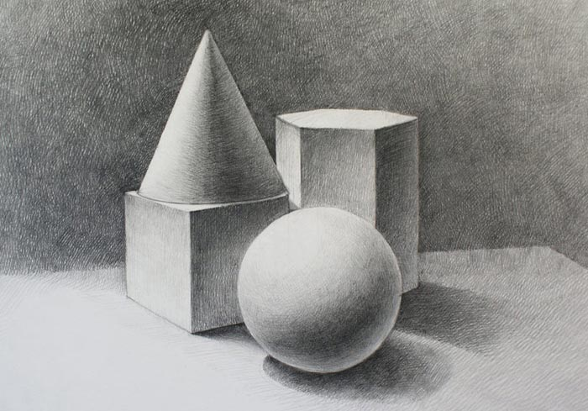

Assignment No: 2
- Practice shading techniques. ...
- Practice tonal gradations. ...
- Learn from the Old Masters.

