Department of Mechanical Engineering&Tech
College Of Engineering and Technology
University of Sargodha

Lab Manual
Mechanical Vibrational (lab)
Session-(2018-2022)
BSc Mechanical Engineering&Tech
Lab Instructor: Engr. Anam Shahzadi
Name:..........
Roll No: ........
Semester: .....
Instructor Signature: ____
Marks Obtained : _________
Grade : _________

- List of Experiments:-

- Experiment no# 01:-
- To Study lay out and its types and objectives with examples.

- Experiment no# 02:-
- To investigate theeffect of small amplitude.
- To determine the radius of gyration of a compound pendulum it’s centre of gravity.
- To verify that the compound pendulum periodic time of oscillation for small amplitude.

- Experiment no# 03:-
- To measure the time period of Simple pendulum using steel and wooden ball.

- Experiment no# 04:-
- To determine the moment of inertia of a horizontal rectangular drop bar about its centre of mass using the bifilar suspension technique.

- Experiment no# 05:-
- To evaluate the static and dynamic Test of mas spring system.

- Experiment no# 06:-
- To find centre of percussion by using compound pendulum.

- Experiment no# 07:-
- To find the value of g using reversible Pendulum apparatus (Kater Pendulum).

- Experiment no# 08:-
- To find the damping coefficient by using free vibration with damper.

- Experiment no# 09:-
- To find the frequency by using lateral vibrational system.

- Experiment no# 10:-
- To measure the forced vibration frequency with damping.

- Experiment no# 11:-
- To measure forced vibration frequency without damping.
Experiment No# 01

- Objective:
“To Study lay out and its types and objectives with examples.”
- THEORY:
Layout
In manufacturing, facility layout consists of configuring the plant site with lines, buildings, major facilities, work areas, aisles, and other pertinent features such as department boundaries. While facility layout for services may be similar to that for manufacturing, it also may be somewhat different—as is the case with offices, retailers, and warehouses. Because of its relative permanence, facility layout probably is one of the most crucial elements affecting efficiency. An efficient layout can reduce unnecessary material handling, help to keep costs low, and maintain product flow through the facility.
Firms in the upper left-hand corner of the product-process matrix have a process structure known as a jumbled flow or a disconnected or intermittent line flow. Upper-left firms generally have a process layout. Firms in the lower right-hand corner of the product-process matrix can have a line or continuous flow. Firms in the lower-right part of the matrix generally have a product layout. Other types of layouts include fixed-position, combination, cellular, and certain types of service layouts.
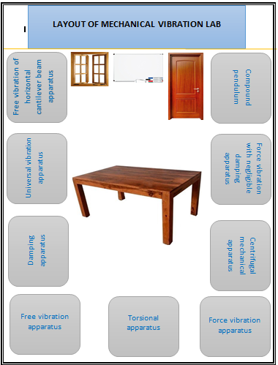

PROCESS LAYOUT
Process layouts are found primarily in job shops, or firms that produce customized, low-volume products that may require different processing requirements and sequences of operations. Process layouts are facility configurations in which operations of a similar nature or function are grouped together. As such, they occasionally are referred to as functional layouts. Their purpose is to process goods or provide services that involve a variety of processing requirements. A manufacturing example would be a machine shop. A machine shop generally has separate departments where general-purpose machines are grouped together by function (e.g., milling, grinding, drilling, hydraulic presses, and lathes). Therefore, facilities that are configured according to individual functions or processes have a process layout. This type of layout gives the firm the flexibility needed to handle a variety of routes and process requirements. Services that utilize process layouts include hospitals, banks, auto repair, libraries, and universities.
Improving process layouts involves the minimization of transportation cost, distance, or time. To accomplish this some firms use what is known as a Mouther grid, where subjective information is summarized on a grid displaying various combinations of department, work group, or machine pairs. Each combination (pair), represented by an intersection on the grid, is assigned a letter indicating the importance of the closeness of the two (A = absolutely necessary; E = very important; I = important; O = ordinary importance; U = unimportant; X = undesirable). Importance generally is based on the shared use of facilities, equipment, workers or records, work flow, communication requirements, or safety requirements. The departments and other elements are then assigned to clusters in order of importance.
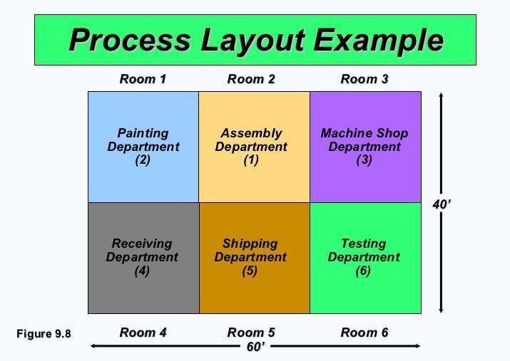
- Advantages of process layouts
Advantages of process layouts include:
- Flexibility. The firm has the ability to handle a variety of processing requirements.
- Cost. Sometimes, the general-purpose equipment utilized may be less costly to purchase and less costly and easier to maintain than specialized equipment.
- Motivation. Employees in this type of layout will probably be able to perform a variety of tasks on multiple machines, as opposed to the boredom of performing a repetitive task on an assembly line. A process layout also allows the employer to use some type of individual incentive system.
- System protection. Since there are multiple machines available, process layouts are not particularly vulnerable to equipment failures.
- Disadvantages of process layouts
Disadvantages of process layouts include:
- Utilization. Equipment utilization rates in process layout are frequently very low, because machine usage is dependent upon a variety of output requirements.
- Cost. If batch processing is used, in-process inventory costs could be high. Lower volume means higher per-unit costs. More specialized attention is necessary for both products and customers. Setups are more frequent, hence higher setup costs. Material handling is slower and more inefficient. The span of supervision is small due to job complexities (routing, setups, etc.), so supervisory costs are higher. Additionally, in this type of layout accounting, inventory control, and purchasing usually are highly involved.
- Confusion. Constantly changing schedules and routings make juggling process requirements more difficult.

PRODUCT LAYOUT
Product layouts are found in flow shops (repetitive assembly and process or continuous flow industries). Flow shops produce high-volume, highly standardized products that require highly standardized, repetitive processes. In a product layout, resources are arranged sequentially, based on the routing of the products. In theory, this sequential layout allows the entire process to be laid out in a straight line, which at times may be totally dedicated to the production of only one product or product version. The flow of the line can then be subdivided so that labor and equipment are utilized smoothly throughout the operation.
Two types of lines are used in product layouts: paced and unpacked. Paced lines can use some sort of conveyor that moves output along at a continuous rate so that workers can perform operations on the product as it goes by. For longer operating times, the worker may have to walk alongside the work as it moves until he or she is finished and can walk back to the workstation to begin working on another part (this essentially is how automobile manufacturing works).
On an unpacked line, workers build up queues between workstations to allow a variable work pace. However, this type of line does not work well with large, bulky products because too much storage space may be required. Also, it is difficult to balance an extreme variety of output rates without significant idle time. A technique known as assembly-line balancing can be used to group the individual tasks performed into workstations so that there will be a reasonable balance of work among the workstations.
Product layout efficiency is often enhanced through the use of line balancing. Line balancing is the assignment of tasks to workstations in such a way that workstations have approximately equal time requirements. This minimizes the amount of time that some workstations are idle, due to waiting on parts from an upstream process or to avoid building up an inventory queue in front of a downstream process.
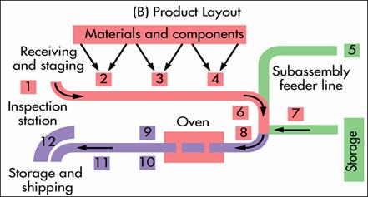

- Advantages of product layouts
Advantages of product layouts include:
- Output. Product layouts can generate a large volume of products in a short time.
- Cost. Unit cost is low as a result of the high volume. Labor specialization results in reduced training time and cost. A wider span of supervision also reduces labor costs. Accounting, purchasing, and inventory control are routine. Because routing is fixed, less attention is required.
- Utilization. There is a high degree of labor and equipment utilization.
- Disadvantages of product layouts
Disadvantages of product layouts include:
- Motivation. The system's inherent division of labor can result in dull, repetitive jobs that can prove to be quite stressful. Also, assembly-line layouts make it very hard to administer individual incentive plans.
- Flexibility. Product layouts are inflexible and cannot easily respond to required system changes—especially changes in product or process design.
- System protection. The system is at risk from equipment breakdown, absenteeism, and downtime due to preventive maintenance.

FIXED-POSITION LAYOUT
A fixed-position layout is appropriate for a product that is too large or too heavy to move. For example, battleships are not produced on an assembly line. For services, other reasons may dictate the fixed position (e.g., a hospital operating room where doctors, nurses, and medical equipment are brought to the patient). Other fixed-position layout examples include construction (e.g., buildings, dams, and electric or nuclear power plants), shipbuilding, aircraft, aerospace, farming, drilling for oil, home repair, and automated car washes. In order to make this work, required resources must be portable so that they can be taken to the job for "on the spot" performance.
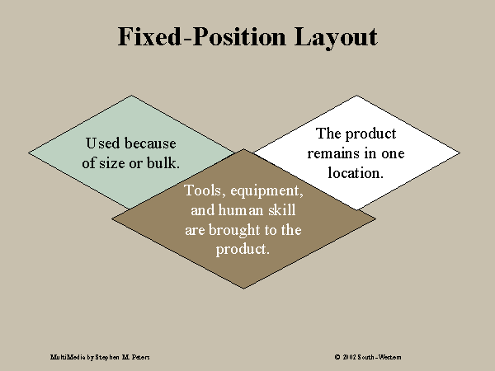

- Disadvantages of Fixed –Position Layout
Disadvantages include:
- Space. For many fixed-position layouts, the work area may be crowded so that little storage space is available. This also can cause material handling problems.
- Administration. Oftentimes, the administrative burden is higher for fixed-position layouts. The span of control can be narrow, and coordination difficult.

COMBINATION LAYOUTS
Many situations call for a mixture of the three main layout types. These mixtures are commonly called combination or hybrid layouts. For example, one firm may utilize a process layout for the majority of its process along with an assembly in one area. Alternatively, a firm may utilize a fixed-position layout for the assembly of its final product, but use assembly lines to produce the components and subassemblies that make up the final product (e.g., aircraft).

CELLULAR LAYOUT
Cellular manufacturing is a type of layout where machines are grouped according to the process requirements for a set of similar items (part families) that require similar processing. These groups are called cells. Therefore, a cellular layout is an equipment layout configured to support cellular manufacturing.
Processes are grouped into cells using a technique known as group technology (GT). Group technology involves identifying parts with similar design characteristics (size, shape, and function) and similar process characteristics (type of processing required, available machinery that performs this type of process, and processing sequence).
Workers in cellular layouts are cross-trained so that they can operate all the equipment within the cell and take responsibility for its output. Sometimes the cells feed into an assembly line that produces the final product. In some cases a cell is formed by dedicating certain equipment to the production of a family of parts without actually moving the equipment into a physical cell (these are called virtual or nominal cells). In this way, the firm avoids the burden of rearranging its current layout. However, physical cells are more common.
An automated version of cellular manufacturing is the flexible manufacturing system (FMS). With an FMS, a computer controls the transfer of parts to the various processes, enabling manufacturers to achieve some of the benefits of product layouts while maintaining the flexibility of small batch production.
- Advantages of cellular manufacturing
Some of the advantages of cellular manufacturing include:
- Cost. Cellular manufacturing provides for faster processing time, less material handling, less work-in-process inventory, and reduced setup time, all of which reduce costs.
- Flexibility. Cellular manufacturing allows for the production of small batches, which provides some degree of increased flexibility. This aspect is greatly enhanced with FMSs.
- Motivation. Since workers are cross-trained to run every machine in the cell, boredom is less of a factor. Also, since workers are responsible for their cells' output.

Experiment No# 02

- Objective:-
1:- To investigate theeffect of small amplitude.
2:- To determine the radius of gyration of a compound pendulum it’s centre of gravity.
3:-To verify that the compound pendulum periodic time of oscillation for small amplitude.
- Apparatus:-
- Compound pendulum
- Stopwatch.

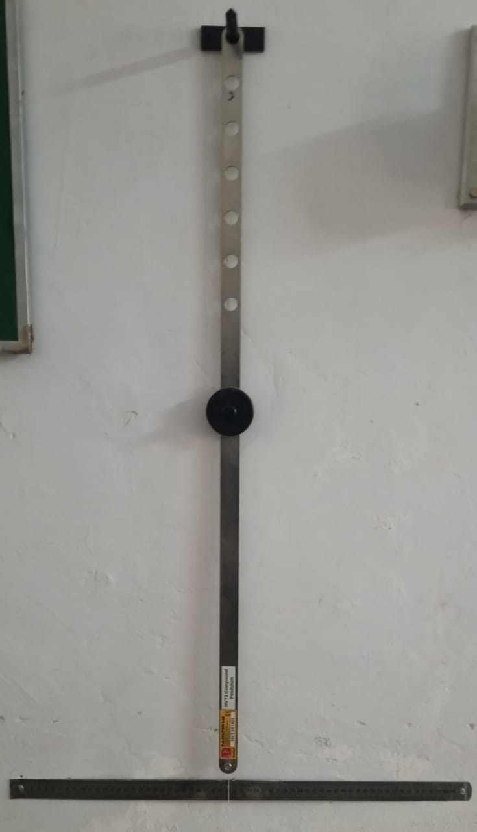

- Theory:-
Compound pendulum
Any swinging rigid body free to rotate about a fixed horizontal axis is called a compound pendulum or physical pendulum. The appropriate equivalent length for calculating the period of any such pendulum is the distance from the pivot to the centre of oscillation.
A compound pendulum has an extended mass, like a swinging bar, and is free to oscillate about a horizontal axis. A special reversible compound pendulum called Katter’s pendulum is designed to measure the value of g, the acceleration of gravity.
Amplitude
The period of swing of a compound pendulum depends on its length, the local strength of gravity, and to a small extent on the maximum angle that the pendulum swings away from vertical, θ0, called the amplitude. It is independent of the mass of the bob.
Radius of Gyration
Radius of gyration or gyradius of a body about an axis of rotation is defined as the radial distance of a point from the axis of rotation at which, if whole mass of the body is assumed to be concentrated, its moment of inertia about the given axis would be the same as with its actual distribution of mass. It is denoted by $R_{g}$.

- Procedure:-
- First hang the pendulum horizontally and move it until it reaches equilibrium so you can find the centre of mass and mark it.
- Secondly hang it vertically inserting the tip of the knife in the first hole from the centre of mass. Then set it oscillating through a small angle.
- Measure the time needed for 20 oscillations and the corresponding h.
- Repeat steps 2 and 3 for the other holes.
- Record your measurements in a table.

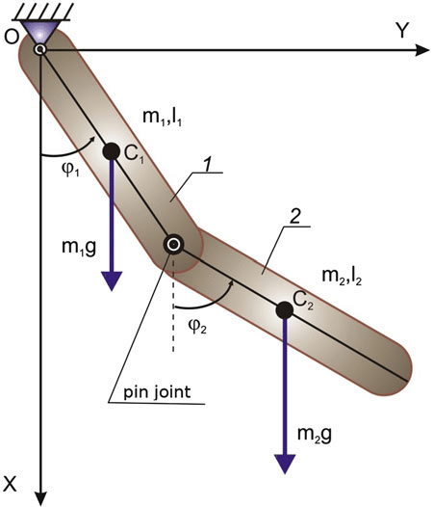

- Observations and calculations:-

Distance  X (cm) | Time period for first 20 vibrations | Time period for 2nd 20 vibrations | Time period for 3rd 20 vibrations | Average time period | Periodic time $T_{p}$ (T/20)
0.473 | 28 | 30 | 30 | 29.3 | 1.45
0.423 | 31 | 29 | 29 | 29.6 | 1.48
0.373 | 28 | 28 | 28 | 28 | 1.45
0.323 | 27 | 27 | 27 | 27 | 1.35
0.273 | 26 | 26 | 26 | 26 | 1.3
0.223 | 26 | 26 | 26 | 26 | 1.3
0.173 | 25 | 25 | 26 | 25.3 | 1.26

T.P_min | 1.265
k_cg | 0.198

- Experimental:-
$k_{eg}$=$\frac{({T.P}_{min})^2×g}{{8π}^{2}}$
T.P=$\frac{number of vib}{totle time}$
- Theoretical:-
$$k_{eg}=\sqrt{\frac{I×g}{m}}$$
$$I=\frac{m(a^{2}+b^{2})}{12}$$
$$T.P=2π\sqrt{x^{2}+\frac{k^{2}}{gx}}$$

- Comments:-
- The period of swing of a simple gravity pendulum depends on its length, the local strength of gravity, and to a small extent on the maximum angle that the pendulum swings away from vertical, θ0, called the amplitude.
- It is independent of the mass of the bob.
- When released, the restoring force acting on the pendulum's mass causes it to oscillate about the equilibrium position, swinging back and forth.
Experiment No# 03

- Objective:-

“To measure the time period of Simple pendulum using steel and wooden ball.”

- Apparatus:-
- Simple pendulum
- Stopwatch
- Thread
- Wooden and steel balls (bobs)

- Theory:-
Simple pendulum
A pendulum is a weight suspended from a pivot so that it can swing freely.When a pendulum is displaced sideways from its resting, equilibrium position, it is subject to a restoring force due to gravity that will accelerate it back toward the equilibrium position. When released, the restoring force acting on the pendulum's mass causes it to oscillate about the equilibrium position, swinging back and forth.
Time Period
The period of swing of a simple gravity pendulum depends on its length, the local strength of gravity, and to a small extent on the maximum angle that the pendulum swings away from vertical, θ0, called the amplitude. It is independent of the mass of the bob. If the amplitude is limited to small swings, the period T of a simple pendulum, the time taken for a complete cycle:-
$$T=2π\sqrt{\frac{L}{G}}$$
Where L is the length of pendulum and G is the gravitational acceleration.

- PROCEDURE:-

- The period T of a simple pendulum (measured in seconds) is given by the formula:
- T=2 π$√\frac{L}{G}$
- T = time for 30 oscillations
using equation (1) to solve for “g”, L is the length of the pendulum (measured in meters) and g is the acceleration due to gravity (measured in meters/sec2). Now with a bit of algebraic rearranging, we may solve Eq. (1) for the acceleration due to gravity g. (You should derive this result on your own).
g = 4 π²L/T2

- Measure the length of the pendulum to the middle of the pendulum bob. Record the length of the pendulum in the table below.

- With the help of a lab partner, set the pendulum in motion until it completes 30 to and fro oscillations, taking care to record this time. Then the period T for one oscillation is just the number recorded divided by 30 using (eq. 2).

- You will make a total of eight measurements for g using two different masses at four different values for the length L.
Note: π = 3.14, 4 π² = 39.44

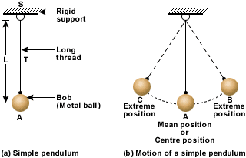

Observations and calculations:-
Length  L (m) | steel | wood | Time period (wood) | Time period (steel) | Theoretical time period
10 | 16.33 | 15.53 | 0.81 | 0.7761 | 0.6343
20 | 20.33 | 19.65 | 1.0165 | 0.9825 | 0.891
30 | 24.08 | 23.66 | 1.204 | 1.183 | 1.0987

Time period=T=2$π\sqrt{\frac{l}{g}}$

- COMMENTS:-
- The period of swing of a simple gravity pendulum depends on its length, the local strength of gravity, and to a small extent on the maximum angle that the pendulum swings away from vertical, θ0, called the amplitude.
- It is independent of the mass of the bob.
- When released, the restoring force acting on the pendulum's mass causes it to oscillate about the equilibrium position, swinging back and forth.

Experiment No# 04

- Objective:-
“To determine the moment of inertia of a horizontal rectangular drop bar about its centre of mass using the bifilar suspension technique.”
- Apparatus:-
- Bifilar suspension apparatus.
- Weights.
- Measuring tape.
- Ropes.

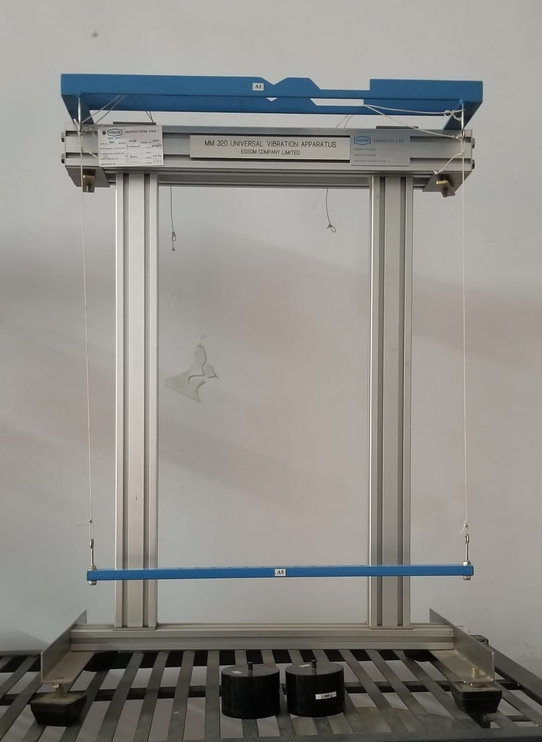

- Theory:-
INTRODUCTION

The bifilar suspension is a technique used to determine the moment of inertia of any type of object about any point on the object. This is done by suspending two parallel cords of equal length through the object examined. However, the approach taken for this experiment is to determine the moment of inertia of a drop by suspending the cords through the mass centre of bodies, obtaining an angular displacement about the vertical axis through the centre of mass by a sensibly small angle.
- SYSTEM LAYOUT AND APPARATUS USED
The apparatus used for this experiment consists of a uniform rectangular drop bar suspended by fine wires (assumed to have negligible weight contribution to the system). This rectangular bar contains holes equidistant from each other and two extra with equal masses of 1.85kg, are made to peg through these holes. Chucks are also in place to alter length of suspended wires.
In addition an enclosed-type measuring tape and weight balance were also used for the experiment.
A diagram on the arrangement of the apparatus used is illustrated below:

- Procedure:-

- With the bar suspended by the wires, the length L was adjusted to a convenient extent and then distance, b, between the wires was measured.

- The bar was then tilted through a very small angle about the vertical axis and time taken for 20 oscillations of the bar, was recorded. From this, the periodic time was also calculated.
- The length L was further adjusted and the time taken for another 20 oscillations was recorded.
- The inertia of the rectangular bar was then increased by including the “two 1.85kg masses” symmetrically on either side of the centreline distance x apart.
- Then step 3 was repeated but with different values of L
- The length of the wire L was then fixed at a value and the time taken was recorded for 20 oscillations at varying distances x, between the two 1.85kg masses.
- The rectangular bar was then detached from the apparatus arrangement and taken to weight balance in order to determine the mass of the bar.
- The internal diameters of the holes, the thickness of the rectangular were also measured.
- All measurements and data recorded were collated for experimental analysis.

- Calculations and calculations:-

L(m) | Distance (mm) | Time period for 20 oscillations  (s) | T.P  (s) | $$T^{2}$$ | m  (kg) | $$K_{cg}$$ | $$I_{cg}$$
0.3 | 0 | 22.17 | 1.106 | 1.2232 | 1.24 | 0.019 | 0
0.4 | 0 | 26.95 | 1.3415 | 1.815 | 1.24 | 0.020 | 0
0.5 | 0 | 28.71 | 1.4352 | 2.0606 | 1.24 | 0.014 | 0
0.3 | 265 | 21.41 | 1.0705 | 1.145 | 4.84 | 0.021 | 0.339
0.4 | 265 | 25.47 | 1.2785 | 1.634 | 4.84 | 0.018 | 0.339
0.5 | 265 | 28.4 | 1.42 | 2.0164 | 4.84 | 0.0177 | 0.339
0.3 | 220 | 23 | 1.15 | 1.3225 | 4.84 | 0.0107 | 0.234
0.4 | 220 | 25.5 | 1.275 | 1.6256 | 4.84 | 0.011 | 0.234
0.5 | 220 | 29.08 | 1.457 | 2.114 | 4.84 | 0.016 | 0.234

Graph:-

- Precaution:-

- Measurement taken from the rule and the weight balance was done such that the line of sight and the markings of the measuring equipment were in alignment in to reduce errors due to parallax.
- When taking down the time for the oscillations at various distances ‘x’ and a fixed length ‘L’ for table 3 data, the length L was periodically checked after each test in order to maintain the fixed length value of 0.4m
- Precautionary methods were in place to keep the masses at a very comfortable position so as to avoid slip or fall which could in-turn cause harm to our feet.
- The experiment is done such that the oscillation was not dampened by carefully tilting the bar before release for oscillations.

- Comments:-

- The periodic time significantly increased when the length of the wires also go increased.
- The periodic time also increased when the distances between the masses added to system reduced
- The moment of inertia determined using the analytical approach was approximately equal to the value determined from test 2 in table 2 above.
- The moment of inertia determined from the graph representation was greater than the value gotten from the analytical approach indicating that the two masses added during the experiment had a part to play in the increment of the moment of inertia and also unavoidable human errors caused a variation in their values.
- The radius of gyration and moment of inertia reduced after the length of wire was increased from test 1 to test 2 but increased right after till test 4.

Experiment No# 05

- Objective:-
“To evaluate the static and dynamic Test of mas spring system.”
- Apparatus:-
- Static and dynamic test mass spring system apparatus.

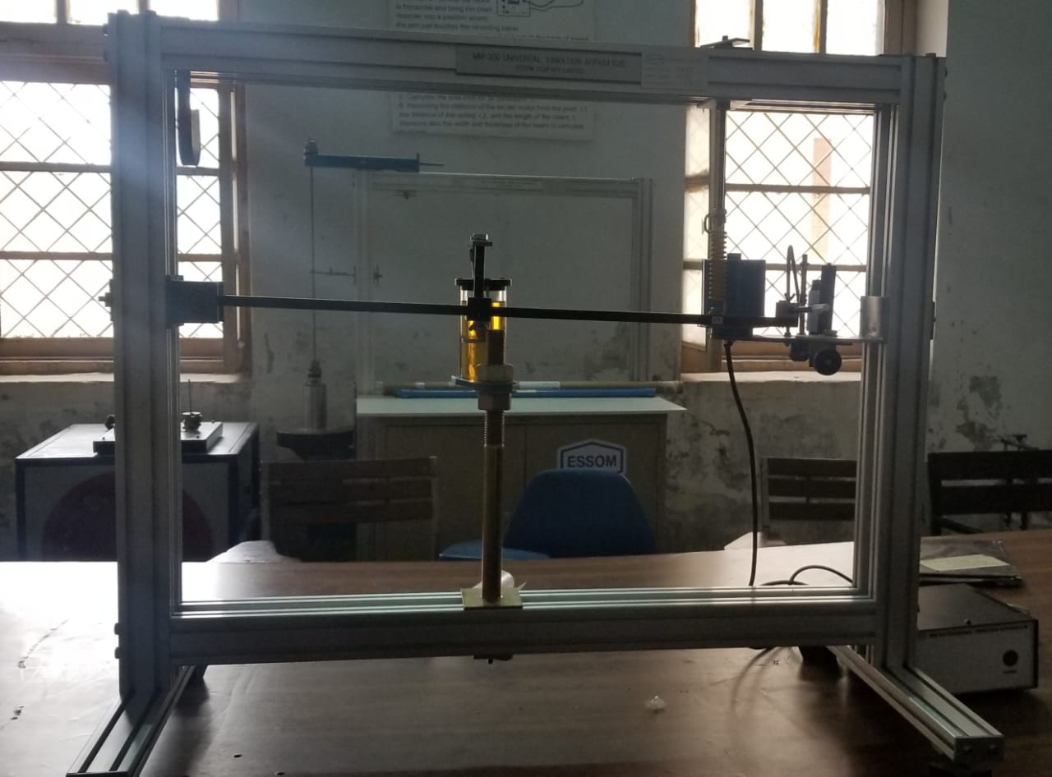

- Theory:-
Static and Dynamic testing
Static is found by measuring the displacement from equilibrium by adding different weights and dynamic is found by measuring periods by also adding different weights but using the samedisplacement’
In this lab the mechanical behaviour of a spring is investigated. Springs are characterized by a linear restoring force and exhibit simple harmonic motion. This behaviour occurs in many other physical systems, such as 3D solids, waves, electrical circuits, etc. The concept is central to many subjects, and is discussed at length in physics, electrical engineering and mechanical engineering textbooks. Here we will measure the force constant using both static and dynamic methods and compare with Hooke’s law. An ideal spring follows a linear force-distance relation and is massless. The static behaviour then is described by Hooke’s Law:
F(x) = -KS ($x-$)
where F is the force exerted by the spring (opposing the external stretch force), (X-X0) is the stretch distance, measured from the resting position X0 where the force is zero, and KS is the static spring constant. In this lab, the force is generated by calibrated weights hung on a vertically suspended spring. Any system described by Hooke’s law will exhibit “simple harmonic motion" if it is displaced from $x_{0}$ and released.

- PROCEDURE:-
For the static measurements, calibrated weights were hung from the spring and the overall length between the centres of the two end-hooks was measured using a meter stick, by sighting carefully to minimize parallax. Data are taken first by adding and then by removing weights to establish uncertainties. For the dynamic measurements, the elapsed time for 3 complete cycles of oscillation was recorded for each mass. Both the start and stop times were marked at the top of the oscillation, after “synchronizing” to the pace of the motion. The amplitude was kept below 3 cm, to avoid non-linearity. A small decay of amplitude after 3 beats was noticed, but is not expected to affect the average period.
- Arrange the apparatus on table.
- Check and set the apparatus according to experimental technique.
- For static testing of spring mass system put weight for testing.
- After putting weight apply the force on spring mass system,
- After applying force note down the deflection covered by spring mass.
- For dynamic testing apply force on spring mass system.
- Then take the stop watch and find out the no of vibrations completed w.r.t time.
- After calculating T then take the square of this T.
- Repeat experiment for different weights for static and dynamic testing.
    - Length of spring=145mm
    - Deflected length=152.4mm
    - 6” *25.4= 152.4

- Observations and calculations

Static Testing | Dynamic Testing

Mass  (g) | force | deflection | T | $$T^{2}$$
500 | 4.905 | 4 | 0.875 | 0.765
1000 | 9.81 | 7 | 0.833 | 0.69
1500 | 14.715 | 8 | 0.753 | 0.56
2000 | 19.62 | 9 | 0.741 | 0.0.55
2500 | 24.55 | 11 | 0.650 | 0.422
3000 | 29.43 | 12 | 0.61 | 0.382

- Comments:-
For the static measurement, the fit to Equation 1 is good. That is, there is no systematic deviation from the trend. All physical systems that follow this behaviour shall henceforth be said to follow Hooke’s Law. We note that, for applied mass less than 0.4kg, the spring has a fixed length of 12 cm. This can be understood as a pre-loaded tension, corresponding to a “rest length” of L0 = 10.2 ± 0.14 cm which is shorter than the physical length of Lm = 12 cm. The scatter in the data (random uncertainty) is about ± 0.5cm. This is attributed to parallax errors in reading the length. This could be improved using a travelling microscope, or more simply with a mirror assembly next to the ruler to allow auto-collimation of the sighting. It was expected that the stretch length might drop below the trend line for large applied force, due to material limitations (real springs get stronger), but this was not observed. This behaviour might become visible with reduced scatter. For the dynamic measurement, the fit to Equation 3 is good, meaning there is no systematic deviation from the trend, within the scatter of approximately 0.7 sec. Concerning this scatter: Some uncertainty is expected due to errors of start and stop times.

Experiment No# 06

- Objective:-
“To find centre of percussion by using compound pendulum.”
- Apparatus:-
- Bar
- compound pendulum
- centre of percussion
- Shock
- Vibration

- Theory:-
In many engineering applications, commonly used objects can be treated as compound pendulum. Some of these regularly used applications are a drumstick, a tennis racquet, a baseball bat, a sword or a cricket bat etc. It is a body which is fixed about a pivot point and can oscillate freely which is known as a pendulum. When a horizontal force is applied anywhere on the body and allowed to swing freely from its equilibrium position, then the gravity force will attempt to return the body to its mean position and at the same time its inertia force will make it to go beyond. Thus, the body (pendulum) will swing back and forth. This paper studies the importance of centre of percussion in such objects and their various applications are discussed. It presents the dynamic analysis of a compound pendulum subjected to a horizontal force and an alternative analytical and graphical approach to locate the centre of percussion (COP. The graph showing the variation of the horizontal shock at the pivot point with respect to the location of the impact force clearly finds the COP. The COP is also known as a “sweet spot” as the horizontal reaction or the shock at the pivot point vanishes which creates a case of „no shock‟. This also creates the minimum vibrations to the swinging.
The English mathematician John Wallis noticed that impacted body begins to rotate upon experiencing an impulsive force, and concluded that the percussion or striking of a moving body can be greatest at a particular point the so-called “Centre of Percussion” in which the whole percussion force of the body can be concentrated.
The fundamental basis of locating COP is that the natural frequency of the object remains same if the suspension point and centre of percussion are interchanged. These basic equations to find the frequency and time period and to locate the position of COP [2] are described below in Equations 1 to 6. IO (mgd) 0 && (1) where Io is the mass moment of inertia about axis O, m is the mass of the body and g is the acceleration due to gravity. is the angular displacement and && is the angular acceleration of the body.
Natural frequency of compound pendulum = w= $√\frac{mgd}{I}$
Period of oscillation = 2$(\frac{Pi}{W})$

- Procedure: -

- Note down the time for 20 oscillations.
- Calculate the time period.
- Find out the centre of gravity using formula.
- Find stiffness constant.
- After calculating all these find out the centre of percussion.

- Observations and calculations

Time of 20 oscillations | T  (s) | W  (m) | Centre of gravity | $$K_{0}$$  (m) | K g  (m) | COP  $$q_{0}$$ | L  (m)
25.91 | 1.2955 | 0.18 | 0.260 | 0.329 | 0.202 | 0.417 | 0.417
25.65 | 1.2925 | 0.23 | 0.269 | 0.332 | 0.194 | 0.409 | 0.409
36.7 | 1.3125 | 0.28 | 0.278 | 0.349 | 0.197 | 0.418 | 0.436

- Comments:-
In many engineering applications of objects in sports and automotive vehicles, the location of centre of percussion is an important design concern and criteria as it produces a „no shock‟ condition. Their design is based on the dynamic conditions and the variation of geometry of the object. This paper has presented an alternative method to locate the centre of percussion using the basic dynamic equations with a graphical approach.

Experiment No# 07

- Objective:-
“To find the value of g using reversible Pendulum apparatus (Kater Pendulum)”
- Apparatus:-
- MM320-a1 Pendulum cross beam
- MM320-a3 Pendulum cross beam
- MM320-a4 Pendulum cross beam
- Theory:-
What is Kater Pendulum?
A Kater Pendulum is that which has two adjustable knife-edges at its ends and one adjustable bob in between as shown in the fig.
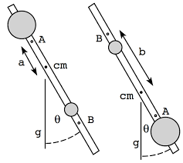

By adjusting the bob G such that the periodic time is approximately the same when the pendulum is suspended from point A as when suspended from point B. by reversing in the distance “a” of the center of mass from point A and the distance “b’ of G from point B, as well as the two periodic times $T_{A}$and $T_{B}$, can then be measured. The value of “g” acceleration due to gravity can also be accurately determined from the following equation:
$$g=2\left(a+b\right) 2(a-b)$$
It is also noted that when $T_{A}=T_{B}$exactly the distance between A and B becomes the equivalent pendulum ‘L’.

- Observations and calculations:-

Test no. | Knife edge | Distance  a  (m) | Distance  b  (m) | Time for 50 oscillations  (s) | Periodic time  T  (s) | $$T^{2}$$  ($s^{2}$) | g  (m/$s^{2}$)
1 | A | 0.400 | 0.200 | 70.23 | 1.405 | 1.973 | 9.90
 | B | 0.200 | 0.400 | 62.31 | 1.246 | 1.553
2 | A | 0.375 | 0.225 | 67.63 | 1.353 | 1.830 | 9.92
 | B | 0.225 | 0.375 | 60.35 | 1.207 | 1.457
3 | A | 0.350 | 0.250 | 65.89 | 1.318 | 1.737 | 9.94
 | B | 0.250 | 0.350 | 60.78 | 1.216 | 1.478
4 | A | 0.325 | 0.275 | 63.97 | 1.279 | 1.637 | 9.85
 | B | 0.275 | 0.325 | 61.18 | 1.224 | 1.497
5 | A | 0.305 | 0.295 | 63.89 | 1.278 | 1.633 | 9.88
 | B | 0.295 | 0.305 | 63.38 | 1.268 | 1.607

- Comments:-
- Your first task is to make a 50 cm long simple pendulum. If there is already a thread of the right length attached to a stopper, skip to step 2. Cut a piece of thread approximately 75 cm long. Thread one end of it through the hole in a free rubber stopper and tie it off by looping it back above the stopper. Tie a large loop in the other end of the thread so that the pendulum length—as measured from the point at which the pendulum will pivot to the center of mass of the stopper—is about 50 cm.
- This process is the same as the previous one except you will time 10 consecutive cycles. That is, start the stopwatch when the pendulum passes through the midpoint coming from the left. The first cycle is complete the next time it comes through 5 from the left, and so on. After 10 cycles have been completed, stop the watch and record the total time. Repeat this 10 times, for a total of ten measurements of ten cycles.

Experiment No# 08

- Objective:-
“To find the damping coefficient by using free vibration with damper”
- Apparatus:-
- Free vibration apparatus.
- Damper
- Measuring tape

- Theory:-
What is Damping?
Damping is an influence within or upon an oscillatory system that has the effect of reducing, restricting or preventing its oscillations. In physical systems, damping is produced by processes that dissipate the energy stored in the oscillation.
What is damping coefficient?
A damping coefficient is a material property that indicates whether a material will bounce back or return energy to a system. For example, a basketball has a low damping coefficient (a good bounce back).
What is damper?
A damper is a device that deadens, restrains, or depresses.Damper may refer toDashpot, a type of hydraulic or mechanical damperShock absorber (British or technical use: damper), a mechanical device designed to dissipate kinetic energy.
What is free vibration?
Free vibration is a type of vibration in which a force is applied once and the structure or part is allowed to vibrate at its natural frequency. A plucked guitar string is an example of free vibration.
Procedure: -
- First of all, set the free vibration apparatus.
- Mark three different spots on the beam (cantilever) at different distances from the point at which beam is fixed.
- Then set the damper at these three different lengths and vibrate the beam.
- Vibration of beam generates a graph on the paper. Then measure $Y_{n}$from the graph.
- Then measure “A” from the given formula:-
A$=\frac{\log_{e}({\frac{Y_{n}}{Y_{n}+1}})×2}{T}$

- Then measure the moment of inertia “$I_{0}$” from given formula:-
$$I_{0=\frac{mL^{3}}{3}}$$
- Then measure the damping coefficient “c” from given formula:-
$$c=\frac{AI_{0}}{a^{2}}$$

- At the end measure the average damping constant.

- Calculations and observations:-

Damping to prior distance “a”  (m) | $$\frac{Y_{n}}{Y_{n}+1}$$ | $$\log_{e}({\frac{Y_{n}}{Y_{n}+1}})$$ | Time  (s) | A  ($s^{-1})$ | A$I_{0}$ | Damping coefficient  (C)
0.133 | 1.15 | 0.1398 | 0.325 | 0.8603 | 0.1993 | 11.3025
0.241 | 1.61 | 0.4782 | 0.325 | 2.9122 | 0.6767 | 11.6510
0.333 | 2.28 | 0.824 | 0.325 | 5.0721 | 1.1787 | 10.63

Graph:-

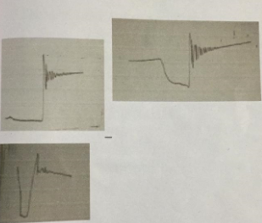

- Comments:-
- In physical systems, damping is produced by processes that dissipate the energy stored in the oscillation.
- In physical systems, damping is produced by processes that dissipate the energy stored in the oscillation.
- It is also important in the harmonic oscillator.
- The damping ratio provides a mathematical means of expressing the level of damping in a system relative to critical damping.

Experiment No# 09
- Objective:-
“To find the frequency by using lateral vibrational system.”
- Apparatus:-
- Lateral vibrational system
- Wight
- Measuring tape
- Steel beam25mm*9mm*750mm
- Speed controller
- Exciter motor 30watt 3000 rpm with unbalanced and angular scale disc
- Damper with stand and damping and damping adjustment screw,a clamp to the beam and oil.

- Theory:-
Damping
Damping is an influence within or upon an oscillatory system that has the effect of reducing, restricting or preventing its oscillations. In physical systems, damping is produced by processes that dissipate the energy stored in the oscillation.
Critical Damping
Critical Damping is important so as to prevent a large number of oscillations and there being too long a time when the system cannot respond to further disturbances. Instruments such as balances and electrical meters are critically damped so that the pointer moves quickly to the correct position without oscillating
Vibration
Vibration means quickly moving back and forth (or up and down) about a point of equilibrium. The vibration may be periodic (having a pattern) or random. Something that is vibrating may shake at the same time.
Frequency
Frequency is the number of occurrences of a repeating event per unit of time. It is also referred to as temporal frequency, which emphasizes the contrast to spatial frequency and angular frequency. The period is the duration of time of one cycle in a repeating event, so the period is the reciprocal of the frequency.

- Procedure:-
- Suspend different sizes of mass m below the motor.
- For each mass adjust the speed control unit the beam vibrates and its natural frequency.
- For accurate value of frequency, take the beam through a rage of excessive amplitude several times to note the limits of the range.
- Then record the natural frequency for each mass.

- Calculations and observations :-

m | Motor speed | f | $$f^{2}$$ | $$\frac{1}{f^{2}}$$
(Kg) | (rpm) | (Hz) | (Hz) | (Hz)
3.01 | 813 | 13.55 | 183.6025 | 0.005447
3.4 | 772 | 12.867 | 165.5511 | 0.00604
3.8 | 734 | 12.233 | 149.6544 | 0.006682
5.01 | 650 | 10.833 | 117.3611 | 0.008521

- Graph:-

- Comments:-
- The period is the duration of time of one cycle in a repeating event, so the period is the reciprocal of the frequency.
- Instruments such as balances and electrical meters are critically damped so that the pointer moves quickly to the correct position without oscillating.
- The vibration may be periodic (having a pattern) or random. Something that is vibrating may shake at the same time.

Experiment no# 10
Objective:-
“To measure the forced vibration frequency with damping.”
Apparatus:-

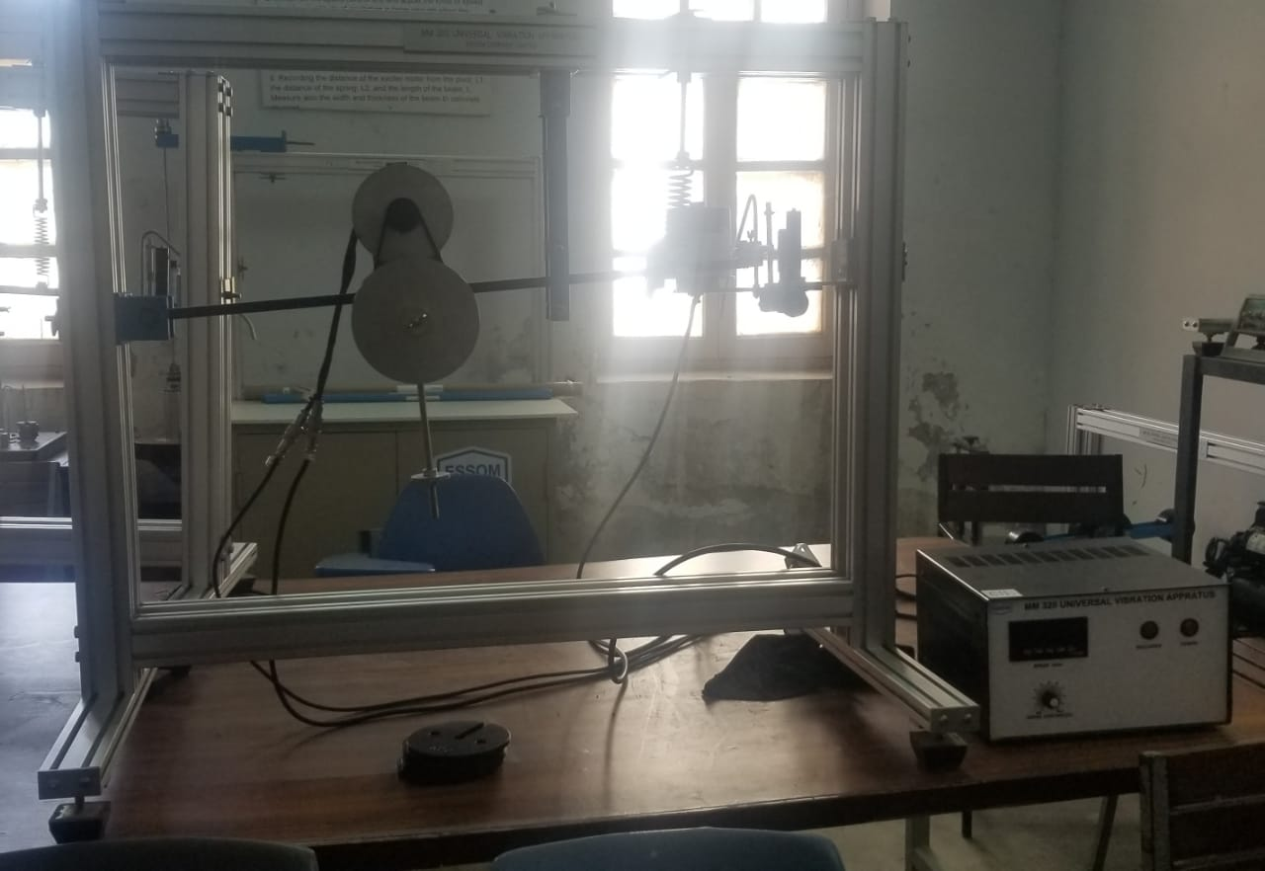

Theory:-
Forced vibration
Forced vibration is when an alternating force or motion is applied to a mechanical system, for example when a washing machine shakes due to an imbalance. Forced vibration is a type of vibration in which a force is repeatedly applied to a mechanical system.
Forced vibration frequency
Forced vibrations occur when the object is forced to vibrate at a particular frequency by a periodic input of force. ... If an object is being forced to vibrate at its natural frequency, resonance will occur, and you will observe large amplitude vibrations. The resonant frequency is f_{o}.

Damper
A damper is a device that deadens, restrains, or depresses. Damper may refer to Dashpot, a type of hydraulic or mechanical damper Shock absorber (British or technical use: damper), a mechanical device designed to dissipate kinetic energy.
Damping
Damping is an influence within or upon an oscillatory system that has the effect of reducing, restricting or preventing its oscillations. In physical systems, damping is produced by processes that dissipate the energy stored in the oscillation.
Procedure:-
- To do this experiment, we vary the exciter speed (Figure 11) slowly through its available range by using the needle and observing the variation of the amplitude of the beam response.
- Give motor speed in rpm.
- By view-ing the approximate frequency at which resonance occurs, it is possible to fine tune the range of frequencies over which it is useful to take results
- Phase angle should be in degree ,
- After that, we can in-crease the speed range by suitable increments (0.1 Hz)
- At each speed, we record the tachometer frequency (Hz), and the peak-to-peak amplitude of the signal re-sponse.
- Calculate the static angular displacement.
- We recorded the peak-to-peak output amplitude; we clicked on “Auto Scale”. It is the complete amplitude of the LVDT signal. An example of the signal is about how to measure the peak-to-peak amplitude.
- amplitude is obtained by dividing the peak-to-peak response amplitudes by the square of the excitation frequencies because the inertia force applied to the beam by the exciter is proportional to the square of frequency.
- We can identify the resonance frequency from the response peak after plotting the normalized amplitude against the excitation frequency (Figure 13).
- Calculate nThe resonance frequency of damping forced vibration by equation.

- Observations and calculations:-
- Spring stiffness=k=123.782 N/m
- motor distance=$a_{m}$=0.38 m
- mass of beam=$m_{beam}$=7.135 kg
- spring distance=b=0.64 m
- mass of motor=$m_{motor}$=7.135 kg
- beam length=L=0.745 m

Motor speed  (rpm) | Disc speed  $ω$ rad/sec | Frequency ratio, r  $$ω/ω_{n}$$ | Amplitude, $X_{max}$  (mm) | Angular amplitude,  $θ_{max}$ rad | Phase angle, $∅$degree | Static angular displacement,  $${ θ}_{0}$$  rad | “Dynamic magnifier”  $${ D}_{m}$$
450 | 14.40 | 0.75 | 1.00 | 0.001342 | 35 | 0.0008355 | 1.606
503 | 16.09 | 0.84 | 2.00 | 0.002685 | 40 | 0.0010439 | 2.572
550 | 17.60 | 0.92 | 15.50 | 0.020805 | 50 | 0.0012481 | 16.669
558 | 17.85 | 0.93 | 25.50 | 0.034228 | 69 | 0.0012847 | 26.643
643 | 20.57 | 1.08 | 3.25 | 0.004362 | 178 | 0.0017059 | 2.557
1037 | 33.18 | 1.73 | 1.00 | 0.001342 | 180 | 0.0044370 | 0.303
1123 | 35.93 | 1.88 | 1.00 | 0.001342 | 180 | 0.0052035 | 0.258

Graph:-

- Comments:-
- Due to damping energy losses occurs which makes the natural frequency smaller.
- Damping also effects the speed of motor, oscillation, vibration.
- Phase angle is also reduced.

- Experiment no# 11

- Objective: -
“To measure forced vibration frequency without damping.”

- Apparatus: -

- Theory: -
Forced vibration
Forced vibration is when an alternating force or motion is applied to a mechanical system, for example when a washing machine shakes due to an imbalance. Forced vibration is a type of vibration in which a force is repeatedly applied to a mechanical system.
Forced vibration frequency
Forced vibrations occur when the object is forced to vibrate at a particular frequency by a periodic input of force. ... If an object is being forced to vibrate at its natural frequency, resonance will occur, and you will observe large amplitude vibrations. The resonant frequency is f_{o}.
Damper
A damper is a device that deadens, restrains, or depresses. Damper may refer to Dashpot, a type of hydraulic or mechanical damper Shock absorber (British or technical use: damper), a mechanical device designed to dissipate kinetic energy.
Damping
Damping is an influence within or upon an oscillatory system that has the effect of reducing, restricting or preventing its oscillations. In physical systems, damping is produced by processes that dissipate the energy stored in the oscillation.

- Procedure:-

- To do this experiment, we vary the exciter speed (Figure 11) slowly through its available range by using the needle and observing the variation of the amplitude of the beam response.
- Give motor speed in rpm.
- By view-ing the approximate frequency at which resonance occurs, it is possible to fine tune the range of frequencies over which it is useful to take results
- Phase angle should be in degree ,
- After that, we can in-crease the speed range by suitable increments (0.1 Hz)
- At each speed, we record the tachometer frequency (Hz), and the peak-to-peak amplitude of the signal re-sponse.
- Calculate the static angular displacement.
  - We recorded the peak-to-peak output amplitude; we clicked on “Auto Scale”. It is the complete amplitude of the LVDT signal. An example of the signal is about how to measure the peak-to-peak amplitude.
- amplitude is obtained by dividing the peak-to-peak response amplitudes by the square of the excitation frequencies because the inertia force applied to the beam by the exciter is proportional to the square of frequency.
- We can identify the resonance frequency from the response peak after plotting the normalized amplitude against the excitation frequency (Figure 13).
- Calculate nThe resonance frequency of damping forced vibration by equation.

- Observation and Calculations:-

- Mass of beam=$m_{beam}$=1.88 kg
- Mass of motor=6.735 kg
- Motor distance=a=0.33
- Spring distance=b=0.64
- Length=L=0.745 m
- Deflection at rpm=11m
- Weight at motor=2kg
- Spring deflection=$\frac{deflection at ×6}{L}$
- Deflection weight=$\frac{mgh}{6}$

Additional  weight | Mass of motor with additional weight  (Kg) | Motor speed  (rpm) | Oscillations for 20 vibration  (sec) | Period from recorder | Mass moment of inertia  $$I_{0}$$ | $$\sqrt{B}$$  (Rad/sec) | $$\sqrt{B}$$  (Hz)
0 | 6.735 | 470 | 8.54 | 7 | 1.322 | 19.54 | 3.11
0.4 | 7.135 | 470 | 8.78 | 7 | 1.380 | 19.13 | 3.04
0.8 | 7.535 | 470 | 8.31 | 7 | 1.438 | 18.84 | 2,98
1.2 | 7.435 | 470 | 8.53 | 7 | 1.445 | 18.38 | 2.92
1.6 | 8.335 | 470 | 8.87 | 7 | 1.553 | 18.03 | 2.87

Forced vibration frequency
Unbalanced speed (Hz) | Oscillation (Hz) | Recorder (Hz)
2.39 | 2.39 | 2.86
2.41 | 2.43 | 2.92
2.71 | 2.74 | 3.34
3.41 | 3.44 | 3.95

- Comments:-
- Due to damping energy losses occurs which makes the natural frequency smaller.
- Damping also effects the speed of motor, oscillation, vibration.
- Phase angle is also reduced.

