Advertising and Sales Promotion
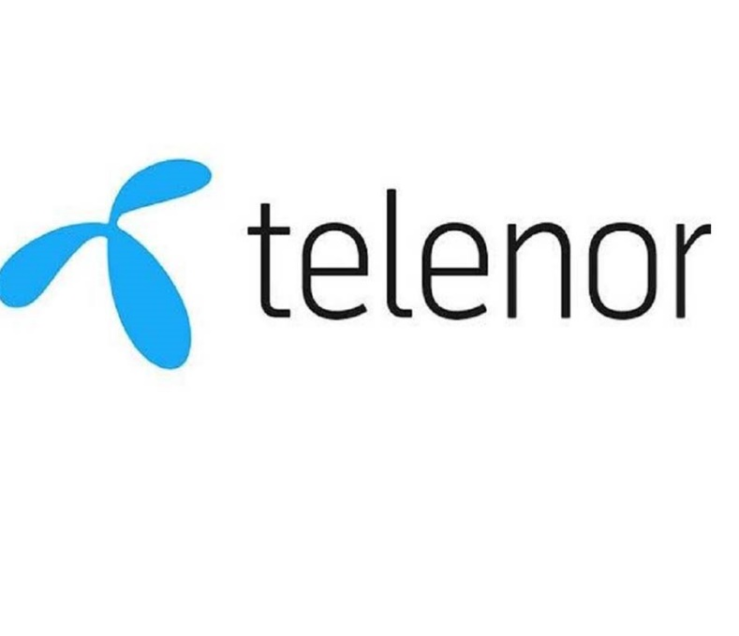
In the development of ads, the marketers answer to following questions including 1) who their target audience is (type of customers or consumers), 2) what kind of advertising to use (audio, print, electronic), 3) how to reach the customers (which type of media to use), 4) what to say to them (the copy thrust) and 5) who will do the word (firm’s own advertising department or advertising agency).
Place
Reminder ads
Competitive ads
Pioneering ads
Target markets
Product
Price
Promotion
Sales promotion
Mass selling
Personal selling
Publicity
Advertising
Who will do the work?
Target audience
Copy thrust
Media types
Kind of advertising

Indirect ads
Direct ads

Promotion
- Personal selling occurs when a sales representative meets with a potential client for the purpose of transacting a sale.
- Sales promotion is the process of persuading a potential customer to buy the product. Sales promotion is designed to be used as a short-term tactic to boost the buying behavior.
- Mass marketing is the advertising or promotion of a product, good or service to a wide variety of audiences.
  - Publicity is the activity of increasing the awareness about a person, product or service and to grab the attention of the crowd. It is a way to project your company or a brand in front of the potential customer.
  - Advertising is a means of communication with the users of a product or service. Advertising is a marketing tactic involving paying for space to promote a product, service, or cause.
Kind of advertising
    - Pioneering ads are usually done in the early stages of the product life cycle; it informs the potential customers about new company, brand of product.
    - Reminder ads tries to keep the product name before public. It may be useful when the product has achieved brand preference.
    - Competitive ads tries to develop selective demand for a specific brand. It is related to the competitive advantage of the brand on other brands. It consists of two types.
      - Direct type aims for immediate buying action
      - Indirect type effects future buying behaviors
Target audience
The marketing manager decides who will be the target audiences (potential customers or consumers). The market segmentation best describes the targeted audience.
Media types
Television and cable, newspapers, direct mail, radio, yellow papers, magazines, billboards and internet can be used as media for ads.
Copy thrust
What the words and illustrations will be used in the ads? It is the job of advertising specialists but still marketing manager and advertising managers ensures that the job is done well. A guide to message planning is known as AIDA in which A (getting attention), I (holding interest), D (arousing desire) and A (obtaining action).
Who will do the work?
Some organizations have their own advertising department. However, most of the organization consult advertising agencies which are specialized in making ads.

