PHARMACEUTICAL INDUSTRY

Definitions
These terms are used frequently in the pharmaceutical industry:
Biologics are bacterial and viral vaccines, antigens, antitoxins and analogous products, serums, plasmas and other blood derivatives for therapeutically protecting or treating humans and animals.
Bulks are active drug substances used to manufacture dosage- form products, process medicated animal feeds or compound prescription medications.
Diagnostic agents assist the diagnosis of diseases and disorders in humans and animals. Diagnostic agents may be inorganic chemicals for examining the gastrointestinal tract, organic chemicals for visualizing the circulatory system and liver and radioactive compounds for measuring the function of organ system.
Drugs are substances with active pharmacological properties in humans and animals. Drugs are compounded with other materials, such as pharmaceutical necessities, to produce a medicinal product.
Ethical pharmaceuticals are biological and chemicals agents for preventing, diagnosing or treating disease and disorders in humans or animals. These products are dispensed by prescription or approval of a medical, pharmacy or veterinary professional.
Excipients are inert ingredients which are combined with drug substances to create a dosage form product. Excipients may affect the rate of absorption, dissolution, metabolism and distribution in humans or animals.
Over-the-counter pharmaceuticals are drug products sold in a retail store or pharmacy which do not require a prescription or the approval of a medical, pharmacy or veterinary professional.
Pharmacy is the art and science of preparing and dispensing drugs for preventing, diagnosing or treating diseases or disorders in humans and animals.
Pharmacokinetics is the study of metabolic processes relating to the absorption, distribution, biotransformation, and elimination of a drug in humans or animals.
Pharmacodynamics is the study of drug action relating to its chemical structure, site of action, and the biochemical and physiological consequences in humans and animals.
The pharmaceutical industry is an important component of health care systems throughout the world; it is comprised of many public and private organizations that discover, develop, manufacture and market medicines for human and animal health (Gennaro 1990). The pharmaceutical industry is based primarily upon the scientific research and development (R&D) of medicines that prevent or treat diseases and disorders. Drug substances exhibit a wide range of pharmacological activity and toxicological properties (Hardman, Gilman and Limbird 1996; Reynolds 1989). Modern scientific and technological advances are accelerating the discovery and development of innovative pharmaceuticals with improved therapeutic activity and reduced side effects. Molecular biologists, medicinal chemists and pharmacists are improving the benefits of drugs through increased potency and specificity. These advances create new concerns for protecting the health and safety of workers within the pharmaceutical industry (Agius 1989; Naumann et al. 1996; Sargent and Kirk 1988; Teichman, Fallon and Brandt-Rauf 1988).
Many dynamic scientific, social and economic factors affect the pharmaceutical industry. Some pharmaceutical companies operate in both national and multinational markets. Therefore, their activities are subject to legislation, regulation and policies relating to drug development and approval, manufacturing and quality control, marketing and sales (Spilker 1994). Academic, government and industry scientists, practising physicians and pharmacists, as well as the public, influence the pharmaceutical industry. Health care providers (e.g., physicians, dentists, nurses, pharmacists and veterinarians) in hospitals, clinics, pharmacies and private practice may prescribe drugs or recommend how they should be dispensed. Government regulations and health care policies on pharmaceuticals are influenced by the public, advocacy groups and private interests. These complex factors interact to influence the discovery and development, manufacturing, marketing and sales of drugs.
The pharmaceutical industry is largely driven by scientific discovery and development, in conjunction with toxicological and clinical experience (see figure 79.1). Major differences exist between large organizations which engage in a broad range of drug discovery and development, manufacturing and quality control, marketing and sales and smaller organizations which focus on a specific aspect. Most multinational pharmaceutical companies are involved in all these activities; however, they may specialize in one aspect based upon local market factors. Academic, public and private organizations perform scientific research to discover and develop new drugs. The biotechnology industry is becoming a major contributor to innovative pharmaceutical research (Swarbick and Boylan 1996). Often, collaborative agreements between research organizations and large pharmaceutical companies are formed to explore the potential of new drug substances.

Figure 79.1 Drug development in the pharmaceutical industry
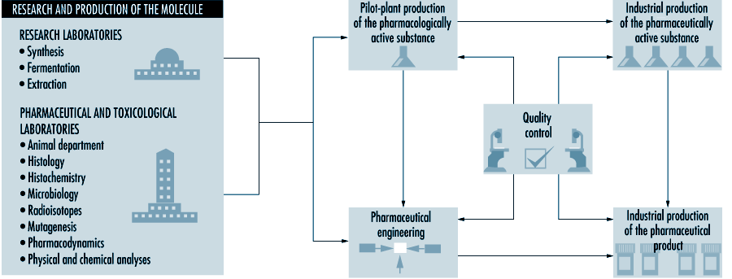
Many countries have specific legal protections for proprietary drugs and manufacturing processes, known as intellectual property rights. In instances when legal protections are limited or do not exist, some companies specialize in manufacturing and marketing generic drugs (Medical Economics Co. 1995). The pharmaceutical industry requires large amounts of capital investment due to the high expenses associated with R&D, regulatory approval, manufacturing, quality assurance and control, marketing and sales (Spilker 1994). Many countries have extensive government regulations affecting the development and approval of drugs for commercial sale. These countries have strict requirements for good manufacturing practices to ensure the integrity of drug manufacturing operations and the quality, safety and efficacy of pharmaceutical products (Gennaro 1990).
International and domestic trade, as well as tax and finance policies and practices, affect how the pharmaceutical industry operates within a country (Swarbick and Boylan 1996). Significant differences exist between developed and developing countries, regarding their needs for pharmaceutical substances. In developing countries, where malnutrition and infectious diseases are prevalent, nutritional supplements, vitamins and anti-infective drugs are most needed. In developed countries, where the diseases associated with ageing and specific ailments are primary health concerns, cardiovascular, central nervous system, gastrointestinal, anti-infective, diabetes and chemotherapy drugs are in the greatest demand.
Human and animal health drugs share similar R&D activities and manufacturing processes; however, they have unique therapeutic benefits and mechanisms for their approval, distribution, marketing and sales (Swarbick and Boylan 1996). Veterinarians administer drugs to control infectious diseases and parasitic organisms in agricultural and companion animals. Vaccines and anti-infective and antiparasitic drugs are commonly used for this purpose. Nutritional supplements, antibiotics and hormones are widely employed by modern agriculture to promote the growth and health of farm animals. The R&D of pharmaceuticals for human and animal health are often allied, due to concurrent needs to control infectious agents and disease.

Hazardous Industrial Chemicals and Drug-related Substances
Many different biological and chemical agents are discovered, developed and used in the pharmaceutical industry (Hardman, Gilman and Limbird 1996; Reynolds 1989). Some manufacturing processes in the pharmaceutical, biochemical and synthetic organic chemical industries are similar; however, the greater diversity, smaller scale and specific applications in the pharmaceutical industry are unique. Since the primary purpose is to produce medicinal substances with pharmacological activity, many agents in pharmaceutical R&D and manufacturing are hazardous to workers. Proper control measures must be implemented to protect workers from industrial chemicals and drug substances during many R&D, manufacturing and quality control operations (ILO 1983; Naumann et al. 1996; Teichman, Fallon and Brandt-Rauf 1988).
The pharmaceutical industry uses biological agents (e.g., bacteria and viruses) in many special applications, such as vaccine production, fermentation processes, derivation of blood-based products and biotechnology. Biological agents are not addressed by this profile due to their unique pharmaceutical applications, but other references are readily available (Swarbick and Boylan 1996). Chemical agents may be categorized as industrial chemicals and drug-related substances (Gennaro 1990). These may be raw materials, intermediates or finished products. Special situations arise when industrial chemicals or drug substances are employed in laboratory R&D, quality assurance and control assays, engineering and maintenance, or when they are created as by-products or wastes.

Industrial chemicals
Industrial chemicals are used in researching and developing active drug substances and manufacturing bulk substances and finished pharmaceutical products. Organic and inorganic chemicals are raw materials, serving as reactants, reagents, catalysts and solvents. The use of industrial chemicals is determined by the specific manufacturing process and operations. Many of these materials may be hazardous to workers. Since worker exposures to industrial chemicals may be hazardous, occupational exposure limits, such as threshold limit values (TLVs) have been established by government, technical and professional organizations (ACGIH 1995).

Drug-related substances
Pharmacologically active substances may be categorized as natural products and synthetic drugs. Natural products are derived from plant and animal sources, while synthetic drugs are produced by microbiological and chemical technologies. Antibiotics, steroid and peptide hormones, vitamins, enzymes, prostaglandins and pheromones are important natural products. Scientific research is focusing increasingly on synthetic drugs due to recent scientific advances in molecular biology, biochemistry, pharmacology and computer technology. Table 79.1 lists the principal pharmaceutical agents.
Active drug substances and inert materials are combined during pharmaceutical manufacturing to produce dosage forms of medicinal products (e.g., tablets, capsules, liquids, powders, creams and ointments) (Gennaro 1990). Drugs may be categorized by their manufacturing process and therapeutic benefits (EPA 1995). Drugs are medicinally administered by strictly prescribed means (e.g., oral, injection, skin) and dosages, whereas workers may be exposed to drug substances by inadvertently breathing airborne dust or vapours or accidentally swallowing contaminated foods or beverages. Occupational exposure limits (OELs) are developed by toxicologists and occupational hygienists to provide guidance on limiting worker exposures to drug substances (Naumann et al. 1996; Sargent and Kirk 1988).
Pharmaceutical necessities (e.g., binders, fillers, flavouring and bulking agents, preservatives and antioxidants) are mixed with active drug substances, providing the desired physical and pharmacological properties in the dosage form products (Gennaro 1990). Many pharmaceutical necessities have no or limited therapeutic value and are relatively non-hazardous to workers during drug development and manufacturing operations. These materials are anti-oxidants and preservatives, colouring, flavouring and diluting agents, emulsifiers and suspending agents, ointment bases, pharmaceutical solvents and excipients.

Pharmaceutical Operations, Related Hazards and Workplace Control Measures
Pharmaceutical manufacturing operations may be categorized as basic production of bulk drug substances and pharmaceutical manufacturing of dosage form products. Figure 79.2 illustrates the manufacturing process.

Figure 79.2 Manufacturing process in the pharmaceutical industry
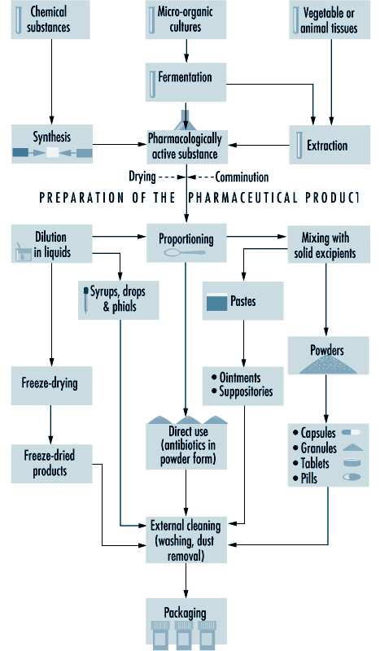
Basic production of bulk drug substances may employ three major types of processes: fermentation, organic chemical synthesis, and biological and natural extraction (Theodore and McGuinn 1992). These manufacturing operations may be discrete batch, continuous or a combination of these processes. Antibiotics, steroids and vitamins are produced by fermentation, whereas many new drug substances are produced by organic synthesis. Historically, most drug substances were derived from natural sources such as plants, animals, fungi and other organisms. Natural medicines are pharmacologically diverse and difficult to produce commercially due to their complex chemistry and limited potency.

Fermentation
Fermentation is a biochemical process employing selected micro-organisms and microbiological technologies to produce a chemical product. Batch fermentation processes involve three basic steps: inoculum and seed preparation, fermentation, and product recovery or isolation (Theodore and McGuinn 1992). A schematic diagram of a fermentation process is given in figure 79.3 . Inoculum preparation begins with a spore sample from a microbial strain. The strain is selectively cultured, purified and grown using a battery of microbiological techniques to produce the desired product. The spores of the microbial strain are activated with water and nutrients in warm conditions. Cells from the culture are grown through a series of agar plates, test tubes and flasks under controlled environmental conditions to create a dense suspension.

Figure 79.3 Diagram of a fermentation process
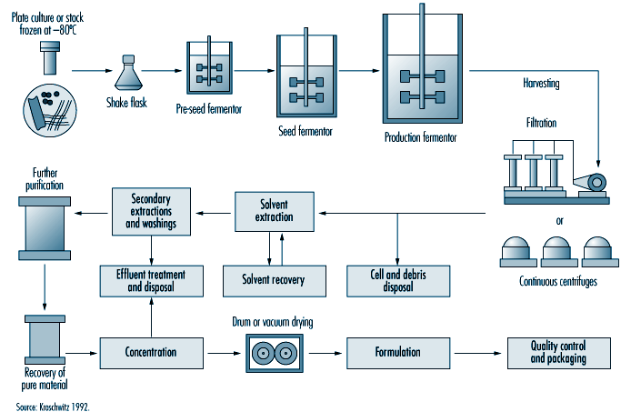
The cells are transferred to a seed tank for further growth. The seed tank is a small fermentation vessel designed to optimize the growth of the inoculum. The cells from the seed tank are charged to a steam sterilized production fermentor. Sterilized nutrients and purified water are added to the vessel to begin the fermentation. During aerobic fermentation, the contents of the fermentor are heated, agitated and aerated by a perforated pipe or sparger, maintaining an optimum air flow rate and temperature. After the biochemical reactions are complete, the fermentation broth is filtered to remove the micro-organisms, or mycelia. The drug product, which may be present in the filtrate or within the mycelia, is recovered by various steps, such as solvent extraction, precipitation, ion exchange and absorption.
Solvents used for extracting the product (table 79.2) generally can be recovered; however, small portions remain in the process wastewater, depending upon their solubility and the design of the process equipment. Precipitation is a method to separate the drug product from the aqueous broth. The drug product is filtered from the broth and extracted from the solid residues. Copper and zinc are common precipitating agents in this process. Ion exchange or adsorption removes the product from the broth by chemical reaction with solid materials, such as resins or activated carbon. The drug product is recovered from the solid phase by a solvent which may be recovered by evaporation.

Table 79.2 Solvents used in the pharmaceutical industry
Solvents | Processes
Acetone | C | F | B
Acetonitrile | C | F | B
Ammonia (aqueous) | C | F | B
n-Amyl acetate | C | F | B
Amyl alcohol | C | F | B
Aniline | C
Benzene | C
2-Butanone (MEK) | C
n-Butyl acetate | C | F
n-Butyl alcohol | C | F | B
Chlorobenzene | C
Chloroform | C | F | B
Chloromethene | C
Cyclohexane | C
o-Dichlorobenzene (1,2-Dichlorobenzene) | C
1,2-Dichloroethane | C |  | B
Diethylamine | C |  | B
Diethyl ether | C |  | B
N,N-Dimethyl acetamide | C
Dimethylamine | C
N,N-dimethylaniline | C
N,N-dimethylformamide | C | F | B
Dimethyl sulphoxide | C |  | B
1,4-Dioxane | C |  | B
Ethanol | C | F | B
Ethyl acetate | C | F | B
Ethylene glycol | C |  | B
Formaldehyde | C | F | B
Formamide | C
Furfural | C
n-Heptane | C | F | B
n-Hexane | C | F | B
Isobutyraldehyde | C
Isopropanol | C | F | B
Isopropyl acetate | C | F | B
Isopropyl ether | C |  | B
Methanol | C | F | B
Methylamine | C
Methyl cellosolve | C | F
Methylene chloride | C | F | B
Methyl formate | C
Methyl isobutyl ketone (MIBK) | C | F | B
2-Methylpyridine | C
Petroleum naphtha | C | F | B
Phenol | C | F | B
Polyethylene glycol 600 | C
n-Propanol | C |  | B
Pyridine | C |  | B
Tetrahydrofuran | C
Toluene | C | F | B
Trichlorofluoromethane | C
Triethylamine | C | F
Xylenes | C
C = chemical synthesis, F = fermentation, B = biological or natural extraction.Source: EPA 1995.

Worker health and safety
Worker safety hazards may be posed by moving machine parts and equipment; high pressure steam, hot water, heated surfaces and hot workplace environments; corrosive and irritating chemicals; heavy manual handling of materials and equipment; and high noise levels. Worker exposures to solvent vapours may occur when recovering or isolating products. Worker exposures to solvents may result from uncontained filtration equipment and fugitive emissions for leaking pumps, valves and manifold stations during extraction and purification steps. Since the isolation and growth of micro-organisms are essential for fermentation, biological hazards are reduced by employing non-pathogenic microbes, maintaining closed process equipment and treating spent broth before its discharge.
Generally, process safety concerns are less important during fermentation than during organic synthesis operations, since fermentation is primarily based upon aqueous chemistry and requires process containment during seed preparation and fermentation. Fire and explosion hazards may arise during solvent extractions; however, the flammability of solvents is reduced by dilution with water in filtration and recovery steps. Safety hazards (i.e., thermal burns and scalding) are posed by the large volumes of pressurized steam and hot water associated with fermentation operations.

Chemical synthesis
Chemical synthesis processes use organic and inorganic chemicals in batch operations to produce drug substances with unique physical and pharmacological properties. Typically, a series of chemical reactions are performed in multi-purpose reactors and the products are isolated by extraction, crystallization and filtration (Kroschwitz 1992). The finished products are usually dried, milled and blended. Organic synthesis plants, process equipment and utilities are comparable in the pharmaceutical and fine chemical industries. A schematic diagram of an organic synthesis process is given in figure 79.4 .

Figure 79.4 Diagram of an organic synthesis process
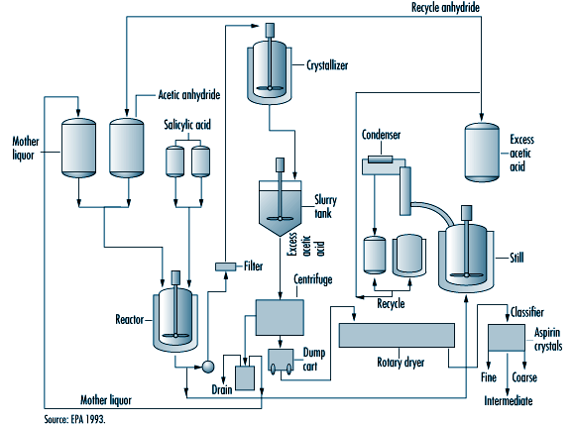
Pharmaceutical chemistry is becoming increasingly complex with multi-step processing, where the product from one step becomes a starting material for the next step, until the finished drug product is synthesized. Bulk chemicals which are intermediates of the finished product may be transferred between organic synthesis plants for various technical, financial and legal considerations. Most intermediates and products are produced in a series of batch reactions on a campaign basis. Manufacturing processes operate for discrete periods of time, before materials, equipment and utilities are changed to prepare for a new process. Many organic synthesis plants in the pharmaceutical industry are designed to maximize their operating flexibility, due to the diversity and complexity of modern medicinal chemistry. This is achieved by constructing facilities and installing process equipment that can be modified for new manufacturing processes, in addition to their utility requirements.
Multi-purpose reactors are the primary processing equipment in chemical synthesis operations (see figure 79.5). They are reinforced pressure vessels with stainless, glass or metal alloy linings. The nature of chemical reactions and physical properties of materials (e.g., reactive, corrosive, flammable) determine the design, features and construction of reactors. Multi-purpose reactors have external shells and internal coils which are filled with cooling water, steam or chemicals with special heat-transfer properties. The reactor shell is heated or cooled, based upon the requirements of the chemical reactions. Multi-purpose reactors have agitators, baffles and many inlets and outlets connecting them to other process vessels, equipment and bulk chemical supplies. Temperature-, pressure- and weight-sensing instruments are installed to measure and control the chemical process in the reactor. Reactors may be operated at high pressures or low vacuums, depending upon their engineering design and features and the requirements of the process chemistry.

Figure 79.5 Diagram of a chemical reactor in organic synthesis
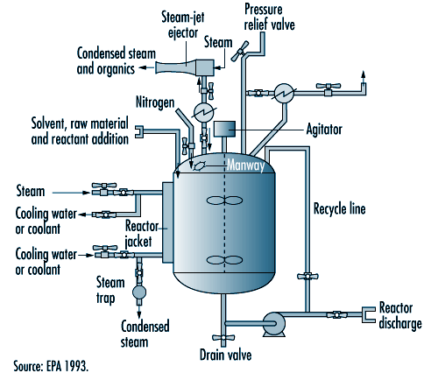

Figure 79.6 Examples of steroidal and non-steroidal oestrogen structure
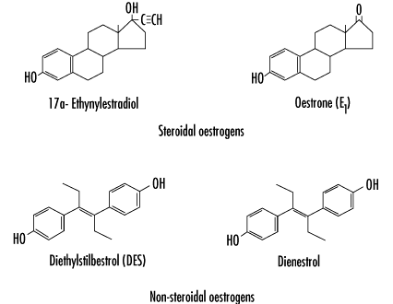

Figure 79.7 Typical oral contraceptive tablet manufacturing process flow
9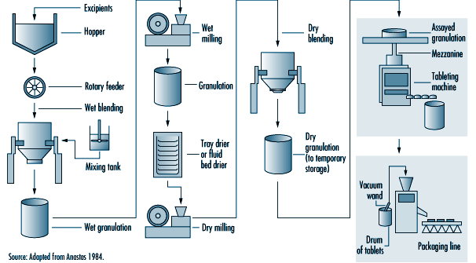
Heat exchangers are connected to reactors to heat or cool the reaction and condense solvent vapours when they are heated above their boiling point, creating a reflux or recycling of the condensed vapours. Air pollution control devices (e.g., scrubbers and impingers) can be connected to the exhaust vents on process vessels, reducing gas, vapour and dust emissions (EPA 1993). Volatile solvents and toxic chemicals may be released to the workplace or atmosphere, unless they are controlled during the reaction by heat exchangers or air control devices. Some solvents (see table 79.2) and reactants are difficult to condense, absorb or adsorb in air control devices (e.g., methylene chloride and chloroform) due to their chemical and physical properties.
Bulk chemical products are recovered or isolated by separation, purification and filtration operations. Typically, these products are contained in mother liquors, as dissolved or suspended solids in a solvent mixture. The mother liquors may be transferred between process vessels or equipment in temporary or permanent pipes or hoses, by pumps, pressurized inert gases, vacuum or gravity. Transferring materials is a concern due to the rates of reaction, critical temperatures or pressures, features of processing equipment and potential for leaks and spills. Special precautions to minimize static electricity are required when processes use or generate flammable gases and liquids. Charging flammable liquids through submerged dip tubes and grounding and bonding conductive materials and maintaining inert atmospheres inside process equipment reduce the risk of a fire or explosion (Crowl and Louvar 1990).

Worker health and safety
Many worker health and safety hazards are posed by synthesis operations. They include safety hazards from moving machine parts, pressurized equipment and pipes; heavy manual handling of materials and equipment; steam, hot liquids, heated surfaces and hot workplace environments; confined spaces and hazardous energy sources (e.g., electricity); and high noise levels.
Acute and chronic health risks may result from worker exposures to hazardous chemicals during synthesis operations. Chemicals with acute health effects can damage the eyes and skin, be corrosive or irritating to body tissues, cause sensitization or allergic reactions or be asphyxiants, causing suffocation or oxygen deficiency. Chemicals with chronic health effects may cause cancer, or damage the liver, kidneys or lungs or affect the nervous, endocrine, reproductive or other organ systems. Health and safety hazards may be controlled by implementing appropriate control measures (e.g., process modifications, engineering controls, administrative practices, personal and respiratory protective equipment).
Organic synthesis reactions may create major process safety risks from highly hazardous materials, fire, explosion or uncontrolled chemical reactions which impact the community surrounding the plant. Process safety can be very complex in organic synthesis. It is addressed in several ways: by examining the dynamics of chemical reactions, properties of highly hazardous materials, design, operation and maintenance of equipment and utilities, training of operating and engineering staff, and emergency preparedness and response of the facility and local community. Technical guidance is available on process hazard analysis and management activities to reduce the risks of chemical synthesis operations (Crowl and Louvar 1990; Kroschwitz 1992).

Biological and natural extraction
Large volumes of natural materials, such as plant and animal matter, may be processed to extract substances which are pharmacologically active (Gennaro 1990; Swarbick and Boylan 1996). In each step of the process, the volumes of materials are reduced by a series of batch processes, until the final drug product is obtained. Typically, processes are performed in campaigns lasting a few weeks, until the desired quantity of finished product is obtained. Solvents are used to remove insoluble fats and oils, thereby extracting the finished drug substance. The pH (acidity) of the extraction solution and waste products can be adjusted by neutralizing them with strong acids and bases. Metal compounds frequently serve as precipitating agents, and phenol compounds as disinfectants.

Worker health and safety
Some workers may develop allergic and/or skin irritation from handling certain plants. Animal matter may be contaminated with infectious organisms unless appropriate precautions are taken. Workers may be exposed to solvents and corrosive chemicals during biological and natural extraction operations. Fire and explosion risks are posed by storing, handling, processing and recovering flammable liquids. Moving mechanical parts; hot steam, water, surfaces and workplaces; and high noise levels are risks to worker safety.
Process safety issues are often reduced by the large volumes of plant or animal materials, and smaller scale of solvent extraction activities. Fire and explosion hazards, and worker exposures to solvents or corrosive or irritating chemicals may occur during extraction and recovery operations, depending upon the specific chemistry and containment of process equipment.

Pharmaceutical manufacturing of dosage forms
Drug substances are converted into dosage-form products before they are dispensed or administered to humans or animals. Active drug substances are mixed with pharmaceutical necessities, such as binders, fillers, flavouring and bulking agents, preservatives and antioxidants. These ingredients may be dried, milled, blended, compressed and granulated to achieve the desired properties before they are manufactured as a final formulation. Tablets and capsules are very common oral dosage forms; another common form is sterile liquids for injection or ophthalmic application. Figure 79.8 illustrates typical unit operations for manufacturing of pharmaceutical dosage-form products.

Figure 79.8 Pharmaceutical manufacturing of dosage-form products
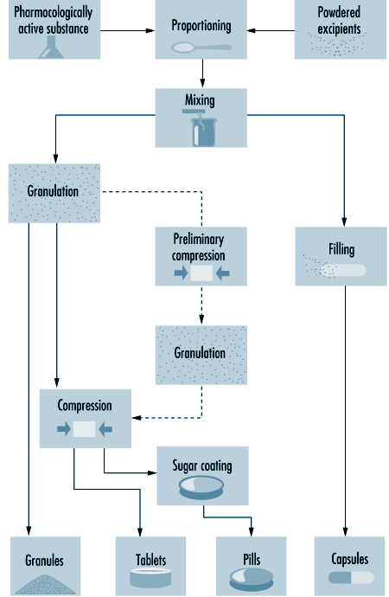
Pharmaceutical blends may be compressed by wet granulation, direct compression or slugging to obtain the desired physical properties, before their formulation as a finished drug product. In wet granulation, the active ingredients and excipients are wetted with aqueous or solvent solutions to produce course granules with enlarged particle sizes. The granules are dried, mixed with lubricants (e.g., magnesium stearate), disintegrants or binders, then compressed into tablets. During direct compression, a metal die holds a measured amount of the drug blend while a punch compresses the tablet. Drugs that are not sufficiently stable for wet granulation or cannot be directly compressed are slugged. Slugging or dry granulation blends and compresses relatively large tablets which are ground and screened to a desired mesh size, then recompressed into the final tablet. Blended and granulated materials may also be produced in capsule form. Hard gelatin capsules are dried, trimmed, filled and joined on capsule-filling machines.

Control measures
Fire and explosion prevention and protection; process containment of hazardous substances, machine hazards and high noise levels; dilution and local exhaust ventilation (LEV); use of respirators (e.g., dust and organic vapour masks and, in some cases, powered air-purifying respirators or air-supplied masks and suits) and personal protective equipment (PPE); and worker training on workplace hazards and safe work practices are workplace control measures applicable during all of the various pharmaceutical manufacturing operations described below. Specific issues involve substituting less hazardous materials whenever possible during drug development and manufacturing. Also, minimizing material transfers, unsealed or open processing and sampling activities decreases the potential for worker exposures.
The engineering design and features of facilities, utilities and process equipment can prevent environmental pollution and reduce worker exposures to hazardous substances. Modern pharmaceutical manufacturing facilities and process equipment are reducing environmental, health and safety risks by preventing pollution and improving the containment of hazards. Worker health and safety and quality control objectives are achieved by improving the isolation, containment and cleanliness of pharmaceutical facilities and process equipment. Preventing worker exposures to hazardous substances and pharmaceutical products is highly compatible with the concurrent need to prevent workers from accidentally contaminating raw materials and finished products. Safe work procedures and good manufacturing practices are complementary activities.

