HALF-SIB SELECTION WITH PROGENY TEST

Half-sib refers to a plant or family of plants with a common parent or pollen source. A half-sib selection procedure based on a progeny test differs from mass selection because the new population is constituted by compositing half-sib lines selected from progeny performance rather than from phenotypic appearance. Progenies of 25 to 50 plants are grown in replicated plots, so that the variance and mean performance may be evaluated. An example of the half-sib selection procedure as used with corn follows (Fig. 10.5):

First season. Select 50 to 100 plants with desired features from an open-pollinated source population, keeping the seed harvested from each plant separate. The seed from each plant will constitute a different breeding line.

Second season. Using seeds harvested from open-pollinated plants in the previous season, grow a progeny test of each line in an isolated area. Retain some of the seed of each line as remnant seed.

Third season. The population is reconstituted by compositing equal quantities of either (a) seed harvested from the 5 to 10 superior progenies, or (b) remnant seed from the 5 to 10 lines with superior progeny performance. Grow the composite in isolation with open-pollination to obtain new gene combinations. Seed harvested in the third season may be:
- increased as a new open-pollinated cultivar,
- planted as a source population to start a new selection cycle, or
- planted as a source population for isolation of new inbreds in a hybrid breeding program.
The half-sib procedure is applicable to cross-pollinated crops, like corn or sugarbeets, where sufficient seed can be harvested from a single plant to grow a yield trial, or to cross-pollinated crops where self-pollination cannot be consummated due to self-incompatibility systems.
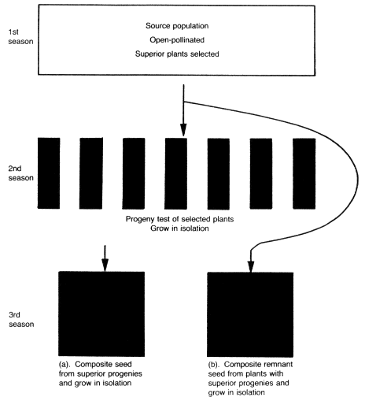

HALF-SIB SELECTION WITH TESTCROSS

In this procedure the selection of the half-sib lines to composite is based on testcross performance rather than progeny performance. An example of the procedure as used with corn follows (Fig. 10.6):

First season. Prior to flowering, select 50 to 100 plants with desired plant characters from a source population:
- pollinate a tester parent plant with pollen from each of the selected plants and harvest crossed seed from the tester parent and open-pollinated seed from the selected plants, keeping identity of each seed lot; or
- With pollen from each selected plant, pollinate a tester plant and self-pollinate the selected plant. Harvest crossed seed from tester parent plants and selfed seed from selected plants, keeping identity of each seed lot.

Second season. Grow testcross progenies.

Third season. Reconstitute the population (a) by mixing equal quantities of open-pollinated seed from 5 to 10 selected plants with superior testcross progeny performance; or (b) by mixing equal quantities of selfed seed from 5 to 10 selected plants with superior testcross progenies. Grow the seed composite in an isolated seed plot with open-pollination to obtain new gene combinations.

The half-sib testcross procedure permits control over the testcross parents so that a more precise evaluation of the genotype of the selected plant is obtained than from growing a progeny obtained by open-pollination as in the previous procedure. If the tester is an inbred line, plants in each of the lines in the testcross progeny nursery will have one parental gamete in common. Procedure (b) would be superior to procedure (a) because only genes from the plants with superior testcross progenies enter into the gene pool of the composite, whereas in procedure (a) one-half of the genes originate from a random selection of pollen from the source population.

The procedures outlined are applicable to corn and other cross-pollinated crops in which sufficient seed can be produced by crossing to grow a replicated testcross progeny trial. For procedure (b), self-pollination is necessary in addition, a requirement that could not be accommodated in self-incompatible species.

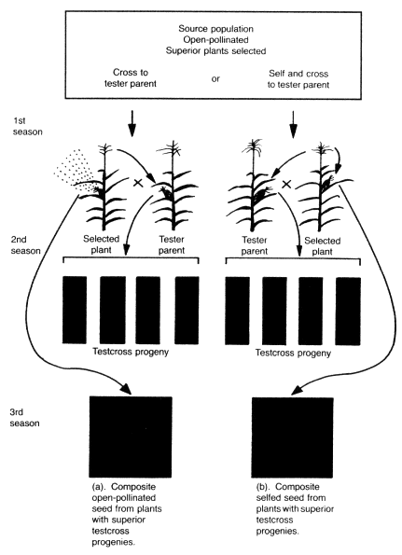

FULL-SIB SELECTION

With full-sib selection, crosses are made between selected pairs of plants in the source population, with the crossed seed used for progeny tests and for reconstituting the new population. An example of the procedure follows (Fig. 10.7):

First season. Cross 150 to 200 pairs of plants selected from the source population. Reciprocal crosses may be made to provide a larger quantity of crossed seed.
Second season. Grow a replicated progeny test with seed from each pair of crosseskeeping the remnant crossed seed.

Third season. Reconstitute the source population by mixing equal quantities of remnant crossed seed from 15 to 20 paired crosses with superior progeny performance, and grow in isolation with open-pollination to obtain new gene combinations.

Full-sib selection measures the combining ability from mating specific pairs of plants and only those pairs with superior progeny performance enter into the composite. The procedure is applicable to many cross-pollinated species, including self-incompatible species
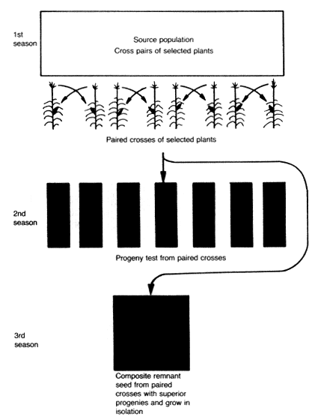

Fig. 10.7.Full-sib selection based on progeny test performance of paired crosses.

SELECTION FROM S₁ PROGENY TEST

S₁ progeny tests may be utilized to evaluate selected plants from an open-pollinated source nursery. S₁ refers to the progeny following self-pollination of plants in an open-pollinated population, or in the F₂ following a cross. The procedure follows (Fig. 10.8):

First season. Select 50 to 100 plants from a source nursery prior to flowering. Self-pollinate and harvest selfed seed from selected So plants.

Second season. Grow replicated S₁ progeny trial, keeping remnant selfed (S₀) seed.
Third season. Composite equal quantities of remnant seed from the So plants with superior progenies, and grow the seed composite in isolation to obtain new gene combinations 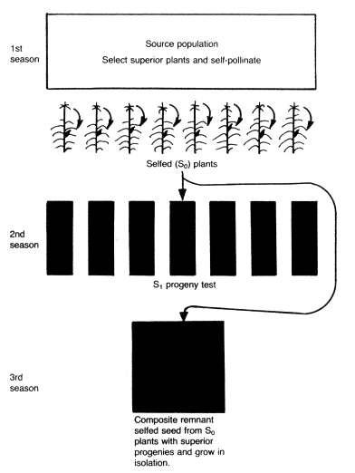

Fig. 10.8.Selection based on S₁ progeny performance.

.

Selection is based on performance of S₁ plant progenies. Each S₁ progeny evaluated receives only the genes present in the parent So plant; no genes are introduced into the line from open-pollination or tester parents. The procedure is applicable to corn and other cross-pollinated species in which a quantity of seed sufficient for a replicated progeny trial and remnant seed for making the composite can be obtained by self-pollination. It would not be applicable to self-incompatible species

