TOPIC: CONVERGENT AND DIVERGENT EVOLUTION
CONTENT :
- EVOLUTION
- TYPES OF EVOLUTION
- CONVERGENT EVOLUTION
- CAUSES OF CONVERGENT EVOLUTION
- .DIVERGENT EVOLTION
- CAUSES OF DIVERGENT EVOLUTION
- SIGNIFICANCE OF DIVERGENT EVOLUTION
- PARALLELL EVOLUTION
- CAUSES OF PARALLELL EVOLUTION
- IMPORTANCE OF PARALLELL EVOLUTION

EVOLUTION:
Change in the characteristics of a species over several generations and relies on the process of natural selection. Father of evolution also known as Charles Darwin.
EXAMPLES:
- Peppered moth - This moth had a light coloring darkened after the Industrial Revolution, due to the pollution of the time. ...
- Live Birth in Three-toed Skinks - This lizard can either lay eggs or have live birth

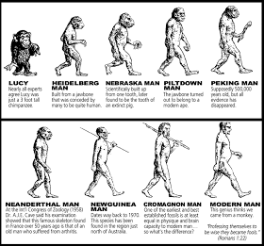

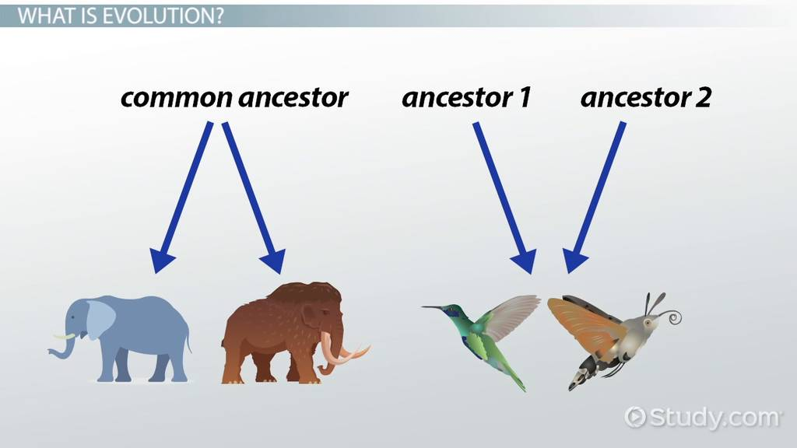

TYPES OF EVOLUTION:

  - Convergent evolution
  - Divergent evolution
  - Parallel evolution

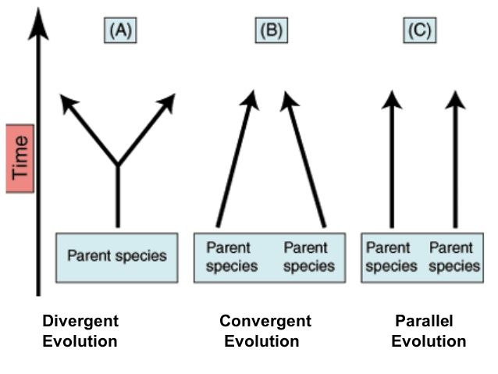

CONVERGENT EVOLUTION:
Convergent evolution is the independent evolution of similar features in species of different periods or epochs in time. Convergent evolution creates analogous structures that have similar form or function but were not present in the last common ancestor of those groups. cladistic term for the same phenomenon is homoplasy. The recurrent evolution of flight is a classic example, as flying insects, birds, pterosaurs, and bats have independently evolved the useful capacity of flight. Functionally similar features that have arisen through convergent evolution are analogous, whereas homologous structures or traits have a common origin but can have dissimilar function . Bird, bat, and pterosaur wings are analogous structures, but their forelimbs are homologous, sharing an ancestral state despite serving different functions.
The opposite of convergence is divergent evolution, where related species evolve different traits. Convergent evolution is similar to parallel evolution, which occurs when two independent species evolve in the same direction and thus independently acquire similar characteristics; for instance, gliding frogs have evolved in parallel from multiple types of tree frog.

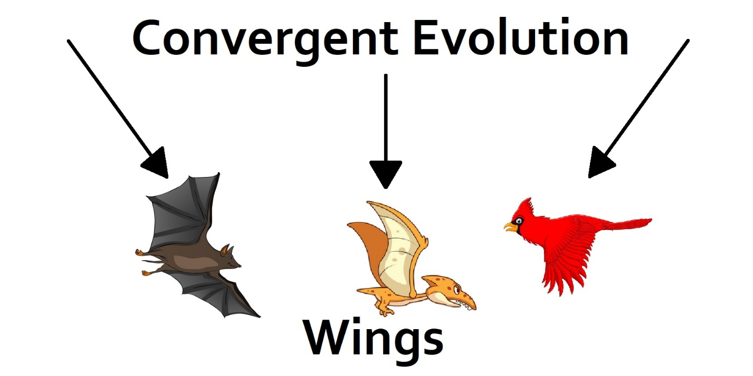

CAUSES OF CONVERGENT EVOLUTION :
Convergence often results from similar genetic changes, which can emerge in two ways: the evolution of similar or identical mutations in independent lineages, which is termed parallel evolution; and the evolution in independent lineages of alleles that are shared among populations, which I call collateral genetic evolution.

An example of convergent evolution is the similar nature of the flight/wings of insects, birds, pterosaurs, and bats .

CONVERGENT EVOLUTION (at molecular level):
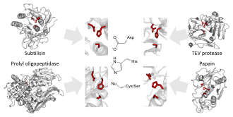
Evolutionary convergence of serine and cysteine protease towards the same catalytic triads organisation of acid-base-nucleophile in different protease superfamilies. Shown are the triads of subtilisin, prolyl oligopeptidase, TEV protease, and papain.

Proteins

Protease active site
Main article: catalytic triad
The enzymology of proteases provides some of the clearest examples of convergent evolution. These examples reflect the intrinsic chemical constraints on enzymes, leading evolution to converge on equivalent solutions independently and repeatedly.
Serine and cysteine proteases use different amino acid functional groups (alcohol or thiol) as a nucleophile. In order to activate that nucleophile, they orient an acidic and a basic residue in a catalytic triad. The chemical and physical constraints on enzyme catalysis have caused identical triad arrangements to evolve independently more than 20 times in different enzyme superfamilies.
Threonine proteases use the amino acid threonine as their catalytic nucleophile. Unlike cysteine and serine, threonine is a secondary alcohol (i.e. has a methyl group). The methyl group of threonine greatly restricts the possible orientations of triad and substrate, as the methyl clashes with either the enzyme backbone or the histidine base. Consequently, most threonine proteases use an N-terminal threonine in order to avoid such steric clashes. Several evolutionarily independent enzyme superfamilies with different protein folds use the N-terminal residue as a nucleophile. This commonality of active site but difference of protein fold indicates that the active site evolved convergently in those families.

HOMOLOGOUS STRUCTURE : Homologous structures are organs or skeletal elements of animals and organisms that, by virtue of their similarity, suggest their connection to a common ancestor. These structures do not have to look exactly the same, or have the same function.

EXAMPLES :
Monkeys, cats, rats and other mammals have tails. In mammals, the tail is an extension of the torso, made of flexible vertebrae. Tails primarily function to ward off insects, but they can also serve as sources of balance for more aloof species, like cats.

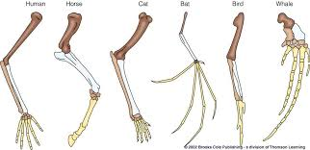

DISTINTION :
Cladistics :
Main article: Cladistics
In cladistics, a homoplasy is a trait shared by two or more taxa for any reason other than that they share a common ancestry. Taxa which do share ancestry are part of the same clade; cladistics seeks to arrange them according to their degree of relatedness to describe their phylogeny. Homoplastic traits caused by convergence are therefore, from the point of view of cladistics, confounding factors which could lead to an incorrect analysis.

Atavism:
Main article: Atavism
In some cases, it is difficult to tell whether a trait has been lost and then re-evolved convergently, or whether a gene has simply been switched off and then re-enabled later. Such a re-emerged trait is called an atavism. From a mathematical standpoint, an unused gene (selectively neutral) has a steadily decreasing probability of retaining potential functionality over time. The time scale of this process varies greatly in different phylogenies; in mammals and birds, there is a reasonable probability of remaining in the genome in a potentially functional state for around 6 million years.

DIVERGENT EVOLUTION:
Divergent evolution or divergent selection is the accumulation of differences between closely related populations within a species, leading to speciation. Divergent evolution is typically exhibited when two populations become separated by a geographic barrier (such as in allopatric or peripatric speciation) and experience different selective pressures that drive adaptations to their new environment. After many generations and continual evolution, the populations become less able to interbreed with one another. The American naturalist J. T. Gulick (1832-1923) was the first to use the term "divergent evolution", with its use becoming widespread in modern evolutionary literature. Classic examples of divergence in nature are the adaptive radiation of the finches of the Galapagos or the coloration differences in populations of a species that live in different habitats such as with pocket mice and fence lizards.
Darwin's finches are a clear and famous example of divergent evolution, in which an ancestral species radiates into a number of descendant species with both similar and different traits. Convergent evolution is when two species with different ancestral origins develop similar characteristics, while divergent evolution refers to when two species diverge from a common ancestor and develop different characteristics .

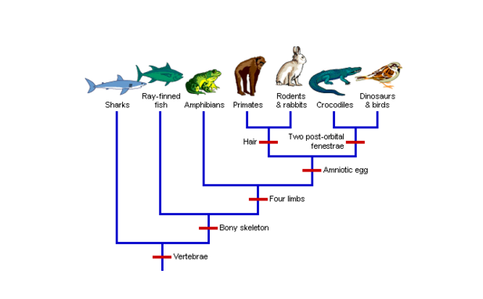

CAUSES OF DIVERGENT EVOLUTION :

Animals undergo divergent evolution for a number of reasons. Predators or their absence, changes in the environment, and the time at which certain animals are most active are chief among them.

DISTINCTIONS : It is always coupled ( clarification needed ) with convergent evolution, as they are both similar and different in various facets such as whether something evolves, what evolves, and why it evolves. It is instructive to compare divergent evolution with both convergent and parallel evolution.

SIGNIFICANCE OF DIVERGENT EVOLUTION:

- Divergent evolution leads to speciation, or the development of a new species.
The differences are produced from the different selective pressures. Any genus of plants or animals can show divergent evolution. An example can involve the diversity of floral types in the orchids. The greater the number of differences present, the greater the divergence.

PARALLELL EVOLUTION :

It can be defined as the independent evolution of similar traits, starting from a similar ancestral condition. Frequently this is the situation in more closely related lineages, where several species respond to similar challenges in a similar way. One of the most spectacular examples of parallel evolution is provided by the two main branches of the mammals, the placentals and marsupials, which have followed independent evolutionary pathways following the break-up of land-masses such as Gondwanaland roughly 100 million years ago. In South America, marsupials and placentals shared the ecosystem (prior to the Great American Interchange); in Australia, marsupials prevailed; and in the Old World the placentals won out.
However, in all these localities mammals were small and filled only limited places in the ecosystem until the mass extinction of dinosaurs forty million years later.
At this time, mammals on all three landmasses began to take on a much wider variety of forms and roles.
While some forms were unique to each environment, surprisingly similar animals have often emerged in two or three of the separated continents.
EXAMPLES :
..Colouration that serves as a warning to predators and for mating displays has evolved in many different species.
- In the plant kingdom, the most familiar examples of parallel evolution are the forms of leaves, where very similar patterns have appeared again and again in separate genera and families.

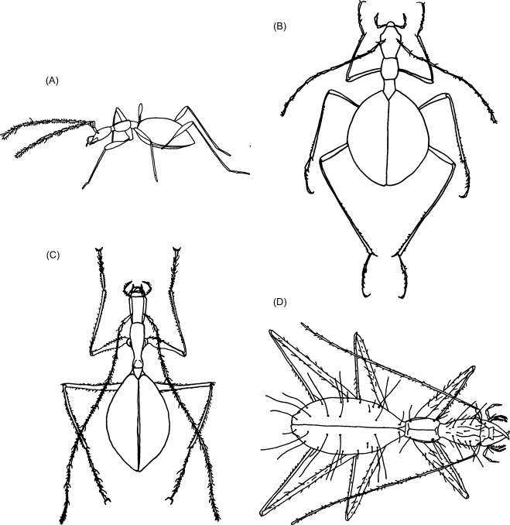

CAUSES OF PARALLELL EVOLUTION :
The repeated and similar large-scale morphological evolutionary trends of distinct lineages suggest that adaptation by means of natural selection (functional constraints) is the major cause of parallel evolution, a very common phenomenon in extinct and extant lineages.
PARALLELL EVOLUTION BETWEEN MARSUPIALS AND PLACENTALS ::;
A number of examples of parallel evolution are provided by the two main branches of the mammals, the placentals and marsupials, which have followed independent evolutionary pathways following the break-up of land-masses such as Gondwanaland roughly 100 million years ago. In South America, marsupials and placentals shared the ecosystem (before the Great American Interchange); in Australia, marsupials prevailed; and in the Old World and North America the placentals won out. However, in all these localities mammals were small and filled only limited places in the ecosystem until the mass extinction of dinosaurs sixty-five million years ago. At this time, mammals on all three landmasses began to take on a much wider variety of forms and roles. While some forms were unique to each environment, surprisingly similar animals have often emerged in two or three of the separated continents. Examples of these include the placental sabre-toothed cats (Machairodontinae) and the South American marsupial sabre-tooth (Thylacosmilus); the Tasmanian wolf and the European wolf; likewise marsupial and placental moles, flying squirrels, and (arguably) mice.

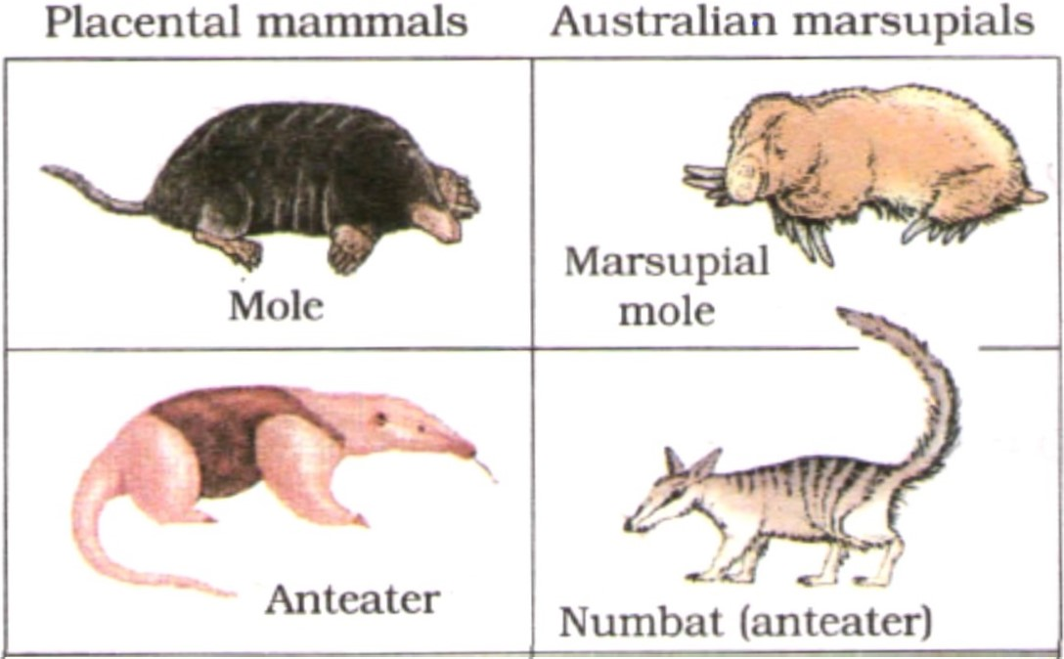

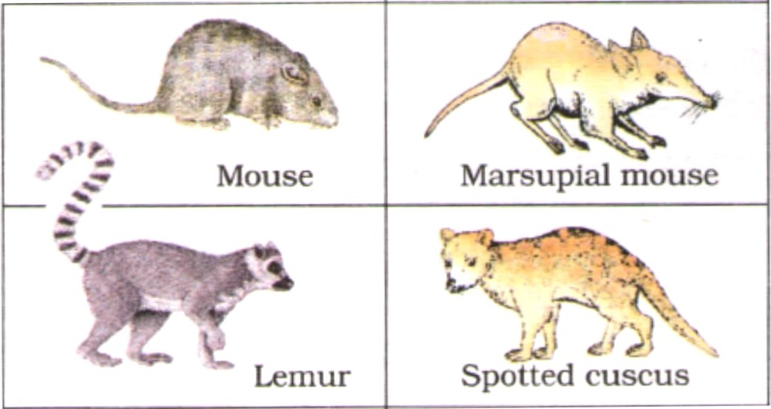

IMPORTANCE OF PARALLELL EVOLUTION :
It shows that very primitive organisms can have the genetic tools available to create greater complexity. As the organism evolves, widely separated species can develop similar traits because the potential for those traits was there right from the beginning.

- MCQS

Tick the correct option
1. Darwin’s primary contribution to biological theory was the idea that
A) an important mechanism of biological evolution is natural selection
B) new alleles arise through mutation
C) evolution is the change in gene frequencies over time
D) genes are the units of inheritance
E) characteristics acquired during an individual’s lifetime can be passed to its offspring

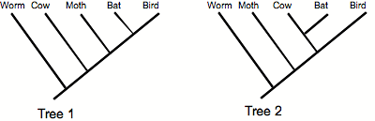
2. Applying the principle of parsimony to the trait "ability to fly," which of the two phylogenetic trees above is better?
A) Tree 1 B) Tree 2

3. What is divergent evolution?
- When two species evolve to become different
- The evolution of similar characteristics in two species with different evolutionary ancestors
- The evolution of two separate species from a common ancestor
- The evolution of two separate species from different ancestors
4 . Darwin's finches are an example of what type of evolution?
- Speciation only
- Macroevolution only
- Divergent evolution and speciation only
- Speciation, macroevolution and divergent evolution

- 5. Bird wings and butterfly wings are an example

  - Homologous structure
  - Analogous structure
  - Mimicry
  - Camoflague
- 6. Shark fins and dolphin fins are examples of analogous structures.
  - True
  - False

7. On the Origin of Species was written by ______
- Charles Darwin
- Ludmila Kuprianova
- Mikhail A. Fedonkin
- Ituhbuna Lawraga
8. An example of convergent evolution is
- Wing of Hawkmoths, the wing of hawks
- Teeth of domestic dog, teeth of a wolf
- Wings of Geospiza magnirostris, wings of Geospiza fortis
- None of the above

9. What is convergent evolution?
- When two species evolve to become different
- The evolution of similar characteristics in two species with different evolutionary ancestors
- The evolution of two separate species from a common ancestor
- The evolution of two separate species from different ancestors

10. Structures that are very different in structure or anatomy but have similar functions such as the wings of a bird and a butterfly.

- Vestigial Structures
- Homologous Structures
- Analogous Structures
- Cladogram

