Product Mix Decisions and strategies.
Definition:
Product mix, also known as product assortment or product portfolio, refers to the complete set of products or services offered by a firm. A product mix consists of product lines, which are associated items that consumers tend to use together or think of as similar products or services.
- Product:
A product is an item produced or procured by the business to satisfy the needs of the customer. It is the actual item which is held for sale in the market. A company usually sells different types of products. E.g. Getz Pharma has more than 100 medicinal products in market.
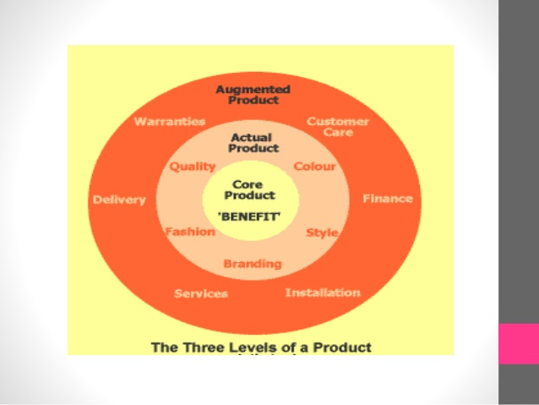

Three levels of a Product:
- Core: Most basic in level. This Product is not the tangible physical product. We can’t touch it. That’s because the core is the benefit of the product that makes it valuable to us.

- Actual: This product is tangible, physical product.

- Augmented: This product is non-physical part of the product. It usually consists of lots of added value, for which we may or may not pay a premium.

- Product formats:

All drug products are available in both traditional and nontraditional markets and manufactured by either local or multinational Pharma companies.

Brand or generic name decision of a product:
- Brand:

Brand name is a name, term, symbol, design or combination of these intended to identify the goods or services one seller or group of sellers and to differentiate the from other competitors.
- Brand mark: It is a part of brand that can be recognized but is not utterable such as design, symbol or distinctive coloring or lettering.

- Trade mark: Brand or a part of brand that is given for its legal protection.

- Copyright: It is an exclusively legal part to reproduce, publish and sell the matter and form of literary, musical or artistic work.

- Brand extension Decision:

It is an effort to use a successful brand name to launch a new or modified products. E.g. neozep tablets, neozep syrup, neozep otic, neozep nasal spray.
- Multibranding decision:

In this strategy the seller develops two or more brands in the same drug product category or the same generic equivalents.

Advantages:
- More shelf space at the selling area of drug outlets.
- Very few consumers of a drug product are that loyal to a brand and will not prefer to try another brand.
- Creating new brands develop healthy competition within the manufacturer’s organization comprising several product divisions.
- Packaging Decisions:

Packaging is a marketing activity of creatively designing and producing the container for a drug product suitable to target markets relative to competitions products.
- Primary package: is the products immediate container. E.g. the bottle holding allerin expectorant and its corresponding label is the primary package.

- Secondary package: is the packaging material that protects the primary package and is thrown away when the drug product is about to be used by the target client.

- Shipping package: is used primarily to store, identify and ship the products to target markets. E.g. A box containing allerin expectorant is a shipping package. Labelling is the part of packaging and consists of printed information appearing or within the package.

- Product Mix Decision:

Product mix or product assortment is the set of product lines and items that a particular seller offers for sale to buyers.

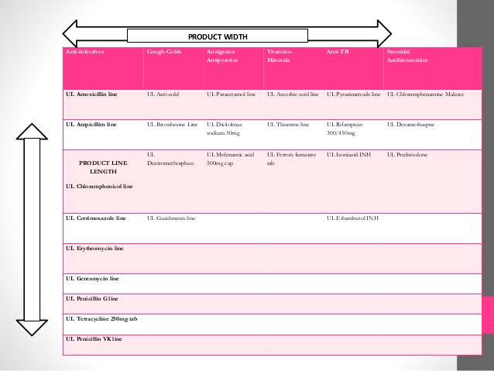

Importance of a Product Mix:
The product mix of a firm is crucial to understand as it exerts a profound impact on a firm’s brand image. Maintaining high product width and depth diversifies a firm’s product risk and reduces dependence on one product or product line. With that being said, unnecessary or non-value adding product width diversification can hurt a brand’s image. In regard to a firm expanding its product mix:
- Expanding the width can provide the firm with the ability to satisfy the needs or demands of different consumers and diversify risk.
- Expanding the depth can provide the firm with the ability to readdress and better fulfill current consumers.
Example: A company may have a wide range of antibiotics, a number of painkillers, a few cough syrups and some other medicines in different categories. All of these put together will be called a Product mix
- Product Mix in Marketing:
Product mix, also known as product assortment, is the total number of product lines that a company offers to its customers. The product lines may range from one to many and the company may have many products under the same product line as well. All of these product lines when grouped together form the product mix of the company.
The product mix is a subset of the marketing mix and is an important part of the business model of a company. The product mix has the following dimensions

Width-Number of Product Lines:
The width of the mix refers to the number of product lines the company has to offer.
For e.g., GSK has a wide product mix comprising antibiotics, painkillers, multivitamins, skin treatments, and antiulcerants.

Length-Total Products:
Length of the product mix refers to the total number of products in the mix. That is if a company has 5 product lines and 10 products each under those product lines, the length of the mix will be 50 [5 x 10].
For e.g. GSK has Augmentin, Ampicillin, and Ampiclox in its antibiotic category.

Depth-Product Variations:
The depth of the product mix refers to the total number of products within a product line. There can be variations in the products of the same product line.
For e.g. GSK’s Antibiotic brand Augmentin come in 375mg, 625mg, and 1g strengths, and other brands are also available in different strengths.

Consistency is Relationship:
Product mix consistency refers to how closely products are linked to each other. Less the variation among products more is the consistency. For example, a Pharma company dealing in just supplement products has more consistency than a company dealing in all types of electronics.
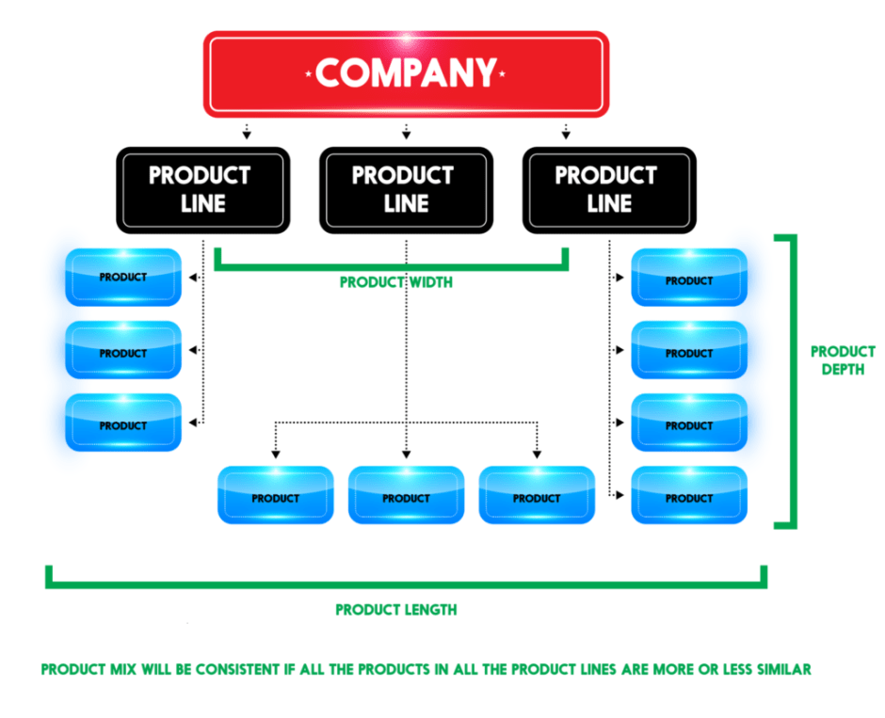

- Product line decision:

A product line is a group of products that are closely related, either because they:
  - Function in the similar manner.
  - Are sold to same customer groups.
  - Are marketed through the same types of outlets.
  - Fall within the given price ranges.

Example: A pharmaceutical company that’s already selling high-priced product line of Paracetamol drug under one of its well-known brand might launch a product line under the same brand name but with lower price.

- Product Mix vs. Product Line:
A product mix is a group of everything a company sells.
However, the product line is a subset of the product mix. A product line refers to a unique product category or product brand a company offers. It is a group of products or services that have been classified together, can be used together, the same customers use, can be purchased in the same place, and have a price range that they fall within for consumers to purchase.

Product Mix depends on many factors like
- Company Age
- Financial Standing
- Area of Operation
- Brand identity, etc.
Many new companies start with limited width, length, depth and high consistency of the product mix, while companies with good financial standing have wide, long, deep and less consistency of the product mix. Area of operation and brand identity also affects its product mix.

